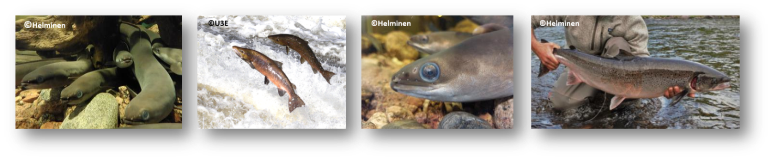
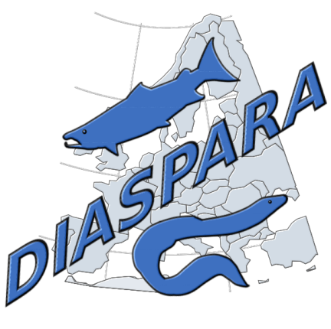EMFAF-2023-PIA-FisheriesScientificAdvice  Project n° 101155914 | DELIVERABLE XX- Title
 | NAME Surname - Institute
 |  | 

Abstract

Index
Abstract 2

Knklnponhbopopbpopobnpoinipnpoinoin

Ionjpoin

Inpionopîn

Boiuboibu

ioubiobu

Quanta autem vis amicitiae sit, ex hoc intellegi maxime potest, quod ex infinita societate generis humani, quam conciliavit ipsa natura, ita contracta res est et adducta in angustum ut omnis caritas aut inter duos aut inter paucos iungeretur.
Dein Syria per speciosam interpatet diffusa planitiem. hanc nobilitat Antiochia, mundo cognita civitas, cui non certaverit alia advecticiis ita adfluere copiis et internis, et Laodicia et Apamia itidemque Seleucia iam inde a primis auspiciis florentissimae.
Ut enim benefici liberalesque sumus, non ut exigamus gratiam (neque enim beneficium faeneramur sed natura propensi ad liberalitatem sumus), sic amicitiam non spe mercedis adducti sed quod omnis eius fructus in ipso amore inest, expetendam putamus.

References
Biseau, A., & Talidec, C. (2003). Report of the Working Group on Nephrops Stocks—Appendix 2: Bay of Biscay Nephrops Medium-term predictions: Simulations of various management measures: Reduction in fishing mortality, improvement of the selection patter and constant landings (pp. 572–585). ICES.
Commission of the European Communities. (2001). Report of the Working Group on the preparation of the future recovery measures for Northern Hake (p. 28). ICES, Vigo.
Dekker, W. (2005). Report of the Workshop on National Data Collection for the European Eel, S\a anga Säby (Stockholm, Sweden), 6–8 September 2005. Fiskeriverket Swedish Board of Fisheries, 282.
ICES. (1991a). Report of the Working Group on Fishery Units in sub-areas VII and VIII (p. 215). ICES, Nantes.
ICES. (1991b). Report of the working group on the assessment of the stocks oh hake (p. 35).
ICES. (1992). Report of the Working Group on the fisheries units in sub areas VII and VIII. ICES.
ICES. (1993). Report of the Working Group on the Assessment of Southern Shelf Stocks of Hake, Monk and Megrim (p. 92).
ICES. (1997). Report of the Study Group on the Precautionary Approach to Fisheries Management (No. ICES CM 1997/Assess:7). ICES.
ICES. (1998). Report of the Study Group on the Precautionary Approach to Fisheries Management (No. ICES CM 1998/ACFM:10). ICES.
ICES. (2003a). Report of the Working Group on Methods on Fish Stock Assessments (p. 171).
ICES. (2003b). Report of the Working Group on Nephrops Stocks (p. 629). ICES.
ICES. (2003c). Report of the Working Group on the Assessment of Southern Shelf Stocks of Hake, Monk and Megrim (p. 451). ICES.
ICES. (2005). Report of the Working Group on the Assessment of Hake, Monk and Megrim (WGHMM).
ICES. (2012). Report of the Workshop on Eel and Salmon DCF Data (WKESDCF) (No. ICES CM / ACOM:62; p. 63).
ICES. (2013a). Report of the Workshop for the Review of Eel Management Plan Progress Reports (WKEMP) (No. ICES CM 2013 / ACOM:32; p. 757).
ICES. (2013b). Report of the Workshop on Evaluation Progress Eel Management Plans (WKEPEMP) (No. ICES CM 2013/ACOM:32). ICES.
ICES. (2014). Report of the Workshop of a Planning Group on the Monitoring of Eel Quality under the subject “Development of standardized and harmonized protocols for the estimation of eel quality” (WKPGMEQ) (No. ICES CM 2014/SSGEF:14; p. 274).
ICES. (2016a). Report of the Workshop of the Working Group on Eel and the Working Group on Biological Effects of Contaminants (WKBECEEL) (No. ICES CM 2015/SSGEPD:20; p. 98).
ICES. (2016b). Report of the Workshop on Eel Stocking (WKSTOCKEEL) [Report]. ICES Expert Group reports (until 2018). https://doi.org/10.17895/ices.pub.8436
ICES. (2017a). Report of the Working Group on the Integrated Assessments of the Barents Sea (WGIBAR).
ICES. (2017b). Report of the Workshop on Designing an Eel Data Call (WKEELDATA) (No. ICES CM 2017/SGIEOM:30; p. 194).
ICES. (2018). Report of the Workshop for the Review of Eel Management Plan Progress Reports (WKEMP) (No. ICES CM 2018/ACOM:46; p. 96).
ICES. (2023). Report of the Workshop on the Development of a Spatial Database and Model for Eels (WKSMEEL) [Report]. Browse ICES content by Type. https://doi.org/10.17895/ices.pub.24648135.v1

