CMS name and version: | Ecwid | 11.0
Additional plugin name and version: | - | -
Module names and versions: | DIBS PW | 1.0.0.

Important notes (possible problems solutions)
- For proper work of this module you need to check all checkboxes in
Integration → Return Values section of DIBS Merchant Administration and
click Save Settings button:
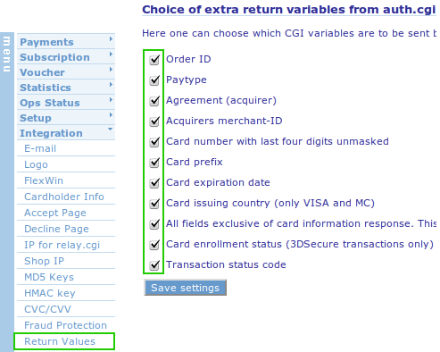

- Technical requirements:
- PHP extension: curl
URL: http://www.php.net/manual/en/curl.installation.php

DIBS module installation

Installing DIBS payment module
- Extract module to the folder on server that has LAMP installation.
- Go to Ecwid admin panel. Choose System Settings then choose Payment.
- In the second table column Payment Processor click Change on the first row, select from dropdown list: Echeck: Authorize.Net SIM and save the changes.
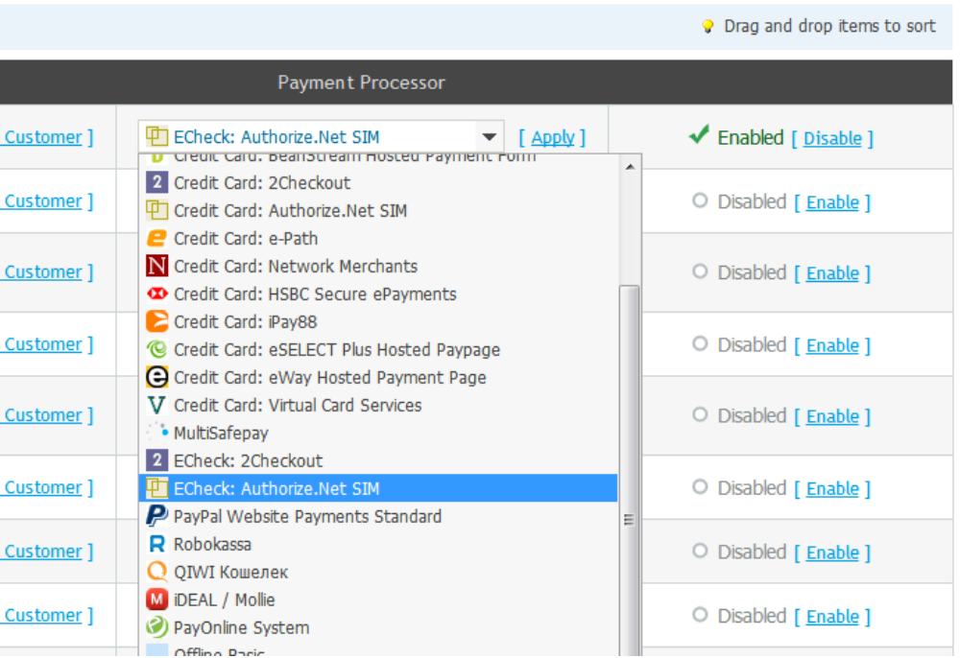
- In the first column you should rename Payment Method to DIBS Payment Window.
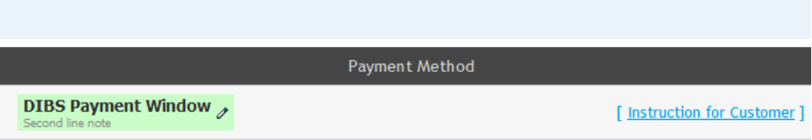
- Enable created method in the third column.
- Click to the Account Details and fill the following: API Login Id - your Merchant Id
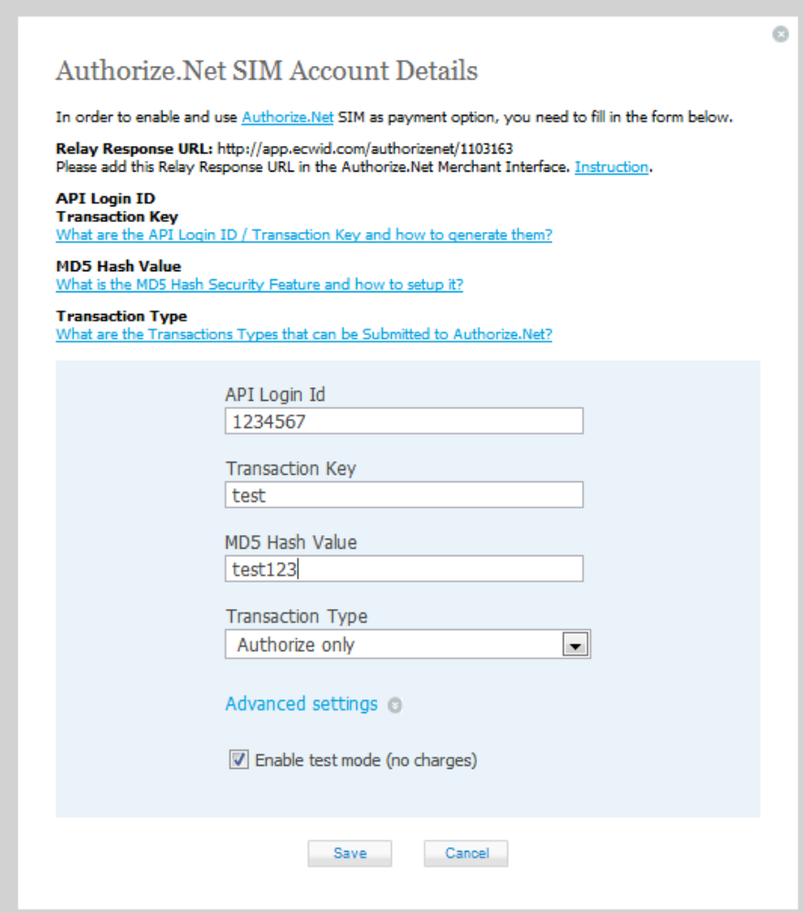
- Fill MD5 Hash Value with any word or couple of words (EX: “test1234”, “test word”, e.t.c).
- Choose Transaction Type.
- Click Advanced Settings and change Endpoint URL. The Endpoint URL is an URL for payment communication between Ecwid shop and DIBS Payment Service. The Endpoint URL must point to the php file “entrypoint.php” that is in Ecwid payment module package. For example. You have a domain http://example.com that accessible from Internet. You must put the Ecwid payment module in the Document Root of your host. And than Ecwid sevrice can access your payment module files. So if host is http://example.com for Endpoint URL you must set http://example.com/entrypoint.php.
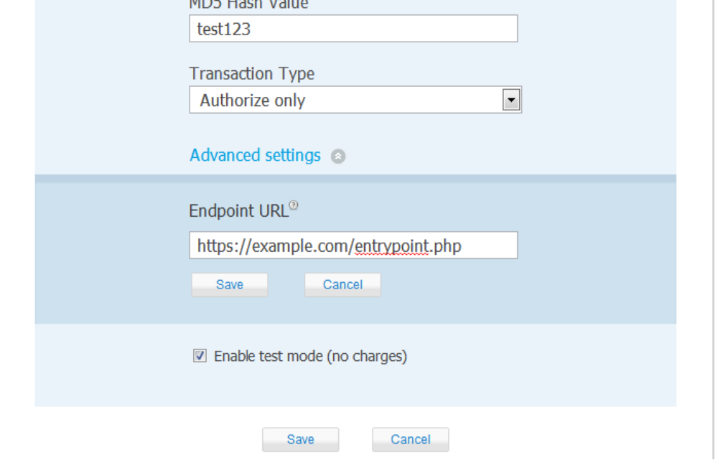
- Also you can enable/disable test mode. And click save.
- The next step is setup of Ecwid payment module. In Ecwid DIBS Payment module folder find MODULE_FOLDER/module/conf/config.ini. This is configuration file.

- Change the settings to the following:
[Ecwid_Payment]
md5Hash = “”; - MD5 Hash Value that you entered in admin area (7)
shopId = “”; - The id of your shop. In admin area look at the right bottom corner.
addfee = “”; - On/Off fee.
host = "https://example.com" the host when you installed Ecwin DIBS Payment module (9)
paytype = ""; - You can change paytype here
account = ""; - You an change account here
hmac = “”; - Your hmac code here.
- That's it. Now you can test shopping.

