CMS name and version: | OXID eShop | 4.5.x
Additional plugin name and version: | - | -
Module names and versions: | DIBS PW | 1.0

Important notes (possible problems solutions)
- For proper work of this module you need to check all checkboxes in
Integration → Return Values section of DIBS Merchant Administration and
click Save Settings button:
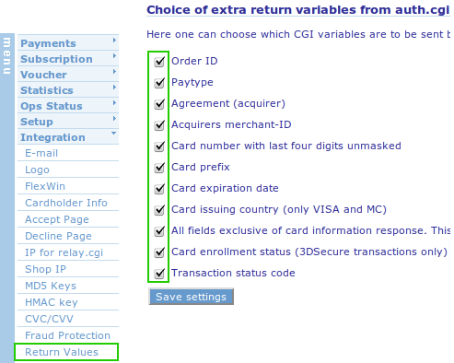

- Also for FlexWin module you need to uncheck Skip accept page checkbox in Integration → FlexWin section of DIBS Merchant Administration and click
Update FlexWin Settings button (this turns FlexWin to send data with POST method):
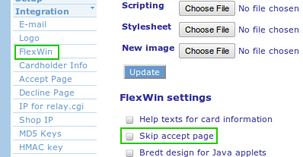

DIBS module installation

Installing DIBS payment module
- In the admin area go to Service->Tools.
- Click on “Choose file” button and choose dibspw_install.sql from installation package.
- Click “Start Update” button.
- Copy content of copy_this folder to your Oxid eShop installation to the
corresponding folders.
- Go to Master Settings->Core Settings->System->Modules. Click Modules link and insert the following lines in the textarea:
order => dibspw/dibspw_order
payment_main => dibspw/dibspw_payment
oxorder => dibspw/dibspw_oxorder
You can open classes.txt file, copy content and then paste in textarea.

Configuring DIBS payment module
- Go to Shop Settings->Payment methods.
- Choose DIBS Payment Window the list of payment methods.
- Fill the fields Merchant Id, Paytype, HMAC code e.t.c with your details.
- Go to Shop Settings->Shipping Methods choose methods you are using, click tab Payment and then click Assign Payment Methods button and assign DIBS Payment Window method. You can read about assigning payment methods in Oxid eShop documentation http://www.oxid-esales.com/en/support-services/documentation-and-help/archive-oxid-eshop/first-steps.html

