

API Reference Documentation
Real time digital recipient verification, fraud detection and transaction hold | freeze
| block API for banks and mobile network operators

Document version: v1.0 Date: 8 Aug 2026

Abbreviations

Abbreviation | Full term
AI | Artificial Intelligence
API | Application Programming Interface
BOT | Bank of Tanzania
DCS | Digital Consumer Shield
FIU | Financial Intelligence Unit
HMAC | Hash-based Message Authentication Code
HTTP / HTTPS | Hypertext Transfer Protocol (Secure)
JSON | JavaScript Object Notation
ML | Machine Learning
MNO | Mobile Network Operator
mTLS | Mutual Transport Layer Security
PSP | Payment Service Provider
RLS | Row-Level Security
SLA | Service Level Agreement
TCRA | Tanzania Communications Regulatory Authority
TLS | Transport Layer Security
TTL | Time To Live
TZS | Tanzanian Shilling

Base URL: https://api.dcs.co.tz/v1 · JSON over HTTPS · one API key per tenant (bank/MNO)

Authentication
Every request requires mutual TLS plus a per-tenant API key in the X-Tenant-Key header. State-changing requests (transaction validation, dispute actions) also require a client-generated X-Request-Id for idempotency — retried requests with the same id return the original result instead of double-processing.
X-Tenant-Key: dcs_live_8f2c1a9e...
X-Request-Id: 8b2f4b7e-30f1-4e2a-9c9a-7a6f0e2d1c44 Content-Type: application/json

Recipient verification
Most money lost by ordinary customers isn't sophisticated fraud — it's sending to the wrong number by mistake. Before a transfer is submitted, the bank/MNO app calls this endpoint with the recipient's account/phone number and shows the customer the real registered name to confirm (the same pattern mobile money apps already use for "confirm recipient"). This runs before the transaction validation below, and catches wrong-number mistakes at the point the customer can still cancel — which is most of what "fraud detection" means to an everyday user.
POST /v1/recipients/verify
→ Request
{
"recipient_external_ref": "hashed-recipient-msisdn-or-acct", "channel": "mobile_money", "tenant_txn_ref": "VOD-2026-0729-88213"
}

← 200 OK
{
"verified": true,
"recipient_display_name": "J. M****I", // partially masked for display "account_age_days": 412,
"first_time_recipient": false
}

Endpoint index

Method | Path | Purpose | Called by
POST | /v1/recipients/verify | Look up and confirm the recipient's registered name before sending | Bank / MNO
POST | /v1/transactions/validate | Real-time fraud detection & validation (core endpoint) — the only synchronous, latency-critical call | Bank / MNO
GET | /v1/transactions/{id} | Retrieve a previously scored transaction | Bank / MNO
POST | /v1/holds/{id}/release | Release a held transaction (manual or automated) | Bank / MNO, DCS ops
POST | /v1/holds/{id}/freeze | Escalate a hold to a freeze pending investigation | DCS ops
POST | /v1/disputes | File a dispute against a hold | Bank / MNO, customer via bank
PATCH | /v1/disputes/{id} | Record a dispute outcome | DCS ops analyst
POST | /v1/webhooks/subscribe | Register a callback URL for async events | Bank / MNO (once, at onboarding)
GET | /v1/health | Service health & current SLA status | Bank / MNO monitoring, DCS ops

POST /v1/transactions/validate
The core endpoint. Called synchronously at authorization time, before funds move. Budget: p95 < 150ms, p99 < 300ms; breach triggers the tenant's configured fail-open/fail-closed policy.
→ Request
{
"tenant_txn_ref": "VOD-2026-0729-88213", "user_external_ref": "hashed-msisdn-or-acct",
"amount": 250000, "currency": "TZS", "channel": "mobile_money", "recipient_external_ref": "hashed-recipient", "device_fingerprint": "...", "occurred_at": "2026-07-29T10:04:00Z"
}

← 200 OK
{
"decision": "warn", // allow | warn | hold | freeze | block "risk_score": 0.41,
"reason_codes": ["AMOUNT_ABOVE_BASELINE"], "advisory": {
"message": "This is unusual for you — please confirm before sending.", "baseline_amount": 100000, "current_amount": 250000
},
"model_version": "lgbm-2026.07-a"
}

Behavioural anomaly advisory
The AI agent keeps a rolling behavioural baseline per customer (typical amount, typical recipients, typical time of day). When a transaction is far outside that customer's own normal pattern — e.g. someone who usually sends under TZS 100,000 suddenly sends TZS 250,000 — the risk isn't necessarily high enough to hold or freeze the funds, but the customer should still get a chance to double-check what they're doing. In that case the decision is warn: the transaction is allowed to proceed, but the response carries an advisory object with a plain-language message the bank/MNO app shows the customer before they confirm — a soft "are you sure?" prompt rather than a block.

Decision states
decision | Meaning | Funds effect
allow | No meaningful risk signal | Transaction proceeds immediately
warn | Unusual for this specific customer's own pattern, not independently risky | Proceeds after the customer confirms the advisory message — no hold placed
hold | Suspicious — needs a time-boxed second validation | Funds paused for ttl_seconds, then auto-release unless escalated
freeze | Confirmed high-risk pattern, needs investigation | Funds locked indefinitely until a DCS ops analyst resolves it (POST /v1/holds/{id}/freeze)
block | Hard rule/deny-list match | Transaction rejected outright, never reaches the ledger

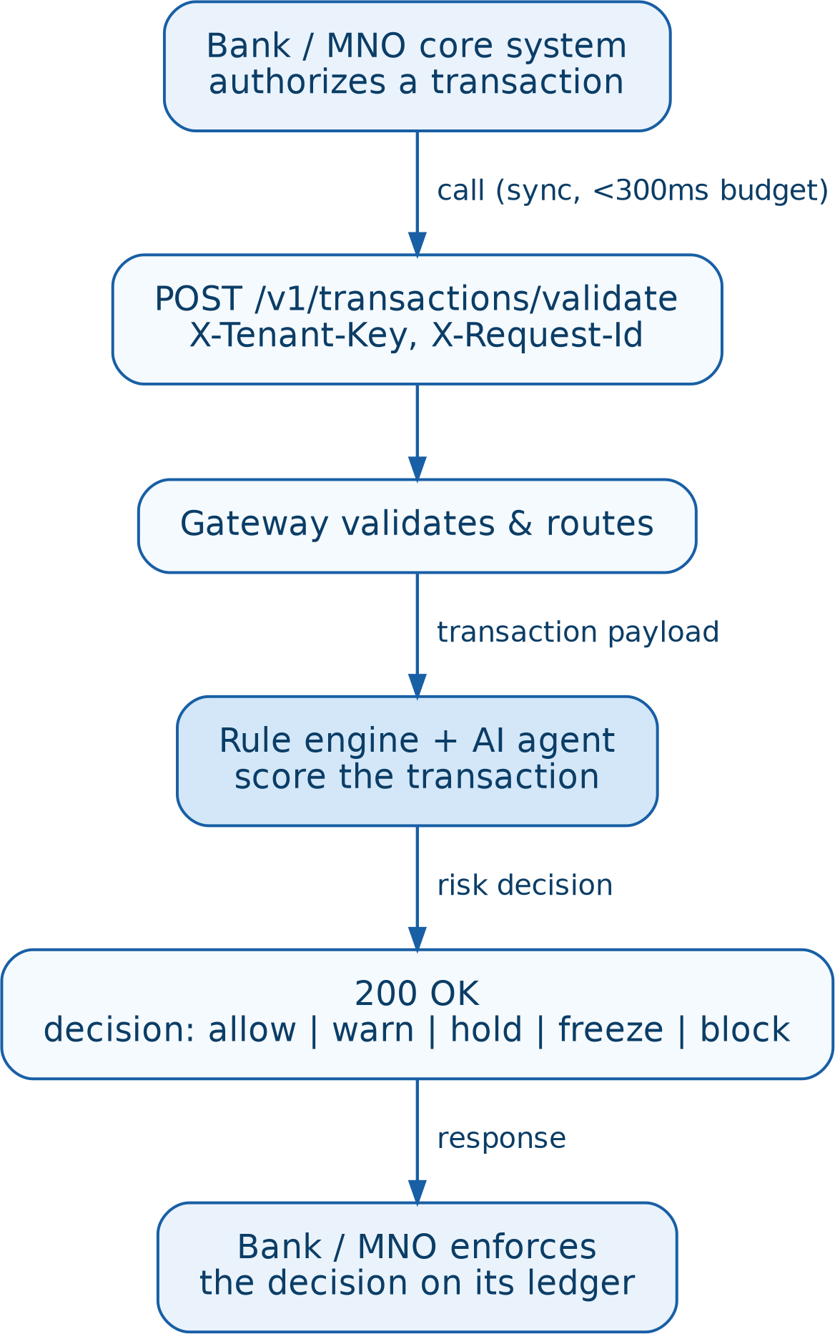
Figure 1. Real-time transaction validation flow
The bank/MNO's own system enforces the returned decision on its own ledger — DCS never touches funds directly.

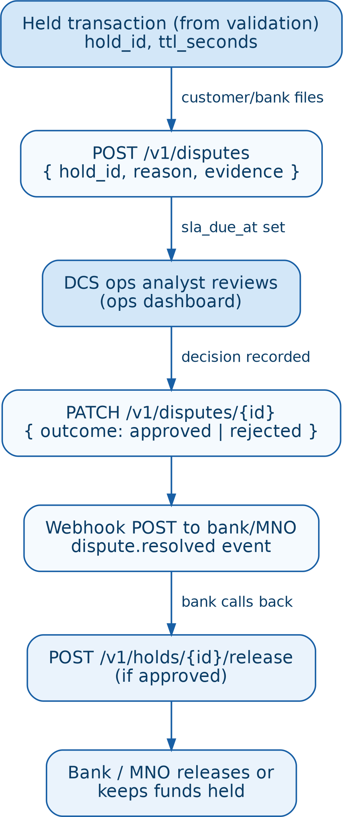
Dispute & hold-release endpoints

Endpoint | Request body | Response
POST /v1/disputes | hold_id, reason, evidence_url | dispute_id, status: "open", sla_due_at
PATCH /v1/disputes/{id} | outcome: "approved"|"rejected", note | dispute_id, outcome, resolved_at
POST /v1/holds/{id}/release | released_by, note | hold_id, status: "released", released_at

Figure 2. Dispute resolution flow
Dispute resolution is asynchronous — DCS notifies the bank/MNO via webhook rather than the bank/MNO polling.

Webhooks
Registered once via POST /v1/webhooks/subscribe. DCS retries failed deliveries with exponential backoff for 24h.
POST https://api.yourbank.co.tz/webhooks/dcs-events X-DCS-Signature: hmac-sha256=...
{
"event": "dispute.resolved",
"dispute_id": "d_71ac...", "hold_id": "h_9f2c...", "outcome": "approved", "resolved_at": "2026-07-30T09:12:00Z"
}

Error codes

HTTP status | Code | Meaning
400 | invalid_payload | Missing or malformed field — request rejected before scoring
401 | invalid_key | X-Tenant-Key missing, revoked, or wrong tenant
409 | duplicate_request | X-Request-Id already processed — original result returned
422 | unscoreable | Payload valid but required feature data unavailable
429 | rate_limited | Per-tenant request quota exceeded
503 | degraded | SLA breach — response follows the tenant's fail-open/fail-closed policy

Rate limits & SLA
  - Default: 200 requests/second per tenant, burstable to 400 for 10s
  - p95 < 150ms, p99 < 300ms on /v1/transactions/validate; breach triggers configured fail-open/fail-closed behaviour
  - Sandbox environment mirrors production limits at 10% quota for pre-production conformance testing

