**Recruiting Pathologists to Truth sTILs**

Greetings! Researchers from the [Office of Science and Engineering Laboratories, CDRH at the US FDA](https://www.fda.gov/about-fda/cdrh-offices/office-science-and-engineering-laboratories), alongside academic, clinical and industry colleagues, are collecting pathologist annotations of stromal tumor infiltrating lymphocytes (sTILs) as data for AI/ML algorithm validation. Volunteer pathologists will receive training in the task through a continuing medical education course (3.00 CME credits) and interactive training on our digital data-collection platform. After training, participants will be assigned pivotal study collections (30-60 min per collection) according to their interest and availability. Through your involvement, you will be generating the reference standard for algorithm validation ensuring high quality commercial products with a faster FDA-pipeline to approval.

[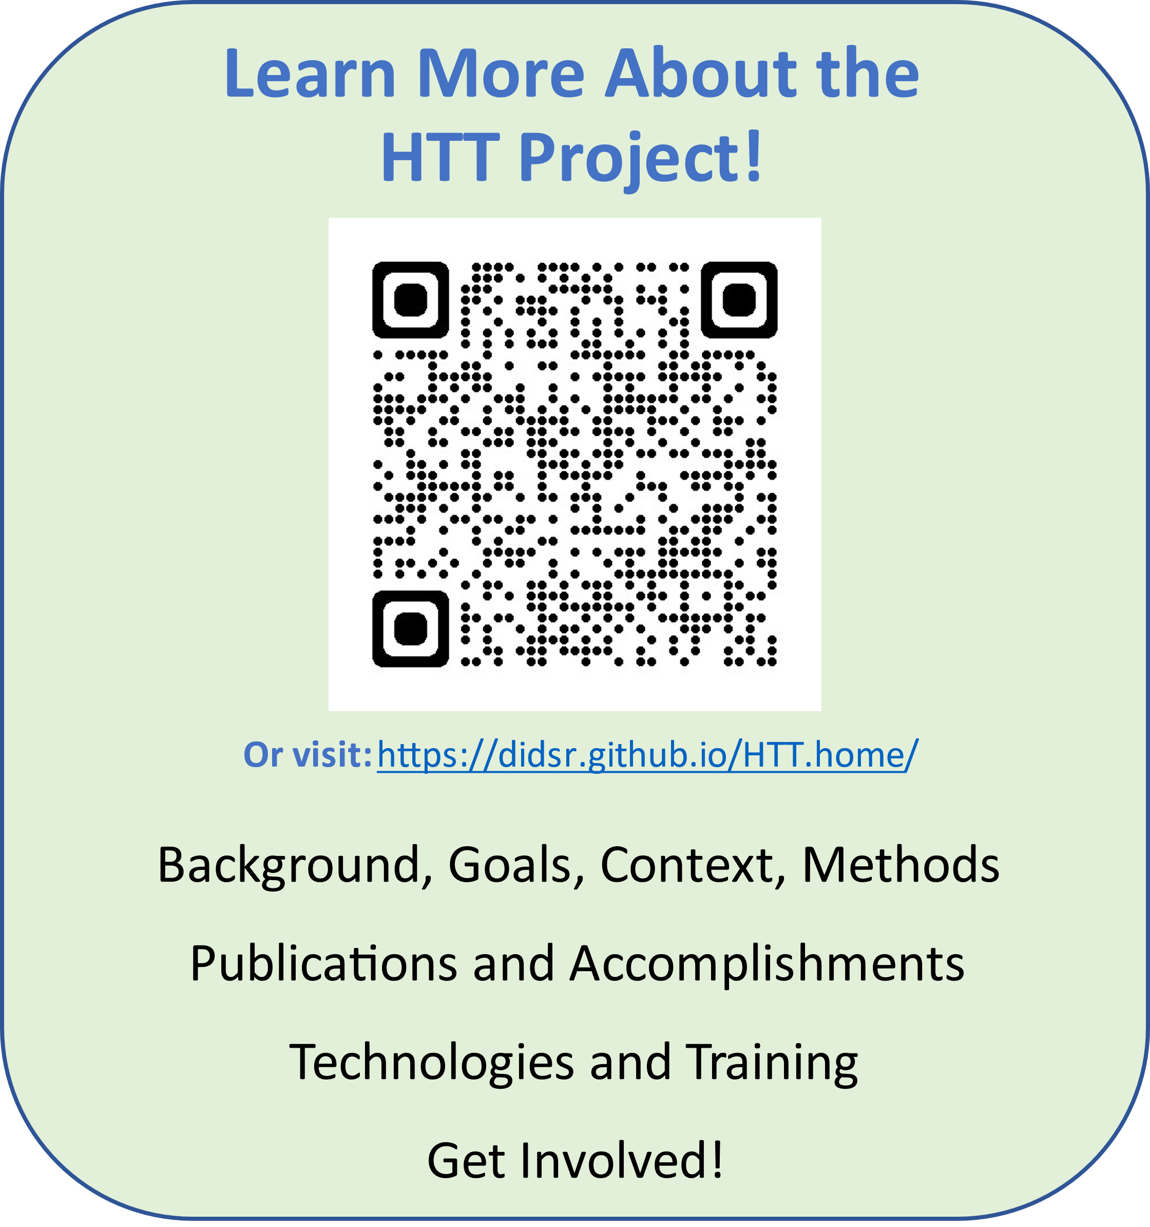](https://didsr.github.io/HTT.home/) [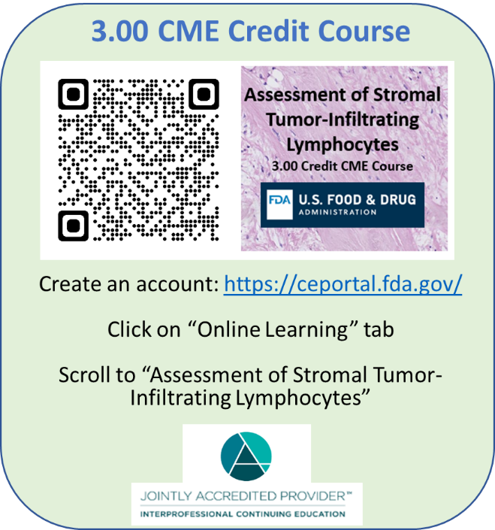](https://ceportal.fda.gov)

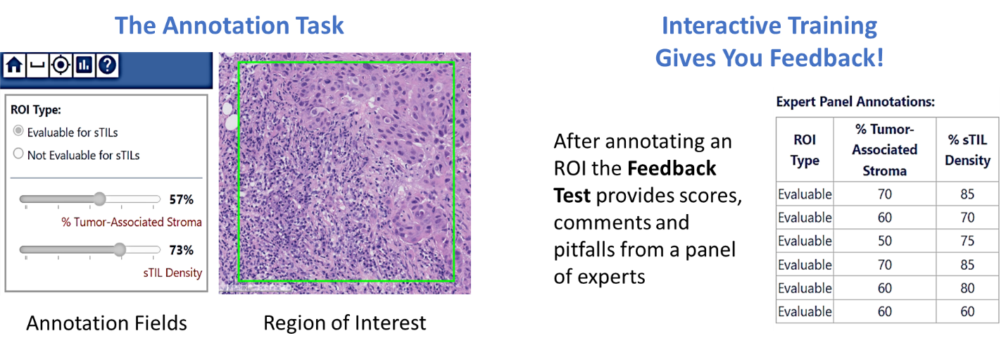

**Questions? Email the project management team:** <https://didsr.github.io/HTT.home/assets/pages/team>