**####################**

**FMA DeepFocus**

Results for My Results

pred:yes pred:no

true:yes 96000 0

true:no 108000 0

Precision: 0.47058823529411764

Precision_CI: (np.float64(0.4684222757821688), np.float64(0.4727541948060665))

Recall: 1.0

Recall_CI: (np.float64(1.0), np.float64(1.0))

Delong Method

AUC: 0.621985546248071

AUC COV: 1.507941475584444e-06

95% AUC CI: [0.61957874 0.62439235]

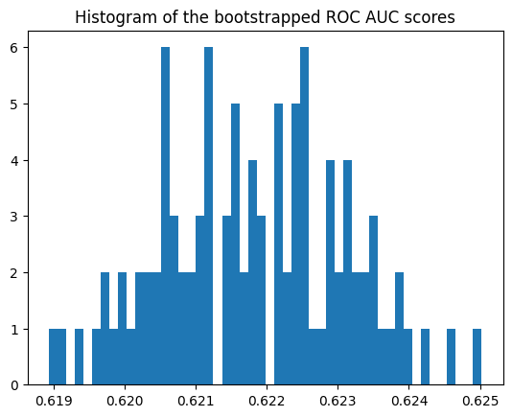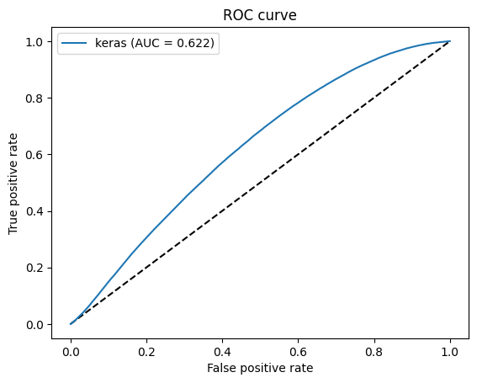

####################

**DLA DeepFocus**

pred:yes pred:no

true:yes 95524 476

true:no 99315 8685

Precision: 0.49027145489352747

Precision_CI: (np.float64(0.48805173626599563), np.float64(0.4924911735210593))

Recall: 0.9950416666666667

Recall_CI: (np.float64(0.9945973414433951), np.float64(0.9954859918899384))

Delong Method

AUC: 0.744275853587963

AUC COV: 9.261746444608057e-07

95% AUC CI: [0.74238962 0.74616208]

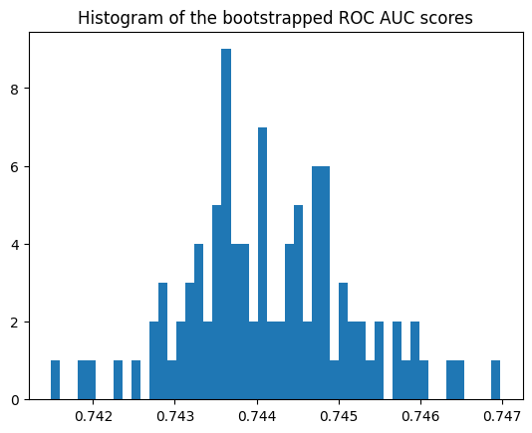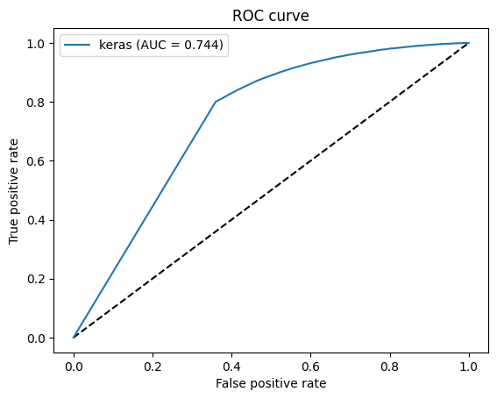

####################

**FMA TCGA**

pred:yes pred:no

true:yes 3997 9

true:no 14343 146

Precision: 0.21793893129770991

Precision_CI: (np.float64(0.21196395526762563), np.float64(0.2239139073277942))

Recall: 0.9977533699450823

Recall_CI: (np.float64(0.9962872483103534), np.float64(0.9992194915798113))

Delong Method

AUC: 0.7230902472986633

AUC COV: 1.9295579483647256e-05

95% AUC CI: [0.71448077 0.73169973]

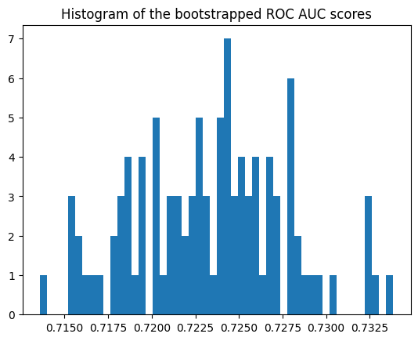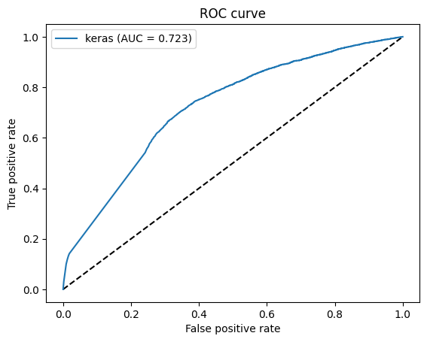

####################

**DLA TCGA**

pred:yes pred:no

true:yes 3956 50

true:no 14426 63

Precision: 0.2152105320422152

Precision_CI: (np.float64(0.20926952518348424), np.float64(0.2211515389009462))

Recall: 0.9875187219171243

Recall_CI: (np.float64(0.9840808094316511), np.float64(0.9909566344025975))

Delong Method

AUC: 0.4752607871269912

AUC COV: 7.5105061315618275e-06

95% AUC CI: [0.46988945 0.48063213]