iMRMC
User Manual
Version 2.1

Brandon D. Gallas, PhD
Xin He, PhD
Rohan Pathare

US Food and Drug Administration
Center For Devices and Radiological Health
Office of Science and Engineering Labs
Division of Imaging and Applied Mathematics

February 14, 2014
iMRMC: Application for Analyzing and Sizing MRMC Reader Studies

The primary objective of this Java application (iMRMC) is to assist investigators with analyzing and sizing multi-reader multi-case (MRMC) reader studies that compare the difference in the area under Receiver Operating Characteristic curves (AUCs) from two modalities. The core elements of this java applet include the ability to do MRMC variance analysis, the ability to size an MRMC trial, and a database containing components of variance from past MRMC studies.

1. Introduction to ROC Reader Studies

ROC reader studies are designed to evaluate and compare imaging devices and acquisition protocols, or generally evaluate image quality according to an objective task. The ROC task is a classification task, e.g., classifying a patient as non-diseased or diseased. Image quality is then defined as the ability of a reader (e.g., a radiologist) to perform such a task.

In a typical ROC reader study the reader is presented with one of two mutually exclusive alternatives (e.g. a tumor-present image or a tumor-absent image). The observer is then asked to rate his or her confidence level of which alternative is presented (e.g., the confidence level of tumor presence on an image). Any number of responses may be used to rate the confidence level. For example, in a traditional clinical reader study, a set of five confidence level responses is used with 1 representing “absolutely sure there is no tumor” and 5 representing “absolutely sure there is tumor present”. Alternatively, reader studies may ask the observer to use a “continuous” rating scale. Such scales are not really continuous but allow the reader to rate each case with a whole number ranging from 1 to 100. The rating values are collected for both non-diseased and diseased cases.

Given ratings for non-diseased and diseased cases, an ROC curve can be traced out by calculating the sensitivity/specificity (TPF/TNF) pair for each confidence level, or threshold, possible [1]. An ROC curve illustrates the tradeoff between sensitivity and specificity of the reader across all thresholds. This tradeoff is realized by a change in the reader’s threshold. In the case of breast cancer screening via mammography, when the threshold is made more aggressive the reader recalls more patients for additional imaging, increasing his or her sensitivity at the price of lower specificity. If the reader’s threshold is moved in the opposite direction, the reader will recall fewer patients; the reader is less aggressive, decreasing his or her sensitivity with the concomitant result of increased specificity. The area under this ROC curve (AUC) is a summary figure-of-merit for describing how well a reader is able to separate the population of diseased patients from non-diseased patients. One interpretation of AUC is that it is the reader’s average sensitivity over all possible specificities. As such, it is a global summary of task performance that avoids thresholds entirely.

To account for the variability in readers, an ROC study is often conducted in a multi-reader paradigm. The endpoint of such an ROC reader study is the reader-averaged AUC value. It is mathematically equivalent to the probability that a random reader will correctly rank a random pair of signal present/absent images in a 2-alternative forced choice (2AFC) setting. The uncertainty in the reader-averaged AUC suffers from two sources of variability: the readers and the cases. To account for both sources of variability, reader studies often involve several trained readers in addition to a dataset of diseased and non-diseased cases. One popular study design for estimating AUC is the fully crossed study design in which every reader reads every case. Statistical methods have been proposed in the literature to analyze fully-crossed MRMC data [1-9]. The origin of each method differs, and consequently, the estimation process of each method differs. Additionally, each method has at its foundation a different decomposition, or representation, of the total variance.

2. Methods

2.1 Variance Estimation
In this software, we utilize two methods to estimate the MRMC variance components of four widely used variance decompositions of the reader-averaged AUC. Then we use these variance decompositions to size a trial. The software can analyze data from a reader-study of two modalities that is fully crossed with readers and cases paired across modalities (every reader reads every case in two modalities).

The first variance estimation method uses U-statistics to provide unbiased estimates of the variance components [4]. This method lacks a positivity constraint and can lead to negative estimates of variance components and total variance. The second variance estimation method uses the non-parametric maximum likelihood estimate (MLE) of the distribution of readers and cases, which is the empirical distribution of readers and cases [2]. Efron and Tibshirani also refer to this estimation method as the “ideal” bootstrap. The MLE estimate of variance components and total variance cannot go negative. The tradeoff for positive variance estimates is a positive bias.

Both variance estimation methods are performed in the source file covMRMC.java (package mrmc.core) within the sole constructor with header:

public covMRMC(double[][][] t0, int[][][] d0, double[][][] t1, int[][][] d1, int R, int N, int D);

2.2 Components of Variance
Regardless of their original developments, the four variance decompositions that are included in this software can be derived from first principles for the reader average of empirical AUCs. As such they are related to one another with simple mappings [3]. The decompositions are
- BDG components [3-5]: The author Brandon D. Gallas (BDG) decomposed the total variance into eight moments from first principles in a fashion equivalent to U-statistics, which decomposes the total variance into seven conditional covariances. The “extra moment” is the mean squared, which is a part of each conditional covariance. There is a term for non-diseased cases, diseased cases, readers, and all combinations. The decomposition treats non-diseased cases separately from diseased cases such that the total variance can be easily generalized to new readers, new non-diseased cases, and new diseased cases.
- BCK components [6]: The authors Barrett, Clarkson, and Krupinski (BCK) decomposed the total variance into seven marginal variances from first principles. They are marginal in the sense that they average over the non-random effects rather than conditioning on them as above. The BCK components are thought of as pure variance terms. There is a term for non-diseased cases, diseased cases, readers, and all combinations. The BCK decomposition treats non-diseased cases separately from diseased cases such that the total variance can be easily generalized to new readers, new non-diseased cases, and new diseased cases.
- DBM components [7]: The authors Dorfman, Berbaum, and Metz (DBM) decomponsed the total variance into six components based on a mixed-model ANOVA. The components are: reader effect, case effect, reader-case effect, modality-reader effect, modality-case effect, and modality-reader-case effect. The DBM decomposition does not treat non-diseased cases separately from diseased cases. So, while the total variance can be easily generalized to new readers and to total cases (with a fixed disease prevalence), additional modeling is needed to separately generalize to new non-diseased cases and new diseased cases (i.e., population with arbitrary disease prevalence).
- MS components [7]: The MS decomposition is based on the same mixed-model ANOVA as the DBM components. MS stands for mean squares, which are estimated from the data first and then mapped to the DBM components. There are six MS components: reader effect, case effect, reader-case effect, modality-reader effect, modality-case effect, and modality-reader-case effect. The MS decomposition does not treat non-diseased cases separately from diseased cases. So, while the total variance can be easily generalized to new readers and to total cases (with a fixed disease prevalence), additional modeling is needed to separately generalize to new non-diseased cases and new diseased cases (i.e., population with arbitrary disease prevalence).
- OR components [8]: The authors Obuchowski and Rockette (OR) decomposed the total variance into six components based on a two-factor ANOVA by modeling the accuracy of the jth reader using the ith diagnostic test. The components are: reader effect, modality-reader effect, same-reader-different-modality covariance, different-reader-same-modality covariance, different-reader-different-modality covariance, and residual error. The OR decomposition does not treat non-diseased cases separately from diseased cases. So, while the total variance can be easily generalized to new readers and to total cases (with a fixed disease prevalence), additional modeling is needed to separately generalize to new non-diseased cases and new diseased cases (i.e., population with arbitrary disease prevalence).

We emphasize that the software presents the four different variance decompositions of the reader average of empirical AUCs estimated by U-statistics and MLE [3]. The software does not estimate the DBM and OR components as originally proposed [7, 8]. They are obtained through linear combinations of the BDG components [3]. It is worth pointing out that the U-statistics and MLE estimation methods in this software are specific to the reader average of empirical AUCs, whereas the original DBM and OR estimation methods can be used for other performance measures. Estimation of components when using fully-crossed data is applicable to the BDG, BCK, DBM, OR and MS decompositions. If using data with a non-fully-crossed study design, only the BDG and BCK components are currently able to be estimated. Calculations for the other decompositions are in development.

2.3 Hypothesis Testing and Confidence Intervals
We use the methods of Hillis et al. 2008 [10] to determine the t-statistic, the corresponding degrees of freedom, and the p-value of the null hypothesis that the two modalities have equal AUCs (or that the single modality AUC = 0.5), and the confidence interval on the difference (or the confidence around the single modality AUC).

2.4 Sizing a Future Study
The variance components can be used to size future studies. In particular, the user specifies the new study design with number of split-plot groups, pairing of readers, pairing of cases, significance level, expected effect size, and the number of readers, normal cases and abnormal cases. The software calculates the expected statistical power of the new study. The software implements two kinds of hypothesis testing. One is for a single modality; the null hypothesis is that the AUC is equal to a specified value. The second compares modalities, the null hypothesis is that the two modalities have the same AUC. The statistical power is computed in two ways. One uses the Z-test, and the other uses an F test from Hillis [9]. The Z-test assumes the variance is known even though it is actually estimated. The Z-test uses the ratio of the affect size over the square root of its estimated variance as the test statistic, and assumes the test statistic follows a standard normal distribution. The F-test does not assume the variance is known. It estimates the non-centrality parameter and the denominator degrees of freedom values using the components of variance (input or estimated) for the specified case and reader sample size and effect size. The degrees of freedom is also determined with an alternate calculation from Obuchowski et al. 2012 [11]. The statistical power is then computed using F distributions, unless the degrees of freedom is greater than 50, at which point the power is computed using a standard normal distribution.

3. Database
The software includes a database that consists of results from simulated data and results from previous MRMC reader studies. We have accrued many reader study datasets and are working on the letters of permission to include them. The datasets are from a variety of sources including FDA sponsor data for imaging device approvals, as well as academic research studies. Each dataset contains
- Basic information of the study: this includes the source of the study, a summary of the study, related publications, and other information.
- Key information of the study: number of readers, number non-diseased cases, number of diseased cases, modalities used, and task.
- Variance representations as outlined above.

See Appendix A for details regarding the summary information.

In addition to the information outlined above, we are working on permission letters to share the ROC scores for each study. The ROC scores that we share are listed on the website. You can download a file with the study description that produced the ROC scores followed by the ROC scores themselves; the file is formatted for use with the iMRMC software. See the “Data Format for ROC Ratings” section for more information on the iMRMC file formatting and the “Sample Permission Letter” section below. We welcome more data. Please contact us.

4. Using the iMRMC Application

4.1 Technical Specifications
The software is written in Java. It requires Java Runtime Environment (JRE) 1.6 or 1.7.

The application has been tested on the following operating systems:
- Ubuntu Linux 12.04 32-bit, success
- Windows 7 64-bit, success

Please let us know what system you have tried to run the application on, and its success. We are attempting to make the application as portable as possible.

4.2 First Time Use
Test that Java is working on your computer by going to
http://java.com/en/download/testjava.jsp

Running the application:

Extract imrmc.zip to the desired folder. It should contain imrmc.jar and the DB folder, containing files for the imrmc database. Double click on imrmc.jar to start the application. Alternatively, navigate to the containing folder via command line and run the command ‘java –jar imrmc.jar’ to start the application (This requires the java system variable to be set if it has not been already. See http://docs.oracle.com/javase/tutorial/essential/environment/paths.html).

4.3 Input data
There are three methods to input data for analysis. The methods can be selected from the pull-down menu next to “Select an input method”.

- The user may choose a study from our database. After selecting a dataset, go to the “Data Analysis” section (4.5).

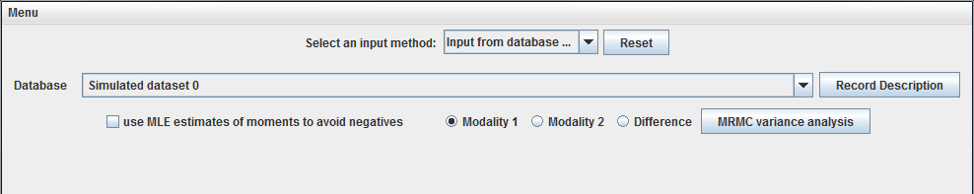
Figure 4.3.1: Database input panel

- The user may choose “Input raw data…”, where “raw data” refers to ROC ratings from an MRMC reader study. See the “Data Format for ROC Ratings” section below to create a properly formatted file of ROC ratings. Click on the “Browse” button to open up a file browser and navigate to a suitable .imrmc input file. Select open or double click on the file to load it into the application. A dialog box will pop up displaying information about the study content (number of readers, number of diseased and normal cases, and number of modalities). If the study is not fully crossed, a dialog box will inform the user as well. If the input file is incorrectly formatted, a dialog box will inform the user, and provide the line in the file at which the error occurs.

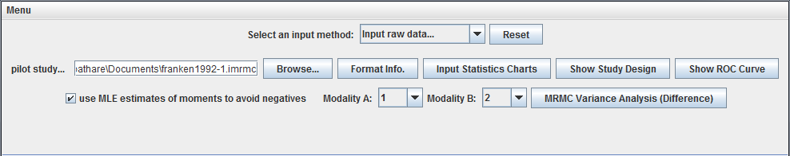
Figure 4.3.2: Raw study data input panel

- The user may choose to input the variance components from an existing study manually. The user may choose to use other software to compute the components of variance and input those components manually into our application to size a trial. The application currently can size trials based on BDG, BCK, DBM, and OR components. After selecting a dataset, skip to the “Data Analysis” section (4.5).

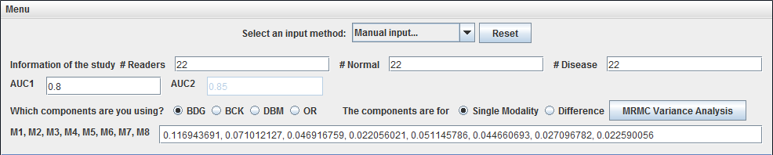
Figure 4.3.3: Manual component input panel

4.4 Data Format for ROC Ratings

Here we describe a properly formatted file of ROC ratings. The file format has two parts: the study description at the top followed by a list of ROC ratings.

4.4.1 Study Description

The study description can include any information as free text, or no information at all. iMRMC looks for four lines corresponding to the size of the experiment.
- N0 = number of cases without disease
- N1 = number of cases with disease
- NR = number of readers
- NM = number of modalities

If it finds this information (formatting shown below), it shows these numbers next to the numbers derived by reading in the data; this is a simple data input check. The study description ends with a line stating “BEGIN DATA:”.

We demonstrate the formatting of these lines in an example. If the study has 9 readers, 55 diseased patients, and 75 non-diseased patients, and 5 modalities, then a corresponding study description can be the following lines:

N0: 75
N1: 55
NR: 9
NM: 5
BEGIN DATA:

4.4.2 List of ROC Ratings

The list of ROC ratings has a row for each score—each reader, case, modality combination observed—in any order. It also has rows specifying the truth state of each case (given by the reference gold-standard reader = truth). iMRMC can handle data that is not fully-crossed for any number of modalities, though only two of those modalities may be used at a time for variance analysis.

For rows recording reader scores, there are four fields in the following order:
- reader id (integer)
- case id (integer)
- modality index (integer)
- score (integer or float)

For rows recording truth states, there are also four fields in the following order:
- -1
- case id (integer)
- 0
- truth state (0 or 1)

The truth state 0 indicates normal or no disease. The truth state 1 indicates abnormal or disease. Higher reader scores should indicate higher likelihood or confidence of disease and low ratings should indicate lesser likelihood or confidence of disease. Otherwise, AUC calculations and ROC curve displays will be incorrect.

FIELDS MUST BE SEPARATED BY COMMAS. NO SPACES.

For example, the first few rows could look like the following:
-1,1,0,1
-1,2,0,0
1,1,1,3
1,1,2,5
1,1,3,55.12
2,1,1,2
2,1,2,7
2,1,3,46.3
1,2,1,1
1,2,2,0
1,2,3,23.32
2,2,1,1
2,2,2,3
2,2,3,15.8

In the example, we see the ROC ratings from two readers reading two cases with three modalities each.
- The first line specifies case 1 is abnormal
(reader id = reference = -1; case id = 1; modality = 0; score = truth state = 1)
- The second line specifies case 2 is normal
(reader id = reference = -1; case id = 2; modality = 0; score = truth state = 0)
- Rows 3-5 show reader 1’s scores for case 1 on modalities 1, 2, and 3.
- Rows 6-8 show reader 2’s scores for case 1 on modalities 1, 2, and 3.
- Rows 9-11 show reader 1’s scores for case 2 on modalities 1, 2, and 3.
- Rows 12-14 show reader 2’s scores for case 1 on modalities 1, 2, and 3.

4.4.3 Formatting Errors

Currently, iMRMC does not provide detailed feedback on formatting errors. The feedback it does provide is to report the experiment size after successfully reading an input file.

Typical errors in formatting are as follows:

- The truth state of every case must be defined once and only once.
  - ERROR: Truth states not defined for all the cases.
  - ERROR: Truth states multiply defined.
- The row containing "BEGIN DATA:" must be typed exactly as given.
  - ERROR: "BEGIN DATA:" not all upper-case.
  - ERROR: "BEGIN DATA:" not terminated with a colon.
- Commas with no spaces must be used to separate the four fields of data describing each ROC rating.
  - ERROR: Spaces, tabs, or semicolons separate the data in the list of ROC ratings. Only commas should be used.

4.5 Data Analysis
ROC Data Analysis Charts

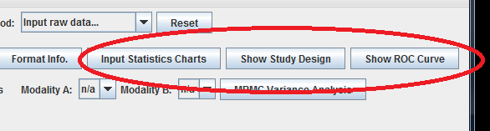
Figure 4.5.1: Data analysis diagram buttons

If raw data was input from a file of ROC ratings, the user can view some visual representations of this data. The “Input Statistics Charts” button, located next to “Format Info.” causes two charts to appear. These charts show information about the study, allowing the user to easily determine if the study has been input correctly. One chart displays the number of cases that each reader scored, and the other displays the number of readers that scored each case. The bars allow for easy visual recognition of where the study is incomplete. Hovering the mouse over a particular bar displays the relevant information for the data.

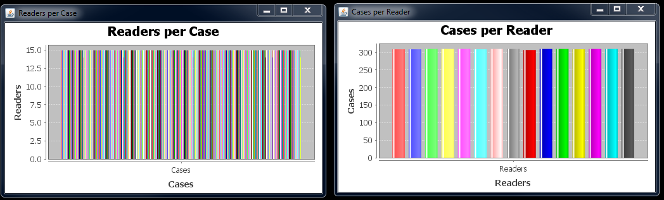
Figure 4.5.2: Input statistics charts

For a more in-depth view of the completeness of the study, the “Show Study Design” button allows the user to view the presence or absence of score data per modality. The user selects a modality to view, and a chart displaying each case and each reader appears. A black square represents an existing score for said modality, case, and reader. A white square represents missing data at this point. Hovering the mouse over a particular square displays this information as “Present/Absent (Case # / Reader #)”.

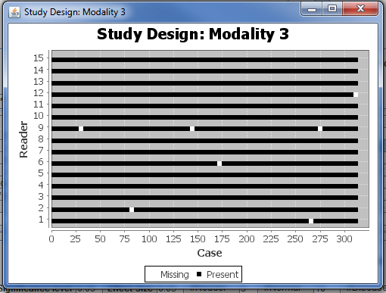
Figure 4.5.3: Study design chart

The “Show ROC Curve” button asks for a modality, and then displays the ROC curves for the given modality. Selecting the various checkboxes on the bottom border of the chart window enables/disables ROC curves for each individual reader, as well as average ROC curves, of which there are four types. Horizontal Average averages in specificity at every possible specificity, Vertical Average averages in sensitivity at every possible specificity, and Diagonal Average averages in the direction of sensitivity+specificity at every sensitivity-specificity (along x=y diagonal line). Pooled Average gathers all reader scores into one large set and calculates the ROC curve across that set.

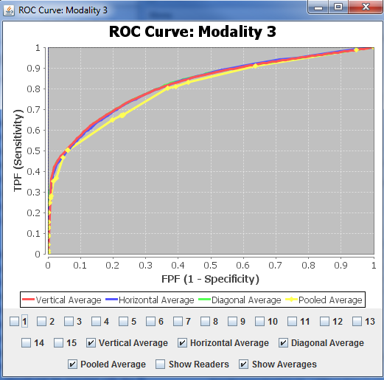
Figure 4.5.4: ROC curve chart

These charts are all resizable, and their contents will scale to the new size automatically. Additionally, clicking and dragging from an upper left to lower right direction zooms the view in on that area. Clicking and dragging from a lower right direction to an upper left direction returns the view to its default zoom.

Variance Analysis

The user can estimate the components of variance for modality 1, modality 2, or the difference in modalities when data is input from the database. Choose the desired modality with the radio buttons and click “MRMC variance analysis” to perform the statistical analysis.

If data is input from raw ROC ratings, there will be a drop-down menu next to “Modality A” and Modality “B”, allowing the user to choose from the various modalities in the input file. If one modality is selected in either only Modality A or only Modality B and the other is set to none, the “MRMC Variance Analysis” button will show which modality the components of variance will be estimated for. If a modality is selected in both Modality A and Modality B, the components of variance will be estimated for the difference in the two modalities. The “MRMC Variance Analysis” button will reflect this.

For manual input of variance components, the relevant information of the study is input, and the radio buttons to choose between single modality and difference are available. Once this is done, the “MRMC Variance Analysis” button will perform the statistical analysis.

If any of the resulting components are negative, the user will be asked if they would like to use MLE estimates instead of the usual u-statistics estimates. The MLE estimates of the components are never negative, and this can help with calculating the variance/error sometimes. If MLE estimates are being used, a double asterisk (**) will appear next to the decomposition names in the table.

The populated table shows the components of variance, which can be given in five different representations: these are available by clicking on the corresponding tab of the “Statistical Analysis” table. For the BDG and BCK representation we have 7 total rows. The “comp M0” and “comp M1” rows show the components for each modality, and the “coeff M0” and “coeff M1” rows give the corresponding coefficients/weights for each component of variance. The “product M0, M1” shows the covariance components for both modalities, and the “2*coeff M0-M1” gives its coefficient/weight. The “total” row displays the contribution towards the total variance by each component. The contributions are summed to produce the total variance, and the square root of that is the standard error, which is displayed to the right of the table. The DBM, OR, and MS tabs are similar, but only contain 3 rows, showing the components, coefficients, and total without separating by modality.

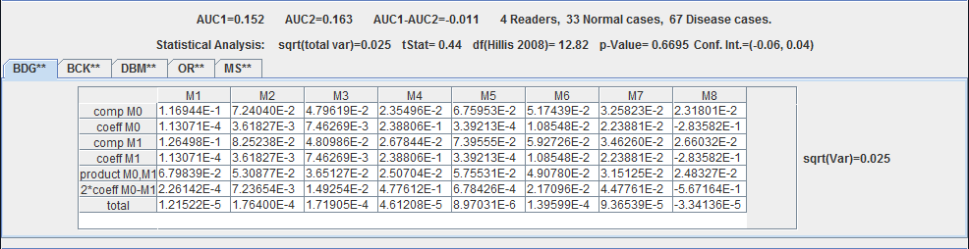
Figure 4.5.5: Variance analysis results table

4.6 Sizing a Future Study
The second panel is for sizing a trial using the components of variance shown. Input the number of split-plot groups, pairing of readers, pairing of cases, number of readers, non-diseased cases, and diseased cases, as well as the significance level and the effect size. Then click “Size a Trial”. The summary statistics that are produced show the square root total variance, the delta, degrees of freedom by Hillis’ method with F-test [9] and BDG method [11], CVF, and statistical power by Hillis’ method and the Z test method.

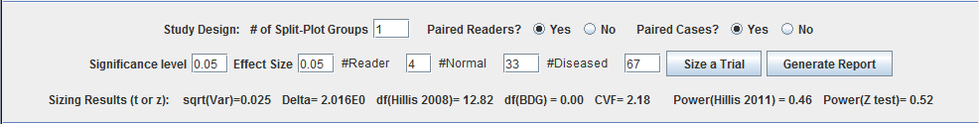
Figure 4.6.1: Study sizing panel

4.7 Generate a Report
The following information is summarized and displayed by the GUI. A report of the results may also be generated:
- size of the existing study and AUC values
- components of variance calculated from the existing study in BDG, BCK, DBM, OR, MS representations
- size of the future study and AUC values
- effect size, significance level, and corresponding statistical power
- For input from database or input of raw data, the report may also include a description of the existing study if available. For the manual input, the report may not include all four kinds of components of variance, depending on whether the input components of variance are convertible to other types of components of variances. For example, if the user chooses to input DBM components of variance, OR components can be derived while BDG components cannot.

4.8 Database
At the bottom of the applet is the means by which we are sharing the whole database (basic information of each study, size of the study, and variance decompositions). The “database” is populated by simulated datasets right now. The buttons at the bottom are related to downloading a spread sheet of that data (work in progress).

5. References
[1] Metz, C. E., “Basic principles of ROC analysis.”, Semin Nucl Med. 1978 Oct;8(4):283-98.
[2] Efron, B. & Tibshirani, R. J, “An Introduction to the Bootstrap: Monographs on Statistics and Applied Probability”, Chapman & Hall, New York, N.Y, 1993.
[3] Gallas, B. D.; Bandos, A.; Samuelson, F. & Wagner, R. F. (2009), 'A Framework for Random-Effects ROC Analysis: Biases with the Bootstrap and Other Variance Estimators', Commun Stat A-Theory 38(15), 2586-2603
[4] Gallas, B. D. (2006), 'One-Shot Estimate of MRMC Variance: AUC', Acad Radiol 13(3), 353-362.
[5] Gallas, B. D. & Brown, D. G. (2008), 'Reader Studies for Validation of CAD Systems', Neural Networks 21(2-3), 387-397.
[6] Clarkson, E.; Kupinski, M. A. & Barrett, H. H. (2006), 'A Probabilistic Model for the MRMC Method. Part 1.Theoretical Development', Acad Radiol 13(11), 1410-1421.
[7] Dorfman, D. D.; Berbaum, K. S. & Metz, C. E. (1992), 'Receiver Operating Characteristic Rating Analysis: Generalization to the Population of Readers and Patients with the Jackknife Method', Invest Radiol 27(9), 723-731.
[8] Obuchowski, N. A. (1995), 'Multireader, Multimodality Receiver Operating Characteristic Curve Studies: Hypothesis Testing and Sample Size Estimation Using an Analysis of Variance Approach with Dependent Observations', Acad Radiol 2(Suppl 1), S22-S29.
[9] Hillis S.L., Berbaum K. S. “Power estimation for the Dorfman-Berbaum-Metz method.” Acad Radiol. 2004 Nov;11(11):1260-73, 2004.
[10] Hillis, S. L.; Berbaum, K. S. & Metz, C. E. (2008), 'Recent developments in the Dorfman-Berbaum-Metz procedure for multireader ROC study analysis.', Acad Radiol 15(5), 647--661.
[11] Obuchowski, N.A.; Gallas, B. D. & Hillis, S. L. (2012), ‘Multi-reader ROC Studies with Split-plot Designs: A Comparison of Statistical Methods’, Acad Radiol 19(12), 1508-1517.

Appendix A
In this appendix we describe the basic and key information we intend to provide for each dataset.

Basic Information
The following fields summarize the data source, setting, experimental conditions, and reference material related to the reader ROC ratings.
- Source: (Owner of data, free text) Data owner or representative, affiliation, mailing address, phone, and email.
- Summary: (free text) A succinct description of the reader study (readers, cases, reference method, rating method) with more details on the task and modalities (treatments) under investigation.
- Publication: (free text) Full references to articles that describe or utilize the reader study or data. This field should also include other sources of information related to the study or data (links to webpages, protocol identifiers).
- Notes: (free text) This field can alert the user to any peculiar issues related to the data. For example, is there any missing data or corrections to the data?
- Acknowledgements: (free text)
- NR: (Number of readers, integer)
- N0: (Number of normal cases, integer)
- N1: (Number of abnormal cases, integer)
- NM: (Number of modalities, integer)
- AUC1: (AUC Modality 1, floating point)
- AUC2: (AUC Modality 2, floating point)
- …
- AUCn: (AUC Modality n, floating point)
- DAUC: (Difference in AUCs, floating point)

Key Information
The following items are critical for determining the application area of the components of (co)variance. They may be renamed and regrouped over time as deemed useful.
- Mod1: (Modality 1, limited choices)
- Mod2: (Modality 2, limited choices)
  - simulation
  - film radiography
  - digital radiography
  - film with CAD
  - film mammography
  - digital mammography
  - SE MRI
  - CINE MRI
  - Multi-detector row CT
  - Digital breast tomosythesis
  - Mammography + ultrasound
  - Mammography + ultrasound + CAD
  - Ultrasound
  - Ultraound + CAD
- Task: (limited choices)
- simulation
- chest and abdominal abnormality detection
- breast abnormality detection
- breast cancer detection
- detection of thoracic aortic dissection
- TaskAdd: (limited choices) This field indicates a modification or qualifier to the task. Multiple qualifiers may be indicated. More liberty will be given to data suppliers in defining these choices. This list is expected to grow.
  - pediatric
  - malignant mass
  - malignant calcification
  - nodule
  - pneumothorax
  - interstitial disease

