iRoeMetz: Application for Simulating MRMC Reader Study Data

iRoeMetz is a Java application which can be used to simulate the results of a number of experiments via Monte Carlo methods given variance components of a theoretical study. These experiment results can be used in MRMC variance analysis programs such as iMRMC.

For an in-depth explanation of MRMC/ROC reader studies, refer to section 1 of the iMRMC user guide titled “Introduction to ROC Reader Studies”.
1. Methods

1.1 Generalized Roe & Metz Model
iRoeMetz makes use of a generalized version of the Roe & Metz model [1]. This generalized model accounts for 18 variances as opposed to the six variances in the original model. The original six variances were of readers, cases, the interaction between readers and cases, and the interaction of modality with the three aforementioned variances. The generalized model takes these existing six and then accounts for the interaction of them against truth and differing modalities [2].
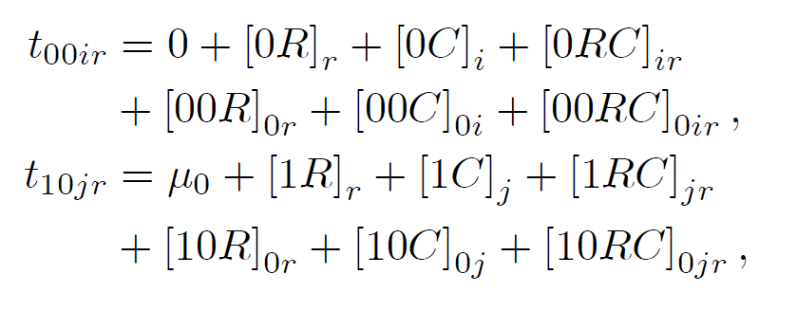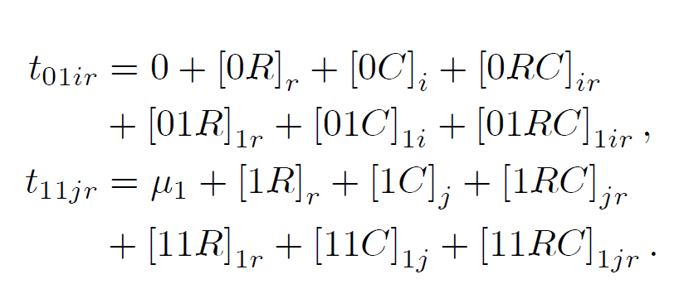
Figure 1.1.1: Generalized Roe & Metz equation

1.2 Simulation
Experiments are simulated by taking normally distributed random variables of the corresponding variance to the input and using them in the equations detailed in Figure 1.1.1. The t-matrices produced by these equations can be used to estimate the components of variance and their respective decompositions (see iMRMC User Guide section 2.1, 2.2 for explanation), and to create simulated reader scores.

The random variables are created by using a pseudo-random number generator known as the Mersenne Twister. This method of random number generation is particularly suited to Monte Carlo trials, and is faster and more efficient than Java’s standard library pseudo-random number generator.

iRoeMetz has the ability to perform numerous simulations at once based on the same input variances. The effect is that the average estimated components of variance over a large number of simulations approaches the calculated components of variance. iRoeMetz scales to multi-core CPUs, providing a speed benefit when performing numerous simulations.

1.3 Calculation
Given the variances, means and experiment size, the components of variance can calculated via numerical integration. This calculation can be found in the source file CofVGenRoeMetz.java (package roemetz.core) inside the method:

public static void genRoeMetz(double[] u, double[] var_t, int[] n);
2. Usage

2.1 Technical Specifications

iRoeMetz is written in Java. It requires Java Runtime Environment (JRE) 1.6 or 1.7 to run.

The application has been tested on the following operating systems:
- Ubuntu Linux 12.04 32-bit, success
- Windows 7 64-bit, success

2.2 First Time Use
Test that Java is working on your computer by going to
http://java.com/en/download/testjava.jsp

Running the application:

Double click on iroemetz.jar to start the application. Alternatively, navigate to the containing folder via command line and run the command ‘java –jar iroemetz.jar’ to start the application (This requires the java system variable to be set if it has not been already. See http://docs.oracle.com/javase/tutorial/essential/environment/paths.html).

2.3 Inputs

The input panel has fields to input all of the parameters of an experiment. Fields beginning with a “v” contain variances, fields beginning with a “μ” contain means, and fields beginning with an “n” contain size parameters. When iRoeMetz is started, these fields contain default values for easy testing, but these can be changed individually or cleared entirely with the “Clear Fields” button. Input parameters can be saved and loaded to/from a .irm file with the “Populate Components from File” and “Save Components to File” buttons.

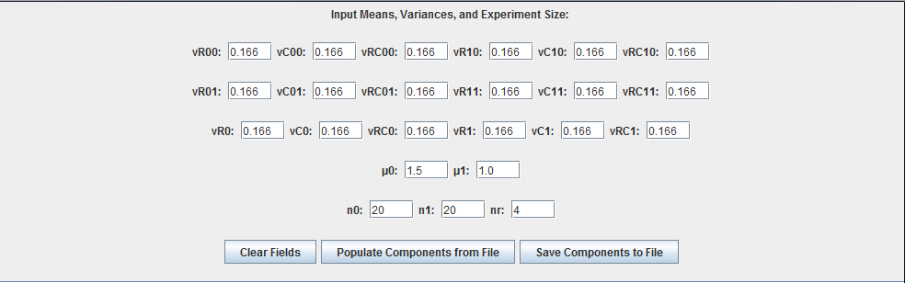
Figure 2.3.1: Experiment input panel

2.4 Simulation Experiments

Once the experiment parameters have been input, we can perform the simulation experiment. There is a field to provide a seed to the random number generator. By default this field contains a number that is different each time iRoeMetz is started. If the same seed is provided to multiple sets of simulations, the results of the simulation will be the same. The next field specifies the number of experiments to be simulated at a time. The “Use Bias” check box determines if biased estimates of the moments will be used. The “Output Location” button displays a window to select the location where the reader scores of the simulated experiments will be written. A separate file will be written for the number of experiments specified. If no directory is selected, the simulation experiments will still be performed, but not written to file. Finally, the “Perform Simulation Experiments” button runs the simulations and displays the averaged results in a pop-up table.


Figure 2.4.1: Experiment simulation panel

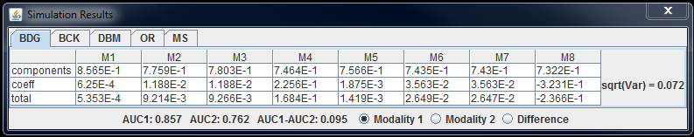
Figure 2.4.2: Averaged simulation results table

2.5 Calculation

The “Perform Calculation” button performs the numerical integration calculation of the components of variance and displays them in a pop-up table.


Figure 2.5.1: Component calculation panel

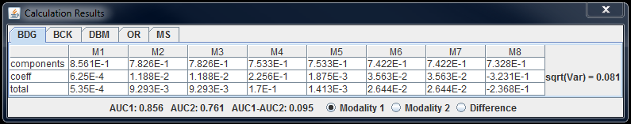
Figure 2.5.1: Calculation results table

3. Functionality with iMRMC

Output files (.imrmc) created when performing simulation experiments can be read in by the iMRMC application via the “Input raw study data” feature (refer to iMRMC User Guide) for individual variance analysis. The iMRMC User Guide also details a standard format for this type of reader score data, so any other application that follows this format will also be able to process the file as input.
4. References

[1] Metz, C. E., “Basic principles of ROC analysis.”, Semin Nucl Med. 1978 Oct;8(4):283-98.

