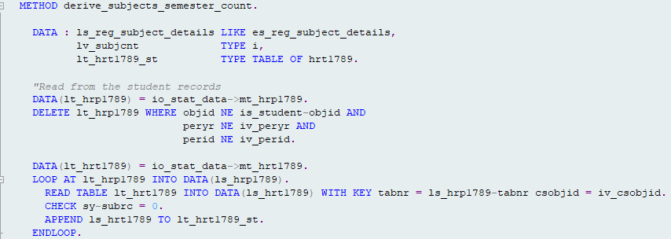

The entries of the internal table lt_hrp1789 should be deleted if they are not in the current period and the objid is different.  
At the moment entries only get deleted if all of the 3 conditions are fulfilled.   
That’s why at the moment, there are more entries than the current period available.

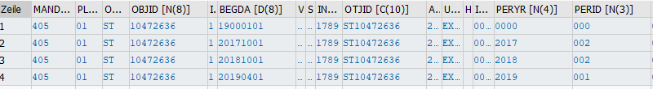  
Table lt_hrp1789 before delete

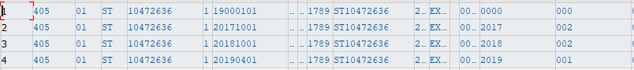  
Table lt_hrp1789 after delete

I don’t know If this is intended to work this way, please have a look at this.

After the tables are filled you loop over the lt_hrp1789 which currently includes all entries.  
  
Then you check if the tabnr of the current line exists in the table lt_hrt1789.  
If yes, the line gets appended to the table lt_hrt1789_st.  
At the moment, we can append one line of each period to the table.  
  
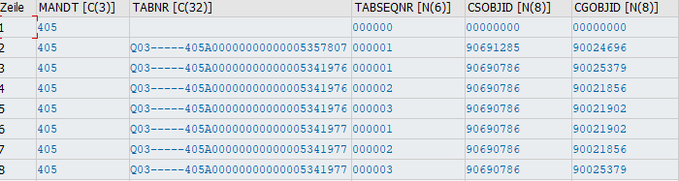  
  
As it is now, it looks like for every TABNR only one line gets appended to lt_hrt1789_st because of the READ TABLE … INTO command.  
  
I did some testing with a Student who has 3 CGs and it only appends 2, because there are only 2 different TABNRs where the CSOBJID is the right one.

Could you please also have a look on that?