

Executive Summary

Credit card fraud is one of the more awkward prediction problems in financial services: the event is rare, the cost of missing it is unevenly distributed, and the cost of over-reacting falls on customers who did nothing wrong. This report documents an end-to-end fraud detection system built across three phases, descriptive pattern discovery in Tableau, predictive modelling in Python, and a prescriptive routing pipeline that turns a probability into an actual decision.

What the project set out to do
The goal was not simply to train a model that scores well. It was to build something that detects fraud while keeping customer satisfaction in view, catching fraud without needlessly blocking legitimate transactions. Those two objectives pull against each other, and most of the analytical work in this project is about locating a defensible point between them rather than optimising either one in isolation.

What the descriptive phase found
The Tableau dashboard surfaced three behavioural patterns that shaped every modelling decision afterwards. Fraud peaks sharply in December, concentrated in online categories. Fraud clusters heavily in late-night hours, peaking between 21:00 and 23:00 and staying elevated until around 04:00. Cardholders aged 65 and over absorb a disproportionate share at 27.36% of all fraud. Each of these became an engineered feature rather than a talking point.

What the models achieved
Three models were trained on the earlier 80% of transactions by date and evaluated on the later 20%, a chronological split rather than a random one, for reasons set out in section 5.2. All three separate fraud from legitimate activity well above chance, with AUC-ROC between 0.9975 and 0.9994. XGBoost is the strongest single model at 0.9481 precision, 0.8908 recall, and 0.9185 F1, catching 1,370 of the 1,538 fraud cases in the test set while raising 75 false alarms.
Class imbalance was handled with cost-sensitive class weighting rather than synthetic oversampling, and every behavioural feature was built to look strictly backwards in time, which turned out to matter a great deal.

What the statistical tests confirmed
McNemar's test returned a significant result for all three pairwise comparisons, confirming the models fail on genuinely different transactions rather than making the same mistakes at slightly different rates. Cochran's Q, run as an omnibus test across all three at once, returned Q = 123.1360 with p below 0.001, which is what licenses reading those pairwise results as valid follow-ups. Mann-Whitney U confirmed all three models produce well-separated score distributions with effect sizes above 0.995.

What the system delivers, stated plainly
The pipeline routes each transaction into one of five bands based on how confident XGBoost is about it, asking for a second opinion only in the range where that confidence is demonstrably unreliable. It reaches 0.9690 precision and 0.8934 recall, beating XGBoost on its own across every metric while cutting false alarms from 75 to 44.
That headline comes with an important qualification, which section 9.8 works through in full rather than burying. Most of the false-alarm improvement comes from one modelling assumption about step-up authentication, not from combining three models. The ensemble bands themselves contribute far less than the top-line comparison implies. Stating that openly is more useful than the larger number would have been.

Table of Contents

Right-click here and choose Update Field to build the contents.

1. Introduction

Credit card fraud remains a persistent and growing problem in the global payments system. Card fraud losses worldwide exceeded $32 billion in 2021 according to the Nilson Report, and the trend has continued upward as digital payment adoption has accelerated. Detecting fraud accurately and in real time is therefore a direct financial concern for issuers as well as a trust concern for cardholders.
This project approaches the problem through a structured three-phase pipeline grounded in the CRISP-DM methodology. Tableau Prep handles cleaning and preparation. Tableau Desktop handles descriptive analysis, surfacing the temporal, categorical and demographic patterns that fraud actually follows in this data. Python handles predictive modelling and the prescriptive routing layer built on top of it.

1.1 Project objectives
- Identify fraud patterns: through descriptive analysis of temporal, categorical and demographic signals.
- Engineer domain-specific features: capturing behavioural anomalies such as per-card amount deviation, night-time activity, geographic distance and implied travel speed.
- Build and evaluate machine learning models: with class-imbalance handling, leak-safe feature construction and a chronological evaluation split.
- Validate model differences statistically: using formal hypothesis tests rather than eyeballed differences in aggregate metrics.
- Construct a prescriptive routing system: mapping model output to tiered, automated business actions.
- Report findings honestly: including the ones that limit what the system can claim.

1.2 Analytics framework
Framework | Method | Business Purpose
Descriptive | Tableau Desktop dashboard | Understand when, where and how fraud occurs
Predictive | ANN, Random Forest, XGBoost | Estimate fraud probability per transaction
Prescriptive | Five-band routing pipeline | Convert probability into an automated decision

2. Dataset Overview

The dataset is a simulated credit card transaction log modelled on United States cardholder spending behaviour. It contains transactions across a range of merchant categories, geographic regions and time periods, with realistic structure in amounts, timing and merchant distribution. Because it is simulated rather than production data, the limitations section returns to what that means for the conclusions.
Attribute | Detail
Total transactions | 1,296,675 records after cleaning
Total fraud cases | 7,506 fraudulent transactions
Fraud rate | 0.5789%, roughly 172:1 imbalance
Unique cards | 983
Date span | 537 days
Key numerical features | amt, age, distance, merch_lat, merch_long
Key categorical features | category, gender, merchant
Target variable | is_fraud (0 = legitimate, 1 = fraudulent)

2.1 Class imbalance
The imbalance is severe: 1,289,169 legitimate transactions against 7,506 fraudulent ones. A model that predicted "not fraud" for every single transaction would be 99.42% accurate and completely useless. Accuracy is therefore not a meaningful metric for this problem, and it is not used anywhere in this report. Every evaluation focuses on precision, recall and F1 for the fraud class, plus AUC-ROC as a threshold-free summary, and, from section 6.5 onward, the dollar value of the fraud actually missed.

3. Data Preparation in Tableau Prep

All cleaning was performed in Tableau Prep Builder before any analysis or modelling. Tableau Prep provides a visual, step-by-step interface where each transformation can be inspected and audited, which makes the cleaning logic reviewable rather than buried in a script.

3.1 Column removal
Several raw columns were identified as irrelevant, redundant or privacy-sensitive and removed before further processing.
Column removed | Reason
Unnamed: 0 | Auto-generated row index with no analytical value
unix_time | Redundant with trans_date_trans_time
first | Cardholder first name, identifying and not predictive
last | Cardholder last name, identifying and not predictive
merch_zipcode | High-cardinality postal code, replaced by lat/long coordinates

3.2 Calculated field (Age)
The raw dataset contained a date of birth column but no age field. Age at the time of each transaction was derived in Tableau Prep as the difference in years between the transaction timestamp and the cardholder's date of birth.
age = DATEDIFF('year', [dob], [trans_date_trans_time])

3.3 Null value handling
Null inspection was carried out across all retained columns after the removal step, with each field assessed individually:
- Numerical fields (amt, distance, lat/long): zero nulls found, no imputation required.
- Categorical fields (category, gender, merchant): negligible null rate below 0.001%, affected rows removed.
- Transaction timestamp: no nulls, and any null row would have been dropped given the field is critical to every time-based feature.
- Age (derived): nulls could only arise from a missing date of birth, so those rows were removed.

3.4 Duplicate removal
Duplicate records were identified using a composite key of trans_num, cc_num and trans_date_trans_time, and removed with Tableau Prep's deduplication step. The cleaned output contains zero duplicate rows, which the notebook re-verifies on load rather than assuming.

3.5 Output to Tableau Desktop and Python
The cleaned dataset was output in two directions: published to Tableau Desktop for dashboard construction, and exported as CSV for the Python modelling pipeline. Both phases therefore work from an identical, single cleaned source, which removes a common source of disagreement between a dashboard and a model.

4. Descriptive Analytics

The cleaned dataset was loaded into Tableau Desktop to build a fraud analytics dashboard combining KPI cards, temporal trend charts, category and merchant analysis, and demographic breakdowns. The purpose of this phase was not reporting for its own sake. It was to find the behavioural signatures worth encoding as features.

4.1 Fraud KPIs and overview
The dashboard's KPI cards establish the baseline fraud landscape. The single most consequential observation is that the average fraudulent transaction is substantially larger than the typical legitimate one. That differential is what motivated building amt_ratio and amt_deviation, which compare a transaction against the spending history of that specific card rather than against a global average.
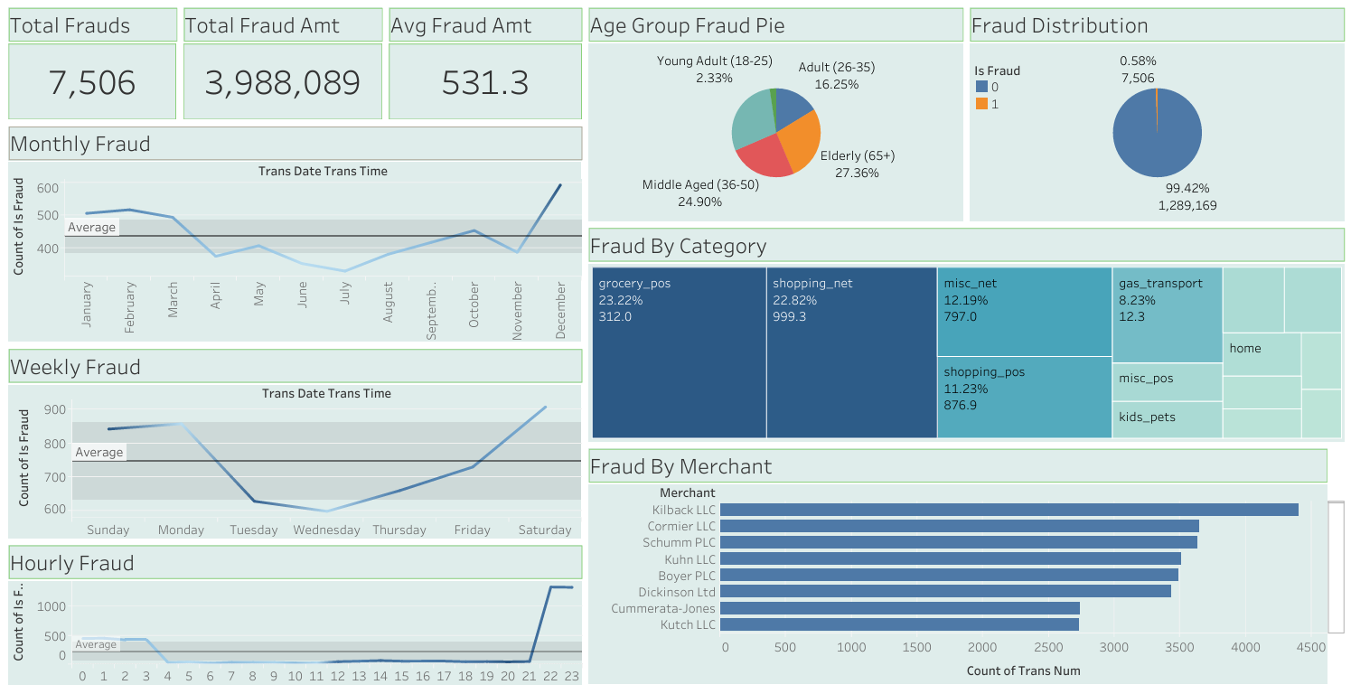
Figure 1: Tableau fraud analytics dashboard

4.2 Temporal fraud patterns
Temporal analysis was the most productive part of the descriptive phase, producing three distinct patterns across monthly, weekly and hourly dimensions.
Monthly
Fraud peaks sharply in December, driven by holiday shopping volume, then falls back to baseline in January. High transaction volume during this period gives fraudulent activity more cover.
Weekly
Saturday, Sunday and Monday consistently record the highest fraud counts, with Saturday running roughly 20 to 25% above the weekly average.
Hourly
Fraud stays near baseline through the day and then rises steeply from 21:00, remaining elevated until about 04:00. This directly produced the is_night flag, defined as 21:00 to 03:59 to match the observed window rather than a generic midnight-anchored block. That feature went on to become the second most important predictor in the XGBoost model.

4.3 Category and merchant analysis
Fraud is concentrated in a small subset of merchant categories rather than spread evenly. The five categories below account for roughly 78% of all fraud cases.
Category | % of fraud | Avg fraud amount | Interpretation
grocery_pos | 23.22% | $312.0 | High volume, easy to abuse at point of sale
shopping_net | 22.82% | $999.3 | Online shopping, highest average amount
misc_net | 12.19% | $797.0 | Miscellaneous online, high-value target
shopping_pos | 11.23% | $876.9 | In-store shopping, significant exposure
gas_transport | 8.23% | $12.3 | Low value but high frequency

4.4 Age group and demographic patterns
Fraud is not evenly distributed across cardholder demographics. Cardholders aged 65 and over absorb 27.36% of all fraud despite representing a smaller share of the transaction base. Middle-aged cardholders between 36 and 50 are the next most affected group. This skew is consistent with social-engineering and card-not-present attacks that disproportionately target older cardholders.

4.5 Hidden cross-dimensional patterns
Beyond the top-level dashboard, several patterns only appeared when filtering across two dimensions at once. These are the patterns a single-variable chart will never show, and they are the clearest argument for why a model is needed rather than a set of static rules.
Hidden pattern 1: online shopping fraud spikes in December
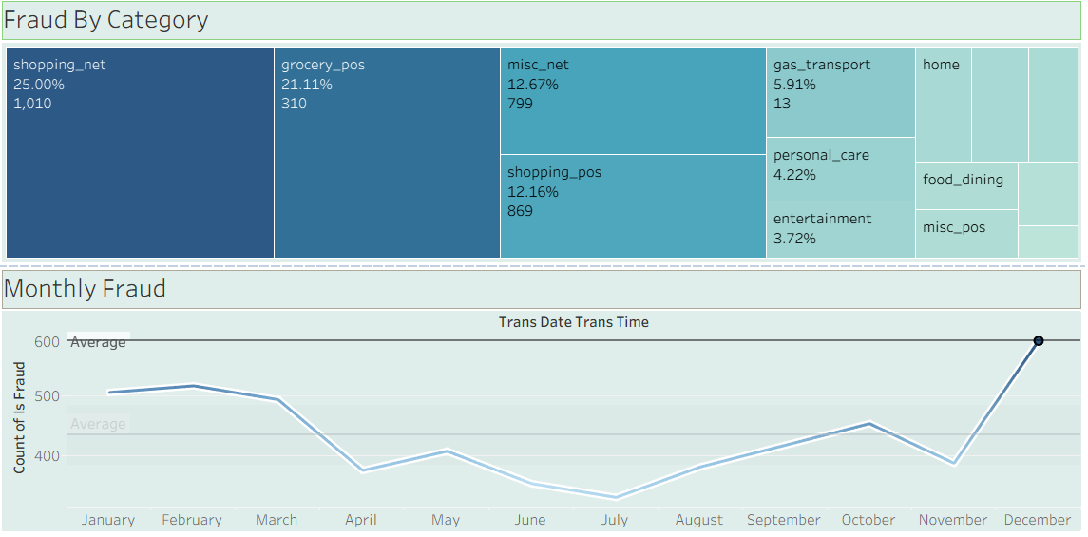
Figure 2: Fraud category distribution in December
Filtering to December alone shows shopping_net fraud running well above its already-elevated baseline, at an average fraud amount of roughly $1,010. Fraudsters target online retail during the holidays specifically, when larger transaction amounts are expected and merchant velocity controls are relaxed.
Hidden pattern 2: grocery_pos fraud concentrates between midnight and 3 AM
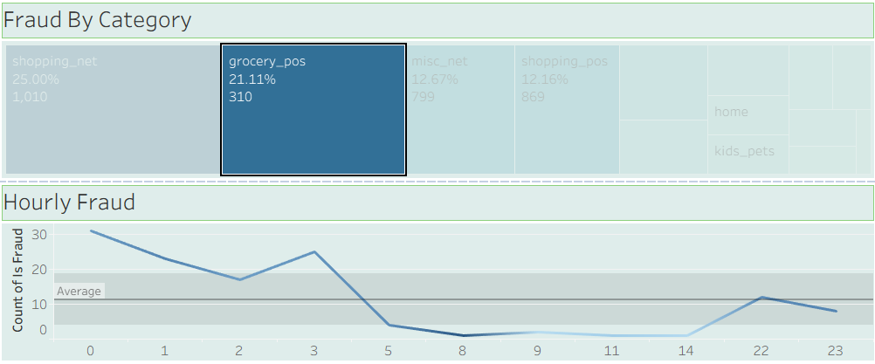
Figure 3: grocery_pos hourly fraud distribution
Filtering grocery_pos by hour shows fraud concentrated between midnight and 03:00, which is an anomaly for a category with almost no legitimate late-night foot traffic. The pattern is consistent with card-present skimming at unattended self-checkout terminals during low-monitoring hours, and it is precisely the kind of interaction between category and time of day that a rule on either dimension alone would miss.

5. Predictive Analytics

The descriptive phase established that fraud follows identifiable patterns, but those patterns interact across time, amount, category, geography and cardholder history in ways that rule-based detection handles poorly. Machine learning models can learn those interactions directly. Three were trained, chosen so that they learn in genuinely different ways rather than three variations on one idea.

5.1 Feature engineering
Feature engineering was the highest-impact step in the whole pipeline. Raw transaction fields alone carry little fraud signal; almost everything useful comes from comparing a transaction against the behaviour of that specific card. The following features were engineered:
- amt_ratio: ratio of the transaction amount to that card's own trailing average spend. A $400 charge is unremarkable on a card that normally spends $350 and very unusual on one that normally spends $20.
- amt_deviation: absolute difference between the transaction amount and the card's trailing average, which behaves differently from the ratio at different amount scales.
- avg_amt_per_card: trailing 150-day average spend for the card, computed strictly before each transaction.
- tx_count_per_card / merch_tx_count: how many transactions that card or merchant has seen before this one, as a measure of how established the account looks.
- prior_fraud_count: how many times this card was previously confirmed fraudulent. Card-level analysis found 77.5% of cards are defrauded at least once and a compromised card averages around 10 fraudulent transactions rather than one, so repeat victimisation is the norm in this data.
- is_night: binary flag for the 21:00 to 03:59 window taken from the Tableau hourly chart.
- implied_speed_kmh: distance from the previous transaction on the same card divided by the time elapsed since it, an impossible-travel check.
- distance: great-circle distance between cardholder and merchant, derived as described in section 5.3.
Why leak-safety matters here
It would be easy to build a feature like "average spend for this card" with a single group-by across the whole dataset. Doing so is also wrong. That average would include transactions occurring after the row being scored, which is information no live system has at the moment it must decide. A model trained on such a feature learns to exploit information it will never have in production, and its reported accuracy is correspondingly inflated.
An earlier version of this project made exactly that mistake across five features. Correcting it was the single most consequential change in the work. Every time-dependent feature is now computed on a time-sorted view and looks strictly backwards: avg_amt_per_card uses a trailing 150-day rolling window with the current row excluded, and the count features use expanding prior counts rather than lifetime totals. The 150-day window was chosen from the data rather than guessed, since the file spans 537 days and most cards stay active across nearly all of it, making 150 days long enough for a stable average and short enough to track genuine drift in spending habits.
Note: The corrected features produced materially lower headline scores than the leaky version did. That drop is the honest cost of the fix, not a regression, and every number in this report is from the corrected pipeline.

5.2 Chronological train and test split
Fixing the features was necessary but not sufficient. A random split has a separate problem even when every individual feature is leak-safe: it allows training rows to sit chronologically after test rows, so the fitted model can absorb patterns from a later period and apply them to an earlier test transaction. No deployed system ever operates that way.
The split used here is chronological. The earliest 80% of transactions by timestamp form the training set and the latest 20% form the test set, with the cutoff falling on 6 March 2020. Stratification is not possible across a real time boundary, so rather than assuming the fraud rates match, they are computed and reported.
Split | Rows | Fraud rate
Training (earlier 80%) | 1,037,340 | 0.5753%
Test (later 20%) | 259,335 | 0.5931%

The test set contains 1,538 fraudulent transactions against 257,797 legitimate ones. Every figure reported from here on refers to that held-out set.

5.3 Geographic distance and why coordinate subtraction fails
A natural first instinct for the distance between a cardholder's home and a merchant is to subtract their latitude and longitude values directly. This introduces a systematic geometric error, because the Earth is not flat and a degree of longitude does not represent a constant distance.
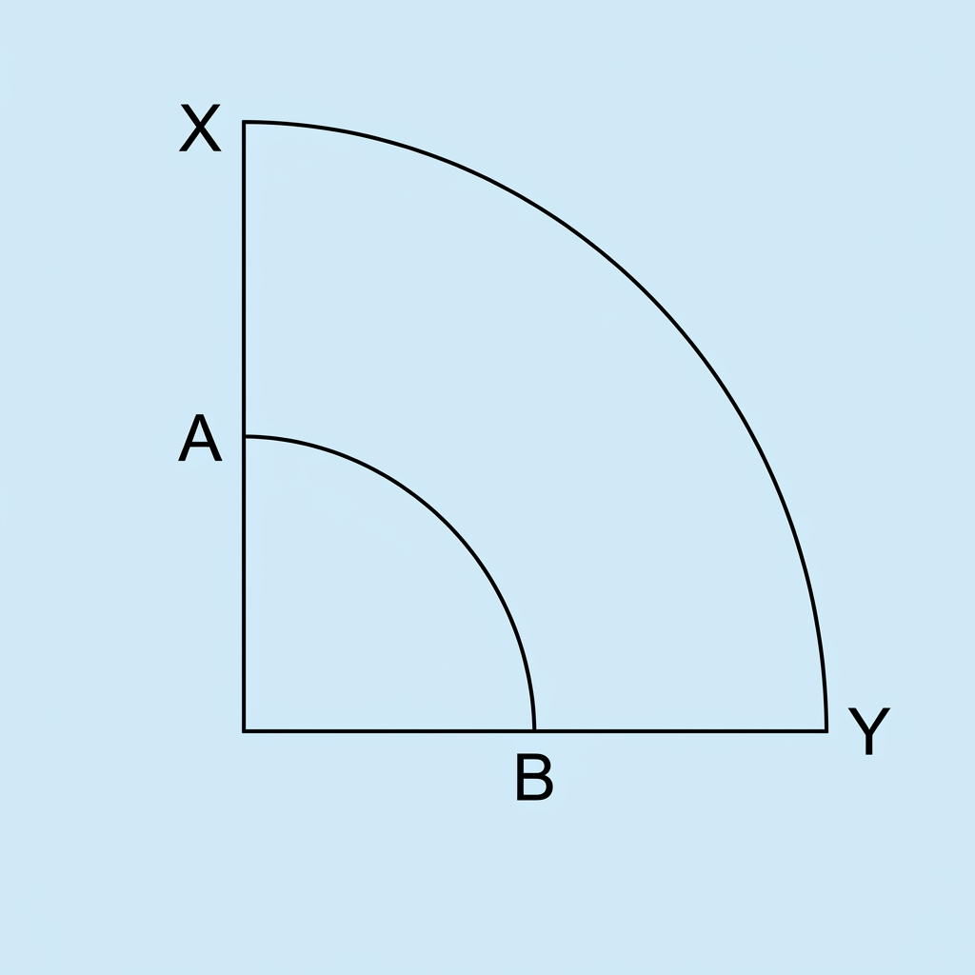
Figure 4: Angular separation covers different distances by latitude
At high latitudes one degree of longitude spans roughly 55 to 80 km, while the same degree at the equator spans about 111 km. Raw coordinate subtraction would therefore understate distance in northern regions and overstate it near the equator, biasing the feature by geography rather than by fraud risk.
To remove that distortion, all coordinates were converted from the spherical latitude and longitude system into Earth-Centred, Earth-Fixed Cartesian coordinates, a standard approach in geodesy and navigation. Each point becomes a true three-dimensional position, and the distance between cardholder and merchant is then a straightforward Euclidean distance that is geometrically correct anywhere on the globe. The same conversion is reused for implied_speed_kmh.
Validating implied_speed before trusting it
The impossible-travel feature was checked against the full dataset before being accepted as a model input. Fraudulent transactions show a median implied speed of 64.3 km/h against 19.9 km/h for legitimate ones, are 2.8 times more likely to exceed 130 km/h, and 4.1 times more likely to exceed 900 km/h, which is faster than a commercial flight and effectively impossible for a genuine cardholder. That measured gap is what justifies the feature, rather than the intuition that it ought to help.

5.4 Class imbalance and threshold selection
Class imbalance was handled with cost-sensitive class weighting inside each model rather than synthetic oversampling such as SMOTE. Weighting tells the model directly that missing a fraud case costs more than a false alarm, without fabricating minority-class examples that may not reflect real fraud behaviour.
The default 0.50 classification threshold was replaced with a value swept per model. Thresholds were re-swept from scratch after the leak-safety fix and the move to a chronological split, because both changes altered the score distributions enough that the previous values no longer sat anywhere near a sensible operating point.
Model | Threshold | Basis
ANN | 0.80 | Swept 0.05 to 0.95; balances recall against a sharp precision fall-off
Random Forest | 0.50 | Swept 0.05 to 0.95; best F1 on the corrected setup
XGBoost | 0.50 | Swept 0.05 to 0.95; best F1 on the corrected setup

5.5 Model 1: Artificial Neural Network
The ANN was implemented in TensorFlow and Keras as a sequential model. Neural networks learn smooth, continuous decision boundaries and feature interactions that a tree's axis-aligned splits cannot represent, which is precisely why it is included alongside two tree-based models.
Layer / Parameter | Configuration
Input layer | 16 numerical features scaled, plus one-hot encoded categoricals
Hidden layer 1 | 128 neurons, ReLU, BatchNorm, Dropout 0.3
Hidden layer 2 | 64 neurons, ReLU, BatchNorm, Dropout 0.3
Hidden layer 3 | 32 neurons, ReLU, Dropout 0.2
Output layer | 1 neuron, sigmoid
Optimizer | Adam, learning rate 0.001
Loss | Binary cross-entropy
Callbacks | EarlyStopping (patience 5), ReduceLROnPlateau (patience 3)
Class weight | {0: 1, 1: 5}
Threshold | 0.80

Batch normalisation after each hidden layer keeps activations in a stable range and reduces the risk of dead ReLU units. Dropout is lower in the final hidden layer to leave more capacity intact immediately before the decision. Training runs up to 50 epochs but stops automatically once validation loss stops improving, restoring the best weights rather than the last ones.
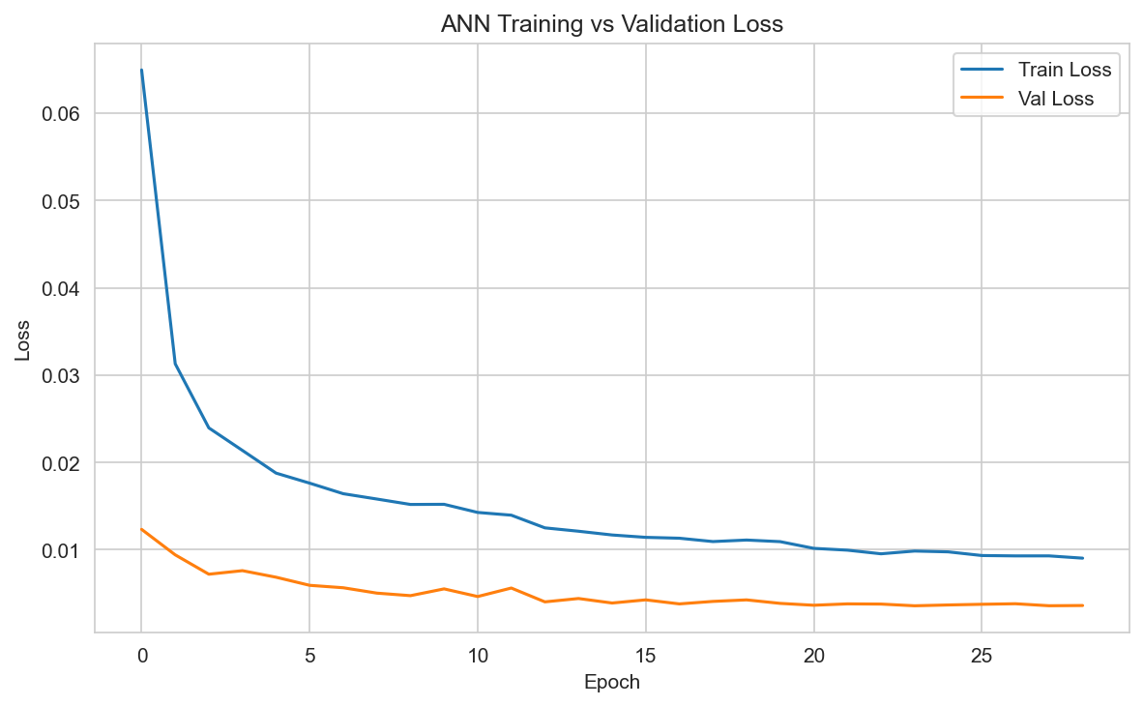
Figure 5: ANN training and validation loss by epoch

5.6 Model 2: Random Forest
Random Forest builds many trees on bootstrapped samples and averages them, reducing variance through bagging. That is a different learning mechanism from boosting, which is the point of including it.
Hyperparameter | Value | Rationale
n_estimators | 200 | Enough trees for a stable average
max_depth | 15 | Limits overfitting on a large, imbalanced set
min_samples_split | 10 | Chosen by grid search over the split and leaf parameters
min_samples_leaf | 5 | Chosen by the same grid search
max_features | sqrt | Standard for classification
class_weight | {0: 1, 1: 20} | Heavier penalty on missed fraud
Threshold | 0.50 | Re-swept after the leak-safety fix

The configuration was not hand-picked. A grid search over class_weight against min_samples_split and min_samples_leaf, holding the tree count and depth fixed, found this combination gave the best F1 across the grid, improving precision and recall together rather than trading one for the other.

5.7 Model 3: XGBoost
XGBoost builds trees sequentially, each one targeting the errors of the ensemble before it. On structured tabular data this usually outperforms bagging, and it does so here.
Hyperparameter | Value | Rationale
n_estimators | 1,500 cap | Generous ceiling, with early stopping deciding the real count
early_stopping_rounds | 20 | Stops once validation logloss plateaus
max_depth | 6 | Shallower trees, typical for boosting
learning_rate | 0.05 | Conservative step size
subsample / colsample_bytree | 0.8 / 0.8 | Row and column sampling for variance reduction
min_child_weight / gamma | 10 / 1 | Regularisation against very small leaves
scale_pos_weight | 5 | Native imbalance handling
Threshold | 0.50 | Re-swept after the leak-safety fix

Setting the estimator cap high matters. Set too low, the model can still be improving on validation loss when training is cut off, and that improvement is lost with no indication it happened. A high cap paired with early stopping lets the data decide instead. In this run training stopped at 944 boosting rounds against the 1,500 cap, with the best round at 943, so the cap was genuinely not binding.
The validation split used for early stopping is carved from the training data only, never from the test set. Otherwise early stopping would be quietly consulting the set reserved for final evaluation.
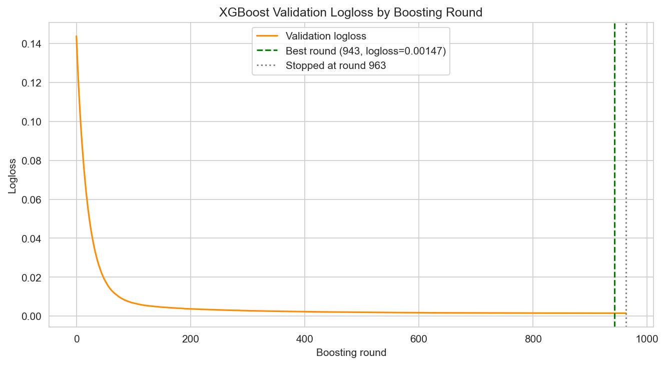
Figure 6: XGBoost validation logloss by boosting round

6. Results and Insights

All three models were evaluated on the same held-out chronological test set of 259,335 transactions containing 1,538 fraud cases.

6.1 Cross-model comparison
Model | Precision | Recall | F1 | AUC-ROC | Caught | Missed | False alarms
ANN | 0.9460 | 0.8544 | 0.8978 | 0.9987 | 1,314 | 224 | 75
Random Forest | 0.8864 | 0.8375 | 0.8613 | 0.9975 | 1,288 | 250 | 165
XGBoost | 0.9481 | 0.8908 | 0.9185 | 0.9994 | 1,370 | 168 | 75

XGBoost leads on every metric. It catches the most fraud while raising exactly the same number of false alarms as the ANN, which is the combination neither other model manages. Random Forest is the weakest of the three and not by a narrow margin, raising more than twice as many false alarms as either alternative while catching the least fraud.
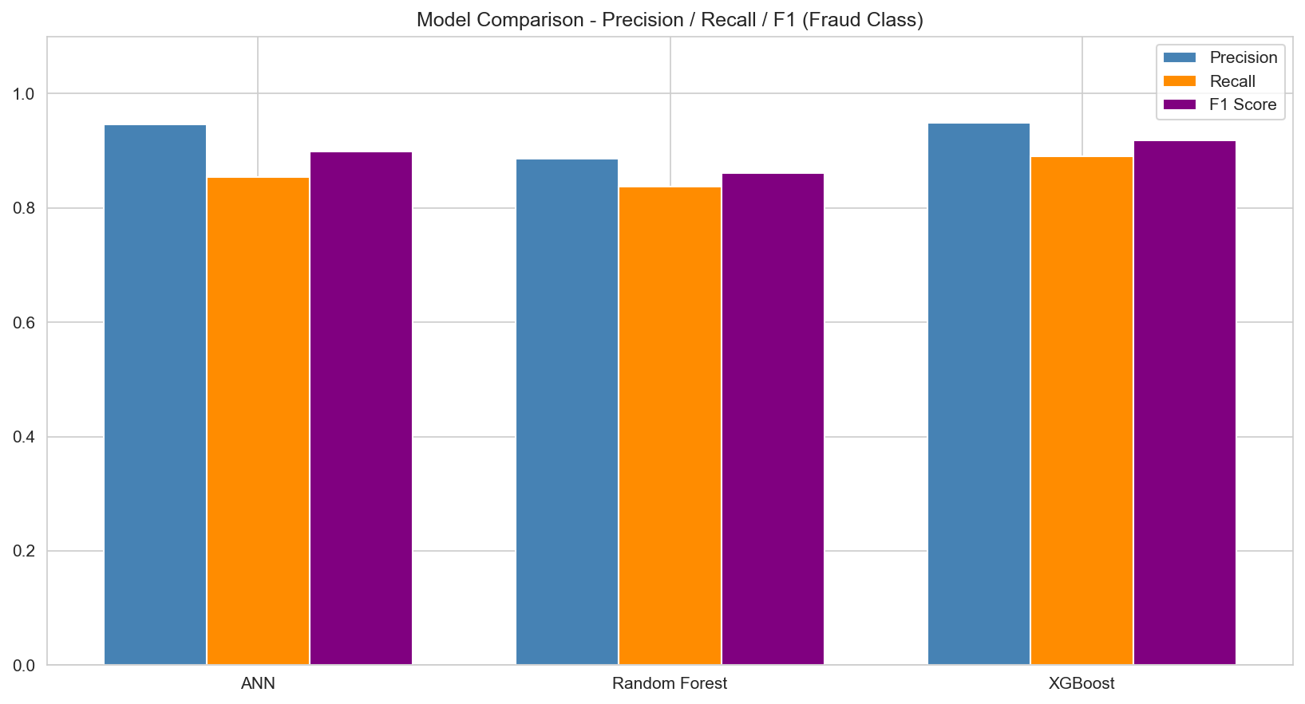
Figure 7: Precision, recall and F1 by model
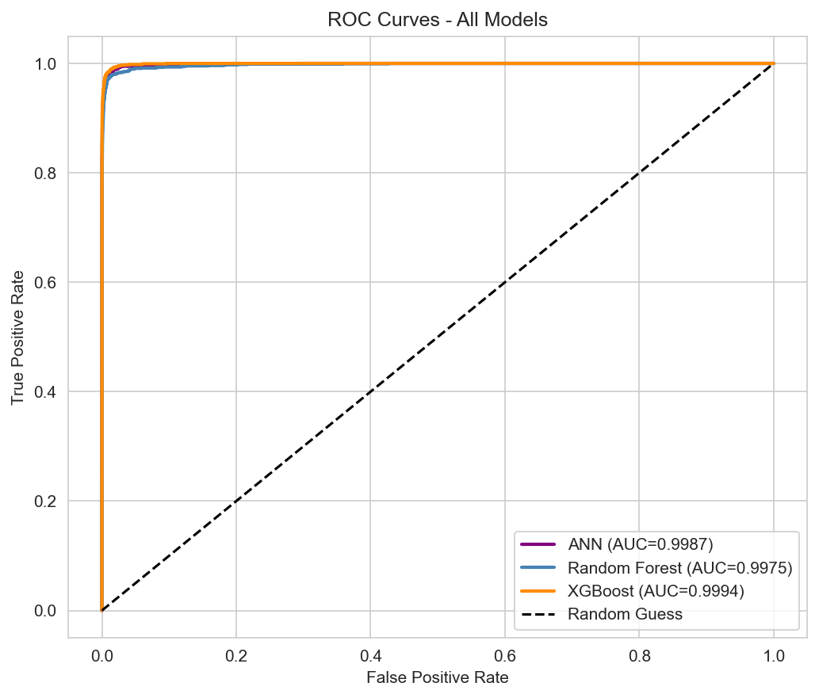
Figure 8: ROC curves for all three models

6.2 Feature importance and what each model leans on
Feature importance does not say which features a model is allowed to use, since every model sees every feature. It shows where each model's decision weight is concentrated.
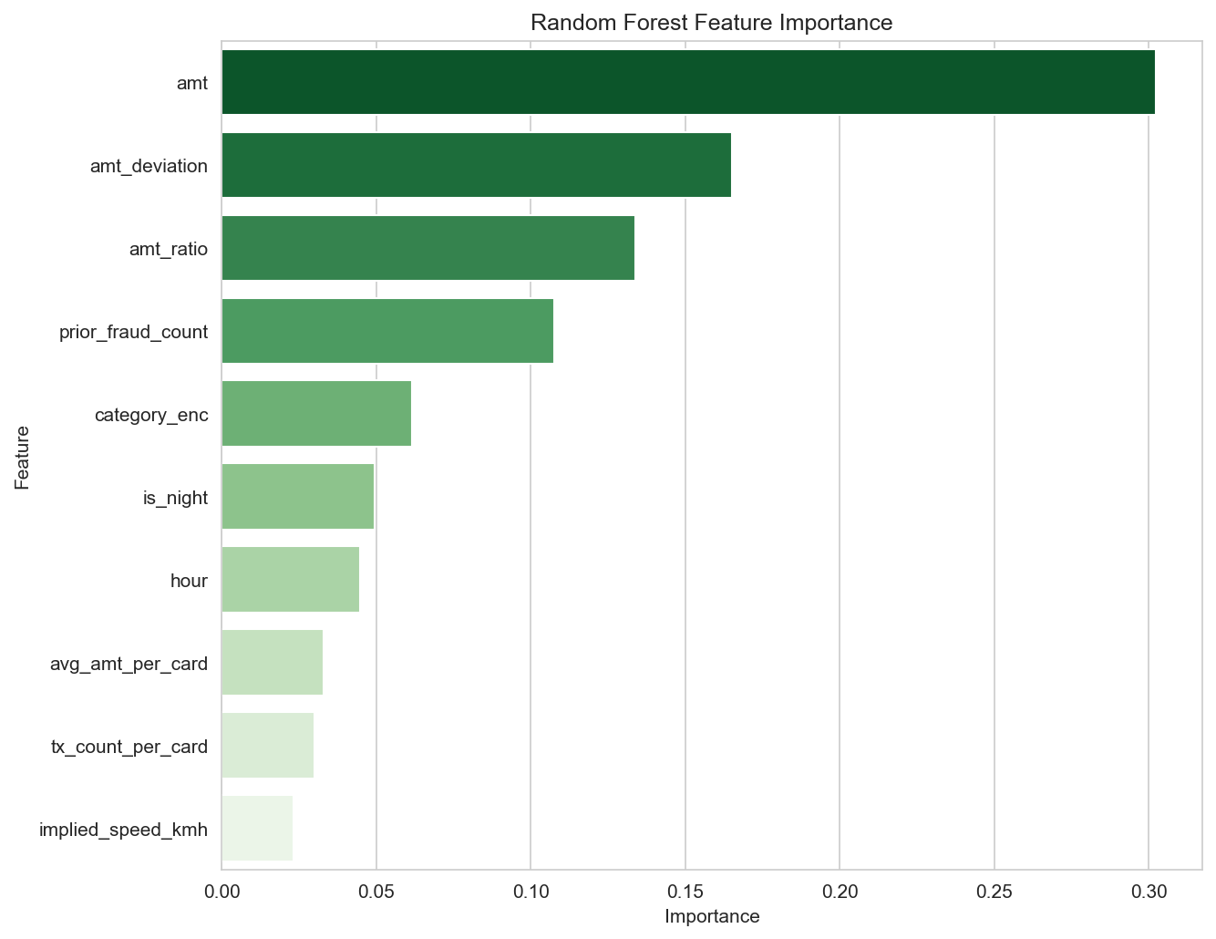
Figure 9: Random Forest feature importance
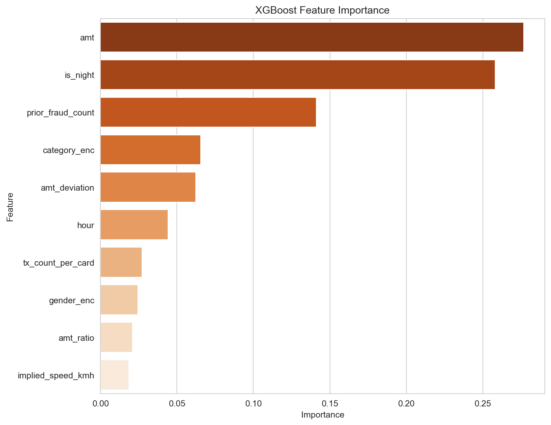
Figure 10: XGBoost feature importance
Random Forest concentrates heavily on amount: amt, amt_deviation and amt_ratio together account for around 60% of its total weight. XGBoost spreads its weight differently, with amt at 0.277 followed immediately by is_night at 0.258, giving it a much stronger temporal component. prior_fraud_count ranks third for both tree models.
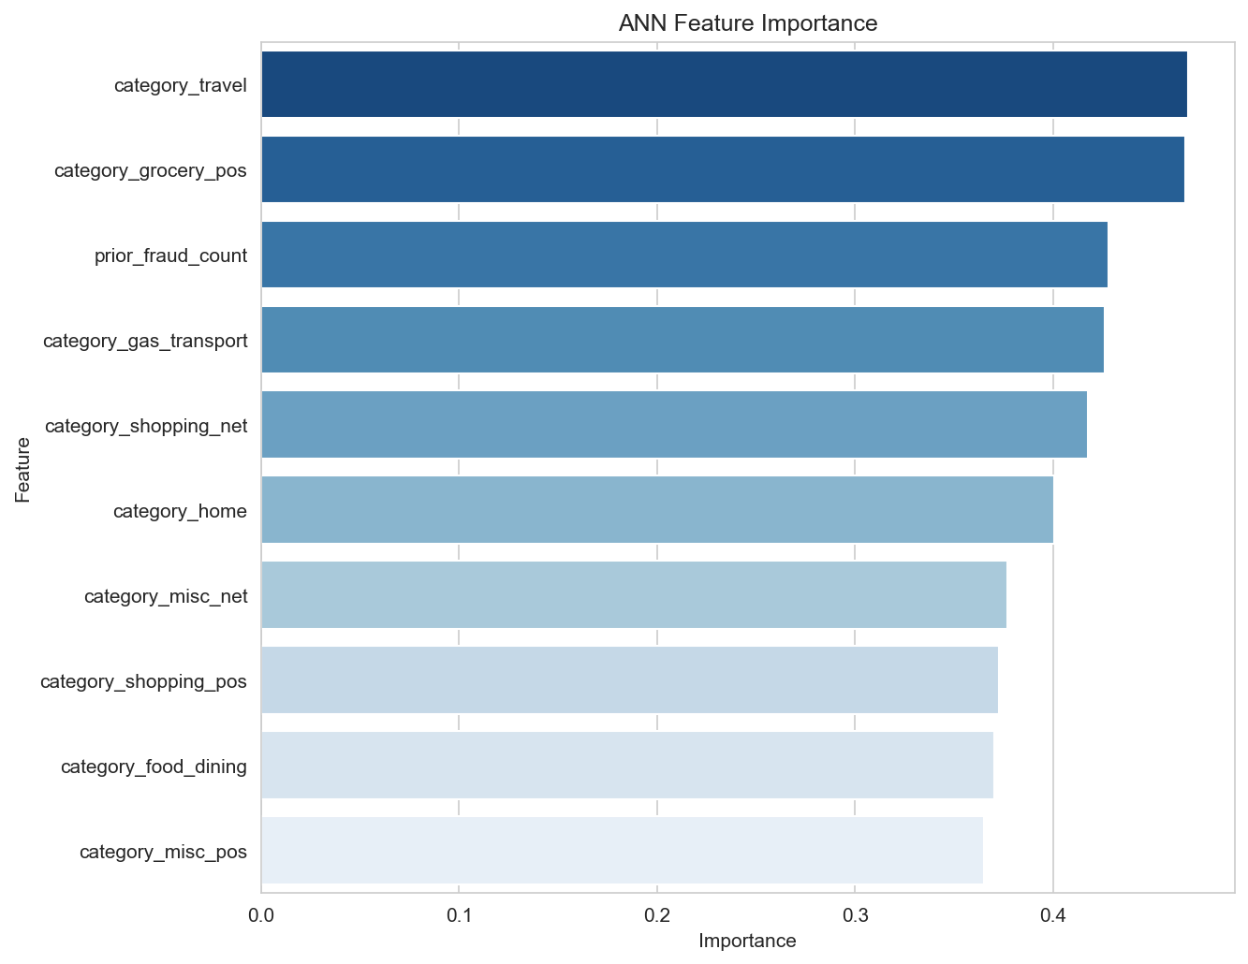
Figure 11: ANN first-layer weight magnitude by feature
The ANN has no native feature importance, so mean absolute first-layer weight magnitude is used as a proxy. Because its categorical inputs are one-hot encoded, it carries an independent weight for each category rather than collapsing them into a single label-encoded integer, which is why category features dominate its top ranks.

6.3 Confusion matrices
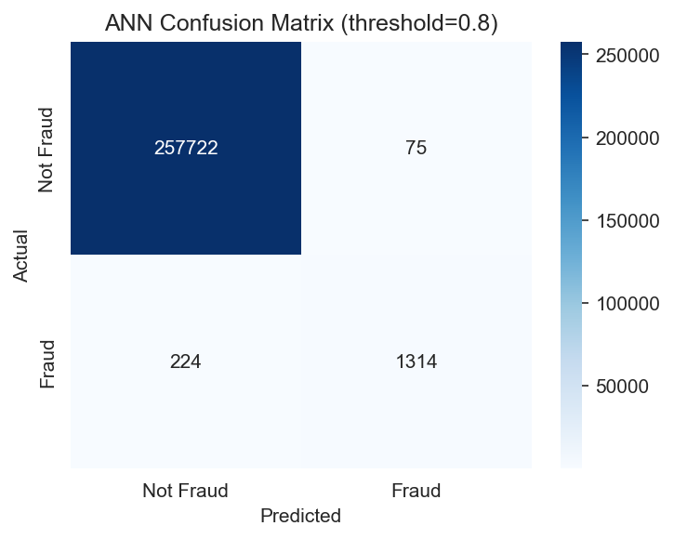
Figure 12: ANN confusion matrix
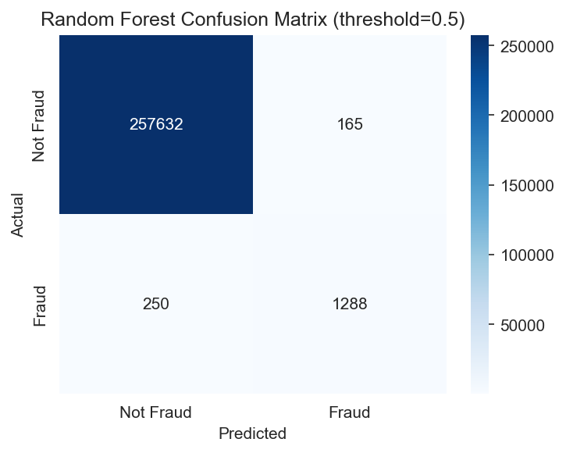
Figure 13: Random Forest confusion matrix
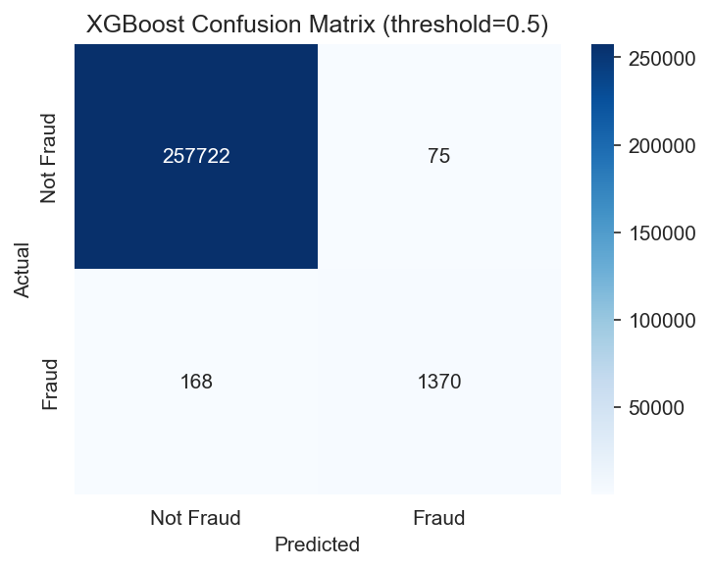
Figure 14: XGBoost confusion matrix
Model | Fraud caught (TP) | Missed fraud (FN) | False alarms (FP)
ANN | 1,314 | 224 | 75
Random Forest | 1,288 | 250 | 165
XGBoost | 1,370 | 168 | 75

The trade-off each model makes is visible directly. Random Forest is not conservative in the useful sense: it raises the most false alarms and still catches the least fraud. XGBoost dominates both other models on this test set.

6.4 Overfitting check
Before trusting any of the above, each model was evaluated on the data it was trained on and compared against its test performance. AUC gap is the more reliable signal here, because precision and recall both depend on the chosen threshold, so a gap there can reflect threshold sensitivity rather than genuine memorisation. AUC is threshold-free and measures ranking quality directly.
Model | Train AUC | Test AUC | AUC gap | Recall gap
ANN | 0.9996 | 0.9987 | 0.0009 | 0.0405
Random Forest | 0.9999 | 0.9975 | 0.0024 | 0.1295
XGBoost | 1.0000 | 0.9994 | 0.0006 | 0.1037

All three AUC gaps come in under 0.003, so on the threshold-free signal none of these models is meaningfully overfitting. The recall gaps are wider and worth explaining rather than passing over. Each model fits its training rows more closely than unseen ones, so training-set fraud scores sit further above the cutoff and more of them clear it. That lifts recall on data the model has already seen without improving how well it ranks fraud above legitimate activity, which is exactly why the AUC gap stays near zero while the recall gap does not. A model that had genuinely memorised the training set would show both gaps widening together.

6.5 Reading thresholds in dollars, not just in counts
Precision and recall describe the trade-off at the one threshold actually chosen. They do not show what happens to the money at risk, or to the number of customers affected, if that threshold moves. For each model the missed-fraud dollar total and the false-alarm count were computed across a grid of thresholds so both error types can be read together.
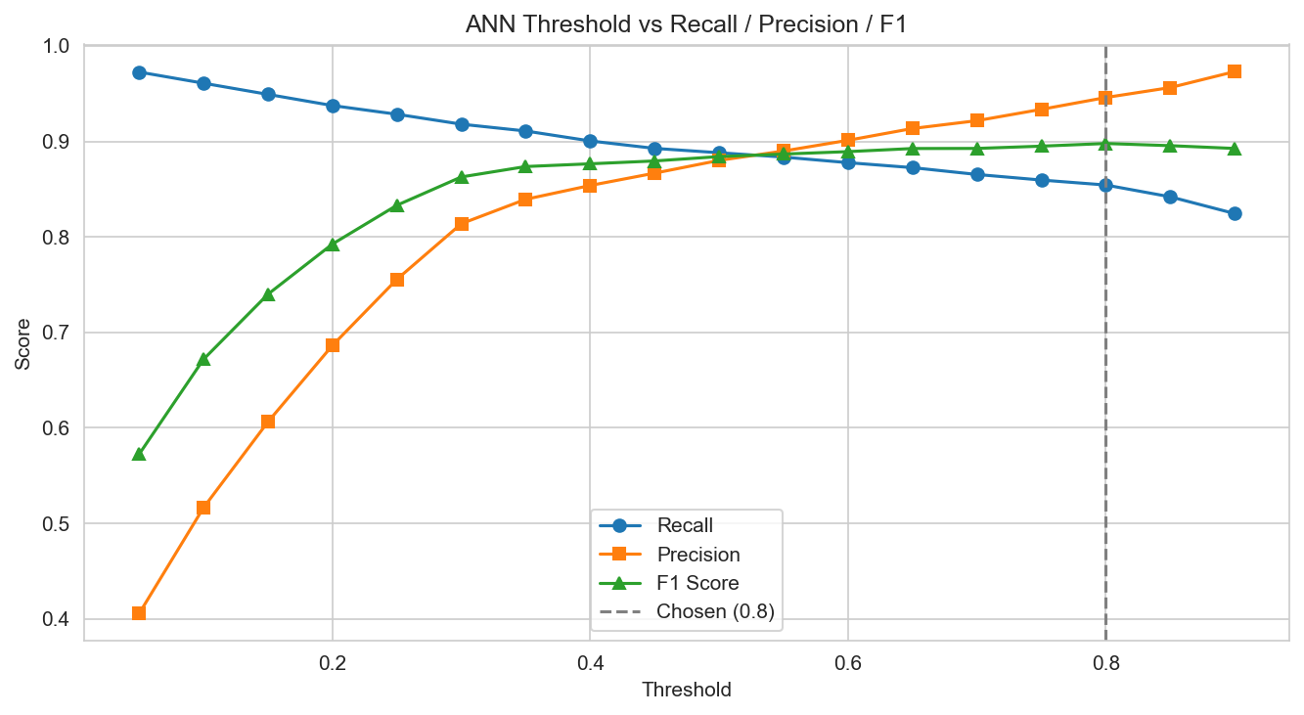
Figure 15: ANN threshold against precision, recall and F1
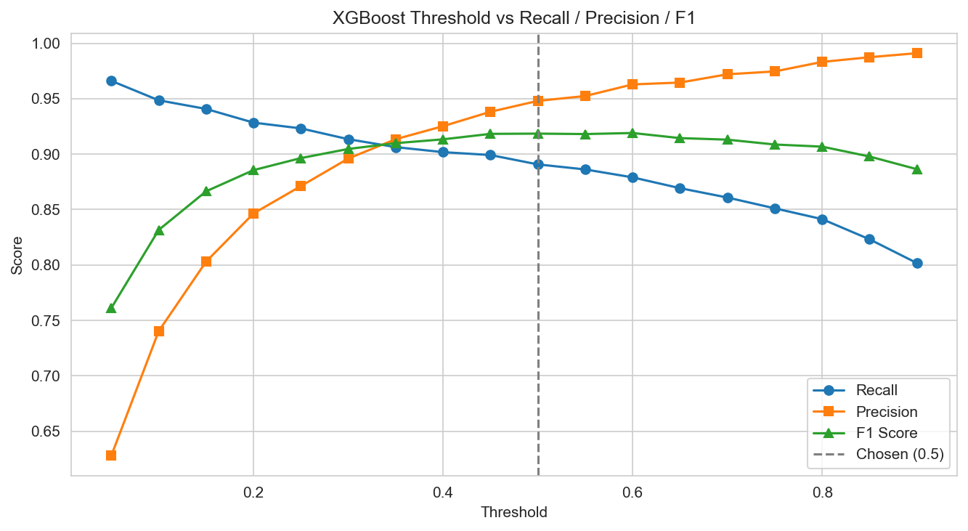
Figure 16: XGBoost threshold against precision, recall and F1
A consistent pattern appears across all three models. The median amount of the fraud being missed stays remarkably flat, around $20 to $24, across almost the whole threshold range. What changes is the mean, which climbs steadily, and then the median breaks upward only at the top of the range: the ANN's median jumps to $50.68 at 0.90 and XGBoost's to $49.14 at the same point, while Random Forest breaks much earlier, reaching $47.91 at 0.70 and $112.90 at 0.80.
The practical reading is that raising a threshold past a certain point stops costing a few more small cases and starts letting genuinely expensive fraud through. Random Forest reaches that point sooner than the other two, which is another way of seeing that it is the weakest model here.
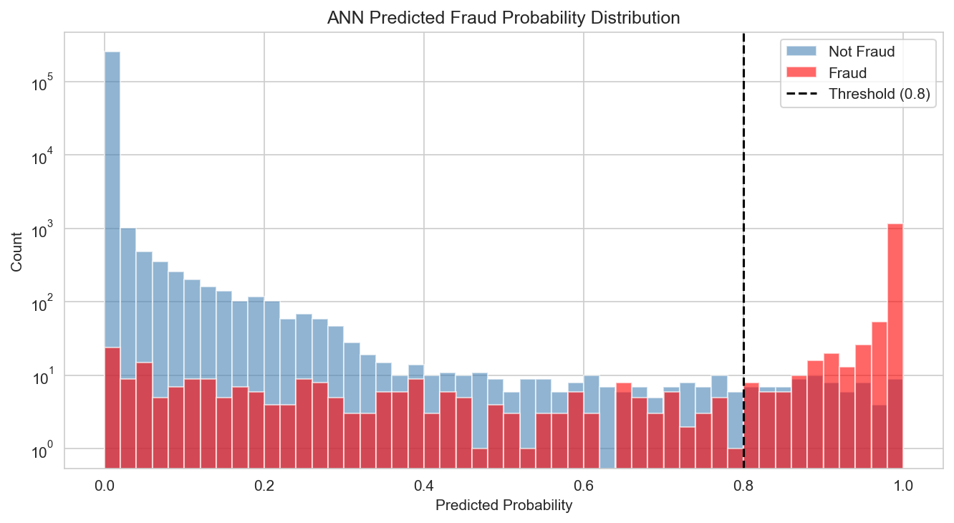
Figure 17: ANN predicted probability distribution by true class
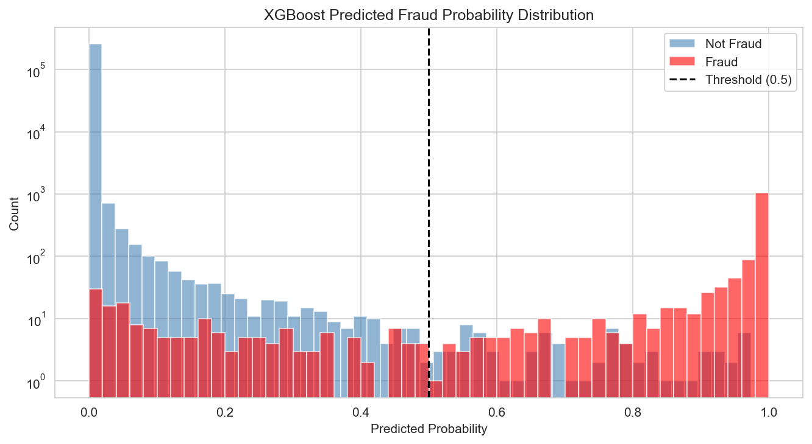
Figure 18: XGBoost predicted probability distribution by true class

7. Statistical Validation

Two different questions need answering before the modelling results can support any architectural decision, and each needs its own test, both evaluated at a significance level of 0.05.
- Question 1: Do the models actually make different mistakes, or do they simply post different aggregate scores? Two models could differ on F1 while agreeing on 99% of individual transactions, in which case combining them gains little. McNemar's test addresses this, and Cochran's Q extends it across all three at once.
- Question 2: Are the probability scores genuinely separating fraud from legitimate activity, independent of any specific threshold? Mann-Whitney U addresses this.

7.1 McNemar's test, pairwise model comparison
McNemar's test is designed for comparing two classifiers on the same test set. Rather than comparing overall accuracy it looks only at the transactions where the two models disagree, one correct and one not, and asks whether those disagreements are lopsided enough to be more than chance. The null hypothesis is that both models make errors on the same transactions and their disagreements are symmetric.
Pair | Both correct | A only | B only | Both wrong | Chi-square | p-value | Decision
ANN vs RF | 258,838 | 198 | 82 | 217 | 47.2321 | 0.000000 | Reject H0
ANN vs XGBoost | 258,969 | 67 | 123 | 176 | 15.9211 | 0.000066 | Reject H0
RF vs XGBoost | 258,866 | 54 | 226 | 189 | 104.4321 | 0.000000 | Reject H0

All three pairs reject the null. Each pair disagrees in a real, lopsided way. The ANN beats Random Forest head to head, 198 cases it alone gets right against 82 the other way. XGBoost beats Random Forest by a wider margin still, 226 against 54, and edges out the ANN by 123 against 67, the narrowest of the three gaps but still significant at p = 0.000066. These are three genuinely different models making different mistakes, which is the precondition for any routing design having something to work with.

7.2 Cochran's Q, omnibus comparison
Running three separate pairwise tests each at a 5% significance level pushes the real chance of a false positive somewhere closer to 14% than 5%. That is the standard multiple-comparisons problem. Cochran's Q addresses it with a single omnibus test across all three models at once, asking whether they all share the same error rate. It stands in the same relation to the pairwise tests as a one-way ANOVA does to a set of t-tests.
Result: Q = 123.1360, df = 2, p below 0.001. The null of equal error rates is rejected, which is what makes it legitimate to read the three pairwise McNemar's results above as valid follow-up comparisons rather than three uncorrected tests standing alone.

7.3 Mann-Whitney U, score separation
Mann-Whitney U is a non-parametric test comparing two distributions without assuming normality, which matters here because fraud probability scores are never normally distributed. They are heavily skewed, with legitimate transactions clustered near zero and fraud concentrated near one. The test compares the scores assigned to confirmed fraud against those assigned to legitimate transactions.
Model | Fraud mean | Fraud median | Legit mean | Legit median | p-value | Effect size
ANN | 0.8890 | 0.9994 | 0.0021 | 0.0000 | < 0.001 | 0.9974
Random Forest | 0.7848 | 0.9134 | 0.0097 | 0.0015 | < 0.001 | 0.9951
XGBoost | 0.8783 | 0.9966 | 0.0010 | 0.0000 | < 0.001 | 0.9988

All three reject the null. The effect size is a rank-biserial correlation running from 0 for no separation to 1.0 for perfect separation, and all three exceed 0.995. In practical terms, if one fraudulent and one legitimate transaction are drawn at random, each model assigns the higher fraud probability to the fraudulent one in more than 99.5% of cases.
This matters specifically because the pipeline in section 9 routes on probability bands. That design is only defensible if the probabilities carry real signal rather than being arbitrary numbers that happen to work at one cutoff. This test is what establishes that.

8. Why One Model Is Not the Whole Answer

XGBoost is the strongest single model, and the statistical tests confirm the three models fail differently. That combination suggests some form of combination should help. This section tests three candidate ways of exploiting it, and reports what happened, including where the answer was no.

8.1 Blanket ensembling, tested and rejected
The first and simplest idea is to combine all three models on every transaction. Three strategies were tested: a simple average of the probabilities, an average weighted by each model's own F1 score, and a majority vote using each model's tuned threshold.
Approach | Precision | Recall | F1 | Caught | Missed | Missed fraud $ | False alarms
XGBoost alone | 0.9481 | 0.8908 | 0.9185 | 1,370 | 168 | $33,174.27 | 75
Ensemble, simple average | 0.9410 | 0.8921 | 0.9159 | 1,372 | 166 | $27,614.94 | 86
Ensemble, F1-weighted | 0.9404 | 0.8921 | 0.9156 | 1,372 | 166 | $27,614.94 | 87
Ensemble, majority vote | 0.9496 | 0.8706 | 0.9084 | 1,339 | 199 | $41,749.31 | 71

No blanket ensemble beats XGBoost alone on F1. The averaging variants do catch two more fraud cases and leave less money on the table, but they pay for it with noticeably more false alarms, 86 or 87 against 75. Majority vote trails on almost every axis. Its AUC also looks artificially low next to the others because a vote count over three is a four-value step function rather than a smooth score, so its precision and recall are the meaningful columns, not its AUC.
That gap is worth chasing deliberately rather than abandoning. The ensemble catches slightly more fraud, and more cheaply, while costing more in customer friction. A routing scheme that could capture the better catch rate without the worse false-alarm rate would be worth building, if the data supports one.

8.2 Routing by anomaly type, tested and rejected
The second idea is more appealing on paper. If each model has a genuine speciality, a transaction showing an amount anomaly could be sent to whichever model handles amount anomalies best, a night-time transaction to whichever model handles temporal signals best, and so on. This would mean choosing a model per situation rather than blending scores everywhere.
The assumption was tested directly against per-condition recall rather than inferred from which features happen to rank highest in each model.
Anomaly condition | Fraud cases | ANN recall | RF recall | XGBoost recall
amt_ratio > 2 | 1,092 | 0.9212 | 0.9267 | 0.9551
amt_ratio > 3 | 1,016 | 0.9232 | 0.9360 | 0.9567
distance > 100 km | 365 | 0.8521 | 0.8274 | 0.8712
is_night = 1 | 1,315 | 0.8776 | 0.8753 | 0.9141
speed > 130 km/h | 572 | 0.8671 | 0.8741 | 0.9161
speed > 900 km/h | 132 | 0.8939 | 0.8939 | 0.9470

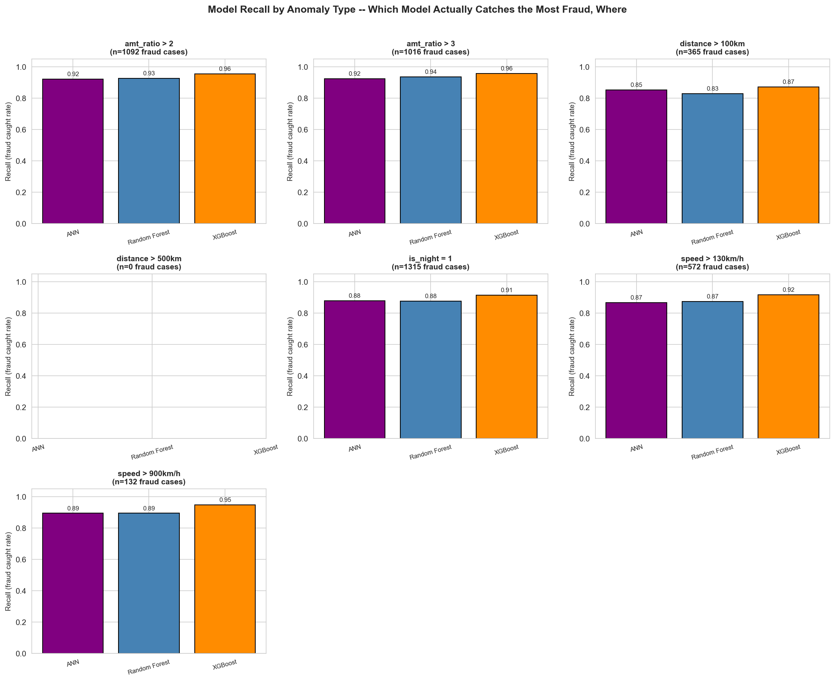
Figure 19: Recall by model within each anomaly type
Result: XGBoost wins every single anomaly category, on both recall and false-positive rate. There is no condition under which deferring to Random Forest or the ANN would catch more fraud, so anomaly-type routing has nothing real to route on. The idea was dropped on this evidence.

This is worth reporting rather than quietly removing. The routing design that follows is only justified because the more attractive alternative was tested first and failed.

8.3 Where a second opinion could actually help
If neither blanket ensembling nor anomaly routing works, the remaining question is narrower: for each individual fraud case, how many of the three models catch it?
Caught by | Fraud cases | % of fraud | Total value
All three models | 1,231 | 80.04% | $736,113.71
Exactly two | 108 | 7.02% | $38,403.25
Exactly one | 63 | 4.10% | $22,019.54
None | 136 | 8.84% | $19,729.77

The obvious figure to take from this table is the wrong one. Adding the caught-by-one and caught-by-two rows gives 171 cases where the models disagreed, and it would be easy to call that the rescuable population. It is not. The pipeline scores every transaction with XGBoost first, so the only fraud a second opinion can possibly rescue is fraud XGBoost itself misses and another model catches. XGBoost misses 168 cases, of which 136 are missed by all three.
The number that matters: That leaves 32 fraud cases, roughly 2% of test-set fraud, where asking the ANN or Random Forest for a second opinion could actually change the outcome. 32 is the real ceiling on what any routing design built from these three models can add, and it sets the bar the added complexity has to clear.

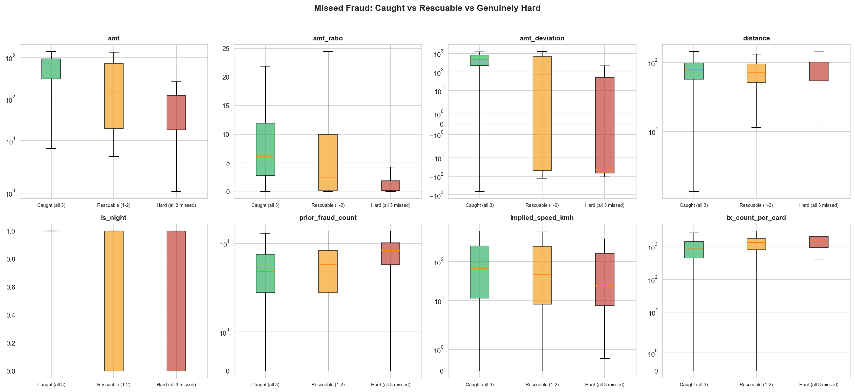
Figure 20: Feature distributions across caught, rescuable and hard fraud

8.4 Why the hard cases are hard
The 136 cases that every model misses are worth understanding, because they set the ceiling on the whole system. Comparing them against the fraud every model catches makes the pattern immediate.
Median value | Caught by all three | Rescuable | Missed by all three
Transaction amount | $725.60 | $139.93 | $21.40
amt_ratio | 6.178 | 2.393 | 0.330
amt_deviation | +463.70 | +76.33 | -41.18
prior_fraud_count | 4 | 5 | 8
tx_count_per_card | 908 | 1,364 | 1,530

The fraud that slips past everything is small, ordinary and sits below the card's own normal spending, with a negative amount deviation and an amount ratio well under 1. Since amt, amt_deviation and amt_ratio are top-ranked features for every model, a fraud case that trips none of them has very little else pointing at it.
The second half of the question is whether these are near misses or confident errors. Comparing each model's own predicted probability across the same three groups settles it.
Coverage group | ANN | Random Forest | XGBoost
Caught by all three | 0.9923 | 0.8934 | 0.9825
Rescuable | 0.7010 | 0.4504 | 0.7200
Missed by all three | 0.1902 | 0.2217 | 0.1335

Finding: These are confident misses, not borderline calls. The models score the hard group between 0.13 and 0.22, well under any working threshold, against 0.89 to 0.99 for the fraud they all catch. A model missing fraud at 0.45 is undecided; a model missing it at 0.13 is wrong with conviction. This is a feature gap, not a threshold problem, and no amount of threshold tuning or routing reaches it.

9. Prescriptive Analytics: The Routing Pipeline

Everything in the preceding sections constrains this design rather than decorating it. XGBoost is the strongest single model and its lead over each of the others is statistically real. Blending all three on every transaction does not beat it. There is no anomaly-type signal to route on. And the genuine second-opinion opportunity is 32 fraud cases, not 171. The pipeline below is what is left after those constraints are respected.

9.1 Where does XGBoost actually need help?
The design rests on there being a region where XGBoost's own probability stops being a reliable guide. That is testable rather than assumable. Binning the test set by predicted probability and comparing what the model predicted in each band against what actually happened gives a direct answer.
Probability band | Transactions | Fraud cases | Mean predicted | Observed rate | Gap
0.00 to 0.10 | 257,364 | 79 | 0.0004 | 0.0003 | 0.0001
0.10 to 0.20 | 284 | 31 | 0.1422 | 0.1092 | 0.0330
0.20 to 0.30 | 119 | 23 | 0.2504 | 0.1933 | 0.0571
0.30 to 0.40 | 69 | 18 | 0.3459 | 0.2609 | 0.0850
0.40 to 0.55 | 68 | 24 | 0.4643 | 0.3529 | 0.1114
0.55 to 0.72 | 76 | 44 | 0.6288 | 0.5789 | 0.0499
0.72 to 0.85 | 73 | 53 | 0.7912 | 0.7260 | 0.0651
0.85 to 1.00 | 1,282 | 1,266 | 0.9863 | 0.9875 | -0.0012

The gap column is the mean predicted probability minus the fraud rate that actually occurred in that band. Near zero means the score is telling the truth and can be left to decide on its own. A large positive gap means the model is overconfident there, calling more fraud than the band actually contains.
Both extremes behave well. Below 0.10 the gap is 0.0001, and above 0.85 it is slightly negative, meaning the model is marginally under-confident at the very top. Overconfidence grows steadily through the middle and peaks at 0.1114 in the 0.40 to 0.55 band. That is the region where a second opinion has something to contribute, and it is where the ensemble bands are placed.
One honest qualification: the 0.55 to 0.85 range still carries a gap of roughly 0.05 to 0.065, which is not negligible. The design does not rely on that range being well calibrated, because the pipeline never asks XGBoost's raw score to decide there. Those transactions are escalated to the customer or blocked outright instead, which sidesteps the calibration question rather than depending on it.

9.2 The five bands
Transactions are routed by how confident XGBoost is about them, with scrutiny escalating as the probability rises.
XGBoost probability | Action | How the decision is made
Below 0.30 | AUTO_ALLOW | XGBoost alone, no further scoring
0.30 to 0.40 | AI_COUNCIL_A | Weighted blend of all three models, 70/15/15
0.40 to 0.55 | AI_COUNCIL_B | Weighted blend shifted further from XGBoost, 60/20/20
0.55 to 0.72 | STEP_UP_AUTH | Escalated to the cardholder for verification
0.72 and above | BLOCK_AND_REVIEW | Blocked, unless the amount override applies

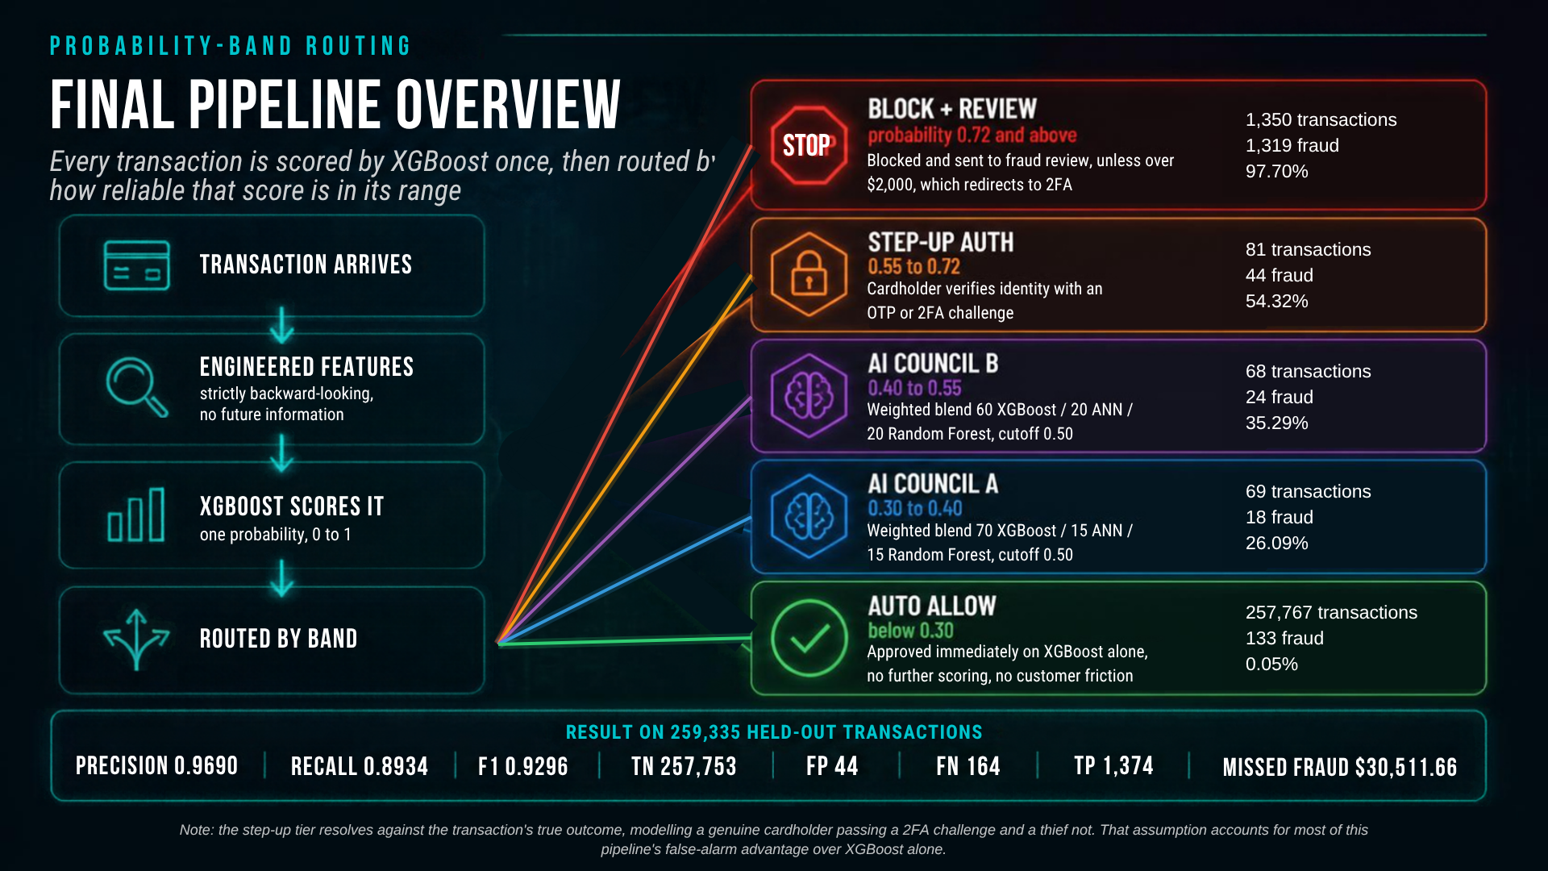
Figure 21: The complete routing pipeline: how a transaction reaches each band, and the volume and fraud rate that band carries
The step-up authentication assumption
The step-up tier resolves against the transaction's true label rather than a model score. This needs stating plainly because it is the single most consequential assumption in the system. It reflects a real capability that no column in this dataset captures: a legitimate cardholder can complete a two-factor challenge and a thief generally cannot. If a card was genuinely compromised, that is a security failure upstream rather than a routing failure, and the thief still fails the challenge on someone else's card.
It is a modelling assumption standing in for a real-world mechanism, not a shortcut taken to improve the metrics. Section 9.6 quantifies exactly how much of the headline result depends on it, which is more than most readers would guess.
Amount override
A transaction in the block tier carrying an amount above $2,000 is redirected to step-up authentication rather than blocked outright. Blocking a large legitimate purchase is a worse customer experience than asking the cardholder to verify it, and on the fraud side the override costs nothing, since a thief still cannot pass the challenge.

9.3 Choosing the ensemble weights
Three weight combinations were tested for the two gray-zone bands, each scored on full pipeline precision, recall and F1 rather than on the gray-zone slice alone.
Combination | Band A weights | Band B weights | Precision | Recall | F1 | Missed
Combo 1 (used) | 70/15/15 | 60/20/20 | 0.9690 | 0.8934 | 0.9296 | 164
Combo 2 | 60/20/20 | 50/25/25 | 0.9663 | 0.8947 | 0.9291 | 162
Combo 3 | 80/10/10 | 70/15/15 | 0.9703 | 0.8934 | 0.9303 | 164

The three come out close to tied, separated by less than 0.001 in F1. That is the useful finding: the band structure is doing the real work, not the exact weight split. Combo 1 is carried into the implementation, and Combo 3's marginal edge is well inside the range where chasing it would be fitting noise.

9.4 The ensemble decision threshold
Within the two council bands a cutoff is still needed to turn the blended probability into a decision. The full 0.10 to 0.90 range was swept against this setup's probabilities.
Cutoff | Precision | Recall | F1 | Missed | False alarms | Missed fraud $
0.40 | 0.9533 | 0.9031 | 0.9275 | 149 | 68 | $26,893.77
0.45 | 0.9624 | 0.8986 | 0.9294 | 156 | 54 | $28,734.21
0.50 (locked) | 0.9690 | 0.8934 | 0.9296 | 164 | 44 | $30,511.66
0.55 | 0.9737 | 0.8908 | 0.9304 | 168 | 37 | $31,752.18
0.65 | 0.9778 | 0.8875 | 0.9305 | 173 | 31 | $35,195.98

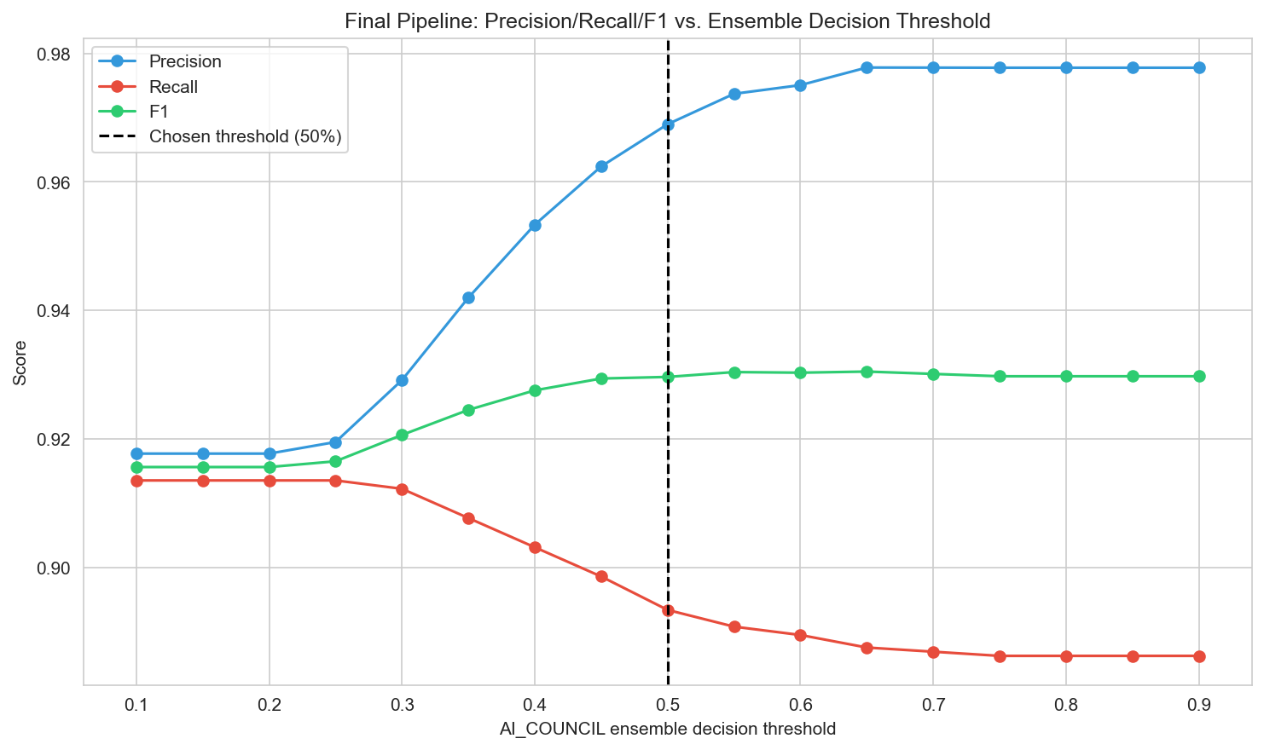
Figure 22: Pipeline precision, recall and F1 against the ensemble decision threshold
F1 does not settle this. It is nearly flat from 0.50 through 0.65 and technically peaks slightly above the chosen value, well inside noise at this sample size. The dollar column is what decides it. Moving from 0.55 down to 0.50 recovers $1,240.52 of missed fraud for seven additional false alarms.
The exchange rate is the honest way to read that decision. Each step down the range buys roughly $177 of avoided fraud loss per additional customer wrongly flagged, against about $574 per case for the earlier move from 0.65 to 0.55. The cheap part of this trade has already been taken; 0.50 accepts a materially worse rate than the previous step did, and it is set there deliberately rather than because a metric pointed at it.

9.5 Pipeline results
Metric | Value
Precision | 0.9690
Recall | 0.8934
F1 | 0.9296
True negatives | 257,753
False positives | 44
False negatives | 164
True positives | 1,374
Missed fraud value | $30,511.66

The routing distribution shows the escalation working as intended, with the fraud rate climbing cleanly through the tiers rather than jumping at an arbitrary cut.
Action | Transactions | Fraud cases | Fraud rate
AUTO_ALLOW | 257,767 | 133 | 0.05%
AI_COUNCIL_A | 69 | 18 | 26.09%
AI_COUNCIL_B | 68 | 24 | 35.29%
STEP_UP_AUTH | 81 | 44 | 54.32%
BLOCK_AND_REVIEW | 1,350 | 1,319 | 97.70%

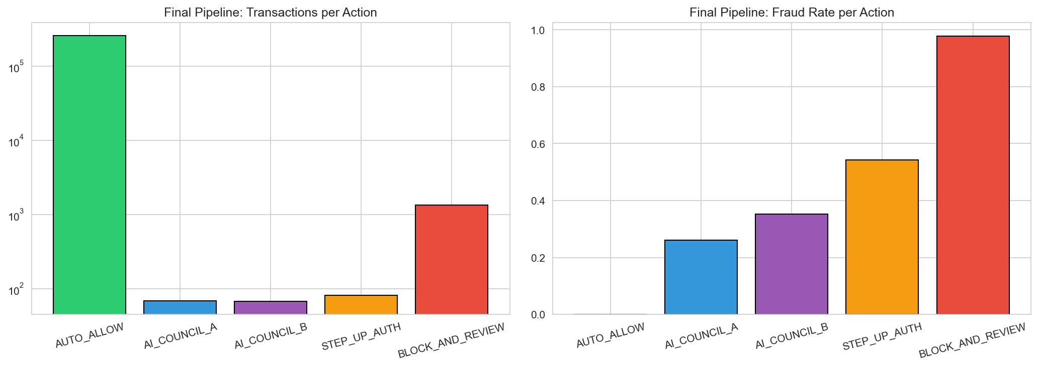
Figure 23: Transactions and fraud rate per routing tier
Over 99.3% of all transactions clear automatically with no friction at all, while the block tier is 97.70% fraud. The two council bands sit where they should, at roughly 26% and 35% fraud, which is exactly the ambiguous middle the calibration check identified.

9.6 What the pipeline actually buys, decomposed
Model | TN | FP | FN | TP | Precision | Recall | F1 | Missed fraud $
XGBoost alone | 257,722 | 75 | 168 | 1,370 | 0.9481 | 0.8908 | 0.9185 | $33,174.27
Final pipeline | 257,753 | 44 | 164 | 1,374 | 0.9690 | 0.8934 | 0.9296 | $30,511.66

On the face of it the pipeline beats XGBoost alone on every number: fewer false alarms, fewer missed fraud cases, higher precision, higher recall, higher F1, and less money left on the table. Every axis moving the same way at once should invite scrutiny rather than satisfaction, because one tier of this pipeline resolves against the true label by design. Splitting the false alarms by routing band shows where the improvement actually comes from.
Routing band | XGBoost alone | Final pipeline | False alarms avoided
AUTO_ALLOW | 0 | 0 | 0
AI_COUNCIL_A | 0 | 0 | 0
AI_COUNCIL_B | 7 | 13 | -6
STEP_UP_AUTH | 37 | 0 | +37
BLOCK_AND_REVIEW | 31 | 31 | 0
Total | 75 | 44 | +31

The finding that matters: The step-up tier alone accounts for 37 avoided false alarms, which is more than the pipeline's entire net improvement of 31. The ensemble bands, where all the weighted-blend machinery actually lives, cost six more false alarms than XGBoost alone would have produced in that same range. They do earn something back: the pipeline catches four more fraud cases than XGBoost alone, 164 missed against 168. But the honest summary is that most of this pipeline's measured advantage is one stated assumption about step-up authentication, with a smaller and more expensive contribution from the ensemble layered on top.

This does not make the assumption wrong. A real step-up challenge does resolve a transaction, and modelling that capability is reasonable when no field in the data captures it. It does mean the headline should be read narrowly, and section 8.3 already showed the ceiling for the routing idea was only 32 cases to begin with. Reporting this openly is worth more than the larger number would have been, because it is the first thing a careful reader would check.

10. Conclusion

This project delivers a complete fraud detection system, from raw transaction data through descriptive pattern discovery, three trained and statistically compared models, and a routing layer that converts a probability into an operational decision. What follows is what each phase contributed and, equally importantly, what the system cannot do.

10.1 What each phase contributed
The descriptive phase was foundational rather than decorative. The Tableau dashboard surfaced night-time grocery fraud, the December online shopping spike and the skew toward elderly cardholders, and each of those became an engineered feature. The is_night flag in particular, defined from the observed 21:00 to 04:00 window rather than a generic assumption, ended up the second most important feature in the strongest model.
The predictive phase produced a less comfortable and more useful finding than expected. Correcting a feature-leakage problem and moving to a chronological split reduced every headline score materially. Those lower numbers are the honest ones. The same phase also showed that three architecturally different models can post similar aggregate metrics while failing on genuinely different transactions, which the statistical tests then confirmed formally.
The prescriptive phase converted model output into decisions, and also produced the most important negative result in the project. Two of the three routing ideas tested did not work, and the one that shipped delivers less on its own merits than its headline comparison suggests.

10.2 Strength of results
Dimension | Result | Significance
Model discrimination | AUC-ROC 0.9975 to 0.9994 | Strong fraud ranking on unseen, later-period data
Fraud capture | 1,374 of 1,538 cases caught | 89.3% recall at 96.9% precision
Block precision | 97.70% fraud rate in the block tier | Few legitimate transactions reach an outright block
Frictionless rate | 99.3% of transactions auto-approved | Minimal impact on genuine cardholders
Statistical validity | All pairwise tests significant, Cochran's Q p below 0.001 | Model differences are real, not sampling noise
Generalisation | AUC gaps below 0.003 train to test | No meaningful overfitting on the threshold-free measure

10.3 Limitations
- The 2FA assumption: the step-up tier assumes a two-factor challenge always resolves correctly, that every legitimate cardholder passes and every thief fails. Real authentication is imperfect in both directions, and the decomposition in section 9.6 shows this single assumption is worth more on its own than the pipeline's entire net improvement over XGBoost alone. Any deployment figure would depend on real pass and fail rates, which this dataset does not contain.
- A hard ceiling on recall: 136 fraud cases, 8.8% of the test set, are missed by all three models. They are small, card-typical transactions that every model scores between 0.13 and 0.22. That is a feature gap rather than a threshold problem, and no routing scheme built from these three models closes it.
- prior_fraud_count is optimistic: this feature is almost certainly stronger here than it would be in production, for two separate reasons. Only 983 unique cards means history accumulates unrealistically fast, and a live system would not know a past transaction was fraudulent until the dispute arrived weeks later. A deployed version would lag by the chargeback window.
- Simulated data: the dataset is a realistic simulation, not production data. Concept drift, emerging fraud typologies and genuine cardholder behavioural change are not represented in it.
- Static band edges: the band edges come from a reliability check on a single run of a single dataset. They should be re-derived on new data rather than treated as fixed constants, which is why they are named constants in the code rather than numbers buried in the routing logic.

10.4 Future work
- Measure the 2FA tier: replacing the step-up assumption with real challenge outcome data would turn the single largest caveat in this report into a measured quantity.
- Find a small-transaction signal: the 136 unreachable cases need a signal that separates small-dollar fraud from small-dollar legitimate spending. Nothing in the current feature set does, and no threshold or routing change substitutes for it.
- Graph-based features: cardholder and merchant relationship graphs would surface coordinated fraud rings, which are invisible to a model scoring one transaction at a time.
- Explainability layer: per-transaction SHAP values would give a human-readable reason for every block or challenge, which matters for both analyst trust and regulatory explainability.
- Periodic recalibration: band edges and thresholds should be recalibrated on a rolling basis as fraud patterns shift, rather than fixed once from a single evaluation.

10.5 Final statement
Effective fraud detection is a system design problem more than a modelling problem. The strongest single model here reaches 0.9185 F1, and the routing layer on top of it reaches 0.9296 while cutting false alarms from 75 to 44. That is a real improvement, and most of it rests on one stated assumption rather than on model combination, which this report says plainly rather than leaving for a reader to discover. The more durable contributions are the negative results: blanket ensembling does not beat a well-tuned single model here, anomaly-type routing has no signal to route on, and 8.8% of fraud is unreachable with the current feature set. Knowing precisely where a system stops working is worth as much as the headline number, and it is what would make this pipeline safe to take further.

11. References

- Choksi, P. (n.d.). Credit card transactions dataset [Data set]. Kaggle. https://www.kaggle.com/datasets/priyamchoksi/credit-card-transactions-dataset
- Dietterich, T. G. (1998). Approximate statistical tests for comparing supervised classification learning algorithms. Neural Computation, 10(7), 1895-1923.
- Chen, T., & Guestrin, C. (2016). XGBoost: A scalable tree boosting system. Proceedings of the 22nd ACM SIGKDD International Conference on Knowledge Discovery and Data Mining, 785-794.
- Han, J., Pei, J., & Tong, H. (2022). Data mining: Concepts and techniques (4th ed.). Morgan Kaufmann.
- Provost, F., & Fawcett, T. (2013). Data science for business: What you need to know about data mining and data-analytic thinking. O'Reilly Media.
- Nilson Report. (2022). Card fraud losses worldwide. HSN Consultants.
- Pedregosa, F., et al. (2011). Scikit-learn: Machine learning in Python. Journal of Machine Learning Research, 12, 2825-2830.
- Seabold, S., & Perktold, J. (2010). Statsmodels: Econometric and statistical modeling with Python. Proceedings of the 9th Python in Science Conference.
- Python Software Foundation. (2023). Python (Version 3.x) [Computer software]. https://www.python.org
- Salesforce. (2026). Tableau Prep Builder and Tableau Desktop [Computer software]. https://www.tableau.com
- Anthropic. (2026). Claude [Large language model]. https://claude.ai
- Perplexity AI. (2026). Perplexity [Large language model]. https://www.perplexity.ai
- Google. (2026). Gemini [Large language model]. https://gemini.google.com

