**ABSTRACT**

This project concern to a process for monitoring the condition of train tracks and more specifically has the object of the identification of defects detected by monitoring equipment on the tracks to be examine to allow maintenance crews to subsequently find these defects. When the supply is given to the device, the DC motor gets start through relay driver circuit. Two IR sensors are fixed in front of the train which is used to find out the crack on the track. Each sensor will produce the signal related to the position with the rail. If the track position is normal both the sensor gives the constant sensed output. If any sensor misses their output condition to fail then there is defect on that side. The sensor will inform this by giving alarm and sends information to the smart phone android app in IOT based via GPRS MODEM. Ultrasonic sensor is used to detect the obstacle in the track if any obstacle detected means the Arduino automatically transmits the message to nearby station via IOT using GPRS MODEM. The location of this rail will automatically sends to each station via IOT using GPRS MODEM.

**Content**

**______________________________________________**

**CHAPTER 1 - INTRODUCTION**….…………………………..….1

**CHAPTER 2 -BLOCK DIAGRAM**………………………………..3

2.1 Block Diagram ………………………………………….…………4 2.2Component Used In Block Diagram………………………………..5

2.3 Block Diagram Description………………………………….……6

**CHAPTER 3 - Circuit Diagram**……………………………….…….8

3.1 Circuit Diagram………………………..………………….………9

**CHAPTER 4- INTRODUCTION OF ARDUINO**…………………..10

4.1Introduction…………………………………………………….…11

4.2Pin Diagram………………………………………………………17

4.3 Features……………………………………………..……………19

**CHAPTER 5 –HARDWARE DESCIPTION**……………………..20

5.1 Power Supply…………………………………………...……….21

5.2 GSM Module …………………………………………………… 27

5.3 GPS Module .........…………………………………………..…...30

5.4 DC Motor…….………………………………………………..…32

5.5 Motor Driver……………………………………………………..34

5.6 Ultra-sonic Sensor……..……………………………………….. 37

5.7 LED……….……………………………………………………...39

5.8 Solar Panels………………………………………………………40

**CHAPTER 6- PROGRAMMING**………………………………...….41

6.1 Algorithm…………………………………………………….....…..42

6.2 Flowchart……………………………………………………….…..43

6.3Program……………..………….…………………………..………..44 **CHAPTER 7 – RESULT, CONCLUSION AND FUTURE SCOPE**…51

7.1 Result………………………………………………………………..52

7.2 Features………………………………………………….……….....53

7.3 Limitations……………………………………………………….....53

7.4 Applications.…………………………………..………………....…53

7.5 Conclusions…………………………………………….…………...54

7.6 Future scope………………………………………….……………..54

**CHAPTER 8 – REFERENCES**…………………………….…….......55

8.1 Books……………………………………………………………….56

8.2 Websites……………………………………………….…………....56

**CHAPTER 9 –APPENDIX**………………………………………........57

List of Component with Price……………..…………………….…..….58

# 

# 

**CHAPTER 1**

**INTRODUCTION**

##### The cracks and other problems with the rails generally go unnoticed due to improper maintenance and irregular manual track line monitoring that is being carried out in the current situation. Nowadays system have some limitations, if the bridge or track damaged, that information goes to railway authority people, they notifies and informs to the corresponding trains it will takes more time informing those information.

##### In the literature survey, the commonly employed rail crack detection schemes in foreign country are usually ultrasonic or eddy current based techniques which are the reasonably good accuracy in most cases. However, the one characteristic which the above mentioned methods have in common is that they are both expensive, which makes them ineligible for implementation in the current Indian scenario. Also, the ultrasonic can only inspect the core of materials; that is, the method cannot check for surface and near surface cracking where many of the faults are located. Many of the most serious defects that can develop in the rail head can be very difficult to detect using the currently available inspection equipment. This system is mainly concerned in identifying the cracks in railway tracks and helps to prevent the accidents the exact place where it is.

**CHAPTER 2**

**BLOCK DIAGRAM**

**2.1 BLOCK DIAGRAM** **:**

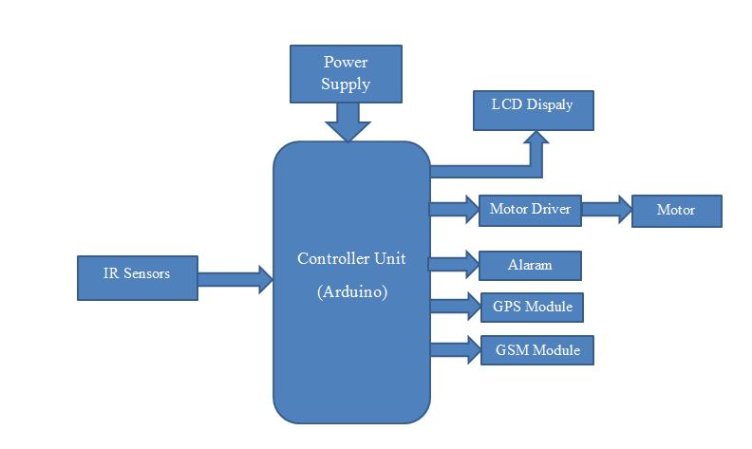

**2.2 BLOCK DIAGRAM DESCRIPTION:**

When the supply is given to the device, the DC motor gets start through relay driver circuit. Two IR sensors are fixed in front of the train which is used to find out the crack on the track. Each sensor will produce the signal related to the position with the rail. If the track position is normal both the sensor gives the constant sensed output. If any sensor misses their output condition to fail then there is defect on that side. The sensor will inform this by giving alarm and sends information to the smart phone android app in IOT based via GPRS MODEM. Ultrasonic sensor is used to detect the obstacle in the track if any obstacle detected means the Arduino automatically transmits the message to nearby station via IOT using GPRS MODEM. The location of this rail will automatically sends to each station via IOT using GPRS MODEM

**2.3 COMPONENT USED IN PROJECT:**

1. Arduino UNO
2. DC Motor
3. Motor Driver(L293D)
4. LED
5. Battery
6. IR sensor
7. Dc 12 v Adapter
8. Solar panel
9. GSM Module
10. GPS Module
11. Diode
12. Resistor
13. Switch
14. Led
15. Header Strips
16. Connectors
17. Connecting wires

**CHAPTER 3**

**CIRCUIT DIAGRAM**

**3 .1 CIRCUIT DIAGRAM :-**

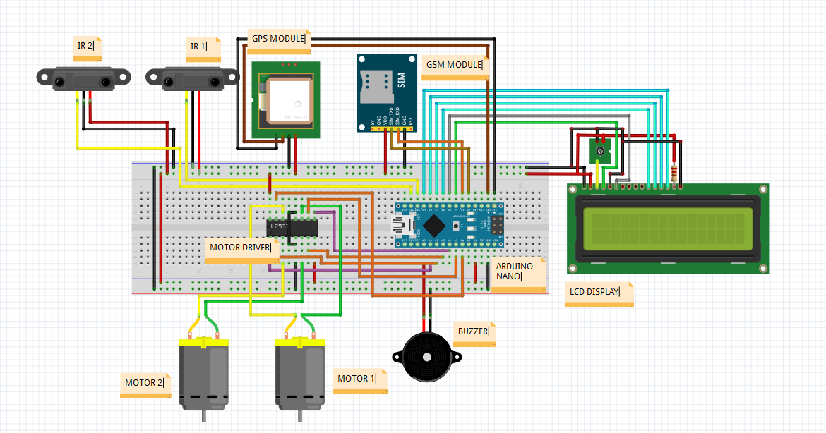

**CHAPTER 4**

**INTRODUCTION TO ARDUINO**

**4.1 INTRODUCTION TO ARDUINO:-**

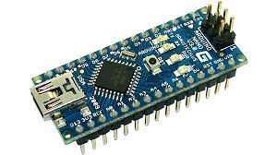

Fig: Ardunio Board

Arduino is an [open-source hardware](https://en.wikipedia.org/wiki/Open-source_hardware) and [software](https://en.wikipedia.org/wiki/Open-source_software) company, project and user community that designs and manufactures [single board microcontrollers](https://en.wikipedia.org/wiki/Single-board_microcontroller) and [microcontroller](https://en.wikipedia.org/wiki/Microcontroller) kits for building digital devices. Its products are licensed under the [GNU Lesser General Public License](https://en.wikipedia.org/wiki/GNU_Lesser_General_Public_License) (LGPL) or the [GNU General Public License](https://en.wikipedia.org/wiki/GNU_General_Public_License) (GPL), permitting the manufacture of Arduino boards and software distribution by anyone. Arduino boards are available commercially in preassembled form or as [do-it-yourself](https://en.wikipedia.org/wiki/Do-it-yourself) (DIY) kits.

Arduino board designs use a variety of [microprocessors](https://en.wikipedia.org/wiki/Microprocessor) and controllers. The boards are equipped with sets of digital and analog [input/output](https://en.wikipedia.org/wiki/Input/output) (I/O) pins that may be interfaced to various expansion boards ('shields') or [breadboards](https://en.wikipedia.org/wiki/Breadboards) (For prototyping) and other circuits. The boards feature serial communications interfaces, including [Universal Serial Bus](https://en.wikipedia.org/wiki/Universal_Serial_Bus) (USB) on some models, which are also used for loading programs from personal computers. The microcontrollers can be programmed using [C](https://en.wikipedia.org/wiki/C_(programming_language)) and [C++](https://en.wikipedia.org/wiki/C%2B%2B) [programming languages](https://en.wikipedia.org/wiki/Programming_language). In addition to using traditional [compiler](https://en.wikipedia.org/wiki/Compiler) [toolchains](https://en.wikipedia.org/wiki/Toolchains" \o "Toolchains), the Arduino project provides an [integrated development environment](https://en.wikipedia.org/wiki/Integrated_development_environment) (IDE) based on the [Processing](https://en.wikipedia.org/wiki/Processing_(programming_language)) language project.

The Arduino project started in 2005 as a program for students at the [Interaction Design Institute Ivrea](https://en.wikipedia.org/wiki/Interaction_Design_Institute_Ivrea) in [Ivrea](https://en.wikipedia.org/wiki/Ivrea" \o "Ivrea), Italy, aiming to provide a low-cost and easy way for novices and professionals to create devices that interact with their environment using [sensors](https://en.wikipedia.org/wiki/Sensor) and [actuators](https://en.wikipedia.org/wiki/Actuator). Common examples of such devices intended for beginner hobbyists include simple [robots](https://en.wikipedia.org/wiki/Robot), [thermostats](https://en.wikipedia.org/wiki/Thermostat) and [motion detectors](https://en.wikipedia.org/wiki/Motion_detector).Arduino is [open-source hardware](https://en.wikipedia.org/wiki/Open-source_hardware). The hardware reference designs are distributed under a [Creative Commons](https://en.wikipedia.org/wiki/Creative_Commons) Attribution Share-Alike 2.5 license and are available on the Arduino website. Layout and production files for some versions of the hardware are also available. Although the hardware and software designs are freely available under [copy left](https://en.wikipedia.org/wiki/Copyleft) licenses, the developers have requested the name Arduino to be [exclusive to the official product](https://en.wikipedia.org/wiki/Generic_trademark) and not be used for derived works without permission. The official policy document on use of the Arduino name emphasizes that the project is open to incorporating work by others into the official product. Several Arduino-compatible products commercially released have avoided the project name by using various names ending in Arduino. Most Arduino boards consist of an [Atmel](https://en.wikipedia.org/wiki/Atmel) 8-bit [AVR microcontroller](https://en.wikipedia.org/wiki/AVR_microcontroller) (ATmega8, ATmega168, [ATmega328](https://en.wikipedia.org/wiki/ATmega328), ATmega1280, ATmega2560) with varying amounts of flash memory, pins, and features. The 32-bit [Arduino Due](https://en.wikipedia.org/wiki/Arduino_Due" \o "Arduino Due), based on the Atmel [SAM3X8E](https://en.wikipedia.org/wiki/Atmel_ARM-based_processors#SAM_3) was introduced in 2012. The boards use single or double-row pins or female headers that facilitate connections for programming and incorporation into other circuits. These may connect with add-on modules termed shields. Multiple and possibly stacked shields may be individually addressable via an [I²C](https://en.wikipedia.org/wiki/I%C2%B2C) [serial bus](https://en.wikipedia.org/wiki/Serial_bus). Most boards include a 5 V [linear regulator](https://en.wikipedia.org/wiki/Linear_regulator) and a 16 MHz [crystal oscillator](https://en.wikipedia.org/wiki/Crystal_oscillator) or [ceramic resonator](https://en.wikipedia.org/wiki/Ceramic_resonator). Some designs, such as the LilyPad, run at 8 MHz and dispense with the onboard voltage regulator due to specific form-factor restrictions. Arduino microcontrollers are pre-programmed with a [boot loader](https://en.wikipedia.org/wiki/Boot_loader) that simplifies uploading of programs to the on-chip [flash memory](https://en.wikipedia.org/wiki/Flash_memory). The default bootloader of the Arduino UNO is the optiboot bootloader. Boards are loaded with program code via a serial connection to another computer. Some serial Arduino boards contain a level shifter circuit to convert between [RS-232](https://en.wikipedia.org/wiki/RS-232) logic levels and [transistor–transistor logic](https://en.wikipedia.org/wiki/Transistor%E2%80%93transistor_logic) (TTL) level signals.

**4. 2 PIN DIAGRAM:-**

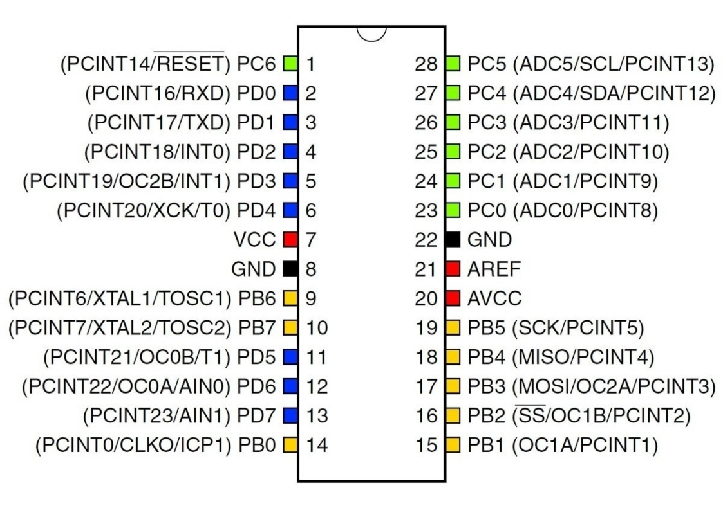

Fig: Pin diagram of Arduino(ATMEGA328P)

* **Pin Descriptions:-**

1. **Power USB:-** Arduino board can be powered by using the USB cable from your computer. All you need to do is connect the USB cable to the USB connection.
2. **Power (Barrel Jack):-**Arduino boards can be powered directly from the AC mains power supply by connecting it to the Barrel Jack.
3. **Voltage Regulator:-**The function of the voltage regulator is to control the voltage given to the Arduino board and stabilize the DC voltages used by the processor and other elements.
4. **Crystal Oscillator:-**The crystal oscillator helps Arduino in dealing with time issues. How does Arduino calculate time? The answer is, by using the crystal oscillator. The number printed on top of the Arduino crystal is 16.000H9H. It tells us that the frequency is 16,000,000 Hertz or 16 MHz.
5. **Arduino Reset:-**You can reset your Arduino board, i.e., start your program from the beginning. You can reset the UNO board in two ways. First, by using the reset button on the board. Second, you can connect an external reset button to the Arduino pin labelled RESET.
6. **Analog pins:-**The Arduino UNO board has six analog input pins A0 through A5. These pins can read the signal from an analog sensor like the humidity sensor or temperature sensor and convert it into a digital value that can be read by the microprocessor.
7. **Digital I/O:-**The Arduino UNO board has 14 digital I/O pins (15) (of which 6 provide PWM (Pulse Width Modulation) output. These pins can be configured to work as input digital pins to read logic values (0 or 1) or as digital output pins to drive different modules like LEDs, relays, etc. The pins labeled “~” can be used to generate PWM.

**4.3 FEATURES:-**

* The operating voltage is 5V
* The recommended input voltage will range from 7v to 12V
* The input voltage ranges from 6v to 20V
* Digital input/output pins are 14
* Analog i/p pins are 6
* DC Current for each input/output pin is 40 mA
* DC Current for 3.3V Pin is 50 mA
* Flash Memory is 32 KB
* SRAM is 2 KB
* EEPROM is 1 KB
* CLK Speed is 16 MHz

**CHAPTER 5**

**HARDWARE DESCRIPTION**

**5.1 POWER SUPPLY CIRCUIT:-**

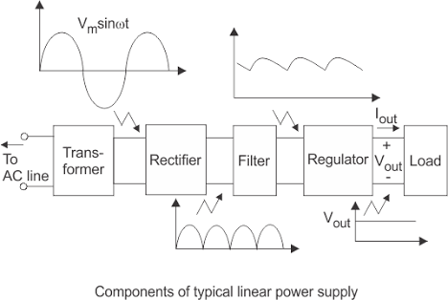

Fig: Block diagram of Power Supply

Each of the blocks is described in more detail below:

• Transformer - steps down high voltage AC mains to low voltage AC.

• Rectifier - converts AC to DC, but the DC output is varying.

• Smoothing - smoothes the DC from varying greatly to a small ripple.

• Regulator - eliminates ripple by setting DC output to a fixed voltage.

**Bridge rectifier:**

A bridge rectifier can be made using four individual diodes, but it is also available in special packages containing the four diodes required. It is called a full-wave Rectifier because it uses the entire AC wave (both positive and negative sections).

1.4V is used up in the bridge rectifier because each diode uses 0.7V when conducting and there are always two diodes conducting, as shown in the diagram below. Bridge rectifiers are rated by the maximum current they can pass and the maximum reverse voltage they can withstand (this must be at least three times the supply RMS voltage so the rectifier can withstand the peak voltages

**Smoothing:**

Smoothing is performed by a large value electrolytic capacitor connected across the DC supply to act as a reservoir, supplying current to the output when the varying DC voltage from the rectifier is falling. The diagram shows the unsmoothed varying DC (dotted line) and the smoothed DC (solid line). The capacitor charges quickly near the peak of the varying DC, and then discharges as it supplies current to the output.

**Voltage regulator:**

Voltage regulator ICs are available with fixed (typically 5, 12 and 15V) or variable output voltages. They are also rated by the maximum current they can pass. Negative voltage regulators are available, mainly for use in dual supplies. Most regulators include some automatic protection from excessive current ('overload protection') and overheating ('thermal protection'). Below is the circuit diagram of power supply which gives output of 5V, as only that much is required for microcontroller. Its circuit diagram and designing calculation are given below.

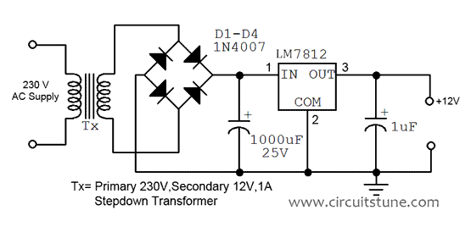

Fig: Circuit diagram of 12V Power Supply

The +12 volt power supply is based on the commercial 7812 voltage regulator IC. This IC contains all the circuitry needed to accept any input voltage from 15 to 24 volts and produce a steady +12 volt output, accurate to within 5% (0.25 volt). It also contains current-limiting circuitry and thermal overload protection, so that the IC won't be damaged in case of excessive load current; it will reduce its output voltage instead.

The advantage of a bridge rectifier is you don’t need a center tap on the secondary of the transformer. A further but significant advantage is that the ripple frequency at the output is twice the line frequency (i.e. 50Hz) and makes filtering somewhat easier.

The use of capacitor c1 and c2 is to make signal ripple free. The capacitor used before the regulator is to make ac signal ripple free and then later which we are using is for safety, if incase there is a ripple left after regulating, then c2nwill remove it.

We require 12V at the o/p of the regulator.

The drop out voltage of the regulator is 2V As per the data sheet)

Vdc = 12+2 = 14V

So at the regulator input, the voltage applied should be of 14V.

According to the formula,

Vdc = 2Vm/Pi

Assuming there is no ripple Capacitor from

Vm= Vdc .pi/2

=12 x 3.14)/2

=18.84V

Vm= 18.84V

During one cycle, two diodes are conducting

Drop out voltage of one diode = 0.7V

Drop out voltage of two diode = 1.4V

Vim = Vm+ 1.4V

=18.84+1.4= 20.24V

Vim=20.24V

Vrms = Vim/sqrt(2)

= 20.24/sqrt(2)

= 14.31V

Vrms = 14.31V

So we select transformer of 15V.

Similarly

Im=Idc x pi/2

Im=700m x 3.14/2

= 1.099A.

Irms= Im/sqrt(2)

= 1.099A/sqrt(2)

` = 777.11mA

Irms = 777.11mA

So we select the transformer of current rating 1A.

Considering the above transformer rating,

We take the transformer of 0-15V/1A

TRANFORMER – 0-15V/1A Stepdown transformer.

2. Rectifier Design:

PIV of diode = Vm = 12.39V

Im= 628mA

**BRIDGE RECTIFIER** –

So, we select the bridge IC of 1Ampere rating.

R = Vdc/Idc

= 15 / 400m

= 37.5Ohms.

Vr = 2(Vim – Vdc)

= 2(20.24 – 12)

= 8.24V

C = Vdc/ (FxRxVr)

= 12/ (100x17.5x8.24)

= 832.17uF

So for Safe working we select capacitor of 1000uF

C1 = 1000uF / 35V Electrolytic Capacitor.

C2 = 0.1uF Ceramic Capacitor.

So the power supply made from the above mentioned components gives the output of 12V.

**5.2 GSM MODULE :-**

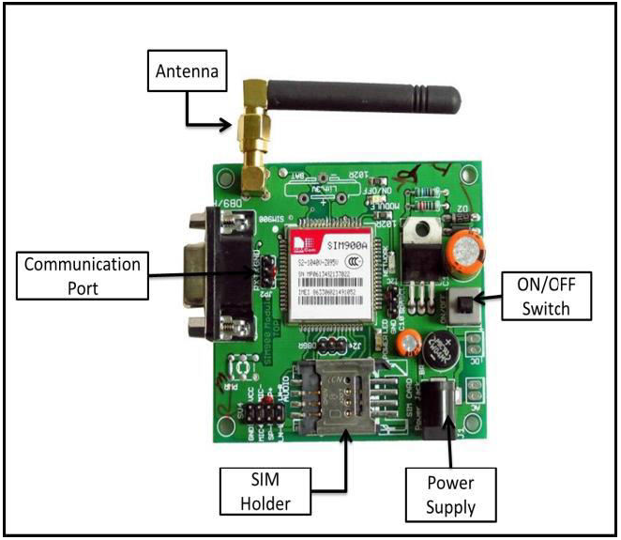

Fig: GSM Module

For communication purpose Bluetooth technology can also be used in the transmitter section. Bluetooth is a wireless networking standard that is aimed at remote control and sensor applications which is suitable for operation in harsh radio environments and in isolated locations. But, the main disadvantages of Bluetooth is short range, low complexity, and low data speed. Therefore, GSM is more advantages over Bluetooth for communication. Hence author use GS modem. A GSM modem is a specialized type wireless modem that works with a GSM wireless network. It accepts a SIM card, and operates over a subscription to a mobile operator, just like a mobile phone. A GSM modem can be an external device or a PC Card / PCMCIA Card. An external GSM modem is connected to a computer through a serial cable or a USB cable. When a GSM modem is connected to a computer, this allows the computer to communicate over the mobile network. While these GSM modems are most frequently used to provide mobile internet connectivity, many of them can also be used for sending and receiving SMS and MMS message. GSM Modem sends and receives data through radio waves. In this project GSM 900 modem is used to send the messages which is shown in figure. It consists of a GSM/GPRS modem with standard communication interfaces like RS-232 (Serial Port), USB, so that it can be easily connected to the other devices. The power supply circuit is also built in the module that can be turn ON by using a suitable adaptor.

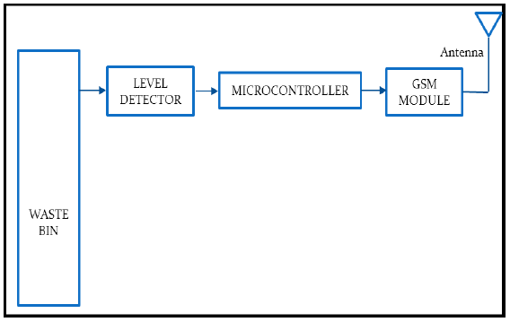

Fig-2 Transmitter Part from Dustbin

The block diagram of transmitter section. Level detector consists of IR sensors which is used to detect the level of the garbage in the dustbin. The output of level detector is given to microcontroller. Four IR sensors are used to indicate the different levels of the amount of the garbage collected in the dustbin which is placed in public area. When the dustbin is filled up to the highest level, the output of fourth IR receiver becomes active low. This output is given to microcontroller to send the message to the Control room via GSM module as shown in above.

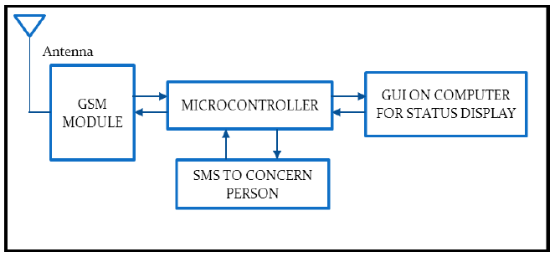

Fig :- Reception Part to GSM

At receiver, control room is present where all the activities are managing. The number of the control room is depending on the dustbins present in the area. The person sitting in the control room monitors the entire system. A GSM Module is connected to the computer of the control room through microcontroller. The entire system is monitor by the person sitting in the

control room.

**5.3 GPS MODULE :-**

SIM28ML is a stand-alone or A-GPS receiver. With built-in LNA, SIM28ML can relax antenna requirement and don’t need for external LNA. SIM28ML can track as low as -165dBm signal even without network assistance. The SIM28ML has excellent low power consumption characteristic (acquisition 16mA, tracking 15mA). SIM28ML supports various location and navigation applications, including autonomous GPS, QZSS, SBAS ranging (WAAS, EGNOS, GAGAN, MSAS), RTCM and A-GPS.

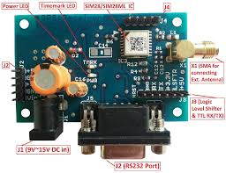

Fig: GPS Module

**KEY FEATURES :**

1. GPS receiver, supports QZSS, SBAS ranging, supports WAAS/EGNOS/MSAS/GAGAN
2. 22tracking/66 acquisition-channel, up to 210 PRN channels
3. Small footprint: 10 .1x 9.7 x 2.5mm, 18-pin LCC package
4. 12 multi-tone active interference cancellers and jamming elimination
5. Indoor and outdoor multi-path detection and compensation
6. Max NMEA update rate up to 5 HZ
7. Advanced software features
   1. EPO orbit prediction
   2. Always Locate advanced location awareness technology
   3. supports logger function
   4. supports active interference cancellation (AIC)
8. Pulse-per-second (PPS) GPS time reference
9. Adjustable duty cycle
10. typical accuracy: ±10ns
11. Interface

UART0/UART1

1. Operating temperature: -40 ~ +85ºC
2. Accuracy 2.5m CEP
3. RoHS compliant

The module provides complete signal processing from antenna input to host port in either NMEA messages. The module requires 2.8V~4.3V power supply. The host port is configurable to UART. Host data and I/O signal levels are 2.85V CMOS compatible.

#### **APPLICATION SCHEMATICS :**

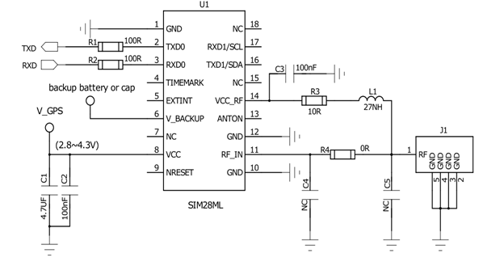

**5.4 DC MOTOR:-**

A DC motor is any of a class of rotary [electrical motors](https://en.wikipedia.org/wiki/Electrical_motor) that converts direct current electrical energy into mechanical energy. The most common types rely on the forces produced by magnetic fields. Nearly all types of DC motors have some internal mechanism, either electromechanical or electronic, to periodically change the direction of current in part of the motor.

DC motors were the first form of motor widely used, as they could be powered from existing direct-current lighting power distribution systems. A DC motor's speed can be controlled over a wide range, using either a variable supply voltage or by changing the strength of current in its field windings. Small DC motors are used in tools, toys, and appliances. The [universal motor](https://en.wikipedia.org/wiki/Universal_motor) can operate on direct current but is a lightweight [brushed](https://en.wikipedia.org/wiki/Brush_(electric)) motor used for portable power tools and appliances. Larger DC motors are currently used in propulsion of electric vehicles, elevator and hoists, and in drives for steel rolling mills.

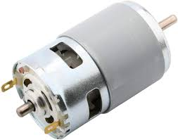

Fig: DC Motor

**WORKING PRINCIPLE:-**

An electric motor is an [electrical machine](https://www.electricaleasy.com/p/electrical-machines.html) which converts electrical energy into mechanical energy. The basic **working principle of a DC motor** is: "whenever a current carrying conductor is placed in a magnetic field, it experiences a mechanical force".

The direction of this force is given by Fleming's left-hand rule and its magnitude is given by F = BIL. Where, B = magnetic flux density, I = current and L = length of the conductor within the magnetic field.

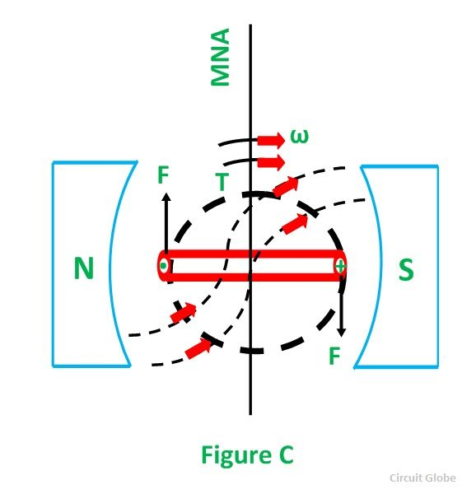

Fig: Working Principle of DC Motor

**FEATURES:**

* Runs on **DC** power or AC line voltage with a rectifier.
* Operating speeds of 1,000 to 5,000 rpm.
* 60-75% efficiency rate.
* High starting torque.
* Low no-load speeds.

**5.5 Motor Driver (L293D):-**

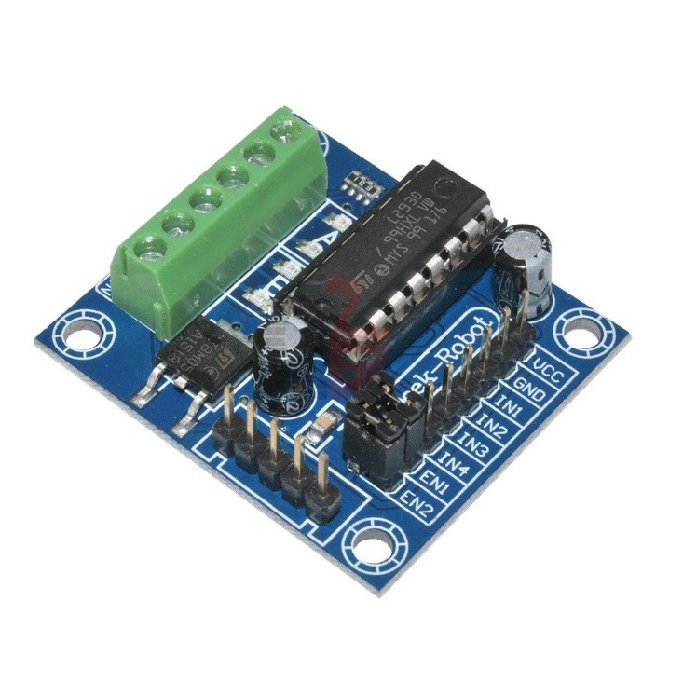

Fig: L293D Motor Driver

The L293 and L293D are quadruple high-current half-H drivers. These devices are designed to drive a wide array of inductive loads such as relays, solenoids, DC and bipolar stepping motors, as well as other high-current and high-voltage loads. All inputs are TTL compatible and tolerant up to 7 V. Each output is a complete totem-pole drive circuit, with a Darlington transistor sink and a pseudo-Darlington source. Drivers are enabled in pairs, with drivers 1 and 2 enabled by 1,2EN and drivers 3 and 4 enabled by 3,4EN. When an enable input is high, the associated drivers are enabled, and their outputs are active and in phase with their inputs. When the enable input is low, those drivers are disabled, and their outputs are off and in the high-impedance state. With the proper data inputs, each pair of drivers forms a full-H (or bridge) reversible drive suitable for solenoid or motor applications. On the L293, external high-speed output clamp diodes should be used for inductive transient suppression. On the L293D, these diodes are integrated to reduce system complexity and overall system size. A VCC1 terminal, separate from VCC2, is provided for the logic inputs to minimize device power dissipation. The L293 and L293D are characterized for operation from 0°C to 70°C.

**FUNCTIONAL BLOCK DIAGRAM :**

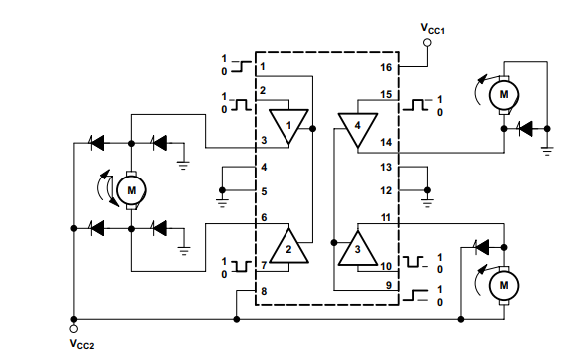

Fig : functional diagram of L293D

**KEY FEATURES :**

* Can be used to run Two DC motors with the same IC.
* Speed and Direction control is possible
* Motor voltage Vcc2 (Vs): 4.5V to 36V
* Maximum Peak motor current: 1.2A
* Maximum Continuous Motor Current: 600mA
* Supply Voltage to Vcc1(vss): 4.5V to 7V
* Transition time: 300ns (at 5Vand 24V)
* Automatic Thermal shutdown is available
* Available in 16-pin DIP, TSSOP, SOIC packages

**PIN CONFIGURATION :**

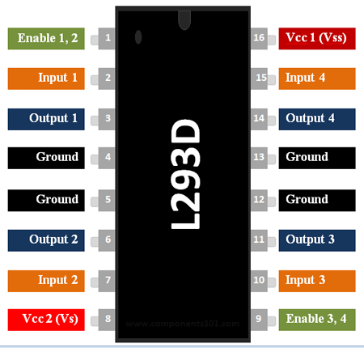

|  |  |  |
| --- | --- | --- |
| **Pin Number** | **Pin Name** | **Description** |
| 1 | Enable 1,2 | This pin enables the input pin Input 1(2) and Input 2(7) |
| 2 | Input 1 | Directly controls the Output 1 pin. Controlled by digital circuits |
| 3 | Output 1 | Connected to one end of  Motor 1 |
| 4 | Ground | Ground pins are connected to ground of circuit (0V) |
| 5 | Ground | Ground pins are connected to ground of circuit (0V) |
| 6 | Output 2 | Connected to another end of  Motor 1 |
| 7 | Input 2 | Directly controls the Output 2 pin. Controlled by digital circuits |
| 8 | Vcc2 (Vs) | Connected to Voltage pin for running motors (4.5V to 36V) |
| 9 | Enable 3,4 | This pin enables the input pin Input 3(10) and Input 4(15) |
| 10 | Input 3 | Directly controls the Output 3 pin. Controlled by digital circuits |
| 11 | Output 3 | Connected to one end of Motor 2 |
| 12 | Ground | Ground pins are connected to ground of circuit (0V) |
| 13 | Ground | Ground pins are connected to ground of circuit (0V) |
| 14 | Output 4 | Connected to another end of Motor 2 |
| 15 | Input 4 | Directly controls the Output 4 pin. Controlled by digital circuits |
| 16 | Vcc2 (Vss) | Connected to +5V to enable IC function |

**5.6 IR SENSOR :-**

An infrared (IR) sensor is an electronic device that measures and detects infrared radiation in its surrounding environment. Infrared radiation was accidentally discovered by an astronomer named William Herchel in 1800. While measuring the temperature of each color of light (separated by a prism), he noticed that the temperature just beyond the red light was highest. IR is invisible to the human eye, as its wavelength is longer than that of visible light (though it is still on the same electromagnetic spectrum). Anything that emits heat (everything that has a temperature [above around five degrees Kelvin](https://www.livescience.com/50260-infrared-radiation.html)) gives off infrared radiation.

There are two types of infrared sensors: active and passive. Active infrared sensors both emit and detect infrared radiation. Active IR sensors have two parts: a light emitting diode (LED) and a receiver. When an object comes close to the sensor, the infrared light from the LED reflects off of the object and is detected by the receiver. Active IR sensors act as [proximity sensors](https://www.fierceelectronics.com/sensors/what-a-proximity-sensor), and they are commonly used in obstacle detection systems (such as in robots).

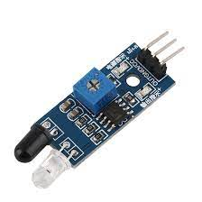

Fig: Ir Sensor

**FEATURES:**

* Operating voltage: +5V
* Practical Measuring Distance: 2cm to 20cm
* Accuracy: 3mm
* Measuring angle covered: <15°
* Operating Current: <15mA
* Operating Frequency: 40Hz

**PIN DESCRIPTION :**

|  |  |
| --- | --- |
| **Pin Name** | **Description** |
| VCC | Power Supply Input |
| GND | Power Supply Ground |
| OUT | Active High Output |

### **ULTRASONIC SENSOR WORKING:**

The IR sensor module consists mainly of the IR Transmitter and Receiver, Opamp, Variable Resistor (Trimmer pot), output LED in brief.

**IR LED Transmitter**

[IR LED](https://components101.com/ir-led-pinout-datasheet) emits light, in the range of Infrared frequency. IR light is invisible to us as its wavelength (700nm – 1mm) is much higher than the visible light range. IR LEDs have light emitting angle of approx. 20-60 degree and range of approx. few centimeters to several feets, it depends upon the type of IR transmitter and the manufacturer. Some transmitters have the range in kilometers. IR LED white or transparent in colour, so it can give out amount of maximum light.

**Photodiode Receiver**

Photodiode acts as the IR receiver as its conducts when light falls on it. Photodiode is a semiconductor which has a P-N junction, operated in Reverse Bias, means it start conducting the current in reverse direction when Light falls on it, and the amount of current flow is proportional to the amount of Light. This property makes it useful for IR detection. Photodiode looks like a LED, with a black colour coating on its outer side, Black colour absorbs the highest amount of light.

**LM358 Opamp**

[LM358](https://components101.com/ic-lm358-pinout-details-datasheet) is an Operational Amplifier (Op-Amp) is used as voltage comparator in the IR sensor. the comparator will compare the threshold voltage set using the preset (pin2) and the photodiode’s series resistor  voltage (pin3).

Photodiode’s series resistor voltage drop > Threshold voltage = Opamp output is High

Photodiode’s series resistor voltage drop < Threshold voltage = Opamp output is Low

When Opamp's output is **high** the LED at the Opamp output terminal **turns ON** (Indicating the detection of Object).

Variable Resistor

The variable resistor used here is a preset. It is used to calibrate the distance range  at which object should be detected.

**5.7 LED:-**

A light-emitting diode (LED) is a [semiconductor](https://en.wikipedia.org/wiki/Semiconductor) [light source](https://en.wikipedia.org/wiki/Light_source) that emits light when [current](https://en.wikipedia.org/wiki/Electric_current) flows through it. [Electrons](https://en.wikipedia.org/wiki/Electron) in the semiconductor recombine with [electron holes](https://en.wikipedia.org/wiki/Electron_hole), releasing energy in the form of [photons](https://en.wikipedia.org/wiki/Photon). The color of the light (corresponding to the energy of the photons) is determined by the energy required for electrons to cross the [band gap](https://en.wikipedia.org/wiki/Band_gap) of the semiconductor.[[5]](https://en.wikipedia.org/wiki/Light-emitting_diode#cite_note-5) White light is obtained by using multiple semiconductors or a layer of light-emitting phosphor on the semiconductor device.

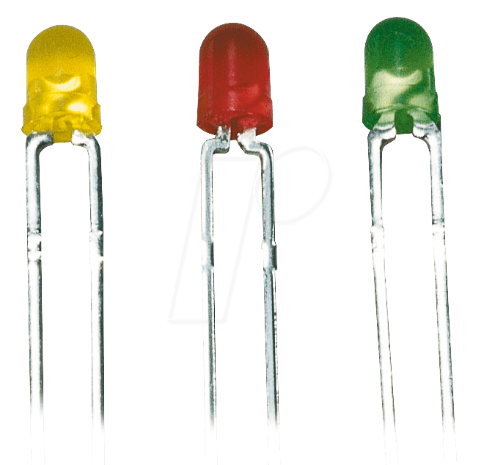

Fig: Light Emitting Diode

**WORKING PRINCIPLE:-**

A light-emitting diode is a two-lead semiconductor light source. It is a p–n junction diode that emits light when activated. When a suitable voltage is applied to the leads, electrons are able to recombine with electron holes within the device, releasing energy in the form of photons. This effect is called electroluminescence, and the colour of the light (corresponding to the energy of the photon) is determined by the energy band gap of the semiconductor.

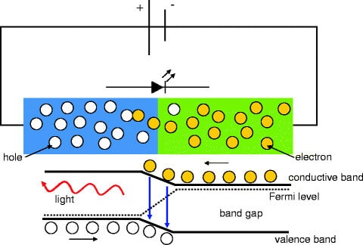

Fig: Working Principle of LED

**FEATURES:**

* **Energy Saving:-** The LEDs are extremely efficient low energy light sources.
* **Light gains:-** In 2005 the white LEDs reached outputs of over 30 lumens / Watt and coloured versions 50 lumens / Watt.
* **Long operational life:-** up to 50,000 hours.
* **Compact light source:-** no other lamp possesses such small dimensions for a comparative light output.
* **No radiation:-** the LEDs do not emit ultraviolet (UV) or infrared (IR) radiation.
* **Durable lamps:-** The LEDs are durable against impact and vibration.
* **Dimmable LEDs:-** the LEDs can be dimmed.
* **Coloured lamps:-** Coloured light can be produced effectively – over 16 million colours.

**5.8 lead Acid battery**

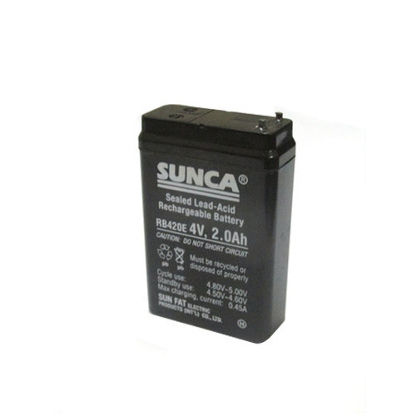

Lead acid batteries are the most commonly used type of battery in photovoltaic systems. Although lead acid batteries have a low energy density, only moderate efficiency and high maintenance requirements, they also have a long lifetime and low costs compared to other battery types. One of the singular advantages of lead acid batteries is that they are the most commonly used form of battery for most rechargeable battery applications (for example, in starting car engines), and therefore have a well-established established, mature technology base.

A lead acid battery consists of a negative electrode made of spongy or porous lead. The lead is porous to facilitate the formation and dissolution of lead. The positive electrode consists of lead oxide. Both electrodes are immersed in a electrolytic solution of sulfuric acid and water. In case the electrodes come into contact with each other through physical movement of the battery or through changes in thickness of the electrodes, an electrically insulating, but chemically permeable membrane separates the two electrodes. This membrane also prevents electrical shorting through the electrolyte. Lead acid batteries store energy by the reversible chemical reaction shown below.

The overall chemical reaction is:

PbO2+Pb+2H2SO4⇔chargedischarge2PbSO4+2H2O

At the negative terminal the charge and discharge reactions are:

Pb+SO42-⇔chargedischargePbSO4+2e-

At the positive terminal the charge and discharge reactions are:

PbO2+SO42-+4H++2e-⇔chargedischargePbSO4+2H2O

As the above equations show, discharging a battery causes the formation of lead sulfate crystals at both the negative and positive terminals, as well as the release of electrons due to the change in valence charge of the lead. The formation of this lead sulfate uses sulfate from the sulfuric acid electrolyte surrounding the battery. As a result the electrolyte becomes less concentrated. Full discharge would result in both electrodes being covered with lead sulfate and water rather than sulfuric acid surrounding the electrodes. At full discharge the two electrodes are the same material, and there is no chemical potential or voltage between the two electrodes. In practice, however, discharging stops at the cutoff voltage, long before this point. The battery should not therefore be discharged below this voltage.

In between the fully discharged and charged states, a lead acid battery will experience a gradual reduction in the voltage. Voltage level is commonly used to indicate a battery's state of charge. The dependence of the battery on the battery state of charge is shown in the figure below. If the battery is left at low states of charge for extended periods of time, large lead sulfate crystals can grow, which permanently reduces battery capacity. These larger crystals are unlike the typical porous structure of the lead electrode, and are difficult to convert back into lead.

**CHAPTER 6**

**PROGRAMMING**

**6.1 ALGORITHM:**

1. Start
2. Initialization Of Gsm Module
3. Serching For Network
4. Initialization Of Gps Module
5. Serching For Network
6. Vehical Moving & Check For Track Crack
7. If Crack Detected Then, Stop Railway & Turn On Buzzer
8. Take Location From Gps Module
9. Send Sms Alert With Location To User
10. End

**6.2 FLOW CHART:**

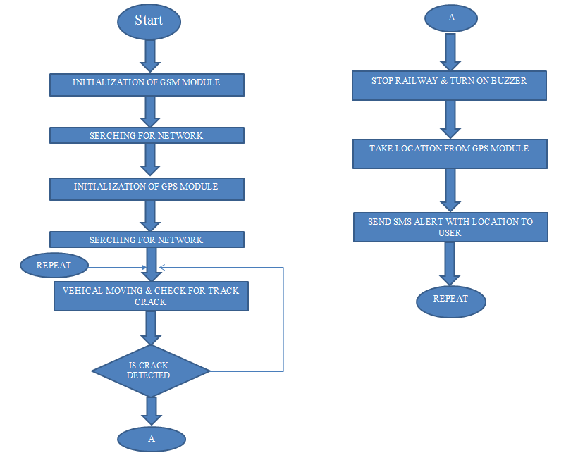

**6.3 PROGRAM:**

#include <LiquidCrystal.h>

#include <SoftwareSerial.h>

#include <TinyGPS.h>

SoftwareSerial mySerial(2, 3);

char phone_no[] = "------------"; //replace with phone no. to get sms

TinyGPS gps;

#define IR1 10

#define IR2 11

#define E1 A1

#define I11 A2

#define I12 A3

#define E2 A4

#define I21 A5

#define I22 A6

#define BUZZ A0

const int rs = 4, en = 5, d4 = 6, d5 = 7, d6 = 8, d7 = 9;

LiquidCrystal lcd(rs, en, d4, d5, d6, d7);

int IRVAL1, IRVAL2;

void setup() {

Serial.begin(9600);

pinMode(E1, OUTPUT);

pinMode(I11, OUTPUT);

pinMode(I12, OUTPUT);

pinMode(E2, OUTPUT);

pinMode(I21, OUTPUT);

pinMode(I22, OUTPUT);

pinMode(BUZZ, OUTPUT);

pinMode(IR1, INPUT);

pinMode(IR2, INPUT);

digitalWrite (BUZZ, HIGH);

delay(2000);

digitalWrite (BUZZ, LOW);

lcd.begin(16, 2);

lcd.clear();

lcd.setCursor(0, 0);

lcd.print("Railway Track");

lcd.setCursor(0, 1);

lcd.print("Crack Detection");

delay(3000);

lcd.clear();

lcd.setCursor(4, 0);

lcd.print("Using");

lcd.setCursor(0, 1);

lcd.print(" GSM & GPS ");

delay(3000);

lcd.clear();

lcd.setCursor(0, 0);

lcd.print("Gsm Initialising");

delay(3000);

lcd.clear();

lcd.setCursor(0, 0);

lcd.print("Searching For");

lcd.setCursor(4, 1);

lcd.print("Network");

delay(5000);

lcd.clear();

lcd.setCursor(0, 0);

lcd.print("Gsm Ready !!");

delay(3000);

lcd.clear();

lcd.setCursor(0, 0);

lcd.print("Gps Initialising");

delay(10000);

lcd.clear();

lcd.setCursor(0, 0);

lcd.print("Gps Ready !!");

delay(3000);

lcd.clear();

lcd.setCursor(4, 0);

lcd.print("All Ok !!");

}

void loop() {

IRVAL1 = digitalRead(IR1);

IRVAL2 = digitalRead(IR2);

if (IRVAL1 && IRVAL2 == LOW)

{

digitalWrite(BUZZ, HIGH);

analogWrite(E1, 0);

analogWrite(E2, 0);

digitalWrite(I11, LOW);

digitalWrite(I12, LOW);

digitalWrite(I21, LOW);

digitalWrite(I22, LOW);

lcd.clear();

lcd.setCursor(0, 0);

lcd.print("CRACK DETECTED");

delay(2000);

digitalWrite(BUZZ, LOW);

loc();

}

else

{

lcd.clear();

lcd.setCursor(4, 0);

lcd.print("All Ok !!");

analogWrite(E1, 100);

analogWrite(E2, 100);

digitalWrite(I11, HIGH);

digitalWrite(I12, HIGH);

digitalWrite(I21, HIGH);

digitalWrite(I22, HIGH);

}

}

void loc()

{

lcd.clear();

lcd.setCursor(0, 0);

lcd.print("Sending SMS !!");

bool newData = false;

unsigned long chars;

unsigned short sentences, failed;

// For one second we parse GPS data and report some key values

for (unsigned long start = millis(); millis() - start < 1000;)

{

while (Serial.available())

{

char c = Serial.read();

Serial.print(c);

if (gps.encode(c))

newData = true;

}

}

if (newData) //If newData is true

{

float flat, flon;

unsigned long age;

gps.f_get_position(&flat, &flon, &age);

mySerial.print("AT+CMGF=1\r");

delay(400);

mySerial.print("AT+CMGS=\"");

mySerial.print(phone_no);

mySerial.println("\"");

delay(300);

mySerial.println("CRACK DETECTED !!");// The SMS text you want to send

delay(100);

mySerial.println("TAKE ACTION");// The SMS text you want to send

delay(100);

mySerial.print("http://www.google.com/maps/?q=");

mySerial.print(flat, 6);

mySerial.print(",");

mySerial.print(flon, 6);

delay(200);

mySerial.println((char)26); // End AT command with a ^Z, ASCII code 26

delay(200);

lcd.clear();

lcd.setCursor(0, 0);

lcd.print("SMS Sent !!");

delay(3000);

}

}

**CHAPTER 7**

**RESULT, CONCLUSION AND FUTURE SCOPE**

**7.1 RESULT:**

The growth in science & technology is a non-stop process. New things and new technology are being invented. As the technology grows day by day, we can imagine about the future in which thing we may occupy every place. The proposed system based on Arduino microcontroller is found to be more compact, user friendly and less composite which can readily be used in order to perform several monotonous and repetitive tasks. However it is designed keeping in mind about the need for industry, it can extended for other purposes such as commercial & research applications. The principle of the development of science is that “nothing is impossible”. [3]This project relates to a process for monitoring the condition of train tracks and more specifically has the object identification of defects detected by monitoring equipment on the tracks to be checked and to allow maintenance crews to subsequently find these defects. This project presents the implementation results of the railway track crack control system using simple components inclusive of a GPRS modem and IR based crack detector assembly. This is cost effective railway track crack detection system with greater accuracy and High speed information transferring after crack detection

**7.2 FEATURES:**

1. Request to send location.
2. Automatic send SMS.
3. Automatic Crack Detection

**7.3 LIMITATIONS:**

1. It reduces man power requirements which results into increase in unemployment's for unskilled people.
2. The training has to be provided to the people involved
3. GSM and others sensors are costly.

**7.4 APPLICATIONS:**

1. Automatic Crack Checking
2. Wireless Application

**7.5 CONCLUSION:**

In this work, the crack on the track, face to face collision and de-railment, all these occurrences are sensed automatically and accidents are prevented, here testing has been carried out by established models and simulation has been done by Arduino ide. The both face to face collision and crack on track are detected 4-5km before by the continuous monitoring of ultrasonic metal detecting sensors which are fixed at the engines, and once detected the train automatically applies brake to stop and even pantographs could be disengaged. But, the de-railment could be controlled by detecting not presences of next compartment. Then an alert is given to driver and automatic emergency brake control is applied. If this system isbrought in railways, the accidents could be controlled and the place of damage could be sent automatically to control room and since its completely automated system this can be used in village areas by which man power is reduced and time is saved.

* 1. **FUTURE SCOPE:**

In the future, the proposed system will also be connected to networking & communication device. So, if any fault is detected the system will automatically broadcast the location and type of fault to every train coming on that route. If the broadcast is done, then the other trains can be diverted or blocked off (Stopped) to avoid any inconvenience. Along with it, the system will conjointly use deflectors, so that if there's any high curvature track then the deflectors can transmit the waves in keeping with the curve.

**CHAPTER 8**

**REFERENCES**

**8.1 BOOKS:**

1. Arduino programming by ryan turner
2. Introduction to Arduino by Christina bagain

**8.2 WEBSITES:**

1. <https://www.arduino.cc/>
2. <https://www.arrow.com/en/research-and-events/articles/ultrasonic-sensors-how-they-work-and-how-to-use-them-with-arduino>
3. <https://mechatrofice.com/arduino/send-gps-location-via-sms>

**CHAPTER 9**

**APPENDIX**

**LIST OF COMPONENT WITH PRICE:**

|  |  |  |  |  |  |
| --- | --- | --- | --- | --- | --- |
| **SR. NO.** | **COMPONENT** | **SPECIFICATION** | **UNIT PRIZE** | **QUANTITY** | **COST** |
| 1 | Arduino Uno | ATMEGA328P | 350 | 1 | 350 |
| 2 | GPS Module | SIM28ML | 475 | 1 | 475 |
| 3 | GSM Module | SIM800L | 550 | 1 | 550 |
| 4 | IR SENSOR | - | 50 | 2 | 100 |
| 5 | Battery | Lead acid | 100 | 3 | 300 |
| 6 | Transformer | Step down (12-0-12) | 120 | 1 | 120 |
| 7 | DC Motor | Voltage: DC 3V-6V  Current: 100mA-120mA | 170 | 2 | 340 |
| 8 | Motor Driver | L293D | 45 | 1 | 45 |
| 9 | Voltage Regulator | 7812/7805 | 10 | 2 | 20 |
| 10 | Capacitor | 1000uF/25v | 3 | 1 | 3 |
| 11 | Resistors | 220Ω | 1 | 5 | 5 |
| 12 | Diode | 1N4007 | 3 | 5 | 15 |
| 13 | Switch | - | 10 | 1 | 10 |
| 14 | LED | 3.3V/20mA | 3 | 5 | 15 |
| 15 | Connector | - | 10 | 3 | 30 |
| 16 | Connecting Wires | Male To Male  Female To Male  Female To Female | 3  3  3 | 25  25  25 | 225 |
| 17 | Header Strips | Male/female | 10 | 2 | 20 |
| 18 | LCD | 16*2 | 150 | 1 | 150 |