Freezer Monitoring
Project: Freezer Monitoring and Logging Dashboard for OpenELIS Global
Version: 1.0
Date: 8/20/2025
Table of Contents
1. Introduction 1
1.1 Purpose 1
1.2 Scope 1
2. Functional Requirements 1
3. Non-Functional Requirements 2
4. Compliance Considerations & Requirements 2
5. Compliance Mapping Matrix 2
6. System Architecture Diagram 3
Appendix A: Modbus Protocol Details 3
Modbus RTU Documentation 3
Modbus TCP Documentation 4
6. System Architecture Diagram (Graphical) 4
CLIA Reporting requirements: 5
1. Introduction 5
2. Report Requirements 5
2.1 Identification Information 5
2.2 Temperature Monitoring Data 5
2.3 Excursion Documentation 5
2.4 Calibration & Validation 5
2.5 Audit Trail 6
2.6 Retention & Accessibility 6
2.7 Report Formats 6
3. CLIA Compliance Emphasis 6
WHO Reporting requirements 6
1. Introduction 7
2. Report Requirements 7
2.1 Identification Information 7
2.2 Temperature Monitoring Data 7
2.3 Excursion Documentation 7
2.4 Calibration & Validation 7
2.5 Audit Trail 7
2.6 Retention & Accessibility 8
2.7 Report Formats 8
3. WHO Compliance Emphasis 8

1. Introduction

1.1 Purpose
This document specifies the functional requirements for integrating a freezer monitoring and logging system into OpenELIS Global. The system will ensure compliance with regulatory standards (CAP, CLIA, FDA, WHO) while providing real-time monitoring, alarm notifications, and reporting capabilities for laboratory freezers.

1.2 Scope
- Monitor temperature and environmental conditions of freezers in medical labs.
- Provide real-time and historical dashboards.
- Generate alerts (visual alarms, SMS, email notifications) for excursions.
- Produce regulatory-compliant reports.
- Support industry-standard protocols (Modbus TCP and RTU).

2. Functional Requirements
- FR-1: System shall support integration with temperature sensors using Modbus and BACnet protocols.
- FR-2: System shall poll sensor data at configurable intervals (default: every 60 seconds).
- FR-3: System shall validate data integrity and log transmission errors.
- FR-4: Dashboard shall display current freezer temperatures with status indicators (Normal, Warning, Critical).
- FR-5: Dashboard shall allow filtering by freezer, location, or time period.
- FR-6: Dashboard shall visualize historical trends (graphs, charts) with zoom and export options.
- FR-7: Dashboard shall support multiple user roles (admin, lab staff, auditor).
- FR-8: System shall trigger alerts when temperature excursions occur beyond configured thresholds.
- FR-9: Alerts shall be available as on-screen visual alarms, email notifications, and SMS text messages.
- FR-10: Alerts shall include details: freezer ID, location, current temperature, excursion duration.
- FR-11: System shall support configurable escalation rules (e.g., notify supervisor if unresolved for 15 minutes).
- FR-12: All sensor readings shall be stored in a secure database with timestamp and freezer ID.
- FR-13: System shall maintain a complete audit trail of alerts, acknowledgments, and corrective actions.
- FR-14: Data retention shall be configurable (minimum 2 years).
- FR-15: System shall generate regulatory reports compliant with CAP, CLIA, FDA, and WHO.
- FR-16: Reports shall include daily/weekly/monthly logs, excursion history, and audit trails.
- FR-17: Reports shall be exportable in PDF, CSV, and XML formats.
- FR-18: User authentication shall be role-based with secure login.
- FR-19: Only authorized users shall configure thresholds, alerts, and reporting schedules.
- FR-20: System shall comply with HIPAA and relevant data protection policies.

3. Non-Functional Requirements
- Performance: Support up to 500 freezers, update within 5 seconds of sensor data.
- Reliability: 99.9% uptime, auto-restart after failures.
- Usability: Accessible via web and mobile, minimal configuration for reports.
- Scalability: Support additional sensors and sites without redesign.

4. Compliance Considerations & Requirements
- CAP: System shall continuously monitor and document temperature excursions. Reports shall align with CAP accreditation requirements for laboratory equipment monitoring.
- CLIA: System shall ensure quality control of laboratory freezers, with secure data logging and validation of temperature monitoring.
- FDA: System shall comply with 21 CFR Part 11, ensuring secure electronic records, electronic signatures, and audit trails for freezer monitoring data.
- WHO: System shall meet WHO laboratory guidelines for freezer monitoring, excursion reporting, and global health compliance requirements.

5. Compliance Mapping Matrix
Standard | Requirement ID(s) | Description
CAP | FR-12, FR-13, FR-15, FR-16 | Continuous monitoring, excursion documentation, and reporting for CAP compliance.
CLIA | FR-12, FR-14, FR-15 | Ensures quality control of laboratory equipment, secure data logging, and validation of freezer monitoring.
FDA | FR-13, FR-15, FR-20 | Compliance with 21 CFR Part 11, including secure electronic records, electronic signatures, and audit trails.
WHO | FR-15, FR-16 | Global laboratory compliance with WHO freezer monitoring and excursion reporting standards.

6. System Architecture Diagram
The following diagram illustrates the high-level system architecture for freezer monitoring integration with OpenELIS Global.
[Sensors: Freezer Temp Probes (Modbus/BACnet)] → [Data Acquisition Middleware] → [OpenELIS Application Layer: Dashboard, Alerts, Reports] → [Notification Services: Email/SMS/Visual Alarms] → [Database: Secure Logging & Audit Trails]

Appendix A: Modbus Protocol Details
Modbus is a serial communications protocol commonly used for industrial control systems. In the freezer monitoring system:
- Communication Standard: Modbus RTU/TCP
- Data Model: Registers (Input, Holding), Coils (Discrete Inputs/Outputs)
- Temperature sensors will map readings into Holding Registers (16-bit values).
- Polling frequency and device addresses configurable per sensor.
- CRC (Cyclic Redundancy Check) ensures data integrity.

Modbus RTU Documentation
- MODBUS over Serial Line Specification & Implementation Guide (V1.0) — This guide covers the Modbus protocol over serial lines (e.g., RS-485, RS-232), including RTU framing, low-level details, timing, addressing, and error checking for Modbus RTU.modbus.org+15modbus.org+15Dräger+15
- MODBUS Application Protocol Specification (v1.1b) — This is the core application-layer specification that defines function codes, data models, framing, PDU/ADU structure, and error handling—applicable to RTU (serial) environments.modbus.org+4modbus.org+4Wikipedia+4

Modbus TCP Documentation
- MODBUS Messaging on TCP/IP Implementation Guide (V1.0b) — This guide details how Modbus messaging is encapsulated within TCP/IP, describing client/server models, the Modbus Application Protocol (MBAP) header, and transaction formats over Ethernet.mks.com+5modbus.org+5Wikipedia+5
- Modbus/TCP Specification Overview — Provided by third-party sources, it offers a clear explanation of how Modbus messages are carried over TCP/IP networks for industrial automation use cases.wingpath.co.uk+2dankohn.info+2

6. System Architecture Diagram (Graphical)
The diagram below illustrates the high-level system architecture for freezer monitoring integration with OpenELIS Global.
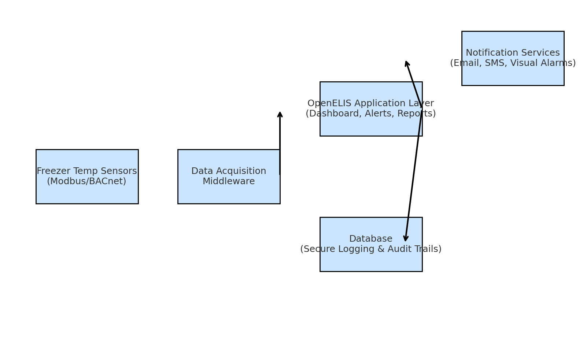

CLIA Reporting requirements:

CLIA Freezer Temperature Data Report Requirements

1. Introduction
This document specifies the detailed requirements for freezer temperature data regulatory reports in compliance with CLIA (Clinical Laboratory Improvement Amendments). The purpose is to guide software developers in designing and implementing a reporting feature that meets regulatory expectations.

2. Report Requirements

2.1 Identification Information
- Freezer/refrigerator unique ID or serial number.
- Physical location (lab section, facility, room number).
- Device/sensor identifier (if applicable).
- Responsible personnel (technician, owner of record).

2.2 Temperature Monitoring Data
- Continuous or periodic logged temperature values.
- Unit of measurement (Celsius or Fahrenheit, consistent).
- Time-stamped record for each measurement.
- Minimum and maximum recorded temperatures for the reporting period.
- Excursions (out-of-range events) with precise temperature, start time, and end time.

2.3 Excursion Documentation
- Duration of each excursion.
- Corrective actions taken (e.g., moved samples, adjusted equipment, repaired freezer).
- Personnel acknowledgment/signature (electronic or manual).
- Escalation record if excursion not resolved within SOP-defined timeframe.

2.4 Calibration & Validation
- Documentation of calibration and validation of thermometers and sensors at required intervals.
- Calibration certifications traceable to NIST or equivalent standard.
- Next due date for calibration clearly indicated.

2.5 Audit Trail
- Complete log of manual entries, edits, acknowledgments.
- Electronic signatures or initials of staff reviewing logs.
- Audit trail must be secure and tamper-evident (align with 21 CFR Part 11 for electronic records).

2.6 Retention & Accessibility
- Reports must be retained for a minimum of 2 years, or longer if required by state/local laws.
- Reports must be easily retrievable for inspection by CLIA surveyors.
- System must support searching and filtering by date range, freezer ID, or location.

2.7 Report Formats
- Daily, weekly, and monthly summary logs of freezer temperatures.
- Exception reports highlighting excursions and corrective actions.
- Reports must be exportable in PDF and CSV formats.
- Reports must be human-readable and printable.

3. CLIA Compliance Emphasis
The following compliance checks must be addressed in the software design:
- Evidence of continuous monitoring for all freezers storing patient specimens.
- Verification that excursions are reviewed, acknowledged, and resolved by qualified personnel.
- Documentation of corrective actions linked to specific excursions.
- Traceable calibration and validation records for all monitoring devices.
- Secure audit trail that demonstrates accountability and data integrity.

WHO Reporting requirements

WHO Freezer Temperature Data Report Requirements

1. Introduction
This document specifies the detailed requirements for freezer temperature data regulatory reports in compliance with WHO (World Health Organization) laboratory quality and biosafety standards. The purpose is to guide software developers in designing and implementing a reporting feature that meets international expectations for laboratories handling biological specimens, vaccines, and pharmaceuticals.

2. Report Requirements

2.1 Identification Information
- Freezer/refrigerator unique ID or serial number.
- Laboratory/facility name and global site code (if applicable).
- Physical location (building, room number, lab section).
- Device/sensor identifier (if applicable).
- Responsible personnel (technician, custodian of record).

2.2 Temperature Monitoring Data
- Continuous or periodic logged temperature values.
- Unit of measurement (Celsius required per WHO).
- Time-stamped record for each measurement.
- Minimum and maximum recorded temperatures for the reporting period.
- Excursions (out-of-range events) with precise temperature, start time, and end time.

2.3 Excursion Documentation
- Duration of each excursion and threshold breached.
- Impact assessment on biological samples, vaccines, or pharmaceuticals.
- Corrective actions taken (e.g., moved samples, backup storage used, maintenance performed).
- Personnel acknowledgment/signature (electronic or manual).
- Escalation record including notification to lab supervisors or national health authorities if required.

2.4 Calibration & Validation
- Calibration records of thermometers and monitoring devices.
- Certification traceable to international or national metrology standards (e.g., NIST, ISO/IEC 17025).
- Date of last calibration and next scheduled calibration.
- Validation checks for monitoring system accuracy.

2.5 Audit Trail
- Complete log of manual entries, edits, acknowledgments.
- Electronic signatures or initials of staff reviewing logs.
- Audit trail must be secure and tamper-evident (aligned with WHO biosafety and data integrity guidelines).

2.6 Retention & Accessibility
- Reports must be retained for a minimum of 5 years to meet WHO expectations for international program support.
- Reports must be retrievable during WHO audits or site inspections.
- System must support multi-site reporting for global laboratory networks.

2.7 Report Formats
- Daily, weekly, and monthly summary logs of freezer temperatures.
- Exception reports with excursions, impact assessment, and corrective actions.
- Reports must be exportable in PDF, CSV, and XML formats.
- Reports must be human-readable, printable, and translatable for international review.

3. WHO Compliance Emphasis
The following compliance checks must be addressed in the software design:
- Evidence of continuous monitoring for all freezers storing vaccines, biological samples, or pharmaceuticals.
- Verification that excursions are assessed for impact on patient safety or research integrity.
- Documentation of corrective actions and escalation to health authorities where required.
- Calibration and validation records traceable to international standards.
- Secure and globally auditable audit trail to ensure transparency and trust in data integrity.

