Tutorial 05B Run Report
Concrete Sparsity Exploration
Direct Word report for students who do not use LaTeX
CE 488/5588 — Applied Artificial Intelligence

Run Summary
- Script executed: python3 concrete-EDA.py
- Captured stdout: concrete-EDA-run-ascii.txt
- Generated figures: age distribution, strength histogram, correlation plot, growth curve example

Key Results
- 1,030 cleaned rows, 11 columns
- 14 unique curing ages; 28 days dominates at 41.3%
- 427 unique mixture designs
- 992 unique mixture-age combinations; sparsity ratio 96.3%
- Strongest positive correlation with strength: Cement (+0.498)
- Strongest negative correlation with strength: Water (-0.290)
- No missing values after cleaning; 4 IQR outliers in strength

Figures
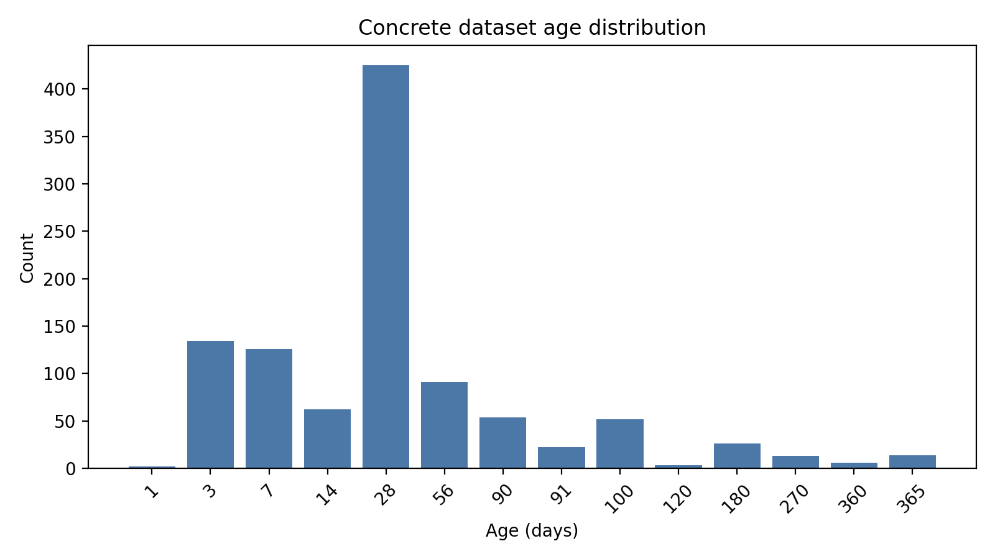
Figure 1. Age distribution in the concrete dataset.
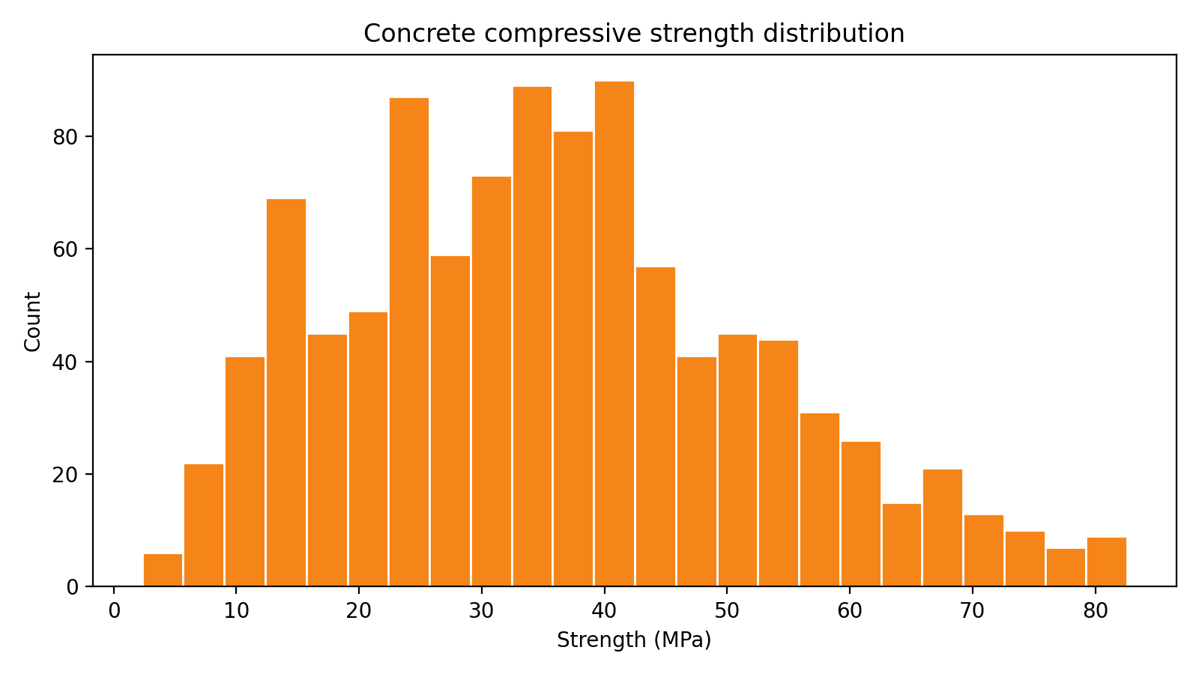
Figure 2. Strength distribution.
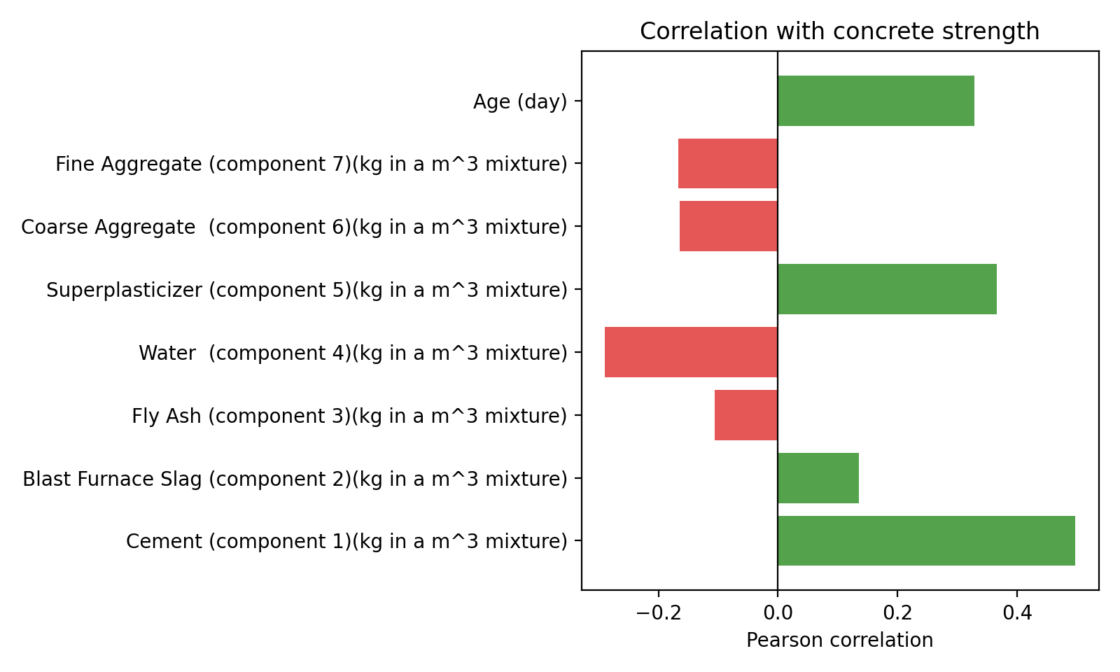
Figure 3. Correlation with concrete strength.
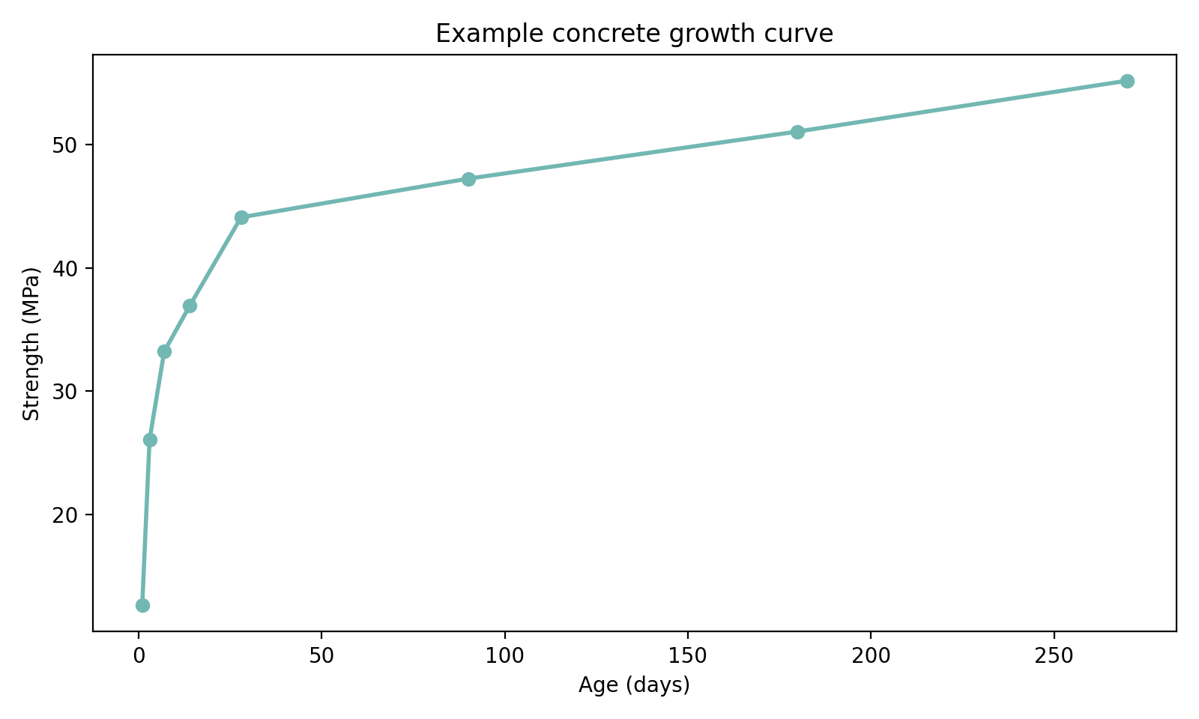
Figure 4. Example growth curve for the mixture with the most age measurements.

Recorded Console Output
============================================================
CONCRETE COMPRESSIVE STRENGTH - SPARSITY EXPLORATION
============================================================

Data file: /Users/chenzhiq/MyProjects/CoursesDev/AppliedAI4Engineering/Tutorials/UCI-Concrete Data/Concrete_Data_CSV.csv
Using encoding: utf-8-sig (handles BOM)
After cleaning: 1030 rows

============================================================
1. BASIC DATASET INFO
============================================================
Rows: 1030
Columns (11):
1. Cement (component 1)(kg in a m^3 mixture)
2. Blast Furnace Slag (component 2)(kg in a m^3 mixture)
3. Fly Ash (component 3)(kg in a m^3 mixture)
4. Water (component 4)(kg in a m^3 mixture)
5. Superplasticizer (component 5)(kg in a m^3 mixture)
6. Coarse Aggregate (component 6)(kg in a m^3 mixture)
7. Fine Aggregate (component 7)(kg in a m^3 mixture)
8. Age (day)
9. Concrete compressive strength(MPa, megapascals)
10. f'c at 28 day
11. NSC

Data types:
Cement (component 1)(kg in a m^3 mixture) float64
Blast Furnace Slag (component 2)(kg in a m^3 mixture) float64
Fly Ash (component 3)(kg in a m^3 mixture) float64
Water (component 4)(kg in a m^3 mixture) float64
Superplasticizer (component 5)(kg in a m^3 mixture) float64
Coarse Aggregate (component 6)(kg in a m^3 mixture) float64
Fine Aggregate (component 7)(kg in a m^3 mixture) float64
Age (day) float64
Concrete compressive strength(MPa, megapascals) float64
f'c at 28 day float64
NSC int64

============================================================
2. BASIC STATISTICS (Numeric Columns)
============================================================
Cement (component 1)(kg in a m^3 mixture) Blast Furnace Slag (component 2)(kg in a m^3 mixture) Fly Ash (component 3)(kg in a m^3 mixture) Water (component 4)(kg in a m^3 mixture) Superplasticizer (component 5)(kg in a m^3 mixture) Coarse Aggregate (component 6)(kg in a m^3 mixture) Fine Aggregate (component 7)(kg in a m^3 mixture) Age (day) Concrete compressive strength(MPa, megapascals)
count 1030.00 1030.00 1030.00 1030.00 1030.00 1030.00 1030.00 1030.00 1030.00
mean 281.17 73.90 54.19 181.57 6.20 972.92 773.58 45.66 35.82
std 104.51 86.28 64.00 21.35 5.97 77.75 80.18 63.17 16.71
min 102.00 0.00 0.00 121.80 0.00 801.00 594.00 1.00 2.33
25% 192.38 0.00 0.00 164.90 0.00 932.00 730.95 7.00 23.71
50% 272.90 22.00 0.00 185.00 6.40 968.00 779.50 28.00 34.44
75% 350.00 142.95 118.30 192.00 10.20 1029.40 824.00 56.00 46.14
max 540.00 359.40 200.10 247.00 32.20 1145.00 992.60 365.00 82.60

============================================================
3. AGE DISTRIBUTION
============================================================
Total rows: 1030
Unique ages: 14
Age (days) Count % Bar
--------------------------------------------------
1.0 2 0.2%
3.0 134 13.0% ######
7.0 126 12.2% ######
14.0 62 6.0% ###
28.0 425 41.3% ####################
56.0 91 8.8% ####
90.0 54 5.2% ##
91.0 22 2.1% #
100.0 52 5.0% ##
120.0 3 0.3%
180.0 26 2.5% #
270.0 13 1.3%
360.0 6 0.6%
365.0 14 1.4%

============================================================
4. UNIQUE MIXTURE DESIGNS
============================================================
Total rows: 1030
Unique mixtures: 427
Avg rows per mixture: 2.41
Max rows per mixture: 20

Zero-inflated components (fraction of zeros):
Cement (component 1)(kg in a m^3 mixture) 0.0%
Blast Furnace Slag (component 2)(kg in a m^3 mixture) 45.7%
Fly Ash (component 3)(kg in a m^3 mixture) 55.0%
Water (component 4)(kg in a m^3 mixture) 0.0%
Superplasticizer (component 5)(kg in a m^3 mixture) 36.8%
Coarse Aggregate (component 6)(kg in a m^3 mixture) 0.0%
Fine Aggregate (component 7)(kg in a m^3 mixture) 0.0%

============================================================
5. GROWTH CURVE DATA
============================================================
Mixtures with 1 age: 246 (57.6%)
Mixtures with 2+ ages: 181 (42.4%)
Total growth curve rows: 784

Top 5 mixtures by number of age measurements:
Ages: [np.float64(1.0), np.float64(3.0), np.float64(7.0), np.float64(14.0), np.float64(28.0), np.float64(90.0), np.float64(180.0), np.float64(270.0)] Strengths: [12.64, 26.06, 33.21, 36.94, 44.09, 47.22, 51.04, 55.16]
Ages: [np.float64(3.0), np.float64(7.0), np.float64(14.0), np.float64(28.0), np.float64(90.0), np.float64(180.0), np.float64(365.0)] Strengths: [13.22, 20.97, 27.04, 32.04, 35.17, 36.45, 38.89]
Ages: [np.float64(3.0), np.float64(7.0), np.float64(14.0), np.float64(28.0), np.float64(90.0), np.float64(180.0), np.float64(270.0)] Strengths: [33.8, 42.42, 48.4, 55.94, 58.78, 61.92, 67.11]
Ages: [np.float64(3.0), np.float64(7.0), np.float64(14.0), np.float64(28.0), np.float64(90.0), np.float64(180.0), np.float64(270.0)] Strengths: [41.64, 52.61, 59.76, 67.31, 69.66, 71.62, 74.17]
Ages: [np.float64(3.0), np.float64(7.0), np.float64(28.0), np.float64(90.0), np.float64(180.0), np.float64(360.0)] Strengths: [8.06, 14.59, 28.24, 39.36, 44.21, 44.7]

============================================================
6. SPARSITY ANALYSIS
============================================================
Total rows: 1030
Unique mixture-age combos: 992
Sparsity ratio: 96.3%
Interpretation: 3.7% of data points are unique observations

Combos with 1 observation: 973
Combos with 2 observations: 5
Combos with 3+ observations: 14
Max observations per combo: 4

============================================================
7. CORRELATION MATRIX (with Strength)
============================================================

Feature Correlation
---------------------------------------------
Cement (component 1)(kg in a m^3 mixture) 0.498
Blast Furnace Slag (component 2)(kg in a m^3 mixture) 0.135
Fly Ash (component 3)(kg in a m^3 mixture) -0.106
Water (component 4)(kg in a m^3 mixture) -0.290
Superplasticizer (component 5)(kg in a m^3 mixture) 0.366
Coarse Aggregate (component 6)(kg in a m^3 mixture) -0.165
Fine Aggregate (component 7)(kg in a m^3 mixture) -0.167
Age (day) 0.329

Strongest positive: Cement (0.498)
Strongest negative: Water (-0.290)

============================================================
8. OUTLIER DETECTION (IQR Method)
============================================================
Q1: 23.71, Q3: 46.14, IQR: 22.43
Lower bound: -9.93, Upper bound: 79.77

Number of outliers: 4

Strength Age Cement
82.60 91 389.9
81.75 28 315.0
80.20 56 323.7
79.99 28 540.0

Strength distribution:
Min: 2.33 MPa
Max: 82.60 MPa
Mean: 35.82 MPa
Median:34.45 MPa
70th percentile: 43.29 MPa (70% of data below this)

============================================================
9. MISSING VALUES
============================================================
No missing values detected.

============================================================
10. DATA IMBALANCE SUMMARY
============================================================
Bin Count %
---------------------------------------------
Early (1-7 days) 262 25.4%
Standard (8-28 days) 487 47.3%
Medium (29-90 days) 145 14.1%
Long (91-180 days) 103 10.0%
Very Long (181-365 days) 33 3.2%

Key insight: Most data is concentrated at 28 days (~41%).
This means models may overfit to the 28-day regime and
perform poorly on other curing times.

============================================================
EXPLORATION COMPLETE
============================================================
Note: This report is generated directly as a Word document, without LaTeX.

