**Experiment no- 11**

**Objective:-** To implement the Apriori algorithm for discovering frequent itemsets and generating association rules from transactional data using R.

**Apriori Algorithm**

The **Apriori algorithm** is a classic algorithm in data mining used for **association rule learning** over transactional databases. It identifies **frequent itemsets** (groups of items frequently bought together) and derives **association rules** that highlight relationships between items.

**Key Concepts:**

* **Itemset:** A group of one or more items.
* **Support:** The proportion of transactions containing the itemset.
* **Confidence:** The likelihood that the RHS item(s) are purchased when the LHS item(s) are purchased.
* **Lift:** A measure of how much more likely RHS is given LHS, compared to random chance.

### ****Steps of the Apriori Algorithm:****

1. **Set minimum support and confidence thresholds.**
2. **Generate all candidate itemsets** of size 1.
3. **Iteratively expand** the itemsets:

* Generate size k itemsets from size k-1 frequent itemsets.
* Prune itemsets with support less than the threshold.

1. **Generate rules** from the frequent itemsets that meet the confidence threshold.
2. **Evaluate rules** using support, confidence, and lift.

**Example-1**

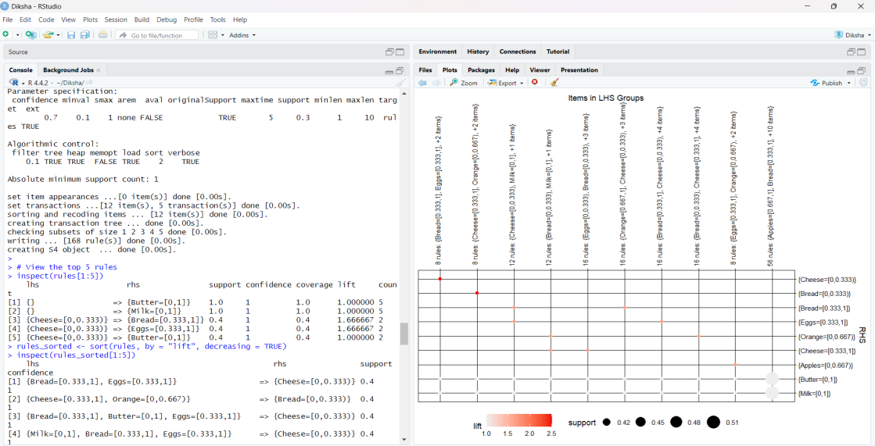

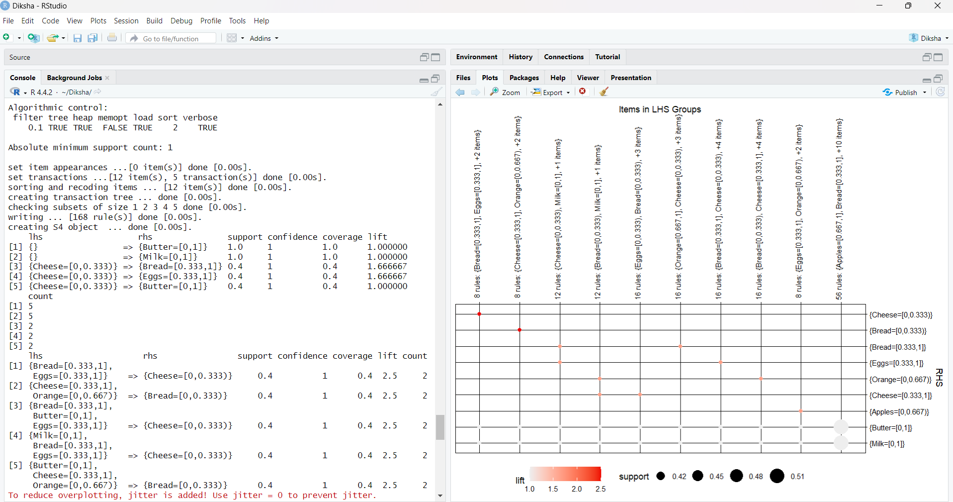

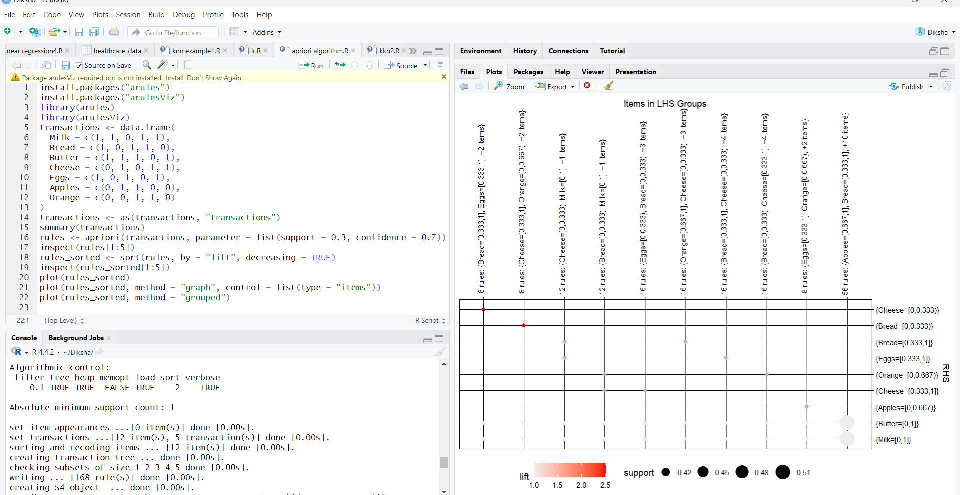

**Example-2**

