Online Bus Ticket Booking System – Project Report

# 1. Problem Statement

Travelers often face issues while booking bus tickets due to outdated systems, manual errors, lack of real-time seat availability, or pricing transparency. Additionally, operators struggle to manage bookings, routes, buses, and availability in one place.  
  
This project offers a comprehensive and centralized web-based solution that enables users to search for buses, view availability, and book seats with seat-type selection (Seater/Sleeper). Admins can manage buses, prices, and bookings easily through a responsive dashboard.  
  
Built using Spring Boot and MongoDB, the system ensures reliability, modularity, and security. It helps streamline the bus booking experience for both users and transport operators.

# 2. Introduction

The Online Bus Booking System is a full-stack application allowing users to book bus tickets online while giving the admin complete control over bus listings, bookings, and seat configurations.  
  
The system supports:  
- User registration & login  
- Bus search based on source/destination and date  
- Dynamic seat layout display  
- Seater/Sleeper classification with pricing  
- Admin panel for managing buses and bookings  
  
Its goal is to replace traditional, error-prone manual systems with a smart, automated, and modern interface.

# 3. Technology Stack

# 4. API Endpoints Overview

|  |  |  |
| --- | --- | --- |
| Method | Endpoint | Description |
| POST | /api/login | Authenticates user and returns JWT token |
| GET | /api/buses/search | Returns buses matching search criteria (from, to, date) |
| POST | /api/book | Books seats for a user based on selected seat type |
| GET | /api/booked-seats/{busId} | Returns booked seats for a specific bus and date |
| POST | /api/admin/add-bus | Adds a new bus (admin only) |
| PUT | /api/admin/edit-bus/{id} | Edits existing bus details |
| DELETE | /api/admin/delete-bus/{id} | Deletes a bus |
| GET | /api/bookings/user/{userId} | Fetches bookings made by a user |
| GET | /api/bookings/all | Displays all bookings (admin view) |

# 5. Output Screenshots (GUI Overview)

1. Landing Page (/): Introduction to the platform and links to login/register  
2. Login Page (/login): Secure form for user login  
3. Register Page (/register): Sign up interface for users  
4. Bus Search Page (/search): Shows available buses based on input data  
5. Bus Details Page (/bus_details): Displays seat layout dynamically based on seat type and date  
6. Booking History: List of past bookings with full details  
7. Admin Dashboard (/admin_dashboard): Allows bus and booking management

# 6. Key Features

- 🪑 Dynamic Seat Layouts: Updates seat layout based on travel date and type  
- 💳 Seat-Type Pricing: Admin sets different prices for Seater/Sleeper  
- 📅 Date-Specific Bookings: Seat availability linked to travel date  
- 🧑‍💼 Admin Panel: Powerful control interface for transport operators  
- 📄 PDF Tickets: Generate downloadable ticket with journey details (optional future enhancement)

# 7. Conclusion & Future Scope

Modern Booking Platform:  
- Automates and digitizes the bus reservation process  
- Provides real-time updates for seat availability  
  
Built on Reliable Technology:  
- Spring Boot and MongoDB for performance and flexibility  
  
Planned Enhancements:  
- ✅ Passenger PDF ticket downloads  
- ✅ Razorpay/Cashfree integration for payments  
- ✅ Role-based access for Agents and Operators  
- ✅ SMS/email notifications for confirmed bookings  
- ✅ Advanced admin analytics dashboard

Login Page:

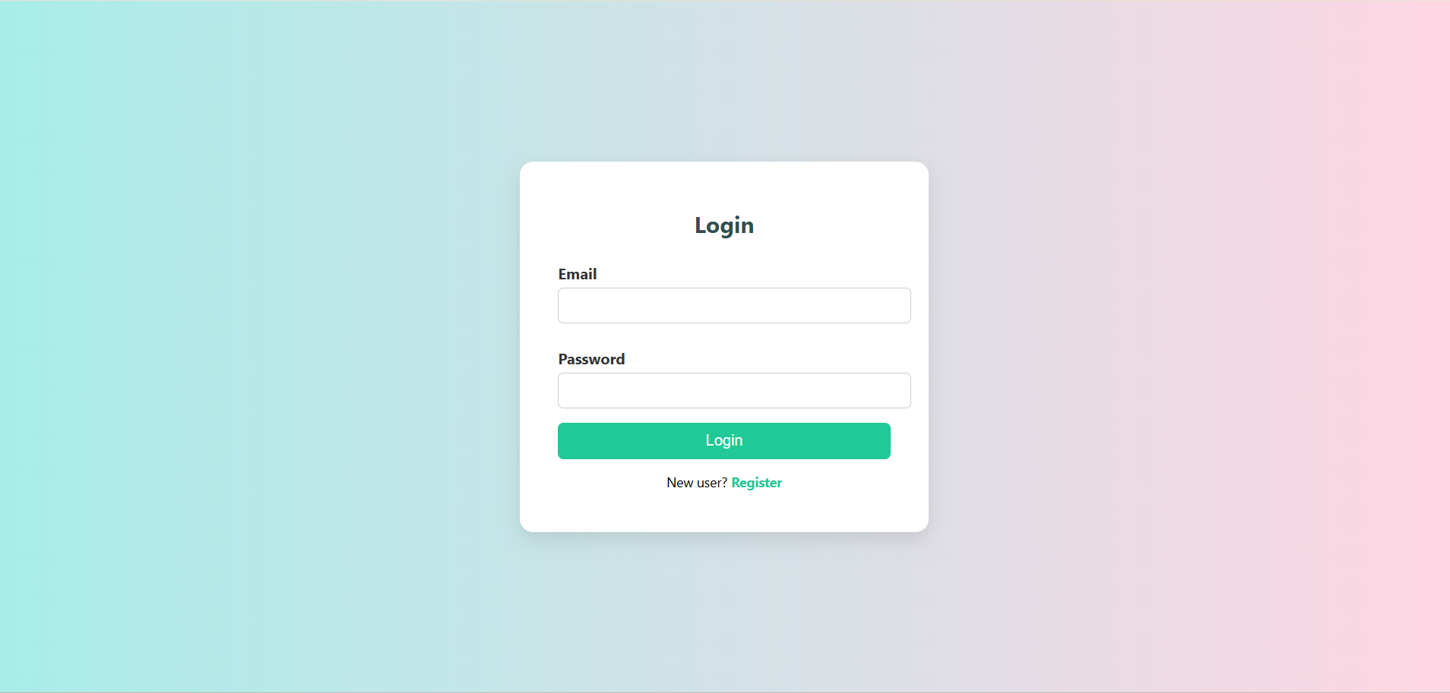

Register Page:

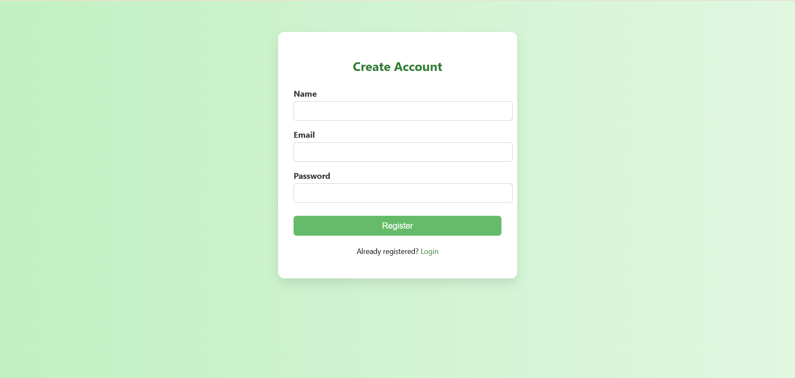

Dashboard Page:

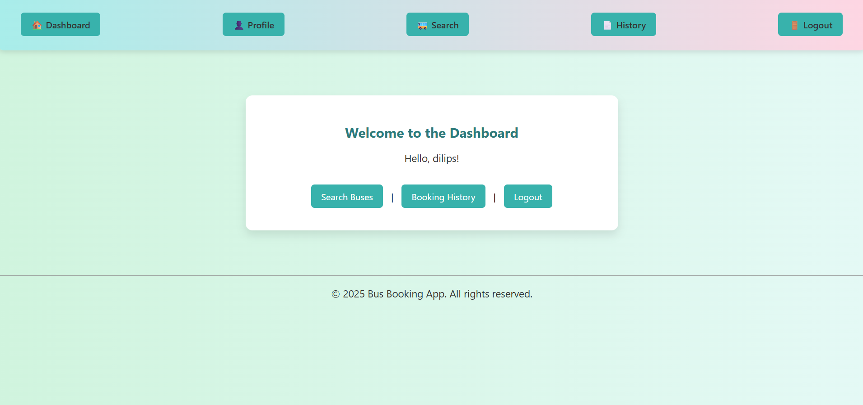

Admin Panel - Manage Buses:

