**Employee Management System – Project Report**

In today’s dynamic work environment, managing employee records efficiently is vital for any organization.  
This Employee Management System is designed to handle CRUD operations for employee data through both REST APIs and a Thymeleaf-based web interface.  
Built with Spring Boot and MongoDB, the project emphasizes simplicity, data integrity, and user-friendly design.

# 1. Problem Statement

Manual handling of employee data is not only inefficient but prone to human errors. Companies often struggle to maintain  
accurate, up-to-date records of their workforce. As businesses scale, it becomes harder to keep track of employee history,  
performance, and organizational role changes. Moreover, without a centralized digital system, collaboration between HR teams  
and managers becomes disconnected. This project proposes a solution to automate and simplify employee data management.

Traditional employee record systems often rely on spreadsheets or manual entries, making it hard to scale, search, or secure data.  
This project aims to digitize employee management using a structured full-stack approach, supporting operations like listing, creating, updating, viewing, and deleting employee details.

# 2. Introduction

This system was developed with the aim to combine robust backend APIs with a clean, user-friendly frontend to cater  
to real-world HR operations. The application supports core operations like employee creation, listing, editing, viewing,  
and deletion. It also ensures data consistency with validations and error handling. Each page in the UI has been carefully  
designed for intuitive use by HR executives who may not be tech-savvy. This makes the platform inclusive and practical for  
organizations of all sizes.

The Employee Management System allows HR teams and developers to manage workforce data efficiently.  
It supports both frontend views using Thymeleaf and backend RESTful APIs that can be integrated with external systems or frontend frameworks.  
The system is modular, secure, and scalable for future enhancements like payroll integration or role-based access.

# 3. Technology Used

The technology stack chosen ensures long-term maintainability and compatibility with industry standards. MongoDB allows  
schema-less storage, making it ideal for documents like employee records which may evolve. Spring Boot simplifies Java  
application setup and provides production-ready APIs quickly. Thymeleaf bridges the gap between Java and HTML, giving  
developers control over page rendering with logic right from the templates.

- Frontend: Thymeleaf templating engine with HTML/CSS

- Backend: Spring Boot with MVC, Validation, and Security

- Database: MongoDB for NoSQL document storage

- Other Tools: Lombok, Springdoc OpenAPI, Spring Security

Key dependencies from `pom.xml` include:

* • org.springframework.boot:spring-boot-starter-data-mongodb:N/A
* • org.springframework.boot:spring-boot-starter-security:N/A
* • org.springframework.boot:spring-boot-starter-thymeleaf:N/A
* • org.springframework.boot:spring-boot-starter-validation:N/A
* • org.springframework.boot:spring-boot-starter-web:N/A
* • org.thymeleaf.extras:thymeleaf-extras-springsecurity6:N/A
* • org.projectlombok:lombok:N/A
* • org.springframework.boot:spring-boot-starter-test:N/A
* • org.springframework.security:spring-security-test:N/A
* • org.springdoc:springdoc-openapi-starter-webmvc-ui:2.8.6

# 4. The Endpoints

* /api/employees — In `EmployeeController.java`, method `getAllEmployees` handles the `/api/employees` route.
* /{id} — In `EmployeeController.java`, method `getEmployeeById` handles the `/{id}` route.
* /{id} — In `EmployeeController.java`, method `updateEmployee` handles the `/{id}` route.
* /{id} — In `EmployeeController.java`, method `deleteEmployee` handles the `/{id}` route.
* /employees — In `EmployeeViewController.java`, method `listEmployees` handles the `/employees` route.
* /create — In `EmployeeViewController.java`, method `showCreateForm` handles the `/create` route.
* /create — In `EmployeeViewController.java`, method `createEmployee` handles the `/create` route.
* /{id}/edit — In `EmployeeViewController.java`, method `showEditForm` handles the `/{id}/edit` route.
* /{id}/edit — In `EmployeeViewController.java`, method `updateEmployee` handles the `/{id}/edit` route.
* /{id} — In `EmployeeViewController.java`, method `viewEmployeeDetails` handles the `/{id}` route.
* /{id}/delete — In `EmployeeViewController.java`, method `deleteEmployee` handles the `/{id}/delete` route.
* /api-error/resource-not-found — In `GlobalExceptionHandler.java`, method `Object>> apiResourceNotFound` handles the `/api-error/resource-not-found` route.
* /api-error/duplicate — In `GlobalExceptionHandler.java`, method `Object>> apiDuplicate` handles the `/api-error/duplicate` route.
* /api-error/internal — In `GlobalExceptionHandler.java`, method `Object>> apiInternalError` handles the `/api-error/internal` route.

# 5. Output Screenshots

## Login Page

This is the secure login screen where users must enter their credentials to access the system.

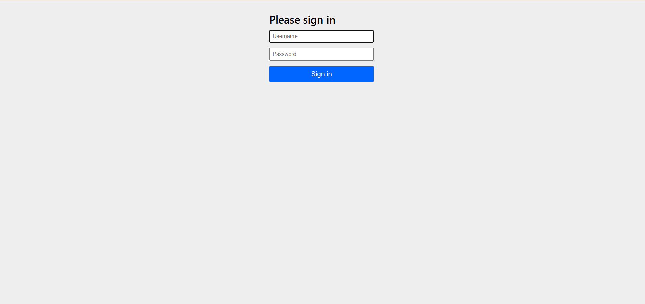

## Home Dashboard

After login, users are taken to a clean dashboard where they can choose to view, add, or manage employees.

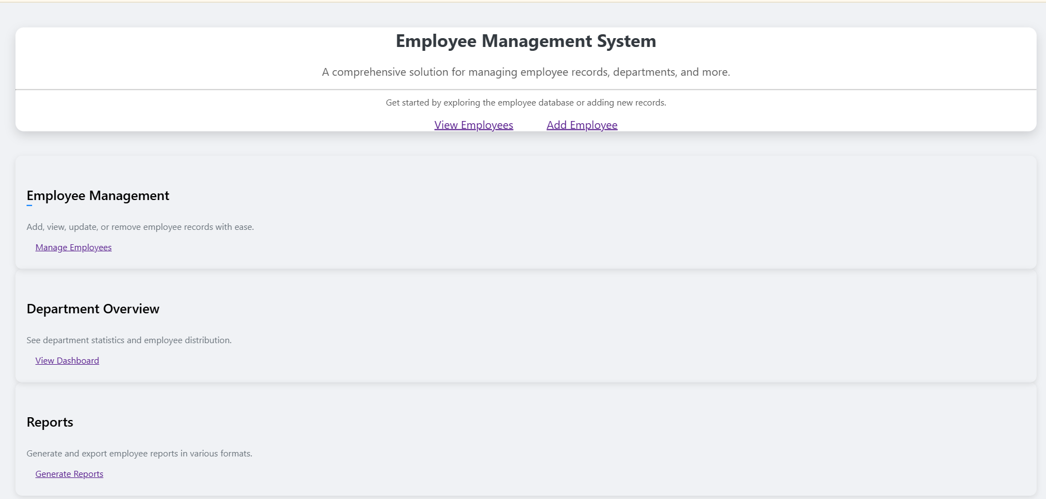

## Employee List View

Displays all employees in a tabular format, allowing quick access to edit, view, or delete operations.

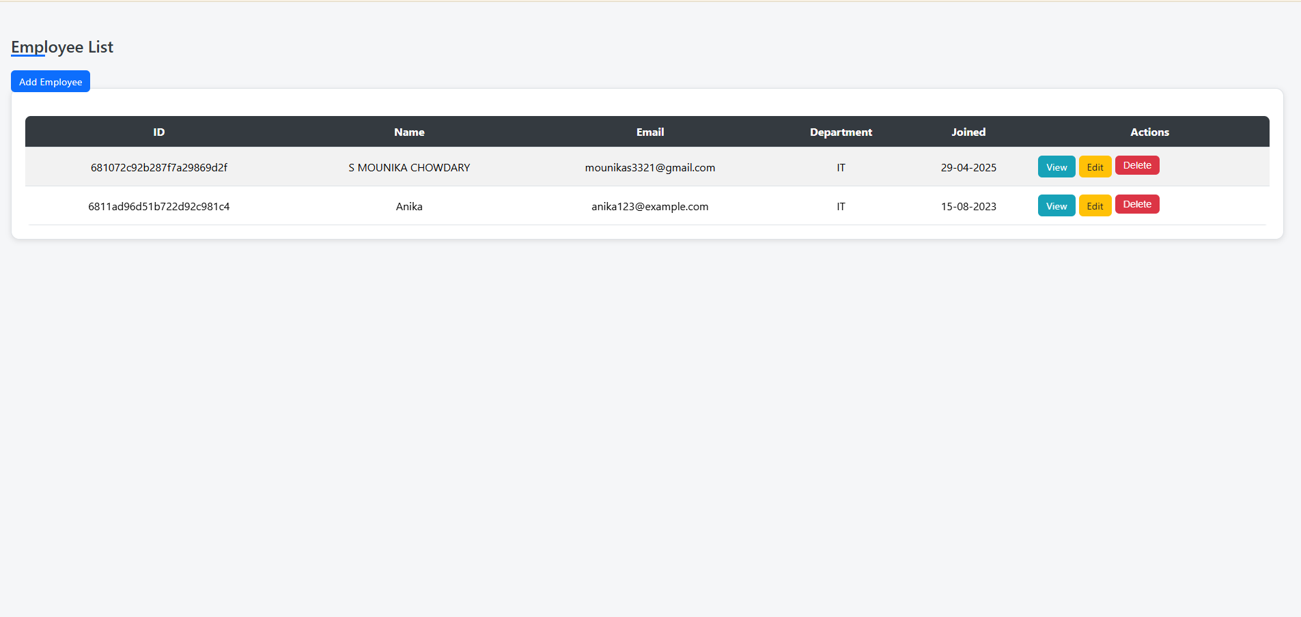

## Employee Details

Shows detailed information of a selected employee including name, department, salary, and join date.

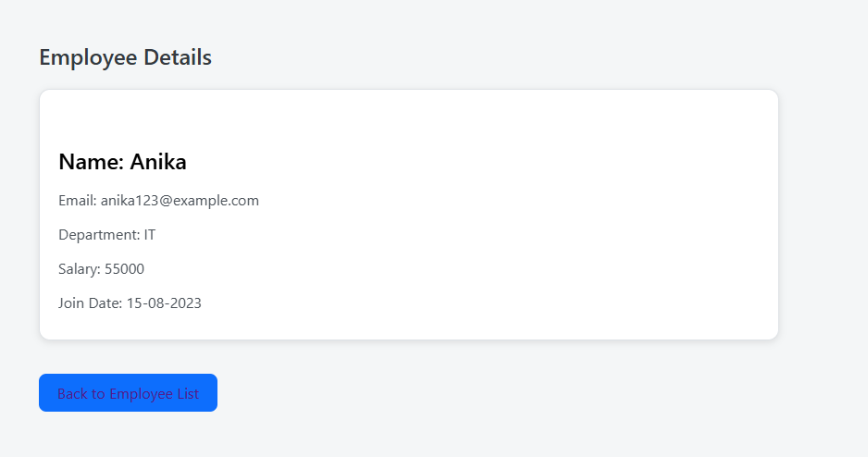

## Create Employee Form

A comprehensive form used to add new employee records with validations on required fields.

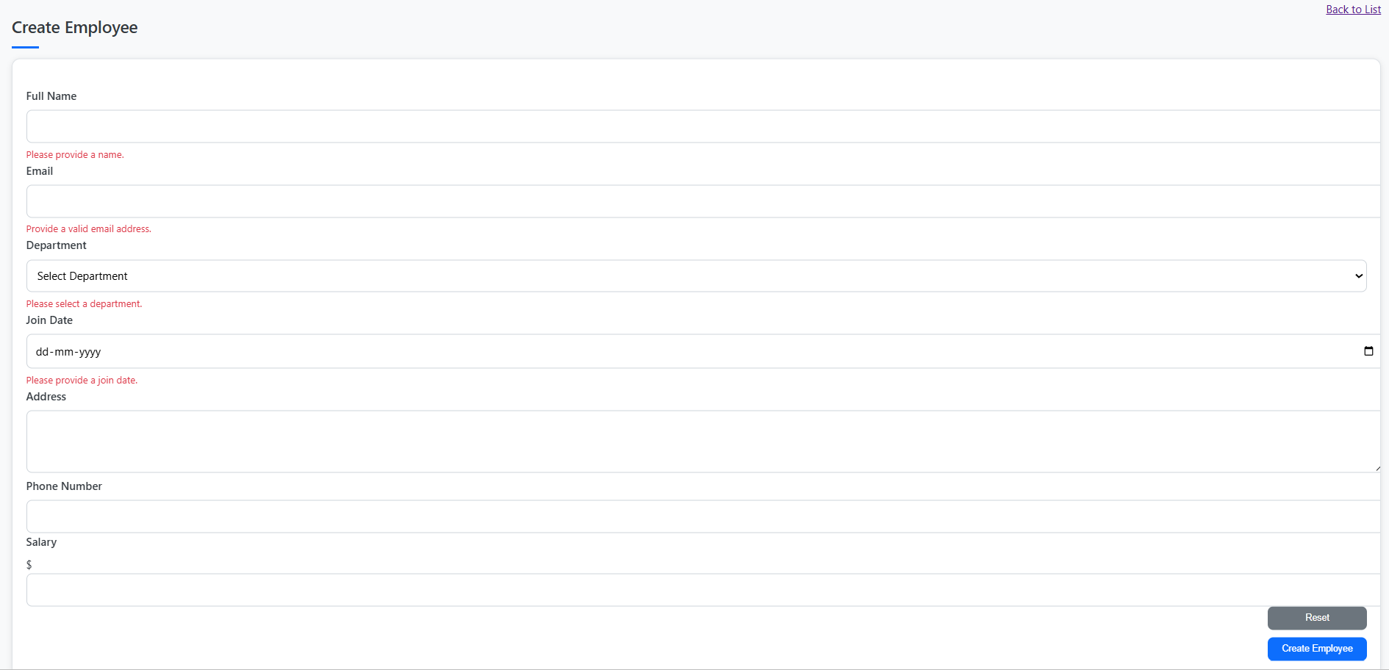

## Edit Employee

A pre-filled form that allows updating of existing employee data like salary or email.

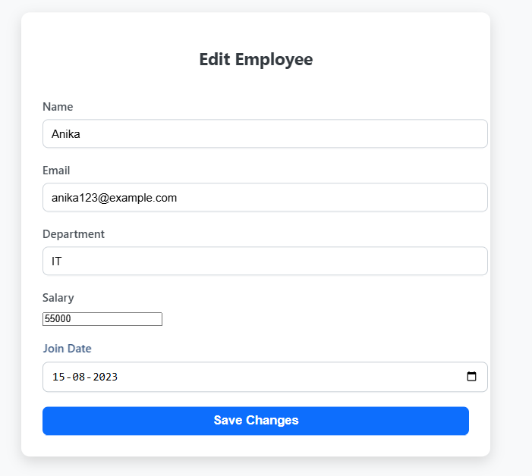

# 6. Conclusion & Future Enhancements

This project has significant real-world value and can be integrated into small-to-medium businesses with ease. Its RESTful  
architecture makes it future-proof for integrations such as employee attendance, leave tracking, or integration with  
payroll software like Zoho Payroll or RazorpayX. Advanced features like role-based authentication, exportable reports,  
and audit trails can be added to further enhance usability and compliance in large organizations.  
  
The Employee Management System provides a solid foundation for HR operations by offering both user-facing and API-driven interfaces.  
It ensures data validation, supports custom exceptions, and prepares the system for future modules like authentication, analytics, and reporting.  
Upcoming improvements may include PDF report generation, email notifications, and integration with third-party HR platforms.

Beyond just storage challenges, traditional employee management often lacks proper audit trails and access control.  
Sensitive employee data—like salaries, personal contact information, and joining history—must be handled with care and accountability.  
This project also addresses these real-world compliance concerns and emphasizes secure handling of workforce data.  
  
The application also supports rapid onboarding through a dedicated 'Create Employee' interface and ensures only valid records   
are saved using backend validation logic. It is structured in a way that new modules like 'Department Management' or   
'Leave Requests' can be added with minimal effort. Its frontend uses Thymeleaf templates to render meaningful and   
interactive views, ensuring HR staff can operate the system without any technical know-how.  
  
Security is a key aspect in this system. Spring Security ensures that only authenticated users can access or modify data.  
Role-based configurations (such as 'admin' vs. 'viewer') can also be implemented in future iterations.  
Additionally, OpenAPI integration (via Springdoc) allows the APIs to be easily tested and documented for developers.  
  
These endpoints follow RESTful conventions, making the backend scalable and modular.  
Each route is designed with HTTP method best practices—for example, `GET` for fetching, `POST` for creation, `PUT` for updates,  
and `DELETE` for removals. This ensures compatibility with frontend frameworks or third-party tools.  
  
Additionally, the solution lays groundwork for modern HR systems. It could be containerized using Docker for scalable deployment.  
Integration with email services or Slack can provide instant alerts for newly created or modified employee records.  
A role-based access panel and dynamic report generation feature (PDF/Excel exports) would significantly increase system value in enterprise environments.  
  
Most organizations today still rely on outdated or fragmented methods to manage their employee data. These methods not only introduce inconsistencies but also consume valuable administrative time.   
HR professionals often face difficulties tracking changes in employee roles, promotions, and personal updates. Without automation and centralized access, compliance with regulatory requirements like data privacy laws becomes a daunting challenge.   
This system addresses these issues by offering a streamlined, secure, and scalable platform for storing and managing employee records. It ensures accuracy, accountability, and efficiency in all HR-related workflows.

The Employee Management System is not just a tool for handling records—it serves as a digital foundation for HR operations. By merging backend efficiency with frontend simplicity, it offers a complete experience for users across different technical backgrounds.  
This application simplifies hiring processes, reduces paperwork, and enhances collaboration among HR teams and leadership. Furthermore, the system is built to adapt to growing needs such as hierarchical role definitions, performance tracking, and document uploads.  
By providing structured views and seamless navigation, it reduces friction for non-technical users while maintaining backend flexibility for future expansions.  
  
The core technologies selected serve two primary purposes—scalability and maintainability. Spring Boot provides a robust API-driven backend while MongoDB delivers agility in managing flexible and evolving data models.   
Thymeleaf integrates server-side data directly into frontend templates, ensuring consistency between the UI and backend logic.  
The inclusion of Spring Security ensures protected access control, making it ready for enterprise-level use. Furthermore, Spring Validation helps maintain clean data entry and prevents form-level errors from affecting the database.  
Lombok eliminates boilerplate code, reducing time spent on repetitive coding. These tools collectively contribute to a modern, maintainable, and secure tech ecosystem for HR solutions.  
  
The API layer has been carefully structured to follow RESTful principles, making each route predictable and consistent. This not only eases frontend integration but also simplifies API testing and documentation.   
Separation between data-handling routes (`/api/employees`) and view-related routes (`/employees`, `/create`, etc.) promotes modular design.  
Error handling is encapsulated under dedicated paths like `/api-error/internal`, making debugging and monitoring easier. With HTTP status codes and JSON responses, the API adheres to modern standards and enables easy consumption by external tools and services.  
  
Below are screenshots from various stages of the application, providing a visual walkthrough of key features. These include the login interface, dashboard, employee listing, detailed view, and the create/edit workflows.  
Each screen was carefully designed to balance visual clarity with function. Forms are straightforward and self-validating, ensuring minimal user error.  
Action buttons are contextually placed and intuitive. The entire flow from logging in to updating records follows a logical, user-centric design.

In conclusion, this project effectively addresses the need for a structured and user-friendly employee management system.  
It lays the foundation for digital transformation in HR departments, streamlining operations and ensuring better data integrity.  
  
Additionally, the lack of centralized access often leads to duplicate records, miscommunication, and manual follow-ups that slow down organizational processes.   
By automating CRUD operations and offering real-time visibility into employee data, this system drastically reduces human effort and administrative overhead.  
  
It is also designed with modularity in mind, meaning future developers can build on top of it easily. This makes it suitable not just as a standalone project but also as a scalable enterprise-grade solution.  
Organizations can use this base to integrate advanced workflows such as project assignments, time tracking, or benefits management.  
  
The choice of MongoDB as the primary data store enables the system to handle dynamic attributes, which is ideal for employee records that may contain optional fields like emergency contact or certifications.  
Its open architecture allows integration with CI/CD tools, enabling automated deployments and version control across development pipelines.  
  
To ensure a consistent developer experience, each endpoint has been designed with predictability in mind. URL naming conventions, structured responses, and proper error messaging facilitate easy debugging and onboarding of new contributors.  
Furthermore, with Springdoc, developers can explore and test APIs directly from a web-based interface, reducing the friction of writing external documentation.

These interfaces were built with a focus on accessibility and clarity. Visual cues and consistent navigation help minimize the learning curve for first-time users.  
Button placements, table layouts, and label consistency were iterated based on typical user behavior to improve intuitiveness.