**URL’s**

YouTube Video: <https://youtu.be/8iDqy0bcICc>

GitHub: <https://github.com/DIM-JACK/ISAD251>

**Storyboard**

In homepage, user can view the function menu on left.

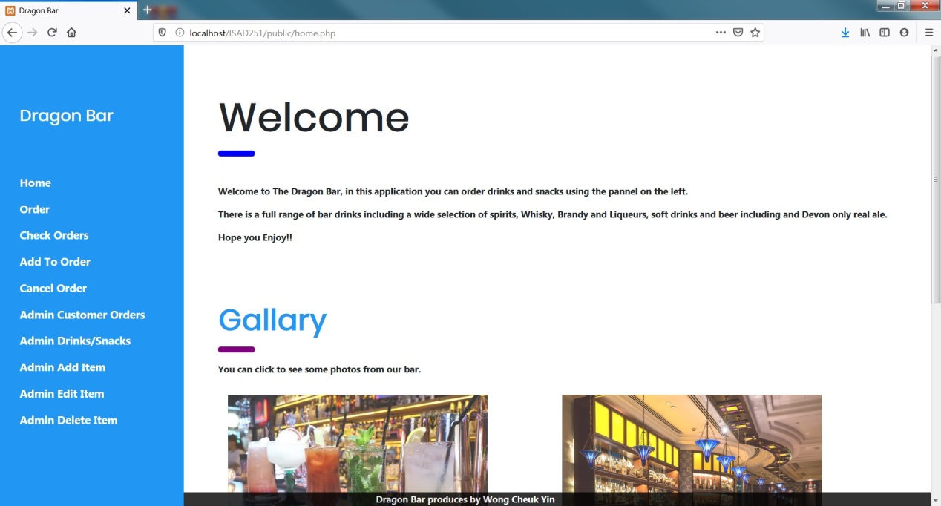

**As a customer I wish to order a drink/snack.**

**As a customer I wish to add to my current order for a drink/snack.**

By Click on ‘Order’, order page shown as below:

User can add the item by enter the item ID, Quantity & Special description.

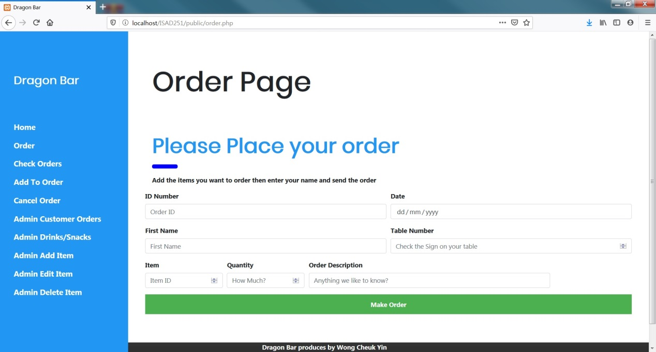

**As a customer I wish to see what I have ordered**

User can check orders by click on ‘Check Orders’ field and enter the Order ID.

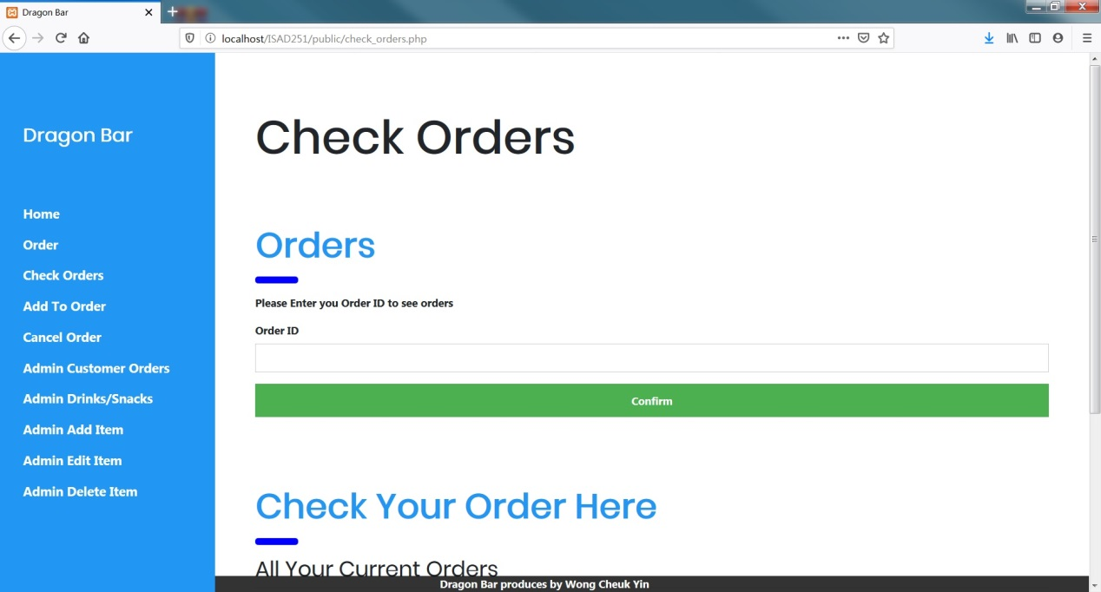

**As a customer I wish to cancel my order for a drink/snack.**

User can cancel order by click on ‘Cancel Order‘ tab, by enter the order ID, user can cancel the order.

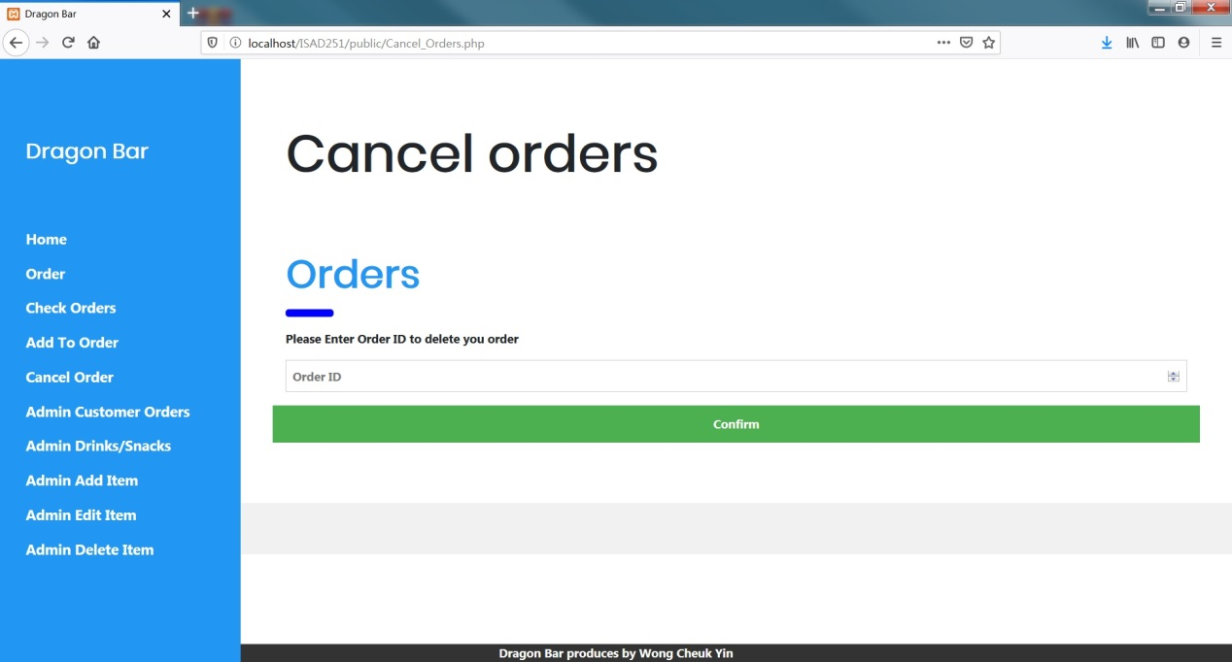

**As the admin I wish to enter details of the drinks/snacks I have for sale.**

**As the admin I wish to read the details of the drinks/snacks I have for sale.**

Admin can use ‘Admin Drinks/Snacks’ to Add, View or Delete items:

First, admin can check the items.

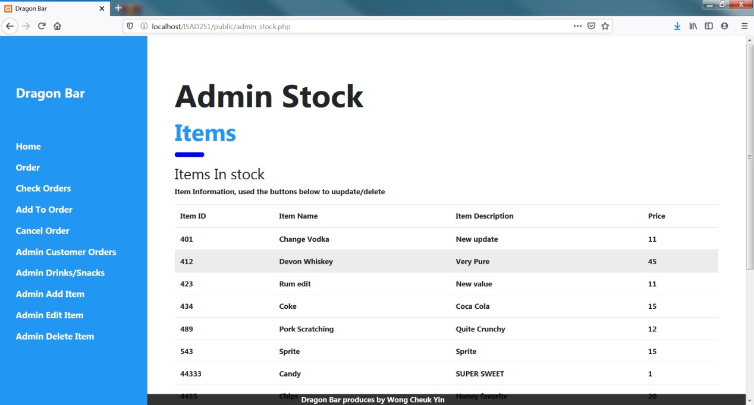

At this page, to scroll down and function button shown. 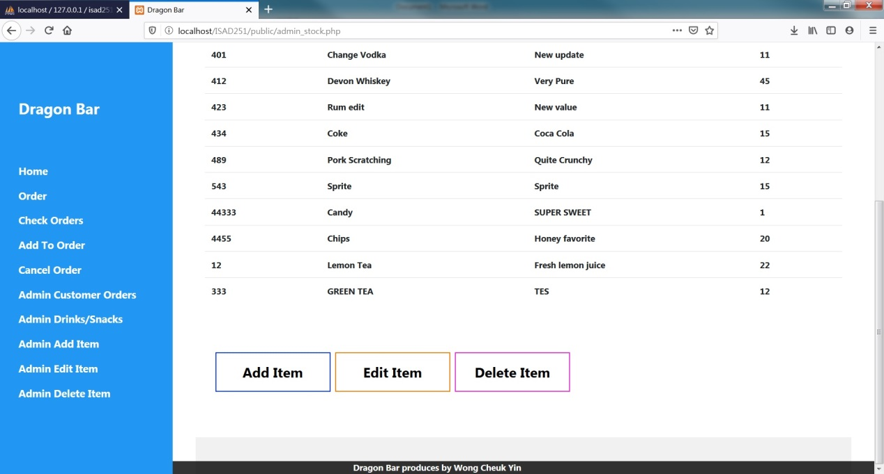

Admin can add item by ‘Admin Add item’ tab

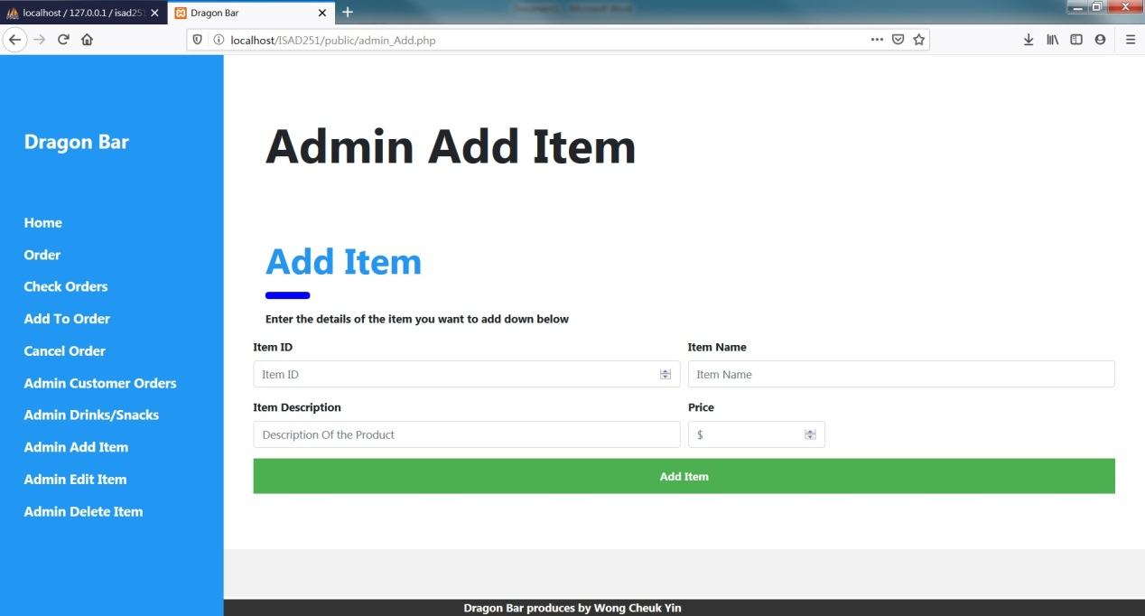

**As the admin I wish to read the details of the drinks/snacks I have for sale.**

**As the admin I wish to edit the details of the drinks/snacks I have for sale.**

Admin can edit item by ‘Admin Edit item’ tab, also thi spage list all itme for admin to check the items.

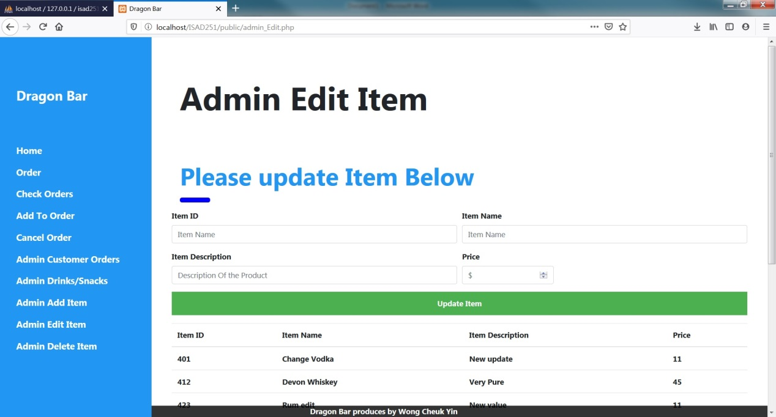

**As the admin I wish to withdraw a drink/snack from sale.**

Admin can use ’Admin Delete Item’ to remove item:

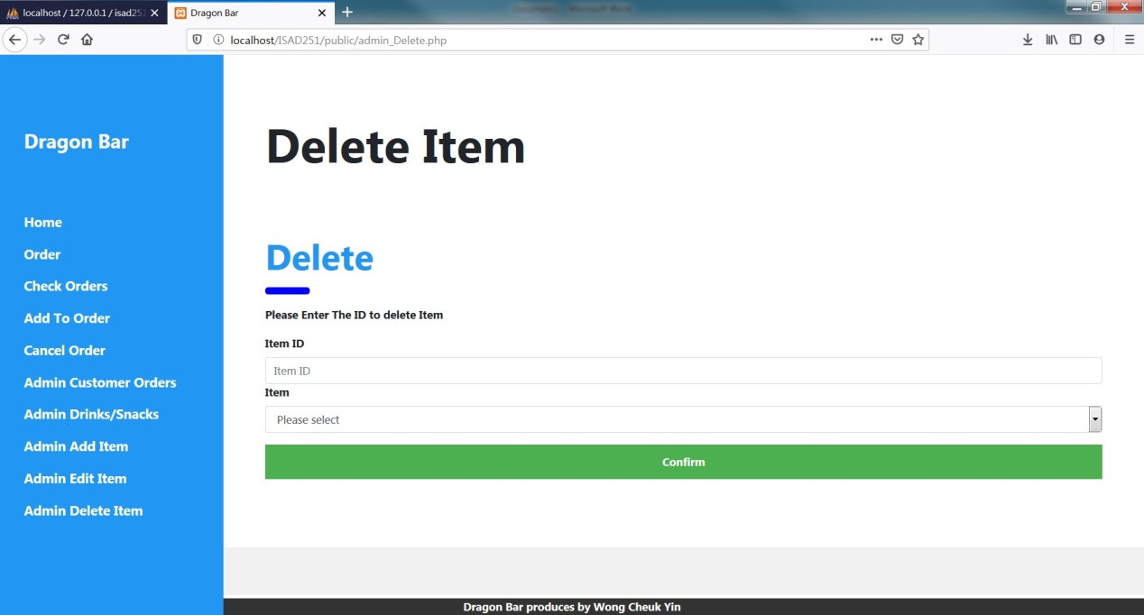

**Activity Diagrams**

**Admin access**

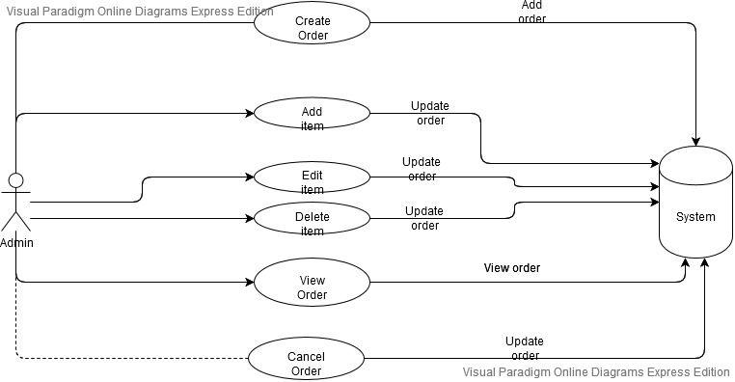

**Customer access**

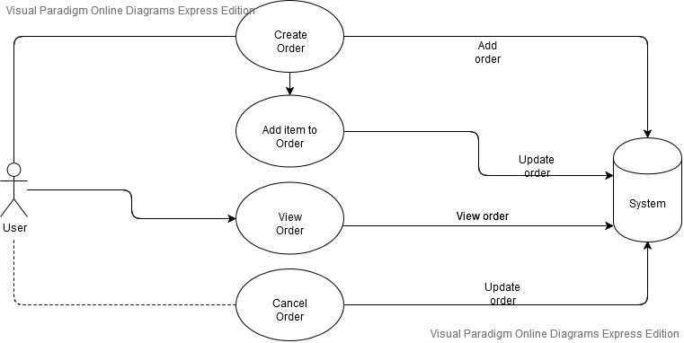

**Server view order flow design:**

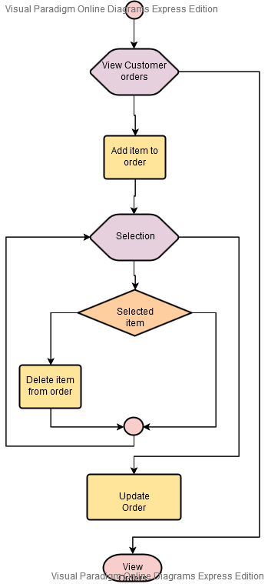

**Peer Review**

Peer Review carried out by: Monica Chan Date: 14/1/2020

**Task conducted:** Admin manage items database

**Was the task easy to carry out? (If no or not really, please say why)**

Yes.

**Did you encounter any errors? (If yes, please explain what)**

Yes, some error message pop up about connect to database but item can update normally.

**Did the author have to explain how to use anything? (If yes, what?)**

No, the interface very easy to understand.

**Did you gain any inspiration for your own practice? (If so what?)**

Yes, use login authentication to classify the user/admin menu & function.

**What constructive advice would you give the author for presenting their work/code in future?**

Everything was presented clearly and understandable.

Peer Review carried out by: Jackson Chui Date: 24/1/2020

**Task conducted:** User make order

**Was the task easy to carry out? (If no or not really, please say why)**

Yes.

**Did you encounter any errors? (If yes, please explain what)**

Yes, some error message pop up about connect to database but item can update normally.

**Did the author have to explain how to use anything? (If yes, what?)**

No, the interface very easy to understand.

**Did you gain any inspiration for your own practice? (If so what?)**

Yes, the menu should list all item for select, no need to input the ID manually.

**What constructive advice would you give the author for presenting their work/code in future?**

Everything was presented clearly and user friendly

Peer Review carried out by: Monica Chan Date: 25/1/2020

**Task conducted:** Check & edit order

**Was the task easy to carry out? (If no or not really, please say why)**

Yes.

**Did you encounter any errors? (If yes, please explain what)**

Yes, can’t check the order item disply.

**Did the author have to explain how to use anything? (If yes, what?)**

Yes, all search need to input ID.

**Did you gain any inspiration for your own practice? (If so what?)**

Yes, all working page should show related database date by click on one button to check/edit.

**What constructive advice would you give the author for presenting their work/code in future?**

Everything was presented clearly and easy to use