**GitHub Repository** Part 1 tag

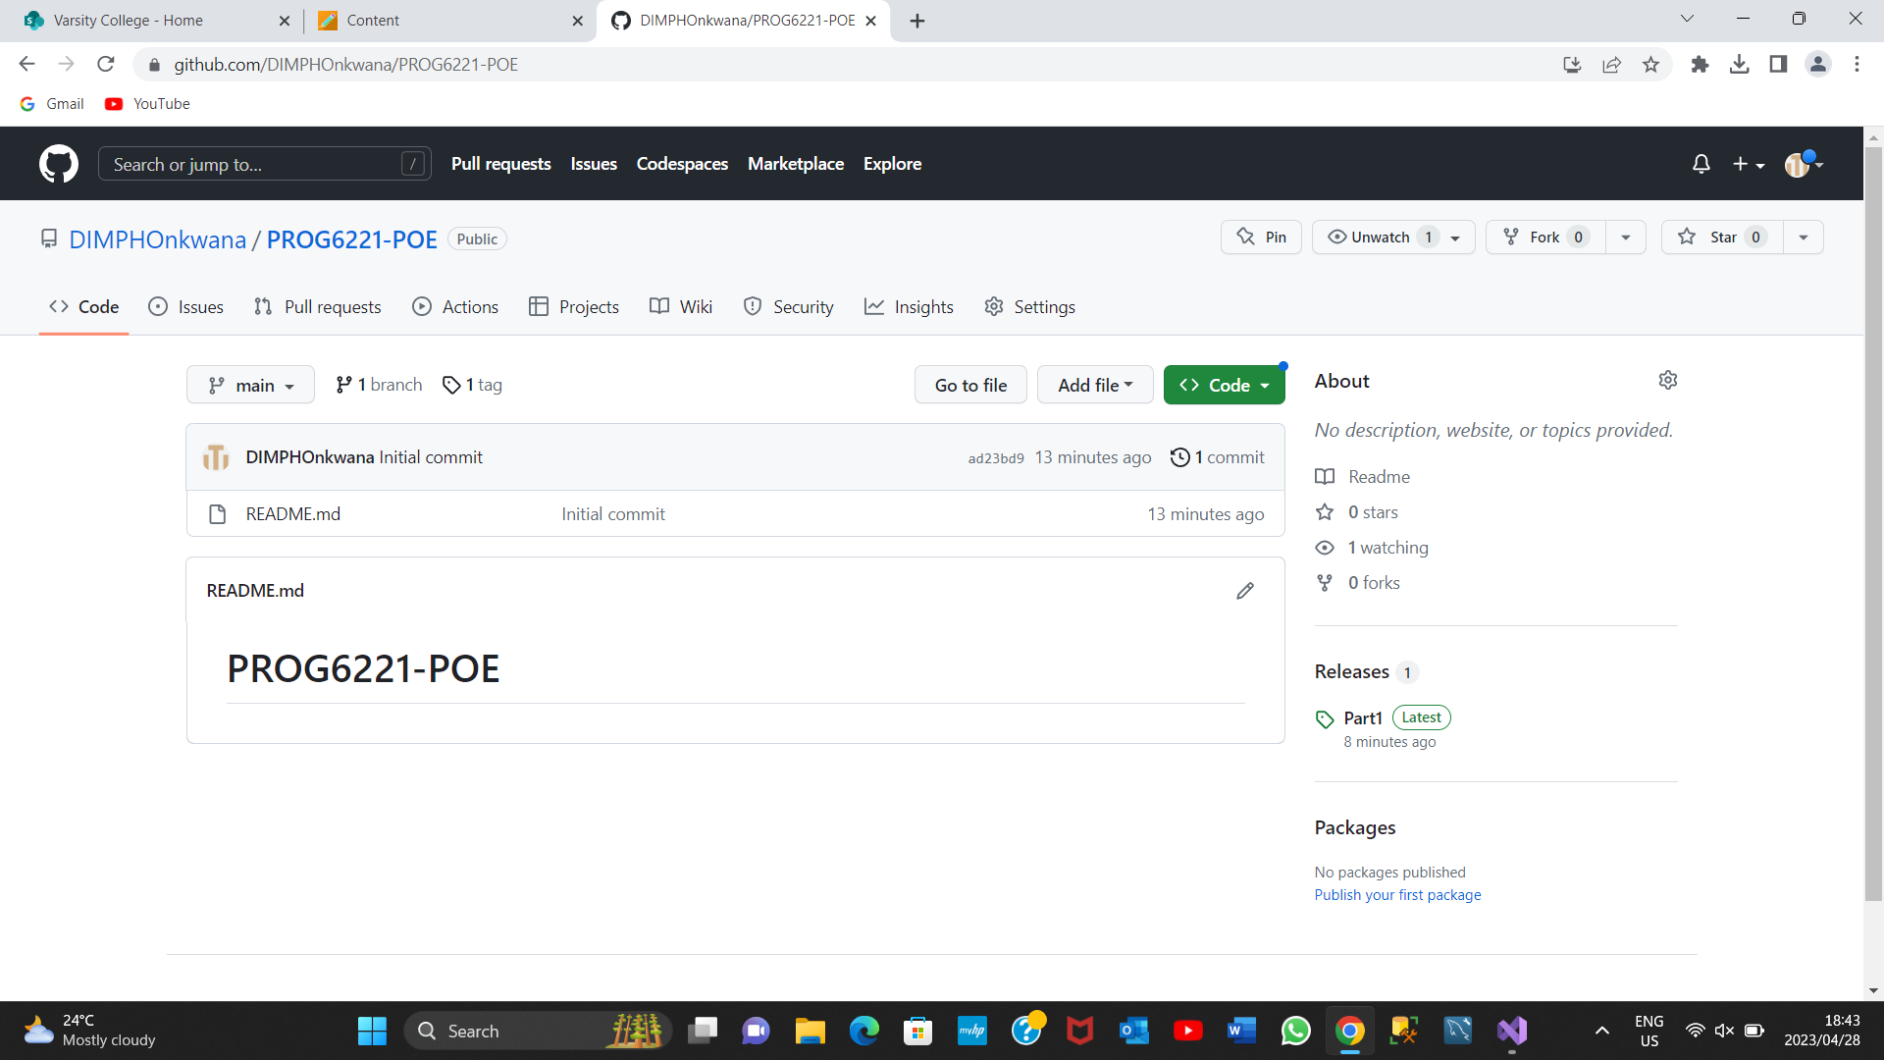

Instructions

1. Open your chosen Coding application,( Microsoft Visual Studio, recommended)
2. Unzip the PROG6221 part 1 folder
3. Open Visual studio ,go to files and run the part 1 folder by clicking on the green start button on the top middle screen
4. Follow the instructions given on the question paper.

**LINK**

<https://github.com/DIMPHOnkwana/PROG6221-POE.git>