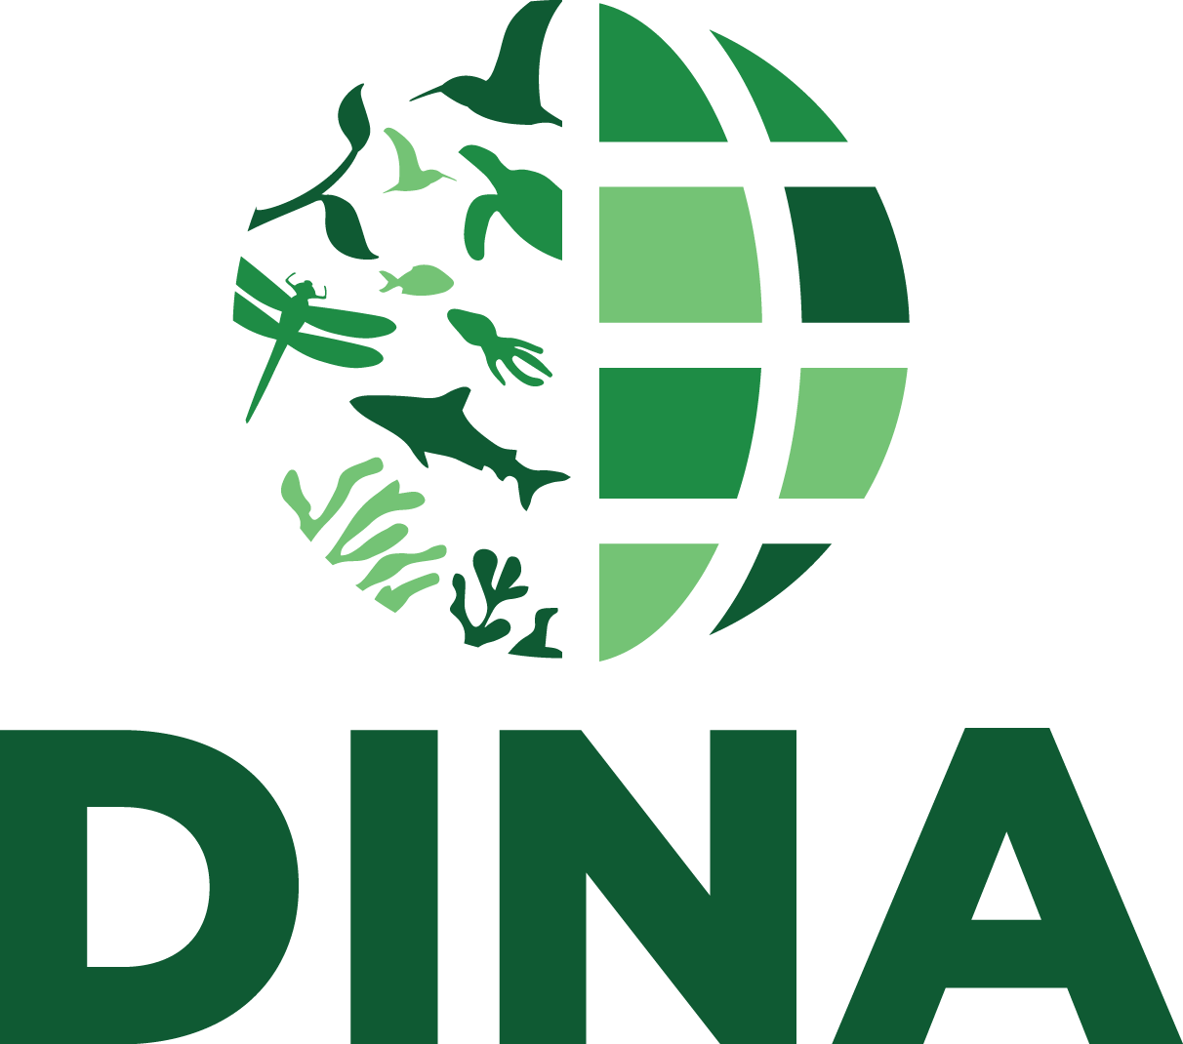
“The DINA consortium is an international collaboration for distributed development of an open-source, web-based information system for managing and sharing natural history collections data. Target datasets include living collections, observation records and molecular data.”

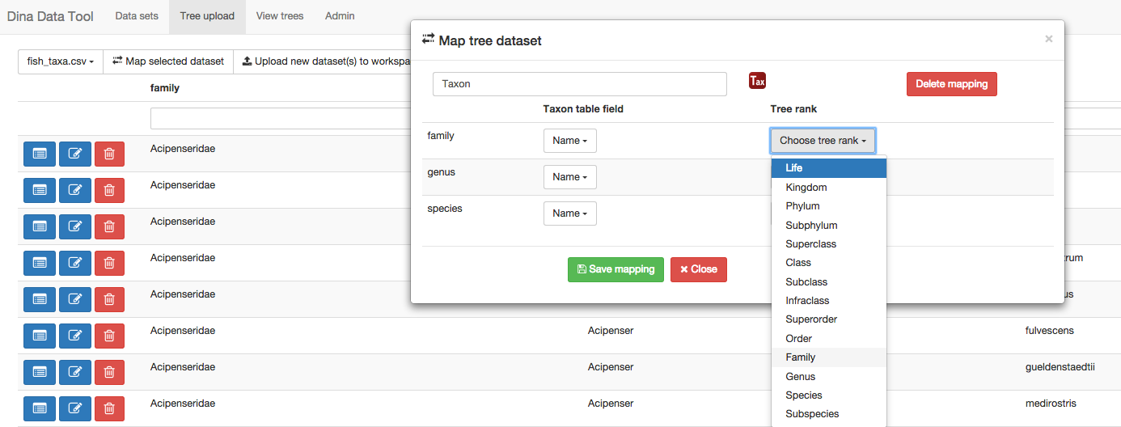
The DINA system is intended for national or major institutional deployments, providing support for multiple installations and for the ability to accommodate for distributed user and storage management.

In the DINA system, web clients provide user interfaces that make use of data delivered through web services using a service-oriented architecture which expose data through web APIs in order to facilitate distributed development of functionally separate modules.
Figure 1. Screenshot from the DINA Data Tool, developed by the Natural History Museum of Denmark.

Current DINA modules
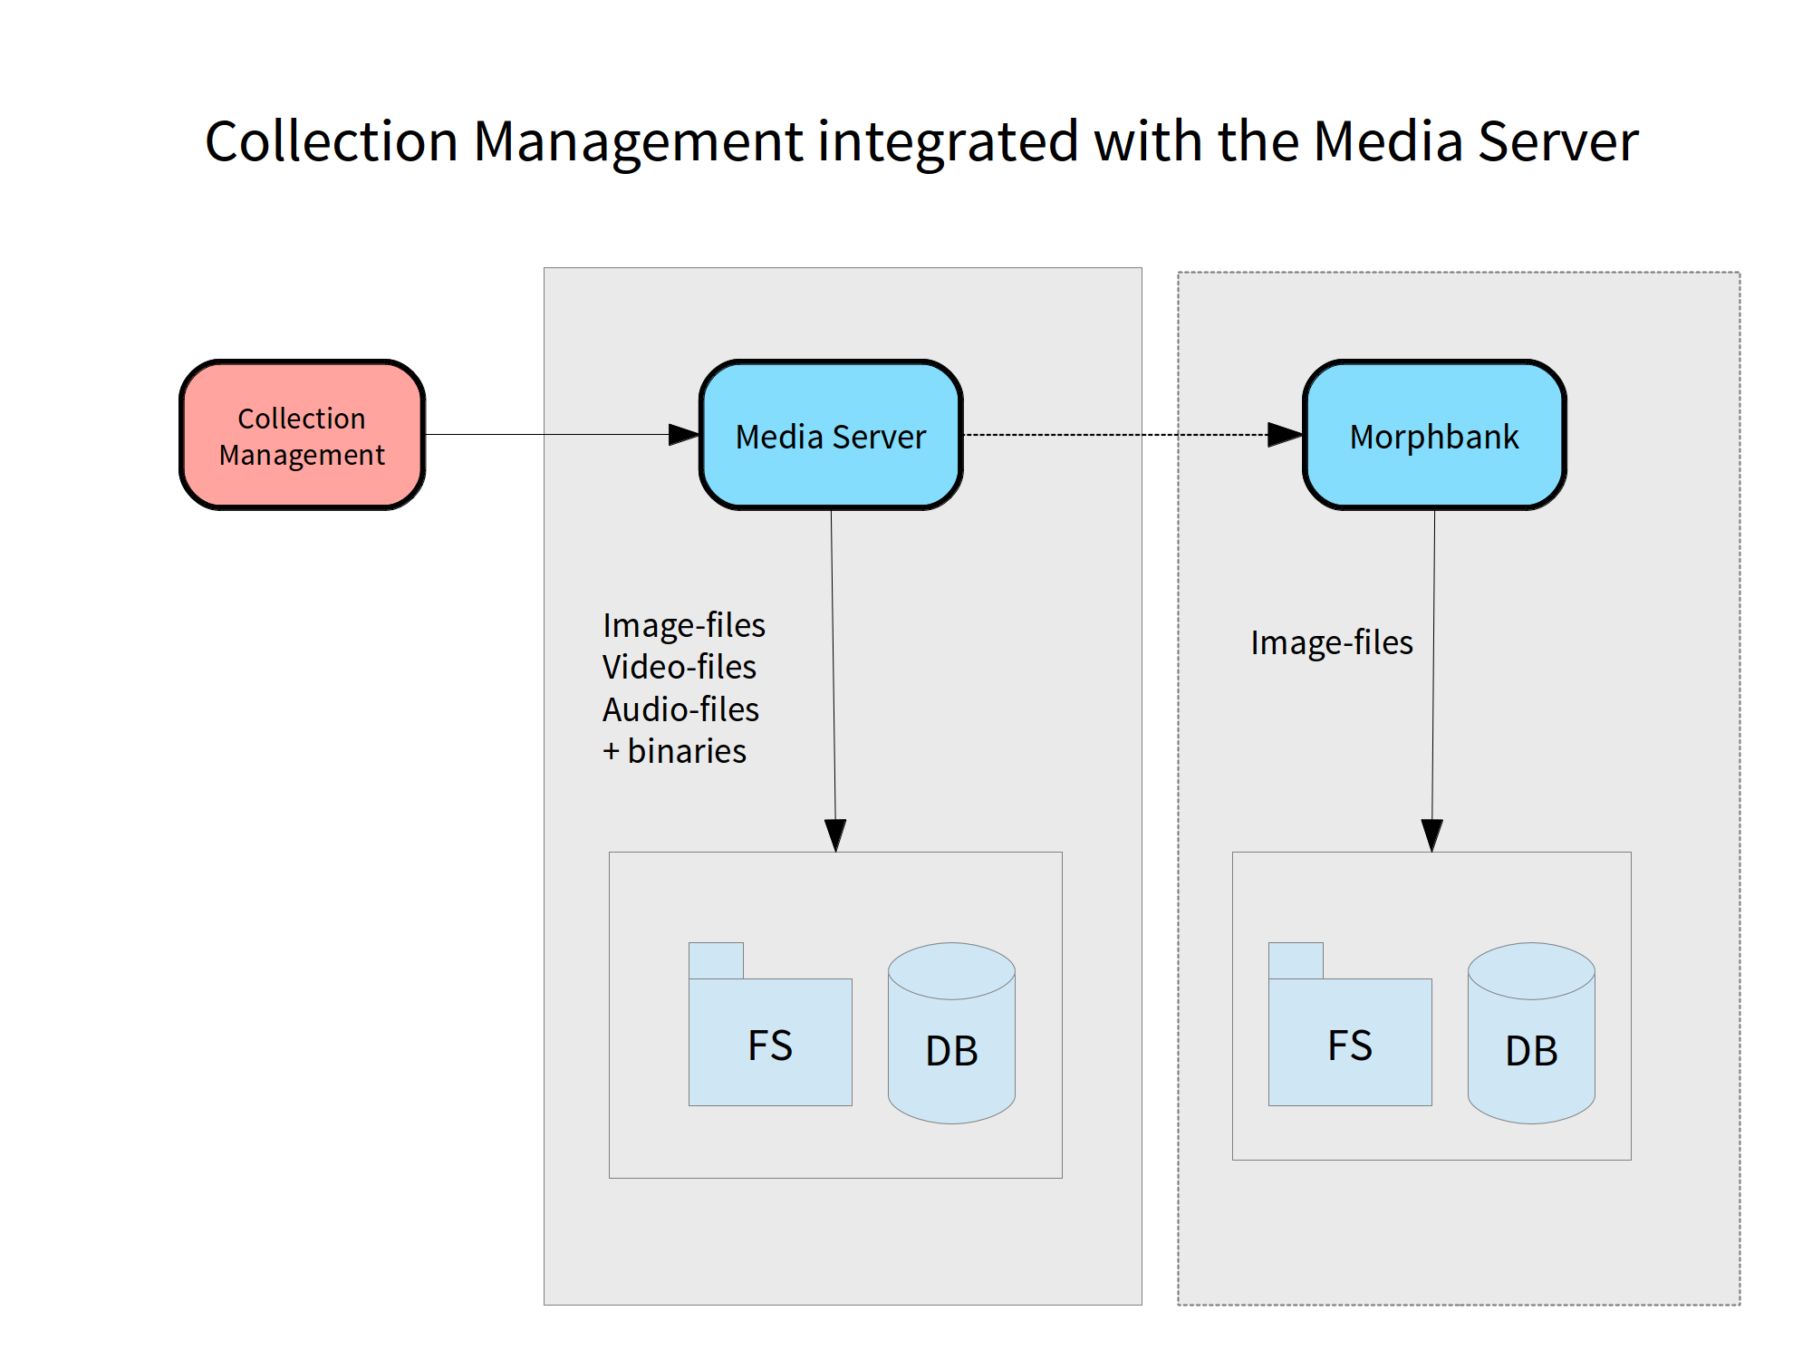
An online version of DINA-Web is available at http://dina-web.net and includes a growing set of similar software components. Examples of contributed modules include the DINA Data Tool (see figure 1) - a lightweight web application supporting data import workflows targeted at the Specify collections manager (http://specifysoftware.org/). There is also the media server for managing audio, images and other files associated with collections (see figure 2). Some additional modules are shown below (see figure 3).
Figure 2. Schematic depiction of the media server.
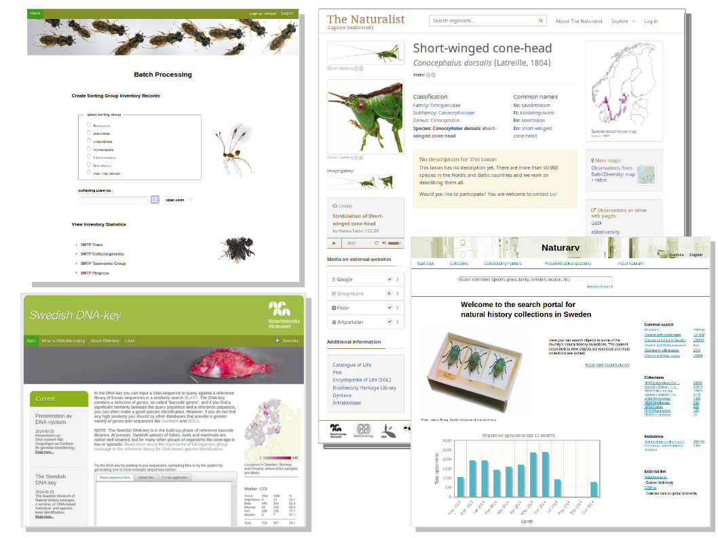
Figure 3. Screenshots of various DINA modules . “Naturfynd” - a collection event workflow data entry client (upper right), “The Naturalist” - a species information web portal which will use the PlutoF taxonomy module and the media server (upper right), the Swedish DNA-key portal (lower left) and “Naturarv” - the DINA search portal (lower right)
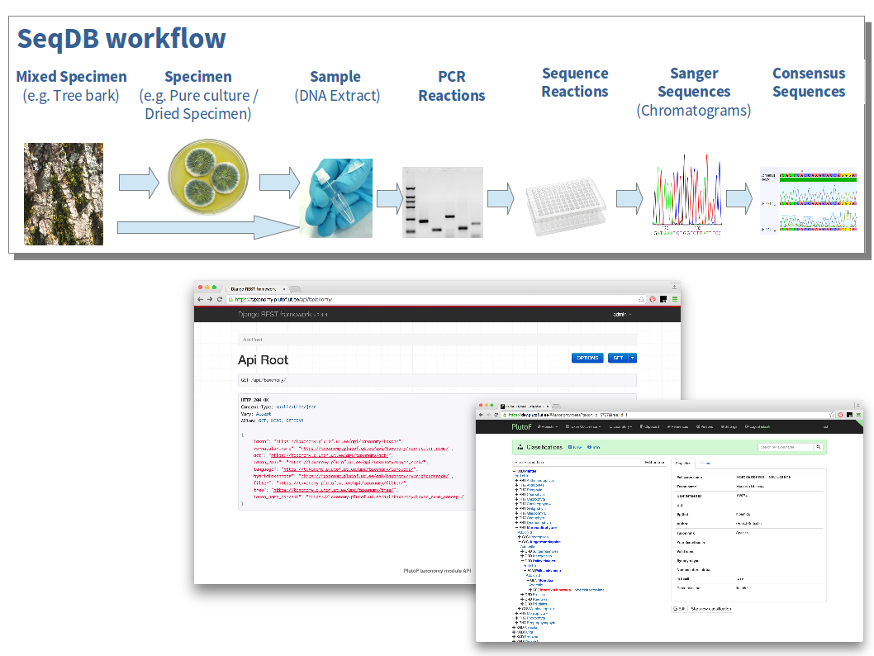
Another recent contribution is SeqDB - a module which allows labs to track experimental protocols and the resulting evidence supporting taxonomic determinations which may be based on morphological and DNA sequencing methods.
Figure 4. The SeqDB DINA module was developed by Agriculture and Agri-Food Canada to manage DNA sequences from research collections.
Figure 5. The PlutoF taxonomy module was developed at the University of Tartu Natural History Museum as a part of the PlutoF workbench 3.0 (https://plutof.ut.ee)

Additionally, the PlutoF taxonomy module provides a RESTful web service that supports management of multiple classifications.

DINA-Web
DINA-Web is the name of the software repository with all DINA related materials and it is hosted at http://github.com/DINA-Web. It contains source code and other relevant materials, including a website for collaborating developers at http://DINA-Web.github.io.

DINA-Web is being packaged to simplify deployments into existing virtualized server environments. Open source software infrastructure integration projects are provided and make use of tools like Vagrant to automate and capture all necessary configuration details for all modules.

DINA Collaborators in the DINA Consortium
The DINA system consists of software components that are being developed by an international network of institutions collaborating under the auspices of the DINA International Consortium. The Memorandum of Cooperation, technical roadmaps, action points, and further project information can be found in a wiki at http://www.dina-project.net. Collaborators include :
Please contact us for questions:

james.macklin@agr.gc.ca
urmas.koljalg@ut.ee
fredrik.ronquist@nrm.se
NScharff@snm.ku.dk Nikolaj Scharff

falko.gloeckler@mfn-berlin.de
E.Haston@rbge.ac.uk Elspeth Haston

ingimar.erlingsson@nrm.se
kevin.holston@nrm.se karin.karlsson@nrm.se markus.skyttner@nrm.se
New partners are welcome to join the collaboration!

Core members, contributing with developer resources
- Agriculture and Agri-Food Canada, Ottawa, CA
- Natural History Museum, Tartu, EE
- Swedish Museum of Natural History, Stockholm, SE
- Natural History Museum of Denmark, Copenhagen, DK

Associate members
- Museum für Naturkunde, Berlin, DE
- Royal Botanic Garden Edinburgh, Edinburgh, UK

