SYSTEM FOR IDENTIFYING AGGRESSIVE
BEHAVIOURS IN PUBLIC PLACES USING
CNN MODEL

DR. N. PUGHAZENDI
Professor
Computer Science and Engineering
Panimalar Engineering College
Chennai, India
pughazendi@gmail.com
DEVESH R
Computer Science and Engineering
Panimalar Engineering College
Chennai, India
mahadevan493devesh@gmail.com
BHUVANESH KUMAR S
Computer Science and Engineering
Panimalar Engineering College
Chennai, India
stbhuvi1203@gmail.com
DINESH KUMAR M
Computer Science and Engineering
Panimalar Engineering College
Chennai, India
dineshm0705@gmail.com

Abstract— Detection of unusual human behavior in public places has become tedious if we undergo it manually. As it is an important task, the human process may be random and unpredictable the classification of suspicious behavior of humans can be demanding. So, we have proposed a system that works as an automated Surveillance System to detect and track suspicious human behavior. In order to prevent violent extremism, robbery, collisions, traffic violations, having to fight, trying to steal, murder, and other sneaky activities, this surveillance enables the observation of human influence in vulnerable and well-known locations like stops, railway stations, airlines, banks, shopping centres, schools, and roadways. In the literature, all of these techniques have been employed to detect human behaviour in surveillance recordings. Object recognition using feature extraction, analysis, and recognition are some of these processes. In our project, we have decided to overcome the drawbacks by using CNN (Convolutional Neural Networks) Model. Our primary goal is to identify the unusual behavior of the people in social areas and alert the coordinator by signaling using the CNN model.
Keywords—Surveillance System, Convolutional Neural Network model, Suspicious activity, Machine learning.

Introduction
With rising crime rates, it becomes a concern if criminals are not recognized promptly and appropriate precautionary measures are not taken. There are surveillance systems deployed in the majority of urban and metropolitan regions, which are constantly collecting data. There is a greater likelihood of suspicious activity occurring as a result of the massive accumulation of surveillance data. The rate of crime or violence has been rising globally in recent years. The finest alternative that may be used in both public and private locations is video surveillance. Due to the increased demand for better security and safety measures, the identification of suspicious activity in public areas has become a crucial topic of research in recent years. Video surveillance systems have gained popularity as a tool for keeping an eye on public areas, but the volume of data these systems produce sometimes be too much for human operators to process. Finding unexpected behaviour in video surveillance data has shown great potential for deep neural networks and other machine learning algorithms. In this project, we want to create the CNN model for suspicious activity detection. A dataset of video footage gathered from numerous cameras in a public setting will be used to train the CNN model. The model will gain the ability to recognize unusual motions and behaviours that may be signs of impending danger. Data pre-processing, model training, and evaluation are just a few of the stages that the project will go through. To prove the superiority of our strategy, we will also contrast the performance of our CNN model with that of other machine learning methods.
The outcomes of this initiative could have a big impact on public safety and security by giving us a quicker, more precise way to spot suspicious activities in public areas. In “Suspicious Activity Detection in Surveillance Footage” by Sathyajit Loganathan and Gayashan Kariyawasam [7], focuses on the analysis of two cases, including abandoned luggage and crimes involving guns that were captured on surveillance footage. In this method, computer vision and machine learning pipelines are used to detect abandoned luggage in videos and handguns in photos. Instead the concept of this paper are as follows we need to detect person behaviour as suspicious or not using CCTV footages and then we have to implement feature extraction concept. Then we can test a video by uploading the frames of the video and then the model predicts its behaviour. This concept has been used in order to recognize and identify the anonymous activity detection in a socially crowded place.

MERITS

The ease of use of the technique proposed by this paper are followed:

Unmatched accuracy: The system should be designed to achieve high accuracy and robustness under varying conditions so that users can rely on the system to make accurate detections.

Real-time performance: The system should be designed to achieve real-time performance so that it can process images and provide results quickly. This can help users to make informed decisions in real-world scenarios.

Fast response time: Ultra-fast Processing for real-time inference results and feedback (~30 frames per second processing) with custom telemetry, inference results.

Custom integration: This can also be pre-trained/custom models can be deployed instantly and are camera independent. They can be pre-installed with existing cameras. So this is scalable and instant deployment.

Integration with other systems: The system should be designed to integrate with other systems, such as control rooms so that users can access and share information easily. This can help improve coordination and communication among authorities by creating notifications like emails,messages,custom alert systems.
The above-mentioned are some of the benefits while using it in real-time.

Related Works

Ms. U. M. Kamthe and Dr. C. G. Patil’s “Suspicious Activity Recognition in Video Surveillance System” [1] predicts the suspicious activities using some predefined conditions and eliminates the training of Dataset in machine learning methods main focus on ATM loitering and abandoned luggage. The future work of this project is to improve the system performances and prediction level.

In “Recognition of Suspicious Human Activities Using KLT and Kalman Filter For ATM Surveillance System” [2] by Suvarna Nandyal and Sanjeev kumar Angadi, the system which detects the suspicious and non-suspicious behaviors of human in ATM uses the Kanade Locus Thomasi algorithm which extracts features and object tracking to detect the suspicious activities this is a real time tracking system.

The proposed system provides additional feature to the CCTV camera's by providing a way to detect the suspicious activities like shop lifting, robbery by Using CNN model proposed by Miwa Takai in “Alert Generation on Detection of Suspicious Activity Using Transfer Learning” [3].

According to “Suspicious Behavior Detection of People by Monitoring Camera” [4] by Abouzar Ghasemi, the system suggested a novel method for the detection of suspicious conduct based on processing the object trajectory. The movement vector of the target object is used in the trajectory processing.

YOLOv3 is used to identify a variety of suspicious activities, such as bag theft and lock-breaking. Both the system's processing speed and detection accuracy are very good. Only in a controlled environment does the current feature extraction technology provide correct findings. Regarding the processing time for a single image detection, according to “Suspicious Activity Detection from YOLOv3” by Nipunjita Bordoloi, Anjan Kumar Talukdar [5].

Aqil Shamnath and Meena Belwal’s “Human Suspicious Activity Detection Using Ensemble Machine Learning Techniques” [6] the decisions made by various models are combined in ensemble machine learning to enhance performance. We can identify suspicious behavior in public transportation, such as chain stealing and bag stealing, using what we've learned. This technique provides a detection accuracy of 88%.

In “Suspicious Activity Detection in Surveillance Footage” by Sathyajit Loganathan and Gayashan Kariyawasam [7], focuses on the analysis of two cases, including abandoned luggage and crimes involving guns that were captured on surveillance footage. In this technique, pistols in photographs and abandoned luggage in movies are both detected using artificial intelligence and machine learning pipelines.

Amrutha C. V and Joytsna Amudha J’s “Deep Learning Approach for Suspicious Activity Detection from Surveillance Video” [8] The combination of both deep learning and machine learning allows for the isolation of various human unusual behaviour from the camera footage. The entire construction is divided into two parts. In the first segment, video frame features are generated, and in the second, a classifier forecasts whether a given class is suspected or ordinary based.

According to Phong H. Nguyen, Cagatay Turkay’s “Understanding User Behavior through Action Sequences: From the Usual to the Unusual” [9], they presented the task evaluation and domain characterization findings first. Then, they discussed the elements of the multi-level analytic strategy, including clustering based on semantic distance and constraint-based sequential pattern mining, as well as multi-scalar representations of users and their sequences.

The paper comprises of six abnormal activities, including the detection of abandoned objects, theft, falls, accidents, and unlawful parking on the road, as well as the detection of violence activity and fire. In surveillance movies, it was formerly possible to spot human activity using techniques like feature extraction, object recognition, and tracking or non-tracking given by Rajesh Kumar Tripathi and Anand Singh Jalal’s “Suspicious human activity recognition: a review” [10].

P. H. Nguyen and C. Turkay’s “A Visual Analytics Approach for User Behavior Understanding through Action Sequence Analysis” [11], in order to offer a thorough insight of user behaviour. Then, they offer the components of a revolutionary visual analytics technique that combines "action space" analysis, pattern recognition, and the interactive visual analysis of various sequences towards that full understanding of user behaviour.

The examination of the two essential elements of a surveillance camera system, behaviour modelling and representation. Techniques for behaviour representation extracting features and description are covered in this review. Frameworks for behavior modelling and classification approaches are also offered, according to “Abnormal behavior recognition for intelligent video surveillance systems” by Amira Ben Mabrouk and Ezzeddine Zagrouba [12].

Zhou Zhigang, Duan Guangxue, Lei Huan’s “Human behavior recognition method based on double-branch deep convolution neural network” [13] This study offers a double-branch deep convolution neural network-based approach for recognising human behaviour. In order to provide information about the parts of the human body and the interconnections between those joints, the properties of the input image are first extracted, and the extracted features are then fed to a double-branch deep convolution neural network.

The algorithm uses technology to reduce the amount of effort spent looking for criminals and identifying suspicious. Study used a face detection approach to examine CCTV footage. According to Patiyuth Pramkeaw, Pearlrada Ngamrungsiri, Mahasak Ketcham’s “CCTV Face Detection Criminals and Tracking System Using Data Analysis Algorithm” [14].

Martin D. Levine’s “Automated Real-Time Detection of Potentially Suspicious Behavior in Public Transport Areas” [15], proposes the investigation of the behavior modelling and representation—the two key components. This review covers feature extraction and description techniques for behavior representation. Frameworks for behavior modelling and classification approaches are also offered.

Methodology

In this section, we’ll go over the suggested end-to-end system for anonymous activity detection in socially crowded environment. A. The training takes place in three phases:

Data Collection and Preprocessing: The construction of a reliable and effective violence detection system depends heavily on the data collecting and preprocessing module for CNN (Convolutional Neural Network)-based violence detection. Data collection and preparation are the module's two main processes. Building a machine learning model always starts with gathering data, and CNN violence detection is no different. The module requires obtaining relevant images and videos from a range of sources, including dashcams, surveillance cameras, and other sources. To guarantee the model's correctness and dependability, the dataset needs to be substantial, diverse, and balanced.Data labelling, which is the next phase and essential for CNN-based Violence detection, is required. To detect a fight and any important objects in the picture, such as a gun or knife, the technique entails scaling the photographs and videos. The scaling and noise removal technique requires a mastery of OpenCV and a keen eye for detail because the accuracy of the model's output depends on the calibre of the input data. The data can be used to train the model for detecting violence once it has been preprocessed and transformed into the necessary format. Data collection and preprocessing are crucial steps in creating a reliable and effective system for detecting violent crimes because the quality of the training data directly affects the model's performance. In conclusion, the data gathering and preprocessing module for CNN-based violence detection is an essential step in creating a reliable and effective system. To gather pertinent information, appropriately label it, and preprocess it into the format necessary for the model training, the module demands careful organisation, attention to detail, and domain experience.

Model training: The creation of a reliable and effective violence detection system depends heavily on the model training module for CNN (Convolutional Neural Network)-based violence detection. The module comprises training the model using the preprocessed data, which is a part of machine learning.

A deep neural network that has been trained using a sizable dataset of images and videos makes up the CNN model. To determine the bounding boxes and class probabilities for each object in an image or video, the model employs a convolutional neural network.

The preprocessed data is fed into the CNN model during the model training phase, and it is trained to identify and categorize items in the image or video. Using gradient descent, the model's parameters are optimized during the training phase to reduce the discrepancy between expected and actual results.

The training data should be varied, extensive, and balanced to guarantee the model's correctness and dependability. A wide range of violence scenarios, lighting circumstances, and other pertinent elements that may affect the model's accuracy should be included in the training data.

After the model has been trained, transfer learning strategies can be used to improve it. A limited collection of photos and videos particular to the intended application is used to fine-tune the model, increasing its efficacy and accuracy.

In conclusion, the CNN model training module for violence detection is essential for creating a reliable and effective system for detecting violence. In this module, the model is trained on preprocessed data, its parameters are optimized, and it is then fine-tuned using transfer learning strategies. The quality and diversity of the training data determine how accurate and reliable the model is, therefore the module calls for careful planning, attention to detail, and competence in machine learning and computer vision

Prediction of output: The final stage in creating a reliable and effective violence detection system is the prediction of output module for violence detection using CNN. The module entails applying the trained CNN model to forecast the likelihood of violence and any pertinent scene elements, such as a knife or gun.Preprocessed data, including photos and videos, must be input into the trained model in order to forecast the output module. A confidence score and class probability for the violence in the scene are produced by the model after it has analysed the input data. The class probabilities show the possibility that an action falls under a particular class, such a fight or not.The CNN model's output can be seen in real time on a monitor or presented to the user as an alert. Depending on the needs of the application, the alert may take the form of a notification, sound, or alarm.The result can be post-processed using a variety of methods, including thresholding, to increase the precision and dependability of the predictions. Setting a minimal threshold for the class probabilities reduces false positives and increases the precision of the model.For real-time violence detection applications, when quick responses are necessary to prevent or lessen the intensity of violence, the prediction of output module is vital. The correctness of the trained model, the efficacy of the post-processing approaches, and the calibre of the preprocessed data all affect how accurate and efficient the module is. In conclusion, the CNN output module prediction for violence detection is essential for creating a reliable and effective violence detection system. The module entails applying the trained model to forecast the occurrence of violence and any pertinent scene elements, visualising the results in real-time, and post-processing the results to increase accuracy and dependability.

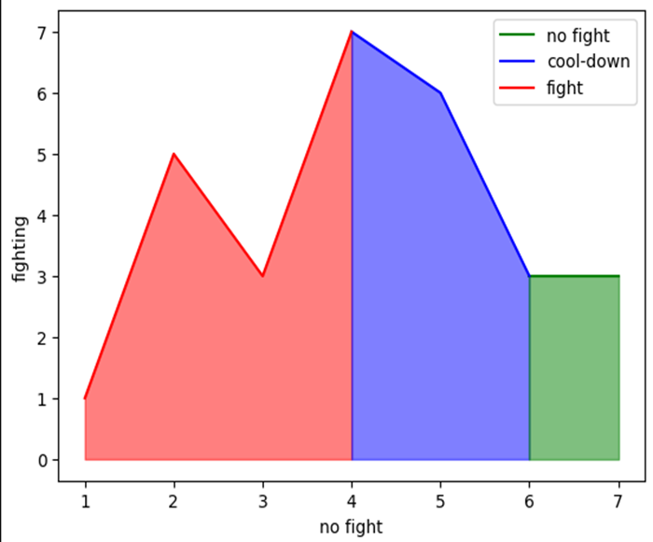
Fig. 1. Line graph

Fig.1 represents a graph between two behaviours (fighting and no fighting). The red line represents fighting behaviour while the green line represents no fight behaviour and the cool down behaviour is represented in blue colour.

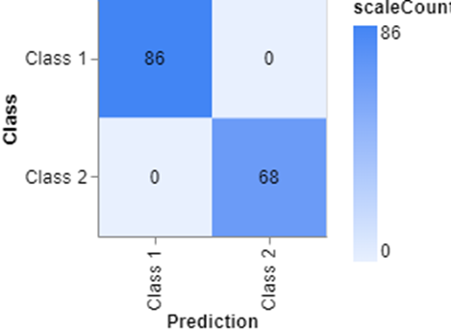
Fig. 2. Confusion matrix

Fig.2 depicts a confusion matrix which is a helpful tool for assessing how well a system for detecting suspicious behaviour is working. It shows the system's total number of accurate predictions, including true positives, false postives, true negatives, and false negatives.

System Architecture
Fig 3 The system architecture for anonymous activity detection can be divided into several components, including:
      - Input Data: The input data used in suspicious activity detection come from various sources, including video surveillance footage, sensor data, and social media feeds. For this project, we analyzed video footage collected from multiple cameras in a public space. The video data was in a standard format, such as MP4 or AVI, and had a resolution of 1080p. The footage was collected for several days and contained various activities that are unusual.
      - Pre-processing: Before feeding the video footage into the CNN algorithm, we performed numerous pre-processing processes to improve the data quality and remove any extraneous information. Pre-processing, which helps to clean and prepare the data before feeding it into the machine learning model, is a crucial stage in the detection of suspicious behaviour. In this project, we pre-processed the video surveillance material using a number of methods to make sure the model could detect suspicious activity with accuracy. In order to lessen the computational load and boost the efficiency of the model, the first step was to shrink the video frames to a standard size. A resolution of 256x256 pixels was used because it was sufficient to capture the required details without being overly computationally demanding .Next, we converted the color space of the frames from RGB to grayscale. This was done to simplify the data and reduce the number of channels in the input, which helped to speed up the model's training time. To further clean the data, we applied background subtraction to remove any stationary background objects such as trees or buildings. This was important to avoid false positives caused by changes in the background environment. Finally, we applied data augmentation techniques to increase the model's robustness and avoid overfitting. This involved randomly zooming, flipping, and rotating the frames to create additional variations of the data. Overall, these pre-processing techniques helped to create a cleaner, standardized, and more robust dataset that enabled the model to accurately detect suspicious activities in the video footage.
> Data Classification: A critical first step in creating a system to detect suspicious activity is data classification. In this study, we classified the video material into suspicious and non-suspect categories using the CNN model. To train the CNN model, we used video data that had been pre-processed. Then the pre-processed data was divided sets like training sets, validation sets and test sets. While the training set was used to train the model, the validation set was used to adjust and prevent overfitting of the model. Using the test set, the model's performance on untested data was evaluated.
      - Training and Testing Sets: A function was utilised to calculate the difference between the expected and real labels during training. The weights and biases of the model were also updated using the Adam optimizer. The results showed that our CNN model was able to accurately classify suspicious activity in the video footage with high precision and recall.
      - Frame Extraction: The frames of the videos are separated using a Python script. The appropriate frames that accurately and clearly depict the action of anonymous are manually chosen for use. The videos from which the extracted frames were taken feature a variety of settings, events, people, and situations. Every action, about 250–300 frames are chosen.

      - Output: After training is complete, the application recognises suspicious human activity by displaying coloured, labelled boxes near the incident for video input. When using an image as an input, the GUI displays the results and a percentage of the output.
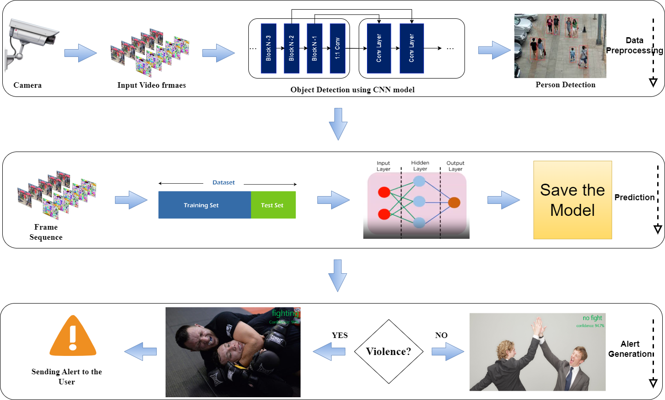
Fig. 3.System architecture

Testing and calculations

Conclusion
In conclusion, our experiment has proven how well a Convolutional Neural Network (CNN) model works for spotting suspicious activities in video surveillance material. We were able to build a strong dataset that allowed the CNN model to precisely identify anomalous behaviors and motions through thorough preprocessing and data augmentation procedures.

Our findings demonstrated that the CNN model attained excellent accuracy and low false positive rates, which are crucial indicators for dependable suspicious activity identification. Additionally, we established the superiority of the CNN model by contrasting our strategy with other machine learning techniques.

Overall, by offering a workable technique for spotting unusual activity that can be used in different contexts, this study will make a contribution to the fields of video analytics and security. The model can be enhanced in the future by experimenting with other designs, fine-tuning hyperparameters, and adding further features like audio and text data.

References

[1] Ms. U. M. Kamthe and Dr. C. G. Patil “Suspicious Activity Recognition in Video Surveillance System”, 2018.
[2] Suvarna Nandyal and Sanjeev kumar Angadi “Recognition of Suspicious Human Activities Using KLT and Kalman Filter For ATM Surveillance System”, 2021.
[3] Miwa Takai “Alert Generation on Detection of Suspicious Activity Using Transfer Learning”, 2020.
[4] Abouzar Ghasemi “Suspicious Behaviour Detection of People by Monitoring Camera”, 2016.
[5] Nipunjita Bordoloi, Anjan Kumar Talukdar “Suspicious Activity Detection from YOLOv3”, 2021.
[6] Aqil Shamnath and Meena Belwal “Human Suspicious Activity Detection Using Ensemble Machine Learning Techniques”, 2022.
[7] Sathyajit Loganathan and Gayashan Kariyawasam “Suspicious Activity Detection in Surveillance Footage”, 2019.
[8] Amrutha C. V and Joytsna Amudha J “Deep Learning Approach for Suspicious Activity Detection from Surveillance Video”, 2020.
[9] Phong H. Nguyen, Cagatay Turkay “Understanding User Behaviour through Action Sequences: From the Usual to the Unusual”, 2019.
[10] Rajesh Kumar Tripathi and Anand Singh Jalal “Suspicious human activity recognition: a review”, 2017.
[11] P. H. Nguyen and C. Turkay “A Visual Analytics Approach for User Behaviour Understanding through Action Sequence Analysis”, 2017.
[12] Amira Ben Mabrouk and Ezzeddine Zagrouba “Abnormal behaviour recognition for intelligent video surveillance systems”, 2017.
[13] Zhou Zhigang, Duan Guangxue, Lei Huan “Human behaviour recognition method based on double-branch deep convolution neural network”, 2018.
[14] Patiyuth Pramkeaw, Pearlrada Ngamrungsiri, Mahasak Ketcham “CCTV Face Detection Criminals and Tracking System Using Data Analysis Algorithm”, 2019.
[15] Martin D. Levine “Automated Real-Time Detection of Potentially Suspicious Behaviour in Public Transport Areas”,2013.

