BANK NETWORK DESIGN



COURT ROAD NETWORKZ SYSTEMS NAGERCOIL, KANYAKUMARI

STUDENT NAME : K.MUTHU

STUDENT ID : NSNCV0323325

STAFF NAME : ANTONET REETA COURSE NAME : CCNA

DATE : 17-07-2023

TABLE OF CONTENT

|  |  |  |
| --- | --- | --- |
| Serial.No | TITTLE | Page.No |
| 1 | Abstract | 1 |
| 2 | Acknowledgment |  |
| 3 | Introduction |  |
| 4 | Network Requirement |  |
| 5 | Hardware & software requirement |  |
| 6 | Switch & router Configuration |  |
| 7 | Network Topology |  |
| 8 | Output Results |  |
| 9 | Conclusion |  |

**Abstract**

The Primary purpose of a computer network is to share resources. A computer network is referred to as client/server if (at least) one of the computers is used to server other computer referred to as client. Beside the computers,other types of devices can be part of the network. In the early day of networking there will be once central server that contains the data and all the clients can access this data through a Network Interface card. Later on client server architecture came into existence, where still burden is there on the server machine. To avoid the disadvantages in distributed computing was introduced which reduce the burden on the server by providing work sharing capabilities. This paper describes how the concept of distributed computing came into existence based on the advantages and disadvantages that raised in earlier networking concepts. The concepts of distributed computing speaks that once data is available within the server (s), it should be able to be accessed and processed from any kind of client device like computer, computer, mobile phone, PDA, etc.

# ACKNOWLEDGMENT

First we would like to thank the Almighty for his wonderful presence with us throughtout the completion of the project and making it as a successful one.

We are expressing our deep gratitude to **COURT ROAD NETWORKZ SYSTEMS INSTITUTION**

which provided us an opportunity in fulfilling our most cherished desire in reaching our goal.

This is a great pleasure to express our deep sense of gratitude and thanks to our guide **MISS ANTONET REETA** for her valuable ideas, instantaneous help, effective support and continued encouragement which enabled for the successful completion of the project

W e g r a t e f u l l y r e m e m b e r t h e a v a i l a b l e suggestion of our respective staff for their valuable and timely guidance for the completion of the project.

W e g r a t e f u l l y r e m e m b e r t h e a v a i l a b l e suggestion of our respective staff for their valuable and timely guidance for the completion of this project. Finally we would like to express our sincere thanks to all our friends who gave good ideas not suggestions for our project.

# INTRODUCTION

Networking is referred as connecting computers electrically for the purpose of sharing i n f o r m a t i o n . R e s o u r c e s s u c h a s a f i l e , application, printer & software. The advantage of networking can be seen in the terms of security, efficiency, manageablility and cost as it allows collaboration between user in a wide range. The switches and router this device that play and important role in data transfer from one place to another using different technology such ad radio waves & wire.

# Networking Requirement

1. The active networking components (Routers, Switches, Wireless access points etc) with quantity.
2. The IP network design for each department.
3. Dynamic IP addressing design for all networks
4. Identify the configuration and features, wherever appropriate, which is required on the active components to setup the network.
5. Analysis, identification and explantion of methodologies to use for access restriction and internet sharing.
6. Creating and mapping IP networks with WAP

# HARDWARE REQUIREMENT

* Processor AMD PRO A4-4350B R4,5 COMPUTE

CORES 2C

+3G 2.50GHz

* RAM 4.00 GB
* System Type 64-bit operating system

# REQUIREMENT

1. The following use cisco packet tracer to design and implement the network solution
2. Use RIP and OSPF as the routing protocol
3. Configure SSH in HR department and IT department
4. Security room, Conference room,

Floor 1 and Floor 5 required to have a Secure network for the users

1. Waiting hall and Conference hall should be in a Wireless Acess Point
2. Class A type IP address used in every department
3. Device in Security room and

Conference hall WAP Switch secure the network WEP password and SSID

are required to communicate with each other

1. Floor 1 and Floor 5 are Server to device allocated IP address Floor 1 is a wired server and Floor 5 is a wireless server
2. All Departments are allocated IP address dynamically
3. Test communication ensure everything configured is working as expected

# SOFTWARE REQUIREMENT

* CISCO Packet Tracer

# ROUTER CONFIGURATION

ROUTER 1

Router>en Router#conf t

Enter configuration commands, one per line. End with CNTL/Z.

R1(config)#ip dhcp pool muthu

R1(config-dhcp)#network 60.0.0.0 255.0.0.0

R1(config)#default-router 60.0.0.1

interface GigabitEthernet0/0

ip address 60.0.0.1 255.0.0.0

no sh

ex

interface Serial0/1/0

ip address 8.0.0.1 255.0.0.0

clock rate 2000000

router rip

network 8.0.0.0

network 60.0.0.0

R1(config)#hostname R1

R1(config)#line vty 0 5

R1(config-line)#password 12345

R1(config-line)#transport input ssh R1(config-line)#login local

R1(config-line)#exit

R1(config)#ip domain name muthu

R1(config)#crypto key generate rsa

The name for the keys will be: R1.12345

Choose the size of the key modulus in the range of 360 to 2048 for your General Purpose Keys. Choosing a key modulus greater than 512 may take a few minutes.

How many bits in the modulus [512]: 512

ROUTER 2

Router>en Router#conf t

Enter configuration commands, one per line. End with CNTL/Z.

ip dhcp pool muthu

R2(config-dhcp)#network 70.0.0.0 255.0.0.0

R2(config)#default-router 60.0.0.1

no ip cef

no ipv6 cef

license udi pid CISCO1941/K9 sn FTX1524F7RT-

spanning-tree mode pvst

interface GigabitEthernet0/0

ip address 70.0.0.1 255.0.0.0

duplex auto

speed auto

interface GigabitEthernet0/1

no ip address

duplex auto

speed auto

shutdown

interface Serial0/0/0

ip address 9.0.0.1 255.0.0.0

interface Serial0/0/1

no ip address

clock rate 2000000

shutdown

interface Serial0/1/0

no ip address

clock rate 2000000

shutdown

interface Serial0/1/1

no ip address

clock rate 2000000

shutdown

interface Vlan1

no ip address

shutdown

router rip

network 9.0.0.0

network 70.0.0.0R2(config-router)#exit

R2(config)#enable password staffroom R2(config)#enable secret room R2(config)#username staff password staffroom R2(config)#hostname R2

R2(config)#line vty 0 5

R2(config-line)#password staffroom R2(config-line)#login local R2(config-line)#exit

Router 3

Router>en

Router#conf t

Enter configuration commands, one per line. End with CNTL/Z. hostname HR

enable password 12345

ip dhcp pool muthu

network 80.0.0.0 255.0.0.0

default-router 80.0.0.1

no ip cef

no ipv6 cef

username HR password 0 12345

ip ssh version 1

ip domain-name k

spanning-tree mode pvst

interface GigabitEthernet0/0

ip address 80.0.0.1 255.0.0.0

duplex auto

speed aut

interface GigabitEthernet0/1

no ip address

duplex auto

speed auto

shutdown

interface Serial0/0/0

ip address 10.0.0.1 255.0.0.0

interface Serial0/0/1

no ip address

clock rate 2000000

shutdown

interface Serial0/1/0

no ip address

clock rate 2000000

shutdown

interface Serial0/1/1

no ip address

clock rate 2000000

shutdown

interface Vlan1

no ip address

shutdown

router rip

network 10.0.0.0

network 80.0.0.0

ip classless

ip flow-export version 9

line con 0

line aux 0

line vty 0 4

password 12345

login

transport input ssh

line vty 5 15

password 12345

login

transport input ssh

end

ROUTER 4

ip dhcp pool muthu

network 90.0.0.0 255.0.0.0

default-router 90.0.0.1

ip cef

no ipv6 cef

username IT password 0 12345

license udi pid CISCO1941/K9 sn FTX1524NHL4-

ip ssh version 1

ip domain-name k

spanning-tree mode pvst

interface GigabitEthernet0/0

ip address 90.0.0.1 255.0.0.0

duplex auto

speed auto

interface GigabitEthernet0/1

no ip address

duplex auto

speed auto

shutdown

interface Serial0/0/0

no ip address

clock rate 2000000

interface Serial0/0/1

no ip address

clock rate 2000000

interface Serial0/1/0

ip address 11.0.0.1 255.0.0.0

interface Serial0/1/1

no ip address

clock rate 2000000

interface Vlan1

no ip address

shutdown

router rip

network 11.0.0.0

network 90.0.0.0

ip classless

ip flow-export version 9

line con 0

line aux 0

line vty 0 4

password 12345

login

transport input ssh

line vty 5 15

password 12345

login

transport input ssh

end

ROUTER 5

Router>en

Router#conf t

Enter configuration commands, one per line. End with CNTL/Z.

interface GigabitEthernet0/0

ip address 7.0.0.2 255.0.0.0

duplex auto

speed auto

interface GigabitEthernet0/1

no ip address

duplex auto

speed auto

shutdown

interface Serial0/0/0

ip address 9.0.0.2 255.0.0.0

clock rate 2000000

interface Serial0/0/1

ip address 8.0.0.2 255.0.0.0

interface Serial0/1/0

ip address 10.0.0.2 255.0.0.0

clock rate 2000000

interface Serial0/1/1

ip address 11.0.0.2 255.0.0.0

clock rate 2000000

interface Vlan1

no ip address

shutdown

router rip

network 7.0.0.0

network 8.0.0.0

network 9.0.0.0

network 10.0.0.0

network 11.0.0.0

ROUTER 6

Router>en Router#conf t

Enter configuration commands, one per line. End with CNTL/Z.

interface GigabitEthernet0/0

ip address 6.0.0.2 255.0.0.0

duplex auto

speed auto

interface GigabitEthernet0/1

ip address 7.0.0.1 255.0.0.0

duplex auto

speed auto

interface Serial0/0/0

ip address 2.0.0.2 255.0.0.0

interface Serial0/0/1

ip address 3.0.0.2 255.0.0.0

interface Serial0/1/0

ip address 4.0.0.2 255.0.0.0

interface Serial0/1/1

ip address 5.0.0.2 255.0.0.0

clock rate 2000000

interface Vlan1

no ip address

shutdown

router ospf 1

log-adjacency-changes

network 4.0.0.0 0.255.255.255 area 0

network 5.0.0.0 0.255.255.255 area 0

network 6.0.0.0 0.255.255.255 area 0

router rip

network 2.0.0.0

network 3.0.0.0

network 4.0.0.0

network 5.0.0.0

network 6.0.0.0

network 7.0.0.0

ROUTER 7

Router>en Router#conf t

Enter configuration commands, one per line. End with CNTL/Z.

ip dhcp pool muthu

network 30.0.0.0 255.0.0.0

default-router 30.0.0.1

spanning-tree mode pvst

interface GigabitEthernet0/0

ip address 40.0.0.1 255.0.0.0

duplex auto

speed auto

interface GigabitEthernet0/1

ip address 6.0.0.1 255.0.0.0

duplex auto

speed auto

interface Serial0/0/0

no ip address

clock rate 2000000

shutdown

interface Serial0/0/1

no ip address

clock rate 2000000

shutdown

interface Serial0/1/0

no ip address

clock rate 2000000

shutdown

interface Serial0/1/1

no ip address

clock rate 2000000

shutdown

interface Vlan1

no ip address

shutdown

router ospf 1

log-adjacency-changes

network 40.0.0.0 0.255.255.255 area 0

network 6.0.0.0 0.255.255.255 area 0

router rip

network 6.0.0.0

network 40.0.0.0

ROUTER 8

Router>en Router#conf t

Enter configuration commands, one per line. End with CNTL/Z.

ip dhcp pool muthu

network 30.0.0.0 255.0.0.0

default-router 30.0.0.1

interface GigabitEthernet0/0

ip address 30.0.0.1 255.0.0.0

duplex auto

speed auto

interface GigabitEthernet0/1

no ip address

duplex auto

speed auto

shutdown

interface Serial0/0/0

ip address 4.0.0.1 255.0.0.0

clock rate 2000000

interface Serial0/0/1

no ip address

clock rate 2000000

shutdown

interface Serial0/1/0

no ip address

clock rate 2000000

shutdown

interface Serial0/1/1

no ip address

clock rate 2000000

shutdown

interface Vlan1

no ip address

shutdown

router ospf 1

log-adjacency-changes

network 30.0.0.0 0.255.255.255 area 0

network 4.0.0.0 0.255.255.255 area 0

router rip

network 4.0.0.0

network 30.0.0.0

# NETWORK TOPOLOGY

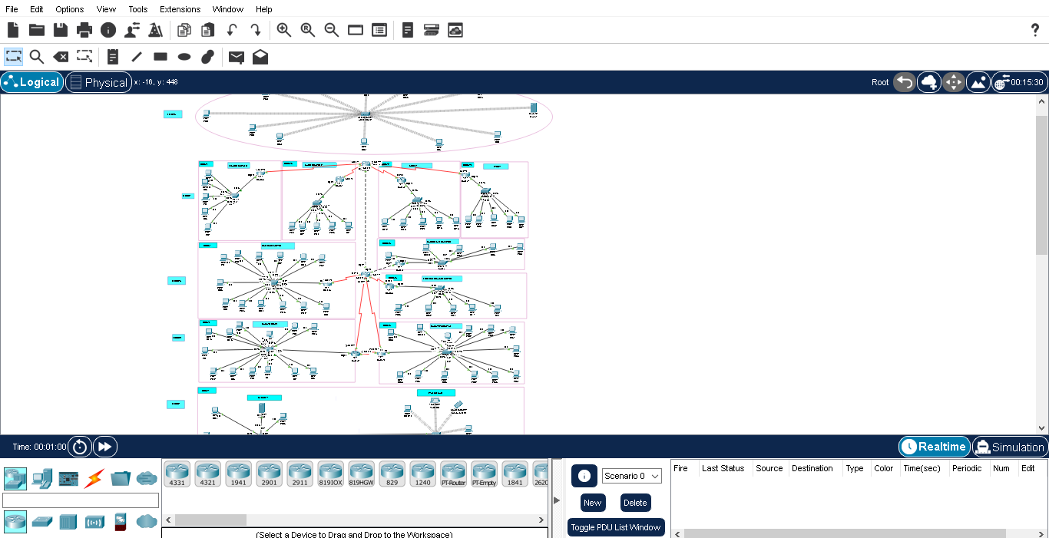

**Wired server and Wireless PING**

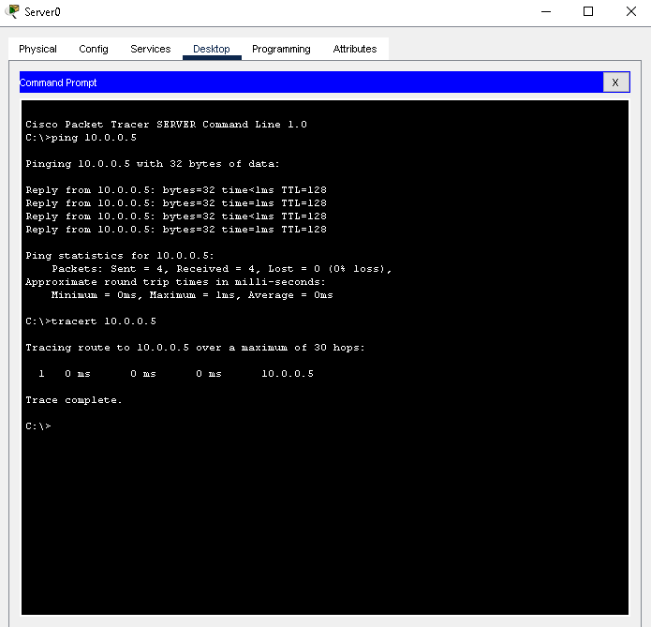

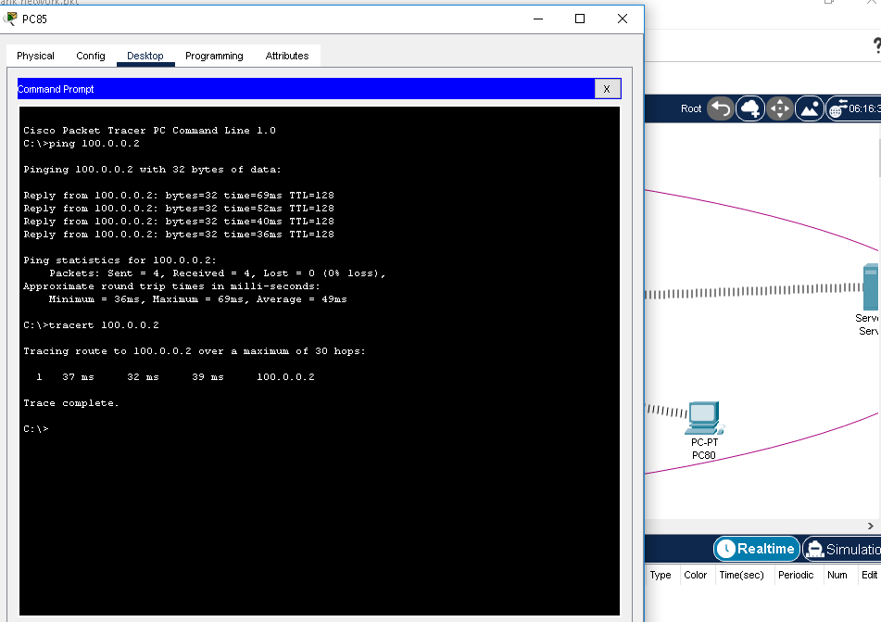

# SSH

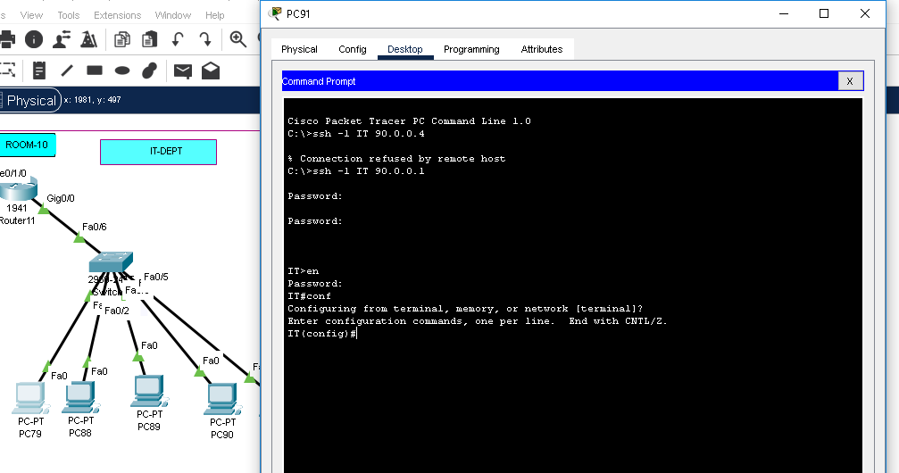

**OSPF ROUTING**

AND PING

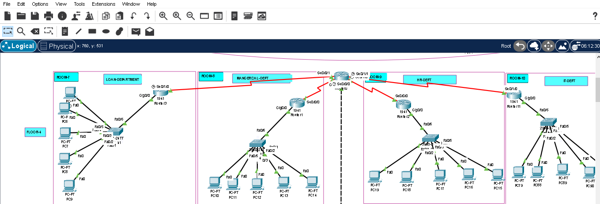

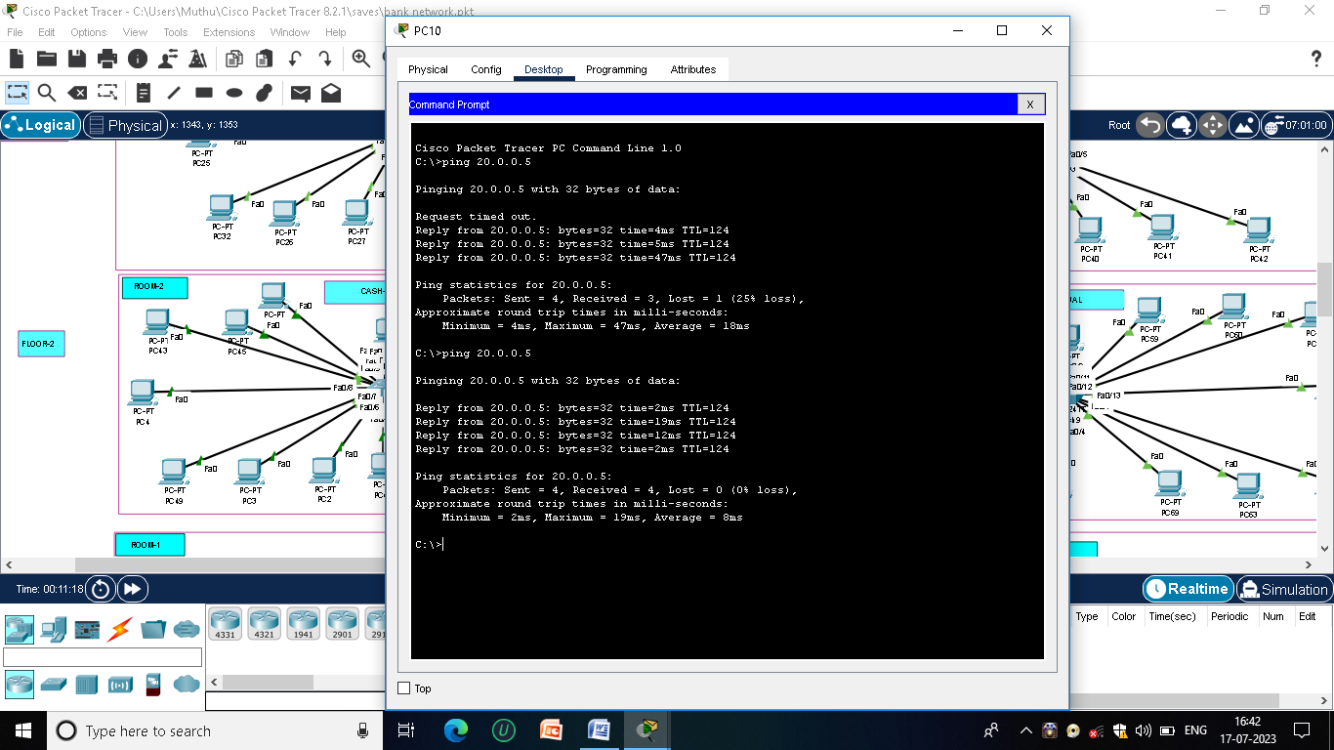

# DHCP IN SERVER

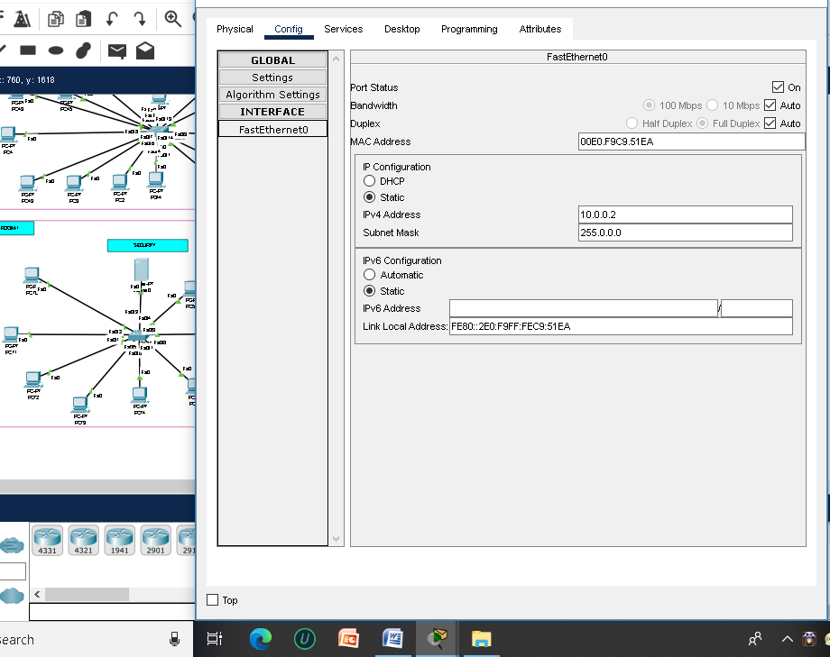

# WIRELESS ACCESSPOINT

# Screenshot (20).png

**CONCLUSION**

The whole network provide the convenient and secure way for the entire users of the bank and use better convenient way to access in order to get uninterrupted network, especially vlan & inter-vlan concept for the particular switches.