NOVA DISTRIBUTED JOB SCHEDULER
Enterprise High-Fidelity Queue Manager & Distributed Job Orchestration

Project: Nova Scheduler Client-Server Stack
Interface: High-Fidelity Cyberpunk Design System
Database Layer: Prisma ORM & PostgreSQL
Date: July 2026
Status: Production Ready

1. Executive Summary
Nova Distributed Job Scheduler is a production-inspired, highly reliable platform built to manage, claim, and execute asynchronous background jobs across multiple distributed worker nodes. The system is engineered with an emphasis on concurrency control, absolute task execution guarantees, priority scheduling, and comprehensive real-time monitoring diagnostics.
Following a high-fidelity visual overhaul, the client applications implement a modern cyberpunk design language, leveraging sleek glassmorphism panels, high-contrast statuses, real-time WebSocket telemetry log streams, and interactive status widgets. This document details the technical infrastructure, database architecture, API specification, and execution topologies of the system.
Key Functional Pillars:
- • Multi-Tenant Project Namespaces: Projects serve as workspace partitions owning dedicated job queues.
- • Advanced Queue Topologies: Support for priority constraints, granular concurrency limits, linear/exponential retry policies, and pause/resume flags.
- • Polyphonic Job Types: Support for Immediate execution, Scheduled execution, Delayed delays, Cron-based Recurring loops, and Batch grouping collections.
- • Active Worker Registry: Heartbeats tracking node memory, load average slots, active channels, and status changes.
- • Dead Letter Queue (DLQ): Secure isolation of permanently exhausted jobs with full stack traces, debug inspectors, and one-click queue resubmissions.

2. System Architecture
The architecture is divided into three key layers: the client layer, the middleware controller (API & Socket Server), and the distributed worker clusters. Persistent state is maintained via a PostgreSQL instance, driven through Prisma schemas.
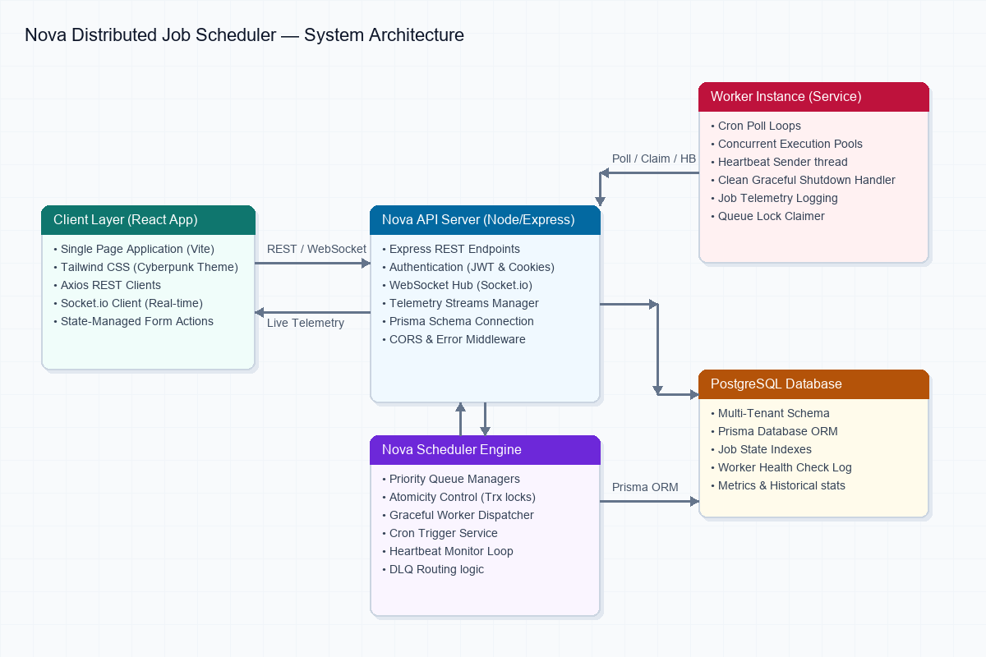
Figure 2.1: Distributed Topology and Data Exchange Flows
Communication between components is governed by two main protocols:
1. REST API HTTP Client: Used by the React frontend and worker nodes to submit transactions, register projects, poll jobs, and retrieve operational states.
2. Socket.io WebSockets: Drives reactive real-time UI components. The API server broadcasts telemetry packets (logs, stats, worker heartbeat intervals) directly to client dashboards.

3. Database Schema & ER Diagram
The relational database schema enforces structure while providing JSONB attributes for payloads and policies. Indexes are placed on columns such as status, runAt, and queueId to optimize high-volume scheduling queries.
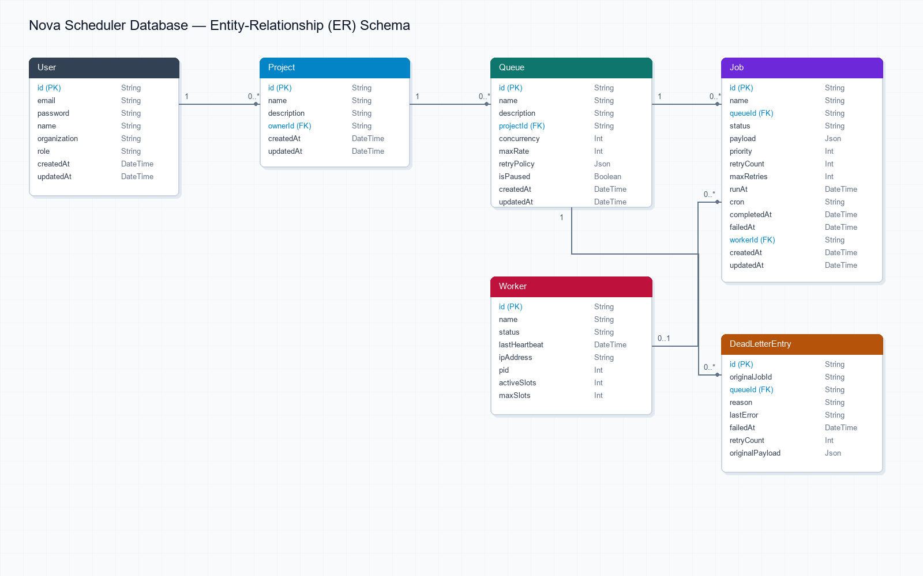
Figure 3.1: Entity-Relationship Diagram (ERD)

Table Schema Definitions
Table: User (Authentication & Management)
Field | Type | Description
id | String (PK) | Unique UUID
email | String (Unique) | Email identifier used for log in
password | String | Salted and hashed credentials password
Table: Job (Execution Engine Core)
Field | Type | Description
id | String (PK) | Job UUID
queueId | String (FK) | Reference to owning queue
status | Enum | QUEUED, SCHEDULED, RUNNING, COMPLETED, FAILED
priority | Integer | Precedence index (higher gets polled first)
cron | String (Nullable) | Standard cron expression for recurring tasks

4. API Endpoint Specifications
Method | Endpoint Path | Description / Functionality
POST | /api/auth/register | Register a new user and initialize tenant workspace
POST | /api/auth/login | Authenticate credentials and issue state session cookies
GET | /api/projects | Retrieve all workspaces for the authenticated organization
POST | /api/projects | Create a new project container
GET | /api/queues | Fetch job queues and associated throughput metrics
POST | /api/jobs | Enqueues immediately, schedules, or schedules recurring cron jobs
POST | /api/jobs/:id/retry | Manual resubmission trigger from DLQ registry

5. Interface Visuals (Cyberpunk Redesign)
The entire user interface has been customized with a cohesive cyberpunk style. Below are screenshots showing the operational pages in action.

Login Interface
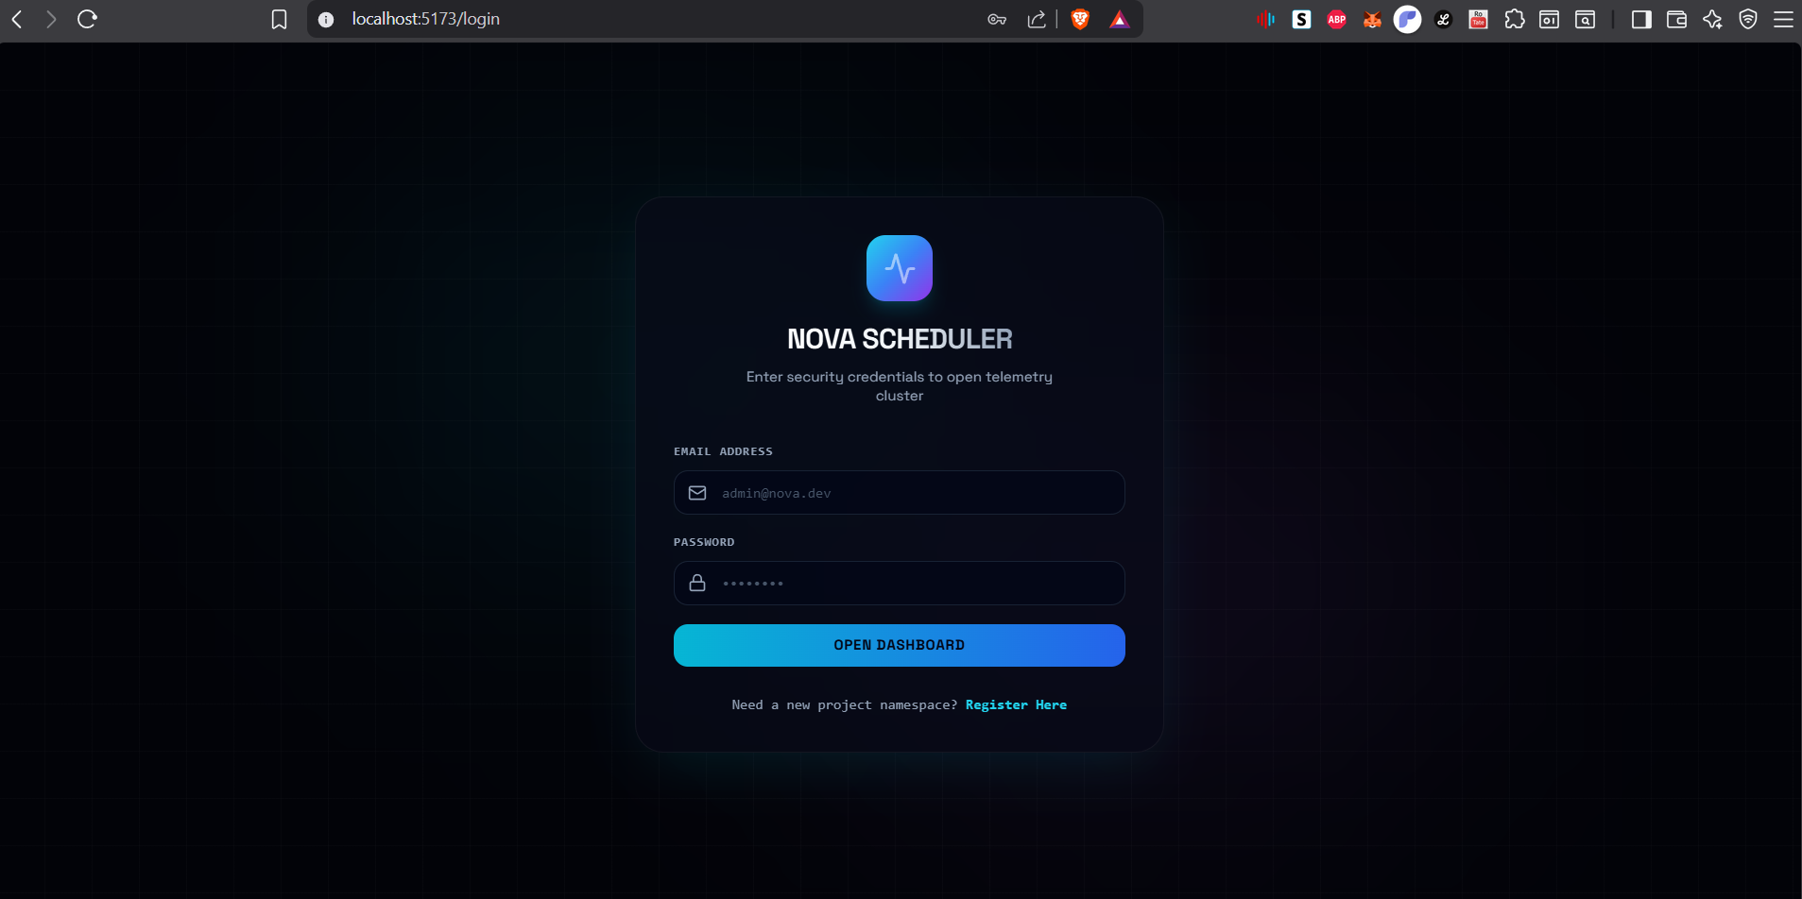
Login Portal: Security credentials gate with neon glow textboxes.

Dashboard Interface
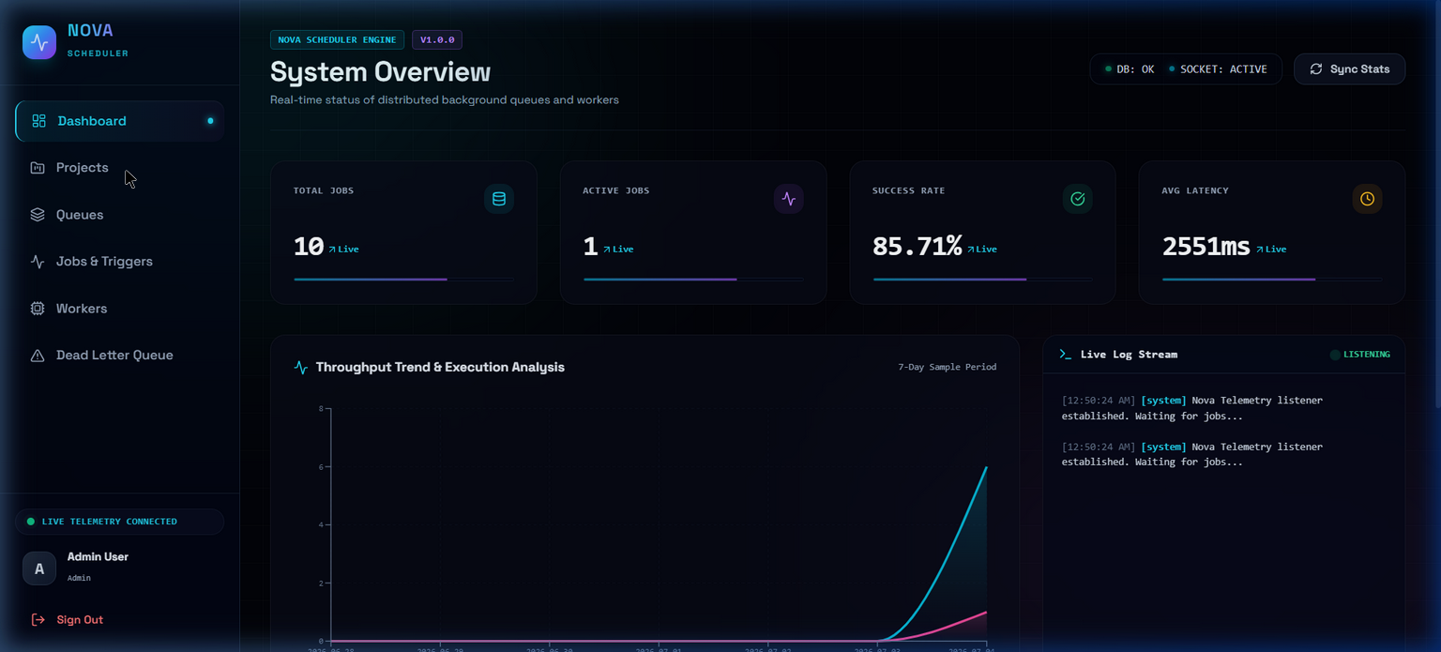
System Overview: Central dashboard displaying real-time success charts and active logs telemetry streams.

Projects Interface
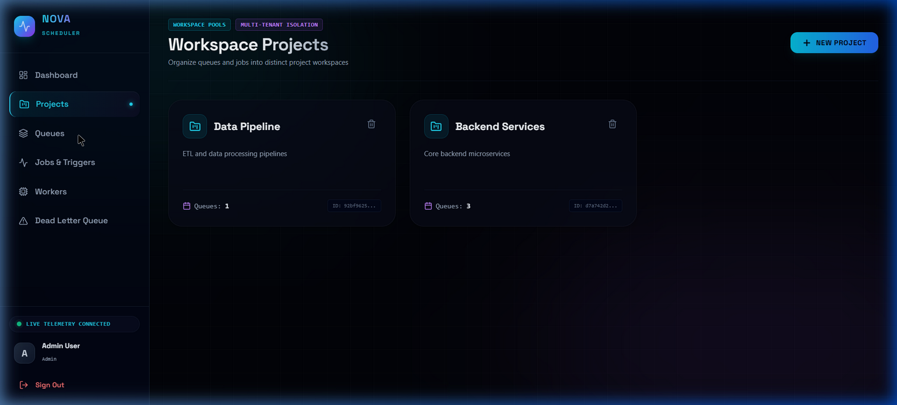
Workspace Projects: Visual workspace cards holding unique namespaces.

Queues Interface
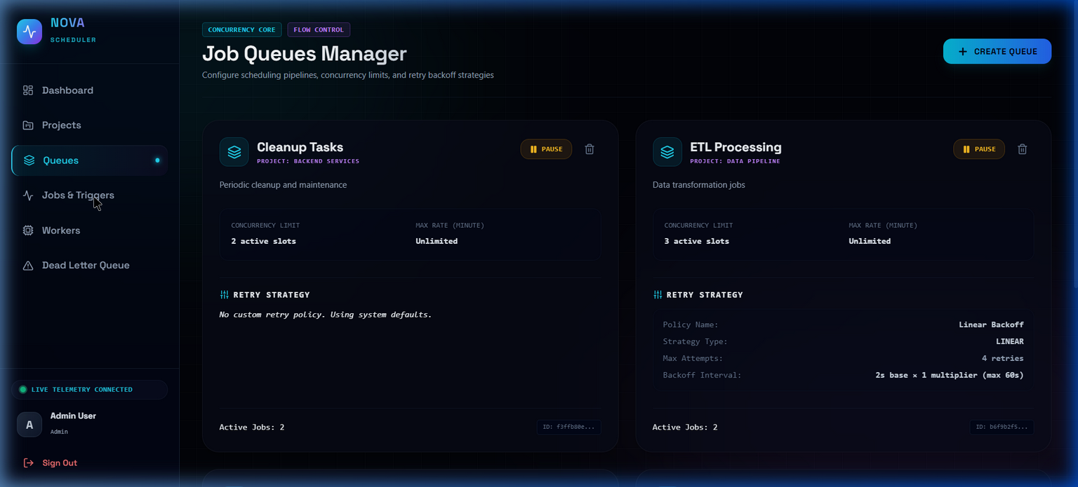
Job Queues Manager: Panel control showing pause states, concurrency slot values, and retry behaviors.

Jobs Interface
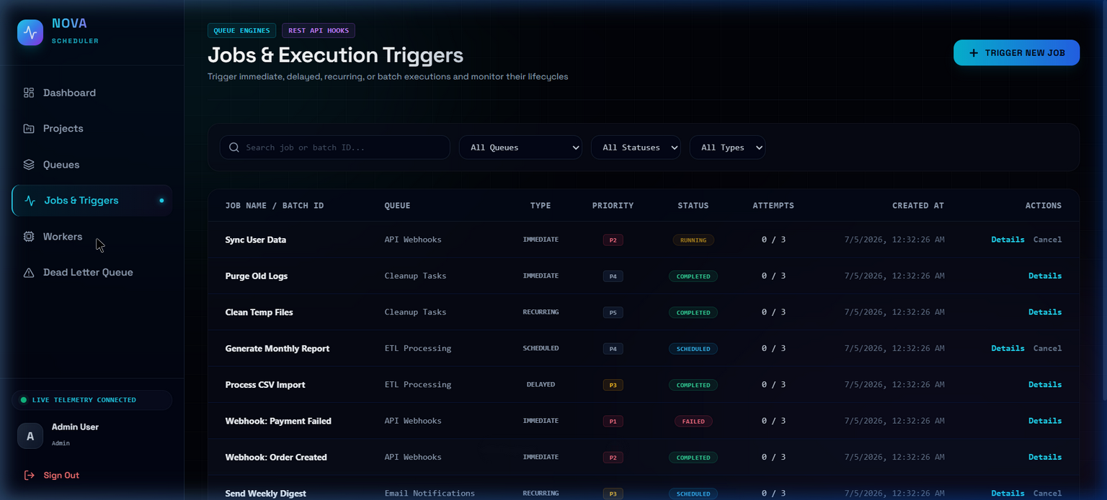
Jobs & Triggers: Execution database table with colored status badges.

Workers Interface
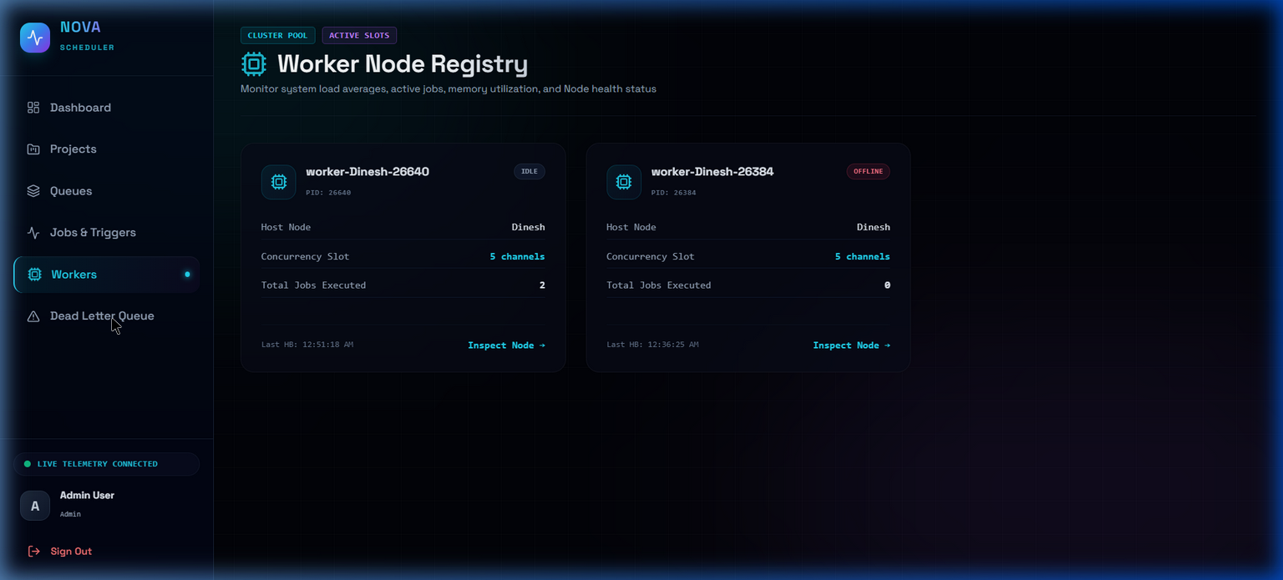
Workers Node Registry: Connected worker cards displaying live telemetry and slot capacity metrics.

6. Setup & Execution Guide

Prerequisites
• Node.js version 18.0.0 or higher
• PostgreSQL Database Server running locally or in Docker
• npm or yarn package manager

Step 1: Environment Sync
Configure the DATABASE_URL environment parameter in server/.env file:
DATABASE_URL="postgresql://postgres:<YOUR_POSTGRES_PASSWORD>@localhost:5432/nova_scheduler?schema=public"

Step 2: Database Initialization
# Run database migrations and seed data
npm run db:seed

Step 3: Running Development Cluster
You can run the full ecosystem concurrently (server + client) using the root wrapper command:
# Starts backend server (port 3000) and frontend client (port 5173)
npm run dev

