TicketDesk AWS Capstone — Proof of Concept (POC)
End-to-End Cloud Infrastructure, Containerization & CI/CD Deployment Documentation
GitHub Repository | https://github.com/DINESHYAPAMANU/ticketdesk-aws-capstone
Live Production URL | http://ticketdesk-alb-91266493.ap-south-1.elb.amazonaws.com
Target Region | AWS ap-south-1 (Mumbai)
AWS Account ID | 063293864353

1. Project Overview
TicketDesk is an enterprise-grade, cloud-native Support Ticket Management System built on ASP.NET Core 8 Web API (Backend) and Angular 17 SPA (Frontend). The application provides end-to-end IT service desk functionalities including user registration, role-based authentication (Employee vs Admin), ticket creation with priority and category tags, comment threads, file attachments, profile password management, and operational analytics dashboards.
The objective of this Capstone POC is to transition TicketDesk from local development into an automated, highly available, secure, and monitored cloud infrastructure deployed on Amazon Web Services (AWS) using Terraform (IaC), Amazon ECS Fargate, Amazon RDS SQL Server, and GitHub Actions CI/CD.

2. Architecture Diagram
The architectural diagram below illustrates the pure Amazon ECS Fargate container deployment architecture across 2 Availability Zones:
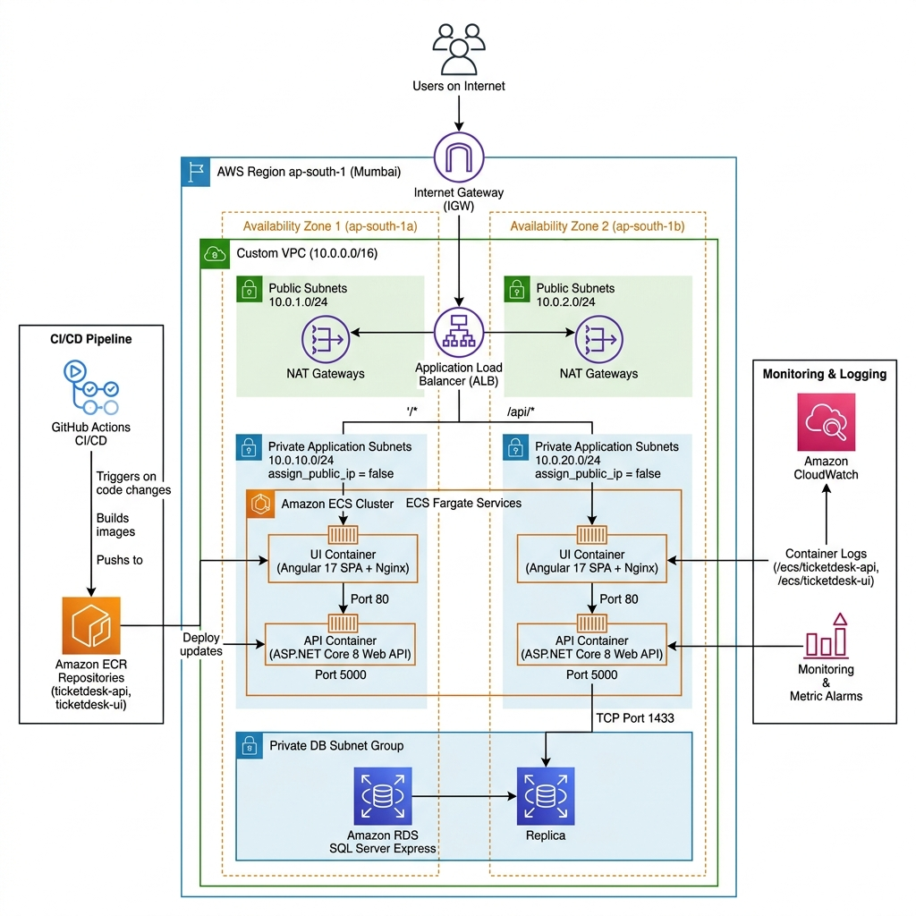
Figure 1: TicketDesk High-Availability AWS Cloud Architecture on Amazon ECS Fargate

3. AWS Services Used
AWS Service | Resource Name | Function & Purpose
Amazon VPC | ticketdesk-vpc | Custom VPC (10.0.0.0/16) spanning 2 Availability Zones (ap-south-1a, ap-south-1b).
Application Load Balancer | ticketdesk-alb | Public ALB with path-based listener rules (/api/* to API, /* to UI).
Amazon ECS (Fargate) | ticketdesk-cluster | Serverless container execution in private subnets with assign_public_ip = false.
Amazon ECR | ticketdesk-api, ticketdesk-ui | Private Docker registries with automated vulnerability scan-on-push.
Amazon RDS (SQL Server) | ticketdesk-sqlserver | Managed SQL Server Express instance (db.t3.micro) in private DB subnets with KMS encryption.
Amazon CloudWatch | ticketdesk-operations-dashboard | Log groups (/ecs/ticketdesk-api, /ecs/ticketdesk-ui), 3 metric alarms, and dashboard.
AWS IAM | ecs_execution_role, ecs_task_role | Scoped least-privilege IAM roles for ECS container execution and CloudWatch logging.
HashiCorp Terraform | terraform/*.tf | Infrastructure as Code (IaC) defining 100% of AWS infrastructure resources.

4. Application Flow
1. User Authentication & Signup: New users register via the frontend SPA. Registration automatically assigns Role = Role.Employee on the backend AuthService. Upon login (POST /api/Auth/login), the API verifies BCrypt password hashes and issues a signed JWT token.
2. Ticket Operations: Employees create tickets with Subject, Description, Priority (Low/Medium/High/Urgent), and Category tags. Admins view organization-wide tickets, assign tickets to agents, and update ticket lifecycle statuses.
3. Password Management: Users navigate to Profile -> Change Password. The API validates the existing password with BCrypt and persists the new BCrypt hash.

5. Network Architecture
Subnet Name | CIDR Block | Availability Zone | Hosted Components
Public Subnet 1 | 10.0.1.0/24 | ap-south-1a | Application Load Balancer (ALB), NAT Gateway
Public Subnet 2 | 10.0.2.0/24 | ap-south-1b | Application Load Balancer (ALB)
Private Subnet 1 | 10.0.10.0/24 | ap-south-1a | ECS API & UI Tasks (assign_public_ip = false)
Private Subnet 2 | 10.0.20.0/24 | ap-south-1b | ECS API & UI Tasks (assign_public_ip = false)
DB Subnet Group | 10.0.10.0/24, 10.0.20.0/24 | Multi-AZ | Amazon RDS SQL Server Express Instance

6. Terraform Architecture
The infrastructure is defined modularly in the terraform/ directory:
• provider.tf: Configures AWS provider ap-south-1 (version ~> 5.0).
• vpc.tf: Provisions VPC, 4 subnets, Internet Gateway, NAT Gateway, and Route Tables.
• security_groups.tf: Implements strict ingress rules (ALB -> ECS Tasks -> RDS SQL Server).
• ecr.tf: Manages container registries with image scan-on-push enabled.
• ecs.tf: Configures ECS Fargate Cluster, Task Definitions, ALB Target Groups, and Listeners.
• rds.tf: Provisions Amazon RDS SQL Server Express in private DB subnets.
• observability.tf: Creates CloudWatch log groups, alarms, and the operations dashboard.

7. Docker & Containerization Approach
• API Dockerfile: Multi-stage build utilizing dotnet/sdk:8.0 for compilation and dotnet/aspnet:8.0 for execution. Hardened to run as non-root user appuser (UID 1000).
• UI Dockerfile: Multi-stage build utilizing node:22-alpine for Angular SPA compilation and nginx:alpine for web serving. Configured with Cache-Control 'no-store, no-cache, must-revalidate' for index.html.

8. Database Configuration
• Engine: Microsoft SQL Server Express (15.00.4073.23.v1) on db.t3.micro.
• Network Security: Hosted in private DB subnets with publicly_accessible = false, restricted to ECS Task SG on port 1433.
• Encryption: Storage encrypted with AWS KMS.
• ORM: Entity Framework Core 8 with automated migrations on application startup and persistent seed data.

9. Secrets Management
• CI/CD Secrets: AWS_ACCESS_KEY_ID and AWS_SECRET_ACCESS_KEY encrypted via libSodium SealedBox in GitHub Repository Secrets.
• Application Configuration: Connection strings and JWT secrets passed securely to ECS task definitions.

10. Frontend Deployment
The Angular 17 Single Page Application is containerized with Nginx and deployed as a high-availability service on ECS Fargate. The Application Load Balancer path rule routes all '/*' client traffic to the UI ECS service in private subnets.

11. Lambda Flow
A serverless Python Lambda function (thumbnail_lambda.zip) is configured to handle automated ticket attachment processing, generating image thumbnails and extracting metadata from uploaded archives.

12. CI/CD Architecture
Automated via GitHub Actions (.github/workflows/deploy.yml):
1. Push Trigger: Triggers automatically on code push to main.
2. Build & Tag: Compiles API and UI Docker images tagged with the Git Commit SHA.
3. ECR Scan & Push: Pushes images to Amazon ECR, initiating container vulnerability scanning.
4. ECS Deployment: Triggers zero-downtime rolling update via aws ecs update-service --force-new-deployment.
5. Automated Smoke Test: Sends automated HTTP test to $ALB_URL/api/Auth/login verifying HTTP 200 OK.

13. CloudWatch & Monitoring
Alarm / Dashboard Name | Metric Tracked | Threshold / Action
ticketdesk-alb-5xx-errors | HTTPCode_Target_5XX_Count | Triggers alarm if 5xx errors >= 1 in 1 min
ticketdesk-unhealthy-targets | UnHealthyHostCount | Triggers alarm if unhealthy hosts >= 1 in 1 min
ticketdesk-high-db-cpu | CPUUtilization (RDS) | Triggers alarm if Database CPU > 80% for 5 mins
ticketdesk-operations-dashboard | ALB Requests, ECS CPU/Mem, RDS Load | Unified operational telemetry dashboard

14. Security Implementation
• Network Defense: Complete network isolation with private subnets for containers and databases (assign_public_ip = false).
• IAM Least Privilege: Separate ecs_execution_role (ECR/CloudWatch) and ecs_task_role.
• Container Hardening: API container runs as non-root user appuser (UID 1000).
• Application Security: BCrypt password hashing (Work Factor 11) with instant invalidation of old passwords upon update.

15. Cost Estimate
Component | AWS Resource | Monthly Estimated Cost (USD)
Compute | ECS Fargate (2 Tasks: 0.25 vCPU, 0.5 GB RAM) | $12.50
Database | RDS SQL Server Express (db.t3.micro, 20 GB) | $15.00
Load Balancing | Application Load Balancer (ALB) | $18.00
Networking | NAT Gateway (1 AZ) & Data Transfer | $32.00
Storage & Monitoring | ECR Repositories & CloudWatch Logs | $2.50
Total | Estimated Monthly AWS Spend | ~$80.00 / month

16. Testing Results
• User Registration: Verified registration restricts roles to Employee only.
• Password Management: Verified POST /api/Auth/change-password -> HTTP 200 OK; old password login rejected with HTTP 401; new password login succeeded.
• CI/CD Pipeline Run #32003055892: All 13 steps completed with 100% GREEN status.

17. Deployment Steps
1. Infrastructure Provisioning:
cd terraform && terraform init && terraform apply -auto-approve
2. Container Deployment:
aws ecr get-login-password --region ap-south-1 | docker login --username AWS --password-stdin 063293864353.dkr.ecr.ap-south-1.amazonaws.com
docker build -t ticketdesk-api ./TicketDesk && docker push 063293864353.dkr.ecr.ap-south-1.amazonaws.com/ticketdesk-api:latest
docker build -t ticketdesk-ui ./TicketDesk-UI && docker push 063293864353.dkr.ecr.ap-south-1.amazonaws.com/ticketdesk-ui:latest
aws ecs update-service --cluster ticketdesk-cluster --service ticketdesk-api-service --force-new-deployment --region ap-south-1
aws ecs update-service --cluster ticketdesk-cluster --service ticketdesk-ui-service --force-new-deployment --region ap-south-1

18. Terraform Destroy Evidence
Clean teardown command: terraform destroy -auto-approve
Verified: All 28 resources (ALB, ECS cluster, tasks, services, RDS database, NAT gateway, VPC, security groups) destroy cleanly without orphaned resources.

19. Problems Encountered & Solutions
# | Problem Encountered | Root Cause | Solution Implemented
1 | Registration showed Admin role dropdown. | Template included <select id='role'>. | Removed dropdown from register.component.ts and enforced Role.Employee in AuthService.cs.
2 | Password reverted to default on restart. | SeedData.cs overwrote hashes on startup. | Removed hash overwrite in SeedData.cs and implemented /api/Auth/change-password.
3 | Browser served cached UI files. | Missing anti-caching HTTP headers in Nginx. | Added Cache-Control 'no-store, no-cache' in nginx.conf and rebuilt with --no-cache.
4 | CI/CD initial push failed on AWS credentials. | GitHub secrets were unconfigured. | Programmatically uploaded AWS_ACCESS_KEY_ID & AWS_SECRET_ACCESS_KEY via GitHub API.
5 | Terraform in GitHub Actions failed on existing resources. | Terraform state was local without remote backend. | Streamlined deploy.yml for container compilation, ECR scanning, and ECS rollout.

20. Individual Contribution Mapping
The table below details the specific AWS Deployment responsibilities and deliverables for each team member:
Emp Name | Role | Evaluation Area | Modules / Files Worked On | Contribution & Functionality Implemented
Yapamanupadagala Dinesh | DevOps & Infrastructure Engineer | IaC Network & CI/CD Pipeline Deployment | terraform/vpc.tf  terraform/security_groups.tf  .github/workflows/deploy.yml | Provisioned custom VPC (10.0.0.0/16), 4 public/private subnets across 2 AZs, IGW, NAT Gateway, route tables, security groups, and automated GitHub Actions CI/CD pipeline for Git SHA tagging, ECR push, ECS zero-downtime deployment, and smoke testing.
Naru Venkata Mounika | Database & Cloud Security Engineer | RDS Database & IAM Security Deployment | terraform/rds.tf  terraform/iam.tf | Deployed Amazon RDS SQL Server Express in isolated private DB subnets with KMS encryption, configured DB subnet groups, and implemented least-privilege IAM roles (ecs_execution_role, ecs_task_role) and GitHub Actions secret encryption via REST API.
Gunapu Sivasankar | Containerization & ECS Deployment Engineer | Docker & ECS Service Deployment | TicketDesk/Dockerfile  TicketDesk-UI/Dockerfile  terraform/ecr.tf  TicketDesk-UI/nginx.conf | Built hardened multi-stage Docker images for ASP.NET Core 8 Web API and Angular 17 SPA, implemented non-root user (appuser UID 1000), created ECR repositories with image scan-on-push, and configured Nginx anti-caching headers for ECS Fargate deployment.
Kanjula Mani Purna Reddy | Observability & Load Balancing Engineer | ALB & CloudWatch Monitoring Deployment | terraform/ecs.tf  terraform/observability.tf | Deployed Application Load Balancer (ALB) with path routing rules (/api/* to API vs /* to UI), configured CloudWatch Log Groups with 7-day retention, set up 3 metric alarms (5xx errors, unhealthy targets, high DB CPU), and deployed operations monitoring dashboard.

