
PES UNIVERSITY
(Established under Karnataka Act No. 16 of 2013)
100-ft Ring Road, Bengaluru – 560 085, Karnataka, India

UE24EC342AC1 - DIP
Aug - Dec 2026

Report on

Retinal Blood Vessel Extraction
Using Classical Digital Image Processing

Submitted by
Shriya Arunkumar (PES1UG24EC206)
Samarth Sheshadri (PES1UG24EC180)
Sahil Nair (PES1UG24EC174)
Group 14
Course Instructor: Dr. Shikha Tripathi
Department of Electronics and Communication Engineering
1 ABSTRACT
This project extracts retinal blood vessels from colour fundus images using classical Digital Image Processing (DIP). The MATLAB-compatible pipeline connects image preparation, transform processing, enhancement and morphology across Units 1 to 4. It produces a binary vessel mask, a width-coloured vessel map, an overlay and quantitative measurements without machine learning.
The pipeline was applied to ten images: five diseased and five healthy, as identified by the team. All ten selected a DCT reconstruction retaining 10% of coefficients. Measured vessel density ranged from 7.90% to 9.17% in the diseased group and 9.38% to 10.53% in the healthy group. This separation describes the present samples; it does not establish a diagnostic threshold. Ground-truth vessel masks were unavailable, so segmentation accuracy and Dice scores could not be measured.
2 INTRODUCTION
Background and problem
A fundus photograph shows the retina, optic disc and blood vessels. Vessels appear as thin dark curves, but uneven lighting, weak contrast and small image size make them difficult to isolate. The problem is to obtain a useful vessel map while preserving fine structures and suppressing background variations.
Objectives and scope
We aim to extract and colour the vessel network, explain the processing through all four course units, and apply one consistent configuration to ten images. Measurements include vessel density, branch points, endpoints, skeleton length and a thin-to-thick vessel ratio. The work compares image processing methods and explores group-level trends; the implemented pipeline does not classify disease.
The ten JPEG files are the team’s test collection. DRIVE is a reference benchmark for future validation, rather than the established source of these ten files. The implementation and saved outputs provide the experimental record used in this report.
3 THEORY AND ALGORITHM
3.1 Unit 1 Digital image fundamentals
The colour image is split into red, green and blue channels. Green provides strong vessel-to-background contrast in the walkthrough image and is used throughout the extraction pipeline. The red channel is used to locate the retinal field of view (FOV).
Field of view and normalization
Pixels above 15% of the maximum red intensity form an initial FOV. Morphological opening, hole filling and largest-component selection clean this mask. Erosion removes the bright outer rim. Green intensities are normalized using the 0.5th and 99.5th percentiles inside the eroded FOV; outside pixels are filled from nearby FOV values to reduce filtering artifacts.
Interpolation sampling and quantization
Images narrower than 400 pixels are enlarged to a reference width of 565 pixels using bicubic interpolation. This gives morphology a finer working grid, although it cannot recover missing image detail. A separate experiment compares nearest-neighbour, bilinear and bicubic interpolation by reducing the image to half size and reconstructing it.
Sampling experiments retain every first, second, fourth or eighth pixel. Quantization experiments use 256, 64, 16 and 4 grey levels. Both demonstrate how reduced representation affects detail. They are comparisons and do not replace the image passed to the next unit.
Measures used in method comparisons
For images normalized to 0–1, mean squared error (MSE) is the mean squared pixel difference inside the FOV. Peak signal-to-noise ratio is PSNR = 10 log10(1/MSE), expressed in decibels. Lower MSE and higher PSNR indicate closer reconstruction, rather than better vessel segmentation.
Vessel contrast-to-noise ratio (CNR) compares the mean vessel and background intensities relative to background variation. When ground truth is absent, the code uses a vessel proxy for this comparison. CNR is therefore an enhancement indicator, not a segmentation accuracy score.
3.2 Unit 2 Image transforms
DFT spectrum
The discrete Fourier transform (DFT) represents an image by spatial frequencies. A shifted log-magnitude spectrum places low frequencies at the centre. The spectrum illustrates the concentration of energy in smooth structures and the contribution of higher frequencies to edges and fine details.
DCT compression and noise experiment
The discrete cosine transform (DCT) represents the image using cosine components. The algorithm retains the largest-magnitude 50%, 25% and 10% of coefficients and applies the inverse transform. It selects the smallest tested percentage whose reconstruction PSNR reaches 35 dB. If none reaches this target, it uses the largest percentage.
A separate copy receives Gaussian noise with standard deviation 0.05. Reconstructing this noisy copy demonstrates noise reduction by coefficient selection. The image forwarded to Unit 3 is the selected reconstruction of the original normalized green channel, rather than the artificially noisy copy.
SVD and matched comparisons
Singular value decomposition (SVD) factorizes the image as A = UΣVᵀ. Keeping the first k singular components gives a rank-k approximation. The project compares ranks 5, 10, 20, 50 and 100, measuring retained energy, reconstruction error and approximate storage requirements.
DCT and SVD are also compared at matched counts of stored numerical values. SVD uses k(H + W + 1) values, and DCT retains the same number of coefficients. Coefficient-position and file-format overheads are excluded, so these ratios are representation estimates rather than measured compressed file sizes.
For the saved testimage1 example, 10% DCT retention gives about 42.7 dB PSNR. At an approximate compression ratio of 15.7, DCT gives about 40.1 dB compared with 27.2 dB for SVD. The configured extraction path uses DCT.
3.3 Unit 3 Enhancement and restoration
Illumination correction and local contrast
A broad Gaussian blur with standard deviation 25 pixels estimates the slowly varying background. Subtracting this estimate reduces uneven illumination. The corrected image is normalized, then processed using contrast limited adaptive histogram equalization (CLAHE). CLAHE enhances local contrast on an 8 by 8 tile grid with a clip limit of 0.01 [3].
Contrast stretching, gamma correction at 0.8, global histogram equalization and CLAHE on the uncorrected image are retained as comparisons. The extraction path uses background correction followed by CLAHE and a 3 by 3 median filter.
Spatial and frequency comparisons
Spatial experiments compare averaging, Gaussian smoothing, Laplacian sharpening and unsharp masking. Smoothing reduces local variation but may weaken narrow vessels; sharpening emphasizes edges and can also emphasize noise.
Frequency experiments compare ideal, second-order Butterworth and Gaussian low-pass filters at cutoff 100. A Gaussian high-pass filter with cutoff 6 illustrates removal of slow intensity variations. These outputs are comparison branches; the code does not automatically select one of them for vessel extraction.
Restoration experiments
Known noise is added to the enhanced image so restoration can be assessed against a clean reference. Gaussian noise of variance 0.005 and salt-and-pepper noise of density 0.05 are processed using mean, median and adaptive Wiener filters. A separate sinusoidal-noise experiment detects spectral peaks and applies Gaussian notch rejection.
The saved example shows the median filter performing well on salt-and-pepper noise and notch filtering removing periodic stripes. These PSNR values assess the controlled restoration experiments and do not measure disease detection or vessel accuracy.
3.4 Unit 4 Morphology and vessel analysis
Directional filtering and black top hat
The enhanced image is inverted and opened with 15-pixel line structuring elements at twelve angles from 0 to 165 degrees. Taking the maximum response preserves elongated structures that align with at least one direction. Inverting back prepares the image for black top-hat filtering.
Black top-hat is the difference between morphological closing and the input: T = closing(I, B) − I [2]. A disk of radius 7 highlights dark narrow structures. The response is normalized inside the FOV and thresholded at its 88th percentile, retaining approximately the strongest 12% before cleanup.
Cleanup and skeleton
Closing with a radius-1 disk connects small gaps. Components smaller than 150 pixels are removed, and holes of up to 30 pixels are filled. The mask is then thinned or skeletonized. Short branches are pruned, endpoints are identified by hit-or-miss templates, and branch points are detected using the crossing number. Connected branch pixels count as one junction.
Width colour and measurements
The distance transform measures each vessel pixel’s distance to background. Local skeleton width is estimated as 2d − 1 pixels, and vessel pixels inherit the width of their nearest skeleton pixel. A colour map encodes width, with thin vessels toward blue and thick vessels toward red. This colour represents estimated width, not disease severity.
Vessel density is the fraction of eroded FOV pixels in the cleaned vessel mask. Skeleton length sums orthogonal links with weight 1 and diagonal links with weight √2. Widths below 4 pixels are counted as thin. Length and width remain measurements on the processed pixel grid; physical units require calibration.
Evaluation when ground truth is available
Inside the FOV, the code can calculate sensitivity = TP/(TP + FN), specificity = TN/(TN + FP), precision = TP/(TP + FP), accuracy = (TP + TN)/N and Dice = 2TP/(2TP + FP + FN). These scores are unavailable for the current ten-image collection because reference vessel masks are absent.
4 FLOWCHART
The central path produces the final vessel mask. Comparison experiments illustrate course concepts while preserving this configured processing sequence.
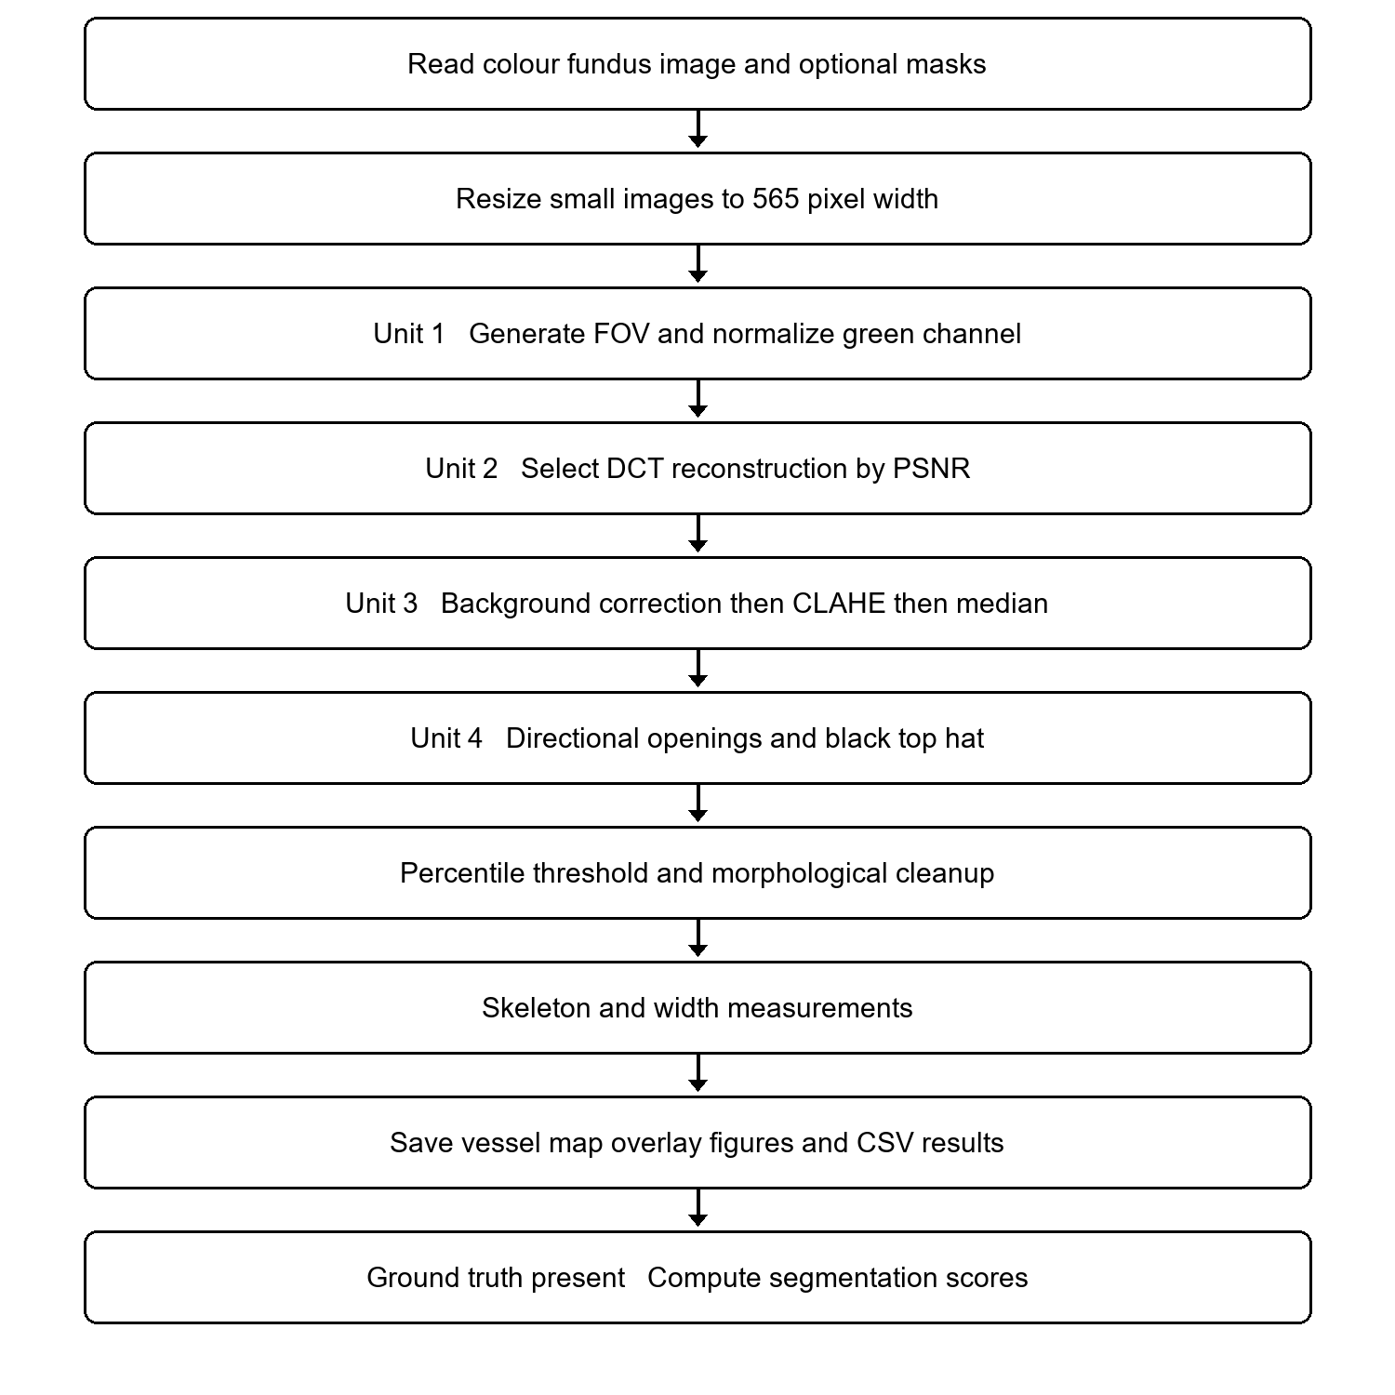
Figure 1 Configured end to end processing path
Run main_pipeline for one image or run_all_images for all images in data. Parameters are centralized in config.m. The batch runner writes a separate output folder for each input.
5 STEP BY STEP WALKTHROUGH
All figures in this section are saved outputs for testimage1, a diseased image in the team’s collection.
Input image and zoom region
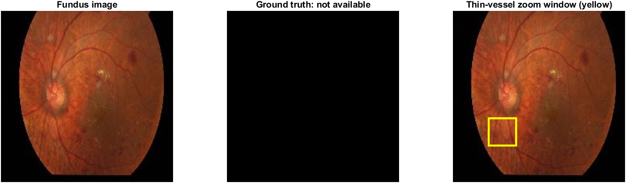
Figure 2 Input image and zoom region for testimage1
The original colour image is enlarged for processing. The ground-truth panel is empty because no manual vessel mask was supplied.
Field of view and normalized green channel
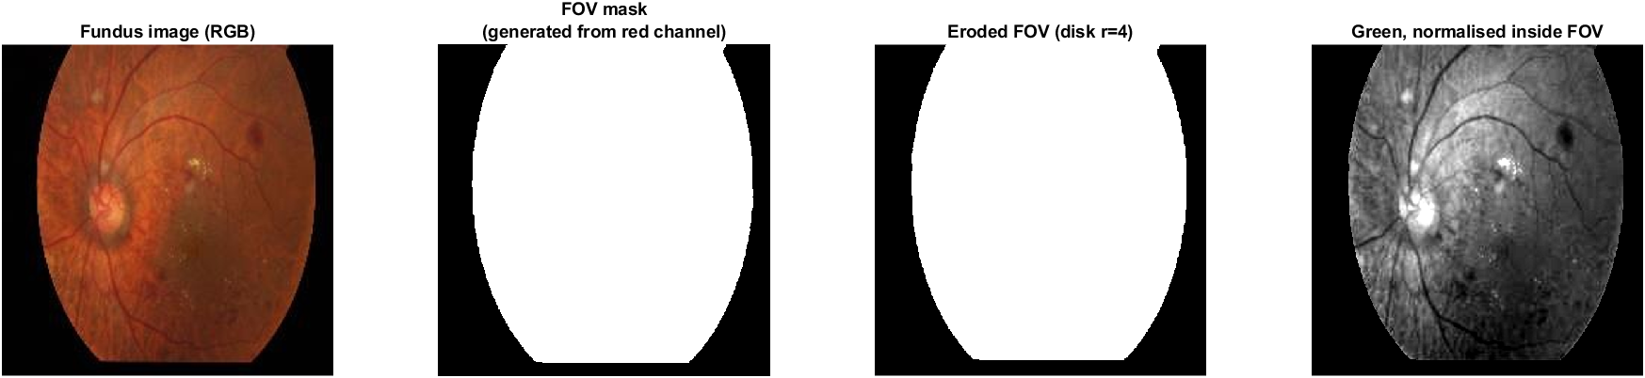
Figure 3 Field of view and normalized green channel for testimage1
The red-channel mask locates the retinal region. Erosion excludes the rim; normalization prepares the green channel for subsequent operations.
5 Walkthrough continued
RGB channels and histograms
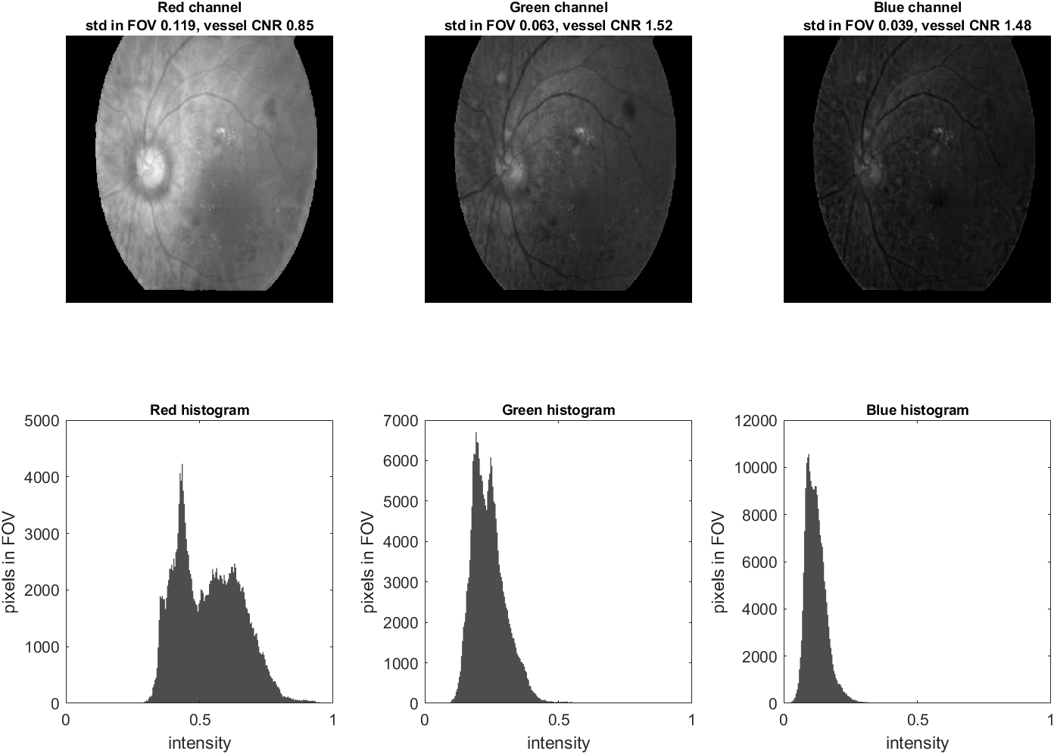
Figure 4 RGB channels and histograms for testimage1
Green gives the largest vessel CNR in this example, approximately 1.52, compared with 0.85 in red and 1.48 in blue.
Interpolation comparison
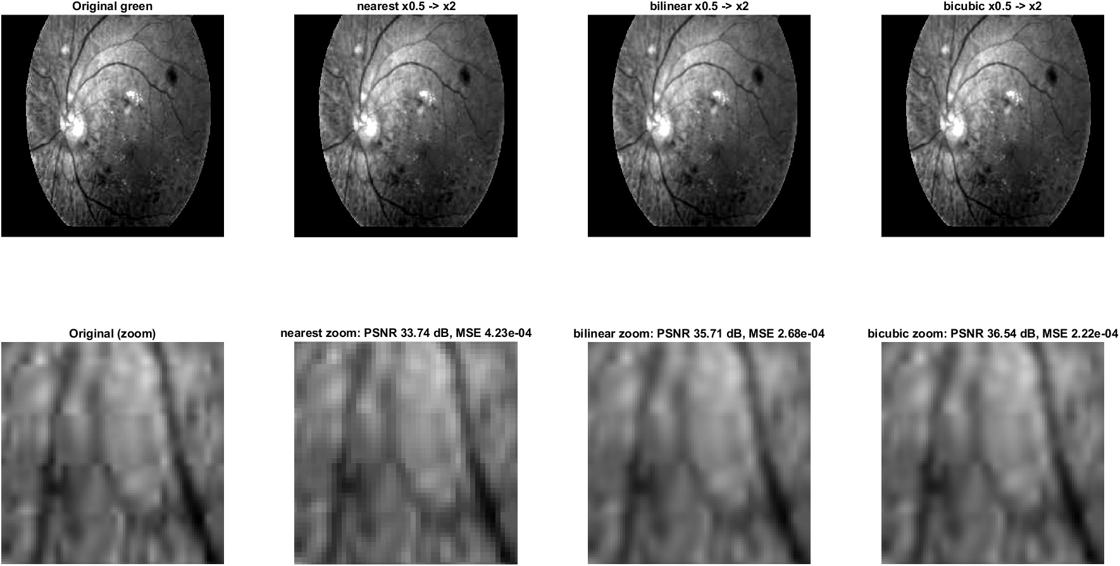
Figure 5 Interpolation comparison for testimage1
A common reduced image is reconstructed with three methods. Bicubic has the highest reconstruction PSNR, about 36.5 dB.
5 Walkthrough continued
Sampling and quantization
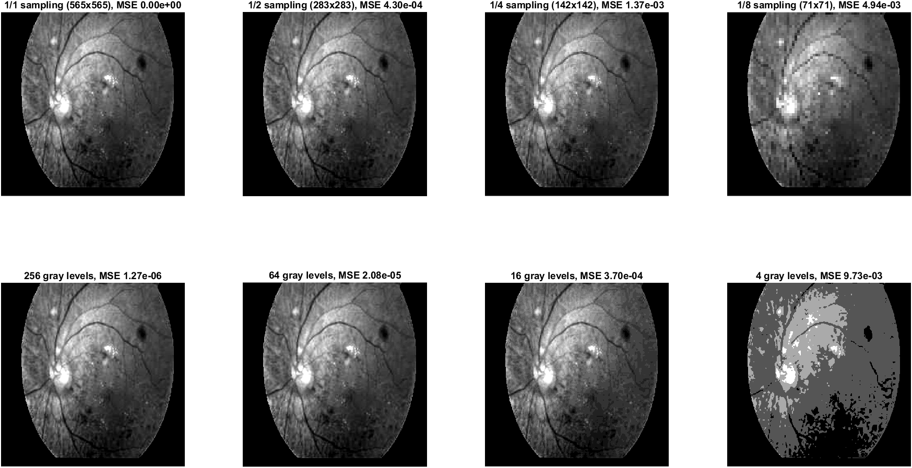
Figure 6 Sampling and quantization for testimage1
Coarser sampling and fewer intensity levels progressively remove detail. These are demonstration branches.
DFT spectrum
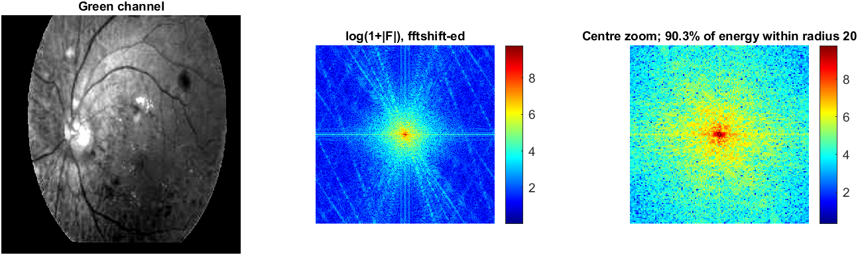
Figure 7 DFT spectrum for testimage1
The shifted spectrum concentrates energy near its centre. Approximately 90.3% falls within the configured central radius.
5 Walkthrough continued
DCT reconstructions
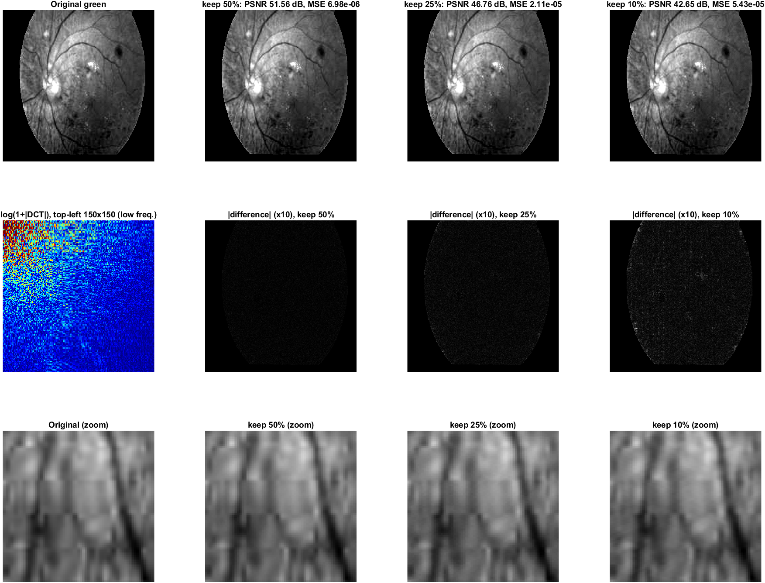
Figure 8 DCT reconstructions for testimage1
Retaining 10% of coefficients still gives about 42.7 dB PSNR, exceeding the 35 dB target and supplying Unit 3.
DCT restoration of a noisy copy
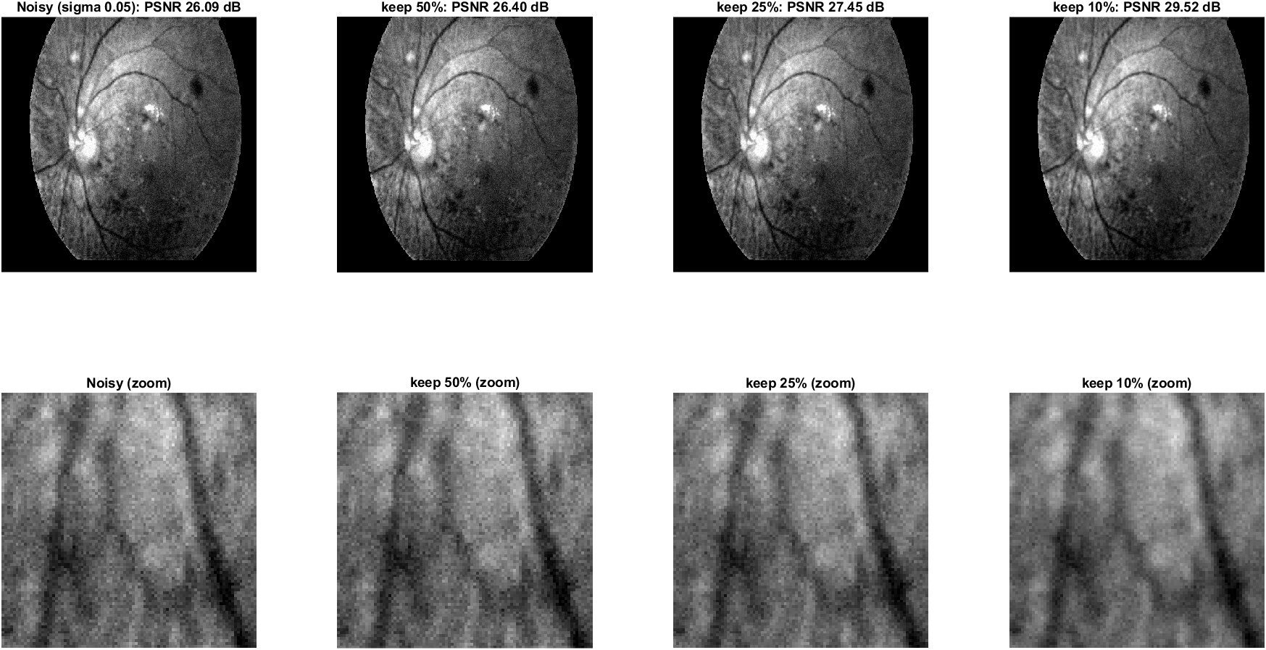
Figure 9 DCT restoration of a noisy copy for testimage1
The controlled noisy example improves to about 29.5 dB at 10% retention. This noisy copy is used only for the experiment.
5 Walkthrough continued
SVD rank comparison
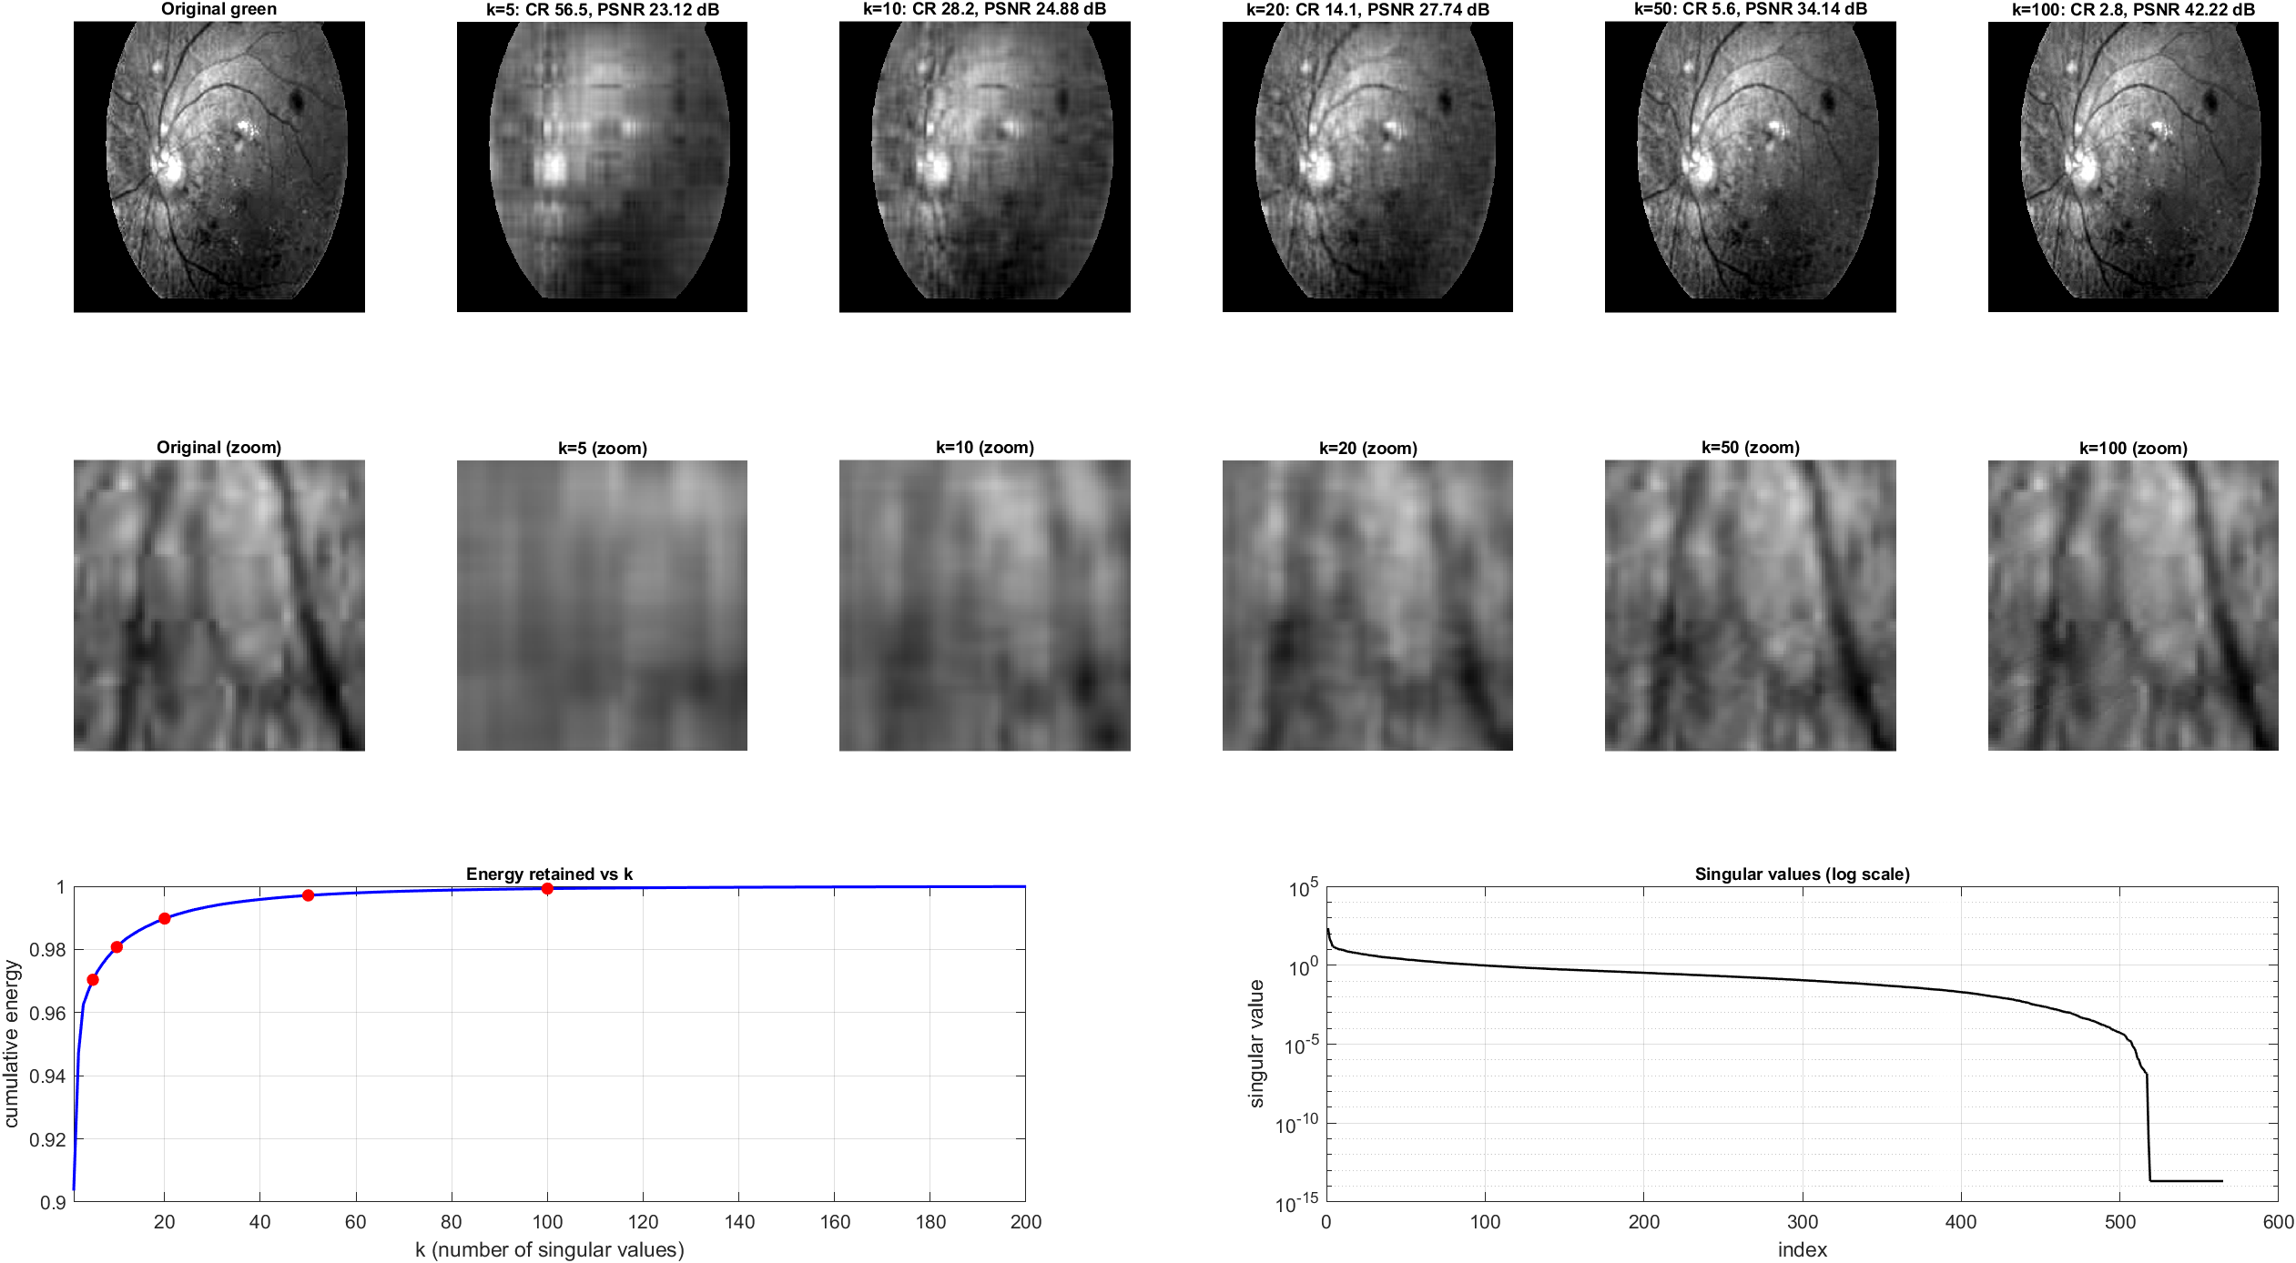
Figure 10 SVD rank comparison for testimage1
Increasing rank restores detail while increasing the number of retained values. Small ranks give smoother approximations.
DCT and SVD at matched representation size
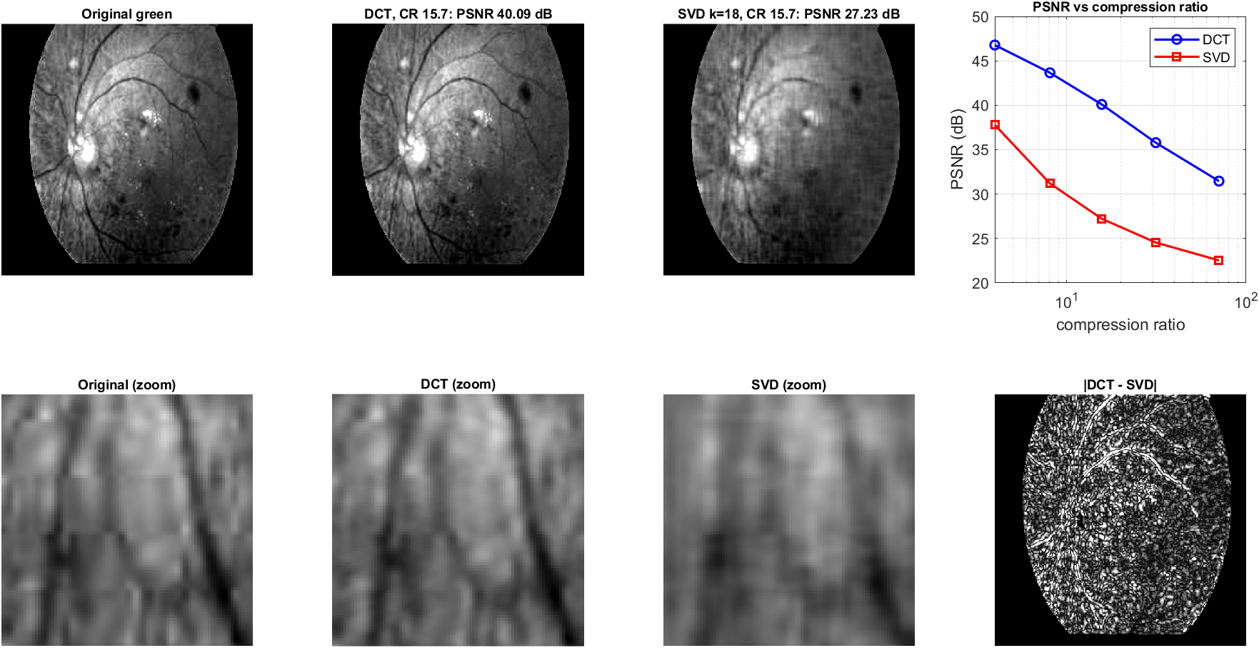
Figure 11 DCT and SVD at matched representation size for testimage1
At the displayed ratio of about 15.7, DCT reconstructs more closely than SVD: approximately 40.1 versus 27.2 dB.
5 Walkthrough continued
Enhancement alternatives
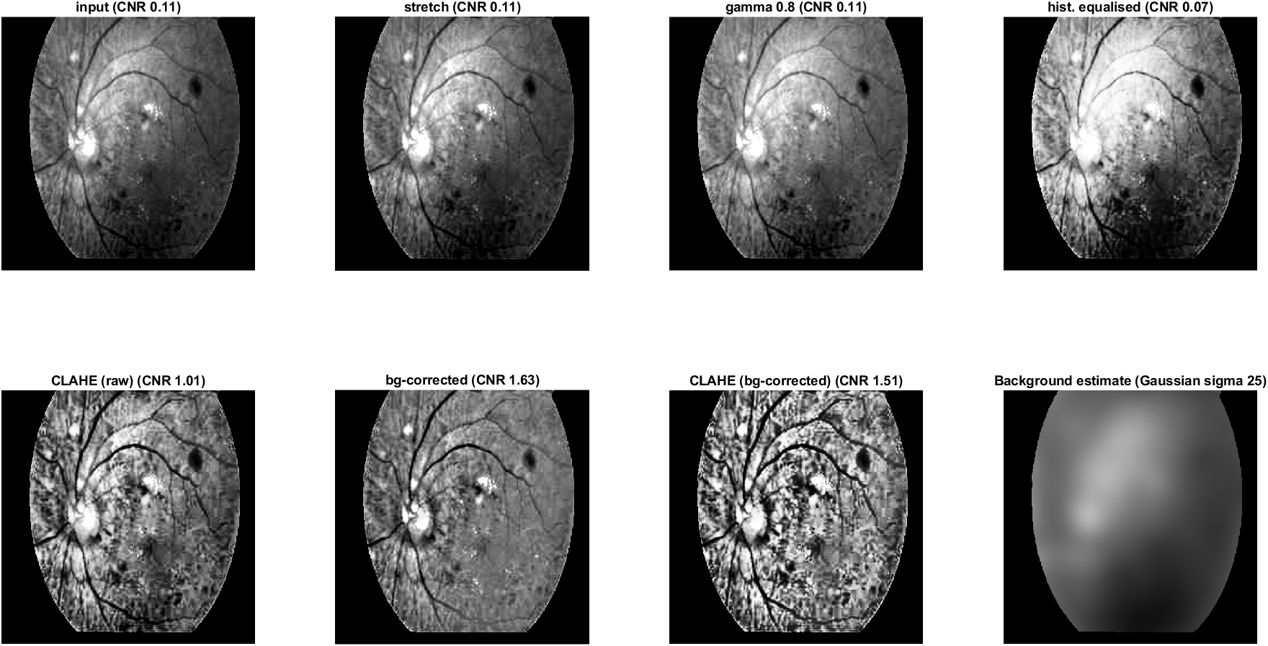
Figure 12 Enhancement alternatives for testimage1
Background subtraction reduces slow lighting variation. CLAHE then improves local contrast; the remaining variants are comparisons.
Enhancement histograms
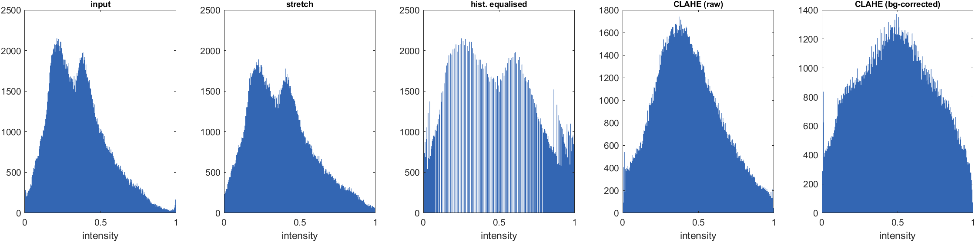
Figure 13 Enhancement histograms for testimage1
The histograms show how the intensity distributions change. Histogram spread alone does not establish vessel accuracy.
5 Walkthrough continued
Spatial smoothing and sharpening
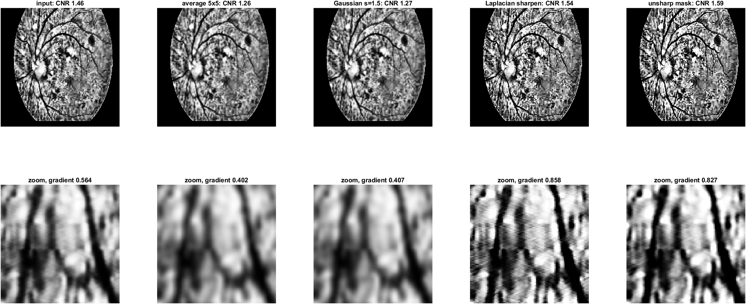
Figure 14 Spatial smoothing and sharpening for testimage1
The zooms illustrate the effect of averaging, Gaussian filtering, Laplacian sharpening and unsharp masking on vessel detail.
Frequency filter comparisons
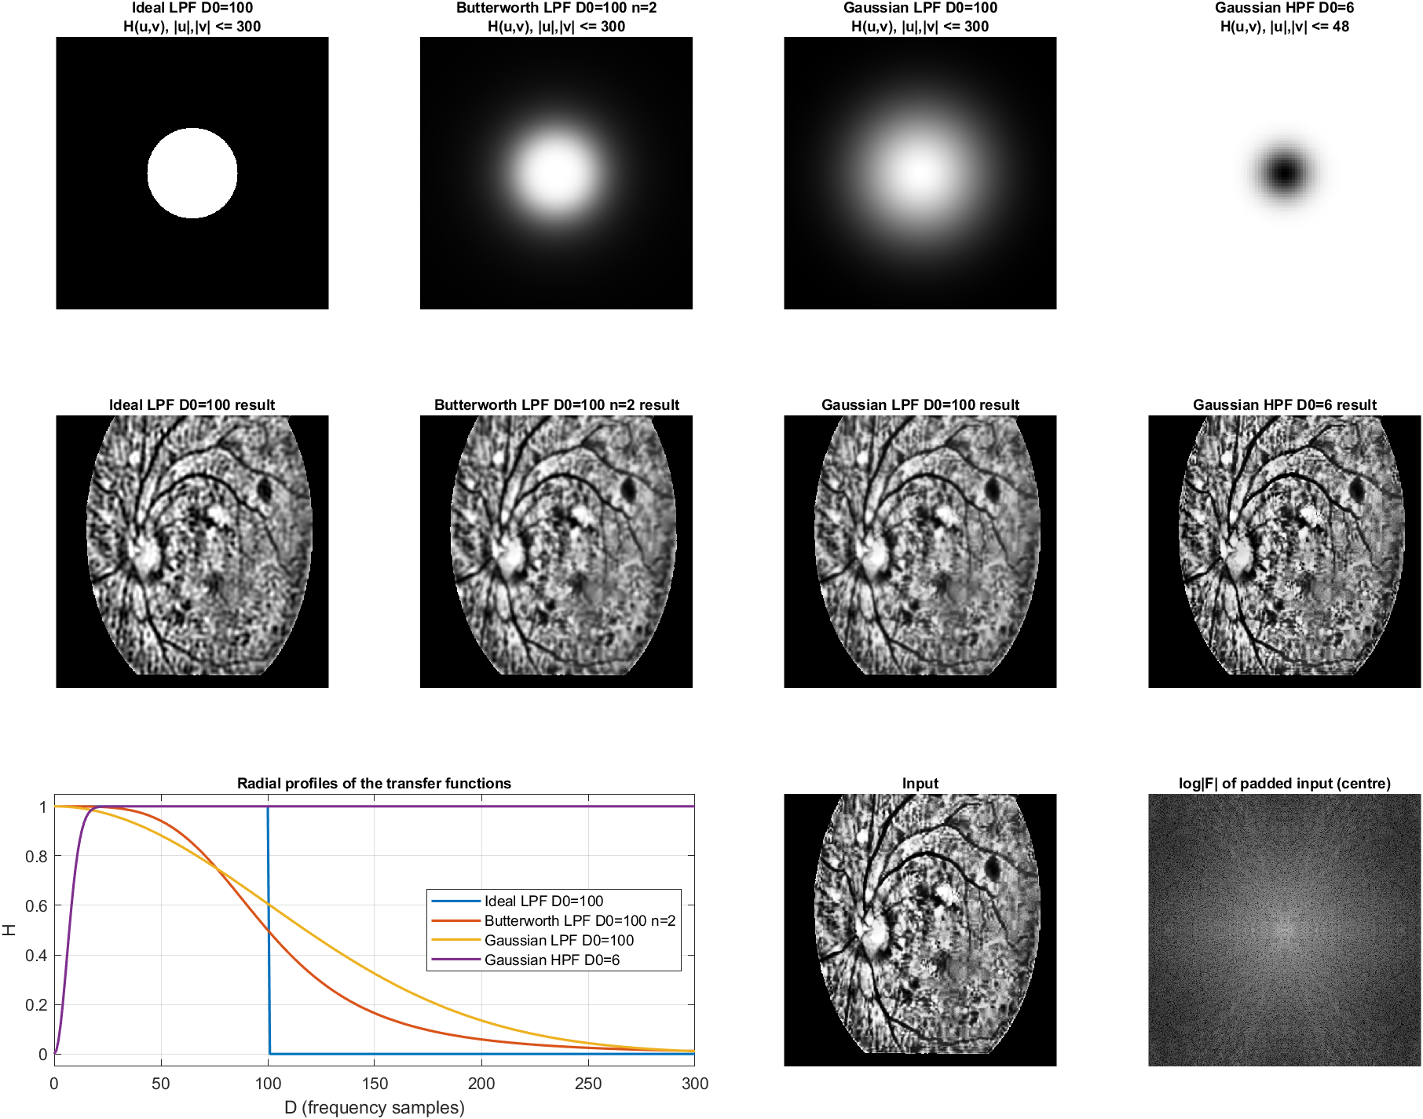
Figure 15 Frequency filter comparisons for testimage1
Filter transfer functions and reconstructed images illustrate the different frequency responses. These images do not replace the configured median-filter output.
5 Walkthrough continued
Gaussian and impulse noise restoration
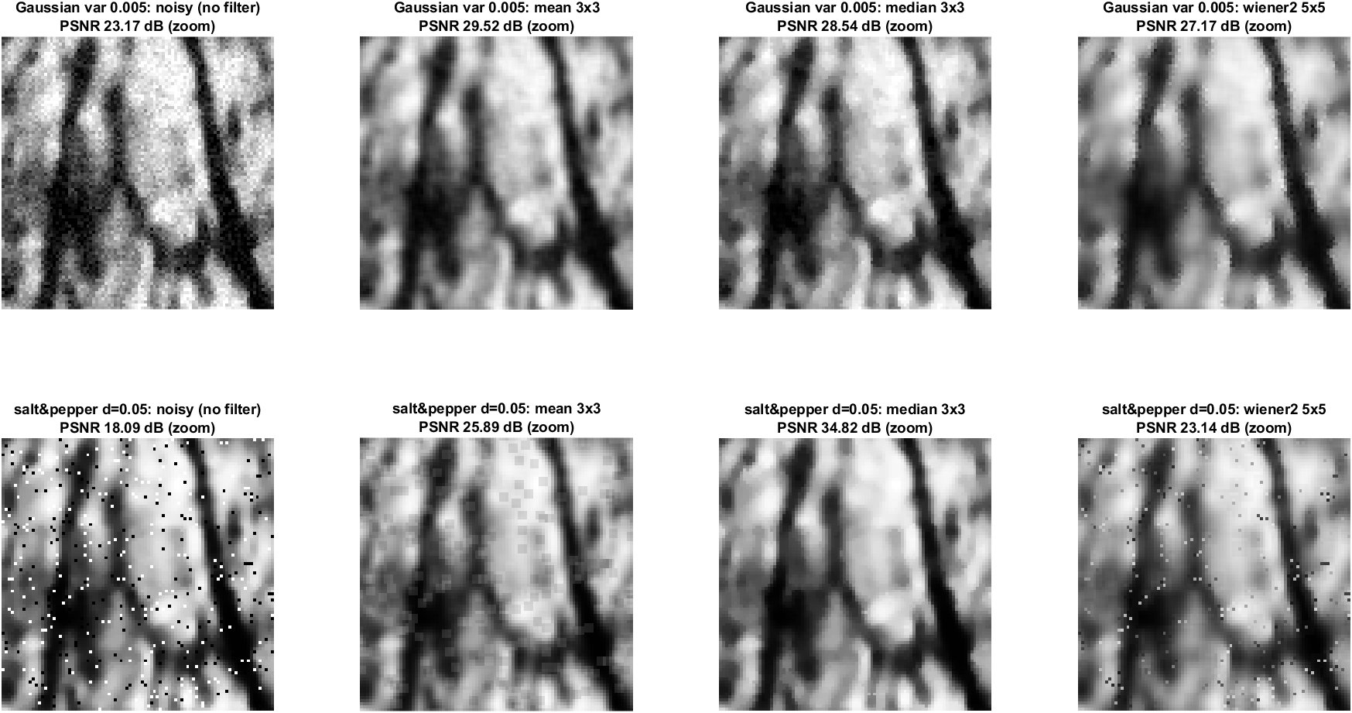
Figure 16 Gaussian and impulse noise restoration for testimage1
Mean, median and Wiener filtering are compared against the known clean image. Median filtering is effective on the added impulse noise.
Periodic noise removal
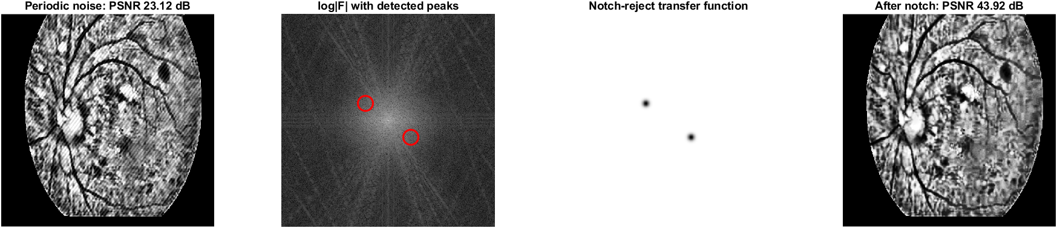
Figure 17 Periodic noise removal for testimage1
The detected spectral peak pair determines the notch positions. The saved example improves from about 23.1 to 43.9 dB.
5 Walkthrough continued
Vessel response and threshold
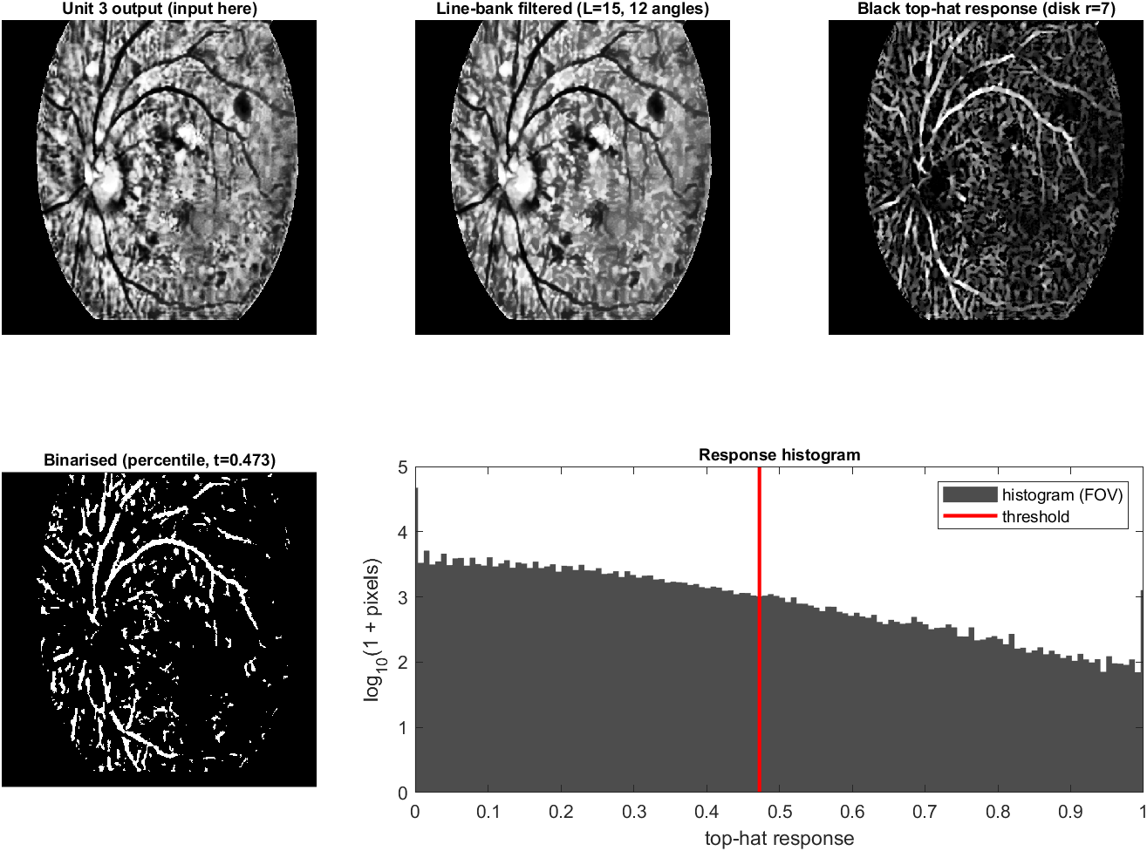
Figure 18 Vessel response and threshold for testimage1
Directional openings favour line structures. Black top-hat filtering highlights dark vessels, and the 88th-percentile threshold forms the initial mask.
Mask cleanup
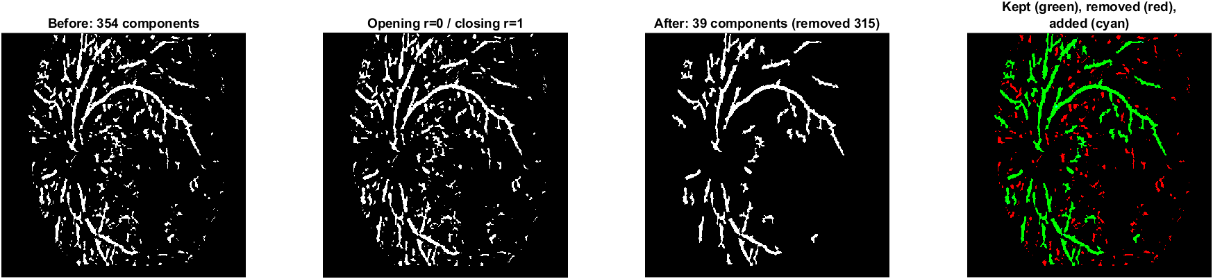
Figure 19 Mask cleanup for testimage1
Closing, area removal and limited hole filling reduce the number of connected components from 354 to 39 in this example.
5 Walkthrough continued
Skeleton and width analysis
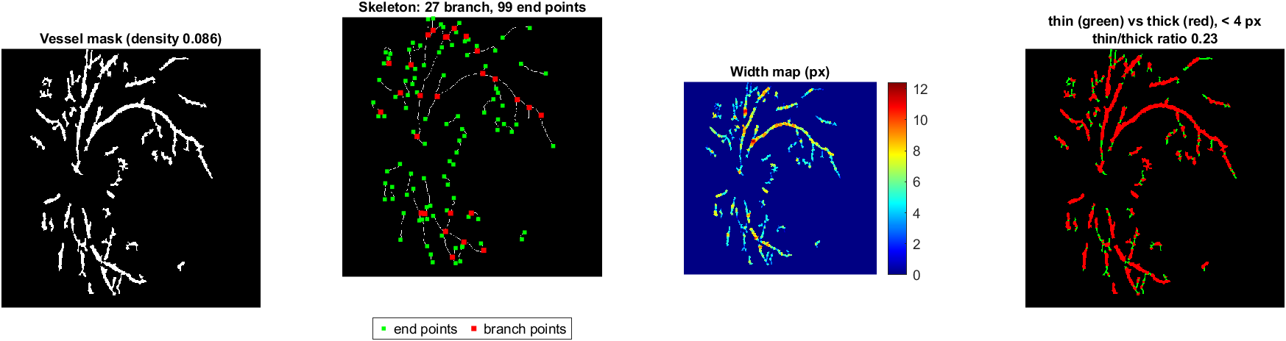
Figure 20 Skeleton and width analysis for testimage1
The cleaned map has 27 branch points and 99 endpoints. Its estimated skeleton length is about 3062 pixels.
Width coloured vessel map
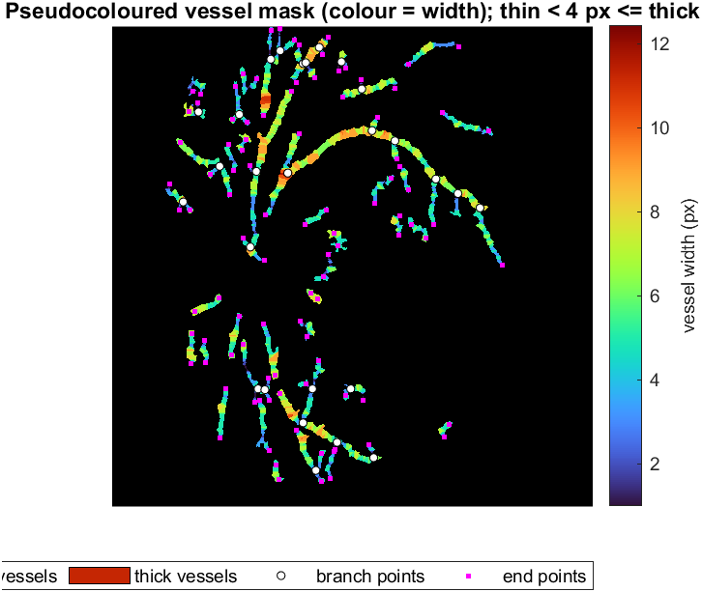
Figure 21 Width coloured vessel map for testimage1
Colour represents estimated vessel width. White markers identify branch points and pink markers identify endpoints in the annotated figure.
5 Walkthrough continued
Vessel overlay
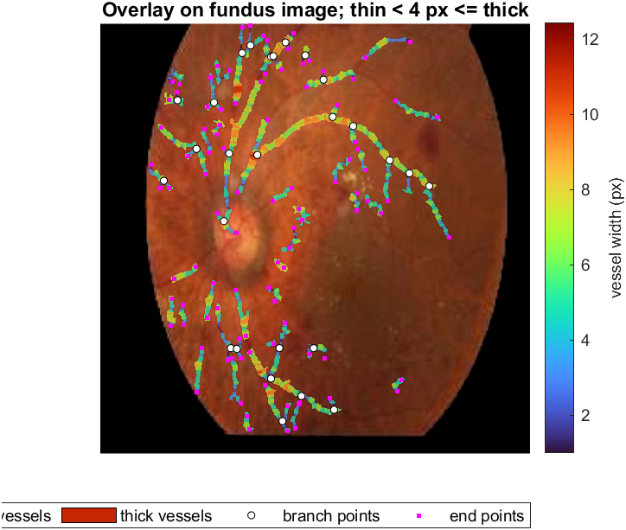
Figure 22 Vessel overlay for testimage1
The extracted network is placed over the fundus photograph for visual assessment of alignment.
Global threshold baseline
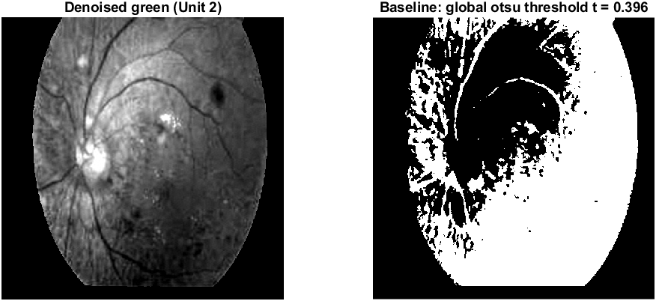
Figure 23 Global threshold baseline for testimage1
Global Otsu thresholding provides a simple baseline. Without ground truth, its relative accuracy cannot be quantified.
6 RESULTS AND OUTPUTS
The same configured pipeline processed all ten inputs. The team identifies testimage1–5 as diseased and testimage6–10 as healthy. These labels describe the input collection; the code extracts vessels and does not generate a disease classification.
6.1 Quantitative measurements
The table reports the saved batch results. Density is expressed as a percentage of the eroded FOV. Length is measured in processed-image pixels, and the thin-to-thick ratio compares areas, rather than numbers of individual vessels.
ID | Group | Density % | Branches | Thin/thick | Length px
1 | Diseased | 8.58 | 27 | 0.231 | 3062
2 | Diseased | 7.90 | 28 | 0.227 | 2894
3 | Diseased | 8.44 | 32 | 0.241 | 3078
4 | Diseased | 9.17 | 40 | 0.173 | 3874
5 | Diseased | 9.09 | 63 | 0.239 | 3906
6 | Healthy | 9.38 | 35 | 0.237 | 2444
7 | Healthy | 9.89 | 55 | 0.189 | 4072
8 | Healthy | 9.49 | 30 | 0.197 | 3788
9 | Healthy | 10.53 | 31 | 0.213 | 2727
10 | Healthy | 10.15 | 30 | 0.238 | 4015

All ten images retained 10% of DCT coefficients. Sensitivity, specificity, accuracy, precision and Dice are unavailable because no ground-truth masks accompanied these inputs. No numerical segmentation superiority over the baseline is claimed.
6.2 Group comparison
Measurement | Diseased mean | Healthy mean
Density percent | 8.64 | 9.89
Branch points | 38.0 | 36.2
Thin/thick ratio | 0.222 | 0.215
Skeleton length px | 3363 | 3409

Density ranges do not overlap in this collection: 7.90–9.17% for diseased images and 9.38–10.53% for healthy images. Branch counts, length and thin-to-thick ratios overlap. The density pattern is exploratory and may depend on image quality, field of view and segmentation settings.
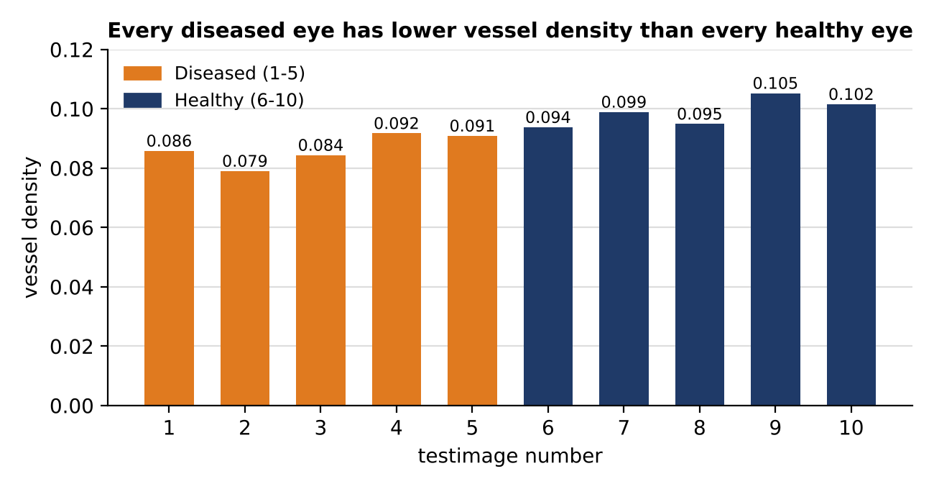
Figure 24 Vessel densities in the ten image collection reproduced from the team report
This chart describes the ten tested samples. Its separation has not been validated on an independent collection.
6.3 Outputs for all ten images
testimage1 Diseased Density 8.58%
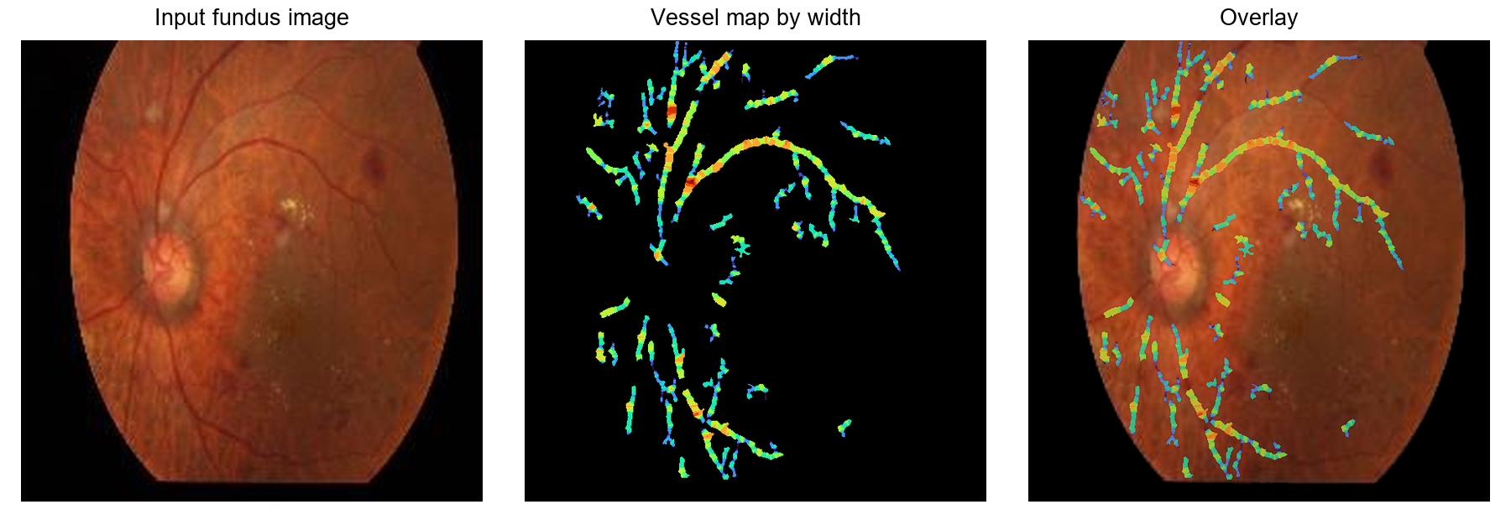
Figure 25 testimage1 input vessel map and overlay
Branches 27 | Skeleton length 3062 px | Thin/thick area ratio 0.231
testimage2 Diseased Density 7.90%
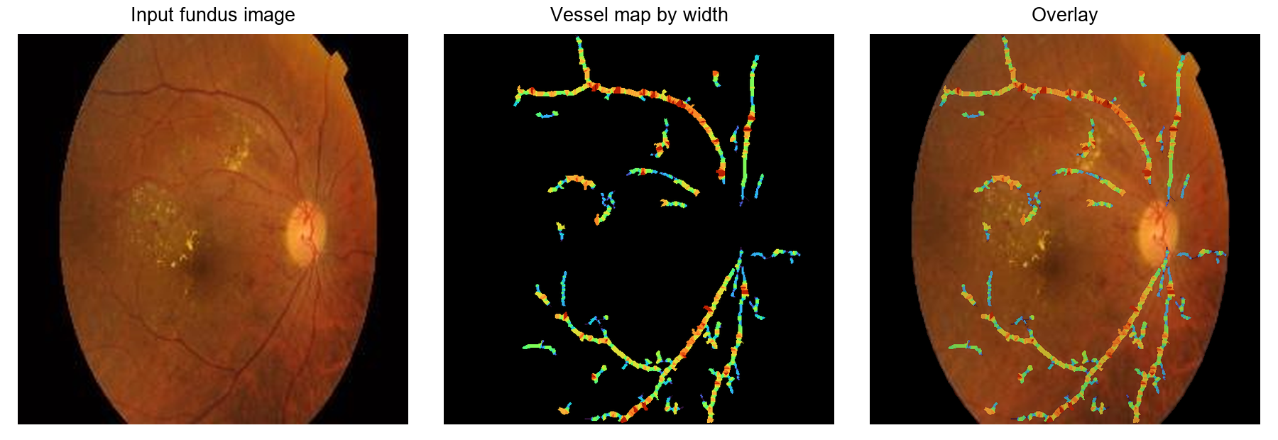
Figure 26 testimage2 input vessel map and overlay
Branches 28 | Skeleton length 2894 px | Thin/thick area ratio 0.227
Colours encode estimated width; they do not encode the healthy or diseased label.
6.3 Outputs continued
testimage3 Diseased Density 8.44%
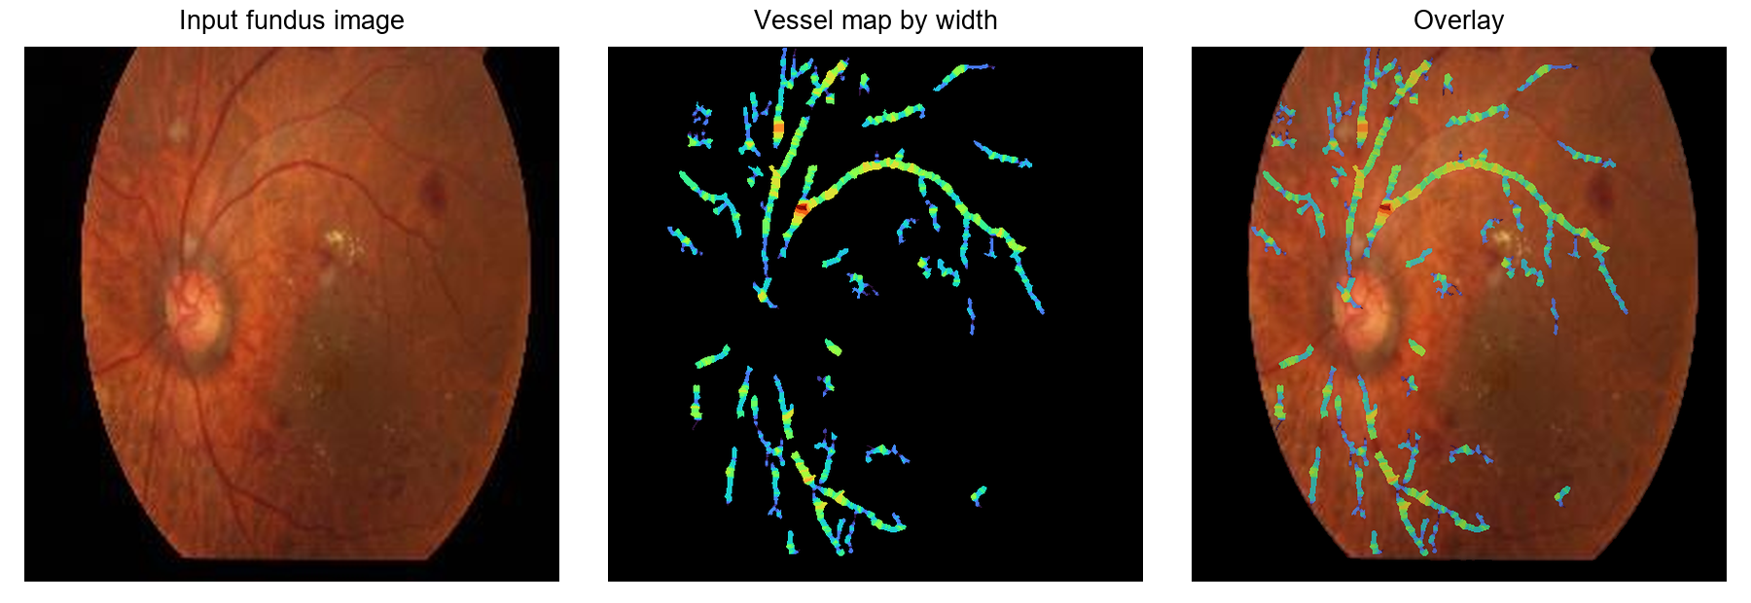
Figure 27 testimage3 input vessel map and overlay
Branches 32 | Skeleton length 3078 px | Thin/thick area ratio 0.241
testimage4 Diseased Density 9.17%
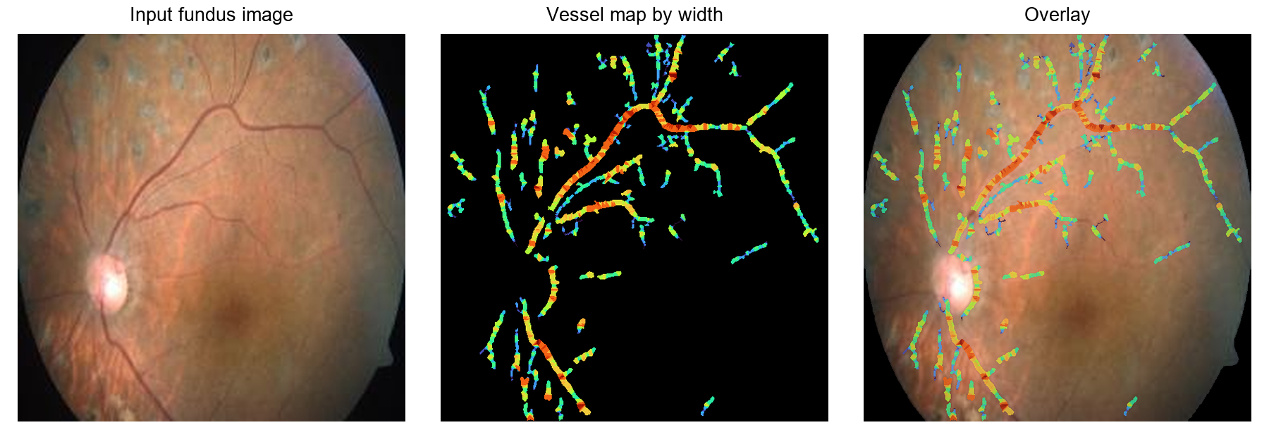
Figure 28 testimage4 input vessel map and overlay
Branches 40 | Skeleton length 3874 px | Thin/thick area ratio 0.173
Colours encode estimated width; they do not encode the healthy or diseased label.
6.3 Outputs continued
testimage5 Diseased Density 9.09%
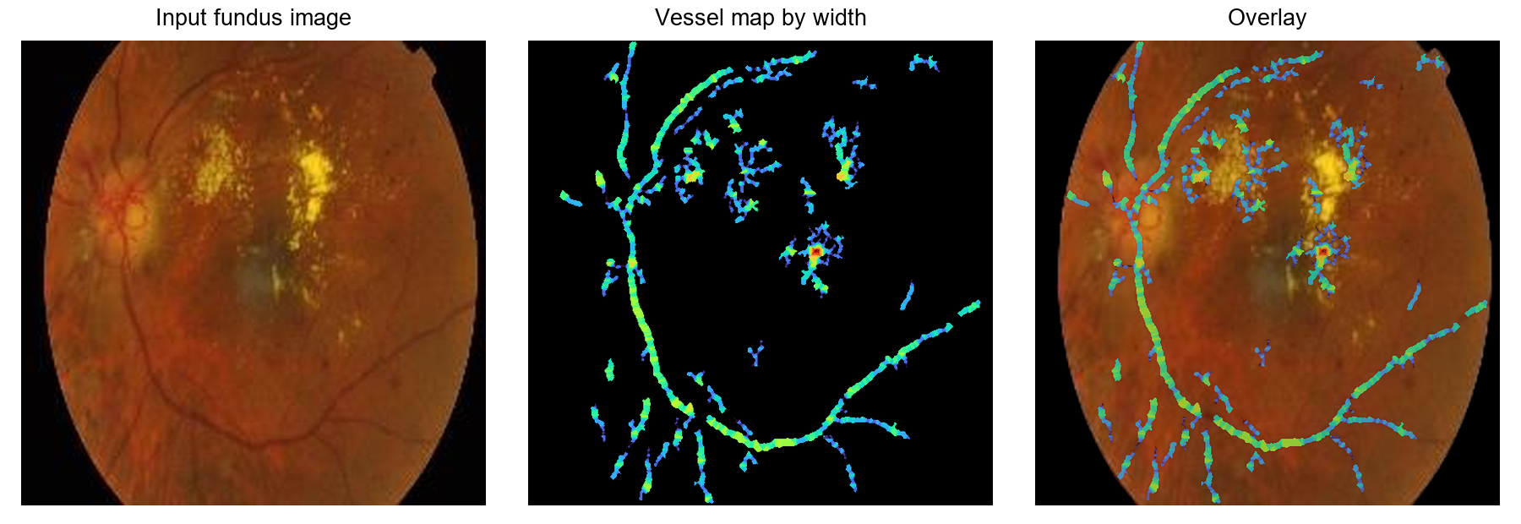
Figure 29 testimage5 input vessel map and overlay
Branches 63 | Skeleton length 3906 px | Thin/thick area ratio 0.239
testimage6 Healthy Density 9.38%
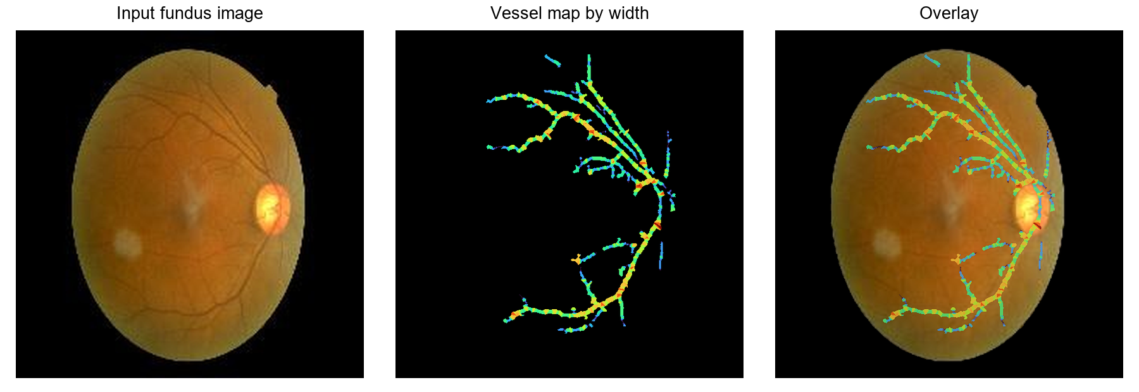
Figure 30 testimage6 input vessel map and overlay
Branches 35 | Skeleton length 2444 px | Thin/thick area ratio 0.237
Colours encode estimated width; they do not encode the healthy or diseased label.
6.3 Outputs continued
testimage7 Healthy Density 9.89%
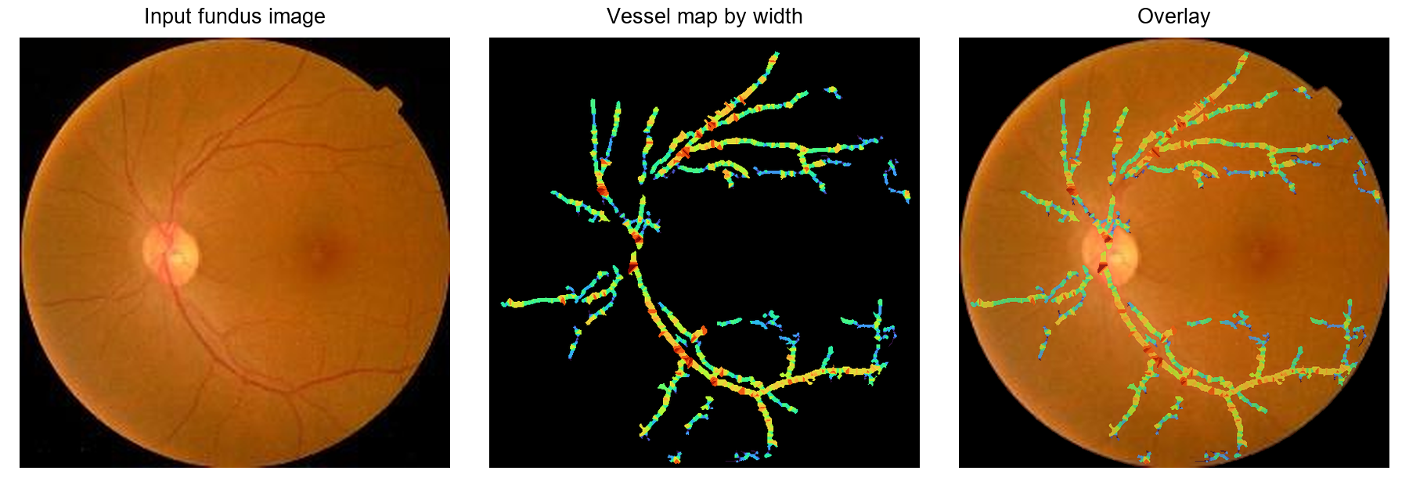
Figure 31 testimage7 input vessel map and overlay
Branches 55 | Skeleton length 4072 px | Thin/thick area ratio 0.189
testimage8 Healthy Density 9.49%
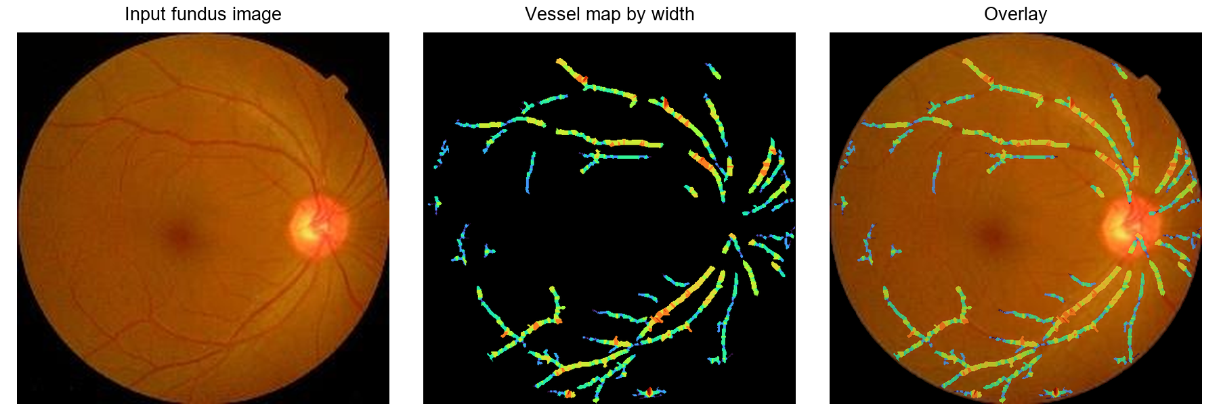
Figure 32 testimage8 input vessel map and overlay
Branches 30 | Skeleton length 3788 px | Thin/thick area ratio 0.197
Colours encode estimated width; they do not encode the healthy or diseased label.
6.3 Outputs continued
testimage9 Healthy Density 10.53%
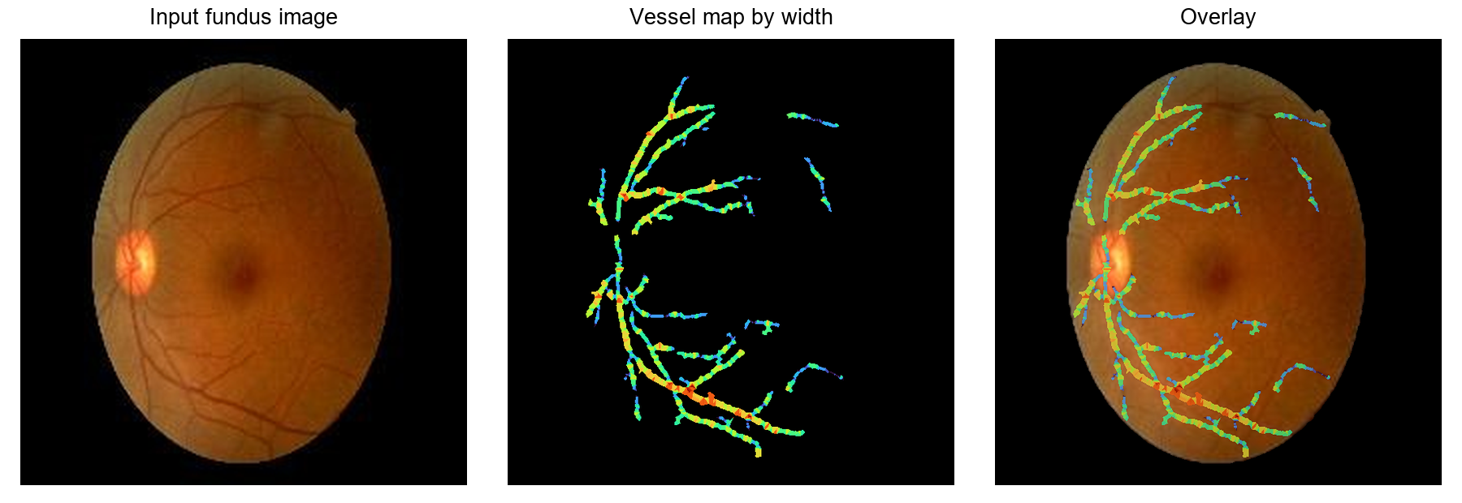
Figure 33 testimage9 input vessel map and overlay
Branches 31 | Skeleton length 2727 px | Thin/thick area ratio 0.213
testimage10 Healthy Density 10.15%
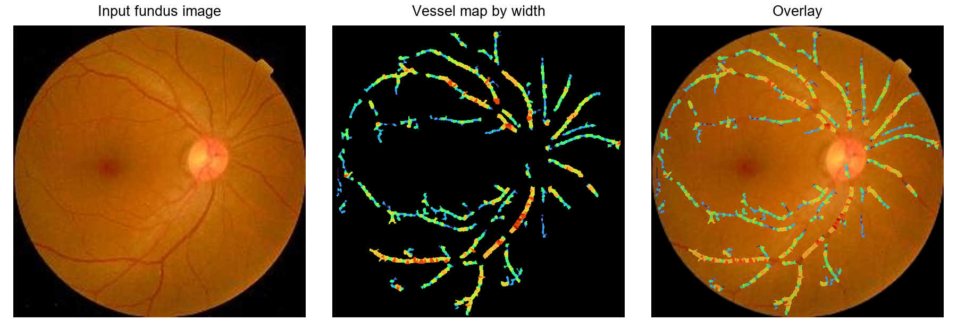
Figure 34 testimage10 input vessel map and overlay
Branches 30 | Skeleton length 4015 px | Thin/thick area ratio 0.238
Colours encode estimated width; they do not encode the healthy or diseased label.
7 OBSERVATIONS AND CONCLUSIONS
Main observations
The green channel, FOV normalization and background correction create a consistent basis for vessel extraction. In the walkthrough, bicubic interpolation reconstructs more closely than the other tested methods, and the selected 10% DCT reconstruction exceeds the PSNR target. These measures support reconstruction choices, while ground-truth masks are still needed to assess vessel segmentation.
Directional morphology and black top-hat filtering form the main extraction stage. Cleanup removes small components and improves the visual continuity of the network. The overlays support qualitative review, but fine vessels can remain fragmented or be removed by filtering and area thresholds.
Interpretation of the ten images
The diseased group has lower extracted vessel density in all five samples. The smallest gap between the groups is about 0.20 percentage points. This narrow separation should not be converted into a clinical cutoff. The other measured features overlap, and five images per group are insufficient to establish a general disease relationship.
The percentile threshold deliberately limits the initial vessel response to approximately 12% of FOV pixels. The final density also depends on cleanup and connectivity. It should therefore be interpreted as a property of the extracted mask under this configuration, rather than a direct measurement of all retinal vessels.
Conclusion and future work
The project demonstrates an explainable vessel-extraction workflow spanning all four DIP units. It generates intermediate figures, final width-coloured maps, overlays and repeatable numerical summaries for ten images. Its present outcome is image analysis and feature extraction, without validated diagnosis.
The next step is evaluation on a larger labelled collection with manual vessel masks, such as a suitable annotated DRIVE subset [4]. Further work can improve thin-vessel connectivity, test parameter sensitivity and add calibrated width or tortuosity measurements. Higher-resolution inputs would reduce dependence on interpolation.
8 NOVELTY AND INDIVIDUAL CONTRIBUTION
Project contribution
The contribution is the integration of classical DIP methods into one reproducible retinal analysis workflow. The project combines FOV-aware measurements, transform comparisons, directional morphology, width-based pseudocolour and automatic ten-image output generation. It does not claim a new segmentation algorithm.
Shriya PES1UG24EC206
Unit 1 image basics (channels, FOV mask, interpolation, sampling and quantisation), project foundation and integration of all units, Unit 3 enhancement (histogram equalisation, CLAHE, background correction, spatial filters).
Samarth PES1UG24EC180
Unit 2 DFT spectrum and DCT compression and denoising, Unit 3 restoration (frequency-domain filters, noise removal with mean, median and Wiener filters, notch filter).
Sahil PES1UG24EC174
Unit 2 SVD compression and DCT vs SVD comparison, Unit 4 morphology (top-hat, line openings, thresholding, cleanup, skeleton, width) and pseudocolour output, evaluation and results across 10 images.
9 REFERENCES
[1] PES University. UE24EC342AC1 Digital Image Processing course material, Units 1–4. August–December 2026.
[2] MathWorks. imbothat — Bottom-hat filtering. https://www.mathworks.com/help/images/ref/imbothat.html
[3] MathWorks. Adjust Contrast Using Adaptive Histogram Equalization. https://www.mathworks.com/help/images/adaptive-histogram-equalization.html
[4] DRIVE. Digital Retinal Images for Vessel Extraction. https://drive.grand-challenge.org/ Reference benchmark for future evaluation.
[5] Group 14. Ten fundus test images, MATLAB-compatible source code and saved experimental outputs. Project experimental record, 2026.

