HOMOMORPHIC FILTERING

The output of images under different lighting conditions

Brightness level - +50

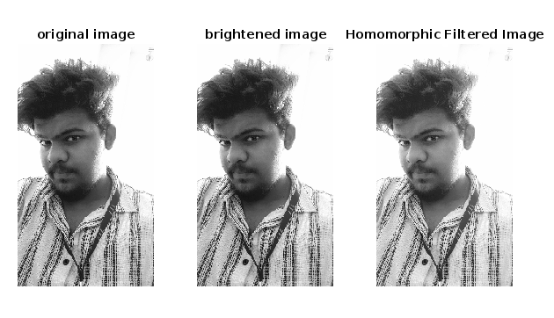

Brightness level +100

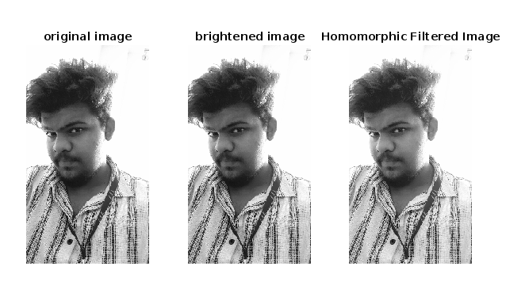

Brightness level +200

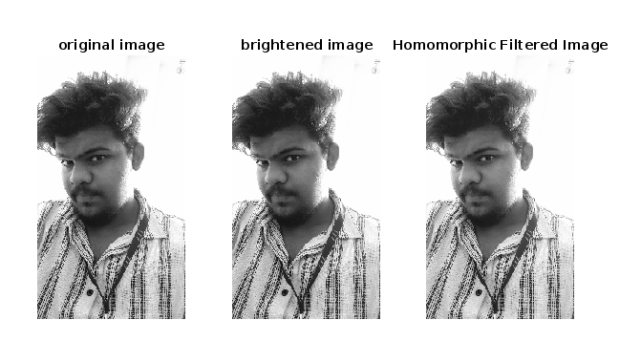

Brightness level +400

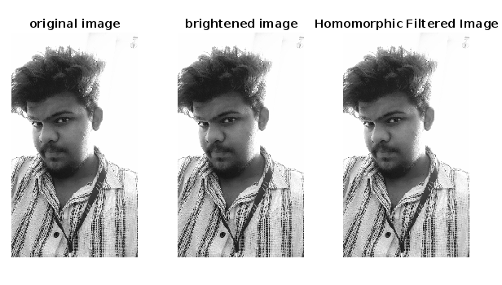

Brightness level +800

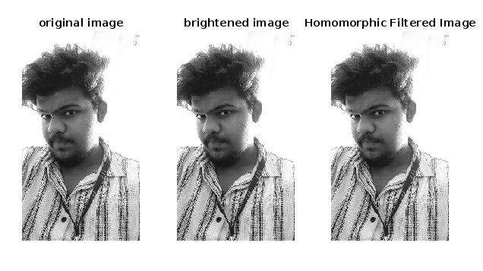

Brightness level 0

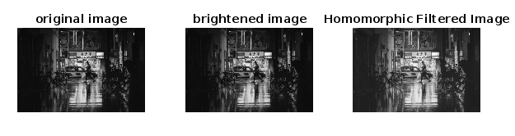

Brightness level +50

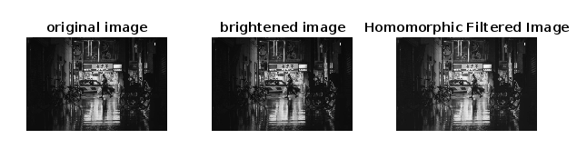

Brightness level +100

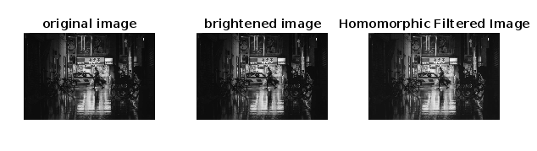

Brightness level +200

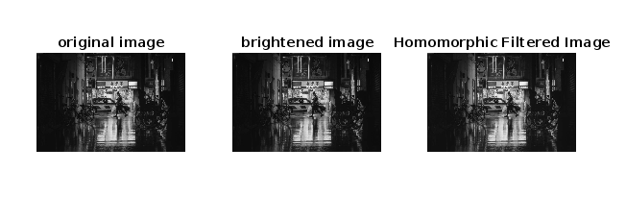

Brightness level +400

