**EXP-7**

**NAME:-** ESWARAVAKA VAMSI

**REG NO :-**21BEC1511

**TASK-1**

clc;

close all;

clear all;

d = 10; % Cutoff frequency

d2 = d^2; % Square of cutoff frequency

f = double(rgb2gray(imread("C:\Users\dsplab\Documents\MATLAB\21BEC1511\7fb3bf58-1ecf-4168-b358-42e4268e55d3.jpg")));

l = log(1 + f); % Logarithmic transformation

z = fft2(l);

[m, n] = size(f);

b = zeros(m, n);

h = zeros(m, n);

for i = 1:m

for j = 1:n

b(i, j) = sqrt((i - m / 2)^2 + (j - n / 2)^2);%eucledian distance

h(i, j) = exp(-b(i, j)^2 / (2 * d2)); % Gaussian filter

end

end

L = 0.5; % Gamma low value

H = 1.5; % Gamma high value

filter = L + (H - L) * h;

s = z .* filter;

g = abs(ifft2(s));%inverse fourier transformation

e = exp(g) - 1;%inverse the logarithmic transformation

subplot(1, 2, 1);

imshow(f, []);

title('Original Image');

subplot(1, 2, 2);

imshow(e, []);

title('Homomorphic Filtered Image');

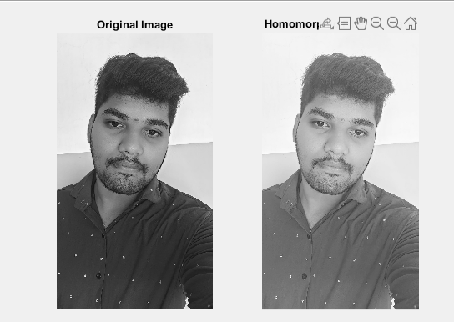

Task -2

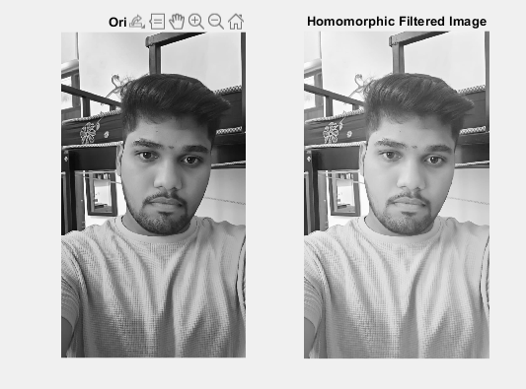

Task-3

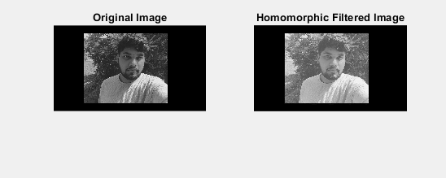

Task -4

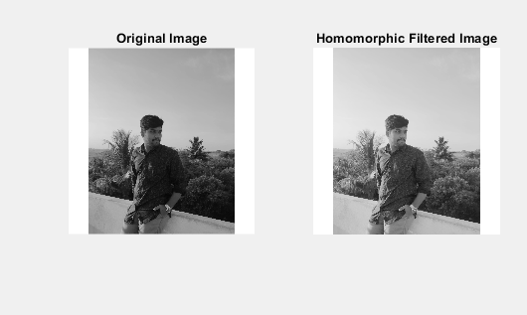

Task-5

