**EXP-8**

**NAME:-**  ESWARAVAKA VAMSI

**REG NO :-** 21BEC1511

**Code:-**

image ="C:\Users\dsplab\Documents\MATLAB\21BEC1511\image.jpg";

img = imread(image);

% Display original image

figure(1);

imshow(img);

title('Original Image');

% Color image smoothing using mean filter

kernel_size = 5;

smoothed_img = imfilter(img, ones(kernel_size) / kernel_size^2, 'replicate');

% Display smoothed image

figure(2);

imshow(smoothed_img);

title('Smoothed Image');

% Measure PSNR and SSIM for smoothed image

psnr_smoothed = psnr(smoothed_img, img);

ssim_smoothed = ssim(smoothed_img, img);

% Display PSNR and SSIM values

fprintf('PSNR of smoothed image: %.2f dB\n', psnr_smoothed);

fprintf('SSIM of smoothed image: %.2f\n', ssim_smoothed);

% Color sharpening using Laplacian filtering

laplacian_kernel = [-1 -1 -1; -1 8 -1; -1 -1 -1];

sharpened_img = img - imfilter(img, laplacian_kernel, 'replicate');

% Display sharpened image

figure(3);

imshow(sharpened_img);

title('Sharpened Image');

% Measure PSNR and SSIM for sharpened image

psnr_sharpened = psnr(sharpened_img, img);

ssim_sharpened = ssim(sharpened_img, img);

% Display PSNR and SSIM values

fprintf('PSNR of sharpened image: %.2f dB\n', psnr_sharpened);

fprintf('SSIM of sharpened image: %.2f\n', ssim_sharpened);

% Sharpening on smoothed image

sharpened_smoothed = smoothed_img - imfilter(smoothed_img, laplacian_kernel, 'replicate');

% Display sharpened smoothed image

figure(4);

imshow(sharpened_smoothed);

title('Sharpened Smoothed Image');

% Measure PSNR and SSIM for sharpened smoothed image

psnr_sharpened_smoothed = psnr(sharpened_smoothed, img);

ssim_sharpened_smoothed = ssim(sharpened_smoothed, img);

% Display PSNR and SSIM values

fprintf('PSNR of sharpened smoothed image: %.2f dB\n', psnr_sharpened_smoothed);

fprintf('SSIM of sharpened smoothed image: %.2f\n', ssim_sharpened_smoothed);

% Smoothing on sharpened image

smoothed_sharpened = imfilter(sharpened_img, ones(kernel_size) / kernel_size^2, 'replicate');

% Display smoothed sharpened image

figure(5);

imshow(smoothed_sharpened);

title('Smoothed Sharpened Image');

% Measure PSNR and SSIM for smoothed sharpened image

psnr_smoothed_sharpened = psnr(smoothed_sharpened, img);

ssim_smoothed_sharpened = ssim(smoothed_sharpened, img);

% Display PSNR and SSIM values

fprintf('PSNR of smoothed sharpened image: %.2f dB\n', psnr_smoothed_sharpened);

fprintf('SSIM of smoothed sharpened image: %.2f\n', ssim_smoothed_sharpened);

**OUTPUT:- 1**

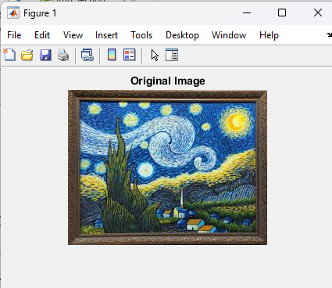

**OUTPUT:- 2**

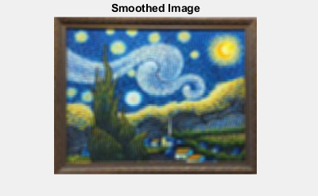

**OUTPUT:- 3**

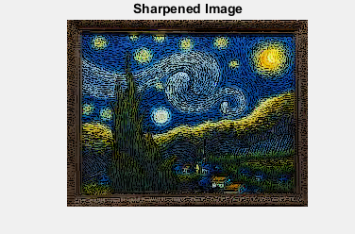

**OUTPUT:- 4**

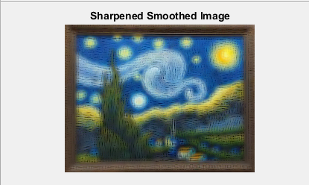

**OUTPUT:- 5**

