DIP

LAB-8

**NAME:** C. RAHUL

**REGD.NO:** 21BEC1424

**AIM:**

Use “starry night” as input image- download from google. Do colour image smoothing using mean filter, visualise it. Measure the quality of the output using PSNR and SSIM ( one line command in matlab). Also, do color sharpening using Laplacian filtering. Evaluate your output using visualisation, PSNR, SSIM. Finally apply sharpening on smoothed image, evaluate and do vice verse too.

**SOFTWARE USED:**

MATLAB R2021a

**CODE:**

image =("C:\Users\dsplab\Downloads\Van_Gogh-Starry_Night.jpg");

img = imread(image);

% Display original image

figure(1);

imshow(img);

title('Original Image');

% Color image smoothing using mean filter

kernel_size = 5;

smoothed_img = imfilter(img, ones(kernel_size) / kernel_size^2, 'replicate');

% Display smoothed image

figure(2);

imshow(smoothed_img);

title('Smoothed Image');

% Measure PSNR and SSIM for smoothed image

psnr_smoothed = psnr(smoothed_img, img);

ssim_smoothed = ssim(smoothed_img, img);

% Display PSNR and SSIM values

fprintf('PSNR of smoothed image: %.2f dB\n', psnr_smoothed);

fprintf('SSIM of smoothed image: %.2f\n', ssim_smoothed);

% Color sharpening using Laplacian filtering

laplacian_kernel = [-1 -1 -1; -1 8 -1; -1 -1 -1];

sharpened_img = img - imfilter(img, laplacian_kernel, 'replicate');

% Display sharpened image

figure(3);

imshow(sharpened_img);

title('Sharpened Image');

% Measure PSNR and SSIM for sharpened image

psnr_sharpened = psnr(sharpened_img, img);

ssim_sharpened = ssim(sharpened_img, img);

% Display PSNR and SSIM values

fprintf('PSNR of sharpened image: %.2f dB\n', psnr_sharpened);

fprintf('SSIM of sharpened image: %.2f\n', ssim_sharpened);

% Sharpening on smoothed image

sharpened_smoothed = smoothed_img - imfilter(smoothed_img, laplacian_kernel, 'replicate');

% Display sharpened smoothed image

figure(4);

imshow(sharpened_smoothed);

title('Sharpened Smoothed Image');

% Measure PSNR and SSIM for sharpened smoothed image

psnr_sharpened_smoothed = psnr(sharpened_smoothed, img);

ssim_sharpened_smoothed = ssim(sharpened_smoothed, img);

% Display PSNR and SSIM values

fprintf('PSNR of sharpened smoothed image: %.2f dB\n', psnr_sharpened_smoothed);

fprintf('SSIM of sharpened smoothed image: %.2f\n', ssim_sharpened_smoothed);

% Smoothing on sharpened image

smoothed_sharpened = imfilter(sharpened_img, ones(kernel_size) / kernel_size^2, 'replicate');

% Display smoothed sharpened image

figure(5);

imshow(smoothed_sharpened);

title('Smoothed Sharpened Image');

% Measure PSNR and SSIM for smoothed sharpened image

psnr_smoothed_sharpened = psnr(smoothed_sharpened, img);

ssim_smoothed_sharpened = ssim(smoothed_sharpened, img);

% Display PSNR and SSIM values

fprintf('PSNR of smoothed sharpened image: %.2f dB\n', psnr_smoothed_sharpened);

fprintf('SSIM of smoothed sharpened image: %.2f\n', ssim_smoothed_sharpened);

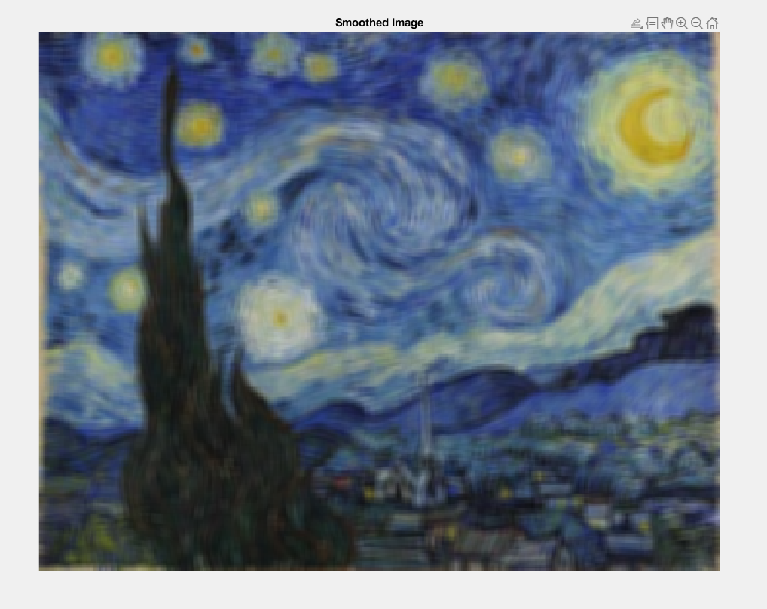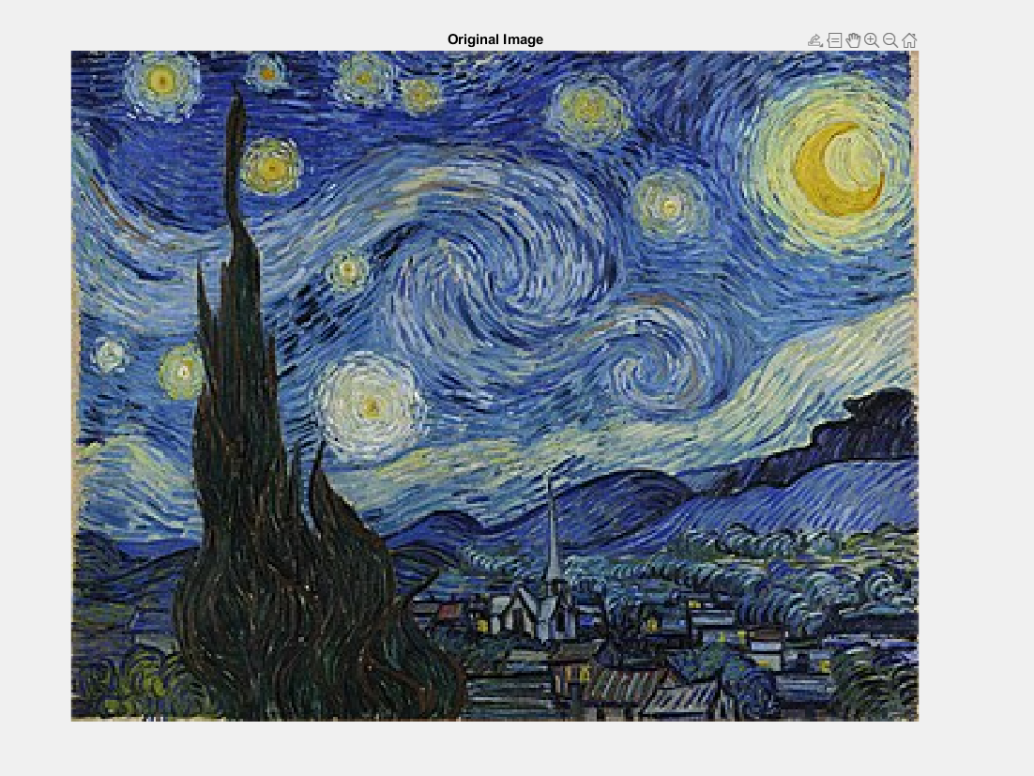

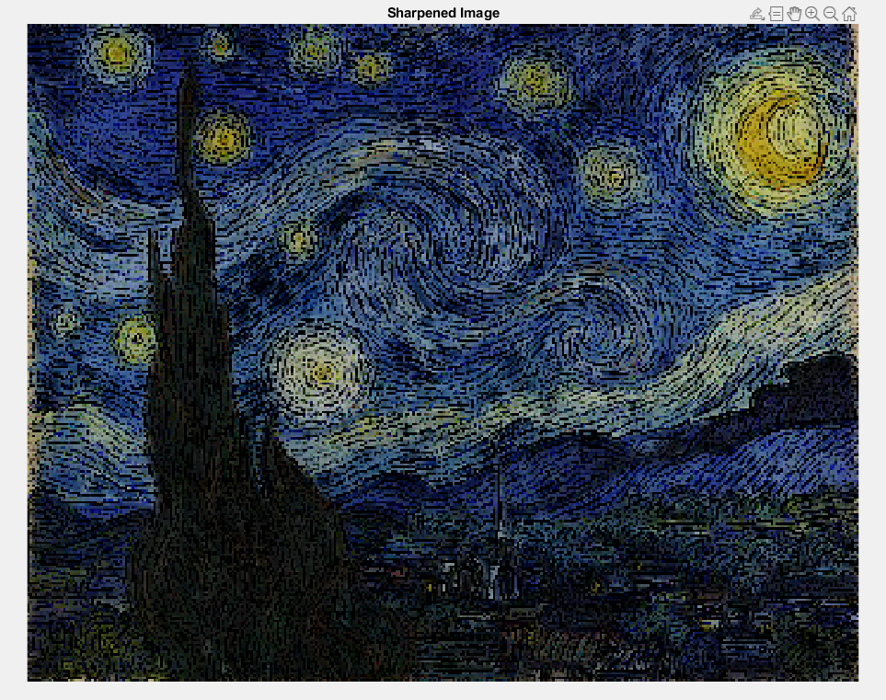

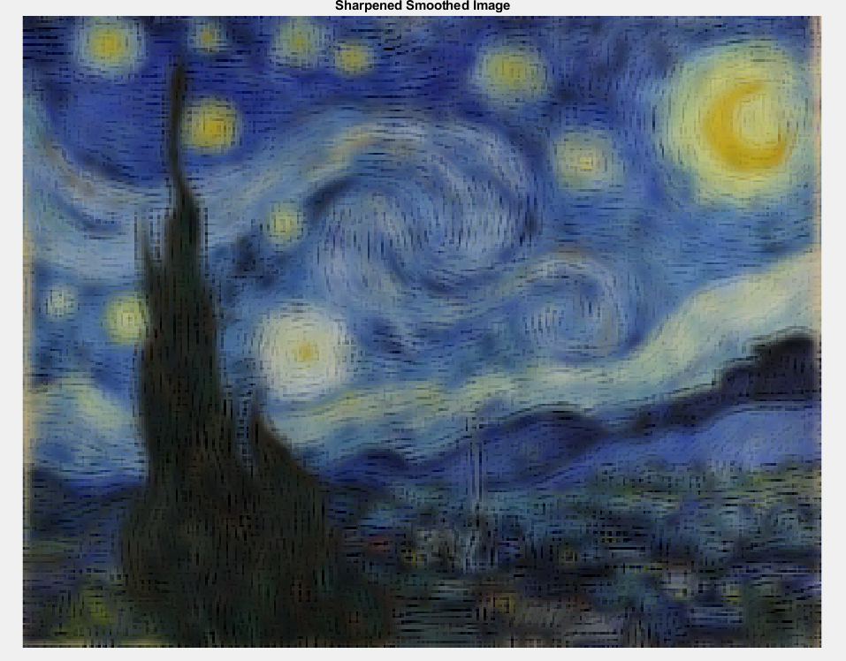

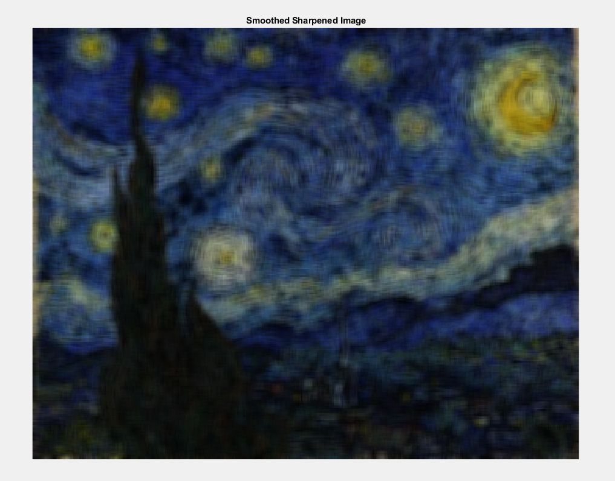

**OUTPUT:**

PSNR of smoothed image: 19.60 dB

SSIM of smoothed image: 0.55

PSNR of sharpened image: 11.03 dB

SSIM of sharpened image: -0.04

PSNR of sharpened smoothed image: 18.78 dB

SSIM of sharpened smoothed image: 0.55

PSNR of smoothed sharpened image: 13.62 dB

SSIM of smoothed sharpened image: 0.40

PSNR of smoothed image: 19.60 dB

SSIM of smoothed image: 0.55

PSNR of sharpened image: 11.03 dB

SSIM of sharpened image: -0.04

PSNR of sharpened smoothed image: 18.78 dB

SSIM of sharpened smoothed image: 0.55

PSNR of smoothed sharpened image: 13.62 dB

SSIM of smoothed sharpened image: 0.40