Experiment – 07 Date: 12/09/24

Name: D. Tarun

Register No. 21BEC1468

**CHALLENGING TASK**

**Aim:**

To design and implement a homomorphic filterring technique using MATLAB and to enhance the contrast of low light image, Evaluate the effectiveness of implementation by applying it to a variety of images with different lighting.

**Required software:** MATLAB

**Procedure**:

* Clear command window, previously opened figure by using clc, close all, clear all commands.
* Type respective code for each task.
* Run the code in MATLAB.

**CODE:**

%Experiment-7:

clc;

close all;

clear all;

d = 10; % Cutoff frequency

d2 = d^2; % Square of cutoff frequency

I=imread("CRFSeve.jpg");

f1 = double(rgb2gray(I));

b(:,:,3)=I(:,:,3)+200;

b(:,:,2)=I(:,:,2)+200;

b(:,:,1)=I(:,:,1)+200;

f=double(rgb2gray(b));

l = log(1 + f); % Logrithmic transformation

z = fft2(l);

[m, n] = size(f);

b = zeros(m, n);

h = zeros(m, n);

for i = 1:m

for j = 1:n

b(i, j) = sqrt((i - m / 2)^2 + (j - n / 2)^2);%eucledian distance

h(i, j) = exp(-b(i, j)^2 / (2 * d2)); % Gaussian filter

end

end

L = 0.5; % Gamma low value

H = 1.5; % Gamma high value

filter = L + (H - L) * h;

s = z .* filter;

g = abs(ifft2(s));%inverse fourier transformation

e = exp(g) - 1;%inverse the logarithmic transformation

subplot(1,3,1)

imshow(f1, [])

title("original image")

subplot(1, 3, 2);

imshow(f, []);

title('brightened image(+200 to each pixel)');

subplot(1, 3, 3);

imshow(e, []);

title('Homomorphic Filtered Image');

OUTPUT:

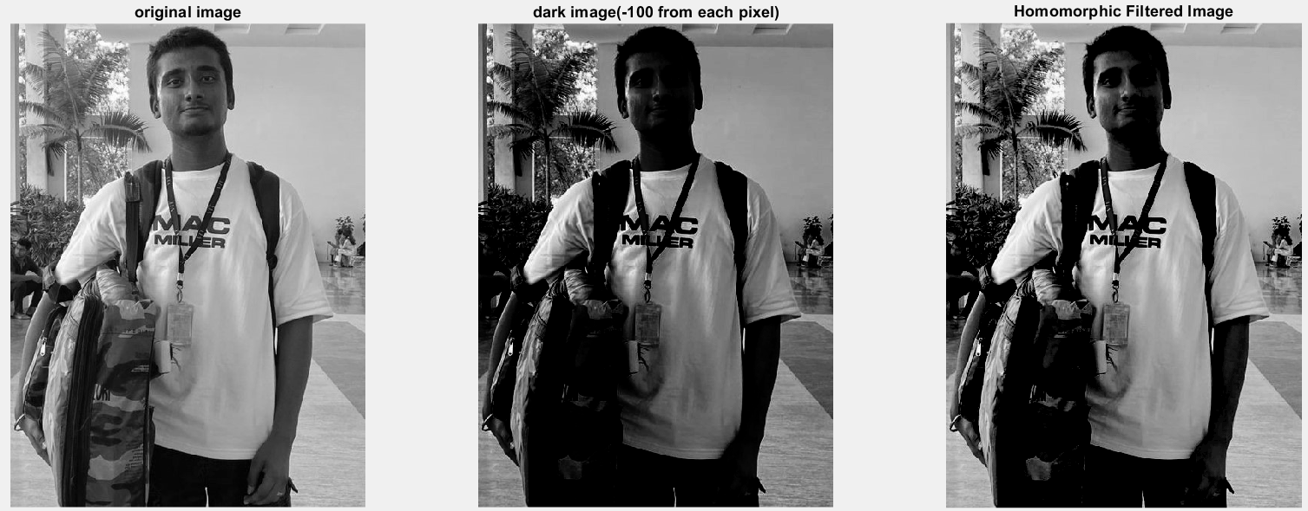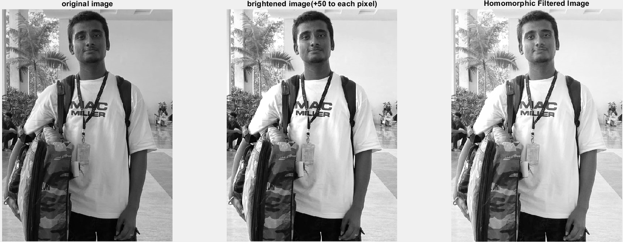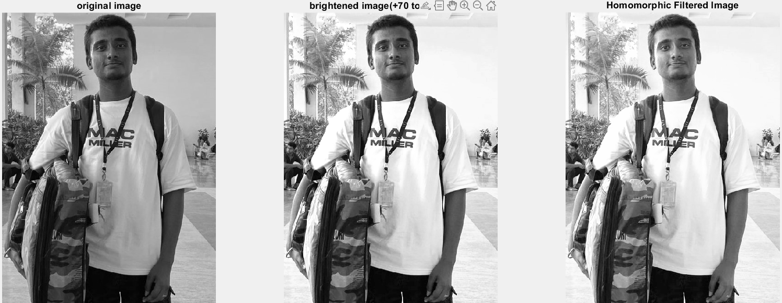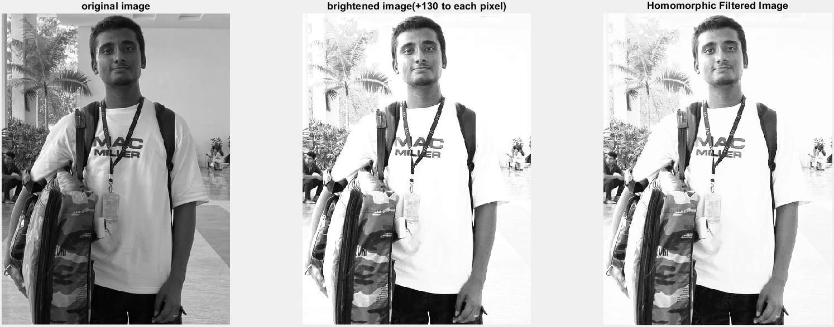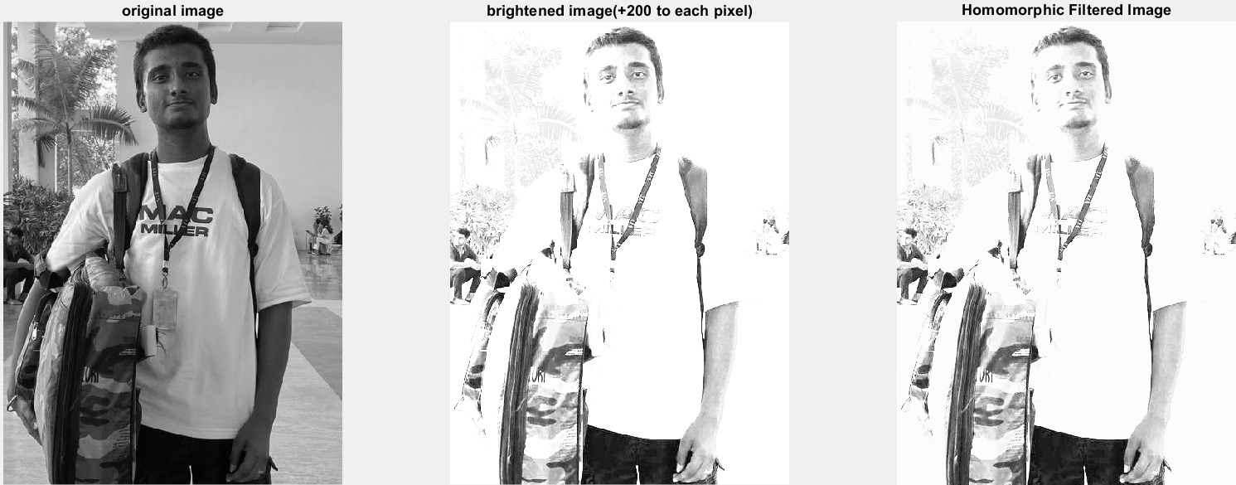

**Result:**

Hence, homomorphic filtering is applied to image by varying contrast of the image and observing effectiveness low light image is done using MATLAB.