Experiment – 08 Date: 26/09/24

Name: D. Tarun

Register No. 21BEC1468

**SMOOTHENING AND SHARPENING**

**Aim:**

To implement smoothening and sharpening of image starry night, along with smoothening after sharpened image and vice versa.

To evaluate the performance using PSNR and SSIM.

**Required software:** MATLAB

**Procedure**:

* Clear command window, previously opened figure by using clc, close all, clear all commands.
* Type respective code for each task.
* Run the code in MATLAB.

**CODE:**

%Experiment-8:

clc;

clear all;

close all;

img = imread('starrynight.jpg');

img = double(img);

avg_kernel = ones(5, 5) / 25;

smoothed_img = zeros(size(img));

for channel = 1:3

smoothed_img(:,:,channel) = conv2(img(:,:,channel), avg_kernel, 'same');

end

smoothed_img = uint8(smoothed_img);

subplot(2,2,1);

imshow(smoothed_img);

title('Smoothed Image');

psnr_smoothed = psnr(smoothed_img, uint8(img));

ssim_smoothed = ssim(smoothed_img, uint8(img));

disp(['PSNR (smoothed): ', num2str(psnr_smoothed)]);

disp(['SSIM (smoothed): ', num2str(ssim_smoothed)]);

lap_kernel = [0 -1 0; -1 5 -1; 0 -1 0];

sharpened_img = zeros(size(img));

for channel = 1:3

sharpened_img(:,:,channel) = conv2(img(:,:,channel), lap_kernel, 'same');

end

sharpened_img = uint8(sharpened_img);

subplot(2,2,2);

imshow(sharpened_img);

title('Sharpened Image');

psnr_sharpened = psnr(sharpened_img, uint8(img));

ssim_sharpened = ssim(sharpened_img, uint8(img));

disp(['PSNR (sharpened): ', num2str(psnr_sharpened)]);

disp(['SSIM (sharpened): ', num2str(ssim_sharpened)]);

sharpened_after_smoothing = zeros(size(smoothed_img));

for channel = 1:3

sharpened_after_smoothing(:,:,channel) = conv2(smoothed_img(:,:,channel), lap_kernel, 'same');

end

sharpened_after_smoothing = uint8(sharpened_after_smoothing);

subplot(2,2,3);

imshow(sharpened_after_smoothing);

title('Sharpened After Smoothing');

psnr_smooth_sharpen = psnr(sharpened_after_smoothing, smoothed_img);

ssim_smooth_sharpen = ssim(sharpened_after_smoothing, smoothed_img);

disp(['PSNR (sharpened after smoothing): ', num2str(psnr_smooth_sharpen)]);

disp(['SSIM (sharpened after smoothing): ', num2str(ssim_smooth_sharpen)]);

smoothed_after_sharpening = zeros(size(sharpened_img));

for channel = 1:3

smoothed_after_sharpening(:,:,channel) = conv2(sharpened_img(:,:,channel), avg_kernel, 'same');

end

smoothed_after_sharpening = uint8(smoothed_after_sharpening);

subplot(2,2,4);

imshow(smoothed_after_sharpening);

title('Smoothed After Sharpening');

psnr_sharpen_smooth = psnr(smoothed_after_sharpening, sharpened_img);

ssim_sharpen_smooth = ssim(smoothed_after_sharpening, sharpened_img);

disp(['PSNR (smoothed after sharpening): ', num2str(psnr_sharpen_smooth)]);

disp(['SSIM (smoothed after sharpening): ', num2str(ssim_sharpen_smooth)]);

**OUTPUT:**

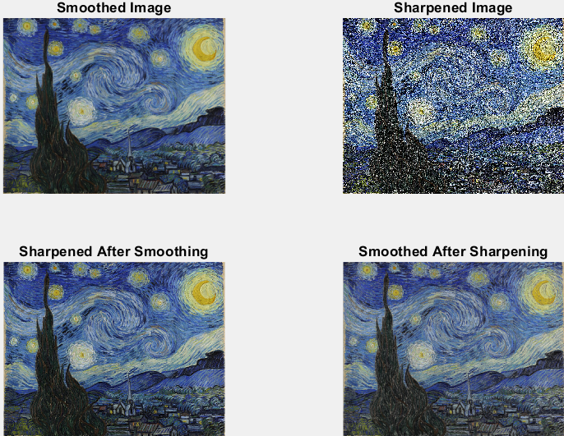

**Result:**

Hence, smoothening and sharpening of image, smoothening of sharpened image and sharpening of smoothened image is done using MATLAB.