Maison des Présences (MDP)

Introduction
Maison des Présences is a light-weight Web app built with HTML5 and Javascript: jQuery and Bootstrap frameworks. Elementary school students may learn correct spelling of their own name as well as try to remember the names of other kids in the class. Audio and visual hints are given, whether the names were correctly spelled.  The app is built in a privacy preserving way so that the student photos stay local within the browser and do not traverse the Internet. The difficulty level of the exercise may be increased with different settings by for example taking into account accent and case sensitivity in input text. | 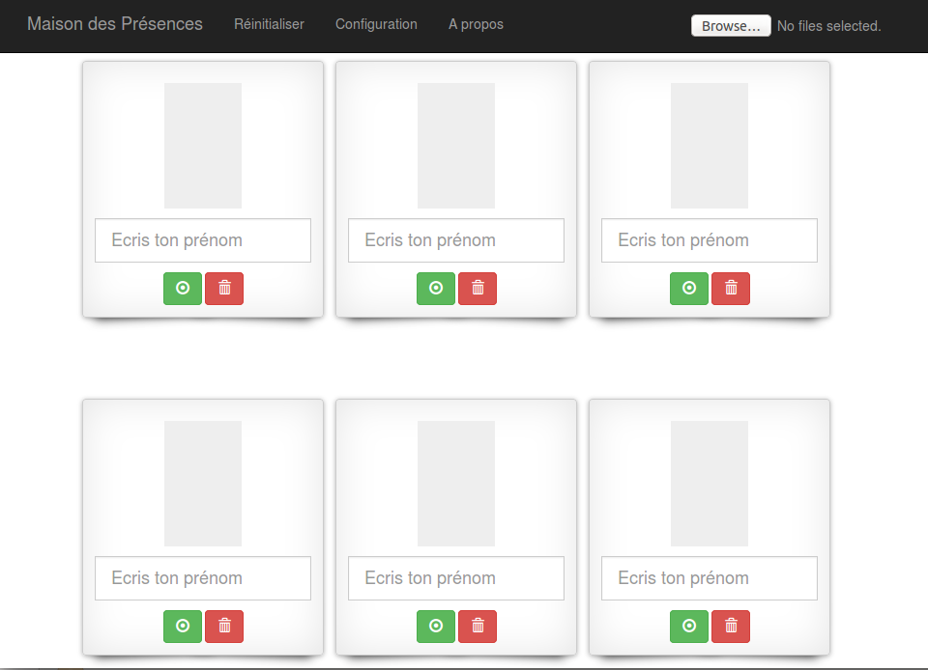

Installation package

 MDP.ZIP |  CSS | FONTS | JS | SND
Index.html | Gallery.css | Glyphicons-halflings-regular.eot | App.js | ko.ogg
 | Toggle-switch.css | Glyphicons-halflings-regular.svg | db.js | ok.ogg
 | Bootstrap.css | Glyphicons-halflings-regular.ttf | Simplestorage.js
 | Shadows.css | Glyphicons-halflings-regular.woff | Shuffle.js
 |  |  | Jquery.easy-confirm-dialog.min.js
 |  |  | Latinise.min_.js
 |  |  | Holder.js
 |  |  | Bootstrap.min.js
 |  |  | Load-image.min.js

MDP package should be installed on a Web server under “Web-root” directory. (In case of Apache httpd this is htdocs-directory). Please name a sub-directory to your liking (e.g. ./MDP/) where to extract MDP.ZIP contents. The proper functioning of the application requires also Internet connectivity from the client device / Web browser (due to the usage of certain online JS-libraries). Main files include:
- index.html – main Single Page Application file, graphical layout of HTML5 components.
- app.js – jQuery javascript application, with handler functions for user actions.
- db.js – IndexedDB javascript persistant storage interface for app.js (images and metadata).
- Gallery.css, Shadows.css, etc. – Stylesheets for visual effects of portrait photo placeholders.
- OK.ogg, KO.ogg – Sound files for correct and incorrect name input values.

Application configuration

MDP is intended to be used in two versions:

http://my.server.com/MDP/?mode=p (for Teacher with full functionality)

and

http://my.server.com/MDP/?mode=e (for Student with limited functionality)

There is no password to protect the access to these different views of the same application, so the URLs are better to be kept secret from the students at least. The lastly used view under configuration is preserved for next MDP application session if no mode parameter value is given.

MDP uses HTML5 localStorage API and IndexedDB API for persistently storing pictures and associated metadata locally within the Web browser, while the target environment is Mozilla Firefox 33.0. The use of IndexedDB requires that in the Firefox browser settings:

“Preferences->Privacy->Remember history”

… should be enabled. If it is not, an Alert pop-up message will be shown.

Application preparatory tasks for the Teacher
After opening the MDP teacher view, a 5 x 5 -grid of empty portrait photo placeholders is presented. The teacher should have class portrait photos on USB stick or disk drive ready for importing them into MDP. Please note that modern digital cameras produce very accurate and large image files, that should be scaled down for smooth Web browsing. Firefox has 10Mb for localStorage and 50Mb for IndexedDB data size quotas, which in case of IndexedDB can be extended with user permission. The images can be imported to MDP in two ways:

- Press the “File upload” - button and select one or several appropriate image files (*.jpg,*.gif, *.png). 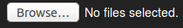
- Through “Drag 'n' Drop” - functionality: Open file browser next to MDP browser window. Select one or several appropriate image files with mouse left-button and Ctrl / Shift -key pressed down. Then move the file selection while mouse left-button pressed down on top of the MDP browser window and release the mouse left-button.

The images should appear in the MDP application and equal amount of empty placeholders for photos are replaced. MDP aims to scale the pictures to target size of 200x250 pixels by default, while conserving aspect ratio. Different image manipulation options can be adopted to app.js from Appendix A. The name fields show initial values from the imported picture files. It is assumed that each picture file is named after the student in the picture: e.g. Pierre.png. Consequently the corresponding name input field should show “Pierre” in this case. The teacher may change the correct naming and remove unwanted photos from the class composition as well:

-  “Update” button may be used to store correct representation of student name and to store it in the IndexedDB.
-  “Delete” button may be used to remove a picture photo and associated name from the IndexedDB.
-  “OK” button is shown only in the student view. After typing the name of the person in the picture student may press either this or “Enter” from keyboard to validate the entry for feedback.

The other configuration options can be found under the main toolbar:

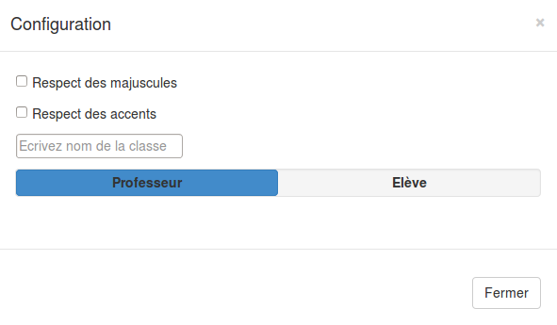

Image 1: Configuration pop-up window

After these preliminary steps the MDP application is ready to be used. The student version of MDP should show only Class name as title heading and Student photos with Name input fields next to OK-button. The main toolbar is hidden from the student. The IndexedDB data (pictures and names) are preserved for future application sessions. Even the clearing of the Firefox cache memories do not affect the MDP application data. If there is a need to reset the system to its initial state, the teacher may press the “Reset” menu item from the main toolbar which brings in the following pop-up.

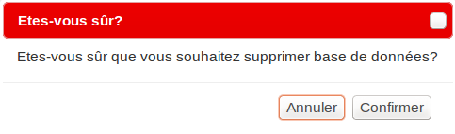
Image 2: Resetting the IndexedDB to its initial state

APPENDIX A Image Manipulation options of the 3rd party library used in MDP
(https://github.com/blueimp/JavaScript-Load-Image#options)

Options
The optional third argument to loadImage() is a map of options:
- maxWidth: Defines the maximum width of the img/canvas element.
- maxHeight: Defines the maximum height of the img/canvas element.
- minWidth: Defines the minimum width of the img/canvas element.
- minHeight: Defines the minimum height of the img/canvas element.
- sourceWidth: The width of the sub-rectangle of the source image to draw into the destination canvas.
Defaults to the source image width and requires canvas: true.
- sourceHeight: The height of the sub-rectangle of the source image to draw into the destination canvas.
Defaults to the source image height and requires canvas: true.
- top: The top margin of the sub-rectangle of the source image.
Defaults to 0 and requires canvas: true.
- right: The right margin of the sub-rectangle of the source image.
Defaults to 0 and requires canvas: true.
- bottom: The bottom margin of the sub-rectangle of the source image.
Defaults to 0 and requires canvas: true.
- left: The left margin of the sub-rectangle of the source image.
Defaults to 0 and requires canvas: true.
- contain: Scales the image up/down to contain it in the max dimensions if set to true.
This emulates the CSS feature background-image: contain.
- cover: Scales the image up/down to cover the max dimensions with the image dimensions if set to true.
This emulates the CSS feature background-image: cover.
- aspectRatio: Crops the image to the given aspect ratio (e.g. 16/9).
This feature assumes crop: true.
- crop: Crops the image to the maxWidth/maxHeight constraints if set to true.
This feature assumes canvas: true.
- orientation: Allows to transform the canvas coordinates according to the EXIF orientation specification.
This feature assumes canvas: true.
- canvas: Returns the image as canvas element if set to true.
- crossOrigin: Sets the crossOrigin property on the img element for loading CORS enabled images.
- noRevoke: By default, the created object URL is revoked after the image has been loaded, except when this option is set to true.
They can be used the following way:
loadImage(

fileOrBlobOrUrl,
function (img) {
document.body.appendChild(img);
},
{
maxWidth: 600,
maxHeight: 300,
minWidth: 100,
minHeight: 50,
canvas: true
}
);
All settings are optional. By default, the image is returned as HTML img element without any image size restrictions.

http://www.html5rocks.com/en/tutorials/offline/quota-research

