https://lh5.googleusercontent.com/Et8XK9-x9atA48OtQO42aawlA8sCnoJd6gcJ6WH-_OJ_n_ZUF18WRC7nqNC_6AY7suyRy4Eb7gy9NxiLgxrnFdMlX5qUSBete1ZpE2BRIHx--ynFcS0SmmOEyYtWerJD-4FJYs5v=s0



**FlyAway Project**

Simplilearn Phase 2

**─**

**MAYUR PATIL**

**Overview**

FlyAway is a simulation for ticket-booking portal that lets people book flights on their website.

Website Admin and Customer can use the same portal to achieve:-

Admin operations:

* **Admin login** - which is authorised according to data in the database.
* **Change password** - Admin needs to enter the old password to authorise.
* **Manage Places**- Add, Delete, Update Places which can be added as Source or Destination later to  manage flights.
* **Manage airlines** - Add, Delete, Update Airlines which can be added as operating Airlines later to  manage flights.
* **Manage Flights** - Add, Delete, Update Flight Routes, Airlines and Prices from existing Place table and Airlines table in database.

Customer Operations:

* Search Flights.
* Check existing Places and operating Airlines if desired flight doesn’t exist.
* Select a flight from search results.
* Confirm flight details like source, destination, date, no.of passengers, total price.
* Enter Customer Details.
* Pay for the displayed price.
* Confirm booking details.
* Redirect to Home Page.

**Home Page :**

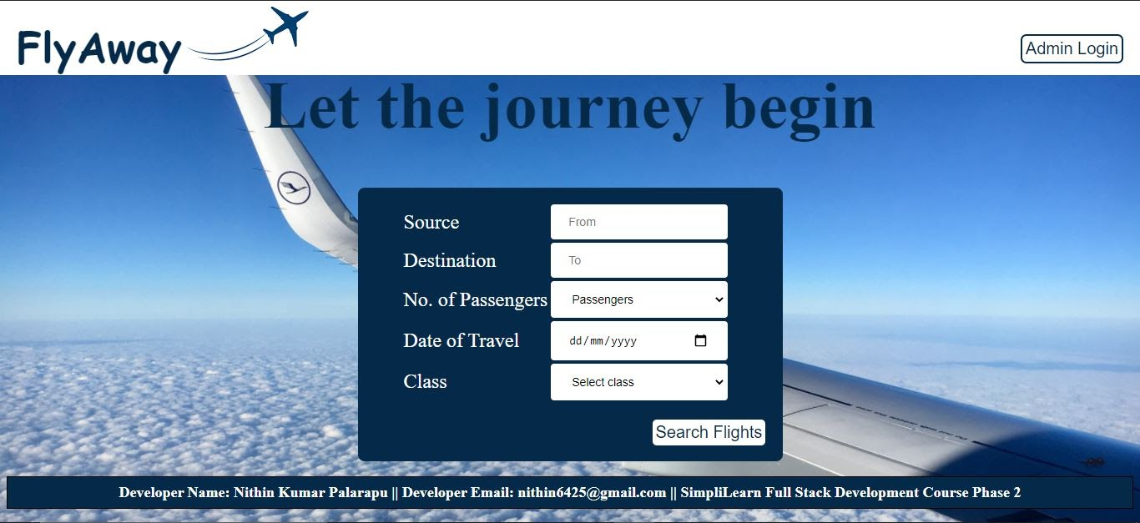

Click  “Admin Login” button to redirect to the Admin login page.

**Admin Login Page:**

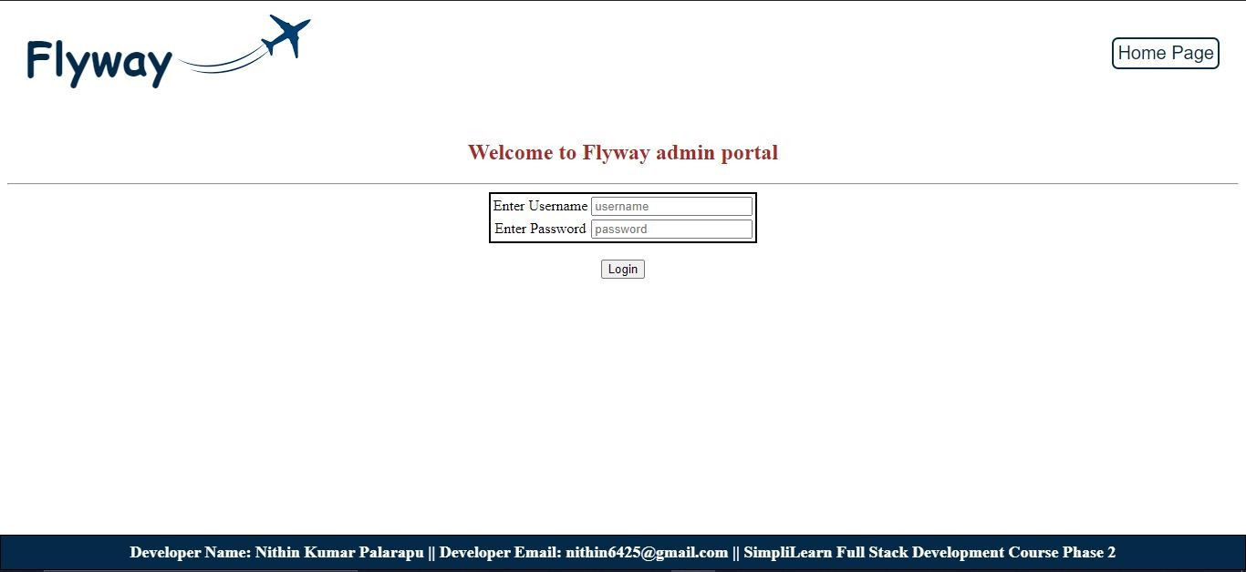

Enter username and password, in which credentials are validated from Database. If username or password are wrong, “Invalid Credentials” is displayed or else the user will be logged in and can see Admin Dashboard.

Invalid Credentials for Admin Login Page

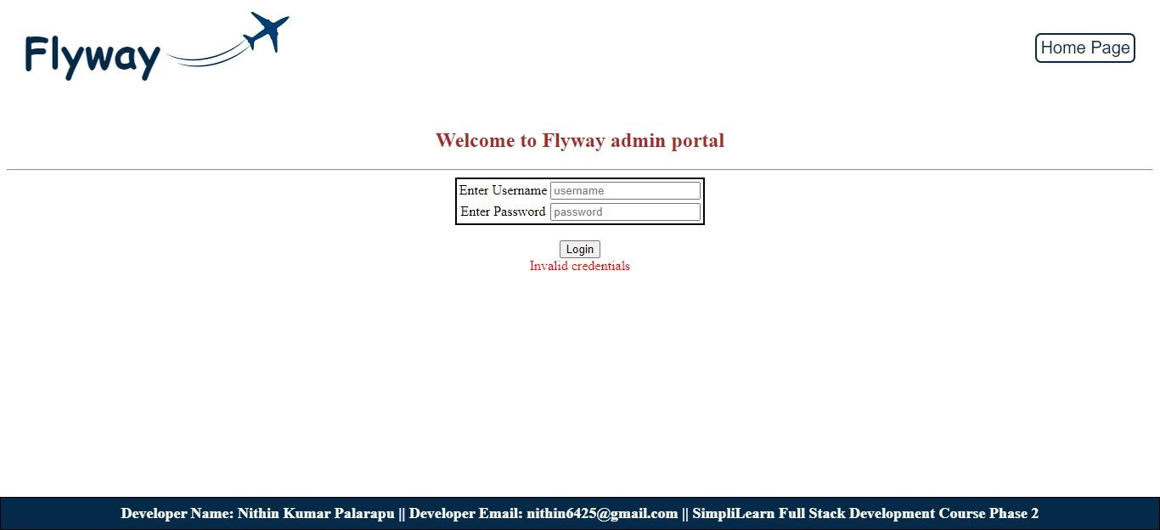

If credentials are valid and matches with database, Dashboard page is opened.

**Admin Dashboard page:**

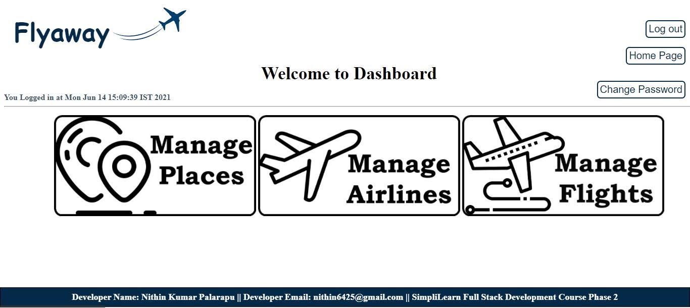

Options in Admin Dashboard Page:

**Log out** - back to the login page.

**Home Page** - Redirect to Home page to search flights.

**Change Password** - Change current user password.

**Manage Places, Airlines, Flights** - Add, Delete and Update options.

**Change Password:**

To change password user need to enter the correct existing password.

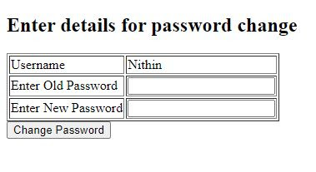

If entered old password is wrong:

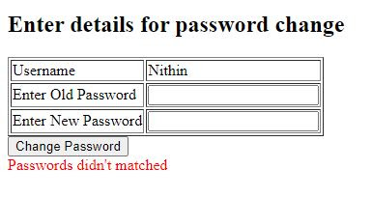

Password can be changed successfully if all conditions are met.

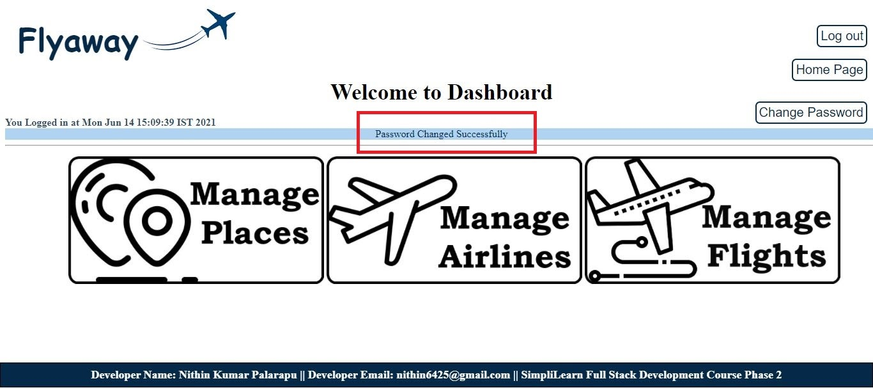

**Manage Places:**

Options in Manage Places page:

* Button for redirect to Admin Dashboard
* Add New Place.
* Display list of existing places with Delete and Update option.

Add Place:

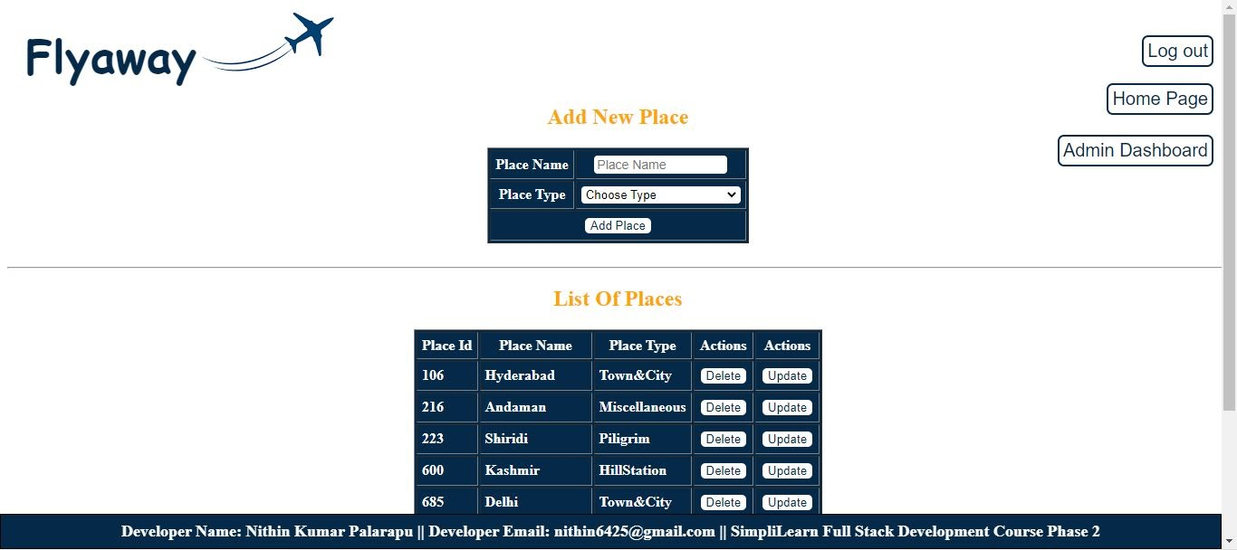

Select PlaceType while adding a new place. *Place_Id is generated by the program itself.*

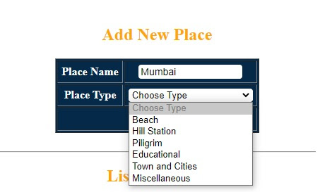

After successfully adding a Place automatically Place_list is refreshed and Displays.

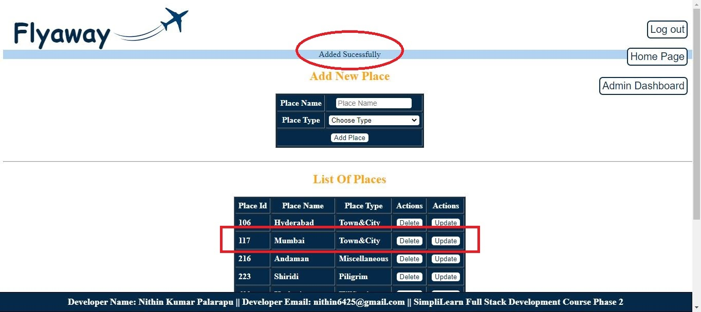

Displays error if any of  fields were empty while adding new place:

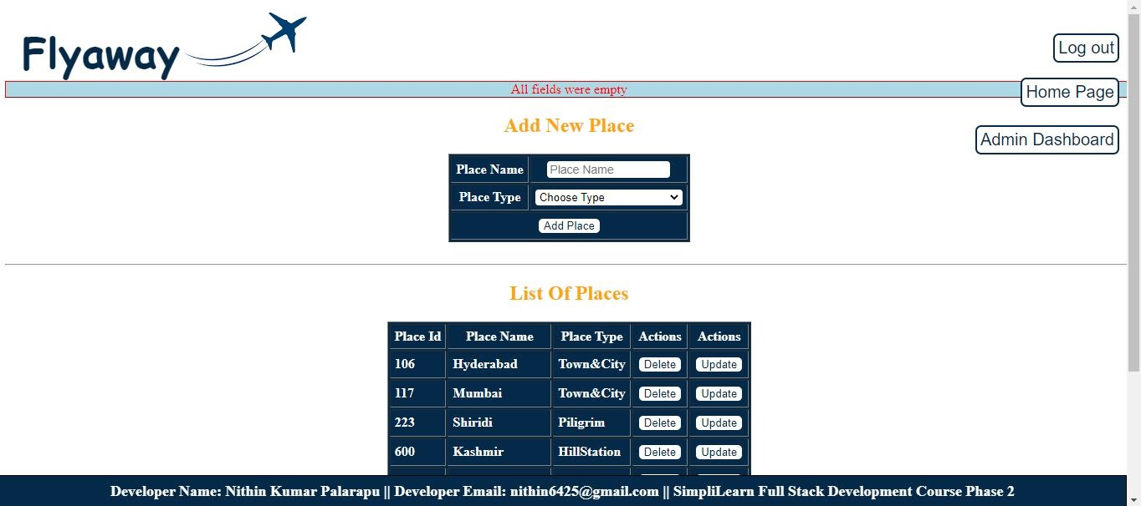

Update Place:

 When Admin clicks on update in Action row. UpdatePlace page will be ready according to PlaceId.

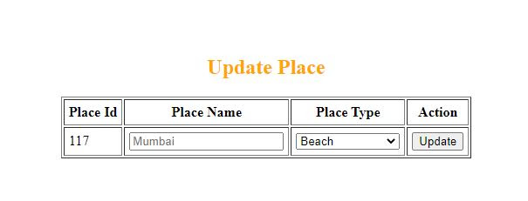

If ALL fields were left empty, displays error. Same as [Click here](https://docs.google.com/document/d/1xsej8dHkR-xfMoYVW1ufhMdZIMyp6toqgpq8aXEWNJg/edit#heading=h.mqezqd54d33m)

Or we can change any of the field or all fields as shown in below image.

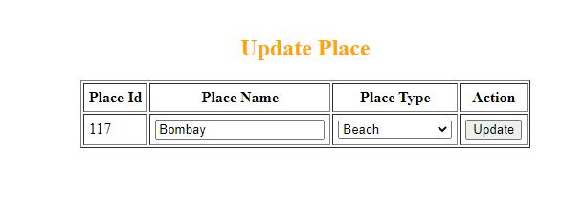

If Update Place happens successfully, it redirects back to Manage Places page with Acknowledgement.

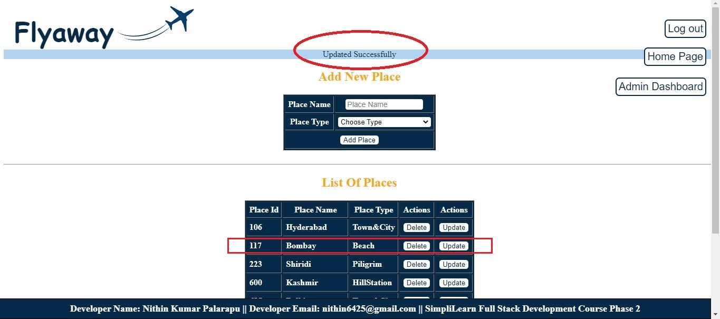

Delete Place:

Just click Delete button which is in the same row of desired place id. Then a prompt or alert appears.

**Note: If you delete any Place All the flights related to place will also be deleted from the flights table in DataBase**.

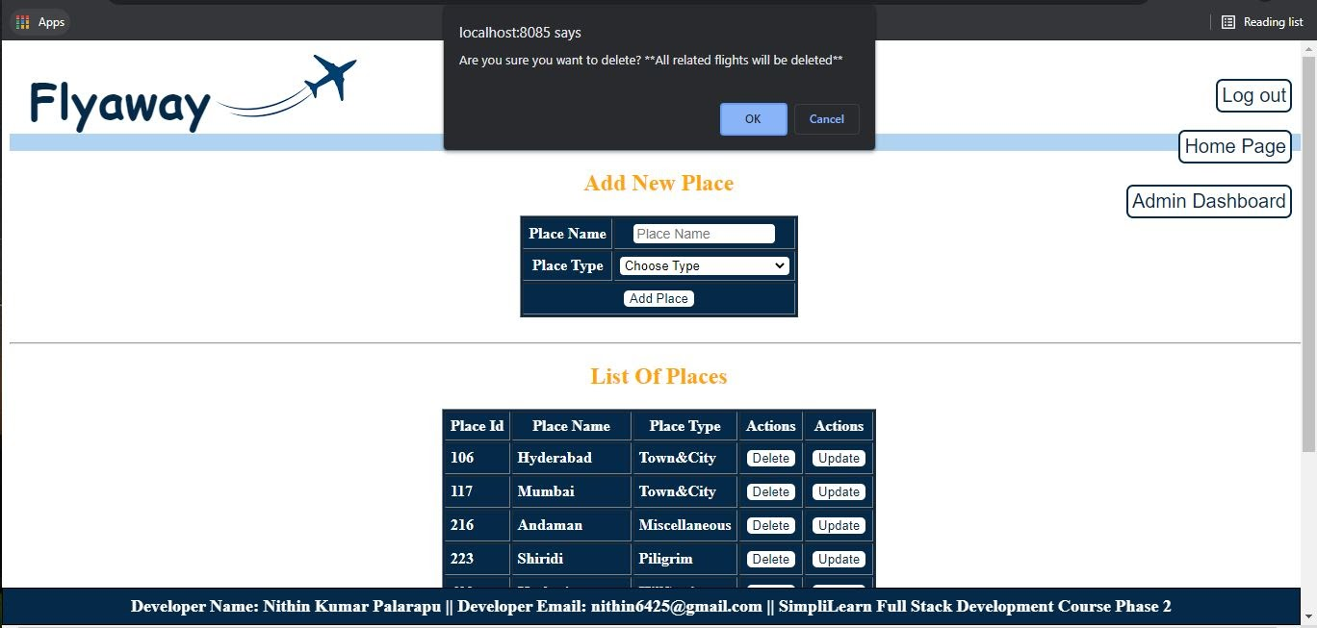

If Admin clicks on “Ok” Acknowledgment will be displayed. Then redirects back to ManagePlace page with a refreshed list.

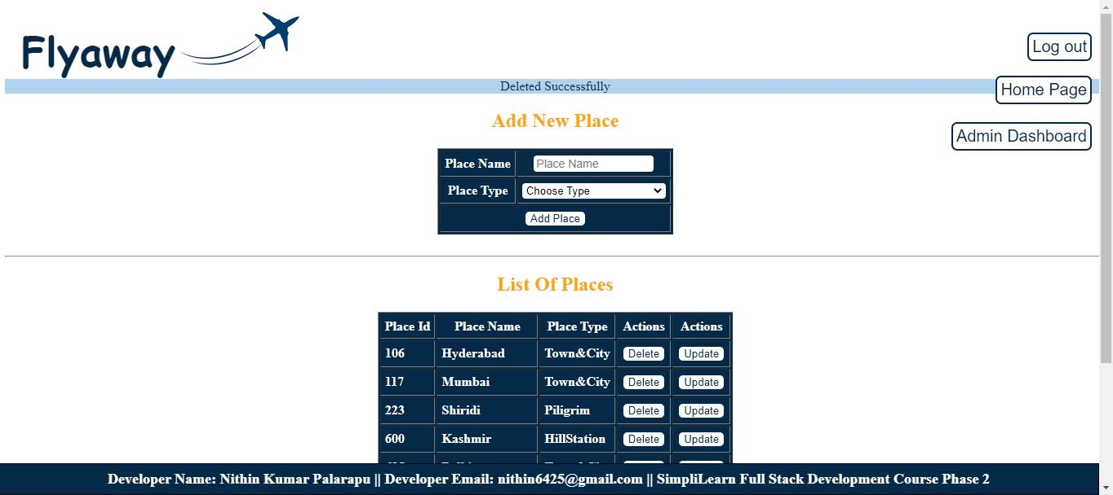

Most of the operations Demo is done.

If we want to go back to **Admin Dashboard** click on button which we can see on right side top.

**Manage Airlines:**

Main page of Manage Airlines is shown below.

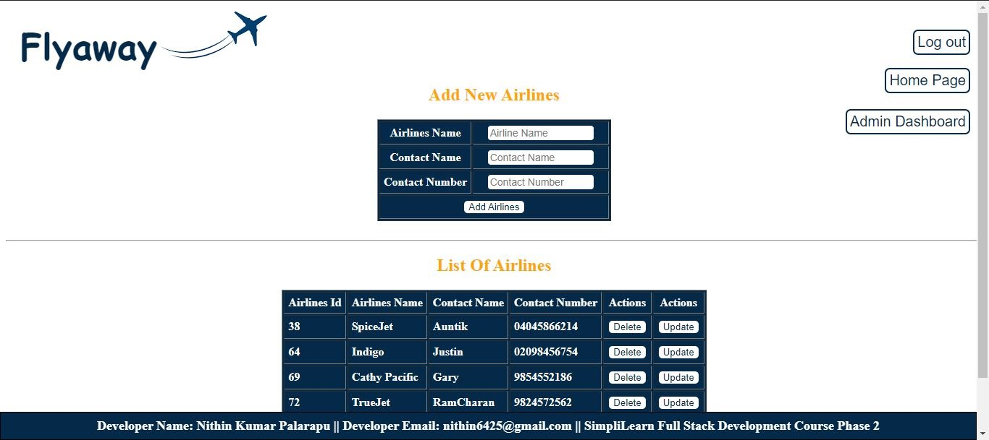

All the Features and Options in Airlines are the same here as Manage Places.

So, straight away we can see options in Manage Flight now. (*next page*)

**Manage Flight:**

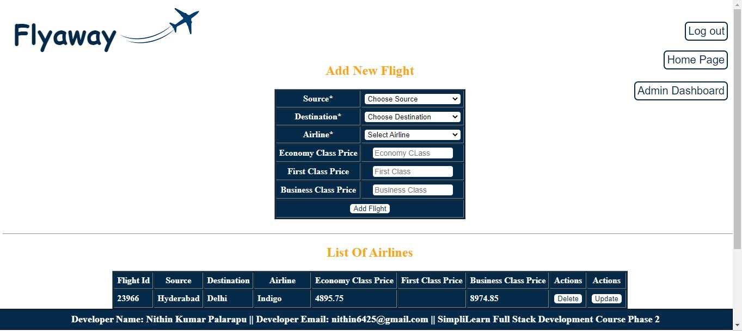

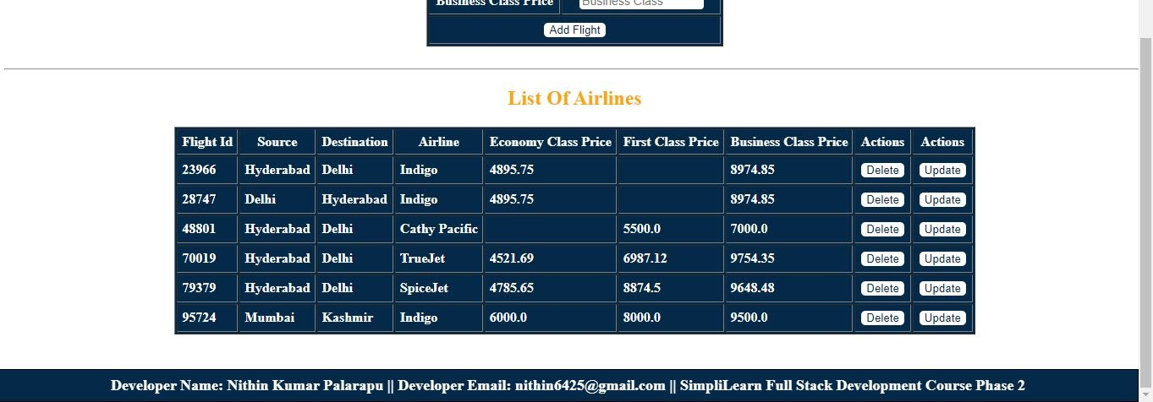

The empty places in the list in price columns indicates Flight doesn’t have respective classes.  
If the flight doesn’t have first class then Admin doesn't need to add price while adding.

Realtime Scenario:

If any customer searches for Hyderabad-Delhi Economy Class.

Flight_id 48801 (Cathy Pacific) will not be displayed in SearchResults as CathyPacific  doesn't provide Economy class.

Here in ManageFlight, We have almost the same options as ManagePlace and ManageAirlines.

But while Adding Source, Destination and Airlines, the list is fetched from Existing Places and Airlines.

Add FLight:

|  |  |
| --- | --- |
| Fetching Source and Destination from existing places in PlaceList. | Fetching Airline list from Existing airlines in AirlineList |
| https://lh3.googleusercontent.com/znaLPPmoj5_ClpckSZEHaRO6Az_uTkV-cPjbw243_x8sb6Q-UlsagbrOGqm34RmcFpuRUutYatwnRNbQcQporHLVrvDazmHIOdWmM5khU1xvCGPQo_ygwuhymQ1MBfywj2zLksSn=s0 | https://lh3.googleusercontent.com/8tbQDuWjMZtatp-3mfPAeE-EVgLStNZQd1ljX7Pt1wepUseCpwDXxdFoQPtkGzYcFVgUaeTVWydFsx3_KV6HOzZ22Vt_IBKHgZqE3lPqjCWOim9lkPkseTU8f4l6-fU-aOKxYJZ4=s0 |

While adding price Admin/User needs to add Source, Destination, Airline and  price of atleast one class in order to add flight.

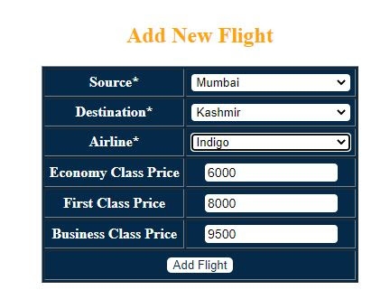

After successful adding flight is done. “Flight Added Successfully” prompt is displayed in the ManageFlight page along with a refreshed Flight List.

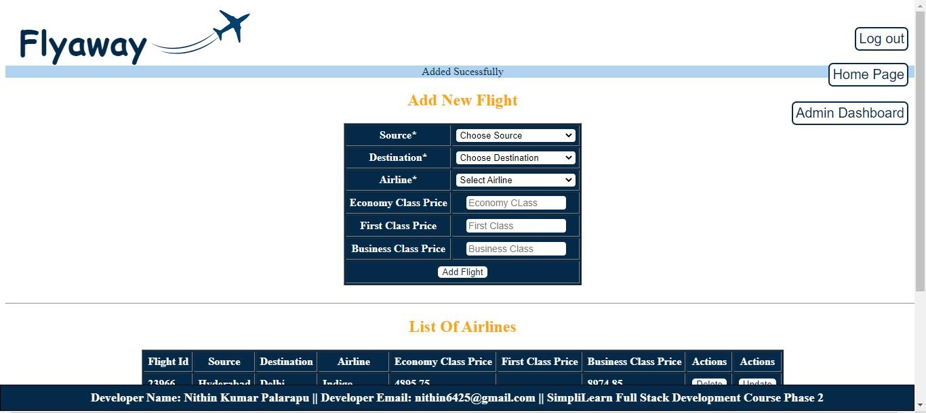

Delete and Update:

Delete and Update Flight also works in the same manner as Place and Airlines.

Operations perform when the user clicks on buttons shown in Highlighted part.

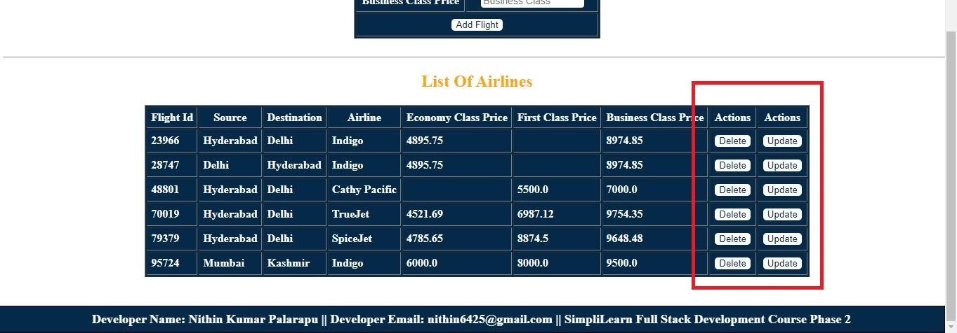

Here are the CRUD operations required on Database.

Now we can look at how this data is used on Customer End (Search and Book Flight ticket).

**Customer Flight Search**

Here Customer search starts from HomePage.



*Customer needs to fill all fields to perform search operations.

Fields empty:

If any of the fields is left empty then a prompt appears on HomePage.

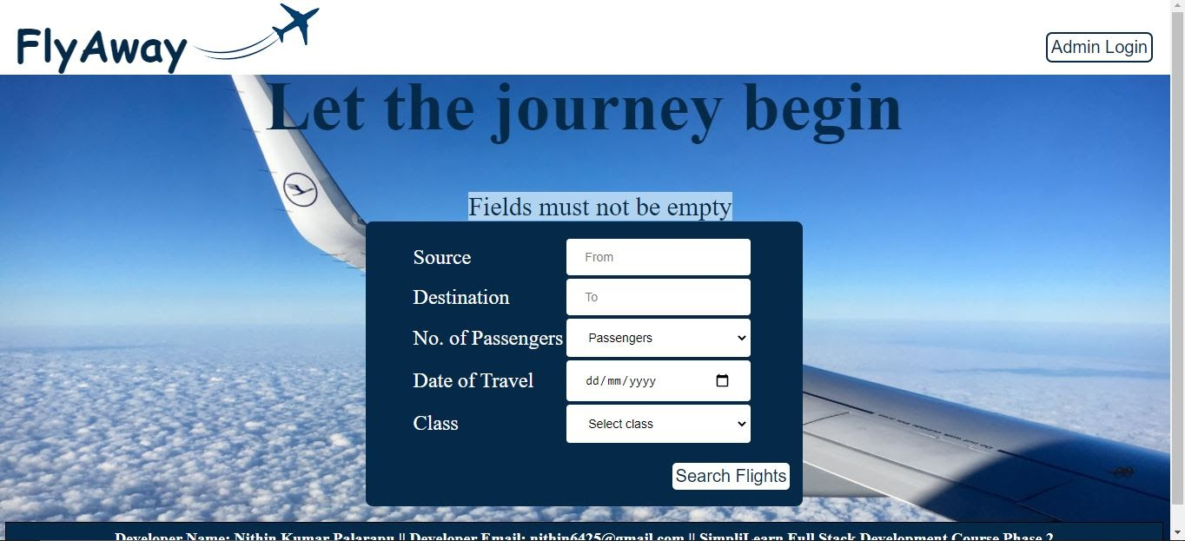

If Source or Destination Doesn’t Exist:

If Customer searches for a place which is not in DataBase (or In other words place which FLYAWAY is not operating currently.) then customer is redirected to page which displays list of Places and Airlines.

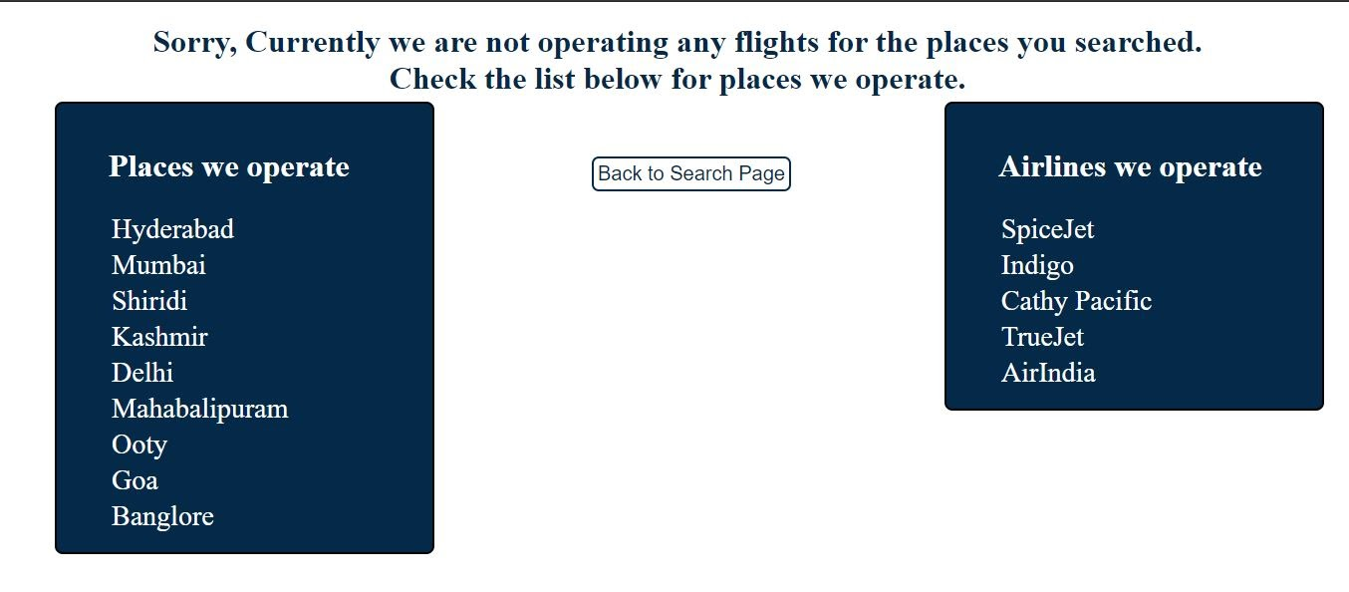

Customer needs to Click on “Back to Search Page” to redirect to HomePage.

IF no flights available in desired route.

*If Customer Search for place which FLYAWAY has in database but no flights operating, then a prompt comes up on HomePage.

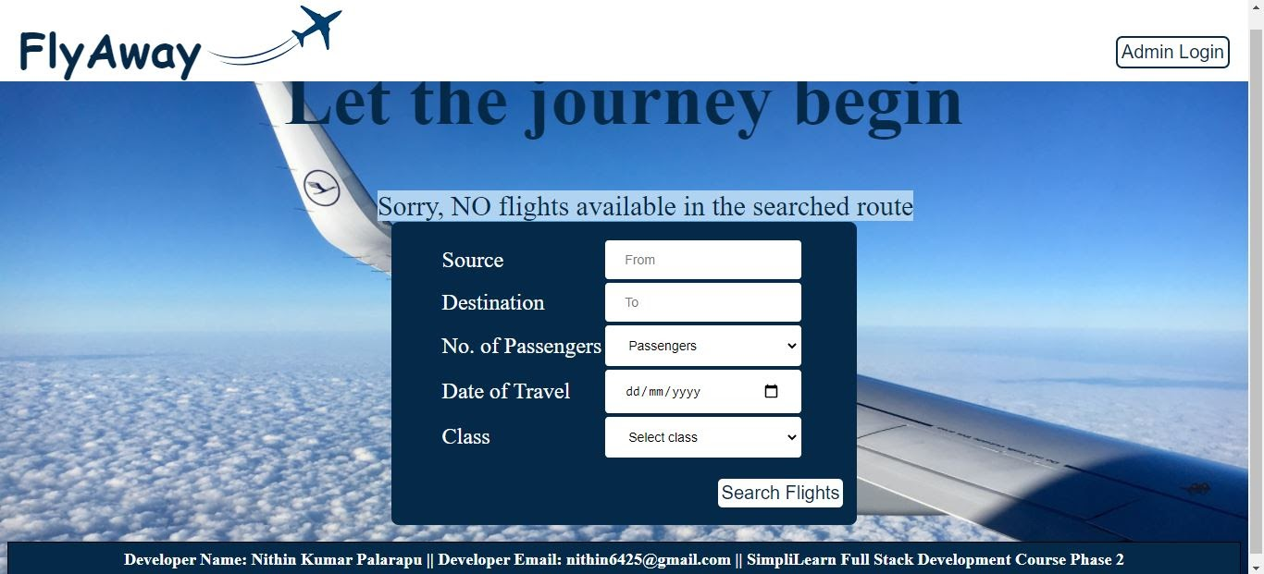

If all the search conditions are fulfilled and found results. (Here I wanted to demo in two different ways.)

|  |
| --- |
| Just a Full list of Flights for you and I will demo the actual SearchResult Page next. |
| https://lh6.googleusercontent.com/rPIXNUnfpdIv2AZxNwEBctv4MmImF-yCEbH1ept_OrqzV3uPQboBPA3RXimJ9Niklu1Ml2625biOChBw1e7N60sqCEDpVVpyvywmNJDGWBZhclt1sUJca1cib5tY_J45VuZa1270=s0 |

If Search Result is positive and Have flights:

Consider customers searched for *Hyderabad* to *Delhi* for *2 passengers*.

|  |
| --- |
| Below shown image is **SearchResult** Page which display’s all results.  If a Customer needs **Business** Class. (4 flights) {“Home Page” button in below image for redirecting back to Main Search} |
| https://lh3.googleusercontent.com/GpCwCole_yn-jROuZcgI0YKYcrj4gwYCt5R0MIvEzKgnA_W_SpeFj731IaJKUlnlhc_UdboLRnUQy7XMy4Lf4k60DSord6VFzZPOscy_6j3t3YMjmvoNIIA752RtVlj_9eKnZjIH=s0 |

Here the image at the top shows 4 flights as search result because in [main list](https://docs.google.com/document/d/1xsej8dHkR-xfMoYVW1ufhMdZIMyp6toqgpq8aXEWNJg/edit#heading=h.ho6d5crgo5z9) shows that all flights from Hyderabad to Delhi have Business Class, but for Economy class only three flights, So you can see in the next image how the page displays only three Search Results.

|  |
| --- |
| If a Customer needs **Economy** class (Same Source and Destination but different class) |
| https://lh5.googleusercontent.com/kcZ2wDQyT_56c2FS7AiQtkI0C1FQKrw3KxQxe7bdx9vPZEPBFj8T67uRDiL_P8UB9MmgmVSq6iF5QoumUf_dXl4h3aqdKL1J38IAvqE6YvGm1xcnXmejpkAdhv3JsEarp0fyAQhE=s0 |

Select any one flight, Click on “Book” button which is adjacent to desired flight. Then customer is redirected to page which confirms flight details and asks for customer details.

Confirm and Pay Page:

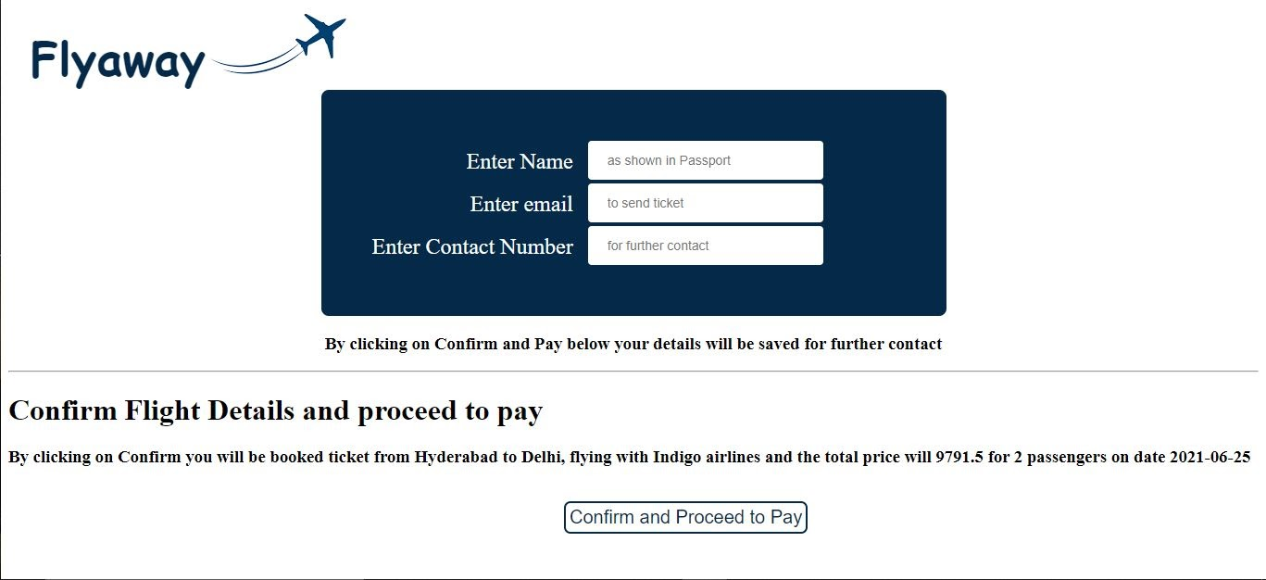

Customer *must* enter their all asked personal details and click on “Confirm and Proceed to Pay” button for next step which payment process.

Dummy Payment Gateway:

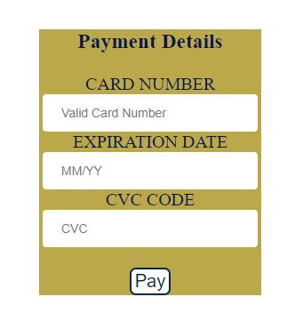

Once user clicks on “Pay” button User can see further confirm ticket details and “Booking Successful” acknowledgement.

The names and contact details in image on top are taken from “[Confirm Details and Pay”](https://docs.google.com/document/d/1xsej8dHkR-xfMoYVW1ufhMdZIMyp6toqgpq8aXEWNJg/edit#heading=h.v3bzhejja8wf) page.   
Customers should click on “Redirect to Home Page” button to redirect back to Home Page.

**\*\*\*Thank You\*\*\***