**TEAM**

A team is a group of individuals working together to achieve their goal.

According to Professor Leigh Thompson of the Kellogg School of Management, "[a] team is a group of people who are interdependent with respect to information, resources, knowledge and skills and who seek to combine their efforts to achieve a common goal".

A group does not necessarily constitute a team. Teams normally have members with complementary skills and generate synergy through a coordinated effort which allows each member to maximize their strengths and minimize their weaknesses.

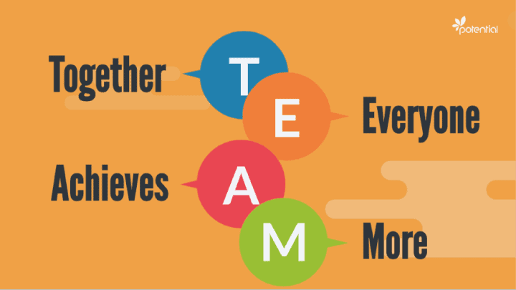

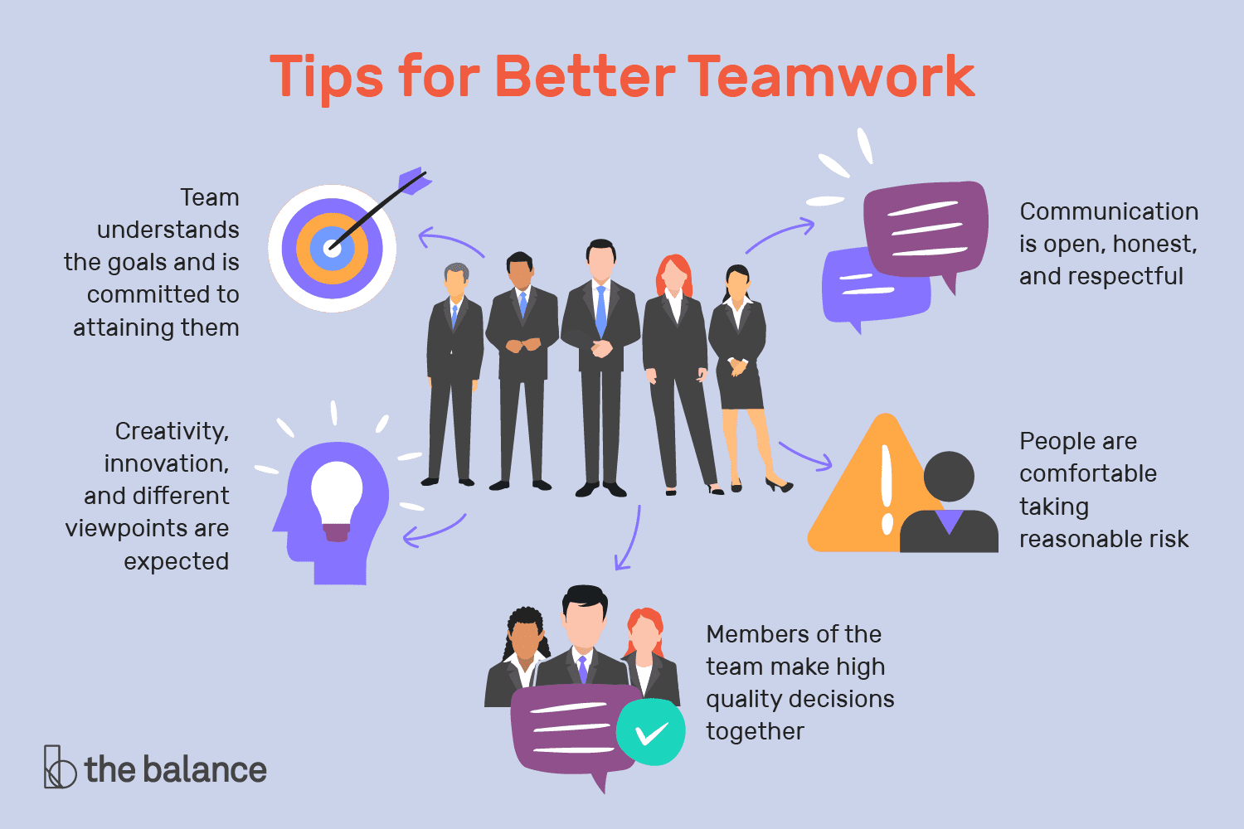

**TYPES**

Action teams

An action team is a group of people with leadership skills. It devises strategies, analyze situations and execute needed actions.

Advisory teams

Advisory teams make suggestions about a final product (Devine, 2002). For instance, a quality-control group on an assembly line would be an example of an advisory team: they may examine the products produced and make suggestions about how to improve the quality of the items being made. A product reaches the final stage and is put for sales after getting approved by the advisory teams. The advisory team consists of experts who possess extraordinary skills.

Command team

The goal of the command team is to combine instructions and to coordinate action among management. In other words, command teams serve as the "middle man" in tasks. For instance, messengers on a construction site, conveying instructions from the executive team to the builders, would be an example of a command team.

Executive team

An executive team is a management team that draws up plans for activities and then directs these activities. An example of an executive team would be a construction team designing blueprints for a new building, and then guiding the construction of the building using these blueprints.

Project teams

A team used only for a defined period of time and for a separate, concretely definable purpose, often[quantify] becomes known as a project team. This category of team includes negotiation-, commission- and design-team subtypes. In general, these types of teams are multi-talented and composed of individuals with expertise in many different areas. Members of these teams might belong to different groups, but receive assignment to activities for the same project, thereby allowing outsiders to view them as a single unit. In this way, setting up a team allegedly facilitates the creation, tracking and assignment of a group of people based on the project in hand. The use of the "team" label in this instance often has no relationship to whether the employees work as a team.

Sports teams

A sports team is a group of people which play sports (often team sports) together. Members include all players (even those who are waiting their turn to play), as well as support members such as a team manager or coach.

Virtual teams

Developments in information and communications technology have seen the emergence of the virtual work-team. A virtual team is a group of people who work interdependently and with shared purpose across space, time, and organisational boundaries using technology to communicate and collaborate. Virtual team members can be located across a country or across the world, rarely meet face-to-face, and include members from different cultures.

Work teams

Work teams are responsible for the actual act of creating tangible products and services. The actual workers on an assembly line would be an example of a production team, whereas waiters and waitresses at a diner would be an example of a service team.

Interdependent and independent

One common distinction is drawn between interdependent and independent teams. The difference is determined by the actions that the team members take while working.

Interdependent teams

A rugby union scrum

A rugby team provides a clear example of an interdependent team:

no significant task can be accomplished without the help and cooperation of every member; within their team members typically specialize in different tasks (r.r the ball, goal kicking and scrum feeding), and the success of every individual is inextricably bound to the success of the whole team. No rugby player, no matter how talented, has ever won a game by playing alone.

Independent teams

On the other hand, a track-and-field team is a classic example of an independent team: races are run, or points are scored, by individuals or by partners every person in a given job performs basically the same actions how one player performs has no direct effect on the performance of the next player

ELEMENTS/INGRIDIENTS OF A TEAM

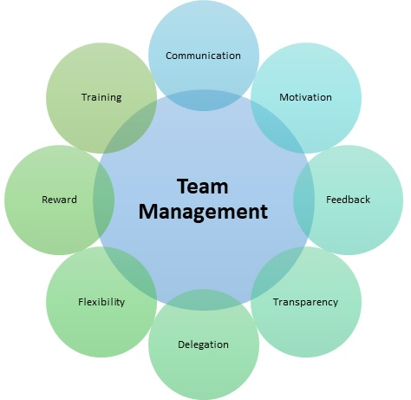

* Ideal Size and Membership.
* Fairness in Decision-Making.
* Creativity.
* Accountability.
* Purpose and Goals.
* Action Plans.
* Roles & Responsibilities.
* Information Sharing.
* Meeting Skills and Practices.
* Decision Making.
* Participation.
* Clear Roles.
* Accepted Leadership.
* Good Relationships.
* Excellent Communication.