TIME MANAGEMENT

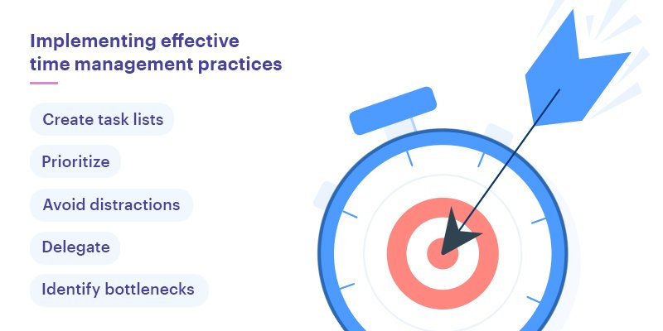

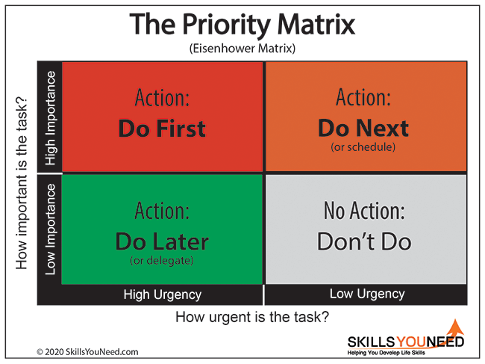

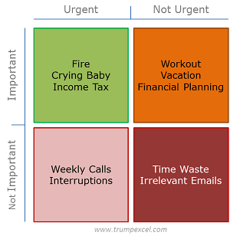

3 P OF TIME MANAGEMENT

PLANNING

PRIORITIZING

PERFORMING

4D OF TIME MANAGEMENT

