**PRESENTATION: STRUCTURE & LANGUAGE**

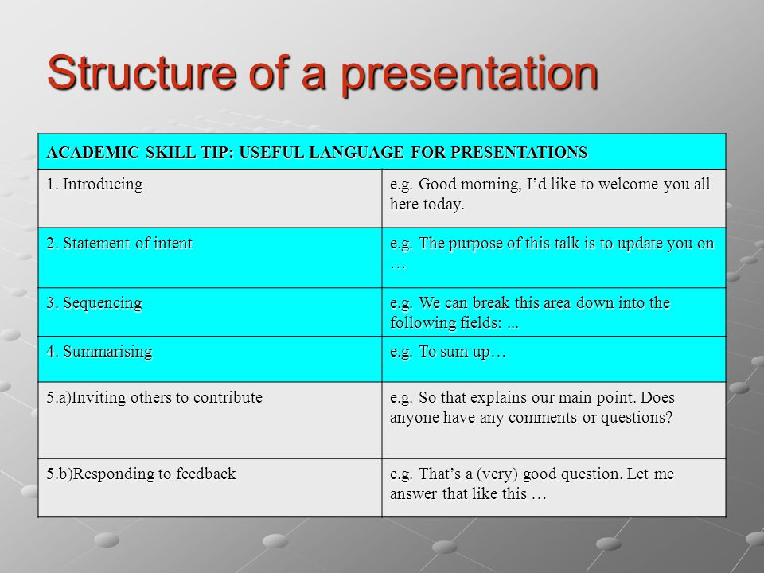

## INTRODUCTION

**Greeting the audience**

* Good morning/afternoon, ladies and gentlemen.
* Good morning/afternoon, everyone.

**Expressing the purpose**

* My purpose/objective/aim today is...
* What I want to do this morning/afternoon/today is...
* I'm here today to...

**Giving the structure**

* This talk is divided into four main parts.
* To start with/Firstly, I'd like to look at...
* Then/Secondly, I'll be talking about...
* Thirdly...
* My fourth point will be about...
* Finally, I'll be looking at...

**Giving the timing**

* My presentation/talk/lecture will take/last about 20 minutes.

**Handling questions**

* At the end of my talk, there will be a chance to ask questions.
* I'll be happy to answer any questions you have at the end of my presentation.

## MAIN BODY

**Visual aids**

* As you can see here...
* Here we can see...
* If we look at this slide...
* This slide shows...
* If you look at the screen, you'll see...
* This table/diagram/chart/slide shows...
* I'd like you to look at this...
* Let me show you...
* Let's (have a) look at...
* On the right/left you can see...

## TRANSITIONS

**Transitions**

* Let's now move on to/turn to...
* I now want to go on to...
* This leads/brings me to my next point, which is...
* I'd now like to move on to/turn to...
* So far we have looked at... Now I'd like to...

## SOME MORE LANGUAGE

**Giving examples**

* Let me give you an example...
* such as...
* for instance...
* A good example of this is...

**Summarising**

* What I'm trying to say is...
* Let me just try and sum that up before we move on to...
* So far, I've presented...

**Digressing**

* I might just mention...
* Incidentally...

## CONCLUDING

**Summing up**

* Summing up...
* To summarise...
* So, to sum up...
* To recap...
* Let me now sum up.

**Concluding**

* Let me end by saying...
* I'd like to finish by emphasising...
* In conclusion I'd like to say...
* Finally, may I say...

**Closing**

* Thank you for your attention/time.
* Thank you (for listening/very much).

**Questions**

* If you have any questions or comments, I'll be happy to answer them now.
* If there are any questions, I'll do my best to answer them.
* Are there any more questions?

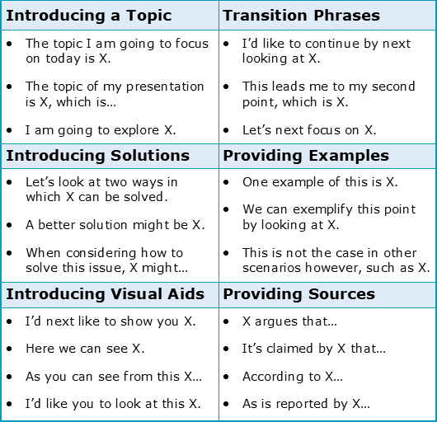

**Active verbs**

Use active verbs instead of passive verbs. Active verbs are much easier to understand. They are much more powerful. Consider these two sentences, which say the same thing:

Toyota sold nine million vehicles last year.

Nine million vehicles were sold by Toyota last year.

**Phrasal verbs**

|  |
| --- |
| Posture is confident (standing up straight) |
| Hands are held in a comfortable position |
| Position is good (facing the audience, not talking to the screen or notes) |
| Movement is natural (not too much or too little) |
| Hands are used well (to emphasise points, to count, to demonstrate) |
| Nervous gestures (touching hair/glasses) are avoided |
| Eye contact is maintained throughout the presentation |
| The speaker looks at the whole audience (not just one or two people) |
| The speaker avoids talking to the screen/notes |

