**SYSTEM DESIGN DOCUMENT**

FOR

LSHTM IDEAS

**DATA INFORMED PLATFORM FOR HEALTH**

Version 1.0

Oct , 2020

Table of Contents

1. Introduction 4

1.1 Purpose of this System Design Document 4

2. General Overview and Design Guidelines/Approach 4

2.1 General Overview 5

2.2 Assumptions / Constraints / Risks 6

2.2.1 Assumptions 6

2.2.2 Constraints 6

2.2.3 Risks 7

3. Design Considerations 7

3.1 Architectural Goals 7

3.1.1 Guiding Principles 7

3.1.2 Scalable 8

3.1.3 Flexible 8

3.1.4 Standards-Based 8

3.1.5 Design Principles 8

3.2 Development Methods & Contingencies 9

3.3 Performance Engineering 9

4. System Architecture and Architecture Design 9

4.1 Hardware Architecture 10

4.1.1 Firewall Layer 10

4.1.2 Public Subnet / DMZ 10

4.1.3 Load balancing Tier 10

4.1.4 Device Interface Web Server Tier 10

4.1.5 Private Subnet 10

4.1.6 Web Application Server 10

4.1.7 Session Cache Cluster 11

4.1.8 Database Layer 11

4.1.9 File Storage Pool 11

4.1.10 Cron Services 11

4.1.11 Disaster Recovery Layer 11

4.1.12 Security Hardware Architecture 11

4.1.13 Performance Hardware Architecture 12

4.2 Software Architecture 12

4.2.1 Server Side Software Architecture 12

4.2.1.1 Technology Stack 12

4.2.1.2 Operating System 12

4.2.1.3 Database Management System 12

4.2.1.3.1 Caching System 13

4.2.1.3.2 Web Server 13

4.2.1.3.3 Application Process Manager 13

4.2.1.3.4 Programming Language 13

4.2.1.3.5 Application Framework 13

4.2.1.4 Application Components 13

4.2.1.4.1 DIPH Web Services API 14

4.3.1 Network Component Involved in Above Mobile Network 14

4.3.2 Communication in Data Center Cloud Infrastructure 15

4.4 Security Architecture 15

5. System Design 17

6. ER Diagram 18

7. Data Dictionary 19

# 1. Introduction

This System Design Document (SDD) of “DIPH web backend & web application” describes how:

1. The functional and non-functional requirements recorded in the Requirements Document,
2. The preliminary user-oriented functional design recorded in the High Level Technical Design Concept/Alternatives document, and
3. The preliminary data design documented in the Logical Data Model (LDM) is transformed into more technical system design specifications from which the system will be built. This SDD is being used to document both high-level system design and low-level detailed design specifications.

This SDD of “DIPH web backend & web application” describes design goals and considerations, provides a high-level overview of the system architecture, and describes the data design associated with the system, as well as the human-machine interface and operational scenarios. The high-level system design is further decomposed into low-level detailed design specifications for each of the system’s components, including hardware, internal communications, software, system integrity controls, and external interfaces. The high-level system design serves as primary input to the Preliminary Design Review (PDR). The low-level detailed design serves as input to the Detailed Design Review (DDR).

## 1.1 Purpose of this System Design Document

Purpose of this System Design Document is to document and track the necessary information required to effectively define architecture and system design of “DIPH web backend & web application” in order to give the development team guidance on architecture of the system to be developed. This Design document will be incrementally and iteratively produced during the system development life cycle, based on the particular circumstances of the DIPH project and the system development methodology used for developing the system. Its intended audience is the project manager, project team, and development team. Some portions of this document such as the user interface (UI) may on occasion be shared with the users, and other stakeholder whose input/approval into the UI is needed. This SDD may or may not need an update on requirements changes depending upon the nature and impact of the change on the software architecture.

# 2. General Overview and Design Guidelines/Approach

This section describes the principles and strategies to be used as guidelines when designing and implementing the system.

## 2.1 General Overview

1. The Data Informed Platform for Health (DIPH) is a decision-making support system which facilitates review and use of data in local level decision-making in the health sector and is evidently an effective mechanism for multi-sectoral data sharing and data-based decision making using local programme and service data at district level.
2. 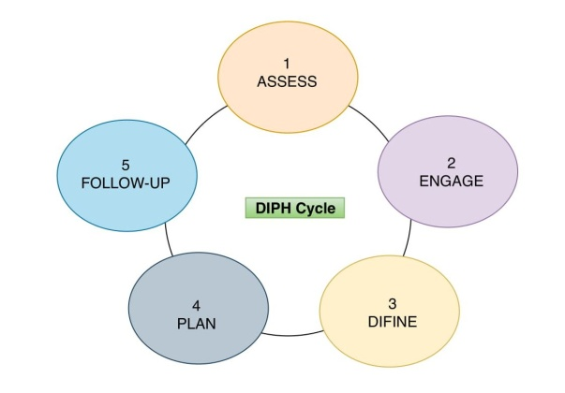Districts are encouraged to select a theme or area of focus based on their local public health needs and based on the available data, local experiences, and health priorities and start a DIPH cycle, which ideally should last four to five months, allowing the districts to have at least 3 cycles in a year. Each DIPH cycle has a designated stakeholder as the theme leader, who is responsible for the overall execution of cycle specific DIPH steps. There can be different theme leaders for different cycles or the health district can designate one person as the theme leader for the entire duration (year) of the DIPH process. Each cycle consists of the districts collectively going through the following five steps (shown below), in doing so they use the DIPH web interface as a tool to gather, analyse, and monitor information and progress against set targets.
3. Each step has multiple forms attached to it, which are internally connected to share data across the platform. The forms can only be filled in an intuitive and logically sequentially manner.
4. 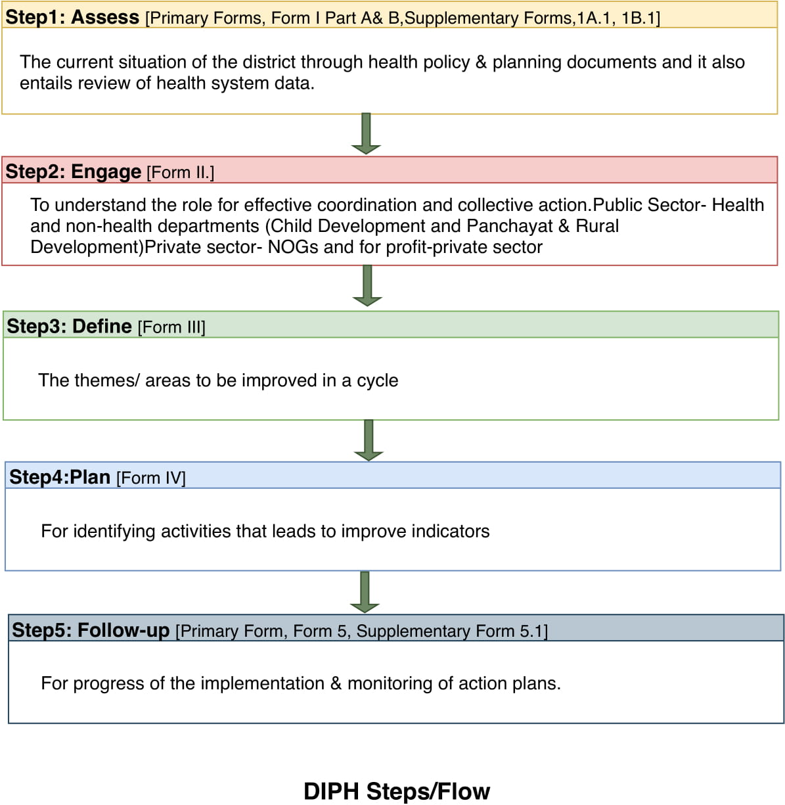

## 2.2 Assumptions / Constraints / Risks

### 2.2.1 Assumptions

There are following assumptions taken in consideration while writing this document.

1. Actors provided in RFP and Mentioned in SRS will be the same for the designed system.

2. Designed system will show up data as input provided.

3. System will not support partial data sync from device to server.

### 2.2.2 Constraints

Following are constraints to design the DIPH System

* 1. Shall use open source technologies
  2. Shall have no legal implications of using 3rd party / Open Source software
  3. All images used in the web application must not have any legal / copyright issues
  4. Shall have the ability to detect and defeat Flooding / DoS (Denial of Service) attacks on the portal. Shall be tested with appropriate tools and report submitted for verification as part of User Acceptance Testing.
  5. Shall have appropriate Authentication, Authorization and User management features
  6. Shall be certified via appropriate VAPT (Vulnerability and Penetration Test) suite and report submitted
  7. No screen shall take more than 10 seconds to load at stipulated loads. Shall be tested via appropriate tools and report submitted
  8. Shall support English for data entry and display
  9. Shall be able to store, search and retrieve data for of past 1 years and archive data for past 5 years
  10. The application shall have log rotation enabled for all log files
  11. Web application must support IE, Chrome and Firefox browsers
  12. Web application should be responsive and support form factor for desktop, tablets .
  13. No password / sensitive information shall be transmitted / stored in clear text anywhere in the communication pathway OR in database
  14. User interface must have a defined style guide which shall be adhered to during the implementation
  15. User interface must follow a uniform pattern with a common style sheet across pages
  16. Shall be built using tools and libraries and protocols that are de facto standards in industry
  17. Shall be secure at all layers – UI, Application and data
  18. Choice of technologies should allow quick development, build and deploy cycles
  19. Shall support quick and easy integration into existing PFMS and other systems as deemed necessary using HTTP based RESTful APIs
  20. Shall not require any special plug-ins and privileges on the browser to access the application
  21. The solution shall be configurable to prevent corruption or loss of data already accepted into the solution in the event of a solution failure
  22. The solution shall support protection of confidentiality of all Protected Health Information (PHI) delivered over the Internet or other known open networks via encryption using triple-DES (3DES) or the Advanced Encryption Standard (AES) and an open protocol such as Transport Layer Security (TLS), Secure Sockets Layer (SSL), Internet Protocol Security (IPsec), XML encryptions, or Secure/Multipurpose Internet Mail Extensions(S/MIME) or their successors.
  23. The solution shall maintain a log of all user activities related to access - view and printing of the validation of the registration validation list. The log, among other details, shall include the user id, access date and time, and type of accesses made. The log shall be linked to the registration record and available for access for the authorized users. The solution shall ensure that registration data is accepted only when submitted by a human and not by an automated program.
  24. The solution shall provide secure and automatic access to external web services
  25. The solution shall provide local data persistence and security on mobile units
  26. The solution shall provide applications to rely on location information for location awareness

### 2.2.3 Risks

Since the requirements on the field might change during actual implementation and might be in a transient state for some time, the overall system design might get affected because of further elaboration of the requirements.

# 3. Design Considerations

Following are the design considerations for the “ DIPH System”.

## 3.1 Architectural Goals

The overall architecture goals of the system are to provide a highly available and scalable websites for the users.

The key Architectural goal is to leverage industry best practices for designing and developing a scalable, enterprise-wide application. To meet this goal, the design of the application will be based on MVC patterns as well as the industry standard development guidelines for building the application with content and user sharing.

### 3.1.1 Guiding Principles

Guiding principles provide a foundation which can be used to validate the design and ensure that it is aligned with application’s overall Architecture.

Some of the guiding principles that are followed during the design and development are outlined below.

### 

### 3.1.2 Scalable

Scalability is the ability of the platform to scale both up and down to support varying numbers of users or transaction volumes. The application should be able to scale horizontally (by adding more servers) or vertically (by increasing hardware capacity or software efficiency).

### 3.1.3 Flexible

Flexibility is the ability of the application to adapt and evolve to accommodate new requirements without affecting the existing operations. Flexibility is all dependent on the complexity of requirements.

### 3.1.4 Standards-Based

Portal services will comply with established industry standards. The standards-compliance will not only apply to application development but also to design, platform/infrastructure and other parts of the application. Examples of standards include HTML, MySQL and PHP.

### 3.1.5 Design Principles

Best practices and design principles will be applied in two main areas –

1. Application’s Services to Web should be uncoupled –
   * 1. Since application’s services are delivered to a web browser therefore it should support a range of modern browsers that support HTML, DHTML, JavaScript and XML.
     2. A common look and feel for the Application.
     3. Client side JavaScript should be used for validating user input and prevents round trips between the browser and the server
     4. The user interface will be designed in such a way that common user interface functionality will be implemented in a similar manner across the board. Examples of this include –
   * A consistent way of capturing date inputs
   * A uniform way of displaying informational and error messages to the users
   * A uniform way of displaying required and optional fields in the screens.

2. Business Rules should be encoded within the application development framework-

* + 1. Business rules will need to be separated from the presentation and database frameworks
    2. Server applications are based on event-based systems. Complex server side event cascades will need to be supported.
    3. Standard frameworks for encoding business rules and events will need to be used.
    4. Adoption of a component based framework needs to be considered to promote reuse of information objects.

## 3.2 Development Methods & Contingencies

The design of the “ DIPH system” follows object oriented design completely. As we are using framework of PHP, Apache for server’s side application development the framework enforces the object oriented design by default. It uses Model View Controller (MVC) design to do the separation of concerns.

## 

## 3.3 Performance Engineering

A contributing factor to System Design will be Performance Requirements. Performance Requirements are the defined scalability or responsiveness expectations of specific workloads that process on a system.

# 4. System Architecture and Architecture Design

This section outlines the system and hardware architecture design of the DIPH system that is being built. Keeping all constraints in mind following is the overall system architecture of the DIPH system

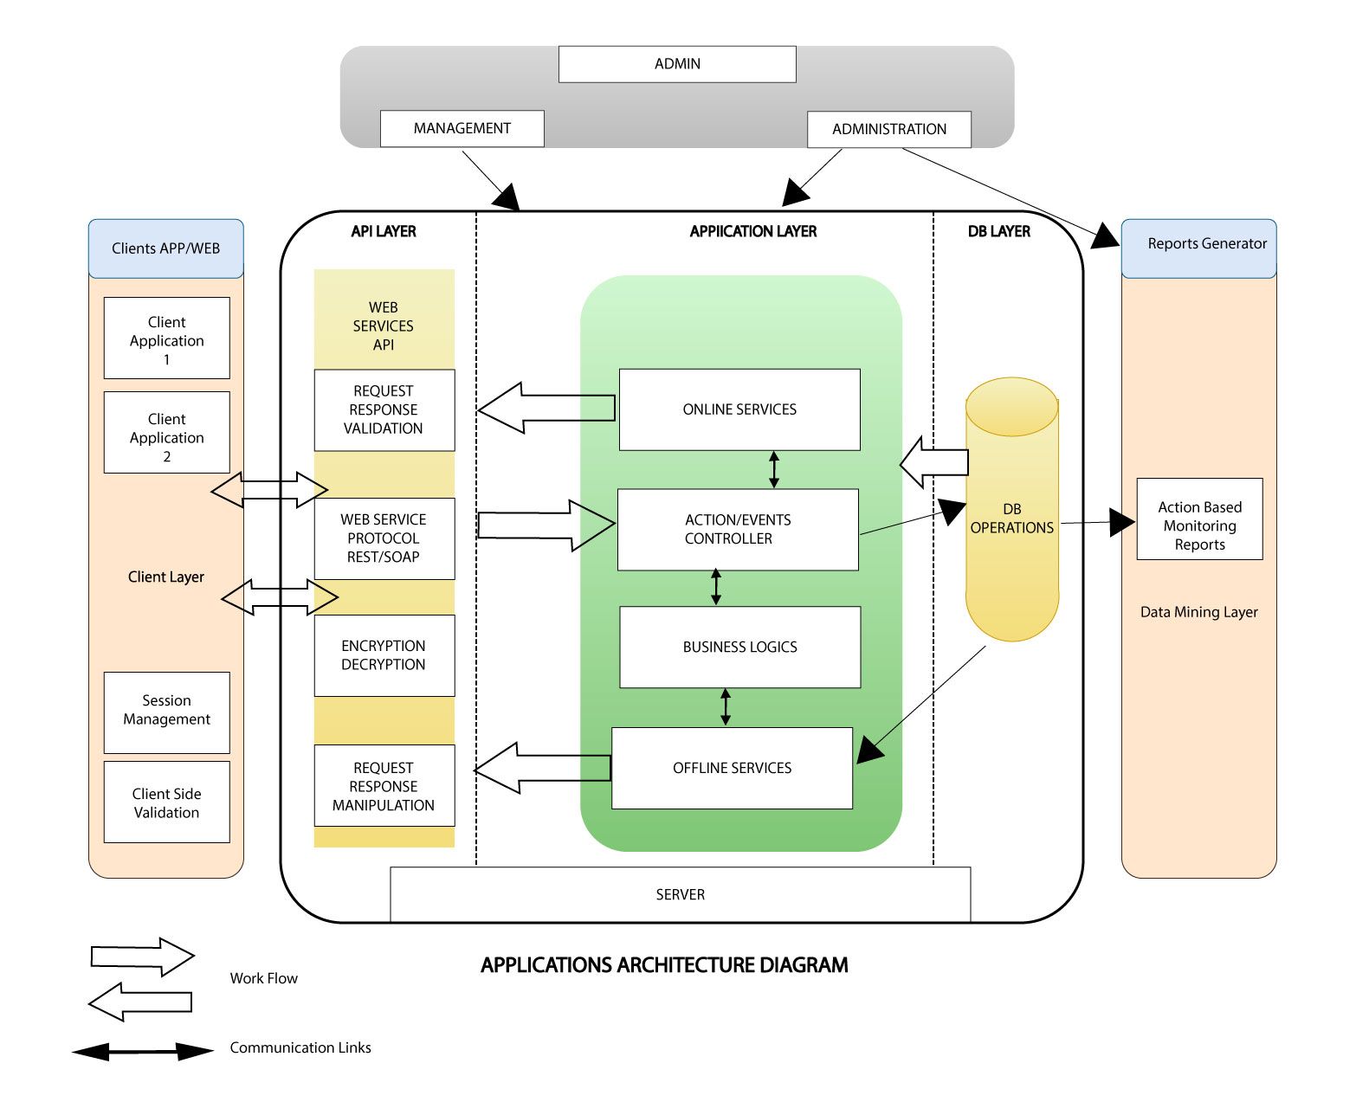

## 4.1 Hardware Architecture

The above architecture is specifically designed for DIPH requirements to fulfil the security, scalability and high availability compliances. The complete infrastructure is divided in many segments and sub segments.

### 4.1.1 Firewall Layer

The DIPH infrastructure shall have double layer security of firewalls. First level primary firewall is put in front of the DMZ. The firewall rules shall be configured to route the traffic from DIPH mobile application and other public traffic to the DMZ. The second layer of firewall will secure the connection between DMZ and the private subnet.

### 4.1.2 Public Subnet / DMZ

This public subnet is designed to create a Demilitarized Zone to prevent the outside world to get direct access to the DIPH backend network. This DMZ shall be behind the primary Firewall and will consist following components.

### 4.1.3 Load balancing Tier

The DMZ will have a cloud based load balancer which shall provide high availability at load balancing tier as the cloud load balancer are always on and have automatic failover. The Load balancer shall load balance the http/s requests to web servers of device interface layer LB algorithms will be done by the Load Balancer by doing health check of the available instances.

### 4.1.4 Device Interface Web Server Tier

This tier shall have 2 or more web servers like Apache having reverse proxy capability also. These servers shall be receiving the requests forwarded from the load balancer tier and will work as an agent for the web application server .

### 4.1.5 Private Subnet

The private subnet shall not be directly accessible by outside world and will be secured by additional layer of firewall. The private subnet consists of the following components.

### 4.1.6 Web Application Server

Web Application Server will run 2 or more servers running the required backend application web services, and DIPH SYSTEM, Web dashboards .

### 4.1.7 Session Cache Cluster

Level 1 Cache will be used to cache the ResultSet objects & Query results to serve the results from cache and minimize database hits & consequently decreasing the response time. The cache cluster shall provide consistent ResultSet data and we shall not need to do any ResultSet replication. The fall-back will always be database base in case of cache miss. Consistent hashing algorithm shall be used for key generation.

### 4.1.8 Database Layer

MySQL database with RDBMS/Master-Master replication shall be used to provide write and read capabilities. For high availability a Hot Standby Failover of active database shall be used. For additional safety we shall periodically backup the database to physical storage, and as a best practice store a copy of backups to another data centre or locally in order to avoid Data Centre failure.

### 4.1.9 File Storage Pool

The file storage pool will store the media files over Network File System and shall be backed with a replication for failover.

### 4.1.10 Cron Services

The cron services will run the scheduled workers to execute the batch jobs.

### 4.1.11 Disaster Recovery Layer

The database and other digital assets like images, multimedia shall be backed up through a secured channel to another to secure the data from any natural disaster and data centre failure. The cloud machine spin up scripts also be backed up in the separate datacentre.

### 4.1.12 Security Hardware Architecture

All the servers will be hosted in a certified & secure data centre which will have strict security policies for access of infrastructure and will be compliant with all datacentre security norms. Multi-Factor authentication will be used for access of the server infrastructure. RAID 5 drives will be used to enable redundancy of the storage drives. Data and digital assets shall be backed up continuously in another data centre. Backups are important for a number of reasons like Computer hardware failure, Software failure, Human errors, any type of disaster etc.The dual firewall and DMZ architecture will protect the servers from any type of attacks.

### 4.1.13 Performance Hardware Architecture

Since we are using cloud as hosting infrastructure server resources can be added on demand easily to increase the performance. In case we face any performance bottleneck like IO or CPU we can have SSD for IO and more number of CPU cores easily.

## 4.2 Software Architecture

The Software Architecture is divided in two main components.

### 4.2.1 Server Side Software Architecture

### 4.2.1.1 Technology Stack

Keeping all the constraints in the mind following technology stack has been finalized.

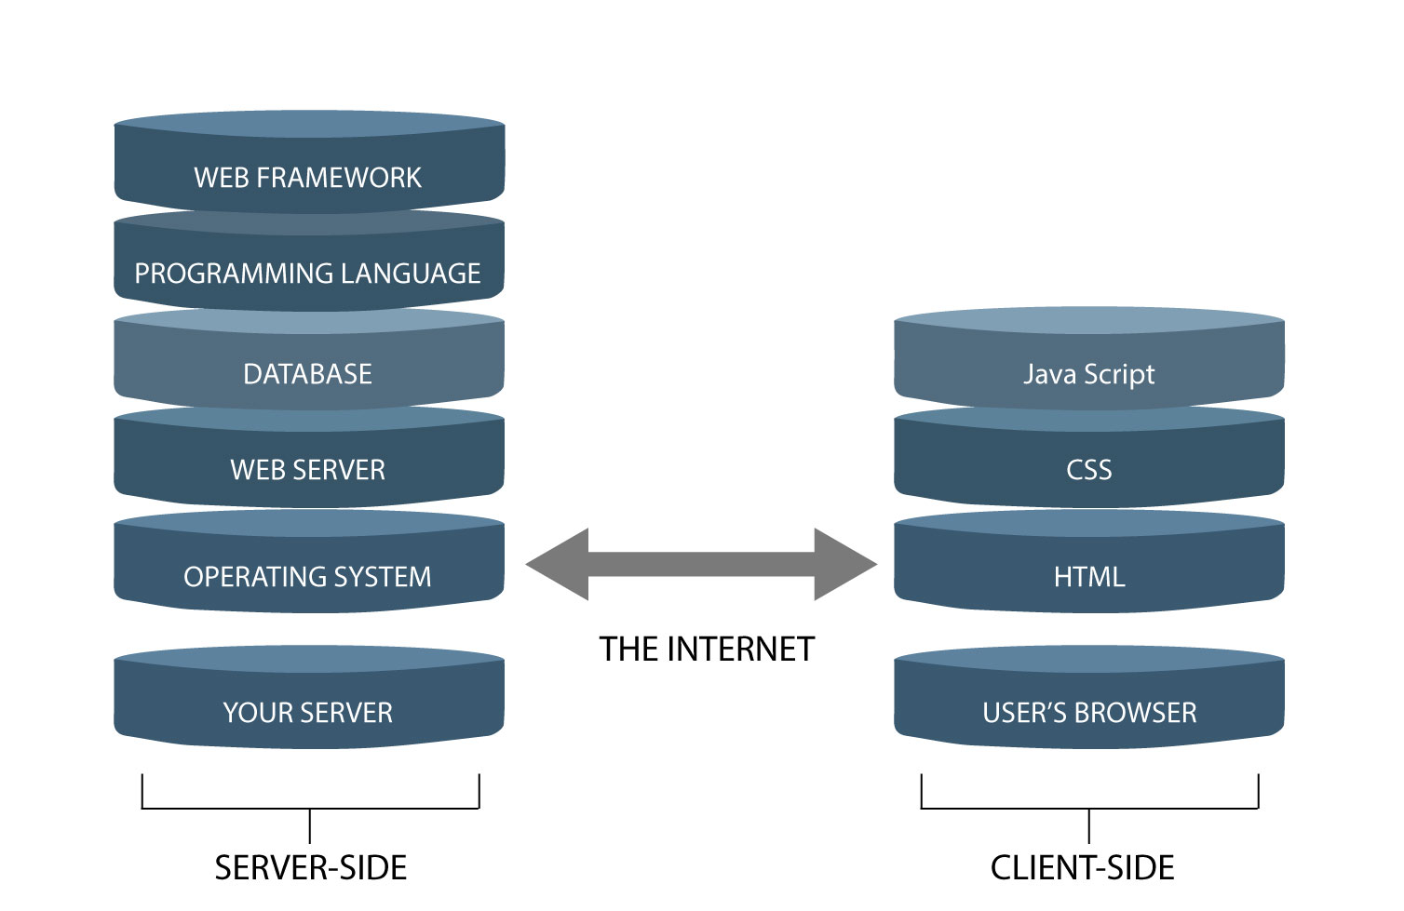

### 4.2.1.2 Operating System

The operating system is a Linux based OS that is open source and comes free of cost. CentOS & Ubuntu servers are two most popular Linux distributions of which one will be used in production environment after benchmarking.

### 4.2.1.3 Database Management System

MySQL, MariaDB storage engine is selected as DBMS. It is an open source and most performance optimized fork of MySQL.

### 4.2.1.3.1 Caching System

Odbc-cache-driver is chosen for in-memory key value store for caching the database, session and configuration objects to provide high performance boost to the system and reduce load on database. Odbc-cache-driver has clustering capability with cache distribution using a consistent key hashing algorithm.

### 4.2.1.3.2 Web Server

Apache is chosen as web server which is one of the most performance servers for high concurrency systems and works on a worker MPM model. It is also high performance for delivery static media files.

### 4.2.1.3.3 Application Process Manager

PHP framework / servlets web container is chosen as Application process manager for PHP. It is an alternative implementation with some additional features useful for sites of any size, especially busier sites. Some of the very good features of are:

• Adaptive process spawning

• Basic statistics

• Advanced process management with graceful stop/start

• Ability to start workers with different configuration files php.ini / server.xml

• logging/ logger

• Emergency restart in case of accidental opcode cache destruction

• Accelerated upload support

• Support for a Application and Server log

### 4.2.1.3.4 Programming Language

PHP is chosen as the programming language as it is most popular open source language for web and any general purpose programming. It is developer friendly, easy to maintain and futuristic.

### 4.2.1.3.5 Application Framework

PHP is chosen as the application development framework for DIPH server side application development as it is the fastest php framework in terms of execution and also is open source. for developing high performance web service APIs as well as web application.

### 4.2.1.4 Application Components

The DIPH server side architecture is divided in following components.

### 4.2.1.4.1 DIPH Web Services API

This is the most important part of the DIPH system as it is the backbone of the whole system. This is the business layer to feed and supply data from and to the client devices. This is being built on the top of framework and following is the architecture of the same.

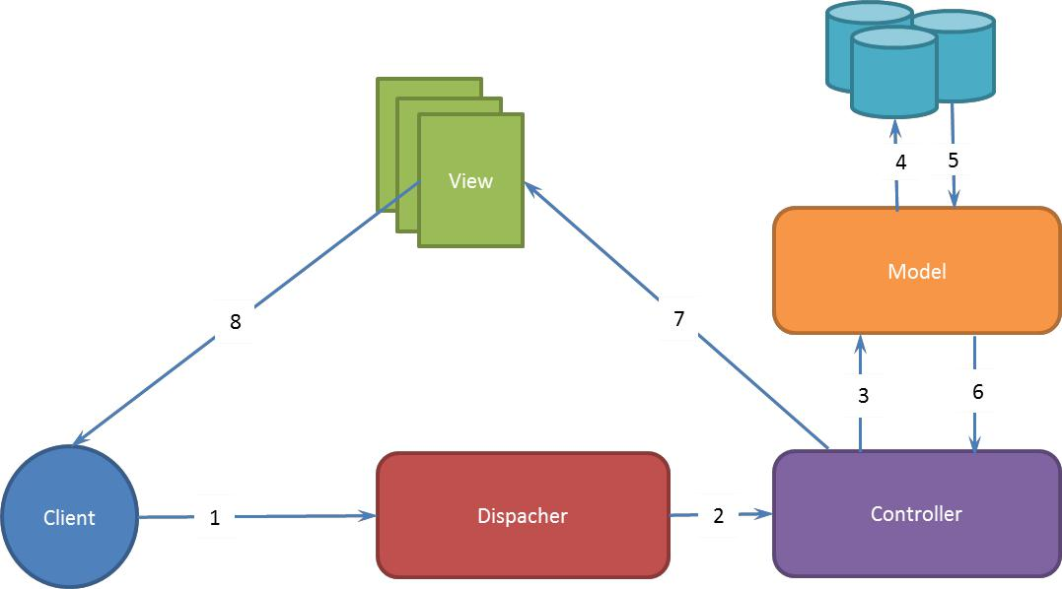

* Model: Model represents the application data communicating to database.
* View: View renders a presentation of model data. In our case, it will be in form of JSON for API request and HTML for dashboard requests.
* Controller: This is essential component of this design which handles requests and fulfill request made by the client (Desktop).
* Dispatcher: Dispatcher receives the requests and sends to the appropriate controller.
* Policy Management: The policy management module is used to manage the policies.
* User Management: The user management module enables administrators to manage users.

### 4.3.1 Network Component Involved in Above Mobile Network

The internal core network elements are GPRS network elements .The key difference from an architectural point between GPRS is the air interface. The mobile handset will communicates with BTS then communicates to a Radio Network Controller (RNC).

**SGSN:** SGSN is responsible for GPRS Mobility Management (GMM) service and it delivers packets to MS and communicates with Home Location Register (HLR) to obtain GPRS subscriber identity SGSN manages registration of the new mobile subscribers in order to keep a record of their Location Area (LA) for packet data routing purposes

**GGSN:** GGSN provides inter-working with external Packet Data Networks (PDNs) by using Gi interface such as Internet. GGSN acts like a router, forwards packets from PDNs to SGSN and vice versa. GGSN is further connected with ISP/GSM cloud giving end to end security.

### 4.3.2 Communication in Data Center Cloud Infrastructure

Following is the cloud infrastructure being used for DIPH system.

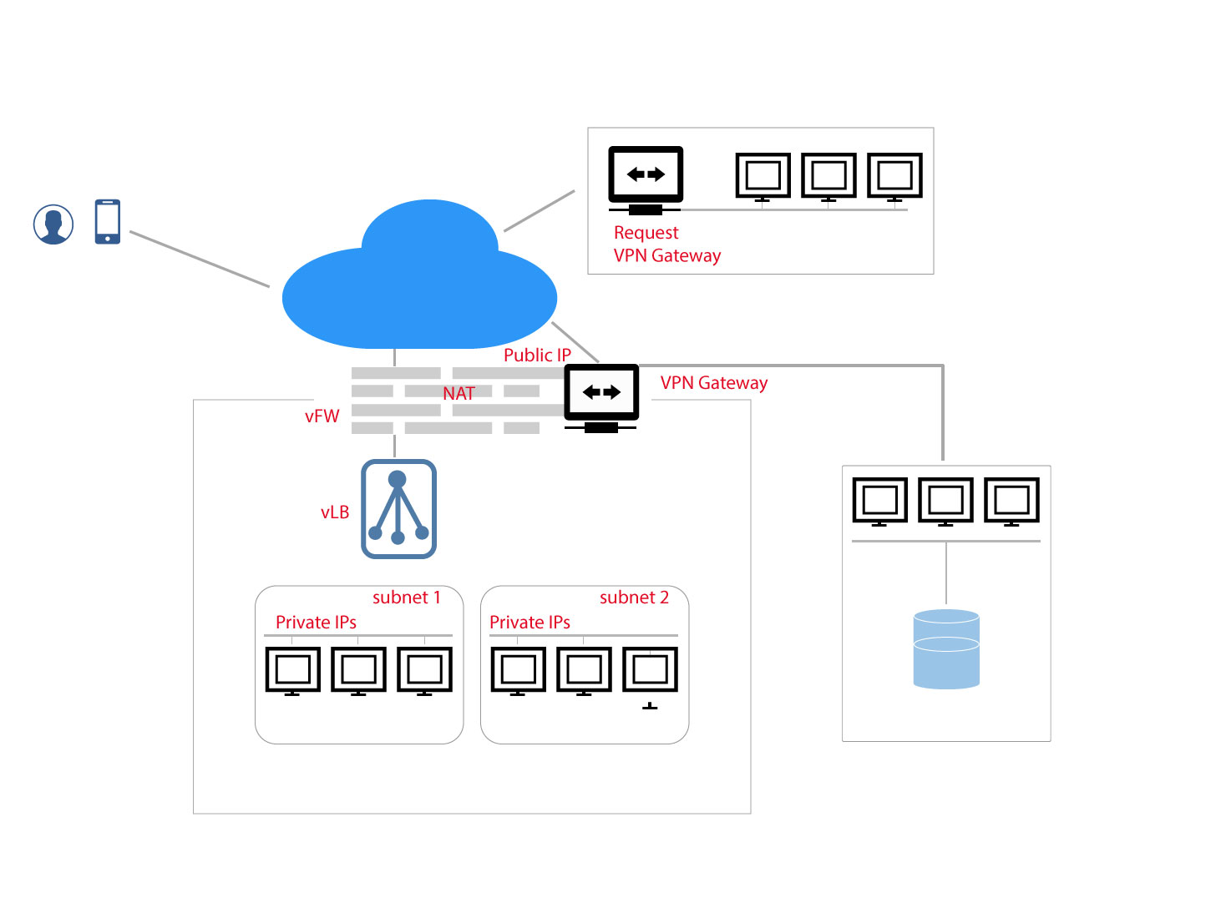

In above Cloud each tenant is provided with his/her own Virtual Private Cloud, each VPC has its own dedicated virtual firewall that allows setting the custom firewall rules for external/internet network.The firewall support ACL rules based on source IP/Destination IP, source port, destination port etc.

Each subnet/network can have its own policy by default all subnets with VPC are allowed to communicate with each other. Each network is a routed network capable of external communication.

## 4.4 Security Architecture

To ensure the security of the DIPH application at every stage following architectural points will be taken care.

1. The devices will be connected GSM that will connect the application to the interface servers will be hosted in a DMZ/public subnet behind a firewall to protect any direct access to the private subnet.
2. Private subnet will be protected with an additional Firewall layer and ip whitelisting security rules
3. The firewalls will have the capability to prevent DOS attacks and any intrusive behaviour
4. The shell access to any server will be controlled by firewall and also be secured by secure key authentication
5. The application will follow OWASP security guidelines strictly to make sure no security loop holes are present in the system Secure socket layer will be used for transport layer security over https
6. SSH+SCP will be used to secure the file transfers
7. All PHI and personal identification data will be encrypted using 3DES/AES encryption algorithms
8. For all reporting purposes to third parties, data will be anonymized as per the United States HIPAA norms
9. The mobile and tablet applications will store all offline data (Text & Media) in encrypted format only.
10. User access control list will be implemented in the solution to make sure users can only access the data and do the operations on that data they are authorized for.
11. The server logs & audit logs will be continuously analysed to get the alerts for any possible security threat
12. A periodic security audit will be done to ensure all the security policies are in place
13. All passwords will be stored as one way hash using SHA1/MD5 with additional salts configured

# 5. System Design

DIPH is a modular, shared, and integrated information system, which meet its objectives by using compatible, interoperable, and open source platforms. The solution, as depicted in the below high level diagram, consists of four key solution layers (Master Registries, Information Systems, Analytics Engine, and Staff or User Interface) hosted over a cloud based central server, seamlessly communicating among each other using internet. The cloud platform sits side by side a proposed intelligent interoperability layer to communicate with any external ICT system developed using standardised metadata and data standards or international health standards. The solution architecture is aligned  with open health information exchange architecture and can communicate and interoperate with systems consistent with the same.

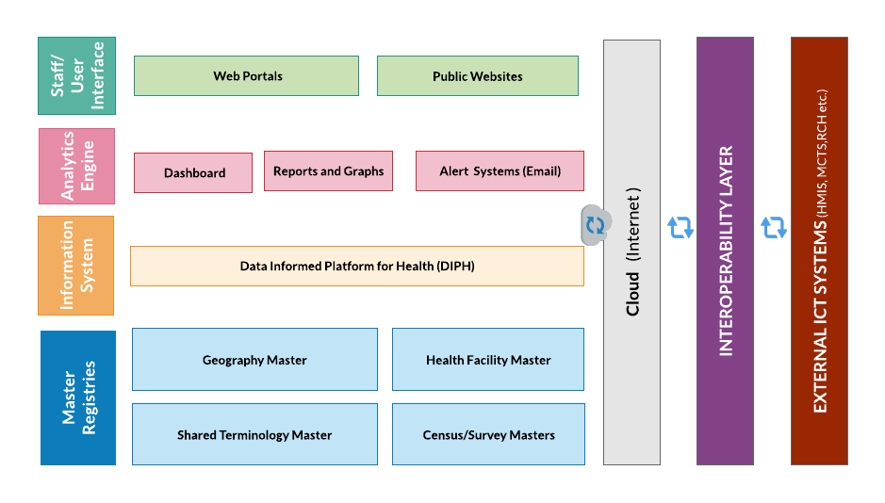

The first layer, **Master Registries**, consists of a mapping of geographies, facilities, census and survey data, and standardised dictionary of terms to be used across multiple systems (called shared terminology masters). This layer will form the fundamental building block of the DIPH digital ecosystem, and will be shared across DIPH irrespective of the technology or communication media used. Lack of such mapping data can prove detrimental to large scale deployment of ICT systems as inconsistent master registries limits both scalability and interoperability. The second layer, called **Information Systems**, consists of the DIPH interface for capturing, generating, consuming, transacting, or viewing thematic progress data and related information. This layer will have its own dedicated transactional databases or tables, but will share the global copies of master registries at all times, in order to uniquely identify an element or event in the ecosystem, over a central shared data warehouse. The third later, called **Analytics Engine**, currently is built to show various visualisations along with tabular and graphical data, the separate layer provides an opportunity to integrate with dedicated analytics platforms such as R, and sends automated progress reminders and emails to the thematic leaders and activity leads. The fourth layer, called **Staff or User Interface**, is the presentation layer normally accessible to an end user or normal citizens in the form of applications (web or mobile), websites, dashboards, or alerts.  Besides the four layers the system consists of a very important layer called **interoperability layer**, this layer will interact with all external communications and will act as a mediator between the information systems layer and external systems, after rule based authentication and validation.

# 6. ER Diagram

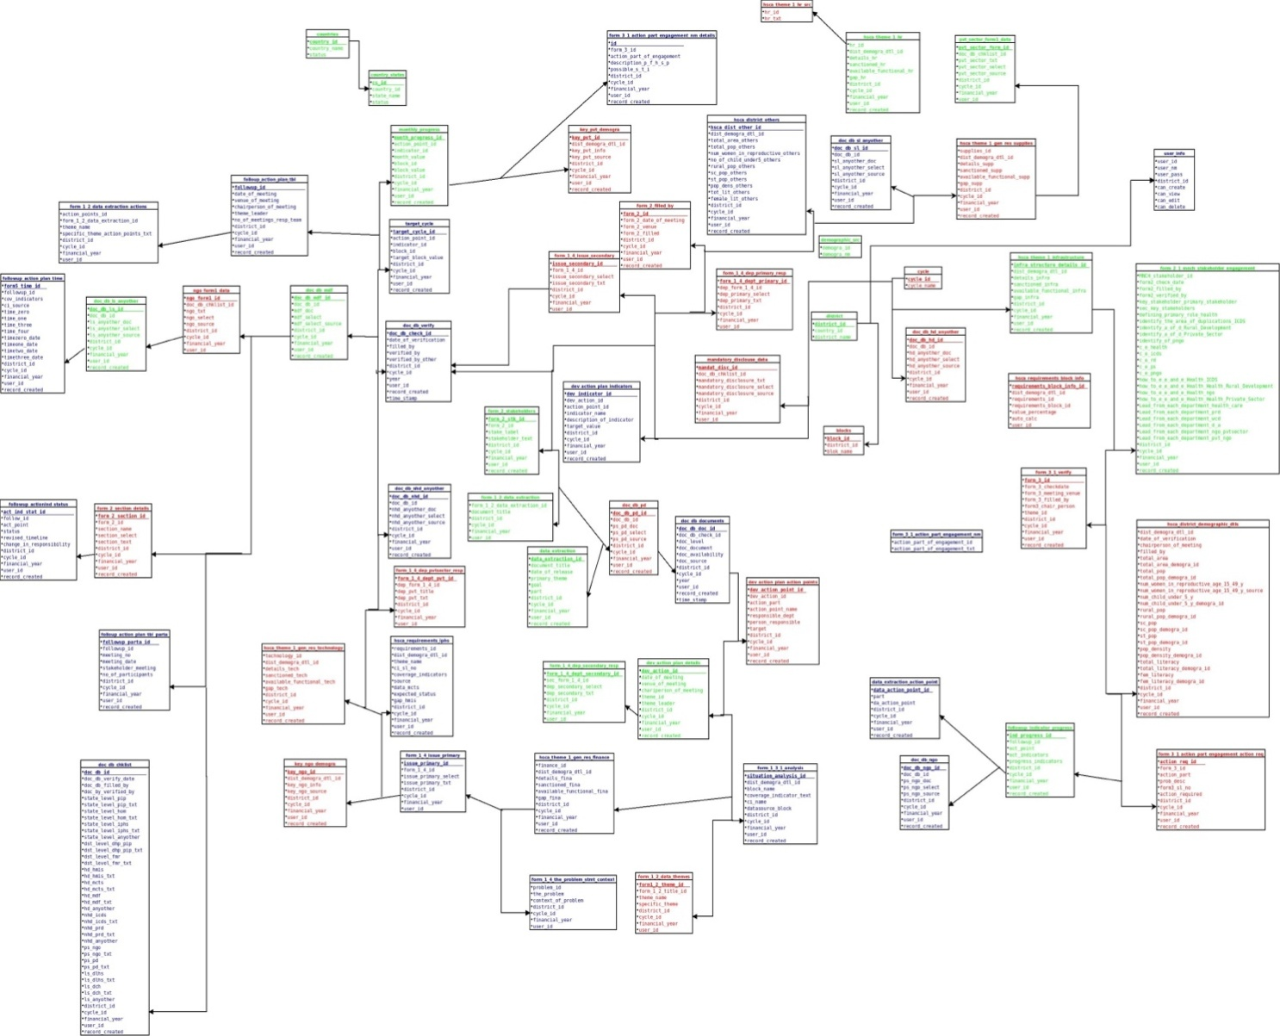

# 7. Data Dictionary

|  |  |  |  |  |  |  |
| --- | --- | --- | --- | --- | --- | --- |
| **Table Name:Blocks** | | | | | | |
| Table Desc | This Table contains Name of blocks on the basis of District | | | | | |
| Column Name | Data Type | Attribute | Null | Default | Links To | Comments |
| block_id | INTEGER | Primary Key | No |  |  | Auto Incremental Value by 1 |
| district_id | INTEGER |  | No |  |  | District Id |
| blok_name | VARCHAR(200) |  | No |  |  | Block Name |

|  |  |  |  |  |  |  |
| --- | --- | --- | --- | --- | --- | --- |
| **Table Name:Countries** | | | | | | |
| Table Desc | This Table contains Name of All countries | | | | | |
| Column Name | Data Type | Attribute | Null | Default | Links To | Comments |
| country_id | INTEGER | Primary Key | No |  |  | Auto Incremental Value by 1 |
| country_name | VARCHAR(200) |  | No |  |  | Country name |
| status | INTEGER |  | No |  |  | Status value “1” or “0” |

|  |  |  |  |  |  |  |
| --- | --- | --- | --- | --- | --- | --- |
| **Table Name:Countries** | | | | | | |
| Table Desc | This Table contains Name of All states mapping by country | | | | | |
| Column Name | Data Type | Attribute | Null | Default | Links To | Comments |
| cs_id | INTEGER | Primary Key | No |  |  | Auto Incremental Value by 1 |
| country_id | INTEGER |  |  |  |  | Country which contains state |
| state_name | VARCHAR(200) |  | No |  |  | State name |
| status | INTEGER |  | No |  |  | Status value “1” or “0” |

|  |  |  |  |  |  |  |
| --- | --- | --- | --- | --- | --- | --- |
| **Table Name:Cycle** | | | | | | |
| Table Desc | This Table contains Name All cycles | | | | | |
| Column Name | Data Type | Attribute | Null | Default | Links To | Comments |
| cycle_id | INTEGER | Primary Key | No |  |  | Auto Incremental Value by 1 |
| cycle_name | INTEGER |  |  |  |  | Cycle name |

|  |  |  |  |  |  |  |
| --- | --- | --- | --- | --- | --- | --- |
| **Table Name:data_extraction** | | | | | | |
| Table Desc | This Table contains goals and document details. | | | | | |
| Column Name | Data Type | Attribute | Null | Default | Links To | Comments |
| data_extraction_id | INTEGER | Primary Key | No |  |  | Auto Incremental Value by 1 |
| document_title | VARCHAR(100) |  |  |  |  |  |
| date_of_release | VARCHAR(200) |  | No |  |  |  |
| primary_theme | INTEGER |  | No |  |  |  |
| goal | VARCHAR(100) |  |  |  |  |  |
| part | VARCHAR(100) |  |  |  |  |  |
| district_id | INTEGER |  |  |  |  |  |
| cycle_id | INTEGER |  |  |  |  |  |
| financial_year | VARCHAR(100) |  |  |  |  |  |
| user_id | INTEGER |  |  |  |  |  |
| record_created | DATE |  |  |  |  |  |

|  |  |  |  |  |  |  |
| --- | --- | --- | --- | --- | --- | --- |
| **Table Name:data_extraction_action_plane** | | | | | | |
| Table Desc | This Table contains excusion plane details | | | | | |
| Column Name | Data Type | Attribute | Null | Default | Links To | Comments |
| data_action_point_id | INTEGER | Primary Key | No |  |  | Auto Incremental Value by 1 |
| da_action_point | VARCHAR(100) |  |  |  |  |  |
| district_id | VARCHAR(200) |  | No |  |  |  |
| cycle_id | INTEGER |  | No |  |  |  |
| financial_year | VARCHAR(100) |  |  |  |  |  |
| user_id | VARCHAR(100) |  |  |  |  |  |
| record_created | INTEGER |  |  |  |  |  |

|  |  |  |  |  |  |  |
| --- | --- | --- | --- | --- | --- | --- |
| **Table Name: demographic_src** | | | | | | |
| Table Desc | This Table contains excusion demographic details | | | | | |
| Column Name | Data Type | Attribute | Null | Default | Links To | Comments |
| demogra_id | INTEGER | Primary Key | No |  |  | Auto Incremental Value by 1 |
| demogra_nm | VARCHAR(100) |  |  |  |  |  |

|  |  |  |  |  |  |  |
| --- | --- | --- | --- | --- | --- | --- |
| **Table Name: dev_action_plan_action_points** | | | | | | |
| Table Desc | This Table contains plane action points | | | | | |
| Column Name | Data Type | Attribute | Null | Default | Links To | Comments |
| dev_action_point_id | INTEGER | Primary Key | No |  |  | Auto Incremental Value by 1 |
| dev_action_id | INTEGER |  |  |  |  |  |
| action_part | VARCHAR(200) |  | No |  |  |  |
| action_point_name | INTEGER |  | No |  |  |  |
| responsible_dept | VARCHAR(100) |  |  |  |  |  |
| person_responsible | VARCHAR(100) |  |  |  |  |  |
| Target | INTEGER |  |  |  |  |  |
| district_id | INTEGER |  |  |  |  |  |
| cycle_id | INTEGER |  |  |  |  |  |
| financial_year | VARCHAR(200) |  |  |  |  |  |
| user_id | INTEGER |  |  |  |  |  |
| record_created | DATE |  |  |  |  |  |

|  |  |  |  |  |  |  |
| --- | --- | --- | --- | --- | --- | --- |
| **Table Name: dev_action_plan_details** | | | | | | |
| Table Desc | This Table contains plane action points details | | | | | |
| Column Name | Data Type | Attribute | Null | Default | Links To | Comments |
| dev_action_id | INTEGER | Primary Key | No |  |  | Auto Incremental Value by 1 |
| date_of_meeting | INTEGER |  |  |  |  |  |
| venue_of_meeting | VARCHAR(200) |  | No |  |  |  |
| chariperson_of_meeting | INTEGER |  | No |  |  |  |
| theme_id | VARCHAR(100) |  |  |  |  |  |
| theme_leader | VARCHAR(100) |  |  |  |  |  |
| district_id | INTEGER |  |  |  |  |  |
| cycle_id | INTEGER |  |  |  |  |  |
| financial_year | VARCHAR(200) |  |  |  |  |  |
| user_id | INTEGER |  |  |  |  |  |
| record_created | DATE |  |  |  |  |  |

|  |  |  |  |  |  |  |
| --- | --- | --- | --- | --- | --- | --- |
| **Table Name: dev_action_plan_indicators** | | | | | | |
| Table Desc | This Table contains plane action points details | | | | | |
| Column Name | Data Type | Attribute | Null | Default | Links To | Comments |
| dev_indicator_id | INTEGER | Primary Key | No |  |  | Auto Incremental Value by 1 |
| dev_action_id | INTEGER |  |  |  |  |  |
| action_point_id | VARCHAR(200) |  | No |  |  |  |
| indicator_name | INTEGER |  | No |  |  |  |
| description_of_indicator | VARCHAR(100) |  |  |  |  |  |
| target_value | INTEGER |  |  |  |  |  |
| district_id | INTEGER |  |  |  |  |  |
| cycle_id | INTEGER |  |  |  |  |  |
| financial_year | VARCHAR(200) |  |  |  |  |  |
| user_id | INTEGER |  |  |  |  |  |
| record_created | DATE |  |  |  |  |  |

|  |  |  |  |  |  |  |
| --- | --- | --- | --- | --- | --- | --- |
| **Table Name: district** | | | | | | |
| Table Desc | This Table contains plane action points details | | | | | |
| Column Name | Data Type | Attribute | Null | Default | Links To | Comments |
| district_id | INTEGER | Primary Key | No |  |  | Auto Incremental Value by 1 |
| country_id | INTEGER |  |  |  |  |  |
| country_id | VARCHAR(200) |  | No |  |  |  |

|  |  |  |  |  |  |  |
| --- | --- | --- | --- | --- | --- | --- |
| **Table Name: doc_db_chklist** | | | | | | |
| Table Desc | This Table contains details of documents checklist | | | | | |
| Column Name | Data Type | Attribute | Null | Default | Links To | Comments |
| doc_db_id | INTEGER | Primary Key | No |  |  | Auto Incremental Value by 1 |
| doc_db_verify_date | INTEGER |  |  |  |  |  |
| doc_db_filled_by | VARCHAR(200) |  | No |  |  |  |
| doc_by_verified_by | INTEGER |  | No |  |  |  |
| state_level_pip | VARCHAR(100) |  |  |  |  |  |
| state_level_pip_txt | INTEGER |  |  |  |  |  |
| state_level_hom |  |  |  |  |  |  |
| state_level_hom_txt |  |  |  |  |  |  |
| state_level_iphs |  |  |  |  |  |  |
| state_level_anyother |  |  |  |  |  |  |
| dst_level_dhp_pip |  |  |  |  |  |  |
| dst_level_dhp_pip_txt |  |  |  |  |  |  |
| dst_level_fmr |  |  |  |  |  |  |
| dst_level_fmr_txt |  |  |  |  |  |  |
| hd_hmis |  |  |  |  |  |  |
| hd_hmis_txt |  |  |  |  |  |  |
| hd_mcts |  |  |  |  |  |  |
| hd_mdf |  |  |  |  |  |  |
| hd_mdf_txt |  |  |  |  |  |  |
| hd_anyother |  |  |  |  |  |  |
| nhd_icds |  |  |  |  |  |  |
| nhd_icds_txt |  |  |  |  |  |  |
| nhd_prd |  |  |  |  |  |  |
| nhd_prd_txt |  |  |  |  |  |  |
| nhd_anyother |  |  |  |  |  |  |
| ps_ngo |  |  |  |  |  |  |
| ps_pd |  |  |  |  |  |  |
| ps_pd_txt |  |  |  |  |  |  |
| ls_dlhs |  |  |  |  |  |  |
| ls_dch |  |  |  |  |  |  |
| ls_anyother |  |  |  |  |  |  |
| district_id | INTEGER |  |  |  |  |  |
| cycle_id | INTEGER |  |  |  |  |  |
| financial_year | VARCHAR(200) |  |  |  |  |  |
| user_id | INTEGER |  |  |  |  |  |
| record_created |  |  |  |  |  |  |

|  |  |  |  |  |  |  |
| --- | --- | --- | --- | --- | --- | --- |
| **Table Name: doc_db_documents** | | | | | | |
| Table Desc | This Table contains documents details | | | | | |
| Column Name | Data Type | Attribute | Null | Default | Links To | Comments |
| doc_db_doc_id | INTEGER | Primary Key | No |  |  | Auto Incremental Value by 1 |
| doc_db_check_id | INTEGER |  |  |  |  |  |
| doc_level | VARCHAR(200) |  | No |  |  |  |
| doc_document | INTEGER |  | No |  |  |  |
| doc_availability | VARCHAR(100) |  |  |  |  |  |
| doc_source | INTEGER |  |  |  |  |  |

|  |  |  |  |  |  |  |
| --- | --- | --- | --- | --- | --- | --- |
| **Table Name: doc_db_hd_anyother** | | | | | | |
| Table Desc |  | | | | | |
| Column Name | Data Type | Attribute | Null | Default | Links To | Comments |
| doc_db_hd_id | INTEGER | Primary Key | No |  |  | Auto Incremental Value by 1 |
| doc_db_id | INTEGER |  |  |  |  |  |
| hd_anyother_doc | VARCHAR(200) |  | No |  |  |  |
| hd_anyother_select | INTEGER |  | No |  |  |  |
| hd_anyother_source | VARCHAR(100) |  |  |  |  |  |
| district_id | INTEGER |  |  |  |  |  |
| cycle_id |  |  |  |  |  |  |
| financial_year |  |  |  |  |  |  |
| user_id |  |  |  |  |  |  |
| record_created |  |  |  |  |  |  |

|  |  |  |  |  |  |  |
| --- | --- | --- | --- | --- | --- | --- |
| **Table Name: doc_db_ls_anyother** | | | | | | |
| Table Desc |  | | | | | |
| Column Name | Data Type | Attribute | Null | Default | Links To | Comments |
| doc_db_ls_id | INTEGER | Primary Key | No |  |  | Auto Incremental Value by 1 |
| doc_db_id | INTEGER |  |  |  |  |  |
| ls_anyother_doc | VARCHAR(200) |  | No |  |  |  |
| ls_anyother_select | INTEGER |  | No |  |  |  |
| ls_anyother_source | VARCHAR(100) |  |  |  |  |  |
| district_id | INTEGER |  |  |  |  |  |
| cycle_id |  |  |  |  |  |  |
| financial_year |  |  |  |  |  |  |
| user_id |  |  |  |  |  |  |
| record_created |  |  |  |  |  |  |

|  |  |  |  |  |  |  |
| --- | --- | --- | --- | --- | --- | --- |
| **Table Name: doc_db_mdf** | | | | | | |
| Table Desc |  | | | | | |
| Column Name | Data Type | Attribute | Null | Default | Links To | Comments |
| doc_db_mdf_id | INTEGER | Primary Key | No |  |  | Auto Incremental Value by 1 |
| doc_db_id | INTEGER |  |  |  |  |  |
| mdf_doc | VARCHAR(200) |  | No |  |  |  |
| mdf_select | INTEGER |  | No |  |  |  |
| mdf_select_source | VARCHAR(100) |  |  |  |  |  |
| district_id | INTEGER |  |  |  |  |  |
| cycle_id |  |  |  |  |  |  |
| financial_year |  |  |  |  |  |  |
| user_id |  |  |  |  |  |  |
| record_created |  |  |  |  |  |  |

|  |  |  |  |  |  |  |
| --- | --- | --- | --- | --- | --- | --- |
| **Table Name: doc_db_ngo** | | | | | | |
| Table Desc |  | | | | | |
| Column Name | Data Type | Attribute | Null | Default | Links To | Comments |
| doc_db_ngo_id | INTEGER | Primary Key | No |  |  | Auto Incremental Value by 1 |
| doc_db_id | INTEGER |  |  |  |  |  |
| ps_ngo_doc | VARCHAR(200) |  | No |  |  |  |
| ps_ngo_select | INTEGER |  | No |  |  |  |
| ps_ngo_source | VARCHAR(100) |  |  |  |  |  |
| district_id | INTEGER |  |  |  |  |  |
| cycle_id |  |  |  |  |  |  |
| financial_year |  |  |  |  |  |  |
| user_id |  |  |  |  |  |  |
| record_created |  |  |  |  |  |  |

|  |  |  |  |  |  |  |
| --- | --- | --- | --- | --- | --- | --- |
| **Table Name: doc_db_nhd_anyother** | | | | | | |
| Table Desc |  | | | | | |
| Column Name | Data Type | Attribute | Null | Default | Links To | Comments |
| doc_db_nhd_id | INTEGER | Primary Key | No |  |  | Auto Incremental Value by 1 |
| doc_db_id | INTEGER |  |  |  |  |  |
| nhd_anyother_doc | VARCHAR(200) |  | No |  |  |  |
| nhd_anyother_select | INTEGER |  | No |  |  |  |
| nhd_anyother_source | VARCHAR(100) |  |  |  |  |  |
| district_id | INTEGER |  |  |  |  |  |
| cycle_id |  |  |  |  |  |  |
| financial_year |  |  |  |  |  |  |
| user_id |  |  |  |  |  |  |
| record_created |  |  |  |  |  |  |

|  |  |  |  |  |  |  |
| --- | --- | --- | --- | --- | --- | --- |
| **Table Name: doc_db_pd** | | | | | | |
| Table Desc |  | | | | | |
| Column Name | Data Type | Attribute | Null | Default | Links To | Comments |
| doc_db_pd_id | INTEGER | Primary Key | No |  |  | Auto Incremental Value by 1 |
| doc_db_id | INTEGER |  |  |  |  |  |
| ps_pd_doc | VARCHAR(200) |  | No |  |  |  |
| ps_pd_select | INTEGER |  | No |  |  |  |
| ps_pd_source | VARCHAR(100) |  |  |  |  |  |
| district_id | INTEGER |  |  |  |  |  |
| cycle_id |  |  |  |  |  |  |
| financial_year |  |  |  |  |  |  |
| user_id |  |  |  |  |  |  |
| record_created |  |  |  |  |  |  |

|  |  |  |  |  |  |  |
| --- | --- | --- | --- | --- | --- | --- |
| **Table Name: doc_db_sl_anyother** | | | | | | |
| Table Desc |  | | | | | |
| Column Name | Data Type | Attribute | Null | Default | Links To | Comments |
| doc_db_sl_id | INTEGER | Primary Key | No |  |  | Auto Incremental Value by 1 |
| doc_db_id | INTEGER |  |  |  |  |  |
| sl_anyother_doc | VARCHAR(200) |  | No |  |  |  |
| sl_anyother_select | INTEGER |  | No |  |  |  |
| sl_anyother_source | VARCHAR(100) |  |  |  |  |  |
| district_id | INTEGER |  |  |  |  |  |
| cycle_id |  |  |  |  |  |  |
| financial_year |  |  |  |  |  |  |
| user_id |  |  |  |  |  |  |
| record_created |  |  |  |  |  |  |

|  |  |  |  |  |  |  |
| --- | --- | --- | --- | --- | --- | --- |
| **Table Name: doc_db_verify** | | | | | | |
| Table Desc |  | | | | | |
| Column Name | Data Type | Attribute | Null | Default | Links To | Comments |
| doc_db_check_id | INTEGER | Primary Key | No |  |  | Auto Incremental Value by 1 |
| date_of_verification | INTEGER |  |  |  |  |  |
| filled_by | VARCHAR(200) |  | No |  |  |  |
| verified_by | INTEGER |  | No |  |  |  |
| verified_by_other | VARCHAR(100) |  |  |  |  |  |
| district_id | INTEGER |  |  |  |  |  |
| cycle_id |  |  |  |  |  |  |
| financial_year |  |  |  |  |  |  |
| user_id |  |  |  |  |  |  |
| record_created |  |  |  |  |  |  |

|  |  |  |  |  |  |  |
| --- | --- | --- | --- | --- | --- | --- |
| **Table Name: folloup_action_plan_tbl** | | | | | | |
| Table Desc |  | | | | | |
| Column Name | Data Type | Attribute | Null | Default | Links To | Comments |
| followup_id | INTEGER | Primary Key | No |  |  | Auto Incremental Value by 1 |
| date_of_meeting | INTEGER |  |  |  |  |  |
| venue_of_meeting | VARCHAR(200) |  | No |  |  |  |
| chairperson_of_meeting | INTEGER |  | No |  |  |  |
| theme_leader | VARCHAR(100) |  |  |  |  |  |
| no_of_meetings_resp_team | INTEGER |  |  |  |  |  |
| district_id | INTEGER |  |  |  |  |  |
| cycle_id | INTEGER |  |  |  |  |  |
| financial_year | VARCHAR(100) |  |  |  |  |  |
| user_id | INTEGER |  |  |  |  |  |
| record_created | DATE |  |  |  |  |  |

|  |  |  |  |  |  |  |
| --- | --- | --- | --- | --- | --- | --- |
| **Table Name: folloup_action_plan_tbl** | | | | | | |
| Table Desc |  | | | | | |
| Column Name | Data Type | Attribute | Null | Default | Links To | Comments |
| followup_id | INTEGER | Primary Key | No |  |  | Auto Incremental Value by 1 |
| date_of_meeting | INTEGER |  |  |  |  |  |
| venue_of_meeting | VARCHAR(200) |  | No |  |  |  |
| chairperson_of_meeting | INTEGER |  | No |  |  |  |
| theme_leader | VARCHAR(100) |  |  |  |  |  |
| no_of_meetings_resp_team | INTEGER |  |  |  |  |  |
| district_id | INTEGER |  |  |  |  |  |
| cycle_id | INTEGER |  |  |  |  |  |
| financial_year | VARCHAR(100) |  |  |  |  |  |
| user_id | INTEGER |  |  |  |  |  |
| record_created | DATE |  |  |  |  |  |

|  |  |  |  |  |  |  |
| --- | --- | --- | --- | --- | --- | --- |
| **Table Name: folloup_action_plan_tbl_parta** | | | | | | |
| Table Desc |  | | | | | |
| Column Name | Data Type | Null | Attribute | Default | Links To | Comments |
| followup_parta_id(Primary) | int(6) | No |  |  |  | Auto Incremental Value by 1 |
| followup_id | int(6) | No |  |  |  |  |
| meeting_no | varchar(100) | No |  |  |  |  |
| meeting_date | varchar(100) | No |  |  |  |  |
| stakeholder_meeting | text | No |  |  |  |  |
| no_of_participants | int(10) | No |  |  |  |  |
| district_id | int(10) | No |  |  |  |  |
| cycle_id | int(6) | No |  |  |  |  |
| financial_year | int(6) | No |  |  |  |  |
| user_id | varchar(100) | No |  |  |  |  |
| record_created | varchar(100) | No |  |  |  |  |

|  |  |  |  |  |  |  |
| --- | --- | --- | --- | --- | --- | --- |
| **Table Name: followup_action_plan_time** | | | | | | |
| Table Desc |  | | | | | |
| Column Name | Data Type | Null | Attribute | Default | Links To | Comments |
| form5_time_id(Primary) | int(10) | No |  |  |  | Auto Incremental Value by 1 |
| followup_id | int(10) | No |  |  |  |  |
| cov_indicators | text | No |  |  |  |  |
| ci_source | varchar(100) | Yes |  |  |  |  |
| time_zero | float | No |  |  |  |  |
| time_one | float | No |  |  |  |  |
| time_three | float | No |  |  |  |  |
| time_four | float | No |  |  |  |  |
| timezero_date | text | No |  |  |  |  |
| timeone_date | text | No |  |  |  |  |
| record_created | varchar(100) | No |  |  |  |  |

|  |  |  |  |  |  |  |
| --- | --- | --- | --- | --- | --- | --- |
| **Table Name: followup_actionind_status** | | | | | | |
| Table Desc |  | | | | | |
| Column Name | Data Type | Null | Attribute | Default | Links To | Comments |
| act_ind_stat_id(Primary) | int(10) |  |  |  |  | Auto Incremental Value by 1 |
| follow_id | int(10) |  |  |  |  |  |
| act_point | text |  |  |  |  |  |
| status | text |  |  |  |  |  |
| revised_timeline | text |  |  |  |  |  |
| change_in_responsibility | text |  |  |  |  |  |
| district_id | int(10) |  |  |  |  |  |
| cycle_id | int(10) |  |  |  |  |  |
| financial_year | varchar(100) |  |  |  |  |  |
| user_id | int(10) |  |  |  |  |  |
| record_created | date |  |  |  |  |  |

|  |  |  |  |  |  |  |
| --- | --- | --- | --- | --- | --- | --- |
| **Table Name: followup_indicator_progress** | | | | | | |
| Table Desc |  | | | | | |
| Column Name | Data Type | Null | Attribute | Default | Links To | Comments |
| ind_progress_id(Primary) | bigint(20) | No |  |  |  | Auto Incremental Value by 1 |
| followup_id | int(10) | No |  |  |  |  |
| act_point | int(10) | No |  |  |  |  |
| act_indicators | int(10) | No |  |  |  |  |
| progress_indicators | text | No |  |  |  |  |
| district_id | int(10) | No |  |  |  |  |
| cycle_id | int(10) | No |  |  |  |  |
| financial_year | varchar(100) | No |  |  |  |  |
| user_id | int(6) | No |  |  |  |  |
| record_created | date | No |  |  |  |  |
| ind_progress_id(Primary) | bigint(20) | No |  |  |  |  |

|  |  |  |  |  |  |  |
| --- | --- | --- | --- | --- | --- | --- |
| **Table Name:form_1_2_data_extraction** | | | | | | |
| Table Desc |  | | | | | |
| Column Name | Data Type | Null | Attribute | Default | Links To | Comments |
| form_1_2_data_extraction_id | bigint(20) | No |  |  |  | Auto Incremental Value by 1 |
| document_title | text | Yes |  |  |  |  |
| district_id | int(10) | No |  |  |  |  |
| cycle_id | int(10) | No |  |  |  |  |
| financial_year | varchar(100) | No |  |  |  |  |
| user_id | int(11) | Yes |  |  |  |  |

|  |  |  |  |  |  |  |
| --- | --- | --- | --- | --- | --- | --- |
| **Table Name: form_1_2_data_themes** | | | | | | |
| Table Desc |  | | | | | |
| Column Name | Data Type | Null | Attribute | Default | Links To | Comments |
| form1_2_theme_id(Primary) | int(6) | No |  |  |  | Auto Incremental Value by 1 |
| form_1_2_title_id | int(6) | No |  |  |  |  |
| theme_name | text | No |  |  |  |  |
| specific_theme | text | No |  |  |  |  |
| district_id | int(10) | No |  |  |  |  |
| cycle_id | int(10) | No |  |  |  |  |
| financial_year | varchar(100) | No |  |  |  |  |
| user_id | int(6) | No |  |  |  |  |

|  |  |  |  |  |  |  |
| --- | --- | --- | --- | --- | --- | --- |
| **Table Name: form_1_3_1_analysis** | | | | | | |
| Table Desc |  | | | | | |
| Column Name | Data Type | Null | Attribute | Default | Links To | Comments |
| situation_analysis_id(Primary) | int(6) | No |  |  |  | Auto Incremental Value by 1 |
| dist_demogra_dtl_id | int(10) | No |  |  |  |  |
| block_name | text | No |  |  |  |  |
| coverage_indicator_text | float(10,2) | No |  |  |  |  |
| ci_name | text | No |  |  |  |  |
| datasource_block | text | No |  |  |  |  |
| district_id | int(10) | No |  |  |  |  |
| cycle_id | int(10) | No |  |  |  |  |
| financial_year | varchar(100) | No |  |  |  |  |
| user_id | int(6) | No |  |  |  |  |
| record_created | date | No |  |  |  |  |

|  |  |  |  |  |  |  |
| --- | --- | --- | --- | --- | --- | --- |
| **Table Name: form_1_4_dep_primary_resp** | | | | | | |
| Table Desc |  | | | | | |
| Column Name | Data Type | Null | Attribute | Default | Links To | Comments |
| form_1_4_dept_primary_id(Primary) | int(10) | No |  |  |  | Auto Incremental Value by 1 |
| dep_form_1_4_id | int(10) | No |  |  |  |  |
| dep_primary_select | text | No |  |  |  |  |
| dep_primary_txt | text | No |  |  |  |  |
| district_id | int(10) | No |  |  |  |  |
| cycle_id | int(10) | No |  |  |  |  |
| financial_year | varchar(100) | No |  |  |  |  |
| user_id | int(10) | No |  |  |  |  |
| form_1_4_dept_primary_id(Primary) | int(10) | No |  |  |  |  |
| dep_form_1_4_id | int(10) | No |  |  |  |  |

|  |  |  |  |  |  |  |
| --- | --- | --- | --- | --- | --- | --- |
| **Table Name: form_1_4_dep_pvtsector_resp** | | | | | | |
| Table Desc |  | | | | | |
| Column Name | Data Type | Null | Attribute | Default | Links To | Comments |
| form_1_4_dept_pvt_id(Primary) | int(10) | No |  |  |  | Auto Incremental Value by 1 |
| dep_form_1_4_id | int(10) | No |  |  |  |  |
| dep_pvt_title | text | No |  |  |  |  |
| dep_pvt_txt | text | No |  |  |  |  |
| district_id | int(10) | No |  |  |  |  |
| cycle_id | int(10) | No |  |  |  |  |
| financial_year | varchar(100) | No |  |  |  |  |
| user_id | int(10) | No |  |  |  |  |

|  |  |  |  |  |  |  |
| --- | --- | --- | --- | --- | --- | --- |
| **Table Name:form_1_4_dep_secondary_resp** | | | | | | |
| Table Desc |  | | | | | |
| Column Name | Data Type | Null | Attribute | Default | Links To | Comments |
| form_1_4_dept_secondary_id(Primary) | int(10) | No |  |  |  | Auto Incremental Value by 1 |
| sec_form_1_4_id | int(10) | No |  |  |  |  |
| dep_secondary_select | text | No |  |  |  |  |
| dep_secondary_txt | text | No |  |  |  |  |
| district_id | int(10) | No |  |  |  |  |
| cycle_id | int(10) | No |  |  |  |  |
| financial_year | varchar(100) | No |  |  |  |  |
| user_id | int(10) | No |  |  |  |  |

|  |  |  |  |  |  |  |
| --- | --- | --- | --- | --- | --- | --- |
| **Table Name: form_1_4_issue_primary** | | | | | | |
| Table Desc |  | | | | | |
| Column Name | Data Type | Null | Attribute | Default | Links To | Comments |
| form_1_4_dept_secondary_id(Primary) | int(10) | No |  |  |  | Auto Incremental Value by 1 |
| sec_form_1_4_id | int(10) | No |  |  |  |  |
| dep_secondary_select | text | No |  |  |  |  |
| dep_secondary_txt | text | No |  |  |  |  |
| district_id | int(10) | No |  |  |  |  |
| cycle_id | int(10) | No |  |  |  |  |
| financial_year | varchar(100) | No |  |  |  |  |
| user_id | int(10) | No |  |  |  |  |

|  |  |  |  |  |  |  |
| --- | --- | --- | --- | --- | --- | --- |
| **Table Name: form_1_4_issue_pvt** | | | | | | |
| Table Desc |  | | | | | |
| Column Name | Data Type | Null | Attribute | Default | Links To | Comments |
| issue_pvt_id(Primary) | int(10) | No |  |  |  | Auto Incremental Value by 1 |
| form_1_4_id | int(10) | No |  |  |  |  |
| issue_pvt_select | text | No |  |  |  |  |
| issue_pvt_txt | text | No |  |  |  |  |
| district_id | int(10) | No |  |  |  |  |
| cycle_id | int(10) | No |  |  |  |  |
| financial_year | varchar(100) | No |  |  |  |  |
| user_id | int(10) | No |  |  |  |  |

|  |  |  |  |  |  |  |
| --- | --- | --- | --- | --- | --- | --- |
| **Table Name: form_1_4_issue_secondary** | | | | | | |
| Table Desc |  | | | | | |
| Column Name | Data Type | Null | Attribute | Default | Links To | Comments |
| issue_secondary_id(Primary) | int(10) | No |  |  |  | Auto Incremental Value by 1 |
| form_1_4_id | int(10) | No |  |  |  |  |
| issue_secondary_select | int(10) | No |  |  |  |  |
| issue_secondary_txt | text | No |  |  |  |  |
| district_id | int(10) | No |  |  |  |  |
| cycle_id | int(10) | No |  |  |  |  |
| financial_year | varchar(100) | No |  |  |  |  |
| user_id | int(10) | No |  |  |  |  |

|  |  |  |  |  |  |  |
| --- | --- | --- | --- | --- | --- | --- |
| **Table Name: form_1_4_the_problem_stmt_context** | | | | | | |
| Table Desc |  | | | | | |
| Column Name | Data Type | Null | Attribute | Default | Links To | Comments |
| problem_id | bigint(20) | No |  |  |  | Auto Incremental Value by 1 |
| the_problem | varchar(100) | Yes |  |  |  |  |
| context_of_problem | text | Yes |  |  |  |  |
| district_id | int(10) | No |  |  |  |  |
| cycle_id | int(10) | No |  |  |  |  |
| financial_year | varchar(100) | No |  |  |  |  |
| user_id | int(11) | Yes |  |  |  |  |

|  |  |  |  |  |  |  |
| --- | --- | --- | --- | --- | --- | --- |
| **Table Name: form_2_1_mnch_stakeholder_engagement** | | | | | | |
| Table Desc |  | | | | | |
| Column Name | Data Type | Null | Attribute | Default | Links To | Comments |
| MNCH_stakeholder_id | bigint(20) | No |  |  |  | Auto Incremental Value by 1 |
| form2_check_date | date | Yes |  |  |  |  |
| form2_filled_by | varchar(200) | Yes |  |  |  |  |
| form2_verified_by | varchar(200) | Yes |  |  |  |  |
| key_stakeholder_primary_stakeholder | text | Yes |  |  |  |  |
| sec_key_stakeholders | text | No |  |  |  |  |
| defining_primary_role_health | text | Yes |  |  |  |  |
| identify_the_area_of_duplications_ICDS | text | Yes |  |  |  |  |
| identify_a_of_d_Rural_Development | text | Yes |  |  |  |  |
| identify_a_of_d_Private_Sector | text | Yes |  |  |  |  |
| identify_of_pngo | text | No |  |  |  |  |
| c_e_health | text | No |  |  |  |  |
| c_e_icds | text | No |  |  |  |  |
| c_e_rd | text | No |  |  |  |  |
| c_e_ps | text | No |  |  |  |  |
| c_e_pngo | text | No |  |  |  |  |
| how_to_e_e_and_e_Health_ICDS | text | Yes |  |  |  |  |
| how_to_e_e_and_e_Health_Health_Rural_Development | text | Yes |  |  |  |  |
| how_to_e_e_and_e_Health_ngo | text | No |  |  |  |  |
| how_to_e_e_and_e_Health_Health_Private_Sector | text | Yes |  |  |  |  |
| Lead_from_each_department_health_care | text | Yes |  |  |  |  |
| Lead_from_each_department_prd | text | Yes |  |  |  |  |
| Lead_from_each_department_wcd | text | No |  |  |  |  |
| Lead_from_each_department_d_a | text | No |  |  |  |  |
| Lead_from_each_department_ngo_pvtsector | text | No |  |  |  |  |
| Lead_from_each_department_pvt_ngo | text | No |  |  |  |  |
| district_id | int(10) | No |  |  |  |  |
| cycle_id | int(10) | No |  |  |  |  |
| financial_year | varchar(100) | No |  |  |  |  |
| user_id | int(10) | No |  |  |  |  |
| record_created | date | No |  |  |  |  |

|  |  |  |  |  |  |  |
| --- | --- | --- | --- | --- | --- | --- |
| **Table Name: form_2_filled_by** | | | | | | |
| Table Desc |  | | | | | |
| Column Name | Data Type | Null | Attribute | Default | Links To | Comments |
| form_2_id(Primary) | bigint(20) | No |  |  |  | Auto Incremental Value by 1 |
| form_2_date_of_meeting | date | No |  |  |  |  |
| form_2_venue | text | No |  |  |  |  |
| form_2_filled | text | No |  |  |  |  |
| district_id | int(10) | No |  |  |  |  |
| cycle_id | int(10) | No |  |  |  |  |
| financial_year | varchar(20) | No |  |  |  |  |
| user_id | int(10) | No |  |  |  |  |
| record_created | date | No |  |  |  |  |

|  |  |  |  |  |  |  |
| --- | --- | --- | --- | --- | --- | --- |
| **Table Name: form_2_section_details** | | | | | | |
| Table Desc |  | | | | | |
| Column Name | Data Type | Null | Attribute | Default | Links To | Comments |
| form_2_section_id(Primary) | bigint(20) | No |  |  |  | Auto Incremental Value by 1 |
| form_2_id | bigint(20) | No |  |  |  |  |
| section_name | varchar(100) | No |  |  |  |  |
| section_select | varchar(200) | No |  |  |  |  |
| section_text | text | No |  |  |  |  |
| district_id | int(10) | No |  |  |  |  |
| cycle_id | int(10) | No |  |  |  |  |
| financial_year | varchar(20) | No |  |  |  |  |
| user_id | int(10) | No |  |  |  |  |

|  |  |  |  |  |  |  |
| --- | --- | --- | --- | --- | --- | --- |
| **Table Name: form_2_stakeholders** | | | | | | |
| Table Desc |  | | | | | |
| Column Name | Data Type | Null | Attribute | Default | Links To | Comments |
| form_2_stk_id(Primary) | bigint(20) | No |  |  |  | Auto Incremental Value by 1 |
| form_2_id | bigint(20) | No |  |  |  |  |
| stake_label | text | No |  |  |  |  |
| stakeholder_text | text | No |  |  |  |  |
| district_id | int(10) | No |  |  |  |  |
| cycle_id | int(10) | No |  |  |  |  |
| financial_year | varchar(20) | No |  |  |  |  |
| user_id | int(10) | No |  |  |  |  |
| record_created | date | No |  |  |  |  |

|  |  |  |  |  |  |  |
| --- | --- | --- | --- | --- | --- | --- |
| **Table Name: form_3_1_action_part_engagement_action_req** | | | | | | |
| Table Desc |  | | | | | |
| Column Name | Data Type | Null | Attribute | Default | Links To | Comments |
| action_req_id(Primary) | int(10) | No |  |  |  | Auto Incremental Value by 1 |
| form_3_id | int(10) | No |  |  |  |  |
| action_part | text | No |  |  |  |  |
| prob_desc | text | No |  |  |  |  |
| form3_sl_no | varchar(300) | No |  |  |  |  |
| action_required | text | No |  |  |  |  |
| district_id | int(10) | No |  |  |  |  |
| cycle_id | int(10) | No |  |  |  |  |
| financial_year | varchar(100) | No |  |  |  |  |
| user_id | int(4) | No |  |  |  |  |
| record_created | date | No |  |  |  |  |

|  |  |  |  |  |  |  |
| --- | --- | --- | --- | --- | --- | --- |
| **Table Name: form_3_1_action_part_engagement_nm** | | | | | | |
| Table Desc |  | | | | | |
| Column Name | Data Type | Null | Attribute | Default | Links To | Comments |
| action_part_of_engagement_id | int(11) | No |  |  |  | Auto Incremental Value by 1 |
| action_part_of_engagement_txt | varchar(100) | Yes |  |  |  |  |

|  |  |  |  |  |  |  |
| --- | --- | --- | --- | --- | --- | --- |
| **Table Name: form_3_1_action_part_engagement_nm_details** | | | | | | |
| Table Desc |  | | | | | |
| Column Name | Data Type | Null | Attribute | Default | Links To | Comments |
| id(Primary) | bigint(20) | No |  |  |  | Auto Incremental Value by 1 |
| form_3_id | int(10) | No |  |  |  |  |
| action_part_of_engagement | text | Yes |  |  |  |  |
| description_p_f_h_s_p | text | Yes |  |  |  |  |
| possible_s_t_i | text | Yes |  |  |  |  |
| district_id | int(10) | No |  |  |  |  |
| cycle_id | int(10) | No |  |  |  |  |
| financial_year | varchar(100) | No |  |  |  |  |
| user_id | int(11) | Yes |  |  |  |  |
| record_created | date | No |  |  |  |  |

|  |  |  |  |  |  |  |
| --- | --- | --- | --- | --- | --- | --- |
| **Table Name: form_3_1_verify** | | | | | | |
| Table Desc |  | | | | | |
| Column Name | Data Type | Null | Attribute | Default | Links To | Comments |
| form_3_id(Primary) | int(10) | No |  |  |  | Auto Incremental Value by 1 |
| form_3_checkdate | date | No |  |  |  |  |
| form_3_meeting_venue | text | No |  |  |  |  |
| form_3_filled_by | text | No |  |  |  |  |
| form3_chair_person | int(4) | No |  |  |  |  |
| theme_id | int(4) | No |  |  |  |  |
| district_id | int(10) | No |  |  |  |  |
| cycle_id | int(10) | No |  |  |  |  |
| financial_year | varchar(100) | No |  |  |  |  |
| user_id | int(10) | No |  |  |  |  |

|  |  |  |  |  |  |  |
| --- | --- | --- | --- | --- | --- | --- |
| **Table Name:hsca_district_demographic_dtls** | | | | | | |
| Table Desc |  | | | | | |
| Column Name | Data Type | Null | Attribute | Default | Links To | Comments |
| dist_demogra_dtl_id | bigint(20) | No |  |  |  | Auto Incremental Value by 1 |
| date_of_verification | date | No |  |  |  |  |
| chairperson_of_meeting | int(4) | No |  |  |  |  |
| filled_by | text | No |  |  |  |  |
| total_area | varchar(100) | No |  |  |  |  |
| total_area_demogra_id | int(4) | No |  |  |  |  |
| total_pop | varchar(100) | Yes |  |  |  |  |
| total_pop_demogra_id | varchar(50) | Yes |  |  |  |  |
| num_women_in_reproductive_age_15_49_y | text | Yes |  |  |  |  |
| num_women_in_reproductive_age_15_49_y_source | text | No |  |  |  |  |
| num_child_under_5_y | varchar(100) | Yes |  |  |  |  |
| num_child_under_5_y_demogra_id | varchar(50) | Yes |  |  |  |  |
| rural_pop | float(10,1) | Yes |  |  |  |  |
| rural_pop_demogra_id | varchar(50) | Yes |  |  |  |  |
| sc_pop | float(10,1) | Yes |  |  |  |  |
| sc_pop_demogra_id | varchar(50) | Yes |  |  |  |  |
| st_pop | float(10,1) | Yes |  |  |  |  |
| st_pop_demogra_id | varchar(50) | Yes |  |  |  |  |
| pop_density | varchar(100) | Yes |  |  |  |  |
| pop_density_demogra_id | varchar(50) | Yes |  |  |  |  |
| total_literacy | float(10,1) | Yes |  |  |  |  |
| total_literacy_demogra_id | varchar(50) | Yes |  |  |  |  |
| fem_literacy | float(10,1) | Yes |  |  |  |  |
| fem_literacy_demogra_id | varchar(50) | Yes |  |  |  |  |
| district_id | int(10) | No |  |  |  |  |
| cycle_id | int(10) | No |  |  |  |  |
| financial_year | varchar(100) | No |  |  |  |  |
| user_id | int(11) | Yes |  |  |  |  |
| record_created | date | No |  |  |  |  |
| district_id | int(10) | No |  |  |  |  |
| cycle_id | int(10) | No |  |  |  |  |

|  |  |  |  |  |  |  |
| --- | --- | --- | --- | --- | --- | --- |
| **Table Name: hsca_district_others** | | | | | | |
| Table Desc |  | | | | | |
| Column Name | Data Type | Null | Attribute | Default | Links To | Comments |
| hsca_dist_other_id(Primary) | int(6) | No |  |  |  | Auto Incremental Value by 1 |
| dist_demogra_dtl_id | int(6) | No |  |  |  |  |
| total_area_others | text | No |  |  |  |  |
| total_pop_others | text | No |  |  |  |  |
| num_women_in_reproductive_others | text | No |  |  |  |  |
| no_of_child_under5_others | text | No |  |  |  |  |
| rural_pop_others | text | No |  |  |  |  |
| sc_pop_others | text | No |  |  |  |  |
| st_pop_others | text | No |  |  |  |  |
| pop_dens_others | text | No |  |  |  |  |

|  |  |  |  |  |  |  |  |
| --- | --- | --- | --- | --- | --- | --- | --- |
| **Table Name: hsca_requirements_block_info** | | | | | | | |
| Table Desc |  | | | | | | |
| Column Name | Data Type | Null | Attribute | Default | Links To | Comments |
| requirements_block_info_id(Primary) | bigint(20) | No |  |  |  | Auto Incremental Value by 1 |
| dist_demogra_dtl_id | bigint(20) | Yes |  |  |  |  |
| requirements_id | int(11) | Yes |  |  |  |  |
| requirements_block_id | int(11) | Yes |  |  |  |  |
| value_percentage | float(10,2) | Yes |  |  |  |  |
| auto_calc | float(10,2) | Yes |  |  |  |  |
| user_id | int(11) | Yes |  |  |  |  |

|  |  |  |  |  |  |  |
| --- | --- | --- | --- | --- | --- | --- |
| **Table Name: hsca_requirements_block_info_remark** | | | | | | |
| Table Desc |  | | | | | |
| Column Name | Data Type | Null | Attribute | Default | Links To | Comments |
| requirements_block_remark_id | bigint(20) | No |  |  |  | Auto Incremental Value by 1 |
| dist_demogra_dtl_id | bigint(20) | Yes |  |  |  |  |
| requirements_id | int(11) | Yes |  |  |  |  |
| block_remark | text | Yes |  |  |  |  |
| user_id | int(11) | Yes |  |  |  |  |

|  |  |  |  |  |  |  |
| --- | --- | --- | --- | --- | --- | --- |
| **Table Name: hsca_requirements_iphs** | | | | | | |
| Table Desc |  | | | | | |
| Column Name | Data Type | Null | Attribute | Default | Links To | Comments |
| requirements_id | bigint(20) | No |  |  |  | Auto Incremental Value by 1 |
| dist_demogra_dtl_id | bigint(20) | Yes |  |  |  |  |
| theme_name | text | No |  |  |  |  |
| ci_sl_no | varchar(20) | No |  |  |  |  |
| coverage_indicators | text | Yes |  |  |  |  |
| source | text | Yes |  |  |  |  |
| data_mcts | varchar(50) | Yes |  |  |  |  |
| expected_status | varchar(20) | No |  |  |  |  |
| gap_hmis | text | Yes |  |  |  |  |
| district_id | int(10) | No |  |  |  |  |
| cycle_id | int(10) | No |  |  |  |  |
| financial_year | varchar(100) | No |  |  |  |  |
| user_id | int(11) | Yes |  |  |  |  |
| record_created | date | No |  |  |  |  |

|  |  |  |  |  |  |  |
| --- | --- | --- | --- | --- | --- | --- |
| **Table Name: hsca_theme_1_gen_res_finance** | | | | | | |
| Table Desc |  | | | | | |
| Column Name | Data Type | Null | Attribute | Default | Links To | Comments |
| finance_id | bigint(20) | No |  |  |  | Auto Incremental Value by 1 |
| dist_demogra_dtl_id | bigint(20) | Yes |  |  |  |  |
| details_fina | varchar(300) | No |  |  |  |  |
| sanctioned_fina | varchar(300) | No |  |  |  |  |
| available_functional_fina | varchar(300) | Yes |  |  |  |  |
| gap_fina | text | Yes |  |  |  |  |
| district_id | int(10) | Yes |  |  |  |  |
| cycle_id | int(10) | No |  |  |  |  |
| financial_year | varchar(100) | Yes |  |  |  |  |
| user_id | int(11) | No |  |  |  |  |
| record_created | date | No |  |  |  |  |

|  |  |  |  |  |  |  |
| --- | --- | --- | --- | --- | --- | --- |
| **Table Name: hsca_theme_1_gen_res_finance** | | | | | | |
| Table Desc |  | | | | | |
| Column Name | Data Type | Null | Attribute | Default | Links To | Comments |
| finance_id | bigint(20) | No |  |  |  | Auto Incremental Value by 1 |
| dist_demogra_dtl_id | bigint(20) | Yes |  |  |  |  |
| details_fina | varchar(300) | No |  |  |  |  |
| sanctioned_fina | varchar(300) | No |  |  |  |  |
| available_functional_fina | varchar(300) | Yes |  |  |  |  |
| gap_fina | text | Yes |  |  |  |  |
| district_id | int(10) | Yes |  |  |  |  |
| cycle_id | int(10) | No |  |  |  |  |
| financial_year | varchar(100) | Yes |  |  |  |  |
| user_id | int(11) | No |  |  |  |  |
| record_created | date | No |  |  |  |  |

|  |  |  |  |  |  |  |
| --- | --- | --- | --- | --- | --- | --- |
| **Table Name: hsca_theme_1_gen_res_supplies** | | | | | | |
| Table Desc |  | | | | | |
| Column Name | Data Type | Null | Attribute | Default | Links To | Comments |
| supplies_id | bigint(20) | No |  |  |  | Auto Incremental Value by 1 |
| dist_demogra_dtl_id | bigint(20) | Yes |  |  |  |  |
| details_supp | varchar(100) | Yes |  |  |  |  |
| sanctioned_supp | varchar(100) | Yes |  |  |  |  |
| available_functional_supp | varchar(100) | Yes |  |  |  |  |
| gap_supp | varchar(100) | Yes |  |  |  |  |
| district_id | int(10) | No |  |  |  |  |
| cycle_id | int(10) | No |  |  |  |  |
| financial_year | varchar(100) | No |  |  |  |  |
| user_id | int(11) | Yes |  |  |  |  |
| record_created | date | No |  |  |  |  |

|  |  |  |  |  |  |  |
| --- | --- | --- | --- | --- | --- | --- |
| **Table Name: hsca_theme_1_gen_res_technology** | | | | | | |
| Table Desc |  | | | | | |
| Column Name | Data Type | Null | Attribute | Default | Links To | Comments |
| technology_id | bigint(20) | No |  |  |  | Auto Incremental Value by 1 |
| dist_demogra_dtl_id | bigint(20) | Yes |  |  |  |  |
| details_tech | varchar(100) | Yes |  |  |  |  |
| sanctioned_tech | varchar(100) | Yes |  |  |  |  |
| available_functional_tech | varchar(100) | Yes |  |  |  |  |
| gap_tech | varchar(100) | Yes |  |  |  |  |
| district_id | int(10) | No |  |  |  |  |
| cycle_id | int(10) | No |  |  |  |  |
| financial_year | varchar(100) | No |  |  |  |  |
| user_id | int(11) | Yes |  |  |  |  |
| record_created | date | No |  |  |  |  |

|  |  |  |  |  |  |  |
| --- | --- | --- | --- | --- | --- | --- |
| **Table Name: hsca_theme_1_gen_src_finance** | | | | | | |
| Table Desc |  | | | | | |
| Column Name | Data Type | Null | Attribute | Default | Links To | Comments |
| finance_id | bigint(20) | No |  |  |  | Auto Incremental Value by 1 |
| dist_demogra_dtl_id | bigint(20) | Yes |  |  |  |  |
| finance_txt_1 | text | Yes |  |  |  |  |
| finance_txt_2 | text | Yes |  |  |  |  |
| finance_txt_3 | text | Yes |  |  |  |  |
| finance_txt_4 | text | Yes |  |  |  |  |
| technology_txt_1 | text | Yes |  |  |  |  |
| technology_txt_1_remark | text | Yes |  |  |  |  |

|  |  |  |  |  |  |  |
| --- | --- | --- | --- | --- | --- | --- |
| **Table Name: hsca_theme_1_gen_supplies** | | | | | | |
| Table Desc |  | | | | | |
| Column Name | Data Type | Null | Attribute | Default | Links To | Comments |
| supplies_id | bigint(20) | No |  |  |  | Auto Incremental Value by 1 |
| finance_id | bigint(20) | Yes |  |  |  |  |
| dist_demogra_dtl_id | bigint(20) | Yes |  |  |  |  |
| drug | varchar(50) | Yes |  |  |  |  |
| issued_qty | int(11) | Yes |  |  |  |  |
| closing_stock | int(11) | Yes |  |  |  |  |
| remark | text | Yes |  |  |  |  |

|  |  |  |  |  |  |  |
| --- | --- | --- | --- | --- | --- | --- |
| **Table Name: hsca_theme_1_hr** | | | | | | |
| Table Desc |  | | | | | |
| Column Name | Data Type | Null | Attribute | Default | Links To | Comments |
| supplies_id | bigint(20) | No |  |  |  | Auto Incremental Value by 1 |
| finance_id | bigint(20) | Yes |  |  |  |  |
| dist_demogra_dtl_id | bigint(20) | Yes |  |  |  |  |
| drug | varchar(50) | Yes |  |  |  |  |
| issued_qty | int(11) | Yes |  |  |  |  |
| closing_stock | int(11) | Yes |  |  |  |  |
| remark | text | Yes |  |  |  |  |

|  |  |  |  |  |  |  |
| --- | --- | --- | --- | --- | --- | --- |
| **Table Name: hsca_theme_1_hr** | | | | | | |
| Table Desc |  | | | | | |
| Column Name | Data Type | Null | Attribute | Default | Links To | Comments |
| hr_id | bigint(20) | No |  |  |  | Auto Incremental Value by 1 |
| dist_demogra_dtl_id | bigint(20) | Yes |  |  |  |  |
| details_hr | varchar(100) | Yes |  |  |  |  |
| sanctioned_hr | varchar(100) | Yes |  |  |  |  |
| available_functional_hr | varchar(100) | Yes |  |  |  |  |
| gap_hr | varchar(100) | Yes |  |  |  |  |
| district_id | int(10) | No |  |  |  |  |
| cycle_id | int(10) | No |  |  |  |  |
| financial_year | varchar(100) | No |  |  |  |  |
| user_id | int(11) | Yes |  |  |  |  |
| record_created | date | No |  |  |  |  |

|  |  |  |  |  |  |  |
| --- | --- | --- | --- | --- | --- | --- |
| **Table Name: hsca_theme_1_hr_src** | | | | | | |
| Table Desc |  | | | | | |
| Column Name | Data Type | Null | Attribute | Default | Links To | Comments |
| hr_id | int(11) | No |  |  |  | Auto Incremental Value by 1 |
| hr_txt | varchar(50) | Yes |  |  |  |  |

|  |  |  |  |  |  |  |
| --- | --- | --- | --- | --- | --- | --- |
| **Table Name: hsca_theme_1_hr_src_dtls** | | | | | | |
| Table Desc |  | | | | | |
| Column Name | Data Type | Null | Attribute | Default | Links To | Comments |
| hr_src_dtls_id | bigint(20) | No |  |  |  | Auto Incremental Value by 1 |
| sanctioned | float(10,2) | Yes |  |  |  |  |
| available_functional | float(10,2) | Yes |  |  |  |  |
| gap | float(10,2) | Yes |  |  |  |  |

|  |  |  |  |  |  |  |
| --- | --- | --- | --- | --- | --- | --- |
| **Table Name: hsca_theme_1_infra_str** | | | | | | |
| Table Desc |  | | | | | |
| Column Name | Data Type | Null | Attribute | Default | Links To | Comments |
| theme_1_infra_structure_id | int(11) | No |  |  |  | Auto Incremental Value by 1 |
| infra_structure_nm | varchar(50) | Yes |  |  |  |  |

|  |  |  |  |  |  |  |
| --- | --- | --- | --- | --- | --- | --- |
| **Table Name: hsca_theme_1_infra_str_dtls** | | | | | | |
| Table Desc |  | | | | | |
| Column Name | Data Type | Null | Attribute | Default | Links To | Comments |
| theme_1_infra_structure_details_id(Primary) | bigint(20) | No |  |  |  | Auto Incremental Value by 1 |
| dist_demogra_dtl_id | bigint(20) | Yes |  |  |  |  |
| theme_1_infra_structure_id | int(11) | Yes |  |  |  |  |
| sanctioned | int(11) | Yes |  |  |  |  |
| available_functional | int(11) | Yes |  |  |  |  |
| gap | int(11) | Yes |  |  |  |  |
| user_id | int(11) | Yes |  |  |  |  |

|  |  |  |  |  |  |  |
| --- | --- | --- | --- | --- | --- | --- |
| **Table Name: hsca_theme_1_infra_str_dtls_remark** | | | | | | |
| Table Desc |  | | | | | |
| Column Name | Data Type | Null | Attribute | Default | Links To | Comments |
| theme_1_infra_structure_details_remark_id(Primary) | bigint(20) | No |  |  |  | Auto Incremental Value by 1 |
| dist_demogra_dtl_id | bigint(20) | Yes |  |  |  |  |
| requirements_id | int(11) | Yes |  |  |  |  |
| infra_remarks | text | Yes |  |  |  |  |

|  |  |  |  |  |  |  |
| --- | --- | --- | --- | --- | --- | --- |
| **Table Name: hsca_theme_1_infrastructure** | | | | | | |
| Table Desc |  | | | | | |
| Column Name | Data Type | Null | Attribute | Default | Links To | Comments |
| infra_structure_details_id(Primary) | bigint(20) | No |  |  |  | Auto Incremental Value by 1 |
| dist_demogra_dtl_id | bigint(20) | Yes |  |  |  |  |
| details_infra | varchar(100) | Yes |  |  |  |  |
| sanctioned_infra | varchar(100) | Yes |  |  |  |  |
| available_functional_infra | varchar(100) | Yes |  |  |  |  |
| gap_infra | varchar(100) | Yes |  |  |  |  |
| district_id | int(10) | No |  |  |  |  |
| cycle_id | int(10) | No |  |  |  |  |
| financial_year | varchar(100) | No |  |  |  |  |
| user_id | int(11) | Yes |  |  |  |  |
| record_created | date | No |  |  |  |  |
|  |  |  |  |  |  |  |
|  |  |  |  |  |  |  |

|  |  |  |  |  |  |  |
| --- | --- | --- | --- | --- | --- | --- |
| **Table Name: key_ngo_demogra** | | | | | | |
| Table Desc |  | | | | | |
| Column Name | Data Type | Null | Attribute | Default | Links To | Comments |
| key_ngo_id(Primary) | bigint(20) | No |  |  |  | Auto Incremental Value by 1 |
| dist_demogra_dtl_id | int(10) | No |  |  |  |  |
| key_ngo_info | text | No |  |  |  |  |
| key_ngo_source | text | No |  |  |  |  |
| district_id | int(10) | No |  |  |  |  |
| cycle_id | int(10) | No |  |  |  |  |
| financial_year | text | No |  |  |  |  |
| user_id | int(20) | No |  |  |  |  |
| record_created | date | No |  |  |  |  |

|  |  |  |  |  |  |  |
| --- | --- | --- | --- | --- | --- | --- |
| **Table Name: key_pvt_demogra** | | | | | | |
| Table Desc |  | | | | | |
| Column Name | Data Type | Null | Attribute | Default | Links To | Comments |
| key_pvt_id(Primary) | bigint(20) | No |  |  |  | Auto Incremental Value by 1 |
| dist_demogra_dtl_id | int(10) | No |  |  |  |  |
| key_pvt_info | text | No |  |  |  |  |
| key_pvt_source | text | No |  |  |  |  |
| district_id | int(10) | No |  |  |  |  |
| cycle_id | int(10) | No |  |  |  |  |
| financial_year | text | No |  |  |  |  |
| user_id | int(20) | No |  |  |  |  |
| record_created | date | No |  |  |  |  |

|  |  |  |  |  |  |  |
| --- | --- | --- | --- | --- | --- | --- |
| **Table Name: mandatory_disclouse_data** | | | | | | |
| Table Desc |  | | | | | |
| Column Name | Data Type | Null | Attribute | Default | Links To | Comments |
| mandat_disc_id(Primary) | int(6) | No |  |  |  | Auto Incremental Value by 1 |
| doc_db_chklist_id | int(6) | No |  |  |  |  |
| mandatory_disclosure_txt | text | No |  |  |  |  |
| mandatory_disclosure_select | int(4) | No |  |  |  |  |
| mandatory_disclosure_source | text | No |  |  |  |  |
| district_id | int(10) | No |  |  |  |  |
| cycle_id | int(10) | No |  |  |  |  |
| financial_year | varchar(100) | No |  |  |  |  |
| user_id | int(4) | No |  |  |  |  |

|  |  |  |  |  |  |  |
| --- | --- | --- | --- | --- | --- | --- |
| **Table Name: monthly_progress** | | | | | | |
| Table Desc |  | | | | | |
| Column Name | Data Type | Null | Attribute | Default | Links To | Comments |
| month_progress_id*(Primary)* | bigint(20) | No |  |  |  | Auto Incremental Value by 1 |
| action_point_id | int(10) | No |  |  |  |  |
| indicator_id | int(10) | No |  |  |  |  |
| month_value | varchar(100) | No |  |  |  |  |
| block_id | int(10) | No |  |  |  |  |
| block_value | int(20) | No |  |  |  |  |
| district_id | int(10) | No |  |  |  |  |
| cycle_id | int(10) | No |  |  |  |  |
| financial_year | varchar(100) | No |  |  |  |  |
| user_id | int(10) | No |  |  |  |  |
| record_created | date | No |  |  |  |  |

|  |  |  |  |  |  |  |
| --- | --- | --- | --- | --- | --- | --- |
| **Table Name: ngo_form1_data** | | | | | | |
| Table Desc |  | | | | | |
| Column Name | Data Type | Null | Attribute | Default | Links To | Comments |
| ngo_form1_id*(Primary)* | int(6) | No |  |  |  | Auto Incremental Value by 1 |
| doc_db_chklist_id | int(6) | No |  |  |  |  |
| ngo_txt | text | No |  |  |  |  |
| ngo_select | int(4) | No |  |  |  |  |
| ngo_source | text | No |  |  |  |  |
| district_id | int(10) | No |  |  |  |  |
| cycle_id | int(10) | No |  |  |  |  |
| financial_year | varchar(100) | No |  |  |  |  |
| user_id | int(4) | No |  |  |  |  |

|  |  |  |  |  |  |  |
| --- | --- | --- | --- | --- | --- | --- |
| **Table Name: pvt_sector_form1_data** | | | | | | |
| Table Desc |  | | | | | |
| Column Name | Data Type | Null | Attribute | Default | Links To | Comments |
| pvt_sector_form_id*(Primary)* | int(6) | No |  |  |  | Auto Incremental Value by 1 |
| doc_db_chklist_id | int(6) | No |  |  |  |  |
| pvt_sector_txt | text | No |  |  |  |  |
| pvt_sector_select | int(4) | No |  |  |  |  |
| pvt_sector_source | text | No |  |  |  |  |
| district_id | int(10) | No |  |  |  |  |
| cycle_id | int(10) | No |  |  |  |  |
| financial_year | varchar(100) | No |  |  |  |  |
| user_id | int(4) | No |  |  |  |  |

|  |  |  |  |  |  |  |
| --- | --- | --- | --- | --- | --- | --- |
| **Table Name: require_blocks** | | | | | | |
| Table Desc |  | | | | | |
| Column Name | Data Type | Null | Attribute | Default | Links To | Comments |
| requirements_block_id | int(11) | No |  |  |  | Auto Incremental Value by 1 |
| block_name | varchar(50) | Yes |  |  |  |  |

|  |  |  |  |  |  |  |
| --- | --- | --- | --- | --- | --- | --- |
| **Table Name: response_dept** | | | | | | |
| Table Desc |  | | | | | |
| Column Name | Data Type | Null | Attribute | Default | Links To | Comments |
| response_id*(Primary)* | int(10) | No |  |  |  | Auto Incremental Value by 1 |
| resp_dept_name | text | No |  |  |  |  |
|  |  |  |  |  |  |  |

|  |  |  |  |  |  |  |
| --- | --- | --- | --- | --- | --- | --- |
| **Table Name: responsibilities** | | | | | | |
| Table Desc |  | | | | | |
| Column Name | Data Type | Null | Attribute | Default | Links To | Comments |
| requirements_block_id | int(11) | No |  |  |  | Auto Incremental Value by 1 |
| block_name | varchar(50) | Yes |  |  |  |  |
|  |  |  |  |  |  |  |

|  |  |  |  |  |  |  |
| --- | --- | --- | --- | --- | --- | --- |
| **Table Name: target_cycle** | | | | | | |
| Table Desc |  | | | | | |
| Column Name | Data Type | Null | Attribute | Default | Links To | Comments |
| target_cycle_id(Primary) | bigint(20) | No |  |  |  | Auto Incremental Value by 1 |
| action_point_id | int(20) | No |  |  |  |  |
| indicator_id | int(20) | No |  |  |  |  |
| block_id | int(20) | No |  |  |  |  |
| target_block_value | int(20) | No |  |  |  |  |
| district_id | int(10) | No |  |  |  |  |
| cycle_id | int(10) | No |  |  |  |  |
| financial_year | varchar(100) | No |  |  |  |  |
| user_id | int(10) | No |  |  |  |  |
| record_created | date | No |  |  |  |  |

|  |  |  |  |  |  |  |
| --- | --- | --- | --- | --- | --- | --- |
| **Table Name: user_info** | | | | | | |
| Table Desc |  | | | | | |
| Column Name | Data Type | Null | Attribute | Default | Links To | Comments |
| user_id | int(11) | No |  |  |  | Auto Incremental Value by 1 |
| user_nm | varchar(50) | Yes |  |  |  |  |
| user_pass | varchar(30) | Yes |  |  |  |  |
| district_id | int(10) | No |  |  |  |  |
| can_create | int(4) | No |  |  |  |  |
| can_view | int(4) | No |  |  |  |  |
| can_edit | int(4) | No |  |  |  |  |
| can_delete | int(4) | No |  |  |  |  |

|  |  |  |  |  |  |  |
| --- | --- | --- | --- | --- | --- | --- |
| **Table Name: verified_by** | | | | | | |
| Table Desc |  | | | | | |
| Column Name | Data Type | Null | Attribute | Default | Links To | Comments |
| verified_id(Primary) | int(10) | No |  |  |  | Auto Incremental Value by 1 |
| verified_by_name | text | No |  |  |  |  |