
Bachelor of Computer Applications
Semester – V
Deep Learning
Assignment : 3
Title: Comparison of Deep Learning Architectures

Submitted By
Name: Dipin Roka
Reg. No.:2411021240007
Date:31/08/2026
Github Repo Link

Submitted To:
Faculty Name: Nagasri p

Department of Computer Application
Alliance University
Chandapura - Anekal Main Road, Anekal Bengaluru – 562106

Table of Contents

1. Introduction 3
2. Task 1 — Basic Architecture of Each Network 3
2.1 Feedforward Neural Network (FNN / MLP) 3
2.2 Convolutional Neural Network (CNN) 4
2.3 Recurrent Neural Network (RNN) 5
3. Task 2 — Suitable Applications and Datasets 5
3.1 Applications of Feedforward Neural Networks 5
3.2 Applications of Convolutional Neural Networks 6
3.3 Applications of Recurrent Neural Networks 6
4. Task 3 — Comparison of the Three Architectures 7
4.1 Discussion of Key Differences 7
5. Conclusion 8
6. References 8

1. Introduction
Deep Learning is a branch of Machine Learning that uses Artificial Neural Networks (ANNs) with many layers to automatically learn patterns from large amounts of data. Instead of a programmer writing fixed rules, the network learns the rules on its own by looking at examples. This makes deep learning very powerful for complex tasks such as recognising images, understanding language, and predicting future values.
A neural network is loosely inspired by the human brain. It is made up of small units called neurons (or nodes) that are arranged in layers and joined together by connections. Every connection carries a number called a weight, and every neuron has a value called a bias. When data enters a neuron, the neuron multiplies each input by its weight, adds them together with the bias, and then passes the result through an activation function (such as ReLU or sigmoid) that decides how strongly the neuron should fire. By adjusting the weights during training — using forward propagation to make a prediction and backpropagation with gradient descent to correct the error — the network slowly becomes more accurate.
No single network design is best for every problem. The shape of the data decides which architecture works well. This report studies three of the most important and foundational deep learning architectures and explains where each one is used:
- Feedforward Neural Networks (FNN) — the simplest design, best for plain numeric or tabular data.
- Convolutional Neural Networks (CNN) — specialised for images and other grid-like data.
- Recurrent Neural Networks (RNN) — built for sequences such as text, speech, and time series.
The following sections cover Task 1 (the basic architecture of each network), Task 2 (their suitable applications and the datasets commonly used with them), and Task 3 (a side-by-side comparison based on structure, input data, and applications).

2. Task 1 — Basic Architecture of Each Network

2.1 Feedforward Neural Network (FNN / Multi-Layer Perceptron)
The Feedforward Neural Network is the oldest and simplest type of artificial neural network. It is also called a Multi-Layer Perceptron (MLP). The name “feedforward” comes from the fact that information moves in only one direction — from the input, through the hidden layers, to the output. There are no loops or cycles; a value never travels backwards during prediction.
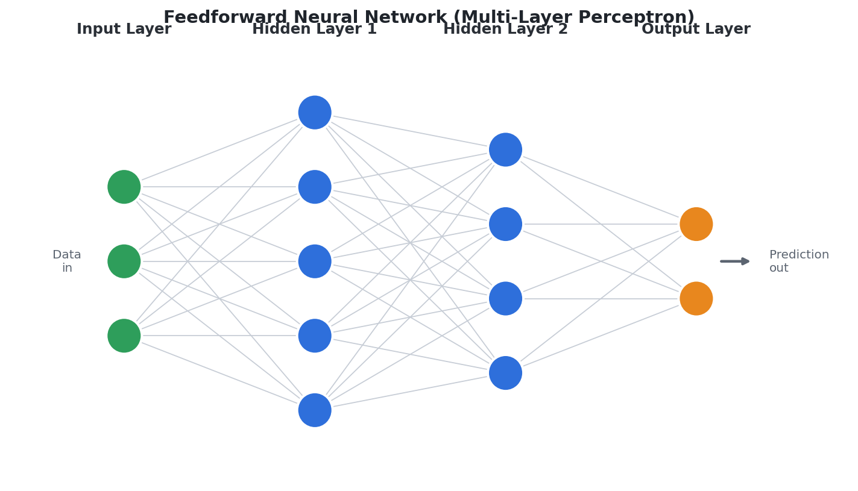
Figure 1: A feedforward network. Data flows left to right through fully connected layers.
It is built from three kinds of layers. The input layer receives the features of the data (for example, the age, income, and marks of a student). The hidden layers sit in the middle and do most of the learning by combining the inputs in many different ways. The output layer produces the final answer — a class label for classification or a number for regression.
An FNN is fully connected (also called dense), which means every neuron in one layer is joined to every neuron in the next layer. Each of these connections has its own weight, and each neuron applies an activation function to introduce non-linearity so the network can learn complex relationships. During training, the network makes a prediction (forward propagation), measures how wrong it is using a loss function, and then uses backpropagation together with gradient descent to adjust all the weights so that the error becomes smaller with each round.
Type of input data: fixed-size numeric vectors, i.e. structured or tabular data where the order and position of features do not carry special meaning. A key limitation is that an FNN treats every input independently — it does not understand the spatial layout of an image or the order of words in a sentence, which is exactly why CNNs and RNNs were invented.

2.2 Convolutional Neural Network (CNN)
A Convolutional Neural Network is a specialised architecture designed mainly for images and other grid-like data. If we tried to feed a full image into a feedforward network, every pixel would need its own connection to every neuron, creating millions of weights and losing all information about which pixels are next to each other. A CNN solves this cleverly by using small filters (also called kernels) that slide across the image to detect local features such as edges, corners, textures, and shapes.
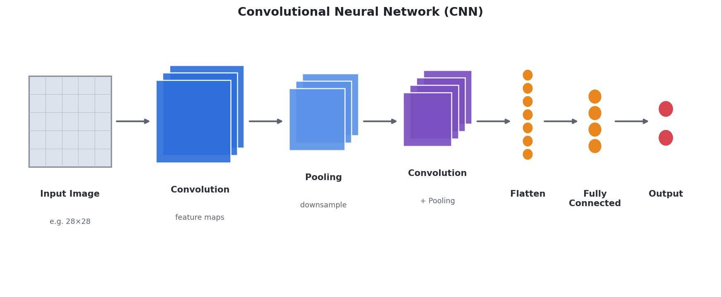
Figure 2: A CNN pipeline — convolution and pooling extract features, which are then flattened and classified.
A CNN is usually made of the following layers. The convolutional layer applies filters across the image to produce feature maps that highlight where a feature was found. A ReLU activation then adds non-linearity. The pooling layer (usually max pooling) shrinks the feature maps, keeping the most important information while reducing computation and making the network less sensitive to the exact position of a feature.
These convolution-and-pooling blocks are stacked several times. The early layers learn simple features like edges, while the deeper layers combine them into complex features like eyes, wheels, or whole objects — building a hierarchy of understanding. Finally, a flatten step turns the 2-D feature maps into a single 1-D list of numbers, which is passed to one or more fully connected layers and an output layer (often using softmax) that gives the final class probabilities.
Type of input data: images and other grid-structured data such as video frames and audio spectrograms. The main strengths of a CNN are parameter sharing (the same filter is reused across the whole image, so far fewer weights are needed), the ability to capture spatial patterns, and translation invariance — it can recognise an object even if it moves to a different part of the picture.

2.3 Recurrent Neural Network (RNN)
A Recurrent Neural Network is designed for sequential data, where the order of the elements matters. Sentences, audio signals, and daily stock prices are all sequences: the meaning of a word depends on the words before it, just as tomorrow’s temperature depends on the recent days. A plain feedforward network has no sense of order, so RNNs add a special ingredient — memory.
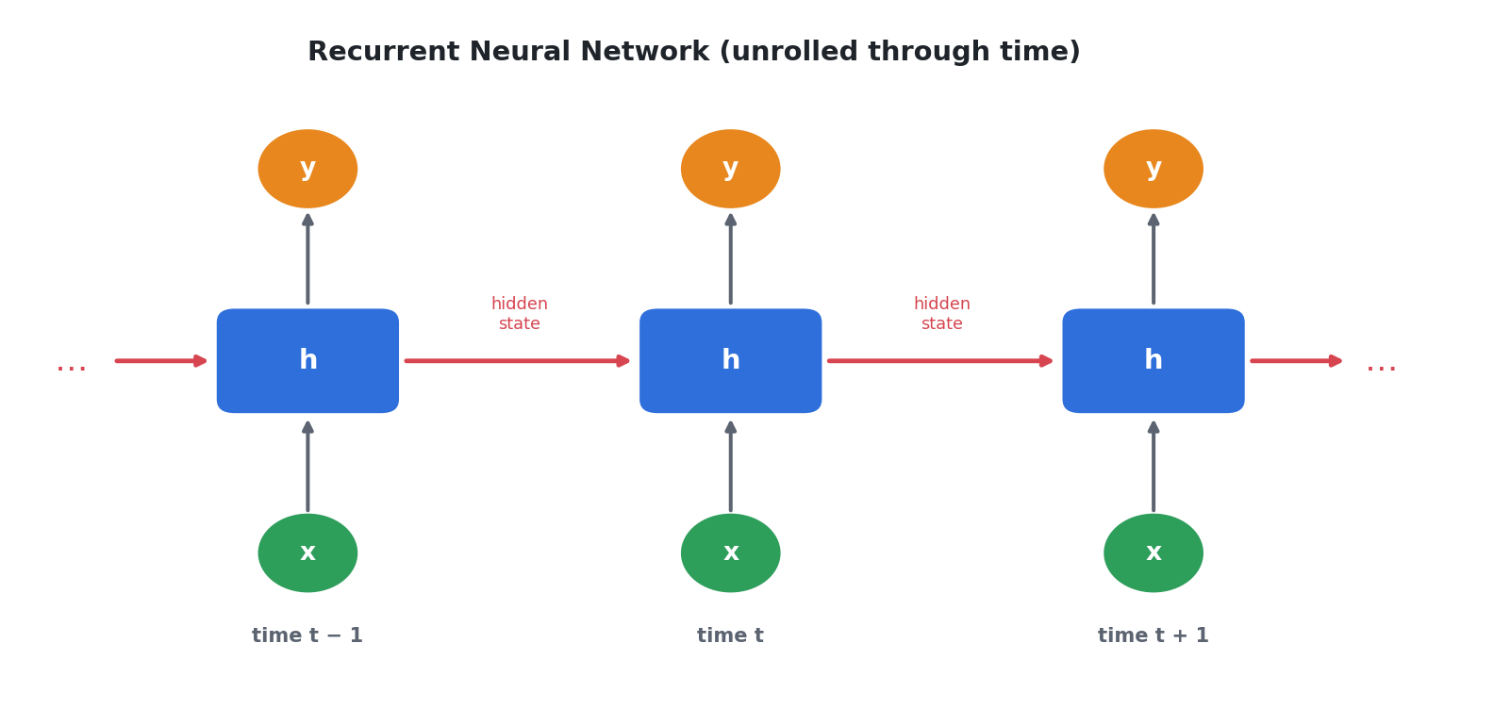
Figure 3: An RNN unrolled through time. The hidden state carries memory from one step to the next.
An RNN processes a sequence one element at a time (for example, word by word). At each time step it looks at the current input and the hidden state — a summary of everything it has seen so far — and uses both to produce an output and an updated hidden state. Because this hidden state is passed forward from step to step, the network effectively has a loop, which is why it is called “recurrent.” Drawing this loop opened out across time (as in Figure 3) is called unrolling the network.
RNNs are trained using a version of backpropagation called Backpropagation Through Time (BPTT). A common problem is the vanishing gradient, where the network struggles to remember information from far back in a long sequence. To fix this, improved versions called LSTM (Long Short-Term Memory) and GRU (Gated Recurrent Unit) use gates that decide what to remember and what to forget, allowing them to capture long-term dependencies much better.
Type of input data: sequences of variable length, such as text, speech, and time-series data. Like a CNN, an RNN shares its weights — here the same weights are reused at every time step — which keeps the model compact and lets it handle sequences of any length.

3. Task 2 — Suitable Applications and Datasets
Each architecture shines on the kind of data it was designed for. This section lists the most common real-world applications of each network, followed by the standard datasets that students and researchers use to train and test them.

3.1 Applications of Feedforward Neural Networks
FNNs work best on structured, tabular data where each column is a feature. They are widely used for straightforward prediction tasks:
- Credit scoring and loan default prediction — deciding whether a customer is likely to repay a loan.
- Customer churn prediction — predicting which customers may stop using a service.
- Medical diagnosis — classifying disease risk from structured patient records.
- Price and demand prediction — regression tasks such as estimating house prices.
- General classification and regression on any numeric dataset.
Datasets commonly used with FNNs:
Iris | 150 flowers described by 4 measurements; a classic classification starter dataset.
Titanic | Passenger details used to predict who survived; popular for tabular classification.
UCI Adult (Census Income) | Predicts whether income exceeds $50K from demographic features.
Pima Indians Diabetes | Medical records used to predict the onset of diabetes.
Boston / California Housing | Numeric features used for house-price regression.

3.2 Applications of Convolutional Neural Networks
CNNs dominate almost every task that involves images or spatial data:
- Image classification — recognising what an image contains (e.g. cat vs. dog, or handwritten digits).
- Object detection — locating and labelling multiple objects in a scene (YOLO, Faster R-CNN).
- Face recognition — identifying or verifying a person from a photo.
- Medical imaging — detecting tumours or abnormalities in X-ray, CT, and MRI scans.
- Self-driving cars — spotting lanes, pedestrians, traffic signs, and other vehicles.
Datasets commonly used with CNNs:
MNIST | 70,000 images of handwritten digits (0–9); the “Hello World” of image recognition.
Fashion-MNIST | Grayscale images of clothing items; a slightly harder drop-in for MNIST.
CIFAR-10 / CIFAR-100 | Small colour images across 10 or 100 object classes.
ImageNet | Over a million labelled images in 1,000 classes; the benchmark for large CNNs.
Chest X-ray / medical sets | Labelled scans used to train diagnostic image models.

3.3 Applications of Recurrent Neural Networks
RNNs (and their LSTM/GRU variants) are the natural choice whenever data comes as a sequence:
- Sentiment analysis — deciding whether a review or tweet is positive or negative.
- Machine translation — converting a sentence from one language to another.
- Speech recognition — turning spoken audio into written text.
- Text generation and chatbots — predicting the next word to produce fluent sentences.
- Time-series forecasting — predicting stock prices, weather, or sales from past values.
Datasets commonly used with RNNs:
IMDB Movie Reviews | 50,000 reviews labelled positive/negative; standard for sentiment analysis.
Penn Treebank (PTB) | A text corpus widely used for language modelling.
Stock / weather time series | Sequential numeric records used for forecasting future values.
Google Speech Commands | Short spoken words used to train speech models.
WMT translation corpora | Paired sentences in two languages for machine translation.

4. Task 3 — Comparison of the Three Architectures
The table below compares Feedforward Neural Networks, CNNs, and RNNs across their structure, the type of input data they expect, and their typical applications.
Aspect | Feedforward (FNN) | CNN | RNN
Also known as | Multi-Layer Perceptron (MLP) | ConvNet | Recurrent Net (LSTM / GRU)
Direction of data flow | One direction: input to output, no loops | Forward through conv & pooling stages | Loops — output feeds back into the next step
Core building block | Fully-connected (dense) neuron | Convolution filter / kernel | Recurrent cell holding a hidden state
Memory of past inputs | No | No | Yes — hidden state acts as memory
Best-suited input data | Fixed-size numeric vectors (tabular data) | Grid-like data — images, video frames | Sequences of variable length — text, speech, time series
Key operation | Weighted sum + activation | Convolution + pooling | Recurrence across time steps
Captures spatial patterns | No | Yes (main strength) | No
Captures order / time | No | No | Yes (main strength)
Parameter sharing | No | Yes — same filter slides over image | Yes — same weights reused each step
Popular variants | Perceptron, Deep MLP | LeNet, AlexNet, VGG, ResNet | LSTM, GRU, Bi-directional RNN
Typical applications | Tabular prediction, classification, regression | Image classification, object & face detection, medical imaging | Language, translation, speech, forecasting
Example datasets | Iris, Titanic, UCI Adult, Pima Diabetes | MNIST, CIFAR-10, ImageNet, Fashion-MNIST | IMDB reviews, Penn Treebank, stock time series

Table 1: Side-by-side comparison of the three deep learning architectures.

4.1 Discussion of Key Differences
Structure. An FNN is a simple stack of fully connected layers with data flowing only forward. A CNN adds convolution and pooling layers that scan the input with small shared filters before a fully connected part makes the decision. An RNN introduces a loop: its hidden state is carried from one time step to the next, giving it a form of memory that the other two networks do not have.
Input data. The three networks are really distinguished by the data they handle. FNNs expect fixed-size numeric vectors (tabular data). CNNs expect grid-like data, most often images, and make use of the spatial arrangement of pixels. RNNs expect sequences of variable length — text, audio, or time series — where the order of elements is meaningful.
Applications. Because of these differences, each network has its own home ground. FNNs are used for tabular prediction problems like credit scoring and churn. CNNs power computer-vision tasks such as image classification, object detection, and medical imaging. RNNs handle language and time-based problems such as translation, sentiment analysis, speech recognition, and forecasting. In modern systems the architectures are often combined — for example, a CNN can read the frames of a video while an RNN models how those frames change over time.

5. Conclusion
This project examined three foundational deep learning architectures and showed that the right choice depends mainly on the shape of the data. Feedforward Neural Networks are the simplest option and suit structured, tabular data. Convolutional Neural Networks use filters and pooling to understand the spatial structure of images, making them the standard for computer vision. Recurrent Neural Networks add a memory through their hidden state, allowing them to model sequences such as text, speech, and time series.
By comparing them on structure, input data, and applications, we can now clearly differentiate the three: FNNs answer “what does this row of numbers mean?”, CNNs answer “what is in this picture?”, and RNNs answer “what comes next in this sequence?” Understanding these strengths helps in selecting or combining the correct architecture for any real-world deep learning problem.

6. References
[1] Goodfellow, I., Bengio, Y., & Courville, A. (2016). Deep Learning. MIT Press. (deeplearningbook.org)
[2] LeCun, Y., Bengio, Y., & Hinton, G. (2015). Deep Learning. Nature, 521, 436–444.
[3] Nielsen, M. (2015). Neural Networks and Deep Learning. (neuralnetworksanddeeplearning.com)
[4] Krizhevsky, A., Sutskever, I., & Hinton, G. (2012). ImageNet Classification with Deep CNNs. NeurIPS.
[5] Hochreiter, S., & Schmidhuber, J. (1997). Long Short-Term Memory. Neural Computation, 9(8).
[6] IBM Cloud Education — “Neural Networks,” “Convolutional Neural Networks,” and “Recurrent Neural Networks” (ibm.com/topics).

