* Estructura de Tablas + Diagrama de entidad relación

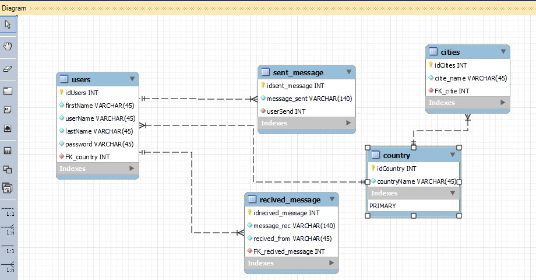

**Nota**: Aquí se aplicó al máximo lo que se explicó en clases la metodología de Normalización de datos

* Script de creación de la base de datos.

|  |
| --- |
| * -- MySQL Workbench Forward Engineering * SET @OLD_UNIQUE_CHECKS=@@UNIQUE_CHECKS, UNIQUE_CHECKS=0; * SET @OLD_FOREIGN_KEY_CHECKS=@@FOREIGN_KEY_CHECKS, FOREIGN_KEY_CHECKS=0; * SET @OLD_SQL_MODE=@@SQL_MODE, SQL_MODE='ONLY_FULL_GROUP_BY,STRICT_TRANS_TABLES,NO_ZERO_IN_DATE,NO_ZERO_DATE,ERROR_FOR_DIVISION_BY_ZERO,NO_ENGINE_SUBSTITUTION'; * -- ----------------------------------------------------- * -- Schema Final_BBDD * -- ----------------------------------------------------- * -- Schema Final_BBDD * -- ----------------------------------------------------- * CREATE SCHEMA IF NOT EXISTS `Final_BBDD` DEFAULT CHARACTER SET utf8 ; * USE `Final_BBDD` ; * -- ----------------------------------------------------- * -- Table `Final_BBDD`.`country` * -- ----------------------------------------------------- * CREATE TABLE IF NOT EXISTS `Final_BBDD`.`country` ( * `idCountry` INT NOT NULL AUTO_INCREMENT, * `countryName` VARCHAR(45) NOT NULL, * PRIMARY KEY (`idCountry`)) * ENGINE = InnoDB; * -- ----------------------------------------------------- * -- Table `Final_BBDD`.`users` * -- ----------------------------------------------------- * CREATE TABLE IF NOT EXISTS `Final_BBDD`.`users` ( * `idUsers` INT NOT NULL AUTO_INCREMENT, * `firstName` VARCHAR(45) NOT NULL, * `userName` VARCHAR(45) NOT NULL, * `lastName` VARCHAR(45) NOT NULL, * `password` VARCHAR(45) NOT NULL, * `FK_country` INT NOT NULL, * PRIMARY KEY (`idUsers`), * INDEX `FK_country_idx` (`FK_country` ASC) VISIBLE, * CONSTRAINT `FK_country` * FOREIGN KEY (`FK_country`) * REFERENCES `Final_BBDD`.`country` (`idCountry`) * ON DELETE CASCADE * ON UPDATE CASCADE) * ENGINE = InnoDB; * -- ----------------------------------------------------- * -- Table `Final_BBDD`.`recived_message` * -- ----------------------------------------------------- * CREATE TABLE IF NOT EXISTS `Final_BBDD`.`recived_message` ( * `idrecived_message` INT NOT NULL AUTO_INCREMENT, * `message_rec` VARCHAR(140) NOT NULL, * `recived_from` VARCHAR(45) NOT NULL, * `FK_recived_message` INT NOT NULL, * PRIMARY KEY (`idrecived_message`), * INDEX `FK_recived_message_idx` (`FK_recived_message` ASC) VISIBLE, * CONSTRAINT `FK_recived_message` * FOREIGN KEY (`FK_recived_message`) * REFERENCES `Final_BBDD`.`users` (`idUsers`) * ON DELETE CASCADE * ON UPDATE CASCADE) * ENGINE = InnoDB; * -- ----------------------------------------------------- * -- Table `Final_BBDD`.`sent_message` * -- ----------------------------------------------------- * CREATE TABLE IF NOT EXISTS `Final_BBDD`.`sent_message` ( * `idsent_message` INT NOT NULL AUTO_INCREMENT, * `message_sent` VARCHAR(140) NOT NULL, * `userSend` INT NOT NULL, * PRIMARY KEY (`idsent_message`), * INDEX `FK_userSend_idx` (`userSend` ASC) VISIBLE, * CONSTRAINT `FK_userSend` * FOREIGN KEY (`userSend`) * REFERENCES `Final_BBDD`.`users` (`idUsers`) * ON DELETE CASCADE * ON UPDATE CASCADE) * ENGINE = InnoDB; * -- ----------------------------------------------------- * -- Table `Final_BBDD`.`cities` * -- ----------------------------------------------------- * CREATE TABLE IF NOT EXISTS `Final_BBDD`.`cities` ( * `idCities` INT NOT NULL AUTO_INCREMENT, * `citie_name` VARCHAR(45) NOT NULL, * `FK_citie` INT NOT NULL, * PRIMARY KEY (`idCities`), * INDEX `FK_citie_idx` (`FK_citie` ASC) VISIBLE, * CONSTRAINT `FK_citie` * FOREIGN KEY (`FK_citie`) * REFERENCES `Final_BBDD`.`country` (`idCountry`) * ON DELETE CASCADE * ON UPDATE CASCADE) * ENGINE = InnoDB; * SET SQL_MODE=@OLD_SQL_MODE; * SET FOREIGN_KEY_CHECKS=@OLD_FOREIGN_KEY_CHECKS; * SET UNIQUE_CHECKS=@OLD_UNIQUE_CHECKS; |

**Tablas:**

1. **Usuarios**

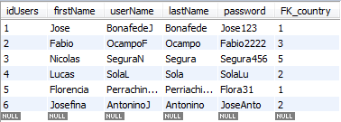

1. **Send_message**

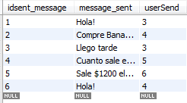

1. **Send_message**

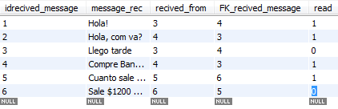

1. **Country**

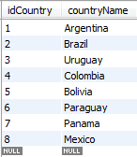

**Consultas**

1. Cantidad de usuarios por país.

|  |
| --- |
| SELECT countryName, COUNT(FK_country)  FROM users AS u  JOIN country AS c  ON u.FK_country = c.idCountry  GROUP BY c.countryName; |
| Resultado: |

1. Cantidad de mensajes por usuario.

|  |
| --- |
| SELECT userName, COUNT(userSend)  FROM sent_message AS u  JOIN users AS c  ON u.userSend = c.idUsers  GROUP BY c.userName; |
| Resultado: |

1. Cantidad de mensajes leídos por usuario