**Project Overview**

Service for connecting shelters/rescue operations with people looking to acquire

dogs. Preventing puppy mills from taking over on day zero should be an

interesting challenge.

The service would comprise the following:

User profile creation/management.

Trust system.

Automatic verification of shelters to ensure legality and humane treatment.

Most of the referenced sites provide some sort of user profile management.

Support for special-needs animals.

There is no existing solution for this.

A listing service for available rescue animals.

Advanced search function to connect prospective owners of domestic animals.

The ASPCA provides a similar, albeit less feature-rich, service.

|  |  |  |  |  |  |  |
| --- | --- | --- | --- | --- | --- | --- |
| services | Our Service | [1] | [2] | [3] | [4] | [5] |
| Lookup directory | V | V | V | X | V | V |
| add/view listings for animals | V | X | X | X | V | X |
| Inform about the problem | V | X | X | V | V | V |
| Locate shelters | V | V | X | V | V | X |
| Special-needs animals | V | X | X | X | X | X |

**Table References:**

[1] Facebook Animal Rescue Directory <http://www.lacroixtees.com/fb_directory/animal-rescue/> [2] Craigslist <http://www.craigslist.org/>

[3] The Humane Society <http://www.humanesociety.org/>

[4] ASPCA [www.aspca.org](http://www.aspca.org)

[5] National Mill Dog Rescue <http://milldogrescue.org/>

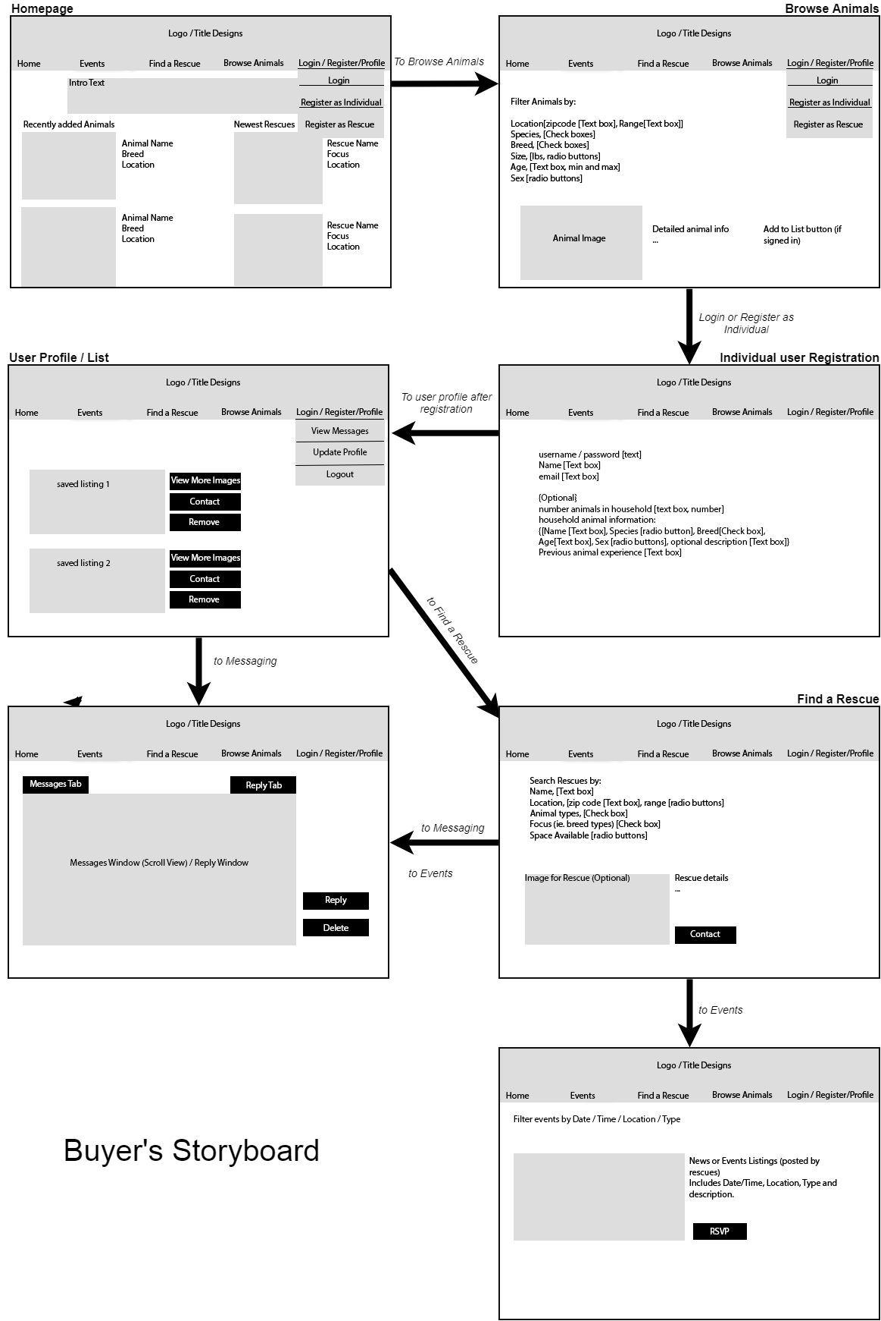

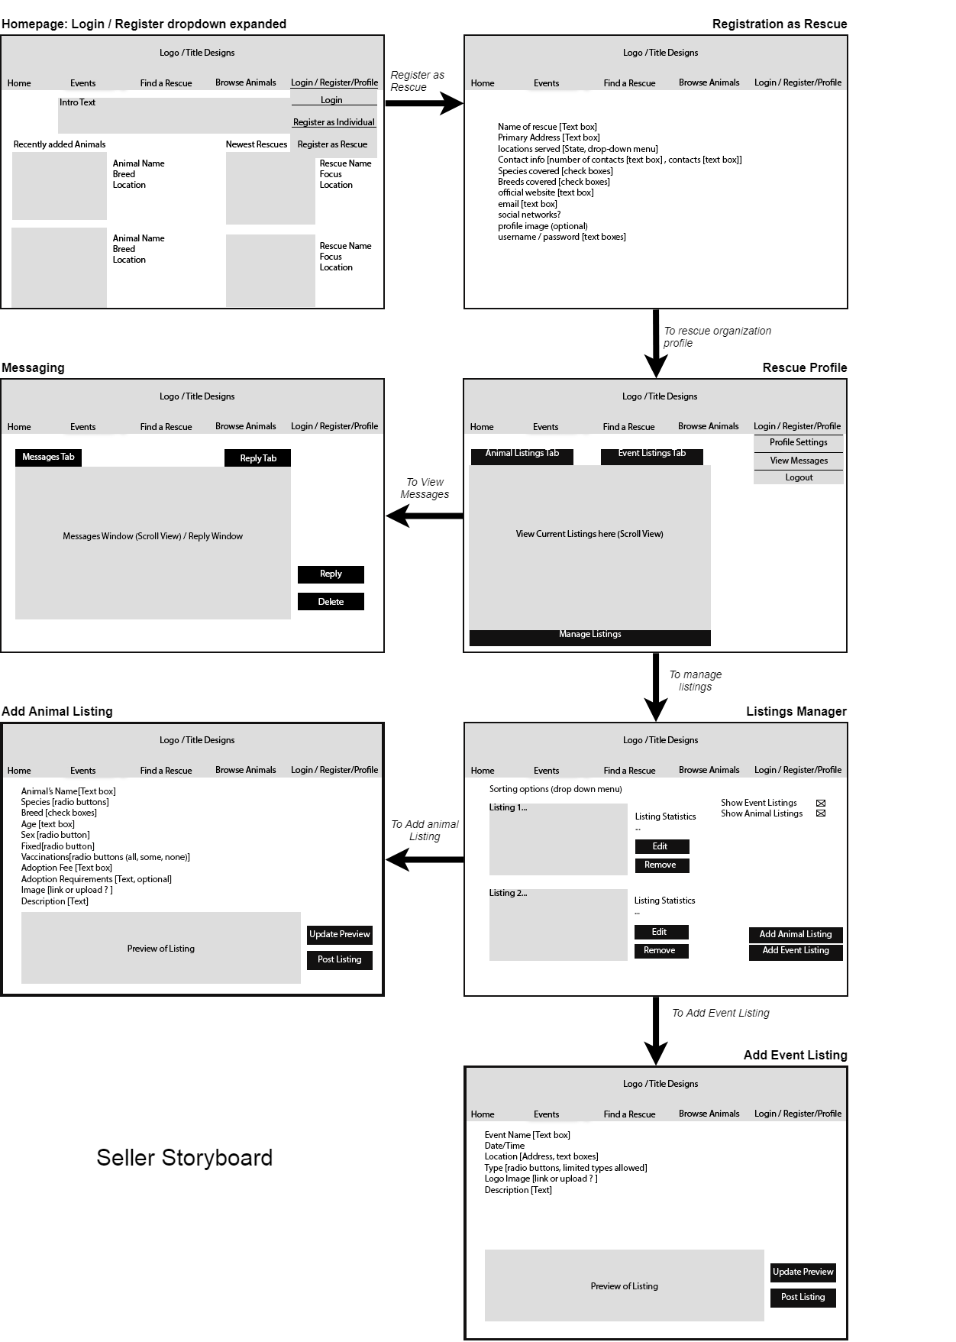

**Mobile page redesigns**

Homepage

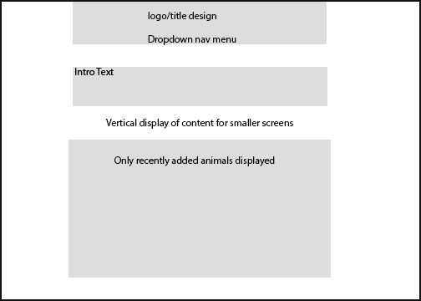

Add Animal Listing page

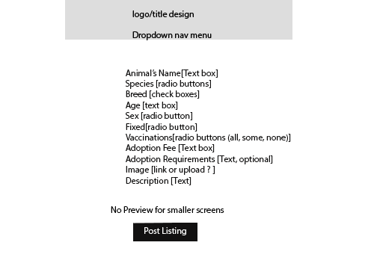

Manage Listings page

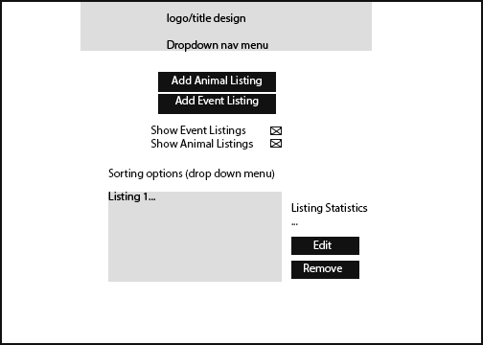

Events Listing page

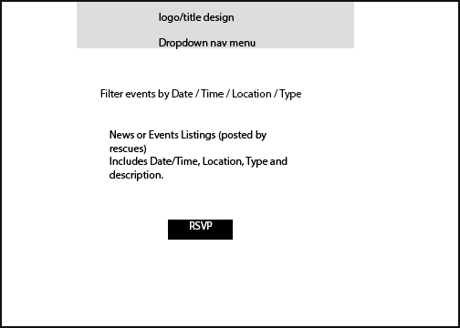

Add Event page

