Create the following table structure in SNOWFLAKE by creating your own warehouse. Insert some 10 rows using INSERT command (check task 3 and same way insert for all task tables) in the table by trying different values for all the columns and then check using SELECT *

Once data is loaded, performed the below task

**Task 1:**

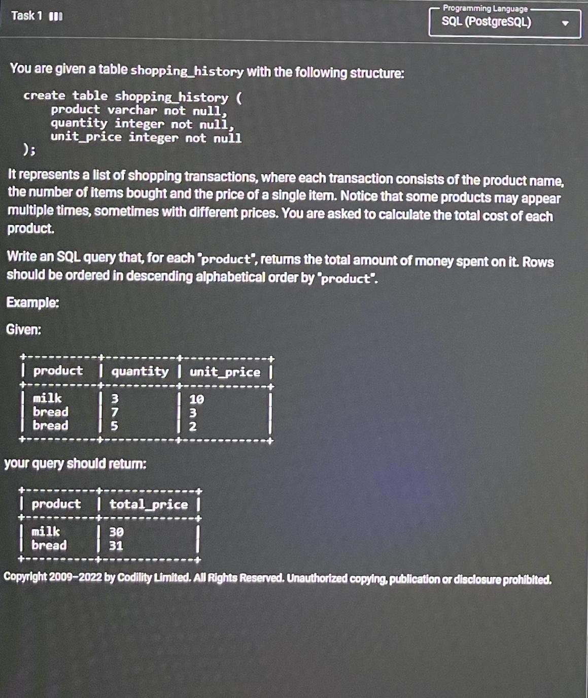

**Task 2:**

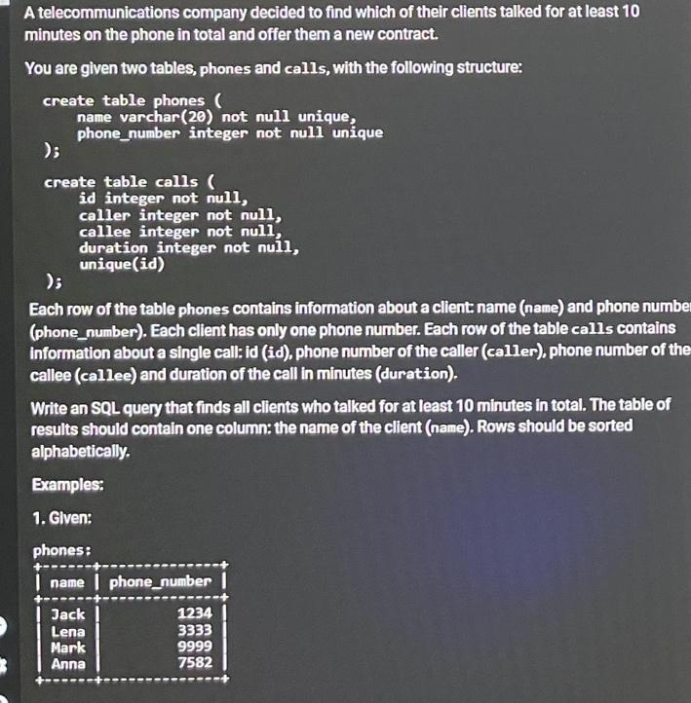 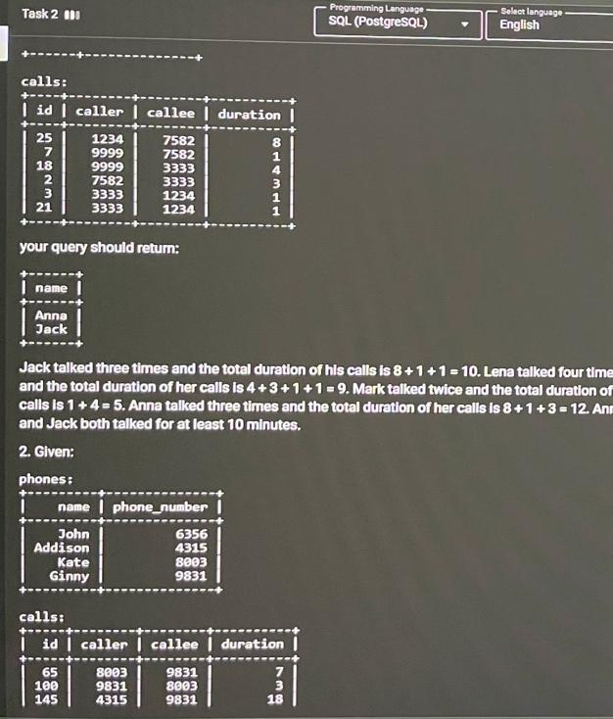

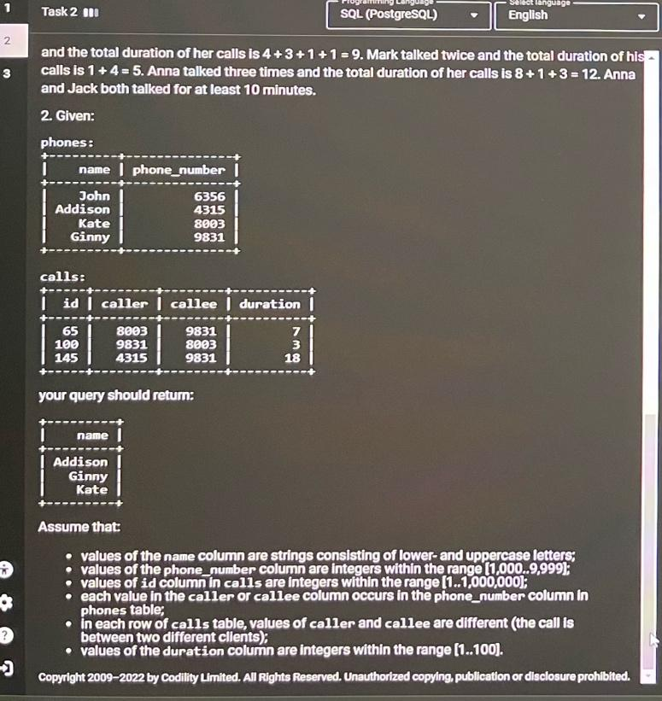

**Task 3:** **Output display is just one column balance**

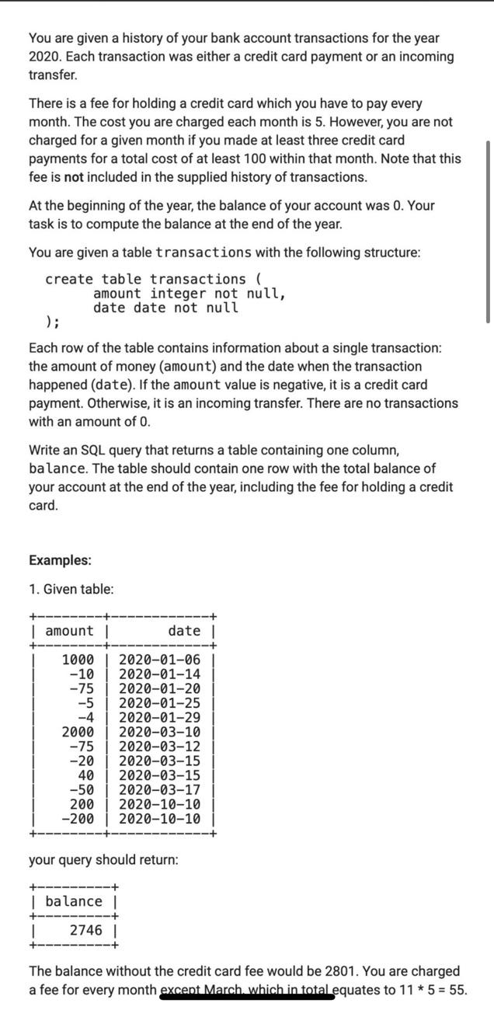 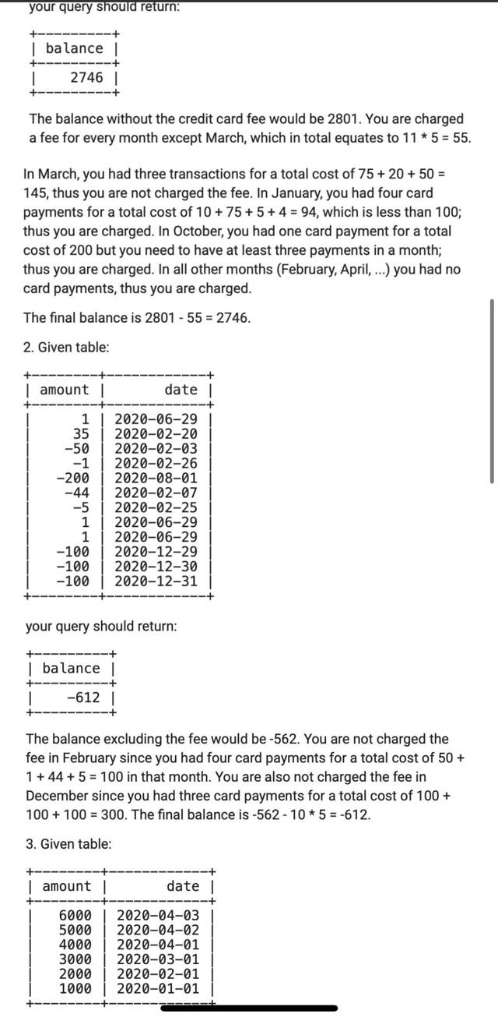

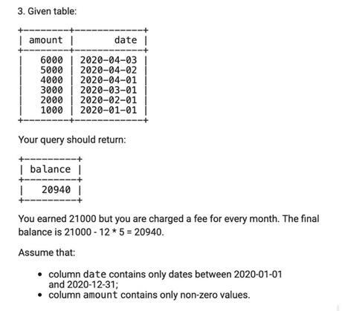

You can add the following data in the table

