Priorizando la Naturaleza
User Guide
A web platform for exploring conservation scenarios in Colombia

Table of Contents
1. Introduction 1
2. Getting Started 1
2.1 Accessing the tool 1
2.2 Choosing a language 1
2.3 Starting a session 2
2.4 Creating an account and logging in 2
3. Building a Scenario 3
3.1 Choosing a model domain 3
3.2 Step 1: What to conserve 3
3.3 Step 2: Cost 4
3.4 Step 3: Existing conservation areas 4
3.5 Viewing the map 4
4. The Map Interface 4
4.1 Reading the map 5
4.2 Basic map controls 5
4.3 Managing your active scenario 6
5. Working with Displayed Layers 6
5.1 The Displayed Layers Box 6
5.2 Finding a layer 6
5.3 Displaying and removing a layer 7
5.4 Adjusting how a layer looks 7
5.5 Keeping the map readable 8
6. Reviewing Metrics 8
6.1 Overview tab 8
6.2 Areas of Interest tab 9
6.3 Comparison tab 10
7. FAQs & Troubleshooting 10
8. Glossary of Terms 11

1. Introduction
Priorizando la Naturaleza (referred to throughout this guide as “the tool”) is a web-based platform that supports conservation decision-making in Colombia. It allows users to explore pre-run conservation scenarios — spatial solutions generated by a systematic conservation planning model — and to visualize how those scenarios relate to biodiversity, ecosystems, costs, existing protected areas, and cultural territories.
It is important to understand what the tool does and does not do:
- The tool visualizes and reports on scenarios that have already been modeled. You choose conservation objectives (what to conserve, conservation targets, cost data, etc.) from a defined set of options, and the tool displays the corresponding pre-computed solution.
- The tool does not run a new prioritization live. Selecting a scenario retrieves the matching pre-run result rather than solving a new model in real time.
- Scenario metrics are pre-calculated at the national, departmental, and municipal levels. They are only generated live when you draw a custom area of interest (AOI).
These distinctions matter because they shape how the tool is best used: as a way to explore and compare pre-built scenarios against other spatial data and your own knowledge of a region or conservation priorities, rather than as a live modeling engine.

How to use this guide
This guide is organized to follow the natural order of using the tool: getting started, building a scenario, exploring the map, and reviewing metrics. It is intended as a companion to the short video walkthrough, which shows the tool in motion, and goes into more depth on each step, defines key terms, and covers a few topics (such as account registration and troubleshooting) that the video only touches on briefly or skips.
Tip: If you only need a quick refresher on one part of the tool, use the Table of Contents above to jump directly to that section.

2. Getting Started

2.1 Accessing the tool
Priorizando la Naturaleza is a web-based tool. Opening it requires an internet connection and a modern web browser (e.g., Chrome, Firefox, Microsoft Edge); no installation is required.

2.2 Choosing a language
You can change the platform's language at any time using the language selector, found in the upper-left corner of the Welcome pop-up and the upper-right of the main tool page. Currently you can choose between Spanish ("ES," the default) and English ("EN"). Changing languages updates menu labels, instructions, and legends throughout the tool.

2.3 Starting a session
The Welcome pop-up appears when first loading the tool and provides a brief overview of how to use the tool. From this pop-up, you can read more about the tool in the separate About page. When you are ready to begin, click the blue Get Started button. This closes the pop-up and takes you to the Scenario Selector, where you'll define the conservation scenario you want to explore (see Section 3).
If you are affiliated with a SIRAP or have administrative privileges, you can also log-in or register for advanced access (see Section 2.4).

2.4 Creating an account and logging in
Priorizando la Naturaleza can be used without an account, which gives any user access to the national-level terrestrial and marine models described throughout this guide. Creating a free account and logging in unlocks additional regional models — scenarios built at a finer geographic scale for specific regions of the country. Account requests are manually verified, however, and not everyone may be eligible to access region-specific data.
To register:
- Click Log In / Register, located on the Welcome pop-up and in the upper-right corner of the main tool page.
- Click Request Access and select the Google account you'd like to use — a Google account is currently required. Follow the prompts to provide your affiliated organization, the region you are interested in, and a brief description of how you plan to use the tool. Requests are currently reviewed manually and may take several business days.
- Once your request is approved, you will log in and set up multi-factor authentication via the Google Authenticator app. The first time, you will be prompted to scan a QR code with your phone to link the two accounts.
- After you set up multi-factor authentication, sign in with your Google account and enter the code from Authenticator when prompted.
After logging in, regional models will appear alongside the national terrestrial and marine options in the Scenario Selector, and region-specific data will be available in the left panel. When you are finished with your session, simply click the Logout button in the upper-right corner of the main tool page.
Note: An account is only required to access regional models and data. If you only need national-level scenarios, you can skip registration and use the tool as a guest.

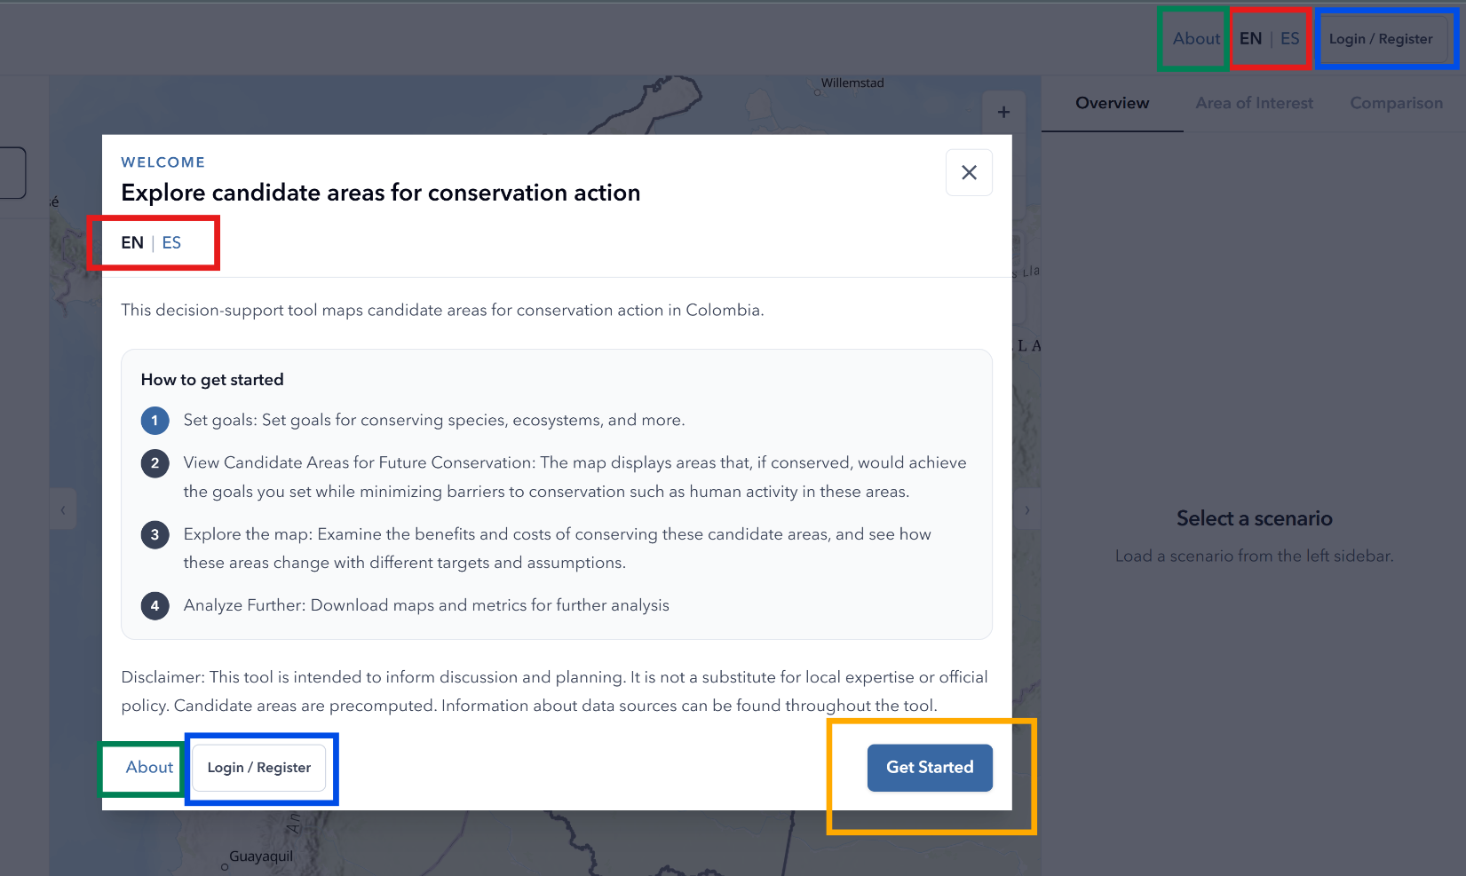
Figure 1: Getting Started and the Welcome pop-up. When first loading the tool, this message will appear. Either within the Welcome pop-up or in the upper-right of the main page, there are tools to: change languages (red box), visit the About page (green box), log-in or register (blue box), or Get Started with selecting a conservation scenario (orange box).

3. Building a Scenario
The Scenario Selector is where you define what should be prioritized by a conservation scenario. The same three-step process applies whether you are working with a terrestrial, marine, or (if logged in) regional model — only the specific conservation features, targets, and cost data available will differ.
Where available, data used throughout this section are hyperlinked to their original public source.

3.1 Choosing a model domain
Start by choosing which type of model you want to explore:
- Terrestrial — national land-based conservation scenarios
- Marine — national ocean and coastal conservation scenarios
- Regional (log-in required) — finer-scale scenarios for a specific region

3.2 Step 1: What to conserve
This step defines the conservation features the scenario should include — the specific options available will vary depending on the model you have selected (terrestrial, marine, or regional), but the options generally include categories such as ecosystems, species, and ecosystem services.
For each category you select, you must set a target. A target is the proportion of that feature you want the scenario to conserve. Targets can be set differently for each category. For example, in a terrestrial model, you might set a target of 17% for each ecosystem, while setting a higher target of 30% for each strategic ecosystem and 30% for every species' range.
Note: “Strategic ecosystems,” “ecosystem services,” and similar terms are defined in the Glossary (Section 8).

3.3 Step 2: Cost
This step defines which cost layer the scenario should use to evaluate tradeoffs — that is, how “expensive” different areas are to conserve in practical or socioeconomic terms. For terrestrial and regional models, you can choose between multiple cost layers. Marine models currently have one fixed cost. The choice of cost layer affects which areas the scenario favors when multiple areas could meet the same conservation target.

3.4 Step 3: Existing conservation areas
This step defines which existing protected or conserved areas should count toward meeting your defined targets:
- The National System of Protected Areas (RUNAP) is always included and cannot be excluded.
- Other Effective Area-Based Conservation Measures (OECMs) can optionally be included as well.
Including OECMs means the scenario will treat those areas as already contributing to your conservation goals, which typically reduces the amount of additional area needed to meet the targets.

3.5 Viewing the map
After you have made your selections across all three steps, click View Map to load the corresponding scenario. This displays the pre-run scenario result matching your selections on the interactive map, described in the next section.
Tip: You can always return to the Scenario Selector later to change any of these selections. For instructions on how to do this, see “Changing your scenario” in Section 4.

4. The Map Interface
Once a scenario loads, the screen is divided into three main areas:
- Left panel — controls what data and layers are shown on the map, with tools for changing visualizations
- Center — the interactive map
- Right panel — metrics describing how the scenario you picked meets conservation targets

4.1 Reading the map
On the map, your scenario is shown using two colors, as described in the legend:
- Blue — existing conservation areas you included in Step 3 (RUNAP, and OECMs if selected).
- Green — additional areas identified by the prioritization model in order to meet your specified conservation targets. These can be interpreted as candidate areas for additional conservation.

4.2 Basic map controls
The map includes several controls along the upper-right side, organized in a few small groups. At the top, the + and – icons let you zoom in and out, working the same way as your mouse or trackpad. Just below those buttons, a corner-bracket frame icon resets the map to the national extent. This functionality is useful if you have zoomed or panned out far from your area of interest. To navigate around the map, simply click and drag your cursor in any direction.
A basemap selector, located underneath the zoom controls, allows you to switch the background map style (for example, satellite imagery versus a topographic reference map) to suit what you are trying to visualize. The pencil icon allows you to draw your own area of interest (AOI; see Section 6.2). The download button saves the map, exactly as displayed, as a static PNG image file.
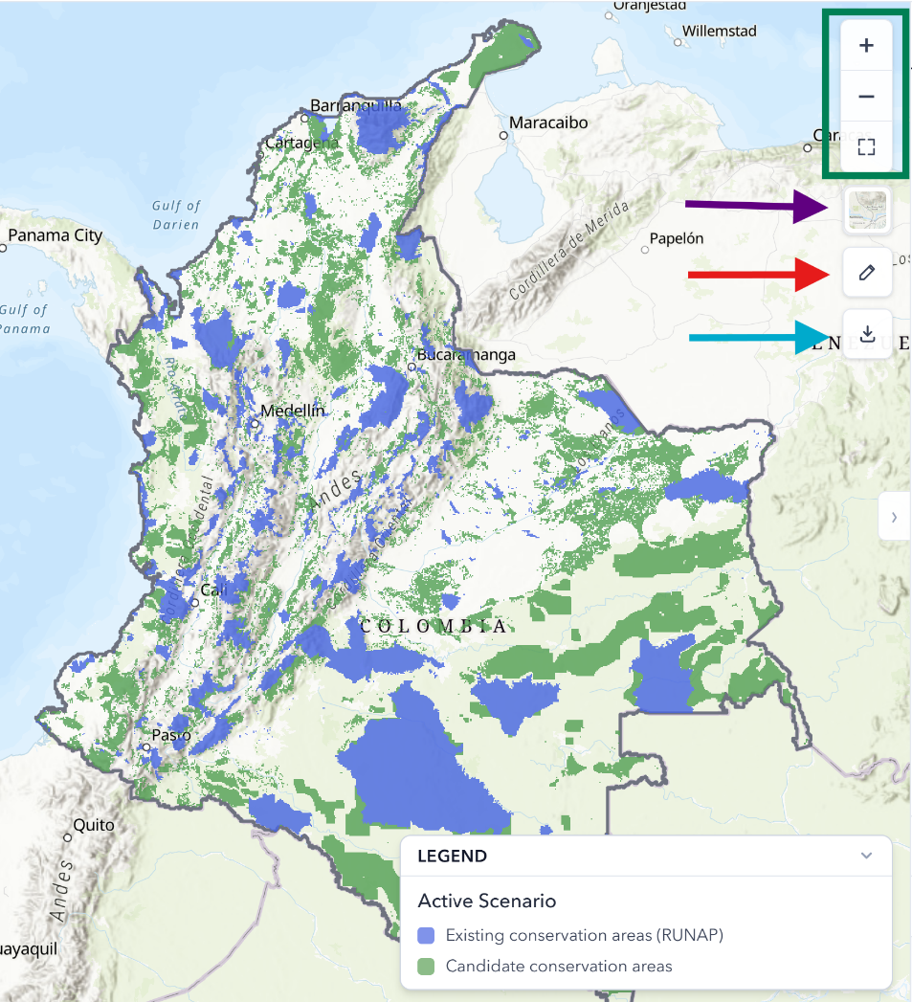
The legend in the lower right can be collapsed using the arrow icon. The legend automatically updates to reflect the data currently displayed on the map.
Figure 2: Map controls. The interactive map includes icons that allow you to: change the zoom and extent (green box), select different base maps (purple arrow), draw a unique AOI (red arrow), and download the map as an image (blue arrow).

4.3 Managing your active scenario
At the top of the left panel, the Active Scenario box shows a summary of the scenario that is currently loaded. From here, you can:
- Click Add Custom Name to rename the scenario to something easier to remember. This functionality is especially useful if you plan to compare multiple scenarios later. The chosen name populates in corresponding tool locations, such as the map legend and Comparison tab.
- Click View Breakdown to recall exactly which options you selected in Steps 1–3, without needing to reopen the full Scenario Selector.
- Click Change to return to the Scenario Selector and adjust your selections or generate a new scenario.

5. Working with Displayed Layers
The left panel gives you access to a wide library of contextual data including administrative boundaries, species and ecosystem data, cultural territories, cost layers, and more. You can add these data to the map to provide context to help interpret the results. This section explains the mechanics of finding, displaying, and styling data layers. Details of the data layers can be explored through the hyperlinks.

5.1 The Displayed Layers Box
The Displayed Layers box, near the top of the left panel, lists every layer currently shown on the map, including the Active Scenario and any other contextual data you have added. You can change each layer’s visibility, styling, and order, which is explained in the sections below.

5.2 Finding a layer
Below the Displayed Layers box, the left panel organizes all Available Layers into browsable categories, such as administrative boundaries, conservation areas, species and biodiversity, ecosystems, cultural and ethnic territories, and cost/land use data. You can scroll through these collapsible categories, or use the Search Layers box to filter by category, layer name, or specific species name. Within the Species and Biodiversity category, a dedicated search box is also available for finding a specific species by name.
Near the top of the Available Layers list, an Available Layer Types filter allows you to narrow the list to Terrestrial, Marine, or Both. This choice only affects which layers are shown in this browsing list. Any layers already displayed on the map remain visible regardless of this setting.
Some, but not all, of the available layers can be explicitly considered as part of a scenario's modeling inputs. These layers display a small indicator showing whether that data was considered in the currently active scenario. For example, RUNAP will always show as considered, since it is included in every scenario, while OECMs will only show as considered if they were selected in the Scenario Selector. This indicator can be toggled on or off using the Show 'Considered in Scenario' Status switch above the layer list.

5.3 Displaying and removing a layer
Click the Display button next to any layer to add it to the map. Once added, the layer will also appear in the Displayed Layers box at the top of the left panel, which lists every layer currently being displayed on the map.
To remove a layer, either click the “X” button next to the layer name in the Displayed Layers box, or click the Displayed button again from its entry lower in the panel to toggle the layer off.

5.4 Adjusting how a layer looks
Once a layer is displayed, there are several ways to control how the layer appears on the interactive map:
- Visibility — click the eye icon in the Displayed Layers box to quickly show or hide a layer without removing it.
- Opacity — for layers with a solid fill, use the opacity slider beneath the layer's name to make it more or less transparent.
- Width — for boundary data with no fill, use the width slider beneath the layer's name to make the polygon's edges thinner or thicker.
- Color / style — click the color swatch next to a layer to open a style widget, which varies depending on the layer type:
  - For binary, filled data, you can change the fill color by picking from a color map, or by specifying a hex code or RGB values.
  - For polygon data, such as administrative boundaries, you can choose a border style (solid, dashed, dotted) and border color. For these layers, the slider beneath the layer's name controls border width rather than opacity.
  - Some polygon data, such as OECMs, also support a fill pattern — solid, mesh, dots, and other options.
- Order — click and drag the dots to the left of a layer's name to reorder layers within the Displayed Layers box; layers higher in the list are drawn on top of those below.
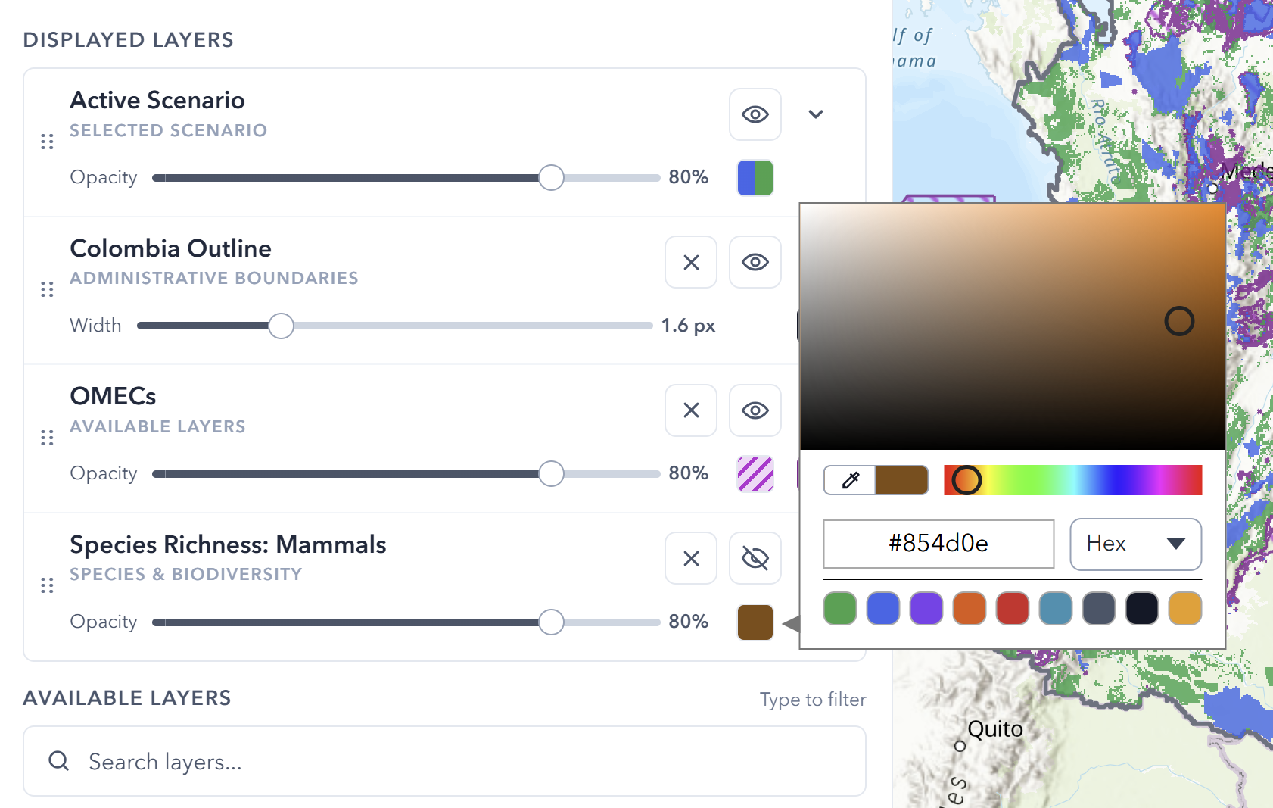
Figure 3: Displayed Layers box. This example shows four layers simultaneously added to the interactive map. As described above, each layer can have custom stylization of colors, borders, opacity, and fill by clicking on the corresponding icons. The eye and X buttons can be used to hide a layer or remove it from the map, respectively.

5.5 Keeping the map readable
Adding many layers to the map can make the map crowded and hard to read. If this happens, click Reset Defaults (at the bottom of the left panel) to clear any added layers and return the map to its default display, showing only the Active Scenario.
Tip: A good practice is to add one or two contextual layers at a time, review what you are seeing, and then remove them before adding the next layer, rather than layering many data sets on top of each other at once.

6. Reviewing Metrics
The right panel quantifies how well your scenario performs against conservation targets. You can explore metrics both for the features you explicitly selected and also for other features that were not part of your selected scenario. Metrics are organized into three tabs, and you can toggle the unit of measurement between square kilometers (km²) and hectares (ha) at any time.

6.1 Overview tab
The Overview tab at the top shows whether the scenario met the conservation targets for the features you selected in Step 1. Below that, an Additional Outcomes section shows how the scenario performs against targets for features you did not explicitly select. This functionality is useful for understanding co-benefits (or gaps) beyond your original objectives.
Clicking View Breakdown below an item opens a more detailed, feature-by-feature view. For example, you might see coverage metrics for individual ecosystems, or you can group ecosystems by different categories to view summary statistics. A text search box lets you look for a specific feature by typing in a name, and you can filter the table by whether a conservation target was met, or sort it by name or coverage statistics.
Scrolling down to the Conservation Summary section reveals additional contextual statistics, such as how much of the candidate conservation area falls within indigenous reserves, the ecosystem service benefits the solution provides, and the various land uses present within candidate areas.
Metrics from this tab can be downloaded as a CSV file for further analysis by clicking on the button at the bottom of the right panel.
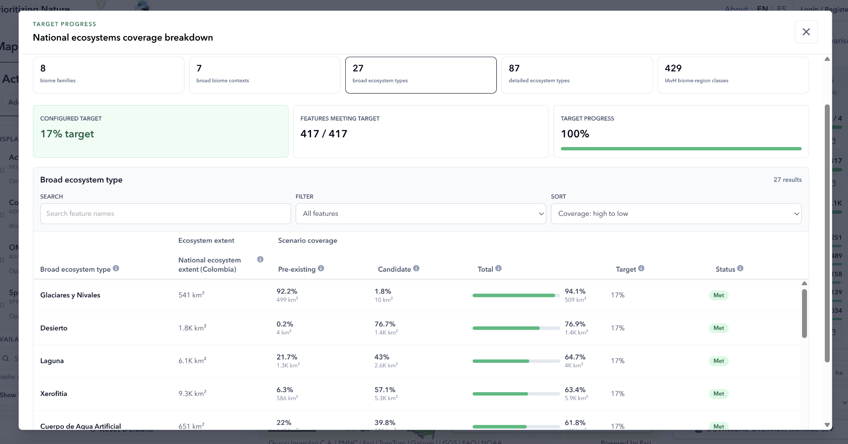
Figure 4: Detailed breakdown of ecosystem metrics. Accessed by clicking View Breakdown under Ecosystems in the right panel. Instead of viewing all 429 individual ecosystem categories used in the model, users can group them into broader ecosystem types to see summary coverage statistics.

6.2 Areas of Interest tab
This tab lets you view similar metrics but constrained to a specific geographic area rather than the whole country or region. You can either select a predefined boundary or draw a custom area:
- Predefined boundary — click a boundary such as a SIRAP, department, or municipality directly on the map to see metrics for that area. The boundary layer must be displayed on the map first (see Section 5.2 and 5.3) before you can click on it. If you do not see the boundary you want, add it from the Available Layers list.
- Custom area of interest — click the pencil icon (see Section 4.2) to begin drawing. Click to place each vertex of your shape, then double-click to complete the polygon. Custom areas can cross administrative boundaries.
In both cases, the tab returns similar categories of metrics such as biodiversity, ecosystems, and more, but they are limited to your selected or drawn area. Metrics from this tab can be downloaded as a CSV file for further analysis.

6.3 Comparison tab
The Comparison tab allows you to compare your current scenario (Scenario A) against a second scenario (Scenario B), which you configure by clicking the Scenario B button and using the same three-step process described in Section 3. You can click the pencil icon in the corner of the Scenario B button to either change the scenario or set a custom name.
After both scenarios are loaded, the map highlights the differences between them:
- Green — areas included only in Scenario A
- Blue — areas included only in Scenario B
- Pink — areas included in both scenarios
These colors can be customized to a different palette, if preferred, by changing individual colors in the Displayed Layers box (see Section 5.4). In addition to this three-color comparison, a swipe tool is also available as an alternative way to visually compare the two scenarios side by side. Clicking the Swipe Slider button immediately splits the map with a vertical line, showing Scenario A on the left and Scenario B on the right. You can click and drag the slider left and right to compare the differences.
Beyond the visual comparison, the Comparisons tab reports quantified differences between the two scenarios. Summary metrics can be downloaded directly from this tab, and the current map view can be downloaded as an image.

7. FAQs & Troubleshooting

The map is slow to draw or unresponsive to interactions
This is usually caused by too many layers being displayed at once, especially detailed layers like species richness and protected area polygons. Try clicking Reset Defaults, then re-adding only the layers you currently need.

I cannot find a specific species or layer
Use the search function within the Species and Biodiversity category to search by name. Please note that species are currently only searchable under their scientific names (genus species). If a layer still cannot be found, confirm you are looking in the correct model type (terrestrial vs. marine) and, for regional data, that you are logged in.

I want to start over with a new scenario
Click Change in the Active Scenario panel to return to the Scenario Selector and choose new objectives, or use the Comparison tab if you want to keep your current scenario visible while exploring an alternative. Alternatively, you can simply refresh the webpage to reset the tool.

I have encountered a bug, or my scenario or data aren’t displaying properly
The tool is relatively new and may still have undiscovered bugs. The easiest fix is to refresh the web page in your browser, which resets the tool. We would appreciate your reporting any significant bugs so we can address them in a future update. Please email prioridades.conservacion@parquesnacionales.gov.co

Can I access regional models and data without an account?
No. Regional models require permissions that are granted through Parques Nacionales Naturales de Colombia. See Section 2.4 for how to register.

8. Glossary of Terms
RUNAP | The National System of Protected Areas (Registro Único Nacional de Áreas Protegidas) — Colombia's official registry of protected areas. Always included in every scenario.
OECM | Other Effective Area-Based Conservation Measure — an area that delivers conservation outcomes outside the formal protected areas system. Optional to include in a scenario.
Strategic ecosystems | An ecosystem type identified as a national priority for conservation due to its ecological importance or vulnerability. These include páramos, dry forests, wetlands, and mangroves (marine model only).
Ecosystem service | A benefit that people obtain from ecosystems, such as groundwater regulation and recharge or carbon storage.
Human footprint | A measure of cumulative human impact on the landscape, used here as a cost layer to represent the practical difficulty or cost of conserving an area.
Conservation target | The proportion (e.g., 17%, 30%, 50%) of a given feature, such as an ecosystem or species range, that a scenario includes.
Area of Interest (AOI) | A geographic area, either a predefined boundary or a custom drawn shape, used to view metrics for a specific location rather than the whole country.
Scenario | A complete, pre-run conservation solution generated from a specific combination of conservation targets, cost data, and existing conservation areas.

