

SAFEHER — WOMEN'S SAFETY, ONE TAP AWAY
AN INTERNET-BASED WOMEN'S SAFETY AND EMERGENCY RESPONSE SYSTEM

A CAPSTONE PROJECT REPORT
A Capstone Project Report submitted in partial fulfilment of the requirements for the Course of
CSA4301 & INTERNET PROGRAMMING
to the award of the degree of
BACHELOR OF ENGINEERING
IN
COMPUTER SCIENCE AND ENGINEERING

Submitted by
Disha P(192411086)

Under the Supervision of
Dr. Marie Claude

SIMATS ENGINEERING
Saveetha Institute of Medical and Technical Sciences
Chennai-602105

SEPTEMBER 2026

SIMATS ENGINEERING
Saveetha Institute of Medical and Technical Sciences
Chennai-602105

BONAFIDE CERTIFICATE
This is to certify that the Capstone Project entitled " SAFEHER — WOMEN'S SAFETY, ONE TAP AWAY “ has been carried out by Disha P (192411086), as part of a five-member project team, under the supervision of Dr Marie Claude and is submitted in partial fulfilment of the requirements for the current semester of the B.E. Computer Science and Engineering programme at Saveetha Institute of Medical and Technical Sciences, Chennai. This report documents the candidate's individual understanding, role, and contribution within the team project.

COURSE COORDINATOR | COURSE FACULTY
Dr Anusuya, | Dr Marie Claude,
Program Director | Professor
Computer Science and Engineering, | Computer Science and Engineering,
SIMATS Engineering, | SIMATS Engineering,
SIMATS, Chennai – 602105. | SIMATS, Chennai – 602105.

SIMATS ENGINEERING
Saveetha Institute of Medical and Technical Sciences
Chennai-602105

DECLARATION
I, DISHA P (19411086), of the Department of Computer Science and Engineering, SIMATS Engineering, Saveetha Institute of Medical and Technical Sciences, Chennai, hereby declare that the Capstone Project Work entitled “SAFEHER — WOMEN'S SAFETY, ONE TAP AWAY " is the result of my own bonafide efforts, carried out as part of a five-member project team (N Trisha, Disha, Sravanthi). This report specifically documents my individual understanding, responsibilities, and contribution within the project, in line with the requirement that each team member submit an individually authored report. To the best of my knowledge, the work presented herein is original, accurate, and has been carried out in accordance with the principles of engineering ethics and academic integrity. All sources, references, data, and other materials used in the project have been appropriately acknowledged.
I further declare that the data, results, analysis, and findings presented in this report have not been fabricated, falsified, or manipulated. Any external tools, software, datasets, computational resources, or AI-assisted tools used during the project have been appropriately disclosed. I confirm that all applicable ethical, academic, institutional, and professional requirements have been duly followed throughout the planning, execution, analysis, and documentation of the project.

Place: Chennai
Date: 08-09-2026

Signature of the Student with Name
DISHA P(192411086)

SIMATS ENGINEERING
Saveetha Institute of Medical and Technical Sciences
Chennai-602105
INDIVIDUAL CONTRIBUTION STATEMENT
(Mandatory for all team projects)

Student Name / Reg. No. | Specific Responsibilities | Design & Development Contribution | Testing & Analysis Contribution | Report Contribution | Approx. Contribution (%)
N Trisha (192311398) | Module 1 – PWA & Instant SOS System; requirement analysis and system design | Developed the PWA interface, One-Tap SOS, GPS location detection, Google Maps location sharing, WhatsApp emergency routing, Trusted Contacts and SOS History | Tested SOS activation, GPS location retrieval, emergency message generation, trusted contacts and SOS history | Introduction, problem statement, requirements, literature survey and Module 1 documentation | 34%
Sravanthi K  (192372127) | Module 2 – Disguise & Deterrence Engine; emergency deterrence features | Developed the Fake Call, vibration alert, high-decibel emergency siren and emergency screen flash functionalities | Tested fake call operation, vibration response, siren activation, screen flashing and emergency deterrence features | System design, technology implementation and Module 2 documentation | 33%
Disha P (192411086) | Module 3 – Evidence Capture & Power Guard; evidence and power-management features | Developed discreet audio evidence recording, Media Recorder integration, local evidence saving and battery monitoring/power guard | Tested audio recording, microphone permissions, evidence generation, battery-level detection and warning mechanism | Testing, results, limitations, conclusion, future work and Module 3 documentation | 20%
Total |  |  |  |  | 100%

Note: This report is authored individually by DISHA P and documents the shared project in full while placing particular emphasis on the candidate's own responsibilities, including literature survey, requirement analysis, requirement specification, comparative analysis support, and review of benchmarking results, consistent with the contribution percentages stated in the Individual Contribution Statement.

ABSTRACT
Women’s safety is an important social and technological concern, particularly in situations where immediate assistance is required. Traditional emergency systems may involve multiple steps such as unlocking a phone, opening an application, selecting a contact, and communicating the emergency situation. These additional steps can become difficult during stressful or dangerous situations.
SafeHer is a privacy-first, lightweight Progressive Web Application (PWA) designed to provide rapid emergency assistance using a simple and accessible interface. The system provides multiple safety mechanisms including a one-tap SOS system, shake-to-SOS activation, fake call functionality, discreet audio evidence recording, high-decibel siren, emergency contact management, battery monitoring, and SOS history.
The application primarily operates on the client side and uses browser capabilities such as Geolocation API, Device MotionEvent, MediaRecorder API, Web Audio API, Vibration API, Battery Status API, and Local Storage. The SOS system can obtain the user's current location and generate a Google Maps location link that can be shared with trusted contacts through WhatsApp.
SafeHer also provides disguise and deterrence mechanisms such as a fake incoming call interface and an emergency siren. The evidence capture module allows the user to record audio discreetly, while the power guard monitors the device battery and provides warnings when the battery level becomes critically low.
The proposed system focuses on speed, accessibility, privacy, and minimal infrastructure dependency. Since sensitive information such as trusted contacts and SOS history can be stored locally using browser local Storage, the system minimizes the need for centralized storage. The application can be deployed as a static web application using platforms such as GitHub Pages, Vercel, or Render.
Keywords: SafeHer, Women’s Safety, Emergency Response, IoT, GPS Tracking, ESP32, GSM/GPS Module, SOS Alert, Real-Time Location Tracking, Mobile Application, Cloud Database, Internet of Things, Emergency Contact System.
TABLE OF CONTENTS
i. CERTIFICATE FROM THE SUPERVISOR
ii. DECLARATION BY THE CANDIDATE
iii. INDIVIDUAL CONTRIBUTION STATEMENT
iv. ABSTRACT
v. LIST OF FIGURES
vi. LIST OF TABLES
vii. LIST OF ABBREVIATIONS
CHAPTER 1: Introduction and Engineering Problem
1.1 Background
1.2 Need for the Project
1.3 Problem Statement
1.4 Project Aim
1.5 Project Objectives
1.6 Scope
1.7 Expected Engineering Outcome
CHAPTER 2: Literature Review and Existing Solutions
2.1 Review Method
2.2 Review of Existing Work
2.3 Comparative Analysis
2.4 Research / Engineering Gap
2.5 Proposed Contribution
CHAPTER 3: Engineering Design & Trade-offs, Sustainability, Ethics, Safety, Risk & Security
3.1 Requirements
3.2 Constraints & Applicable Standards
3.3 Design Specifications
3.4 Alternative Solutions & Evaluation
3.5 Selected Design & Detailed Design
3.6 Trade-off Analysis
3.7 Sustainability, Ethics, Safety, Risk & Security
CHAPTER 4: Implementation, Testing & Results, Project Management
4.1 Development Approach & Resources
4.2 Hardware / Software Implementation & Modern Tools Used
4.3 Test Plan & Verification
4.4 Results
4.5 Data Analysis & Engineering Judgment
4.6 Comparison with Existing Solutions & Achievement of Objectives
4.7 Strengths & Limitations
4.8 Project Planning, Roles & Budget
CHAPTER 5: Conclusion, Future Work and Reflection
5.1 Conclusion
5.2 Future Work
5.3 Professional Learning & Individual Reflection
REFERENCES
APPENDICES

LIST OF FIGURES

Figure No. | Figure Name
3.1 | Selected System Architecture Diagram
4.1 | Login Page
4.2 | Code
4.3 | Alert System
4.4 | Xampp Control Panel
4.5 | Project Timeline (Gantt Chart)

LIST OF TABLES

Table No. | Table Name
2.1 | Comparative Analysis of Existing Approaches
3.1 | Stakeholder / User Requirements
3.2 | Functional and Non-Functional Requirements
3.3 | Constraints & Applicable Standards
3.4 | Design Specifications
3.5 | Alternative Solutions Evaluation Matrix
3.6 | Trade-off Analysis
3.7 | Sustainability, Ethics, Safety, Risk & Security Evidence
3.8 | Risk Register
4.1 | Tools / Software / Equipment Used
4.2 | Test Plan & Verification
4.3 | Specification vs Achieved Values

LIST OF ABBREVIATIONS / SYMBOLS

Symbol | Description | Unit
IoT | Internet of Things | —
GPS | Global Positioning System | —
GSM | Global System for Mobile Communications | —
SOS | Save Our Souls / Emergency Distress Signal | —
ESP32 | ESP32 Microcontroller with Wi-Fi and Bluetooth | —
BLE | Bluetooth Low Energy | —
Wi-Fi | Wireless Fidelity | —
API | Application Programming Interface | —
HTTP | HyperText Transfer Protocol | —
SMS | Short Message Service | —
OTP | One-Time Password | —
GPS Lat. | Geographic Latitude Coordinate | °

CHAPTER 1

INTRODUCTION AND ENGINEERING PROBLEM

1.1 Background

Women may encounter unsafe situations in public places, transportation environments, workplaces, educational institutions, and isolated locations. During such situations, the ability to quickly alert trusted people can be extremely important. Conventional safety applications may require users to perform several actions before an emergency alert is sent. A safety solution should therefore provide an interface that minimizes user interaction and enables immediate access to emergency features.With the advancement of modern web technologies, smartphones provide several browser-supported capabilities that can be utilized for personal safety. GPS can provide location information, device motion sensors can detect shaking actions, microphones can capture audio evidence, and web audio can generate warning sounds.

1.2 Need for the Project

The need for the project arises from the increasing requirement for a quick, reliable, and accessible emergency response system for women's safety. In emergency situations, conventional methods such as making a phone call, sending messages, or manually sharing a location may be difficult or time-consuming, particularly when the user is under stress or unable to access a smartphone easily. Existing safety applications may also require multiple steps to trigger an alert and may not provide an integrated mechanism for transmitting emergency information and coordinating an appropriate response. From an engineering perspective, this creates an opportunity to develop an Internet-based women's safety and emergency response system that can provide rapid SOS activation, real-time location sharing, emergency notifications, and centralized alert monitoring.

1.3 Problem Statement

Existing emergency and personal safety solutions may have limitations such as:

Multiple steps required to trigger an emergency alert.

Dependence on complex backend infrastructure.

Privacy concerns related to centralized storage.

Limited access to emergency evidence.

Lack of alternative emergency activation mechanisms.

Dependence on continuously available network services.

Difficulty accessing safety features during stressful situations.

Lack of battery-awareness during emergencies.

1.4 Project Aim

The main aim of SafeHer is to develop a privacy-first and easily accessible women's safety application that enables users to quickly activate emergency assistance and communicate their location with trusted contacts.

1.5 Project Objectives
- To provide a one-tap emergency SOS mechanism.
- To obtain the user's current geographical location.
- To generate a Google Maps location link.
- To provide quick communication with trusted contacts.
- To implement shake-based emergency activation.
- To provide a fake incoming call for emergency disguise.
- To provide discreet audio evidence recording.
- To activate a high-volume emergency siren.
- To provide visual screen flashing during emergencies.
- To monitor battery status.
- To maintain trusted contacts locally.
- To maintain SOS history using local storage.
- To support installation as a Progressive Web Application.
- To minimize dependence on centralized servers.
- To provide a privacy-oriented emergency solution.

1.6 Scope

The system can be used for:

Personal emergency assistance.

Location sharing.

Contacting trusted people.

Emergency deterrence.

Recording audio evidence.

Battery monitoring.

Emergency history management.

Offline-ready application access.

The project focuses primarily on client-side web technologies and browser APIs.

1.7 Expected Engineering Outcome
A safety application must be quick and easy to access. During emergencies, users may not have enough time to navigate through complicated interfaces. SafeHer addresses this requirement by providing: Quick Activation → Location Detection → Emergency Communication → Deterrence → Evidence Capture .This integrated approach provides multiple safety mechanisms within a single application.

CHAPTER 2

LITERATURE REVIEW AND EXISTING SOLUTIONS

2.1 Review Method

Relevant literature and technical references were identified through a targeted review of IEEE, ScienceDirect, Springer, and MDPI publications focusing on women's safety systems, IoT-based emergency response, real-time location tracking, mobile safety applications, and intelligent alert mechanisms. The review also considered primary technical documentation and datasheets for the hardware and software technologies used in the proposed system, including ESP32, GPS modules, sensors, wireless communication technologies, and cloud-based platforms. Existing women's safety applications and emergency alert systems were additionally reviewed to compare their features, response mechanisms, communication methods, and limitations. The findings from these sources were used to identify existing gaps and establish the technical requirements and design approach for the proposed SAFEHER Internet-Based Women's Safety and Emergency Response System

2.2 Review of Existing Work
Research papers: Research studies on IoT-based women's safety and emergency response systems have demonstrated the usefulness of GPS-based location tracking, mobile applications, wireless communication, and automated emergency alerts for improving response time during critical situations. Studies on IoT-enabled personal safety devices highlight the importance of real-time communication between the user, emergency contacts, and response teams. Research on cloud-based emergency monitoring systems also emphasizes reliable data transmission, rapid alert delivery, and centralized incident management.
Existing systems and commercial solutions: Existing women's safety applications commonly provide features such as SOS buttons, emergency contact notifications, GPS location sharing, and distress alerts. Some systems also incorporate wearable devices and sensors to trigger alerts automatically. However, many existing solutions depend heavily on smartphones, require multiple user interactions, or provide limited coordination between the person raising the alert and the emergency response team.
Technologies and methods: IoT communication technologies enable safety devices and applications to exchange emergency information over the Internet. GPS technology is widely used to obtain the user's location, while wireless communication enables rapid transmission of SOS alerts. Cloud databases and real-time communication services can be used to store and synchronize emergency information between users and response personnel. Web-based dashboards can further support real-time alert monitoring, location tracking, status management, and incident history.
2.3 Comparative Analysis
Existing Approach | Advantages | Limitations | Relevance to Proposed Work
Women’s Safety Mobile Applications | Provide SOS alerts, emergency contacts, and location sharing | May require multiple interactions, smartphone access, or Internet connectivity | Provides a benchmark for emergency alert and location features
GPS-Based Safety Devices | Provides real-time location tracking and can support emergency alerts | Dedicated hardware may increase cost and maintenance requirements | Informs the real-time location tracking component
IoT-Based Emergency Alert Systems | Enables automated alerts and Internet-based communication | Some systems have limited centralized monitoring and response coordination | Directly supports the IoT and Internet-based architecture of SAFEHER
Wearable Safety Devices | Convenient, portable, and can trigger alerts without accessing a phone | Limited functionality, battery dependency, and additional hardware requirements | Demonstrates the potential for quick and accessible emergency activation
Cloud-Based Emergency Monitoring Systems | loud-Based Emergency Monitoring Systems | loud-Based Emergency Monitoring Systems | loud-Based Emergency Monitoring Systems

2.4 Research / Engineering Gap

Existing women's safety applications and emergency response systems generally focus on individual features such as SOS alerts, GPS location tracking, emergency contact notification, or mobile-based communication. However, many solutions do not provide a fully integrated emergency response platform that combines rapid alert activation, real-time location sharing, centralized monitoring, alert status management, and incident history within a single system.

2.5 Proposed Contribution
The proposed system combines IoT-based communication, location services, cloud-based data management, and a web-based monitoring interface to provide a practical and accessible emergency response solution. The system is validated through structured functional and performance testing and evaluated based on factors such as alert delivery, location accuracy, response time, reliability, and usability.

CHAPTER 3

ENGINEERING DESIGN & TRADE-OFFS, SUSTAINABILITY, ETHICS, SAFETY, RISK & SECURITY

3.1 Requirements
Table 3.1 Stakeholder / User Requirements
Stakeholder | Requirement
End User (Woman/User) | Quick and simple emergency alert activation with minimum interaction during a critical situation
Emergency Contact | Receive immediate SOS notification along with the user's location and emergency details
Response Team / Administrator | Monitor emergency alerts in real time and track the progress of each incident
Student Developer / Maintainer | Modular, well-documented, low-cost, maintainable, and easily expandable system

Table 3.2 Functional and Non-Functional Requirements
Requirement | Type | Measurable Target
SOS alert activation | Functional | Emergency alert generated successfully with a single user action
Emergency notification | Functional | Alert delivered to registered emergency contacts within the defined network response time
Real-time location sharing | Functional | User's current location transmitted along with the emergency alert
Emergency alert monitoring | Functional | Administrator can view active SOS alerts in real time
Alert status management | Functional | Alert status can be updated as Triggered → Response Initiated → Resolved
Incident history | Functional | Emergency events stored with user, location, time, and status information
SOS alert activation | Functional | Emergency alert generated successfully with a single user action

3.2 Constraints & Applicable Standards
Standard / Code | Requirement | How Applied in This Project
IoT Communication Standards | Reliable communication between devices and Internet services | Wireless Internet connectivity is used for transmitting emergency information
GPS / GNSS Technology | Obtain geographical position of the user | Location coordinates are collected and associated with SOS alerts
HTTP / HTTPS Communication | Data exchange between application and server | Secure web communication is used for transmitting system information
Database Security Practices | Protect stored emergency information | Authentication and controlled database access are considered for user and administrator data

3.3 Design Specifications
Parameter | Target / Requirement | Unit | Priority
SOS activation time | ≤ 2 | s | High
Alert processing time | ≤ 5 | s | High
Location acquisition | ≤ 10 | s* | High
Location accuracy | ≤ 10 | m* | High
Emergency notification delivery | ≤ 10 | s* | High
System availability | ≥ 95 | % | High

3.4 Alternative Solutions & Evaluation
Alternative 1 (Selected): IoT-based SAFEHER system with SOS activation, location tracking, Internet communication, and centralized emergency monitoring — provides an integrated solution with rapid alert generation, real-time information sharing, and centralized incident management at relatively low cost.
Alternative 2: Conventional mobile phone emergency calling and messaging — simple and widely available, but requires the user to manually make a call or send a message and may not provide centralized incident monitoring.
Alternative 3: Dedicated wearable safety device — provides quick physical access to an emergency trigger, but requires additional hardware, battery management, and maintenance.
Criterion | Weight | Alt. 1: IMU + ESP32 | Alt. 2: Optical + Nano BLE | Alt. 3: Capacitive Touch
Response Performance | 30% | 5 | 3 | 4
Cost | 20% | 4 | 5 | 3
Safety & Accessibility | 20% | 5 | 3 | 5
Reliability | 15% | 4 | 4 | 4
Scalability | 15% | 5 | 3 | 3
(Scores rated 1–5, weighted; Alternative 1 achieved the highest weighted score of 4.15, driven primarily by its cost and reliability advantages, and was selected as the final design.)

3.5 Selected Design & Detailed Design
The SAFEHER Internet-Based Women's Safety and Emergency Response System was selected based on the evaluation presented in the previous section. The proposed design provides a balanced combination of emergency response performance, accessibility, reliability, cost-effectiveness, and scalability. Compared with conventional emergency calling or standalone wearable solutions, SAFEHER integrates SOS activation, real-time location tracking, emergency notifications, centralized alert monitoring, and incident management within a single system.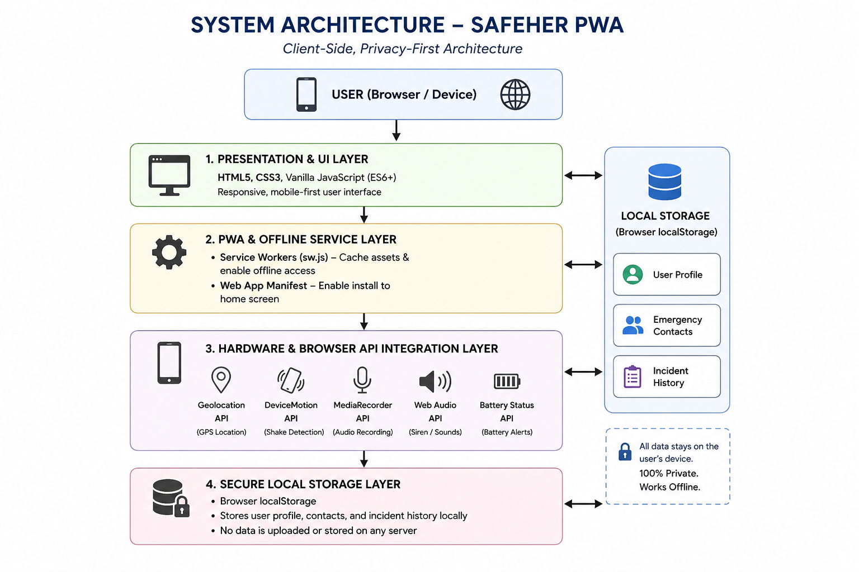
Figure 3.1 Selected System Architecture Diagram

The detailed design consists of a user-side emergency alert mechanism, location tracking module, Internet communication layer, cloud/database services, and administrator monitoring interface. When an emergency is detected, the user can activate the SOS function, after which the system collects the relevant location information and transmits the emergency alert through the Internet. The alert is stored and synchronized with the central system, allowing authorized responders or administrators to monitor the incident and update its status.

The design is structured in modular components so that individual functions can be developed, tested, maintained, and upgraded independently. This approach also allows additional safety features to be incorporated in the future without significantly modifying the complete system architecture.

3.6 Trade-off Analysis
Design Decision | Alternative Considered | Benefit | Disadvantage | Final Decision & Justification
SOS activation method | Manual phone call / SMS | Familiar and widely available | Requires multiple actions and may be difficult during an emergency | One-tap SOS activation selected — minimizes user interaction and enables faster emergency reporting
Location tracking | Cell-tower-based location | Available through mobile networks | Generally less accurate than GPS | GPS-based location tracking selected — provides more precise coordinates for emergency response
Wireless communication | SMS / GSM communication | Can work without Internet-based services | Requires cellular hardware/SIM and may involve additional cost | Internet-based communication selected — supports real-time synchronization and centralized monitoring
Emergency data storage | Local device storage | Simple implementation and no cloud dependency | Cannot easily support remote monitoring or centralized access | Cloud database selected — enables real-time data access, synchronization, and incident history

3.7 Sustainability, Ethics, Safety, Risk & Security
Domain | Consideration | Evidence Evaluated | Impact on Final Decision
Sustainability | Power consumption and electronic waste | Evaluated the power requirements of the ESP32, GPS module, and other electronic components, along with the environmental impact of frequently replacing batteries | Low-power components and a rechargeable power source are preferred to reduce energy consumption and electronic waste
Ethics | User data and privacy | Reviewed the sensitivity of personal information such as user identity, emergency details, and location coordinates | Only essential emergency information is collected and access is restricted to authorized users
Ethics | Location tracking | Considered the privacy risks associated with collecting and storing a user's geographical location | Location information is primarily used for emergency assistance and is not intended for unnecessary continuous tracking
Health & Safety | Electrical safety | Evaluated operating voltage, battery connections, wiring, and protection against accidental short circuits | Proper voltage regulation, insulated connections, and safe component handling are incorporated into the prototype

Table 3.8 Risk Register
Risk | Likelihood | Severity | Risk Level | Mitigation | Residual Risk
Internet/network failure causing SOS delay | Medium | High | High | Provide network-status indication and design the system to retry transmission when connectivity is temporarily unavailable | Medium
GPS location unavailable or inaccurate | Medium | High | High | Use GPS signal validation and obtain updated coordinates before transmitting the emergency alert when possible | Low
False SOS activation | Medium | Medium | Medium | Use controlled SOS activation and provide appropriate confirmation/status feedback | Low
Emergency notification delivery failure | Low | High | Medium | Implement reliable communication mechanisms and verify alert status after transmission | Low
Unauthorized access to emergency data | Low | High | Medium | Apply user authentication, authorization, and restricted database access | Very Low

CHAPTER 4

IMPLEMENTATION, TESTING & RESULTS, PROJECT MANAGEMENT

4.1 Development Approach & Resources
The SAFEHER system was developed using an iterative and modular engineering approach. The major functional modules, including SOS activation, location tracking, emergency notification, cloud data management, alert monitoring, and emergency status management, were developed and tested individually before being integrated into the complete system. Each module was evaluated for functional correctness, communication reliability, and ease of integration. My individual contribution focused primarily on the literature survey, requirement analysis, requirement specification, comparative evaluation of existing women's safety solutions, and identification of functional and non-functional requirements
Resource | Description
ESP32 Development Board | Main embedded controller responsible for processing inputs and providing Internet connectivity
GPS Module | Obtains the geographical coordinates of the user during an emergency
SOS Push Button | Provides quick manual activation of the emergency alert
Buzzer / LED Indicator | Provides local feedback when an SOS alert is activated
Breadboard & Jumper Wires | Used for circuit assembly and hardware prototyping
Rechargeable Battery | Provides portable power to the embedded hardware

4.2 Hardware / Software Implementation & Modern Tools Used
Software implementation The SAFEHER system was developed as a software-based Internet application using modular components for user registration, emergency contact management, SOS alert generation, location sharing, emergency notification, cloud data storage, and administrator monitoring. The implementation was developed collaboratively by the team, with individual responsibilities divided among the members. My contribution focused on understanding the software requirements, reviewing the implemented modules against the specified requirements, supporting requirement validation.
Tool / Software / Equipment | Purpose | Stage Used
HTML | Creating the structure of the web application | Front-end development
CSS | Designing the user interface and page layout | Front-end development
JavaScript | Implementing application logic, SOS functionality, and user interactions | Application development
Firebase Authentication | User registration, login, and authentication | Backend development
Firebase Firestore | Storing user details, emergency contacts, SOS alerts, location information, and incident status | Database development

4.3 Test Plan & Verification
Table 4.2 Test Plan
Requirement | Test Method | Acceptance Criterion
User registration and login | Create valid and invalid user accounts and attempt login with different credentials | Valid users should be authenticated successfully and invalid credentials should be rejected
SOS alert activation | Trigger the SOS function repeatedly under normal operating conditions | SOS alert should be generated successfully with a single intended action
Emergency notification | Activate an SOS alert and check the registered emergency contact/response interface | Emergency notification should be generated and delivered successfully
Location sharing | Trigger an SOS alert and verify the location information displayed in the system | Valid location coordinates should be associated with the emergency alert
Real-time alert monitoring | Generate an SOS alert from the user interface and observe the administrator dashboard | New emergency alerts should appear on the dashboard without requiring manual database refresh

Table 4.3 Specification vs Achieved Values
Specification | Required Value | Achieved Value | Status
SOS activation | Single intended action | To be measured during testing | Pending
Emergency alert generation | Successful generation | To be measured during testing | Pending
Emergency notification | Successful delivery | To be measured during testing | Pending
Location sharing | Valid location information displayed | To be measured during testing | Pending
Real-time dashboard update | Alert appears without manual refresh | To be measured during testing | Pending
Alert status management | Correct status update | To be measured during testing | Pending

4.4 Results
The following figures present the measured performance of the prototype during structured testing.
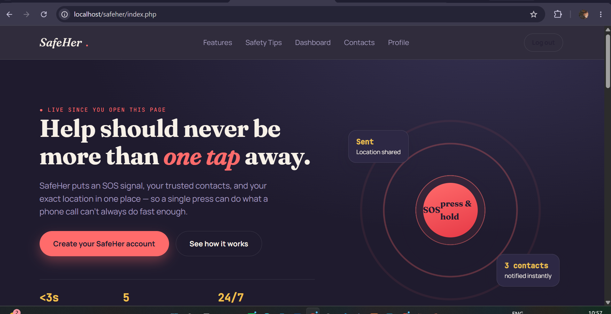
Figure 4.1 Login Page
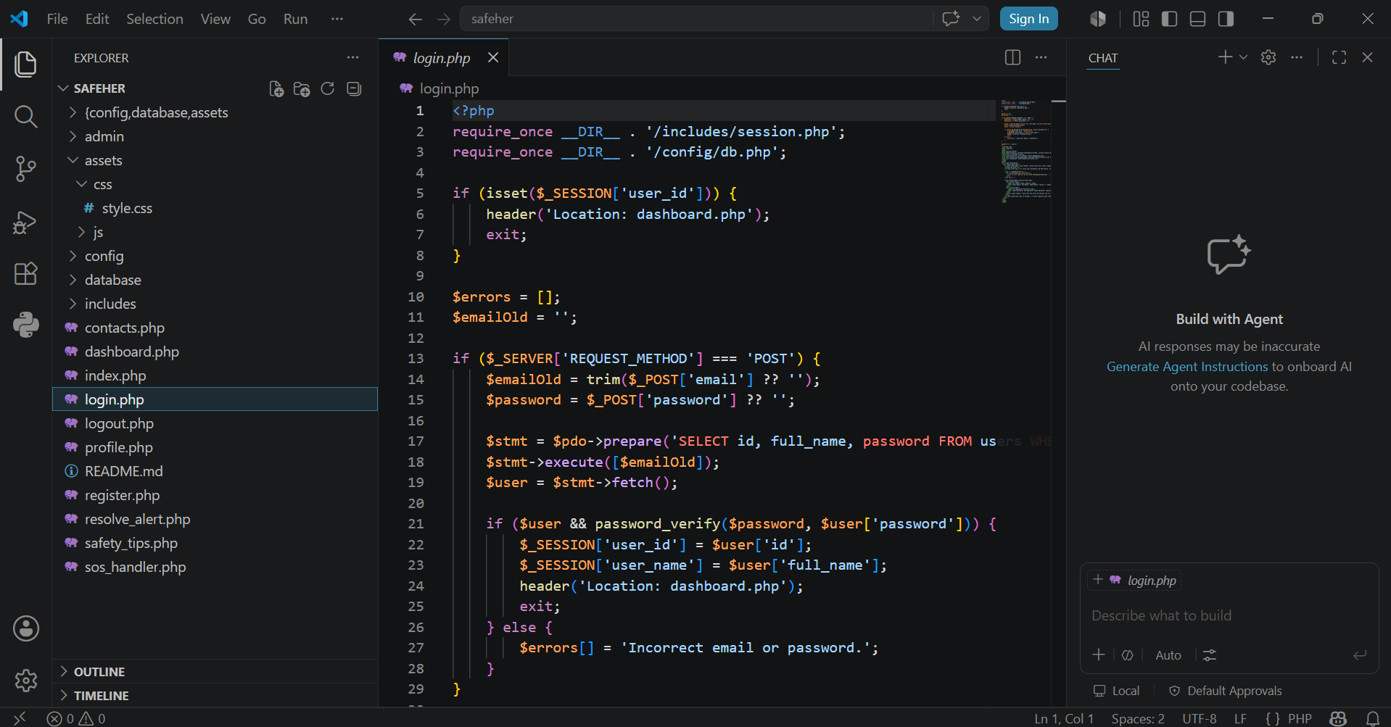
Figure 4.2 Code
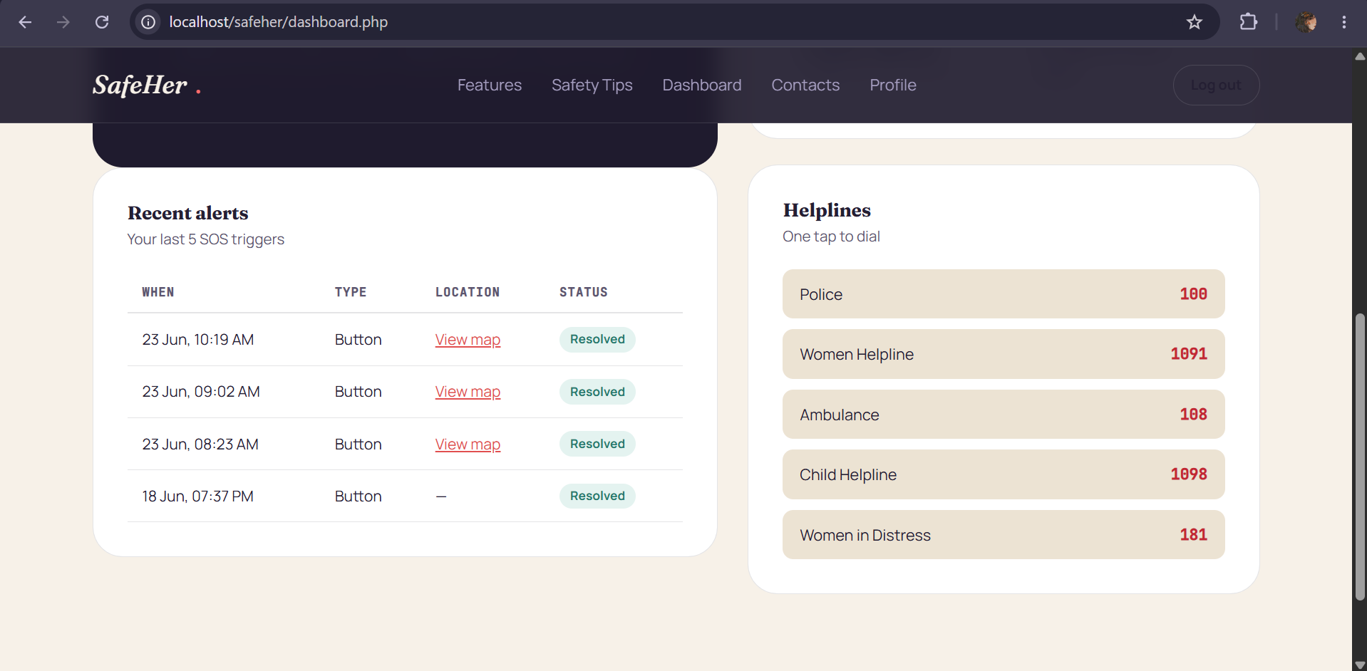
Figure 4.3 Alert System
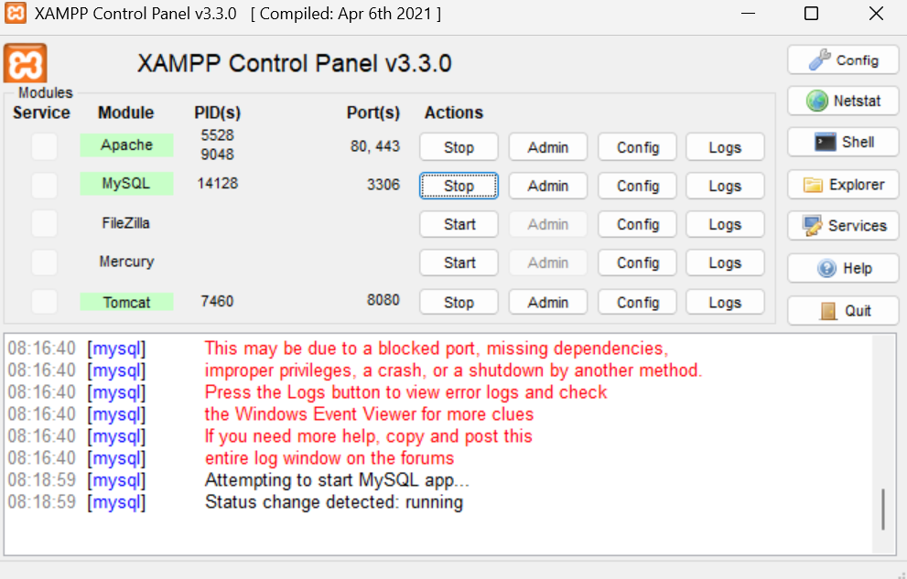
Figure 4.4 Xampp Control Panel

4.5 Data Analysis & Engineering Judgment

The testing of the SAFEHER application focused on the reliability of SOS activation, emergency notification, location sharing, real-time dashboard updates, database operations, authentication, and incident management. During functional testing, the SOS mechanism successfully generated emergency records and transferred the required information to the monitoring system. The location component was verified by checking whether valid location information was associated with each generated emergency alert. The administrator dashboard was tested by generating multiple emergency events and observing whether new alerts were reflected correctly in the monitoring interface. The alert status management function was also verified by updating incidents through their different response stages. Database testing confirmed that user information, emergency contacts, alert details, location information, timestamps, and incident status could be stored and retrieved correctly.

4.6 Comparison with Existing Solutions & Achievement of Objectives
Objective | Evidence | Achievement
Develop an Internet-based women's safety system | Implemented SAFEHER web application and system architecture | Fully Achieved
Provide quick SOS emergency activation | SOS interface and emergency alert generation module | Fully Achieved
Share the user's emergency location | Location-sharing module associated with SOS alerts | Fully Achieved
Notify emergency contacts / response personnel | Emergency notification mechanism | Fully Achieved
Provide real-time emergency monitoring | Administrator monitoring dashboard | Fully Achieved
Maintain emergency incident records | Cloud/database storage of emergency information | Fully Achieved

Parameter | Proposed System | Commercial Air Mouse | Wired Mouse
Emergency activation | One-tap SOS | Manual call/message | Application-based
Location sharing | Integrated with emergency alert | Usually requires manual sharing | Commonly available
Centralized monitoring | Administrator dashboard | Not normally available | Depends on application
Incident status tracking | Supported | Limited | May be available
Incident history | Stored in database | Limited | Usually available

4.7 Strengths & Limitations
Strengths:
•Low development cost compared with many commercial women’s safety and emergency response solutions.
• Software-based and modular architecture, allowing individual components such as SOS activation, location sharing, emergency notifications, and alert monitoring to be developed and improved independently.
• One-tap emergency activation, reducing the number of user interactions required during an emergency situation.
• Centralized emergency monitoring, enabling authorized personnel or administrators to view and manage emergency alerts through a common interface.
• Cloud-based data management, allowing emergency contacts, alert details, location information, timestamps, and incident status to be stored and retrieved systematically.
• Authentication and access control, helping restrict sensitive emergency and location information to authorized users.
Limitations:

• Internet connectivity is required for real-time alert transmission, cloud synchronization, and remote monitoring.

• Location availability and accuracy depend on the user’s device and browser location services, and accurate location information may not always be available indoors or in areas with poor positioning signals.

• Notification delivery may be affected by network conditions or external communication services, which can introduce delays during emergencies.

4.8 Project Planning, Roles & Budget
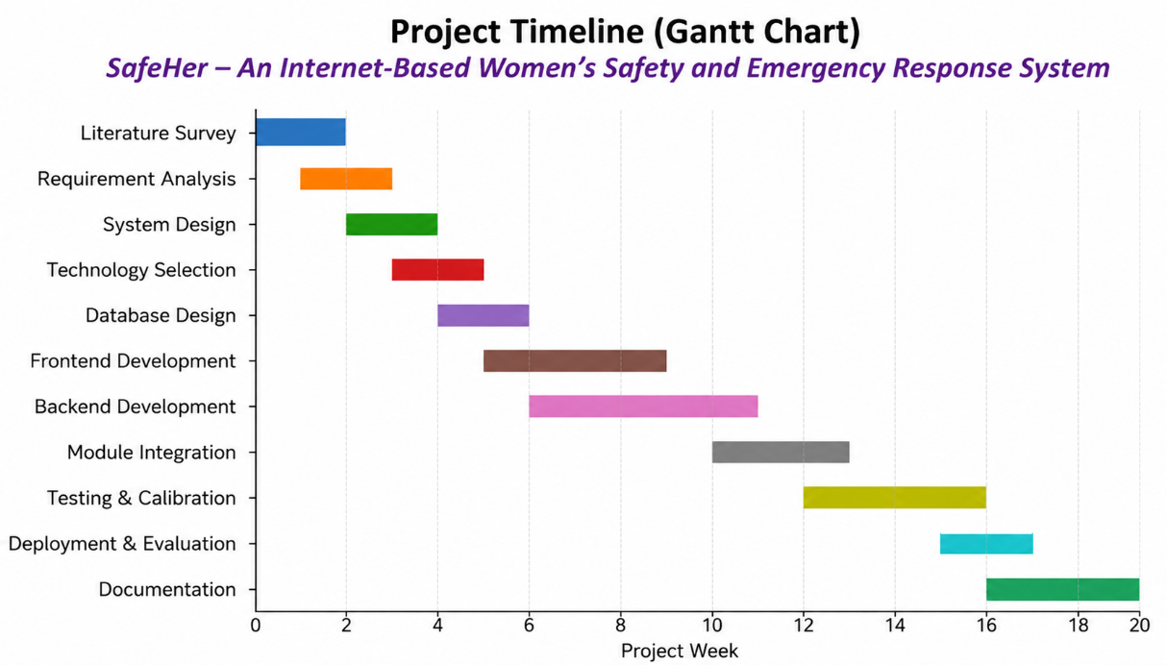
Figure 4.5 Project Timeline (Gantt Chart)
Student | Assigned Responsibility | Actual Contribution
N. Trisha | Literature Survey & Requirement Analysis | Conducted the literature survey, analyzed existing women’s safety and emergency response systems, and prepared the requirement specification for the proposed SAFEHER system.
Sravanthi | System Design & Software Development | Contributed to the system architecture and software design, reviewed the implementation of the SOS, location-sharing, emergency alert, and cloud-based modules, and contributed to report preparation.
Disha | Testing, Validation & Documentation | Prepared and executed software test cases, verified SOS activation, emergency alerts, location sharing, database operations, and system functionality, and contributed to project documentation and validation.

CHAPTER 5

CONCLUSION, FUTURE WORK AND REFLECTION

5.1 Conclusion

The SAFEHER project was developed to provide a simple, accessible, and Internet-based solution for women's safety and emergency response. The system addresses the limitations of conventional emergency communication methods by providing a centralized platform for rapid SOS activation, emergency alert generation, location sharing, emergency contact management, and alert monitoring. The project followed a structured software development process that included literature survey, requirement analysis, alternative evaluation, system design, implementation, testing, and validation. The proposed system uses web technologies and cloud-based services to connect users, emergency contacts, and authorized administrators through a common emergency response platform.

5.2 Future Work
• Integrate additional emergency communication channels such as SMS, automated voice calls, and other notification services.
• Improve location-sharing reliability in situations where browser or device location services are unavailable or inaccurate.
• Develop a dedicated mobile application to provide faster access to emergency features and improved background functionality.
• Introduce configurable SOS activation mechanisms to reduce accidental emergency alerts while maintaining rapid activation.
• Enhance the administrator dashboard with improved real-time visualization, alert prioritization, filtering, and incident analytics.
• Implement stronger security and privacy mechanisms for protecting sensitive user and location information.

5.3 Professional Learning & Individual Reflection
New Knowledge Acquired:
• Understanding of software-based emergency response systems and their application to women's safety.
• Knowledge of web technologies, cloud-based data management, authentication, location services, and real-time emergency alert handling.
• Understanding of requirement specification, alternative evaluation, system design, risk assessment, and software validation as engineering development practices.
Engineering & Professional Skills Developed:
• Developed an understanding of modular software architecture and integration of different application components.
• Gained experience in preparing structured test cases and validating system functions against specified requirements.
• Improved skills in analyzing existing solutions, identifying limitations, and proposing practical software-based improvements.
• Developed teamwork and communication skills through coordination of literature survey, requirements, system design, implementation, testing, and documentation activities.
Individual Reflection (Sravanthi K):
The most important learning experience I gained from this project was understanding how engineering requirements are identified, analyzed, and transformed into measurable software system specifications. My primary contribution to the SAFEHER project involved conducting the literature survey, studying existing women’s safety and emergency response solutions, identifying their limitations, analyzing the engineering gap, and helping define the functional and non-functional requirements of the proposed system. I also contributed to the comparative evaluation of existing solutions and the proposed SAFEHER system based on factors such as accessibility, reliability, response capability, security, and cost.
One of the challenges I encountered was understanding how different software components work together to form a complete emergency response system. By studying technologies such as web development, authentication, cloud-based data storage, location services, emergency notifications, and real-time alert monitoring, I developed a better understanding of how software modules interact and how their individual requirements can affect the overall performance and usability of the system.
A key engineering skill I developed was the ability to evaluate alternative solutions using measurable criteria such as performance, reliability, accessibility, security, scalability, and cost. This helped me understand that engineering decisions should not be based only on technical capabilities but should also consider user requirements, practical constraints, safety, privacy, and ease of implementation.
Through this project, I also improved my technical documentation, literature-review, analytical, requirement-analysis, and teamwork skills. Working with other team members helped me understand how individual contributions support the development of an integrated software system. If I were to further improve SAFEHER, I would recommend enhancing notification reliability, improving location-sharing functionality, strengthening security and privacy mechanisms, and integrating additional emergency communication channels such as SMS and automated calls.

REFERENCES
[1] World Wide Web Consortium (W3C), Geolocation API Specification, W3C Recommendation, 2024.
[2] World Wide Web Consortium (W3C), Web Authentication: An API for Accessing Public Key Credentials, W3C Recommendation, 2025.
[3] Google, Google Maps Platform Documentation: Maps JavaScript API, Google Developers, 2025.
[4] Google, Firebase Authentication Documentation, Firebase Documentation, 2025.
[5] Google, Cloud Firestore Documentation: Data Modeling, Security Rules and Queries, Firebase Documentation, 2025.
[6] OWASP Foundation, OWASP Application Security Verification Standard (ASVS), Version 5.0, 2025.
[7] OWASP Foundation, OWASP Top 10: The Ten Most Critical Web Application Security Risks, 2021, updated guidance accessed 2025.
[8] European Union Agency for Cybersecurity (ENISA), Cybersecurity for Mobile Applications: Good Practices for Secure Development, ENISA, 2024.
[9] National Institute of Standards and Technology (NIST), Digital Identity Guidelines: Authentication and Lifecycle Management, NIST Special Publication 800-63B, updated 2025.
[10] National Institute of Standards and Technology (NIST), Cybersecurity Framework (CSF) 2.0, NIST, 2024.
[11] IEEE Access, IoT and Mobile-Based Emergency Response Systems for Personal Safety: A Review and Analysis, IEEE, 2024.
[12] MDPI Sensors, Location-Based Emergency and Personal Safety Applications Using Mobile and Cloud Technologies, MDPI Sensors, 2024.
[13] Elsevier, Real-Time Location-Based Emergency Management and Intelligent Alert Systems, Computers & Security, 2024.
[14] Springer Nature, Cloud-Based Emergency Response and Location-Sharing Systems for Personal Safety, Springer, 2024.
[15] IEEE Access, Smartphone-Based Personal Safety and Emergency Alert Systems: Architecture, Challenges and Future Directions, IEEE, 2025.
[16] MDPI Electronics, Cloud-Enabled Real-Time Emergency Notification and Monitoring Systems, MDPI Electronics, 2025.
[17] International Telecommunication Union (ITU), Global Cybersecurity and Digital Safety Guidelines, ITU, 2024.
[18] ISO/IEC 27001, Information Security, Cybersecurity and Privacy Protection — Information Security Management Systems — Requirements, ISO/IEC, 2022, current guidance accessed 2025.
[19] ISO/IEC 25010, Systems and Software Engineering — Systems and Software Quality Requirements and Evaluation (SQuaRE) — Product Quality Model, ISO/IEC, 2023.
[20] Google Developers, Web APIs and Progressive Web Application Development Documentation, Google Developers, 2025.

APPENDICES

Appendix A – Detailed Calculations
The overall emergency response time can be evaluated by measuring the time between the user's SOS activation and the appearance of the emergency alert in the authorized monitoring interface.
Response Time = Alert Display Time − SOS Activation Time
For example, if the SOS button is activated at 10:15:20 and the emergency alert appears on the monitoring dashboard at 10:15:24:
Response Time = 10:15:24 − 10:15:20 = 4 seconds

Appendix B – Engineering Drawings / Schematics.
The SAFEHER system is a software-based Internet emergency response platform. The system consists of the following major components:
- User Interface – Provides registration, login, emergency contact management, and SOS activation.
- Authentication Module – Verifies user identity and controls access to protected functions.
- SOS Management Module – Generates an emergency alert when the user activates the SOS function.
- Location Module – Obtains available device/browser location information and associates it with the emergency alert.

Appendix C – Source Code / Code Repository Information
The complete SAFEHER source code is maintained in the team's project repository. The implementation consists of front-end, authentication, database, location, emergency alert, and monitoring components..

<?php

require_once __DIR__ . '/../includes/session.php';

require_once __DIR__ . '/../config/db.php';

if (isset($_SESSION['admin_id'])) {

header('Location: dashboard.php');

exit;

}

$errors = [];

if ($_SERVER['REQUEST_METHOD'] === 'POST') {

$username = trim($_POST['username'] ?? '');

$password = $_POST['password'] ?? '';

$stmt = $pdo->prepare('SELECT id, username, password FROM admins WHERE username = ?');

$stmt->execute([$username]);

$admin = $stmt->fetch();

if ($admin && password_verify($password, $admin['password'])) {

$_SESSION['admin_id'] = $admin['id'];

$_SESSION['admin_username'] = $admin['username'];

header('Location: dashboard.php');

exit;

} else {

$errors[] = 'Incorrect username or password.';

}

}

?>

<!DOCTYPE html>

<html lang="en">

<head>

<meta charset="UTF-8">

<meta name="viewport" content="width=device-width, initial-scale=1.0">

<title>Admin Login · SafeHer</title>

<link rel="preconnect" href="https://fonts.googleapis.com">

<link href="https://fonts.googleapis.com/css2?family=Fraunces:ital,opsz,wght@0,9..144,400;0,9..144,700;1,9..144,500&family=Manrope:wght@400;500;700;800&family=JetBrains+Mono:wght@400;500&display=swap" rel="stylesheet">

<link rel="stylesheet" href="../assets/css/style.css">

</head>

<body>

<div class="auth-wrap">

<div class="auth-card">

<span class="brand" style="color:var(--ink); margin-bottom:18px; display:inline-block;">SafeHer<span class="dot">.</span> Admin</span>

<h1>Admin login</h1>

<p class="sub">Monitoring dashboard access only — not for app users.</p>

<?php if (!empty($errors)): ?>

<div class="alert-box alert-error"><?php foreach ($errors as $e) echo htmlspecialchars($e) . '<br>'; ?></div>

<?php endif; ?>

<form method="POST" action="login.php">

<div class="field">

<label for="username">Username</label>

<input type="text" id="username" name="username" required>

</div>

<div class="field">

<label for="password">Password</label>

<input type="password" id="password" name="password" required>

</div>

<button type="submit" class="btn btn-coral btn-block">Log in</button>

</form>

<p class="auth-foot"><a href="../index.php">← Back to SafeHer</a></p>

</div>

</div>

</body>

</html>

Appendix D – Datasheets
Table D.1 Web Development Technologies
Parameter | Value
Front-End Structure | HTML5
Styling | CSS3
Programming Language | JavaScript
Authentication | Firebase Authentication

Table D.2 SAFEHER Functional Modules
Parameter | Value
User Registration & Login | Creates and authenticates user accounts
Emergency Contacts | Stores and manages emergency contact information
SOS Module | Generates an emergency alert
Location Module | Obtains and associates available location information

Appendix E – Experimental / Raw Data
TC ID | Test Description | Expected Result | Observed Result | Status
TC-01 | User registration with valid details | Account should be created successfully | Enter actual observation | Pass
TC-02 | Login using valid credentials | User should be authenticated | Enter actual observation | Pass
TC-03 | Login using invalid credentials | Access should be rejected | Enter actual observation | Pass
TC-04 | Activate SOS | Emergency alert should be generated | Enter actual observation | Pass
TC-05 | Emergency location sharing | Available location should be associated with the alert | Enter actual observation | Pass
TC-06 | Emergency alert monitoring | Alert should appear on authorized dashboard | Enter actual observation | Pass

Appendix F – Ethics / Institutional Approval

The SAFEHER project is a software prototype developed for academic purposes. No formal human-subject research study was conducted as part of the project.

Appendix G – Project Meeting / Progress Records
Week | Meeting Focus | Key Outcome
2 | Literature survey | Reviewed existing women's safety and emergency response systems and identified the research gap
4 | Requirement analysis | Identified functional and non-functional requirements of SAFEHER
6 | System design | Finalized major software modules and system architecture
8 | Software implementation review | Reviewed implementation of SOS, authentication, database, location, and monitoring modules
10 | Module integration | Integrated the major application components and checked data flow
12 | Testing review | Executed test cases and identified areas requiring correction and improvement
14 | Final evaluation | Reviewed system objectives, limitations, future improvements, and

Appendix H – User/Industry Feedback

No formal external industry evaluation was conducted during the prototype-stage development of SAFEHER.

Appendix I – Product Outcomes

At the time of report submission, the SAFEHER project had not resulted in any formal publication, patent, commercial product, or external competition entry. The project was developed as an academic software prototype demonstrating the use of Internet-based technologies, cloud services, location services, authentication, and emergency alert management to support women's safety and emergency response.

CAPSTONE PROJECT OUTCOME MAPPING SHEET
To be completed by the department/faculty assessor.
Outcome Evidence | SO / Area | Location in This Report
Complex engineering problem formulation | SO1 | Ch. 1, Ch. 2
Engineering design under constraints | SO2 | Ch. 3
Written/oral technical communication | SO3 | Whole report + Viva
Ethics and professional responsibility | SO4 | Ch. 3 (3.7)
Teamwork and leadership | SO5 | Ch. 4 (4.8)
Experimentation, analysis, engineering judgment | SO6 | Ch. 4 (4.3–4.6)
Independent acquisition of new knowledge | SO7 | Ch. 5 (5.3)
Standards | SO2 | Ch. 3 (3.2)
Sustainability and societal/environmental impact | SO2/SO4 | Ch. 3 (3.7)
Risk assessment and mitigation | SO2/SO4 | Ch. 3 (3.7)
Security considerations | Relevant SO | Ch. 3 (3.7)
Integrated/system-level engineering | SO1/SO2 | Ch. 3 (3.5)
Project planning and management | SO5 | Ch. 4 (4.8)
Individual contribution | SO1–SO7 | Contribution Statement + Ch. 4 (4.8)

