SIMATS ENGINEERING
CO5 ASSESSMENT TOOL 1

NAME: DISHA P
REG NO: 192411086
COURSE NAME: INTERNET PROGRAMMING
COURSE CODE: CSA43
1.A hospital management system requires a SOAP-based web service to manage patient information such as registration, appointment scheduling, and medical records. The system must ensure secure, structured, and interoperable communication between different hospital departments.
Design a SOAP-based web service for the hospital system. Explain the structure of SOAP messages (Envelope, Header, Body), define the operations involved (e.g., add patient, get records), and illustrate how data is exchanged between client and server. Justify the use of SOAP in this scenario considering reliability and security.
1. SOAP-Based Web Service for Hospital Management System
A SOAP (Simple Object Access Protocol) based web service can be designed to allow different hospital departments such as Registration, Outpatient, Laboratory, Pharmacy, and Medical Records to securely exchange patient information. SOAP is suitable because it provides a standardized XML-based communication mechanism with support for security, reliability, and interoperability.
1. System Architecture
The hospital management system can follow a client-server architecture:
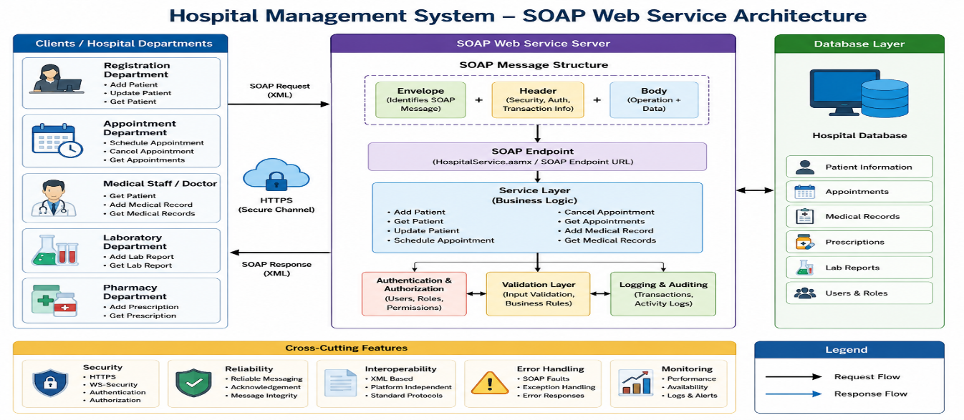
Each department acts as a SOAP client and communicates with the hospital SOAP server using XML messages, normally over HTTPS.
2. Main Operations
The web service can provide the following operations:
Operation | Description
addPatient() | Registers a new patient
getPatient() | Retrieves patient details
updatePatient() | Updates patient information
scheduleAppointment() | Schedules an appointment
cancelAppointment() | Cancels an appointment
getAppointments() | Retrieves appointment details
addMedicalRecord() | Adds a medical record
getMedicalRecords() | Retrieves a patient's medical records
For example, the addPatient() operation can accept:
Patient ID
Patient Name
Age
Gender
Address
Phone Number
Blood Group
The server validates the information and stores it in the hospital database.
3. Structure of a SOAP Message
A SOAP message consists mainly of three important parts:
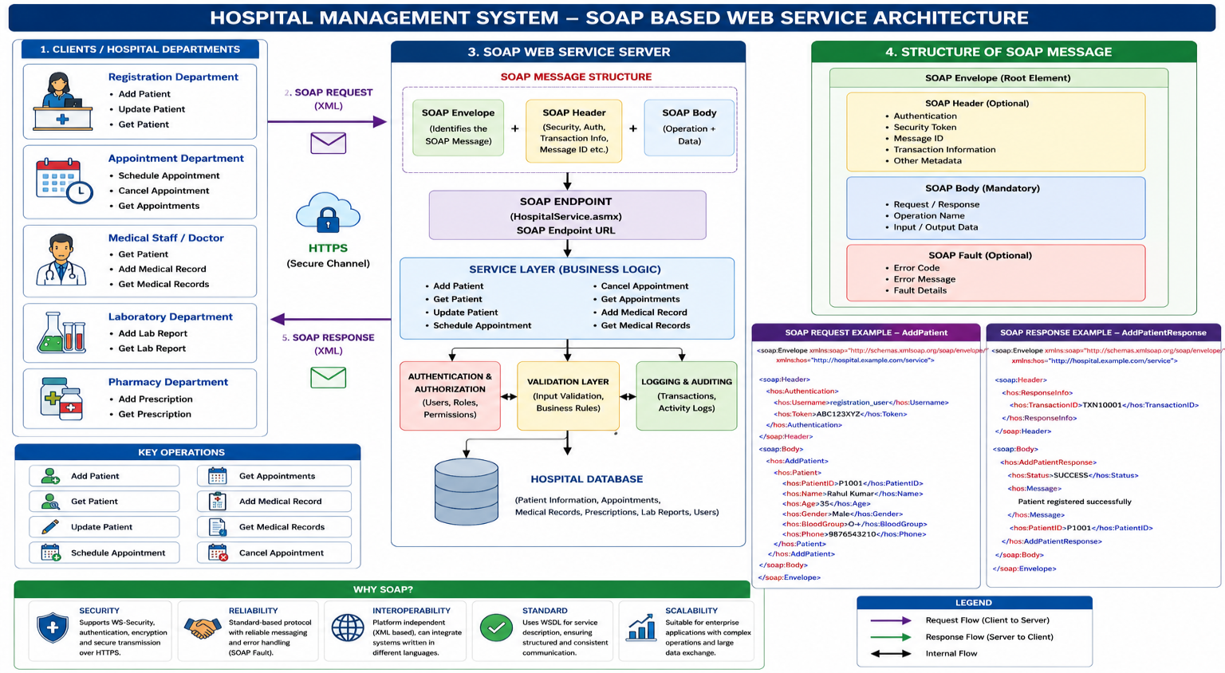
SOAP Message
The Envelope is the root element of every SOAP message. It identifies the XML document as a SOAP message.
B. SOAP Header
The Header contains optional information such as:
- Authentication details
- Authorization information
- Security tokens
- Transaction information
- Message identification
- Reliability information
For a hospital system, authentication information can be placed in the header.
C. SOAP Body
The Body contains the actual request or response. For example, it can contain patient registration information or medical records.
D. SOAP Fault
If an error occurs, the SOAP server can return a Fault message containing information about the error.
4. SOAP Request – Add Patient
Suppose the registration department wants to add a new patient.
The client sends a SOAP request such as:
<?xml version="1.0" encoding="UTF-8"?>
<soap:Envelope
xmlns:soap="http://schemas.xmlsoap.org/soap/envelope/"
xmlns:h="http://hospital.example.com/service">

<soap:Header>
<h:Authentication>
<h:Username>registration_user</h:Username>
<h:Token>ABC123XYZ</h:Token>
</h:Authentication>
</soap:Header>

<soap:Body>
<h:AddPatient>
<h:Patient>
<h:PatientID>P1001</h:PatientID>
<h:Name>Rahul Kumar</h:Name>
<h:Age>35</h:Age>
<h:Gender>Male</h:Gender>
<h:BloodGroup>O+</h:BloodGroup>
<h:Phone>9876543210</h:Phone>
</h:Patient>
</h:AddPatient>
</soap:Body>

</soap:Envelope>
5. SOAP Response
After receiving the request, the SOAP server authenticates the user, validates the data, stores it in the database, and returns a response.
<?xml version="1.0" encoding="UTF-8"?>
<soap:Envelope
xmlns:soap="http://schemas.xmlsoap.org/soap/envelope/"
xmlns:h="http://hospital.example.com/service">
<soap:Header>
<h:ResponseInfo>
<h:TransactionID>TXN10001</h:TransactionID>
</h:ResponseInfo>
</soap:Header>

<soap:Body>
<h:AddPatientResponse>
<h:Status>SUCCESS</h:Status>
<h:Message>Patient registered successfully</h:Message>
<h:PatientID>P1001</h:PatientID>
</h:AddPatientResponse>
</soap:Body>
</soap:Envelope>
The client receives confirmation that the patient has been successfully registered.
6. Get Medical Records Operation
A doctor or authorized department may request a patient's medical records.
Request
<soap:Envelope
xmlns:soap="http://schemas.xmlsoap.org/soap/envelope/"
xmlns:h="http://hospital.example.com/service">
<soap:Header>
<h:Authentication>
<h:Username>doctor01</h:Username>
<h:Token>SECURETOKEN123</h:Token>
</h:Authentication>
</soap:Header>
<soap:Body>
<h:GetMedicalRecords>
<h:PatientID>P1001</h:PatientID>
</h:GetMedicalRecords>
</soap:Body>

</soap:Envelope>
Response
<soap:Envelope
xmlns:soap="http://schemas.xmlsoap.org/soap/envelope/"
xmlns:h="http://hospital.example.com/service">
<soap:Body>
<h:GetMedicalRecordsResponse>
<h:PatientID>P1001</h:PatientID>
<h:MedicalRecord>
<h:VisitDate>2026-08-20</h:VisitDate>
<h:Doctor>Dr. Kumar</h:Doctor>
<h:Diagnosis>Fever</h:Diagnosis>
<h:Prescription>Medication prescribed</h:Prescription>
</h:MedicalRecord>
</h:GetMedicalRecordsResponse>
</soap:Body>
</soap:Envelope>
Only an authenticated and authorized user should be allowed to retrieve such information.
7. WSDL Definition
A SOAP service can publish a WSDL (Web Services Description Language) document. WSDL describes how clients can communicate with the service.
A simplified WSDL structure could contain:
<definitions>
<service name="HospitalService">
<portType name="HospitalPortType">
<operation name="AddPatient">
...
</operation>
<operation name="GetPatient">
...
</operation>
<operation name="ScheduleAppointment">
...
</operation>
<operation name="GetMedicalRecords">
...
</operation>
</portType>
</service>
</definitions>
The WSDL specifies:
- Available operations
- Input parameters
- Output parameters
- Message formats
- Service endpoint
- Communication protocol
Therefore, different hospital departments can develop clients in different programming languages while still communicating with the same service.
8. Security
Security is extremely important because the system handles confidential medical information.
a) HTTPS
SOAP messages should be transmitted using HTTPS to encrypt communication between the client and server.
SOAP Client
│
│ Encrypted HTTPS
▼
SOAP Server
This prevents unauthorized parties from easily reading the data during transmission.
b) Authentication
The SOAP Header can contain authentication information such as a security token or credentials.
<soap:Header>
<Authentication>
<Username>doctor01</Username>
<Token>SECURETOKEN123</Token>
</Authentication>
</soap:Header>
c) Authorization
Authentication alone is not sufficient. The server should determine what each user is allowed to access.
For example:
Doctor → Patient records
Nurse → Limited patient information
Receptionist → Registration and appointments
Administrator → Authorized administrative information
d) WS-Security
SOAP supports WS-Security, which can provide message-level security features such as authentication, integrity, and encryption.
This is useful when sensitive medical information must be protected even beyond transport-level HTTPS.
9. Reliability
SOAP is suitable for hospital systems because reliability is important when exchanging critical information.
For example, an appointment request should not be accidentally lost or processed incorrectly.
SOAP-based web services can work with standards such as WS-ReliableMessaging to support reliable message delivery, acknowledgements, ordering, and handling of communication failures.
A reliable communication flow can be:
Client
│
│ SOAP Request
▼
Server
│
│ Process request
▼
Database
│
│ Success
▼
Server
│
│ SOAP Response
▼
Client
If an error occurs, the server can return a SOAP Fault:
<soap:Fault>
<faultcode>soap:Server</faultcode>
<faultstring>
Patient record could not be retrieved
</faultstring>
</soap:Fault>

10. Interoperability
SOAP uses XML, which is platform-independent.
For example:
Java Registration System
│
│ SOAP/XML
▼
Hospital Server
▲
│ SOAP/XML
│
.NET Medical Records System
Even if different departments use different technologies such as Java, C#, Python, or PHP, they can communicate through the same SOAP interface.

11. Advantages of SOAP for Hospital Management
- High interoperability – Different hospital applications and departments can communicate regardless of programming language or operating system.
- Strong security support – HTTPS and WS-Security can protect sensitive patient information.
- Reliable communication – SOAP can be combined with reliable messaging standards for important transactions.
- Structured communication – XML provides a well-defined structure for requests and responses.
- Standardized interface – WSDL clearly defines available services and their input/output formats.
- Error handling – SOAP Fault provides a standardized mechanism for reporting errors.
- Transaction support – SOAP-based enterprise standards can support complex business transactions.
12. Conclusion
A SOAP-based Hospital Management Web Service provides a structured and standardized method for sharing patient registration, appointment, and medical-record information between hospital departments. The SOAP Envelope provides the overall message structure, the Header carries security and other control information, and the Body contains the actual operation and patient data.
Using HTTPS, authentication, authorization, WS-Security, WSDL, and reliable messaging, the system can provide secure and dependable communication. Therefore, SOAP is particularly appropriate for a hospital environment where data security, reliability, interoperability, and standardized communication are more important than simply minimizing message size.
2.An enterprise application needs to expose its web services so that external systems can understand how to interact with them. The organization plans to use WSDL (Web Services Description Language) to describe the service.
Design the WSDL structure for a web service that provides operations such as retrieving and updating data. Explain the key components of WSDL (types, message, portType, binding, service), and illustrate how they define the service interface and communication details. Provide a clear structure and justify its importance in service integration.
WSDL Structure for a Web Service – 10 Marks
WSDL (Web Services Description Language) is an XML-based language used to describe a web service, its operations, input/output data, communication protocol, and service location. It helps external systems understand and consume the service.
1. Basic WSDL Structure
WSDL Document
│
├── Types → Defines data types
├── Message → Defines input/output messages
├── PortType → Defines operations
├── Binding → Defines communication protocol
└── Service → Defines service endpoint/location
2. Example WSDL
Consider a service with two operations: GetData and UpdateData.
<definitions name="DataService"
targetNamespace="http://example.com/data">

<types>
<xsd:schema>
<xsd:element name="GetDataRequest">
<xsd:complexType>
<xsd:sequence>
<xsd:element name="id" type="xsd:int"/>
</xsd:sequence>
</xsd:complexType>
</xsd:element>
</xsd:schema>
</types>

<message name="GetDataRequest">
<part name="parameters" element="tns:GetDataRequest"/>
</message>

<message name="GetDataResponse">
<part name="result" type="xsd:string"/>
</message>

<portType name="DataPortType">
<operation name="GetData">
<input message="tns:GetDataRequest"/>
<output message="tns:GetDataResponse"/>
</operation>

<operation name="UpdateData">
<input message="tns:UpdateDataRequest"/>
<output message="tns:UpdateDataResponse"/>
</operation>
</portType>

<binding name="DataBinding" type="tns:DataPortType">
<soap:binding transport="http://schemas.xmlsoap.org/soap/http"/>
</binding>

<service name="DataService">
<port name="DataPort"
binding="tns:DataBinding">
<soap:address location="https://example.com/DataService"/>
</port>
</service>

</definitions>
3. Key Components
Component | Purpose
Types | Defines data types and structure using XML Schema (XSD).
Message | Defines the data exchanged between client and server.
PortType | Defines the available operations and their input/output messages.
Binding | Specifies how the service communicates, such as SOAP over HTTP.
Service | Specifies the actual endpoint URL where the service is available.
4. How It Works
External Client
│
│ Reads WSDL
▼
┌─────────────────┐
│ PortType │ → What operations are available?
│ Message │ → What data is exchanged?
│ Binding │ → How is communication done?
│ Service │ → Where is the service located?
└────────┬────────┘
▼
Web Service Server
5. Importance of WSDL
- Provides a standard description of web services.
- Enables different applications and platforms to communicate.
- Clearly defines operations, input, and output.
- Supports automatic client/proxy generation.
- Separates the service interface from implementation.
- Simplifies integration of external systems.
Conclusion: WSDL acts as a contract between the service provider and service consumer, clearly describing what the service does, how to communicate with it, and where to access it. This makes enterprise service integration easier, standardized, and interoperable.
3. A company is experiencing issues in its SOAP-based communication system where requests are not processed correctly, and responses are either delayed or incorrect.
Analyze the SOAP communication process and identify possible issues such as message formatting errors, incorrect namespaces, or endpoint problems. Propose a debugging approach to resolve these issues, including validation of SOAP messages and error handling techniques. Explain how the corrected system ensures reliable communication.

SOAP Communication Debugging – 10 Marks
SOAP communication works through a client-server request and response process. If requests are not processed correctly or responses are delayed/incorrect, the SOAP message, namespace, endpoint, or server configuration may be the cause.
1. SOAP Communication Process
SOAP Client
│
│ SOAP Request (XML)
▼
Endpoint / Web Service
│
├── Validate XML
├── Check Namespace
├── Authenticate
├── Process Request
▼
SOAP Server
│
│ SOAP Response / Fault
▼
SOAP Client
2. Possible Problems
Problem | Effect
Message formatting error | Invalid XML or missing elements causes request failure
Incorrect namespace | Server cannot recognize the requested operation
Wrong endpoint URL | Request does not reach the correct service
Incorrect SOAPAction | Server may not identify the operation
Invalid data types | Request fails during validation
Authentication failure | Server rejects the request
Network/server delay | Response is slow or unavailable
Incorrect response mapping | Client receives unexpected data
3. Debugging Approach
Step 1 – Check Endpoint
Verify that the SOAP request is being sent to the correct service URL.
Client → Correct SOAP Endpoint → Server
Step 2 – Validate SOAP XML
Check that the message contains the correct:
- Envelope
- Header
- Body
- Opening and closing tags
- Required elements
Example:
<soap:Envelope>
<soap:Header>
...
</soap:Header>
<soap:Body>
...
</soap:Body>
</soap:Envelope>
Step 3 – Check Namespaces
Ensure that the namespace in the request matches the namespace expected by the WSDL.
<soap:Envelope
xmlns:soap="http://schemas.xmlsoap.org/soap/envelope/"
xmlns:tns="http://example.com/service">
An incorrect namespace can cause an operation not found error.
Step 4 – Verify WSDL
Compare the request with the WSDL to verify:
- Operation name
- Input/output messages
- Data types
- Endpoint
- Binding
Step 5 – Check SOAP Headers
Verify authentication tokens, SOAPAction, security information, and other required headers.
4. Error Handling
SOAP provides a standard SOAP Fault mechanism.
<soap:Fault>
<faultcode>soap:Server</faultcode>
<faultstring>
Invalid patient ID
</faultstring>
</soap:Fault>
The client should log the fault and handle errors appropriately instead of treating the response as a successful transaction.
5. Testing and Monitoring
Tools such as SoapUI or similar API testing tools can be used to send requests and inspect responses. Server logs should also be checked for:
- Request timestamps
- Error messages
- Authentication failures
- Processing time
- Database errors
6. Ensuring Reliable Communication
After correction:
Client
↓
Validate SOAP Request
↓
Correct Endpoint
↓
Correct Namespace & Operation
↓
Server Processing
↓
SOAP Response / Fault
↓
Client
Conclusion: SOAP communication problems can be resolved by systematically checking the XML structure, namespaces, WSDL, endpoint, headers, network connection, and server logs. Proper SOAP Fault handling, validation, logging, and testing ensure that requests are processed correctly and reliable responses are returned.

