SGMAP / DINSIC
Create accessible workbooks with LibreOffice Calc 5.2
RGAA Resources
Original document: February 2016
Translation: July 2017
- Table of Contents
1.Introduction 4
1.Foreword 4
2.The RGAA and office documents 4
3.Who is this guide for? 4
4.Technical devices used to access content 4
5.About this translation 5
6.Conventions 5
2.How to structure an Calc sheet 6
1.Applicable RGAA Criteria 6
2.Introduction 6
3.Inserting a data table 6
4.Cells organization 6
5.Floating objects 6
3.Using an appropriate presentation 9
1.Applicable RGAA Criteria 9
2.Introduction 9
3.Colors 9
4.Fonts 10
5.Cell Format 10
6.Data format 12
7.Templates 13
4.Language 16
1.Applicable RGAA Criteria 16
2.Introduction 16
3.Language of the workbook 16
4.Language of cell contents 17
5.Comprehensive language 18
5.Giving an alternative to non-textual elements 19
1.Applicable RGAA criteria 19
2.Introduction 22
3.Images 22
4.Images of text 23
5.Charts 23
6.Multimedia files 26
6.Creating navigation aids 27
1.Applicable RGAA criteria 27
2.Introduction 27
3.Sheets names 29
4.Description of the workbook contents 29
5.Naming elements 29
6.Internal links 31
7.External Links 33
7.Creating accessible forms 34
1.Applicable RGAA criteria 34
2.Introduction 34
3.Creating a simple form 35
4.Activating forms design mode 39
5.Adding input areas with controls 40
6.Inserting buttons 42
8.Providing additional information 43
1.Document properties 43
9.Publishing the workbook in other formats 44
1.Introduction 44
2.Publishing in HTML 44
1.Checking the accessibility of the HTML document 44
3.Export to PDF 44
1.Checking the accessibility of a PDF document 46
10.Sources 47
11.License 48

Introduction

Foreword
French law n° 2005-102, of 11 February 2005, for equality of rights and opportunities, participation and citizenship of people with disabilities, makes accessibility a requirement for all public online communication services, for the State, local and regional authorities and the public institutions that depend on them.
The RGAA (General Accessibility Framework for Administrations) aims to promote accessibility of the contents available in digital form. In 2014, the RGAA was redesigned to be up-to-date and more operational. The French administrations currently ought to refer to the RGAA 3.
To meet the needs of diverse groups and contexts, three levels of compliance have been defined: A (lowest), AA and AAA. The level legally expected is level double-A (AA). Success criteria associated with the AAA level may be taken into account in certain contexts where possible and relevant.

The RGAA and office documents
The RGAA applies to any document or application available online: websites, Intranet and web applications, but also the contents downloadable as separate files.
In the Consultation category of the RGAA, criterion 13.7 (Level A) states that "each office document that can be downloaded [must] have an accessible version if necessary". Compliance with this criterion can be achieved in particular by providing an accessible HTML version or by making the document accessible in the format proposed for download.
This companion guide presents the considerations and principles for creating an accessible Calc workbook with LibreOffice 5.2, along with non-normative guidance and procedures for implementing them. Each chapter is divided into topics and incorporates a reference to the corresponding RGAA criteria.
Spreadsheet applications have become very powerful tools, with many features, ranging from very simple to very complex. With Calc 5.2 it is possible to execute a wide range of tasks (data collection, calculation, reporting, dashboards creation, data sharing, etc.) that can be as many barriers for people with disabilities. This guide deliberately refers only to general principles to make accessible workbooks.

Who is this guide for?
These guides are intended for all professionals in government departments, local authorities, agencies, public institutions, public enterprises or anyone wishing to:
- Produce accessible office documents;
- Improve the accessibility of existing office documents;
- Test the level of accessibility of office documents already created.

Technical devices used to access content
A document is accessible if it can be accessed by any user, regardless of the computer tool being used. More and more users are using assistive technologies to overcome barriers to accessing office workbooks or web content. These technical solutions include
- Software assistive technologies (screen readers, voice recognition / dictation software, etc.);
- Hardware assistive technologies (adapted mice, trackballs, Braille displays, etc.).
Content and applications must be compatible with these various assistive technologies, their functionalities and uses.

About this translation
The original document, in French, refers to the LibreOffice suite in its 4.3 version. At the time of translation, the current, more easily available version is 5.2. This translation takes this fact into account and is based on the features of version 5.2 where applicable. Consequently, there may be slight variations from the original material.

Conventions
This document indicates keyboard shortcuts for commands used in the LibreOffice suite. In the Windows operating systems family, the CTRL (Control) key is used as a modifier for many shortcuts. In the MacOS system, the equivalent modifier key is CMD (Command, represented by the ⌘ symbol). In the rest of this document, for clarity, only the Windows shortcut (with CTRL) will be mentioned. Mac users are invited to replace it with CMD.
Texts in bold generally refer to commands and menus available in the user interface. Indications like “File > Save” must be understood as “Open the File menu, and then select the Save item in this menu”.
Mentions like “Right-click on...” actually refer to opening a contextual menu, associated with an item. On most systems, this is usually done by clicking on the item with the right button of a mouse or a trackpad. Another method, on Windows, consists in pressing the “Menu” key on the keyboard. On MacOS based systems, pressing the CTRL key and the left button simultaneously has the same effect. Unfortunately, there is no easy way to activate a contextual menu through a keyboard on a Mac.

How to structure an Calc sheet

Applicable RGAA Criteria

Category | Criteria
Information Structure | Criterion 9.1 [A] On each Web page, is information structured by the appropriate use of headings?  Criterion 9.2 [A] On each Web page, is the document outline coherent?
Navigation | Criterion 12.13 [A] On each Web page, is tabbing order consistent?

Introduction
Although workbooks are relatively accessible to users of assistive technologies, they are nevertheless a complex environment, because the organization of information and their relationships can’t be perceived quickly and globally. It is necessary to ensure that the sheets contents are appropriately identified, with headers and significant names, and that the structure makes sense.

Inserting a data table
It is not possible, with LibreOffice Calc 5.2, to insert a data table. However it is possible to set names (labels) for row or column header cells (see Naming elements).

Cells organization
As a general rule, complex spreadsheets cause more accessibility issues. For a better experience for all, whenever possible:
- Favor a simple structure (for example: headers on only one row);
- Avoid merging or splitting cells;
- Remove empty cells, generally interpreted as the end of the sheet, or missing input (if needed, fill the cell with an explicit mention like “not applicable”, that can have the same text color as the background, so that it’s read by assistive technologies only);
- Do not use advanced features like locking or hiding cells, freeze panes or filter data. If these are deemed necessary, they should be documented to give the opportunity to users to deactivate them.

Floating objects
In LibreOffice Calc, any inserted object (image, graphic, sound file or video) can be anchored to the page (absolute position) or to a cell (relative position). In order to avoid that the object floats, it should be anchored to a cell, which will ensure that this element will always remain linked to the content to which it was originally associated.
To anchor an object to its cell:
- Right-click on the object.
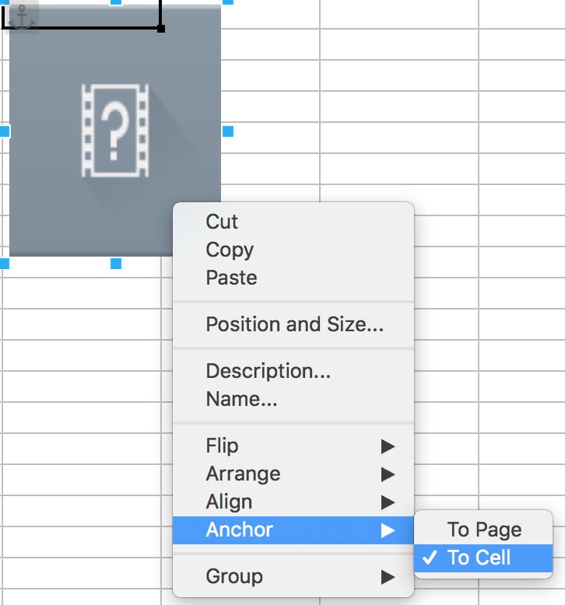
- Select Anchor > To Cell.
To insert a comment, use the Comments feature proposed by Calc, rather than text areas inserted via the Drawing toolbar. When the user moves the cursor to a commented cell, the assistive technology will announce the presence of a comment, that the user can choose to read or ignore.
To insert a comment:
- Select the cell you want to comment.
- Click Insert > Comment (Ctrl + Alt + C)
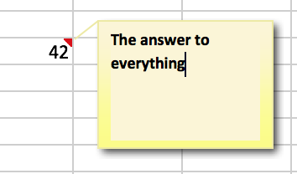
- Type your comment in the text area.
- Click anywhere outside the comment area.
To display the comment, place the mouse cursor over the marker in the corner of the cell, or right-click on the cell and select Show Comment.

Using an appropriate presentation

Applicable RGAA Criteria

Category | criteria
Colors | Criterion 3.1 [A] On each Web page, information must not be conveyed through color only. Has this rule been followed?  Criterion 3.2 [A] On each Web page, information must not be conveyed through color only. Has this rule been implemented in a relevant way?  Criterion 3.3 [AA] On each Web page, is the contrast between the text and background colors sufficient (except in particular cases)?  Criterion 3.4 [AAA] On each Web page, is the contrast between the text and background colors enhanced (except in particular cases)?
Mandatory Elements | Criterion 8.9 [A] On each Web page, tags must not be used only for layout. Has this rule been followed?
Presentation of information | Criterion 10.6 [A] On each Web page, can each link whose nature is not obvious be distinguished from the surrounding text?  Criterion 10.12 [AAA] For each Web page, is line and paragraph spacing sufficient?  Criterion 10.13 [A] For each Web page, are hidden texts correctly rendered by assistive technologies?  Criterion 10.15 [A] On each Web page, information must not be conveyed by shape, size or location alone. Has this rule been implemented in a relevant way?

Introduction
The visual complexity of a workbook can play a decisive role in understanding its content. If the understanding of certain content is conveyed only through color, shape, size or position, with no appropriate styling, users of assistive technologies may miss some information. These information can also be a serious barrier for users with altered color perception.

Colors
If information is conveyed only through color, screen reader users (blind or visually impaired users, in general) and some color blind people will not be able to access it. Any information conveyed through color must therefore also be available via another means, like an explicit text inside a cell, or in a comment (see Floating objects). Example: in a tasks list containing cells with a green background for completed tasks, and a red one for uncompleted tasks, add mentions like “completed task” and “uncompleted task” after the content of the cells.
The contrast between the background and text colors must also be sufficient to make the reading of the workbook comfortable. The RGAA states that the contrast ratio between a non-bold text and its background should be 4.5:1 up to 150% of the default font size, and 3:1 beyond. For bold text, a 4.5:1 contrast ratio is required up to 120% of the default font size, and 3:1 beyond. This applies to text, graphics and images.
A contrast checker is used to determine if colors have sufficient contrasts. The Colour Contrast Analyser, provided by the Paciello Group, can be downloaded free of charge.
Among others, you may also use this online checker proposed by Tanaguru.

Fonts
Whenever possible, some formatting standards should be prioritized to facilitate reading, and make the workbooks legible in the main text editors.
- Standard fonts created for ease of reading: Arial, Calibri, Cambria, Constantia, Garamond, Georgia, Helvetica, Times New Roman, Trebuchet MS, and Verdana;
- Font sizes between 12 and 18 points for the body text;
- Normal or expanded character spacing, rather than condensed.
Avoid long chunks of text in uppercase, italic or underlined fonts.

Cell Format
In order to create more legible Calc sheets, it is sometimes necessary to work on its style and layout. Borders or background colors, modifications of size or cell format can highlight certain types of contents. In order to allow readers to understand the meaning of formatting, it is appropriate to use styles management features proposed by LibreOffice Calc (title, explanatory text, calculation, comment, etc.) rather than directly using character formatting tools.
To apply predefined styles:
- Select the cells you want to apply a style to, including row and column headers.
- Select Format > AutoFormat Styles....
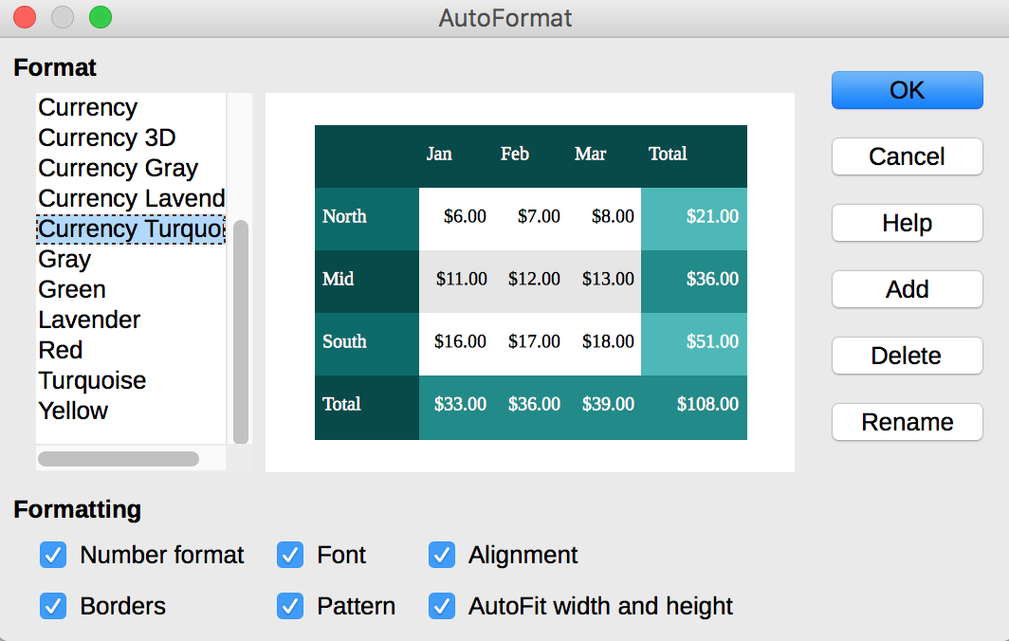
- Select the desired formatting options; a preview of the active selection will be displayed at the center of the dialog box.
- Click OK.
To apply a predefined style to a cell or a range of cells:
- Select the cells you want to apply a style to.
- Go to Format > Styles > Styles and Formatting.
- Double-click on the desired style.
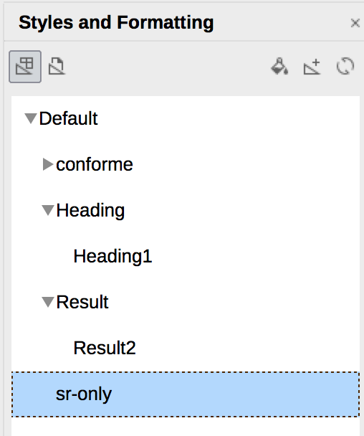
To change the visual characteristics of an existing style:
- Select the cells you want to apply a style to.
- Go to Format > Styles > Styles and Formatting.
- Select the style you want to modify.
- Right-click on it and select Modify...
- Select, for example, the Font tab.
- Select the settings you wish to apply.
- Click OK.

Data format
The rendering of number-based contents (dates, hours, percentages, currency, etc.) will be more comfortable and understandable to users of assistive technologies if these contents have an appropriate number format. To apply an adapted format to your data:
- Select the cells to which you want to apply a number format.
- Go to Format > Cells…
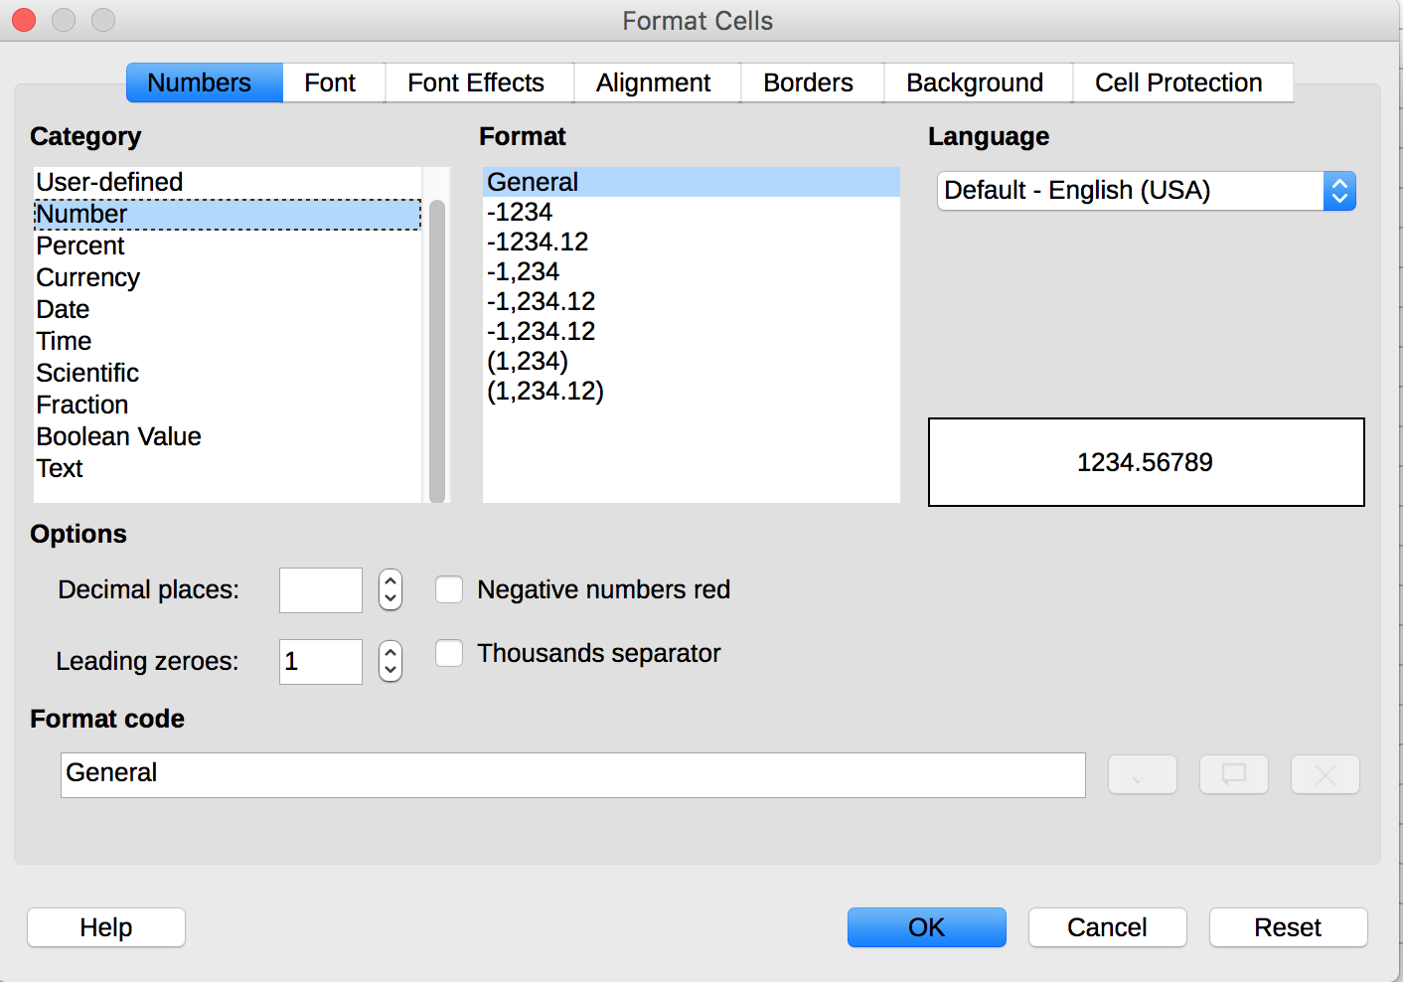
- Under the Numbers tab, in the Category area, select the desired format.
- In the Options area, refine the settings if necessary.
- Click OK.
To remove or deactivate a number format:
- Select the cells for which you want to deactivate a number format.
- Go to Format > Cells…
- Under the Numbers tab, in the Category area, select the Text format (the cells contents will be displayed as they have been entered).

Templates
The Calc 5.2 default template can be used as the basis for accessible workbooks. You can also create your own accessible template from an accessible sheet.
To save a workbook as a template:
- Make sure the workbook meets the structuring, presentation, language, description and navigation rules proposed in this guide.
- Go to File> Properties…
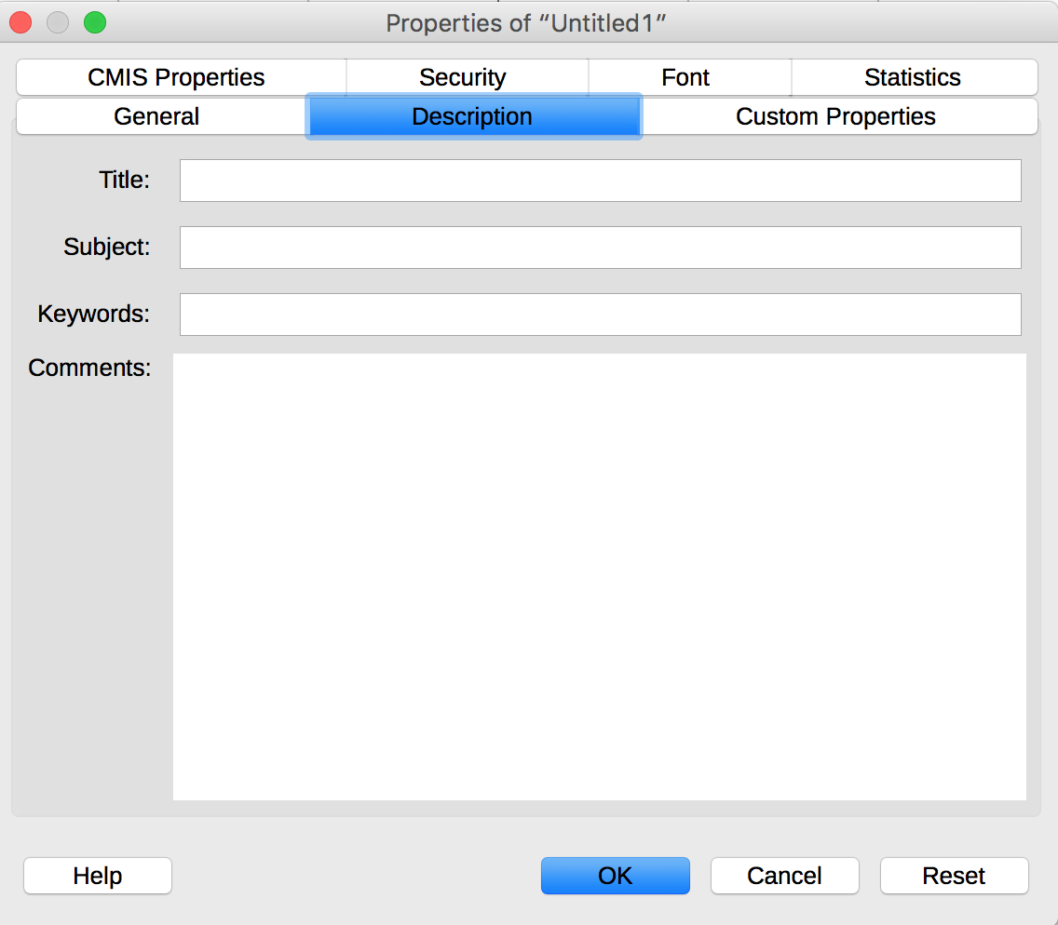
- Under the Description tab, enter a title and a comment that emphasizes the accessibility of the template.
- Click OK.
- Go to File > Templates > Save as Template.
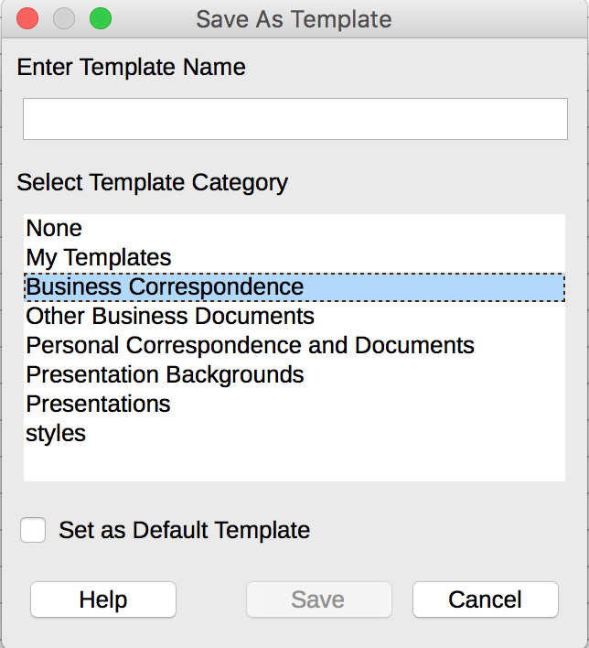
- In the dialog box, enter a name for the template, and, optionally, a category.
- Click Save.
To edit a template, make the desired formatting changes in the file, and then save and close the template.
To create a new workbook from your custom template:
- Click File > New > Templates
- Select the desired template. You can filter by type of document, and category.

Language

Applicable RGAA Criteria

Category | criteria
Mandatory elements | Criterion 8.3 [A] On each Web page, is the default human language identifiable?  Criterion 8.4 [A] For each Web page with a default human language, is the language code appropriate?  Criterion 8.7 [AA] On each Web page, is each change in the human language identified via the source code (except in particular cases)?  Criterion 8.8 [AA] On each Web page, is each change in human language relevant?  Criterion 8.10 [A] On each Web page, are changes in reading direction identified?
Information Structure | Criterion 9.4 [AAA] On each Web page, does the first occurrence of each abbreviation help to know its meaning?
Consultation | Criterion 13.9 [AAA] On each Web page, are unusual expressions, idioms or jargon made explicit?  Criterion 13.10 [AAA] On each Web page, for each expression used in an unusual or restricted way, each idiom or jargon with a definition, is this definition relevant?  Criterion 13.13 [AAA] On each Web page, for each word whose meaning cannot be understood without knowing the pronunciation, is this pronunciation specified?  Criterion 13.14 [AAA] On each Web page, does each text that requires a reading ability more advanced than the lower secondary education level have an alternative version?

Introduction
When the contents of a workbook are clear and accurate, they are easier to consult. To be able to render the document properly, assistive technologies need to be aware of the human language used.

Language of the workbook
The language selected for the workbook determines the dictionary used for spell checking, synonyms and hyphenation, as well as a number of formatting rules. For text-to-speech software, it also determines how content is spoken. It is therefore imperative to define a language for any workbook.
To set the language for the workbook:
- Go to Tools > Options (Windows) or LibreOffice > Preferences (MacOS).
- Open the Language Settings menu, and select Languages.
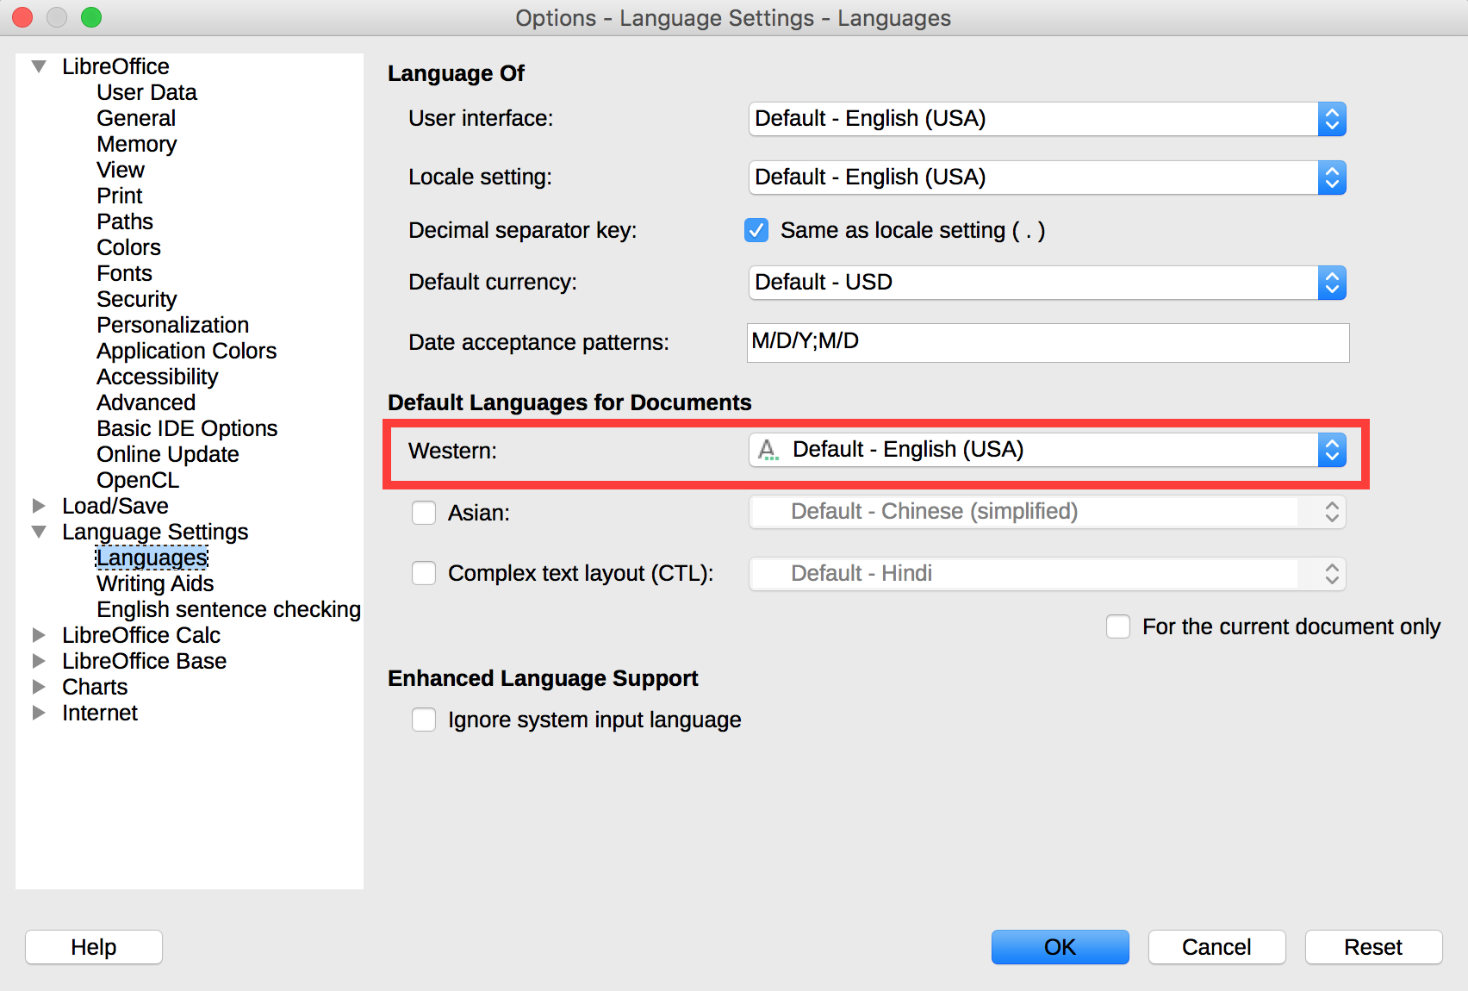
- In the Default Languages for Documents section, choose the primary languages of the workbook. If you want to apply this setting only to the current workbbok, check For the current document only.
- Click OK to close the dialog box.

Language of cell contents
In Calc it is possible to specify the language of a cell or a range of cells:
- Select the cells for which you want to specify a different language.
- Go to Format > Cells…
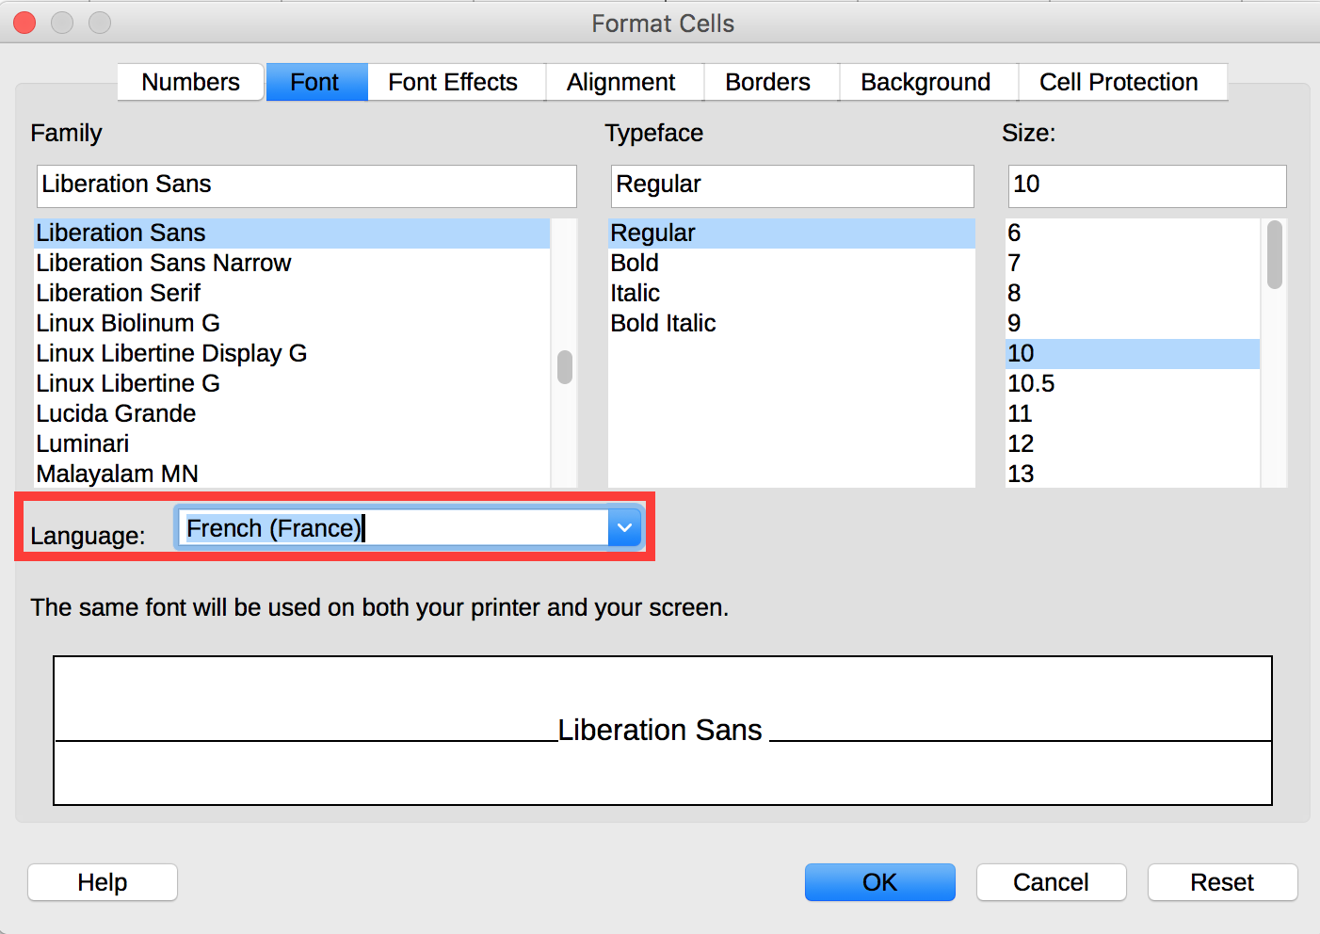
- Under the Font tab, in the Language selection list, select the language to apply.
- Click OK.
It is also possible to specify the language for a word or a group of words inside a cell:
- Select the text for which you want to specify a different language.
- Go to Format > Character…
- Under the Font tab, in the Language selection list, select the language to apply.
- Click OK.

Comprehensive language
Spreadsheets with clear and accurate headers will be accessible to a wider audience. This is also true for values in cells and information that identify cells (names, sheet names) and inserted objects (headings, alternative texts).
A few recommendations:
- Favor clear and accurate titles and texts.
- Provide a name for each sheet (do not leave the default name provided by Calc).
- Provide for each sheet a name that differentiates it from the other ones.

Giving an alternative to non-textual elements

Applicable RGAA criteria

Category | criteria
Images | Criterion 1.1 [A] Does each image have a text alternative?  Criterion 1.2 [A] For each decorative image with a text alternative, is this alternative empty?  Criterion 1.3 [A] For each image conveying information with a text alternative, is this alternative relevant (except in particular cases)?  Criterion 1.6 [A] Does each image conveying information have a detailed description if necessary?  Criterion 1.7 [A] For each image conveying information with a detailed description, is this description relevant?  Criterion 1.8 [AA] When an alternate mechanism is missing, each image of text conveying information must be replaced with styled text, if possible. Has this rule been followed (except in particular cases)?  Criterion 1.9 [AAA] Each image of text conveying information must be replaced with styled text. Has this rule been followed (except in particular cases)?  Criterion 1.10 [A] Is each image caption correctly associated with the corresponding image, if necessary?
Colors | Criterion 3.1 [A] On each Web page, information must not be conveyed through color only. Has this rule been followed?  Criterion 3.2 [A] On each Web page, information must not be conveyed through color only. Has this rule been implemented in a relevant way?  Criterion 3.3 [AA] On each Web page, is the contrast between the text and background colors sufficient (except in particular cases)?  Criterion 3.4 [AAA] On each Web page, is the contrast between the text and background colors enhanced (except in particular cases)?
Consultation | Criterion 13.11 [A] On each Web page, does each cryptic content (ASCII art, emoticon, leetspeak) have an alternative?  Criterion 13.12 [A] On each Web page, for each cryptic content (ASCII art, emoticon, leetspeak) with an alternative, is this alternative relevant?  Criterion 13.15 [A] On each Web page, are sudden changes in luminosity or flashing effects used appropriately?  Criterion 13.16 [AAA] On each Web page, do the sudden changes in luminosity or flashing effects have a frequency lower than or equal to 3 per second?  Criterion 13.17 [A] On each Web page, can each moving or blinking content be controlled by the user?
Multimedia | Criterion 4.1 [A] Does each prerecorded time-based media have a text transcript or an audio description if necessary (except in particular cases)?  Criterion 4.2 [A] For each prerecorded time-based media with a text transcript or a synchronized audio description, are these relevant (except in particular cases)?  Criterion 4.3 [A] Does each prerecorded synchronized time-based media have synchronized captions if necessary (except in particular cases)?  Criterion 4.4 [A] For each prerecorded synchronized time-based media with synchronized captions, are these captions relevant?  Criterion 4.5 [AA] Does each live time-based media have synchronized captions or a text transcript if necessary (except in particular cases)?  Criterion 4.6 [AA] Are each synchronized captions or text transcript, provided for live time-based media, relevant?  Criterion 4.7 [AA] Does each prerecorded time-based media have a synchronized audio description if necessary (except in particular cases)?  Criterion 4.8 [AA] For each prerecorded time-based media with a synchronized audio description, is this audio description relevant?  Criterion 4.9 [AAA] Does each prerecorded time-based media have a sign language interpretation (except in particular cases) if necessary?  Criterion 4.10 [AAA] For each prerecorded time-based media with a sign language interpretation, is this interpretation relevant?  Criterion 4.11 [AAA] Does each prerecorded time-based media have a synchronized extended audio description if necessary (except in particular cases)?  Criterion 4.12 [AAA] For each prerecorded time-based media with a synchronized extended audio description, is this audio description relevant?  Criterion 4.13 [AAA] Does each synchronized or video-only time-based media have a text transcript (except in particular cases)?  Criterion 4.14 [AAA] For each synchronized or video-only time-based media with a text transcript, is this text transcript relevant?  Criterion 4.15 [A] Can each time-based media be clearly identified (except in particular cases)?  Criterion 4.16 [A] Does each non time-based media have, if necessary, an alternative (except in particular cases)?

Introduction
For non-textual elements (images, charts, video and audio files) that convey information not presented as text in their proximity, this information must be described in a replacement text, and completed with a transcription for video and audio. The replacement text that will be rendered to the reader by assistive technologies, when the object gets focus, allowing to understand the purpose of the object, or to become aware of the presence of a transcription. Without proper description, these elements can't be perceived by assistive technologies.

Images
If possible, inserting images inside an Calc spreadsheet should be avoided, because they can cause reading order issues.
When inserting an image is necessary, you should ask yourself 3 questions before choosing the text that will be rendered in place of the image:
- Is the image purely decorative, not conveying any information and having no function?
- Does the item convey information?
- Does the image have a function (for example, a picture serving as a link)?
If the image is purely decorative, it should not be assigned alternative text.
If the image conveys information, it must be associated with a replacement text. This alternative, which also serves as a title, must succinctly describe the information conveyed by the image and its meaning in context.
For an image that serves as a hyperlink, the alternate text must be able to understand the function and the destination of the link. The conditions for returning this replacement text require that it be as short as possible (a maximum length of 80 characters is strongly recommended).
A replacement text should not:
- Include copyright information (for example, for a photo, the name of the copyright holder and the date of the picture)
- Start with "picture of..." or "photo of...".
To associate an alternative text to an image that conveys information or serves as a hyperlink:
- Right-click on the image and select Description...
- Fill in the Title box and click OK.

A detailed description is sometimes necessary when the information conveyed by the image is more complex. This requires an interpretation of the image. To insert a detailed description:
- Right-click on the image and select Description...
- In the Description dialog box, fill the Title field. This will help the readers decide if they want to proceed with reading the detailed description.
- In the Description box, type the detailed description, trying to be as concise and objective as possible, then click OK.

Images of text
Images of text are images that contain text that is necessary to understand the content of the workbook. It is not recommended to use images of texts when it is possible to reproduce the same effects by defining styles for "actual" text (see Cell Format).
If the text is part of a logo or an element associated with the graphic identity of an organization or a company, it is advisable to propose a textual alternative to the image, while following the recommendations above.

Charts
Spreadsheets are convenient to organize and execute calculation on data, but are not always the best way to present them. Visualization as charts makes it generally easier to interpret, and seeing trends and relationships.
If the needs of users with disability are taken into account by design, charts can be made accessible to all. To make their consultation easier, charts should be inserted in separate sheets, with a sheet title that explicitly mentions the presence of a chart.
Fonts, colors and shapes must be chosen with consideration for the needs of color-blind and partially sighted readers. Color must not be used alone to convey information. Emphasize the use of dashed line styles to improve readability, and, if necessary, replace predefined colors to meet the contrast requirements (see Colors).
To insert a chart:
- Select the data you want to include in the chart.
- Go to Insert > Chart...
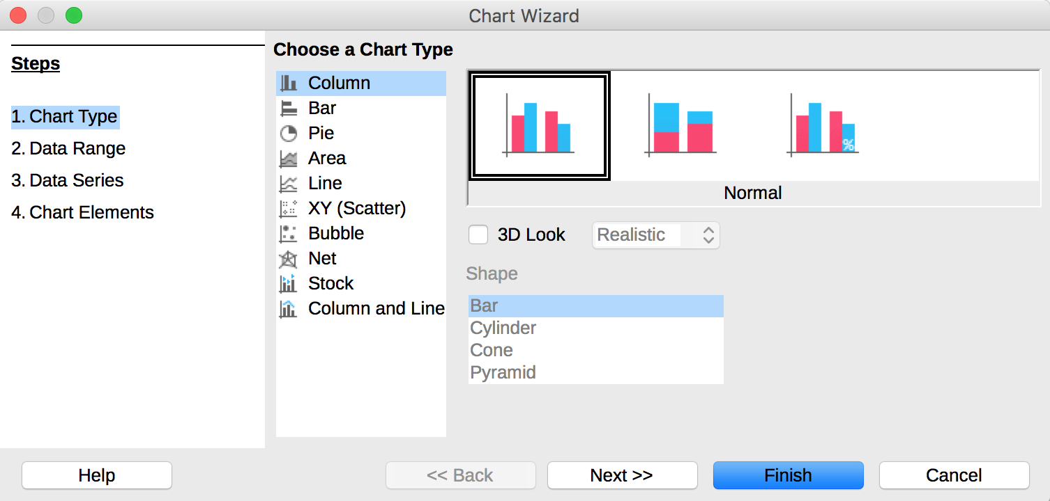
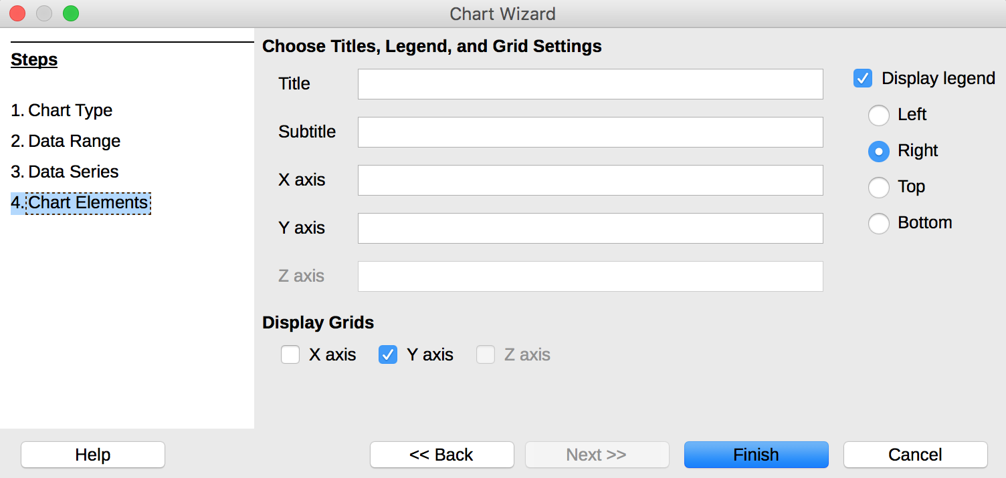
- In the Chart Wizard dialog box, follow the steps 1 to 4 to create your chart, taking care to fill all the fields that allow to identify the charts components (step 4).
To modify the label format:
- Right-click on the axes labels to format, then click on Format Axis…
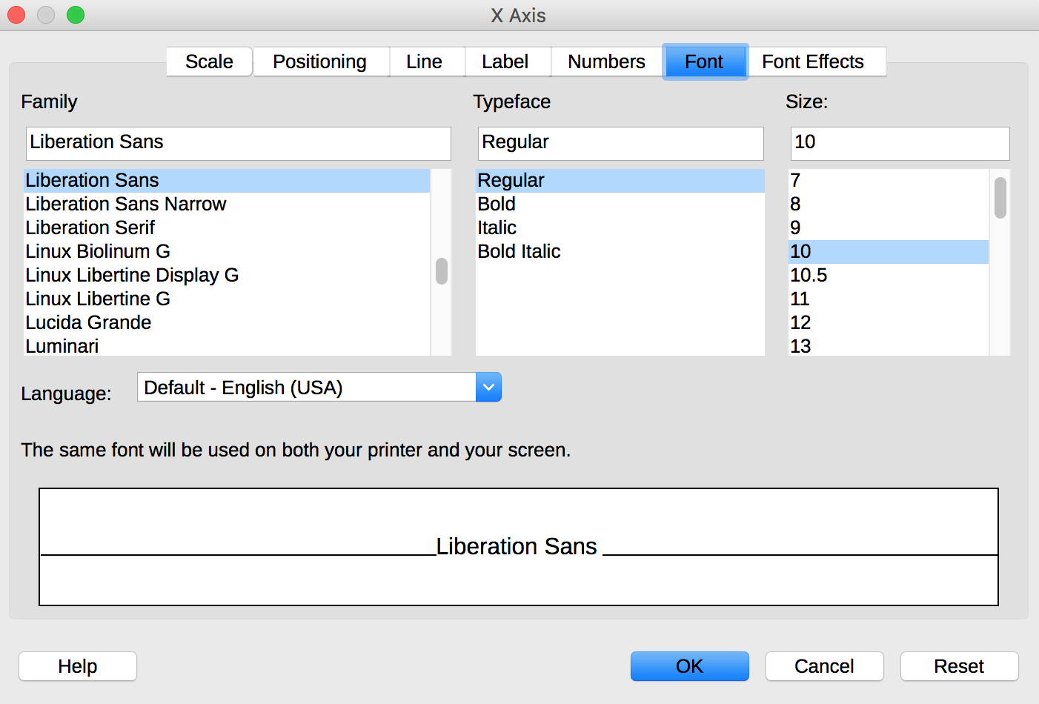
- Under the Font tab, choose the formatting options.
- Click OK.
The same process can be applied to change settings like the numbers type, for all axes.

The title and labels of the axes provide necessary elements for the interpretation of the data presented, but will not suffice to transmit the specifics of the graphic necessary for its comprehension to someone who fails to see it.
For simple charts, a simple replacement text may suffice. For more complex or detailed charts, it is necessary to provided a detailed description. In both cases, you must avoid listing the raw data as a textual alternative, but rather to explain the information that you wish to convey by inserting the chart in the workbook.
To add a replacement text with a detailed description for more complex charts:
- Select the entire graph by clicking on the border of the chart (as opposed to a shape or element inside the chart).
- Right-click on the chart and select Description...
- In the Description dialog box, enter a text for title. This will help the readers decide if they want to proceed with reading the detailed description.
- In the Description box, type the detailed description, trying to be as concise and objective as possible, then click OK.

Multimedia files
It is possible to insert video or audio files in a LibreOffice Calc workbook.
To insert a video or audio file:
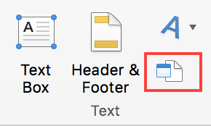
- Go to Insert > Media > Audio or Video…
- In the file dialog box, select the file you want to insert.
- Click on Open.
Note: some media formats are not supported. For these formats, it is still possible to insert a hyperlink to the file, that will be read by the media player installed on the computer.
A replacement text must accompany any video or audio clip (see technique described in Images). It is also necessary to provide a transcript for any video or audio sequence, and to ensure that the videos include closed or open captions (embedded in the video or via an online alternative).
It is sometimes necessary to propose an audio description, i.e. an additional soundtrack added to the video that describes the visual elements: actions, movements, expressions, sets, etc. This audio description must be played in blank spaces between the dialogues and the important sound elements.
The transcript and audio descriptions may be proposed in an annex or in a downloadable file located on a distant server, and accessed via a link located close to the object. The link text must clearly identify the proposed audio description or transcription for the media file, because it is technically not possible to associate them by other means than wording.
The purpose of a transcription is to provide a coherent alternative to multimedia content. Readers must have access to all the information conveyed by the video or audio file, including the dialogues between the participating protagonists, the location, the main actions and the atmosphere.

Creating navigation aids

Applicable RGAA criteria

Category | criteria
Links | Criterion 6.1 [A] Is each link explicit (except in particular cases)?  Criterion 6.2 [A] For each link with a link title, is this title relevant?  Criterion 6.3 [AAA] Is each link text alone explicit out of context (except in particular cases)?  Criterion 6.4 [A] For each web page, does each identical link have the same purpose and target?  Criterion 6.5 [A] On each Web page, does each link, except in anchors, have a text?
Navigation | Criterion 12.7 [AA] On each page within a collection of pages, are links facilitating navigation available?

Introduction
When the contents of a workbook are well identified, they are easier to consult. In addition to the structuring elements described in the previous sections, it is possible to enrich the workbook with navigation elements pointing to contents inside and outside of it.
LibreOffice includes a powerful tool to access directly to the various elements of a document: the Navigator. This feature is also useful to control the document structure and ensure that the elements it is composed of are correctly identified.
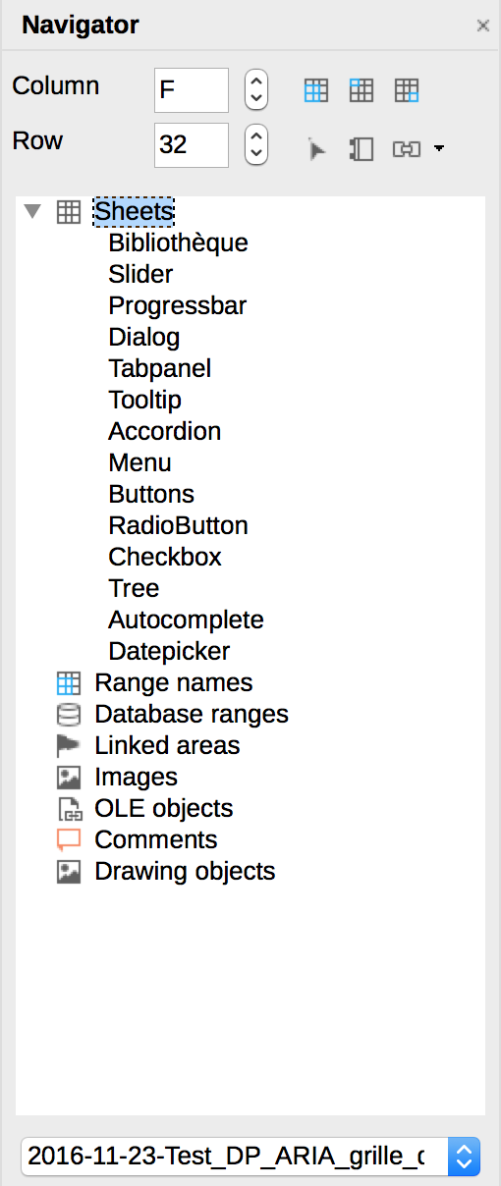
There are 3 ways to open the Navigator:
- View > Navigator.
- Click on the  icon in the sidebar.
- Press the F5 key.
To display the elements of a category, click on the triangular arrow next to the category name. To access quickly to an element in the document, double-click on it in the Navigator.

Sheets names
The sheets names, presented as tabs, must be explicit in order to help the users understand the nature of each sheet of the workbook. Any empty sheet must be deleted.
To rename a sheet:
- Right-click on its tab, and select Rename Sheet.
- Enter a short and unique name, that describes the content of the sheet.
To delete a sheet, right-click on its tab, and select Delete Sheet.

Description of the workbook contents
For workbooks containing complex tables of charts, a short description of the workbook contents, mentioning the sheets it contains, can help users to get a global perception of it, and so be more efficient when browsing the workbook.
The first sheet can be dedicated to this description, with links to the sheets composing the workbook (see Internal links). Since screen readers users, in Western languages, generally start reading at the first cell (A1), if possible, the description should start there. For example: “This workbook contains 2 sheets. The first sheet includes a table that starts in A1 and ends in M75, and presents the budget for 2017 [hypertext link to the sheet]. The second sheet includes a table a table that starts in A1 and ends in M75, and presents the previsional budget for 2017 [hypertext link to the sheet]”.
Before distributing the workbook, remember to place the cursor in the cell where this description is.

Naming elements
Calc provides the possibility to name different parts of the workbook. When a significant name is associated to data, they become more understandable to users of assistive technologies (for example, instead of “=(B2+C9)*$D$6”, the screen reader will output “Travel_expenses+VAT”). Indeed, some users move in the workbook by named elements. These named elements can also be referenced elsewhere in the workbook (see Internal links).
Please note:
- Naming elements must be done once the workbook is ready to be shared. Any modification (change in the sheets order, or addition of a row) requires an update of the names.
- A name can be specific to a given sheet, or applicable to a whole workbook.
- A name must always be unique in its own range.
To define column labels:
- Select the cells that will serve as column headers.
- Go to Insert > Named Expressions > Labels…
- Click on the Shrink icon in order to be able to select a range. Click on Expand to display the whole dialog box again.
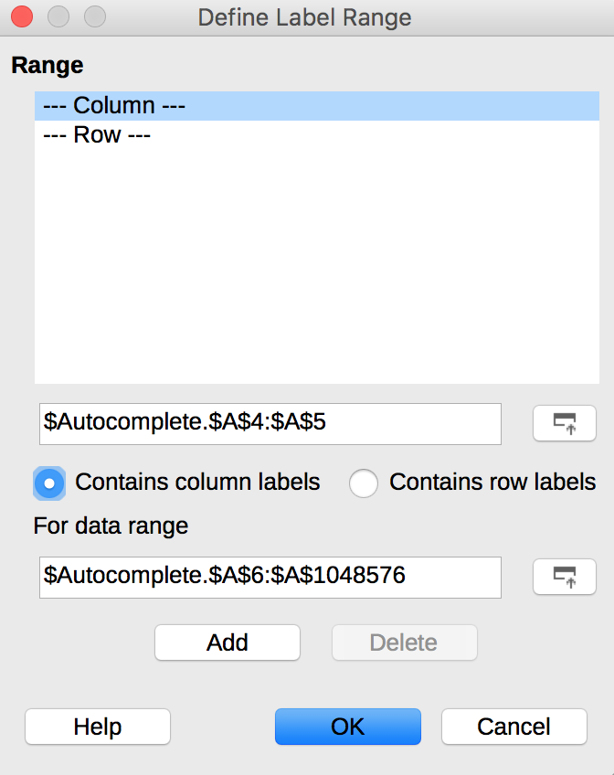
- Check the Contains column labels radio button.
- Click on Add.
- If the sheet contains row labels, repeat the previous steps by selecting the row labels et checkin Contains row labels, then click on Add.
- Click OK.
To define a name:
- Go to Insert > Named Expressions > Define...
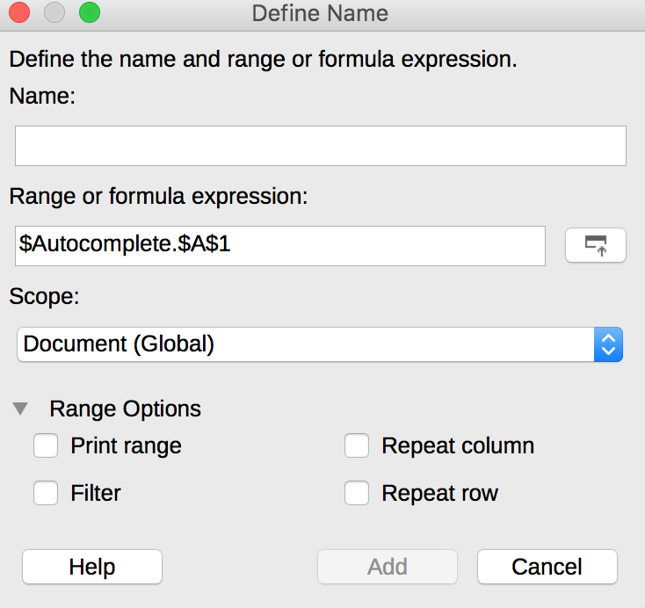
- Define a unique, non-ambiguous name.
- Click on the Shrink icon in order to be able to select a range. Click on Expand to display the whole dialog box again.
- Select the scope (for the current sheet or the whole workbook).
- Click on Add.

Internal links
It is possible to insert links to named cells or ranges to allow users to navigate within a workbook other than from cell to cell.
To insert a link to a named element:
- Position the cursor where you want to insert and / or edit an internal link.
- Go to Insert > Hyperlink.
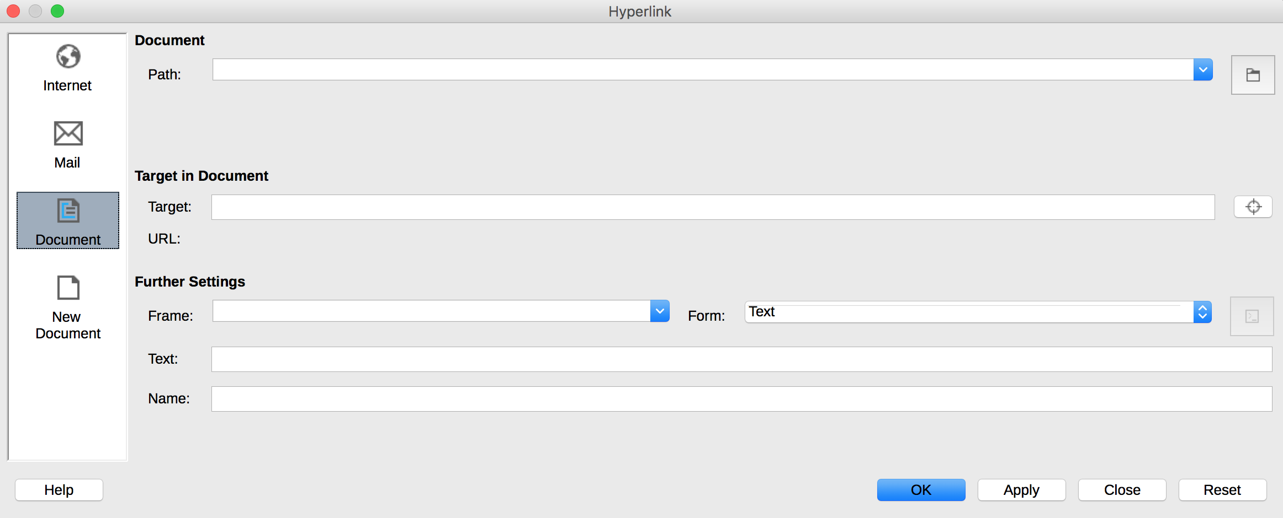
- In the Hyperlink dialog box, in the left section, select Document.
- In the Target in document area, click on the Target icon (circle containing a dot at its center).
- In the Target in document dialog box, open the Range Names branch of the tree menu, and select the named element you want to link to.
- Click on Apply then Close.
- In the Further Settings section of the Hyperlink dialog box, in the Text field, add an explicit link text, providing the destination of the link.
- Click on Apply then Close.

External Links
Hypertext links can also be used to provide a quick access to information stored in another file or in a web page.
It is recommended to use link texts that make the understandable in their context.

- Position the cursor where you want to insert and / or edit a link.
- Go to Insert > Hyperlink.
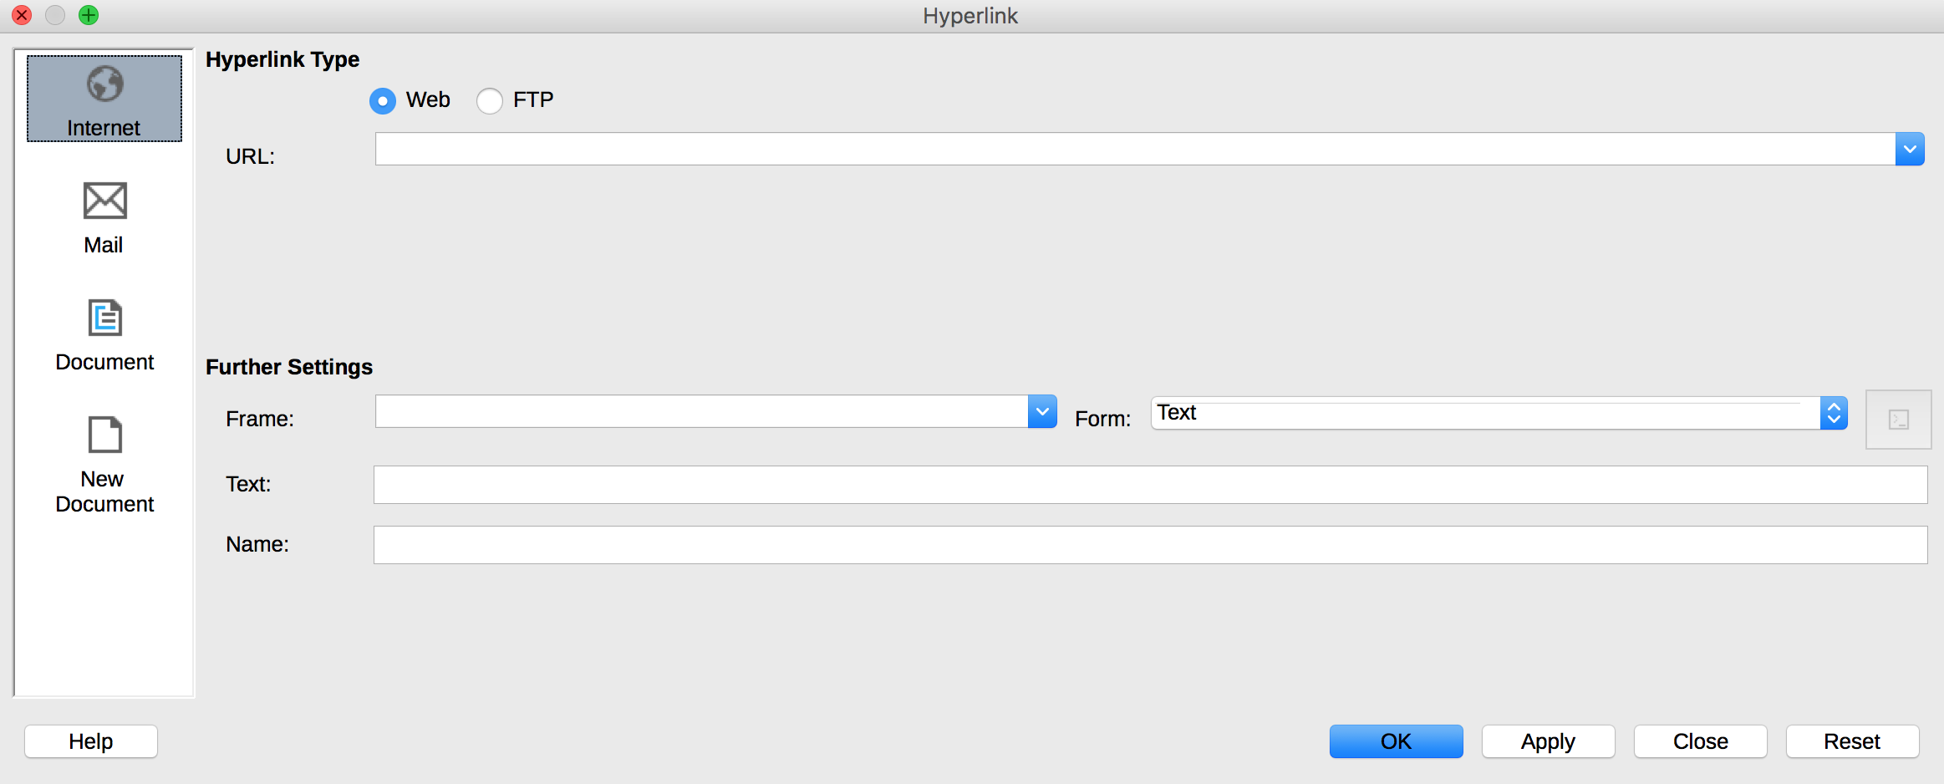
- In the Hyperlink dialog box, in the left section, select Internet.
- In the URL field, insert the address the link must point to.
- In the Further Settings section, in the Text field, add an explicit link text, providing the destination of the link.
- Click on Apply then Close.

Creating accessible forms

Applicable RGAA criteria

Category | Criteria
Forms | Criterion 11.1 [A] Does each form field have a label?  Criterion 11.2 [A] Is each label associated with a form field relevant?  Criterion 11.3 [AA] On a given page, or set of pages, all form fields with similar functions must have consistent labels. Has this rule been followed?  Criterion 11.4 [A] In each form, are each label and its related control positioned next to each other?  Criterion 11.5 [A] In each form, is the information of same nature grouped together, if necessary?  Criterion 11.6 [A] In each form, does each form field grouping have a legend?  Criterion 11.7 [A] In each form, is each legend, related to a form field grouping, relevant?  Criterion 11.8 [A] In each form, is each selection list structured in a relevant way?  Criterion 11.9 [A] In each form, is the text of each button relevant?  Criterion 11.10 [A] In each form, is the input control used in a relevant way?  Criterion 11.11 [AA] In each form, is input control accompanied, if necessary, by suggestions helping with the correction of input errors?  Criterion 11.12 [AA] For each form, can financial, legal or personal data be changed, updated or retrieved by the user?  Criterion 11.13 [AAA] For each form, can all data be changed, updated or recovered by the user?  Criterion 11.14 [AAA] For each form, is input assistance available?  Criterion 11.15 [AAA] For each form, is each input assistance relevant?

Introduction
A form is an input space, which can have several "fields" where the user can enter text, check boxes, select from a list of predefined terms, press buttons, and so on.
Well-designed forms will be accessible to users of assistive technology, provided they follow a few simple rules:
- The sheet name must indicate the presence of a form in the sheet;
- The focus path (tab order) must be logical and understandable;
- Each form field must be identified, with a replacement text;
- Form fields must be editable;
- Information of the same nature should be grouped and labelled clearly;
- For complex forms, a short description, providing the number of questions or sections, and an estimate of the time required to complete the form, may be proposed. The first sheet of the workbook can be reserved for this description, with links to the sections of the form (see Internal links) Since Western languages screen reader users usually start their navigation in the first cell (A1), this description should be placed here.
To facilitate navigation and a logical flow, the questions and the areas reserved for the answers can be arranged in a two-column table with the headers "Questions" and "Answers" (see Naming elements).

Creating a simple form
When you do not need to use sophisticated features, a simple form of text boxes may be sufficient. The format of the cells in the second column can be modified to help the user identify the input fields (see Cell Format).

Calc 5.2 offers a data validation tool, that improves the accessibility of certain input areas by enabling:
- the indication of input format;
- the insertion of drop-down lists;
- the provision of an input help message when the input field receives focus;
- the warning of the user when the input format is incorrect.

To set the desired input format:
- Select the input field.
- Go to Data > Validity.
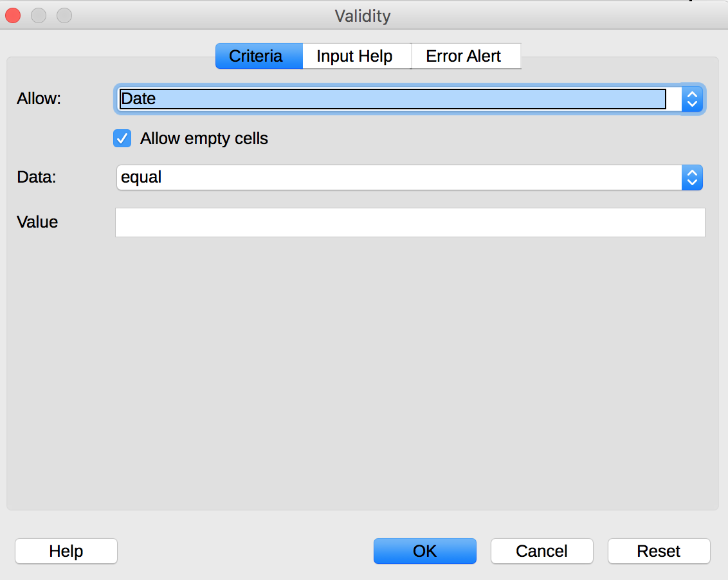
- Under the Criteria tab of the Validity dialog box, in the Allow drop-down box, select the desired format type, and complete the settings according to the chosen format.
- Click OK.

To create a drop-down list:
- Select the input field.
- Go to Data > Validity.
- Under the Criteria tab of the Validity dialog box, in the Allow drop-down box, select List.
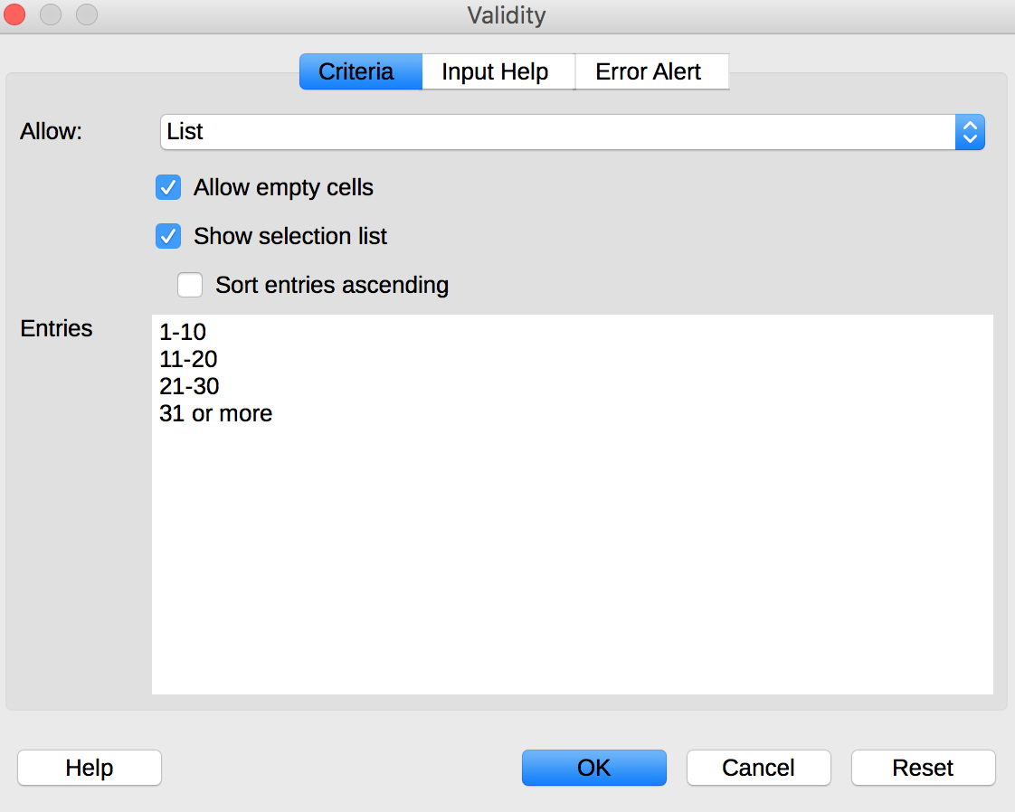
- In the Entries box, enter the first value, followed by a line feed, then repeat until the list is complete.
- Click OK.

To create an input help which will be displayed as a tooltip and announced when the user makes changes to the input field:
- Select the input field.
- Go to Data > Validity.
- Click Input Help.
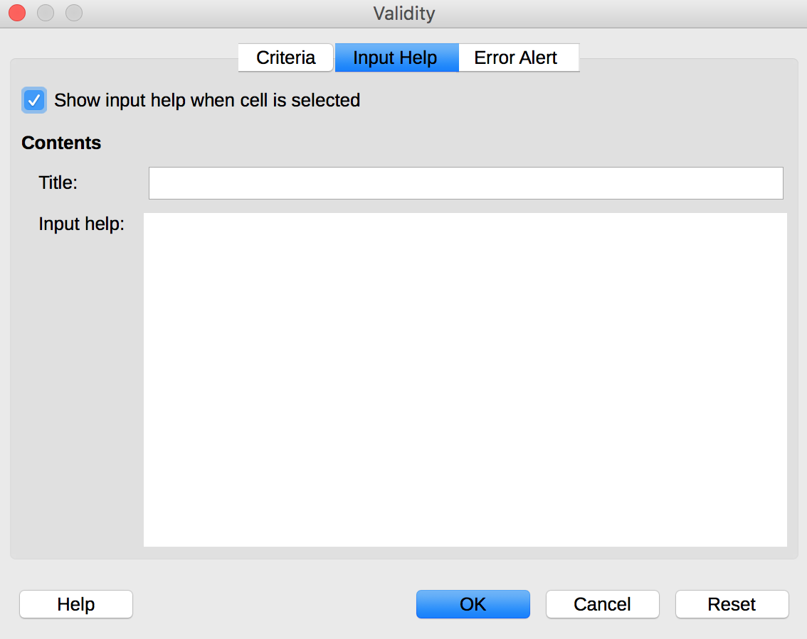
- Ignore the Title field. Enter an instructional text in the Input message box.
- Make sure that the “Show input message when cell is selected” check box is selected.
- Click OK.

To create an error message:
- Select the input field.
- Go to Data > Validity.
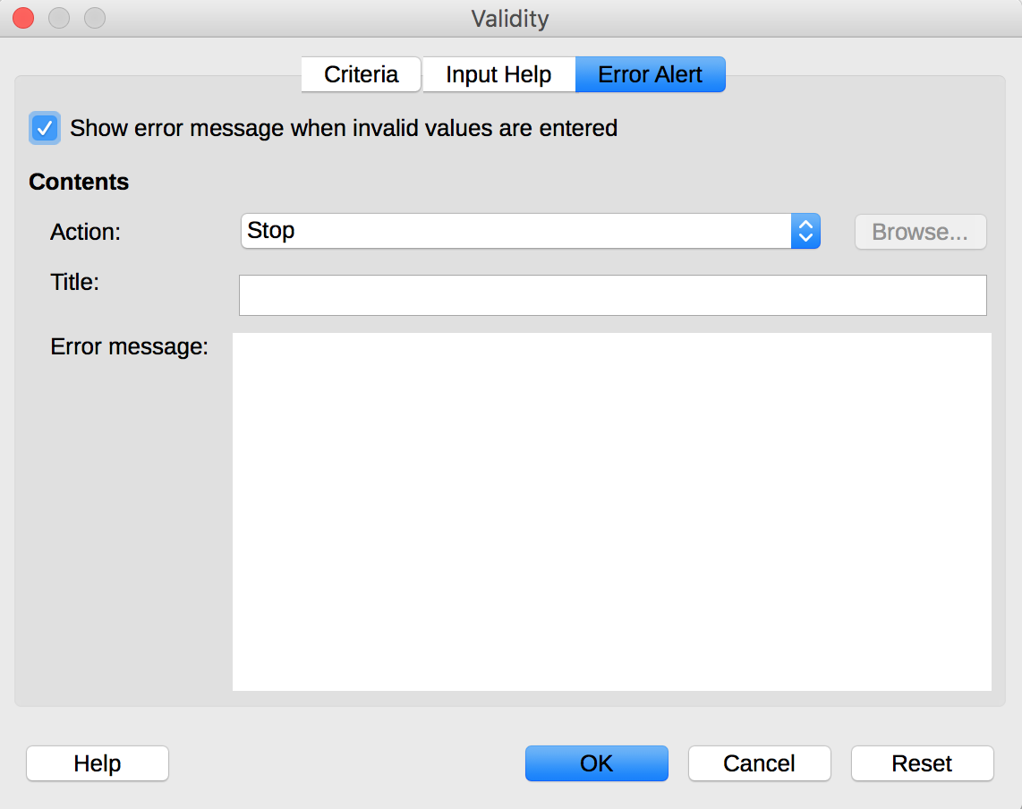
- Click on Error Alert.
- Select the Action type of icon to be displayed (Stop, Warning or Information) and enter the Title of the error alert and an Error message that will allow the user to correct the format (explanation and an example of correct format, for instance).
- Make sure that the “Show error message when invalid values are entered” is checked.
- Click OK.

Activating forms design mode
LibreOffice Calc provides two toolbars that contain the functions required to create and edit a form: the Form Controls toolbar and the Form Design toolbar. To activate these menus:
- Go to View> Toolbars.
- Check Form Controls.
- Go to View> Toolbars.
- Check Form Design.
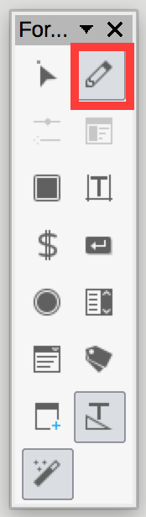
To compose the form, the author should write and format the text relating to the form: title of the form, questions and explanations. These elements facilitate the understanding and use of the form.
The Toggle Design Mode button allows to save a form and keep it in Design mode.

Adding input areas with controls
Once the structure of the form is designed, in the first column, you may insert different input areas with content controls (text boxes, check boxes, combo boxes, etc.). For each field, you must specify a title and instructional text.
To insert a form field with control:
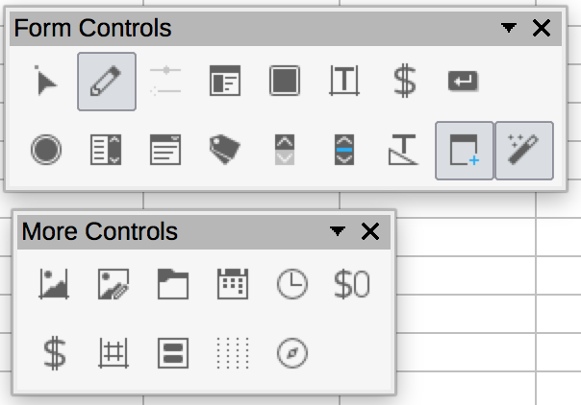
- In the floating Form Control toolbar, click on the icon corresponding with the type of field you want to insert (text box, check box, radio button, drop-down list, and so on).
- Draw the area on the cell where you want to insert a field.
- To create a replacement text that will serve as a help text, right-click on the inserted area, and select Control… to open the Control Properties dialog box. Options vary depending on the type of field. You can modify the visual aspect of the field. To make it accessible, make sure to fill in the following information:
  - Name: choose a name appropriate for the purpose of the field
  - Help text: will appear in a tooltip when the user will hover the mouse over the field, and will be output to assistive technologies.
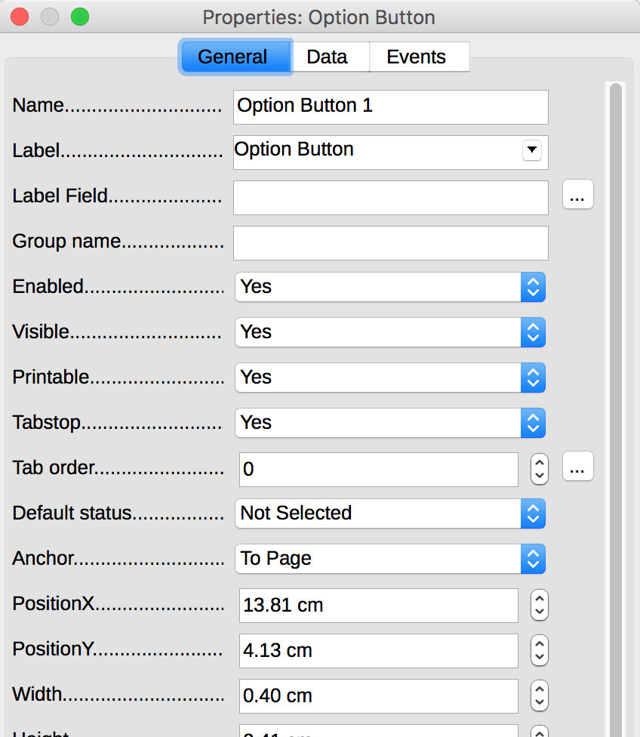
- Close the dialog box (there is no validation button, the changes are saved when closing).
When the Design mode is deactivated, the form behaves like it will for the recipient of the form: check boxes can be checked, list elements can be selected, etc.
To test the form, click Toggle Design Mode again.

Inserting buttons
It is possible to insert buttons that can be set to trigger features. These buttons are not accessible to assistive technologies.
Certain features can be triggered through hypertext links. These links can be formatted (borders, background color, fonts, etc.) to look like buttons (see Cell Format).
When it is not possible to activate a feature with a hypertext link, then an alternative method to access this feature must be proposed.

Providing additional information

Document properties
Document properties, also known as metadata, are information about a file that describes or identifies it. They include information such as title, author's name, subject, and keywords identifying the topics or content of the document.
When opening a document, some assistive technologies refer to these properties to announce the title of the document and to summarize the content.
These properties are also preserved and used when the document is published in another format. (see Error: Reference source not found).
To view and edit the properties of a workbook in LibreOffice Calc 5.2:
- Click File > Properties
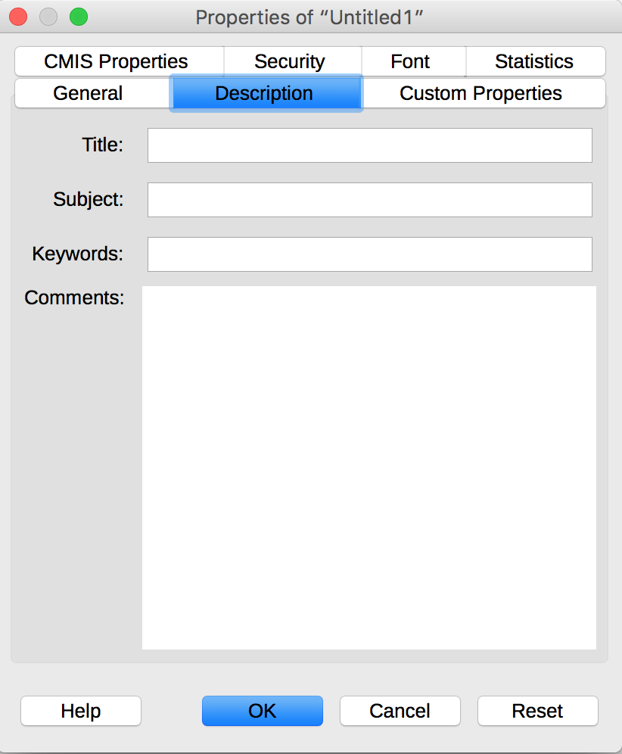
- Under the Description tab, enter a title for the workbook, optionally its subject, key words, and a comment on the accessibility of the document.

Publishing the workbook in other formats

Introduction
If the techniques described in this guide are used during the creation of a workbook, this workbook will not only be read by users of assistive technologies for the software used for creation, but its semantic composition will also allow for better conversion into other formats, although some adjustments may still be necessary depending on the chosen format.
In this guide, the publication process is described for the following formats:
- HTML
- PDF
Conversion to these formats assumes that workbooks are properly structured upstream, by following the guidelines described in the previous chapters of this guide.
It is necessary to ensure that the elements related to the accessibility of the workbook are preserved when saving or exporting to other formats. This evaluation work and any corrections due to loss of information or conversion errors will not be discussed in detail in this guide.

Publishing in HTML
LibreOffice Calc allows native publishing of an HTML document. A title and a list of hyperlinks are inserted automatically at the beginning of the HTML document to allow access to the sheets composing the workbook. When saving the file, LibreOffice generates files for objects associated to the page (images, charts, etc.), that are saved in the same folder as the HTML file. The title of these documents is the name of the Calc file, followed by a sequence of numbers.
To save as HTML:
- Go to File > Save As…
- Choose the name and location of your workbook.
- In the File type list, select HTML Document (Calc) (*.html).
- Click on Save.
During export, some semantic information will be preserved. However, it will be necessary to remove useless HTML tags, and to add missing tags, manually, through a HTML editor. Known non-preserved information include:
- Replacement texts (titles and description);
- Headers identifiers (for rows and headers).

Checking the accessibility of the HTML document
Open the HTML workbook in a browser such as Mozilla Firefox and use the HTML test tools to check the accessibility of the page. You may refer to the RGAA 3 2016 Testing Methodology for detailed instructions.

Export to PDF
PDF (Portable Document Format) is a format developed by Adobe Systems. It preserves the formatting defined by the author, regardless of the application or platform used to read it.
PDF may contain tags that reflect the workbook structure. A tree of tags represents the organizational structure of the workbook and allows assistive technologies to determine the presentation and interpretation of its content.
When the techniques described in this guide are followed when creating the workbook, the conditions are optimal for the workbook to be converted to PDF without loss of structure or information.
To export to PDF:
- Click File > Export as PDF…
- Under the General tab of the PDF Options dialog box, check Tagged PDF (add document structure).
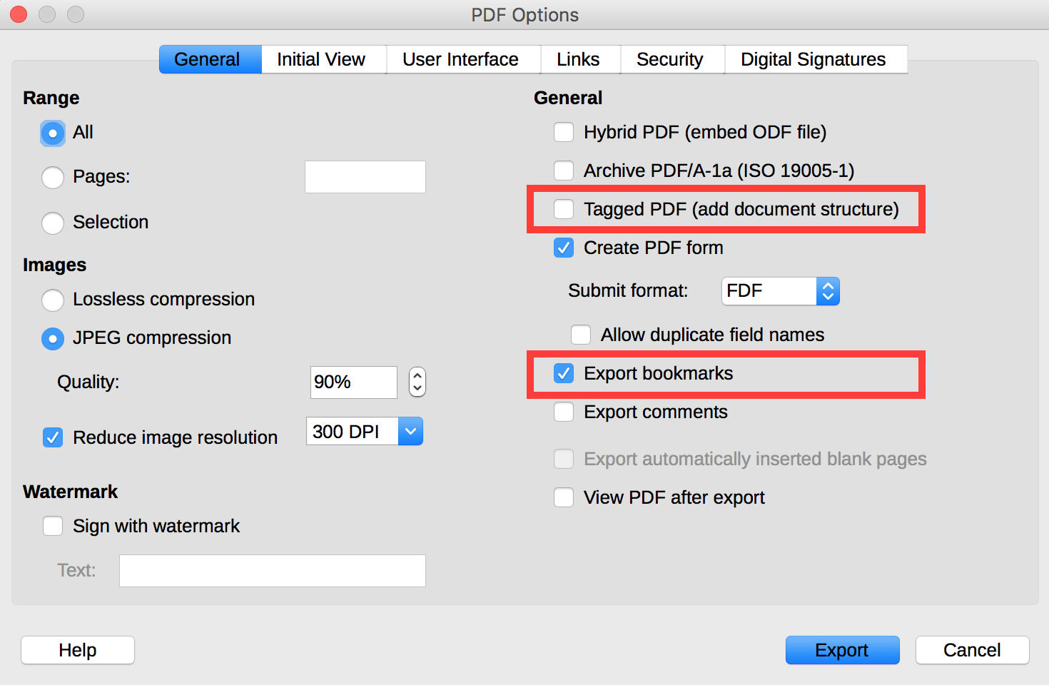
- Under the same tab, check Export Bookmarks.
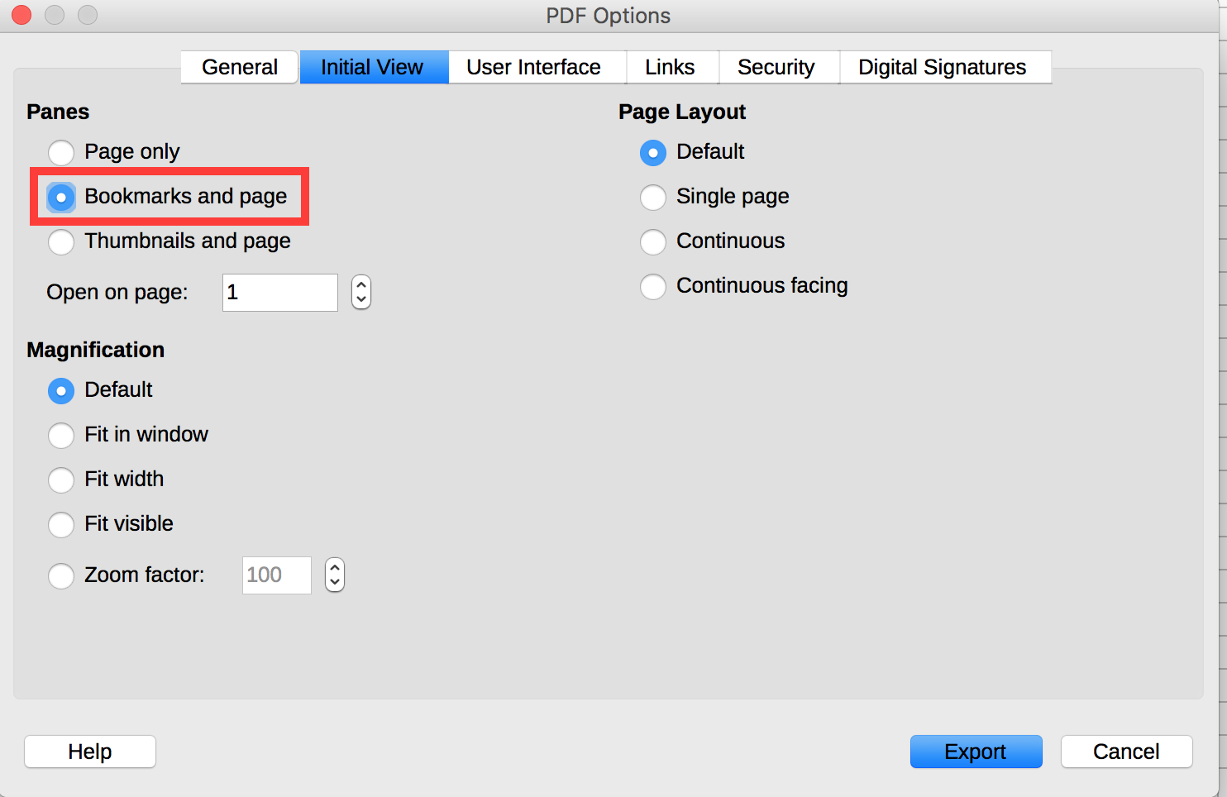
- Under the Initial View tab, in the Panes section, check Bookmarks and page.
- Click on Export.
- Enter a name and a location for your file.
- Click on Export.

Checking the accessibility of a PDF document
The evaluation of the accessibility of the PDF document requires a screen reading software to check that the reading order and restitution of content are correct. To enable the consultation of the workbook with screen reading software, make sure that the permissions are set correctly:
- Open the file in Adobe Acrobat and open the File > Properties > Protection menu.
- In the Protection method drop-down list, select No protection.
- Click OK and close the dialog box.
If a number of conversion problems can be detected with a screen reader software (reading order, correct markup, passages in a foreign language, etc.), the Adobe Acrobat Professional software (paid solution) is required to correct possible markup errors.

Sources
Authoring Techniques for Accessible Office Documents: OpenOffice Calc (v 3.2), Accessible Digital Office Document Project (ADOD), developed by the Inclusive Design Research Centre, OCAD University (Ontario, Canada) as part of an EnAbling Change Partnership project with the Government of Ontario and UNESCO (United Nations Educational, Scientific and Cultural Organization).
Creating accessible Calc worksheets, RNIB (Word, 192 KB).
LibreOffice Calc Help.

License
This document is the property of the Secrétariat général à la modernisation de l'action publique (SGMAP). It is placed under Open Licence 1.0 or later (PDF, 541 kb), equivalent to a Creative Commons BY license. To indicate authorship, add a link to the original version of the document available on the DINSIC's GitHub account.

URL: https://disic.github.io/rgaa_referentiel_en/criteria.html#crit-13-7
https://www.paciellogroup.com/resources/contrastanalyser/
http://contrast-finder.tanaguru.com/?lang=en
http://disic.github.io/rgaa_methodologie/en/
http://adod.idrc.ocad.ca/oocalc
http://www.rnib.org.uk/sites/default/files/Creating%20accessible%20Calc%20spreadsheets.docx
https://help.libreoffice.org/Calc/Welcome_to_the_Calc_Help
http://ddata.over-blog.com/xxxyyy/4/37/99/26/licence/Licence-Ouverte-Open-Licence-ENG.pdf
https://github.com/DISIC

