SGMAP / DINSIC
Create accessible presentations with LibreOffice Impress 5.2
RGAA Resources
Original presentation: February 2016
Translation: June 2017
- Table of Contents
1.Introduction 4
1.Foreword 4
2.The RGAA and office presentations 4
3.Who is this guide for? 4
4.Technical devices used to access content 4
5.About this translation 5
6.Conventions 5
2.How to structure a presentation 6
1.Applicable RGAA Criteria 6
2.Introduction 6
3.Slide Master 6
4.Adding new slides 8
5.Outline View 9
6.Titles 10
7.Lists 10
8.Slide numbers 10
9.Columns 11
10.Headers and Footers 11
11.Notes 11
12.Reading order 13
3.Using an appropriate presentation 15
1.Applicable RGAA Criteria 15
2.Introduction 15
3.Colors 15
4.Fonts 16
5.Styles 16
6.Templates 17
4.Language 19
1.Applicable RGAA Criteria 19
2.Introduction 19
3.Language of the presentation 19
4.Abbreviations and acronyms 20
5.Unusual, idiomatic or specialized expressions 20
6.Words or passages in a foreign language 20
7.Comprehensive writing 21
5.Giving an alternative to non-textual elements 22
1.Applicable RGAA criteria 22
2.Introduction 24
3.Images 24
4.Images of text 26
5.Charts 26
6.Multimedia 29
7.Mathematical Formulas 30
6.Creating accessible tables 31
1.Applicable RGAA criteria 31
2.Introduction 31
3.Layout tables 31
4.Data tables 31
1.Formatting 32
2.Row and column headers 32
3.Text alternative 34
4.Copying and pasting tables from a LibreOffice Calc workbook or LibreOffice Writer document 34
7.Creating navigation aids 35
1.Applicable RGAA criteria 35
2.Introduction 35
3.Summary slide and Internal links 35
4.External links 37
5.Transitions 38
6.Animations 40
8.Providing additional information 42
1.Document properties 42
9.Publishing the presentation in other formats 43
1.Introduction 43
2.Publishing in HTML 43
1.Checking the accessibility of the HTML document 44
3.Export to PDF 44
1.Accessibility evaluation of a PDF document 45
10.Impress presentation as a support for oral presentation 46
11.Sources 47
12.License 48

Introduction

Foreword
French law n° 2005-102, of 11 February 2005, for equality of rights and opportunities, participation and citizenship of people with disabilities, makes accessibility a requirement for all public online communication services, for the State, local and regional authorities and the public institutions that depend on them.
The RGAA (General Accessibility Framework for Administrations) aims to promote accessibility of the contents available in digital form. In 2014, the RGAA was redesigned to be up-to-date and more operational. The French administrations currently ought to refer to the RGAA 3.
To meet the needs of diverse groups and contexts, three levels of compliance have been defined: A (lowest), AA and AAA. The level legally expected is level double-A (AA). Success criteria associated with the AAA level may be taken into account in certain contexts where possible and relevant.

The RGAA and office presentations
The RGAA applies to any presentation or application available online: websites, Intranet and web applications, but also the contents downloadable as separate files.
In the Consultation category of the RGAA, criterion 13.7 (Level A) states that "each office presentation that can be downloaded [must] have an accessible version if necessary". Compliance with this criterion can be achieved in particular by providing an accessible HTML version or by making the presentation accessible in the format proposed for download.
This companion guide presents the considerations and principles for creating an accessible Impress presentation with LibreOffice Impress 5.2, along with non-normative guidance and procedures for implementing them. Each chapter is divided into topics and incorporates a reference to the corresponding RGAA criteria.
Impress is a slideshows creation and presentation software. The context of use as well as the ability of participants to follow the slides can vary considerably from presentation to presentation. Used primarily as a visual medium for an oral presentation, but also sometimes as a stand-alone medium, an Impress document can introduce many barriers to the proper understanding of the presentation.
To create Impress presentations accessible to everyone, regardless of individual capabilities or limitations, well-structured, well-organized, clear and concise documents should be developed.

Who is this guide for?
These guides are intended for all professionals in government departments, local authorities, agencies, public institutions, public enterprises or anyone wishing to:
- Produce accessible office presentations;
- Improve the accessibility of existing office presentations;
- Test the level of accessibility of office presentations already created.

Technical devices used to access content
A presentation is accessible if it can be accessed by any user, regardless of the computer tool being used. More and more users are using assistive technologies to overcome barriers to accessing office presentations or web content. These technical solutions include
- Software assistive technologies (screen readers, voice recognition / dictation software, etc.);
- Hardware assistive technologies (adapted mice, trackballs, Braille displays, etc.).
Content and applications must be compatible with these various assistive technologies, their functionalities and uses.

About this translation
The original presentation, in French, refers to the LibreOffice suite in its 4.3 version. At the time of translation, the current, more easily available version is 5.2 and above. This translation takes this fact into account and is based on the features of version 5.2 where applicable. Consequently, there may be slight variations from the original material.

Conventions
This presentation indicates keyboard shortcuts for commands used in the LibreOffice suite. In the Windows operating systems family, the CTRL (Control) key is used as a modifier for many shortcuts. In the MacOS system, the equivalent modifier key is CMD (Command, represented by the ⌘ symbol). In the rest of this presentation, for clarity, only the Windows shortcut (with CTRL) will be mentioned. Mac users are invited to replace it with CMD.
Texts in bold generally refer to commands and menus available in the user interface. Indications like “File > Save” must be understood as “Open the File menu, and then select the Save item in this menu”.
Mentions like “Right-click on...” actually refer to opening a contextual menu, associated with an item. On most systems, this is usually done by clicking on the item with the right button of a mouse or a trackpad. Another method, on Windows, consists in pressing the “Menu” key on the keyboard. On MacOS based systems, pressing the CTRL key and the left button simultaneously has the same effect. Unfortunately, there is no easy way to activate a contextual menu through a keyboard on a Mac.

How to structure a presentation

Applicable RGAA Criteria

Category | Criteria
Information Structure | Criterion 9.1 [A] On each Web page, is information structured by the appropriate use of headings?  Criterion 9.2 [A] On each Web page, is the presentation outline coherent?  Criterion 9.3 [A] On each Web page, is each list structured appropriately?  Criterion 9.5 [AAA] On each Web page, is the meaning of each abbreviation relevant?  Criterion 9.6 [A] On each Web page, is each quotation identified properly?
Navigation | Criterion 12.13 [A] On each Web page, is tabbing order consistent?

Introduction
The notion of structure is central to any presentation. In addition to facilitating reading, formatting (font, size, spacing, etc.) and the position of the elements convey to the reader a first glimpse of the hierarchy of the content.
Content areas are the main building blocks of an Impress presentation. To be perceptible by assistive technologies, any text, image, list, chart, table etc. composing a presentation must be positioned in an appropriate and properly identified content area. For this reason, the structure of the presentation depends first on the choice of layout.
When composing the presentation, the use of layout features in LibreOffice Impress makes it possible to ensure that all the elements of the presentation follow a logical order, and that they are easily reachable via the keyboard and easily read with assistive technologies.

Slide Master
The Slide Master stores all slides style and layout information, including the size and positioning of the content areas. A slide master, in edition mode, has 5 content areas: Title, Object, Date, Footer, and Slide Number. Styles for every new slide are inherited from this slide master.
Any master layout created or used must meet the accessibility requirements outlined in this guide. LibreOffice Impress proposes a selection of predefined masters. They can be customized to meet RGAA requirements with regards to colors and fonts (see Error: Reference source not found).
It is best to create a master layout before you start creating the presentation so that any new slides are based on at least one accessible master.
To a predefined master:
- Go to View > Slide Master
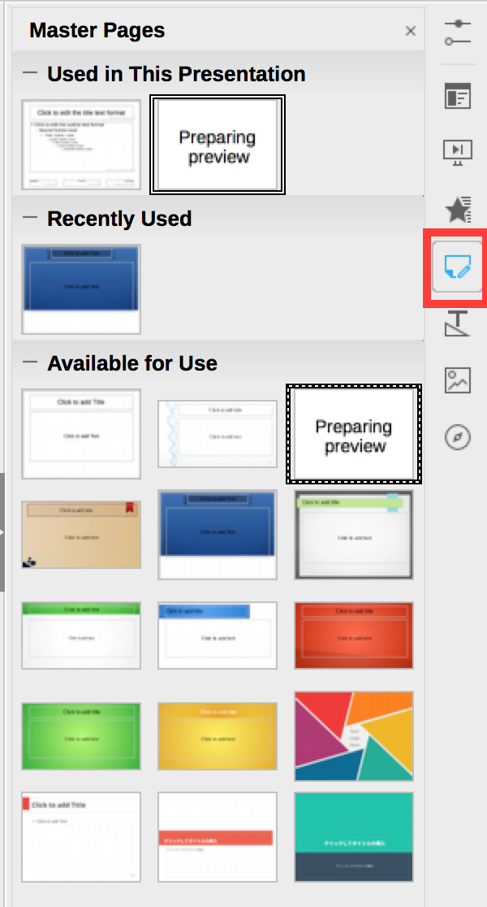
- A selection of predefined slide masters can be displayed in a pane, at the right-side of the edition window. Click on the Master Pages button in the Sidebar to display it. Right-click on the Slide Master of your choice and select Apply to Selected Slides.
- Close the Master View toolbar to toggle back to Normal mode.
To create a new master slide:
- Go to View > Slide Master.

- Click on the New Master button in the Master View toolbar.
- A new slide master appears in the Slides pane. Modify its visual aspect according to your needs, while following the accessibility requirements presented in this guide.
- Name the new master: right-click on the slide in the Slides pane and select Rename Master
- Close the Master View toolbar to toggle back to Normal mode.
  - Adding new slides
To ensure that textual content is accessible, pre-defined slide layouts based on the slide master must be preferred. Manually added text boxes will not be recognized by screen readers, and may disrupt the reading order (see Reading order).
To add a slide with a new layout:
- Click Slide > New Slide. This new slide will have the same layout as the slide master.
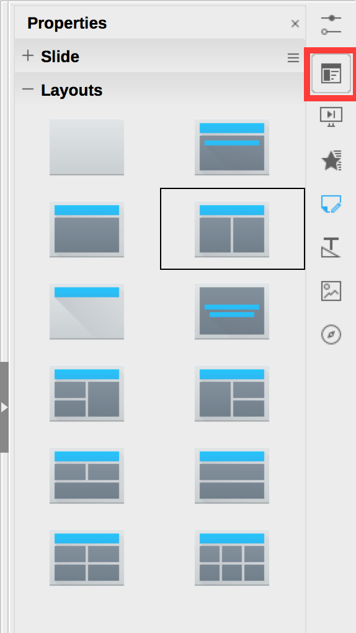
- In the sidebar, click on Properties. This will open the Properties pane on the right-side of the edition window. In the Layouts section, select a layout that suits your needs. If a slide should contain an image, for example, select a layout that includes a content area.
- Fill the slide with contents.

Outline View
LibreOffice Impress provides an outline view that allows you to view any text that is accessible to assistive technologies. Any text on the slide that is not in the Outline View pane will not be read by assistive technologies.
Beyond a control tool, this display mode also provides a convenient way to build a detailed outline that can serve as a starting point for a new presentation.
The titles in the outline view pane represent the titles of the slides, and the indented elements represent the unordered list items.
To create a presentation outline from the Outline View:
- Create a first slide from a master layout (see Adding new slides).
- Go to View > Outline View.
- Type the title of the first slide. Press the Enter key to move to the next line and type the next title. To turn a title into an unordered list item, click on the Demote button in the toolbar.


Titles
Each slide must have a unique title that identifies the nature of the content presented on the slide. Titles structure the content of the presentation and give users the ability to navigate through this structure. If properly inserted, they will also be preserved if the document is saved in PDF format.
Only titles in the “Click to add title” field will be recognized by assistive technologies.

Lists
Lists are used to structure enumerations. When arriving on a list that is properly declared as such, a screen reader user can know the length of the list. If the list elements are actually paragraphs structured by the insertion of dashes in the form of "-" signs or other special characters, they will not be rendered correctly by certain assistive technologies, which will interpret them as a sequence of separate paragraphs.
If you are using a layout that does not include a default bulleted list:
- Select the lines of text in a text area or table that you want to turn into a bulleted list or numbered list.
- Go to Format > Bullets & Numbering…
- Under the Options tab of the Bullets & Numbering dialog box, select the desired format in the Bullets section (for unordered lists) or the Numbering section (for ordered lists).
- Click OK.

Slide numbers
Slide numbers provide important landmarks for any user, including users of assistive technology.
If you use a slide master (see Slide Master) that includes a page number, skip to step 2. If not, switch to Slide Master mode, then:
- Go to Insert > Field > Page Number. Position the Page Number box in the location of your choice, by dragging it with the mouse.
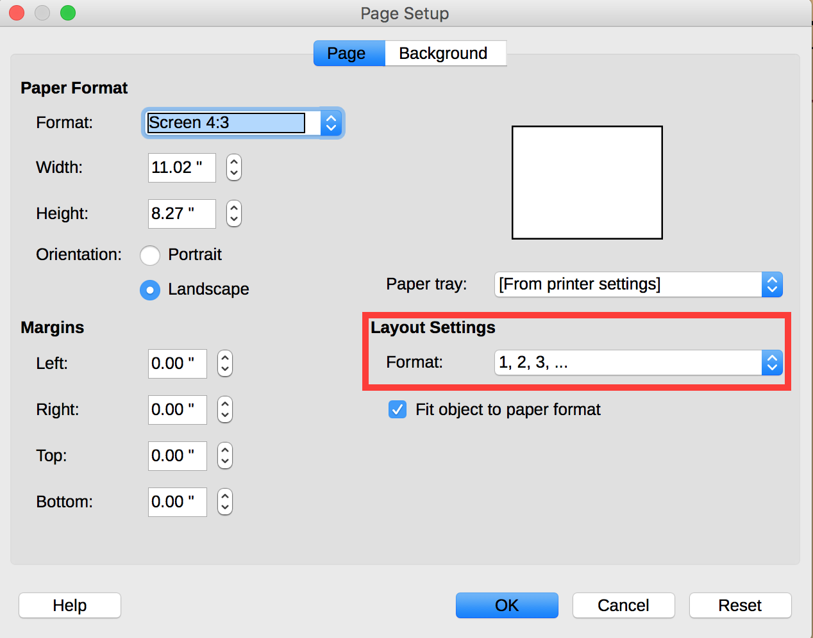
- To modify the format, go to Slide > Slide Properties… In the Page Setup dialog box, under the Page tab, select the numbering format of your choice in the Layout Settings section.

Columns
Mock-columns, created with the tab key or using a data table, can cause difficulties for assistive technology users.
To split a text into two columns, use a predefined layout that includes a column-based layout (two parallel text areas or more).

Headers and Footers
Headers and Footers are not read automatically by screen readers. For this reason, important information should not be contained in these areas.

Notes
The notes area completes slides with information that is not intended to be projected, but can be printed or viewed directly in the Impress file. Because they are well taken into account by assistive technologies, these notes make it possible to enrich the document in order to provide additional information to their users.
To display the notes area:
- Go to View > Notes
- Select the slide for which you intend to add notes.
- Type your notes directly in the notes area below the slide content area (the frame can be resized if needed).
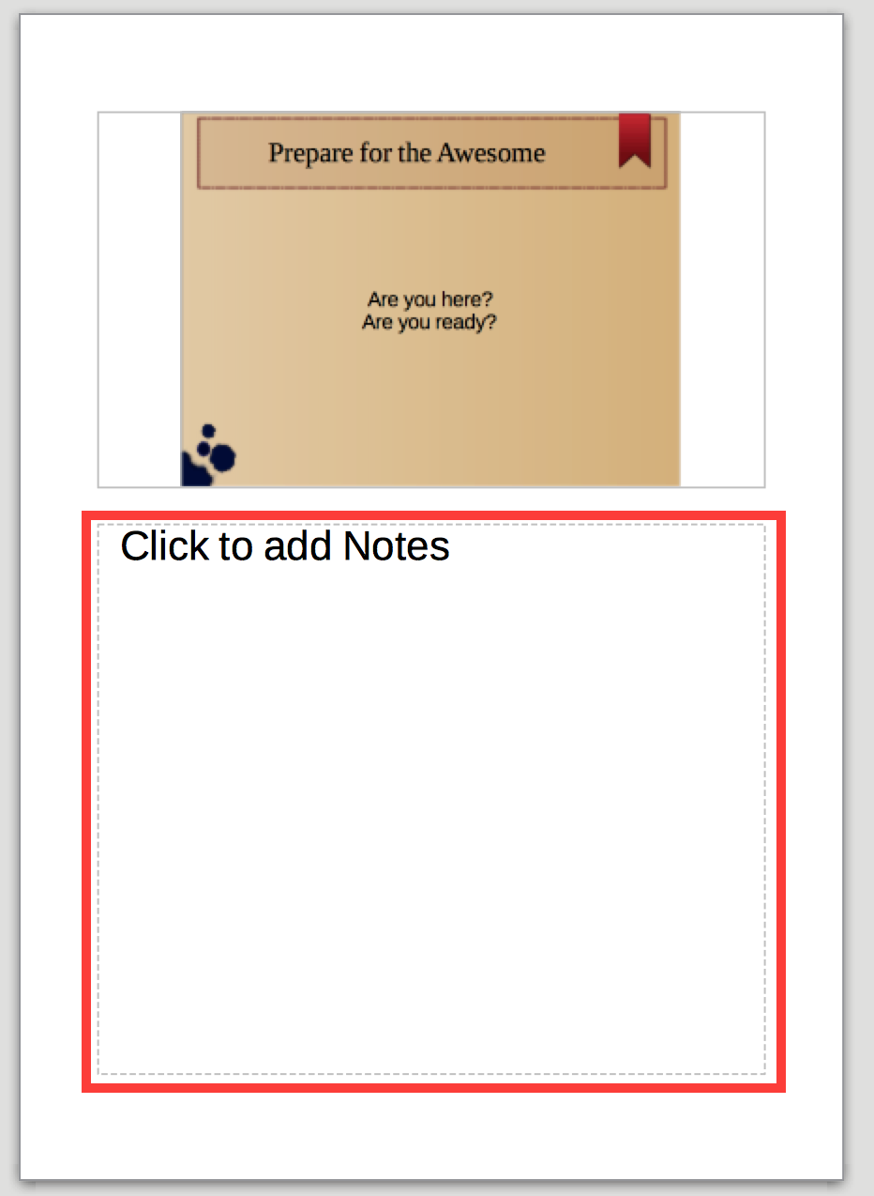
When distributing the slides, consider notifying the users with the presence of notes, through a mention in the first slide.

Reading order
Assistive technologies scan the presentation in a linear fashion. Many users use the Tab key to go from an element to the next one, and Shift + Tab to go back. Some precautions need to be taken so that the reading order is consistent:
- Make sure that the first element of each slide is its title.
- Ensure that each text or object (picture or multimedia content) is preceded by a title, or has a caption to identify it.
- Do not use data tables for layout of contents (text or images) in the presentation.
- Do not use tab keys to create columns.
- Ensure text or images are inserted in suitable areas and do not float outside the content areas.
- Group multiple components of an image to facilitate navigation in the slide and allow for the allocation of only one replacement text.
For more complex slides, you may need to specify a reading order. Impress organizes objects if there is an overlap. This organization also allows for imposing a given reading order for the various objects in the slide. To do this:
- Right-click on the object.
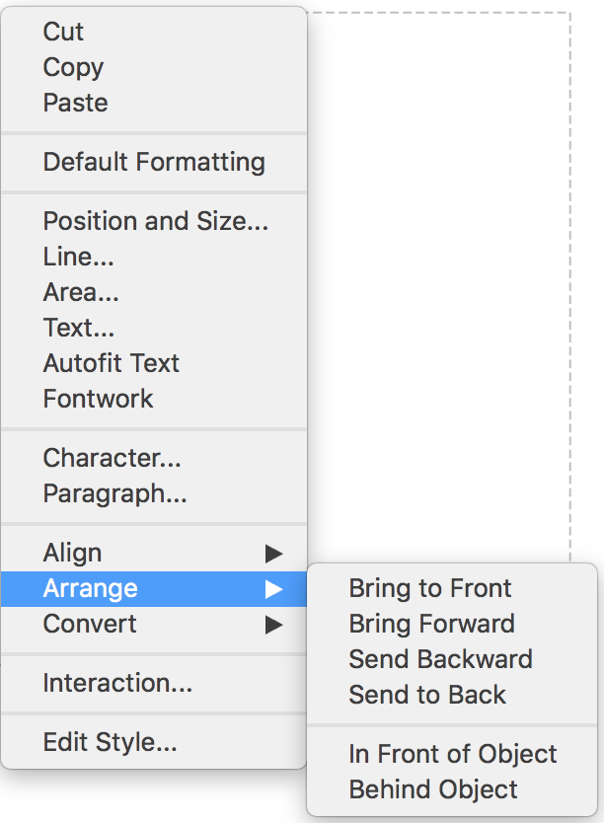
- Select Arrange…
- For the first item, select Bring to Front
- For the last item, select Bring to Back
- For other items, select Bring Forward or Send Backward to define a coherent reading order.
- When you are finished, navigate in the slide with the Tab and Shift + Tab keys to make sure that the reading order is correct.

Using an appropriate presentation

Applicable RGAA Criteria

Category | criteria
Colors | Criterion 3.1 [A] On each Web page, information must not be conveyed through color only. Has this rule been followed?  Criterion 3.2 [A] On each Web page, information must not be conveyed through color only. Has this rule been implemented in a relevant way?  Criterion 3.3 [AA] On each Web page, is the contrast between the text and background colors sufficient (except in particular cases)?  Criterion 3.4 [AAA] On each Web page, is the contrast between the text and background colors enhanced (except in particular cases)?
Mandatory Elements | Criterion 8.9 [A] On each Web page, tags must not be used only for layout. Has this rule been followed?
Presentation of information | Criterion 10.6 [A] On each Web page, can each link whose nature is not obvious be distinguished from the surrounding text?  Criterion 10.12 [AAA] For each Web page, is line and paragraph spacing sufficient?  Criterion 10.13 [A] For each Web page, are hidden texts correctly rendered by assistive technologies?  Criterion 10.15 [A] On each Web page, information must not be conveyed by shape, size or location alone. Has this rule been implemented in a relevant way?

Introduction
The visual complexity of a presentation (the quantity, density and variety of fonts, colors, texts, etc.) can play a decisive role in understanding its content. If the meaning of certain content is conveyed only through color, shape, size or position, readers with no vision, low vision, or altered color perception, may miss some information.

Colors
If information is conveyed only through color, screen reader users (blind or visually impaired users, in general) and some color blind people will not be able to access it. Any information conveyed through color must therefore also be available via another means (for example, an appropriate style).
For information provided through color in text, the solution is to add an explanatory text. For example, in this procedure:
1. Do this.
2. Do that.
3. Do something else.
4. Finish by...
Note: the steps in blue are optional.
The only way to fix it is to change the note:
1. Do this
2. Do that
3. Do something else
4. Finish by...
Note: the steps in blue (2 and 3) are optional.
The contrast between the background and text colors must also be sufficient to make the reading of the presentation comfortable. The RGAA states that the contrast ratio between a non-bold text and its background should be 4.5:1 up to 150% of the default font size, and 3:1 beyond. For bold text, a 4.5:1 contrast ratio is required up to 120% of the default font size, and 3:1 beyond. This applies to text, graphics and images.
A contrast checker is used to determine if colors have sufficient contrasts. The Colour Contrast Analyser, provided by the Paciello Group, can be downloaded free of charge.
Among others, you may also use this online checker proposed by Tanaguru.

Fonts
Whenever possible, some formatting standards should be prioritized to facilitate reading, and make the presentations legible in the main text editors.
- Standard fonts created for ease of reading: Arial, Calibri, Cambria, Constantia, Garamond, Georgia, Helvetica, Times New Roman, Trebuchet MS, and Verdana;
- Font sizes between 18 and 30 points for the body text;
- Normal or expanded character spacing, rather than condensed.
Avoid long chunks of text in uppercase, italic or underlined fonts.
Use the same font faces on all slides, and avoid the text effects (shadings, halos, etc.)

Styles
Using styles allows to modify the formatting of certain types of contents in several locations of the presentation. It can’t be used to provide a hierarchical structure to contents.
To change the format of a type of content (Title, subtitle, outline 1, outline 2, etc.):
- Go to Style > Styles and Formatting
- Select a style to modify.
- Right-click and select Modify…
- Select, for example, the Font tab.
- Select the desired font settings.
- Click OK.

Templates
The template used by LibreOffice Impress by default is blank, and can be used as a basis for the creation of an accessible presentation. It is then possible to create a customized template from this starting point.
To save a presentation as a template:
- Ensure that the document follows the structure, layout, language, description and navigation guidelines proposed here.
- Go to File > Properties…
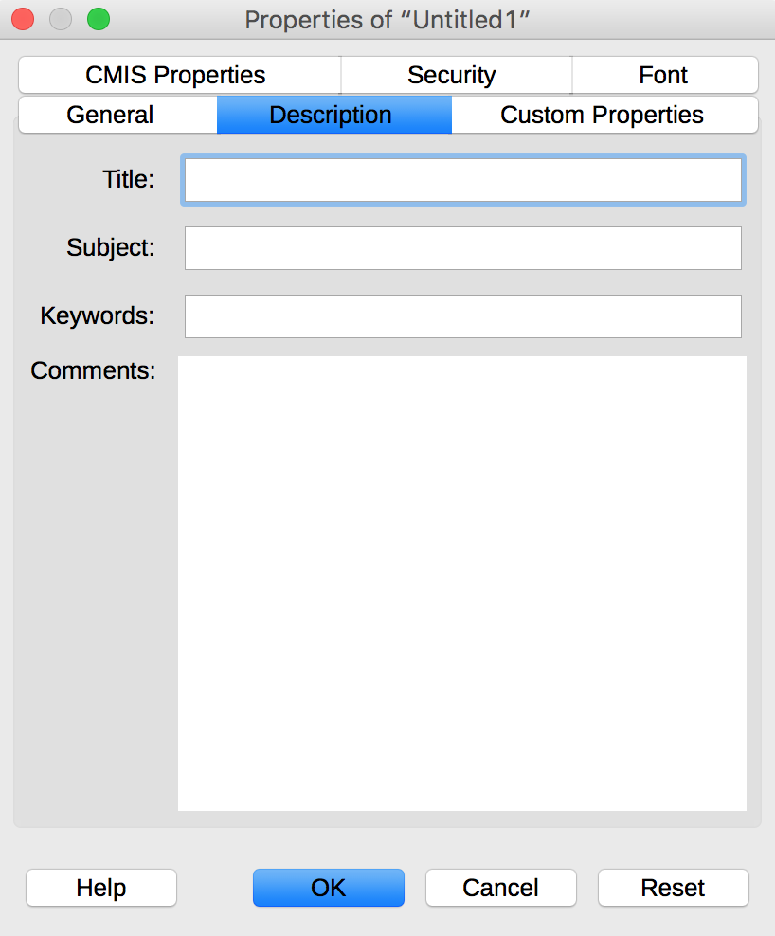
- Under the Description tab, enter a title and a comment that emphasizes the accessible nature of the template.
- Click OK.
- Go to File > Templates > Save as template
- Select the location for your template file and save it.
- In the dialog box, enter a name for your template.
- If you want this template to be used as default, choose Define as default.
- Click OK.
To modify a template, apply the desired formatting modifications, then save and close the template.
To create a new document based on the customized template:
- Go to File New > Templates.
- Double-click where the template has been saved.
- Double-click on the template.

Language

Applicable RGAA Criteria

Category | criteria
Mandatory elements | Criterion 8.3 [A] On each Web page, is the default human language identifiable?  Criterion 8.4 [A] For each Web page with a default human language, is the language code appropriate?  Criterion 8.7 [AA] On each Web page, is each change in the human language identified via the source code (except in particular cases)?  Criterion 8.8 [AA] On each Web page, is each change in human language relevant?  Criterion 8.10 [A] On each Web page, are changes in reading direction identified?
Information Structure | Criterion 9.4 [AAA] On each Web page, does the first occurence of each abbreviation help to know its meaning?
Consultation | Criterion 13.9 [AAA] On each Web page, are unusual expressions, idioms or jargon made explicit?  Criterion 13.10 [AAA] On each Web page, for each expression used in an unusual or restricted way, each idiom or jargon with a definition, is this definition relevant?  Criterion 13.13 [AAA] On each Web page, for each Impress whose meaning cannot be understood without knowing the pronunciation, is this pronunciation specified?  Criterion 13.14 [AAA] On each Web page, does each text that requires a reading ability more advanced than the lower secondary education level have an alternative version?

Introduction
When the contents of a presentation are clear and precise, they are easier to consult. In order to present a document correctly, assistive technologies also need to be able to determine the language of the contents.

Language of the presentation
The language selected for the presentation determines the dictionary used for spell checking, synonyms and hyphenation, as well as a number of formatting rules. For text-to-speech software, it also determines how content is spoken. It is therefore imperative to define a language for any presentation.
To set the language for the presentation:
- Go to Tools > Language > For all text
- Select the language for the whole presentation.

Abbreviations and acronyms
In LibreOffice Impress, there is no mechanism for identifying acronyms, or abbreviations.
To facilitate understanding:
- The meaning of abbreviations and acronyms shall be indicated in clear text in their first occurrences, followed by the abbreviation or acronym between parentheses. For example: National Aeronautics and Space Administration (NASA);
- You can link an acronym or an abbreviation to a glossary via a bookmark or a hyperlink. (see External links).

Unusual, idiomatic or specialized expressions
When it is necessary to use unusual, idiomatic or specialized expressions, an accessible definition must be provided. These definitions can be proposed in the Notes area.

Words or passages in a foreign language
Words in a foreign language must be correctly marked so that the speech synthesizers pronounce them correctly.
To mark up a change of language:
- Select the text that must be marked up.
- Go to Format > Character...
- In the Character dialog box, open the Font tab.
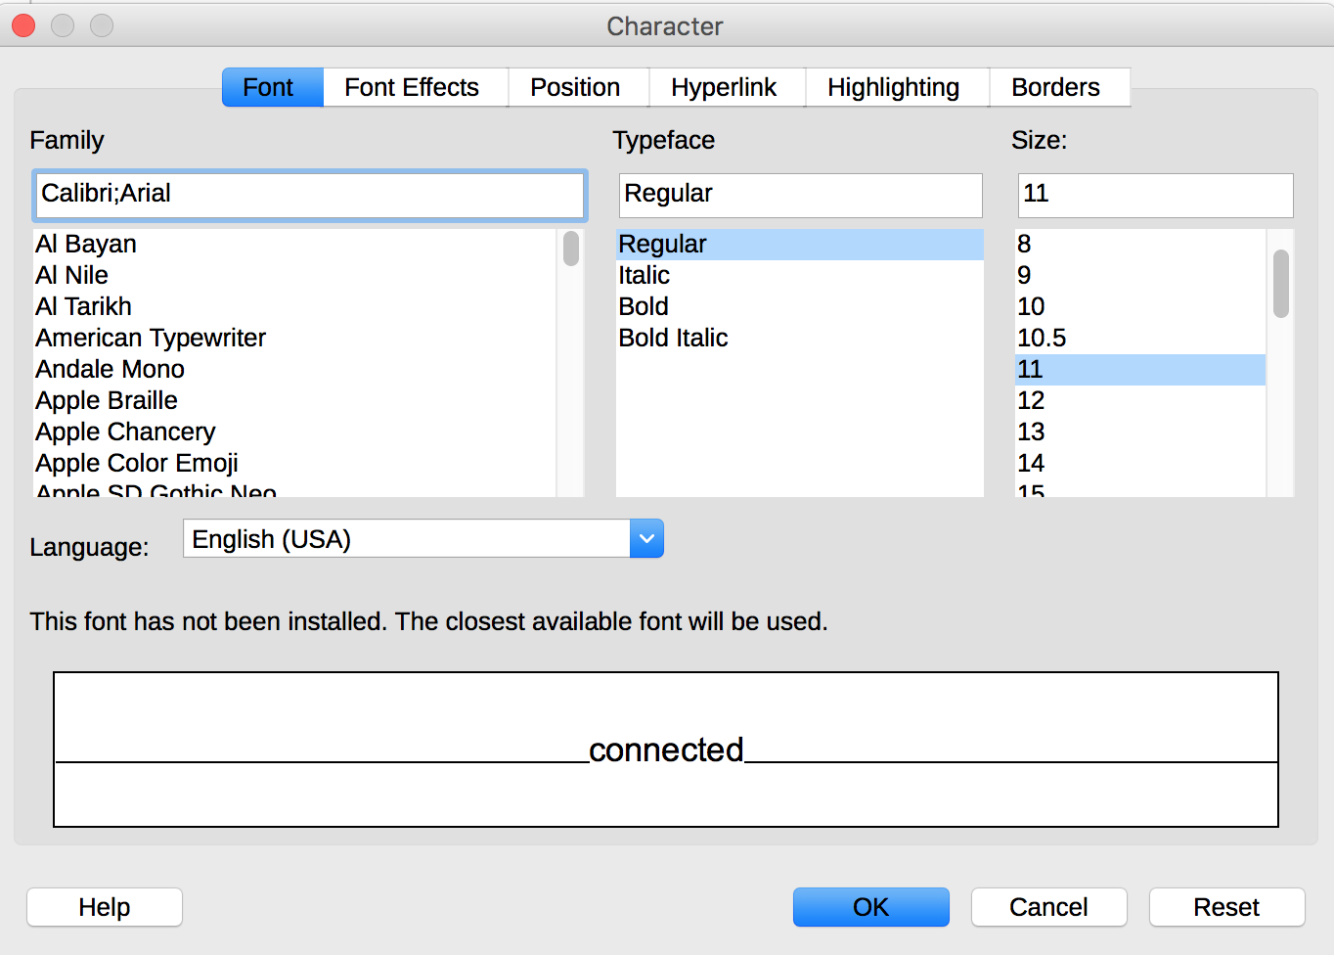
- Select the appropriate language.
- Click OK.
No visual changes will occur; only assistive technologies will have access to this information.

Comprehensive writing
Clear and precise presentations will be accessible to a wider audience. The conveyed message will be more understandable if the slides contents are concise and well organized. Good practices include:
- Choose a clear and descriptive title.
- If possible, keep lists limited to 3 to 7 items by slide: uncluttered slides are easier to understand.
- End each sentence with a full stop, to indicate its end to assistive technologies.

Giving an alternative to non-textual elements

Applicable RGAA criteria

Category | criteria
Images | Criterion 1.1 [A] Does each image have a text alternative?  Criterion 1.2 [A] For each decorative image with a text alternative, is this alternative empty?  Criterion 1.3 [A] For each image conveying information with a text alternative, is this alternative relevant (except in particular cases)?  Criterion 1.6 [A] Does each image conveying information have a detailed description if necessary?  Criterion 1.7 [A] For each image conveying information with a detailed description, is this description relevant?  Criterion 1.8 [AA] When an alternate mechanism is missing, each image of text conveying information must be replaced with styled text, if possible. Has this rule been followed (except in particular cases)?  Criterion 1.9 [AAA] Each image of text conveying information must be replaced with styled text. Has this rule been followed (except in particular cases)?  Criterion 1.10 [A] Is each image caption correctly associated with the corresponding image, if necessary?
Colors | Criterion 3.1 [A] On each Web page, information must not be conveyed through color only. Has this rule been followed?  Criterion 3.2 [A] On each Web page, information must not be conveyed through color only. Has this rule been implemented in a relevant way?  Criterion 3.3 [AA] On each Web page, is the contrast between the text and background colors sufficient (except in particular cases)?  Criterion 3.4 [AAA] On each Web page, is the contrast between the text and background colors enhanced (except in particular cases)?
Multimedia | Criterion 4.1 [A] Does each prerecorded time-based media have a text transcript or an audio description if necessary (except in particular cases)?  Criterion 4.2 [A] For each prerecorded time-based media with a text transcript or a synchronized audio description, are these relevant (except in particular cases)?  Criterion 4.3 [A] Does each prerecorded synchronized time-based media have synchronized captions if necessary (except in particular cases)?  Criterion 4.4 [A] For each prerecorded synchronized time-based media with synchronized captions, are these captions relevant?  Criterion 4.5 [AA] Does each live time-based media have synchronized captions or a text transcript if necessary (except in particular cases)?  Criterion 4.6 [AA] Are each synchronized captions or text transcript, provided for live time-based media, relevant?  Criterion 4.7 [AA] Does each prerecorded time-based media have a synchronized audio description if necessary (except in particular cases)?  Criterion 4.8 [AA] For each prerecorded time-based media with a synchronized audio description, is this audio description relevant?  Criterion 4.9 [AAA] Does each prerecorded time-based media have a sign language interpretation (except in particular cases) if necessary?  Criterion 4.10 [AAA] For each prerecorded time-based media with a sign language interpretation, is this interpretation relevant?  Criterion 4.11 [AAA] Does each prerecorded time-based media have a synchronized extended audio description if necessary (except in particular cases)?  Criterion 4.12 [AAA] For each prerecorded time-based media with a synchronized extended audio description, is this audio description relevant?  Criterion 4.13 [AAA] Does each synchronized or video-only time-based media have a text transcript (except in particular cases)?  Criterion 4.14 [AAA] For each synchronized or video-only time-based media with a text transcript, is this text transcript relevant?  Criterion 4.15 [A] Can each time-based media be clearly identified (except in particular cases)?  Criterion 4.16 [A] Does each non time-based media have, if necessary, an alternative (except in particular cases)?
Consultation | Criterion 13.11 [A] On each Web page, does each cryptic content (ASCII art, emoticon, leetspeak) have an alternative?  Criterion 13.12 [A] On each Web page, for each cryptic content (ASCII art, emoticon, leetspeak) with an alternative, is this alternative relevant?  Criterion 13.15 [A] On each Web page, are sudden changes in luminosity or flashing effects used appropriately?  Criterion 13.16 [AAA] On each Web page, do the sudden changes in luminosity or flashing effects have a frequency lower than or equal to 3 per second?  Criterion 13.17 [A] On each Web page, can each moving or blinking content be controlled by the user?

Introduction
As Impress' primary purpose is to support and illustrate an oral presentation, an important place is often allocated to rich content such as photos, maps, graphics and mathematical formulas that enrich the presentation and convey information to users.
For non-textual elements that convey information, this information must be described verbally in the case of an oral presentation, and presented in text form when the document is intended to be consulted autonomously. Without proper description, these elements remain non-perceivable by assistive technologies that will signal the presence of a graphic element without any other information.
LibreOffice Impress includes tools for creating alternative text that will be rendered to users of assistive technologies.

Images
Any image must be inserted in a content area dedicated to pictures.
You should ask yourself 3 questions before choosing the text that will be rendered in place of the image:
- Is the image purely decorative, not conveying any information and having no function?
- Does the item convey information?
- Does the image have a function (for example, a picture serving as a link)?
If the image is purely decorative, it should not be described and assigned some alternative text.
If the image conveys information, it must be described and associated with a replacement text. This alternative, which also serves as a title, must succinctly describe the information conveyed by the image and its meaning in the context.
For an image that serves as a hyperlink, the alternate text must be able to understand the function and the destination of the link. The conditions for returning this replacement text require that it be as short as possible (a maximum length of 80 characters is strongly recommended). If the information requires a longer alternative, a detailed description must be provided.
A replacement text should not:
- Include copyright information
- Start with "picture of..." or "photo of...".
To associate an alternative text to an image that conveys information or serves as a hyperlink:
- Right-click on the image and select Properties...
- In the Image dialog box, under the Options tab, in the Alternative (Text only) input box, type the alternative text.
- Click OK.
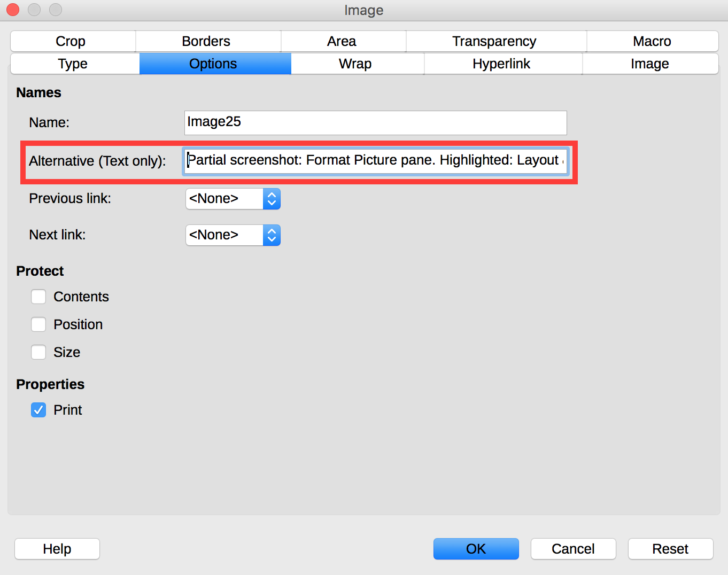
Note that if an image is replaced (right-click on the image and select Replace…), its alternative text will be preserved. If necessary, update this alternative text accordingly.
A detailed description is sometimes necessary when the information conveyed by the image is more complex. This requires an interpretation of the image.
There is no embedded mechanism in LibreOffice Impress 5.2 to associate a detailed description with an image. However, you can add a link on the image itself, in the caption, or next to the image, pointing to a detailed description in an annex of your document. Create this annex and the detailed description, and see the Summary slide and Internal links section for detailed procedure to link to it.
It is also possible to complete this description with information in the Notes area (see Notes).

Images of text
Images of text are images that contain text that is necessary to understand the content of the presentation. It is not recommended to use images of texts when it is possible to reproduce the same effects by defining styles for "actual" text.
If the text is part of a logo or an element associated with the graphic identity of an organization or a company, it is advisable to propose a textual alternative to the image, while following the recommendations above.

Charts
If the needs of persons with disabilities are taken into account during the design phase, charts can be accessible to everyone.
Creating a chart accessible to color-blind and partially sighted readers involves to:
- Not use color alone to convey information (use of textures or shapes to differentiate the components of the graph for example);
- Emphasize the use of dashed line styles to improve readability;
- If necessary, replace predefined colors to meet the contrast requirements (see Colors).
Every chart, like any picture, must be inserted in a dedicated content area.
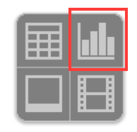
- When inserting a new slide, select the chart icon at the center of the content area.
- Right-click on the inserted chart and select Chart Type...
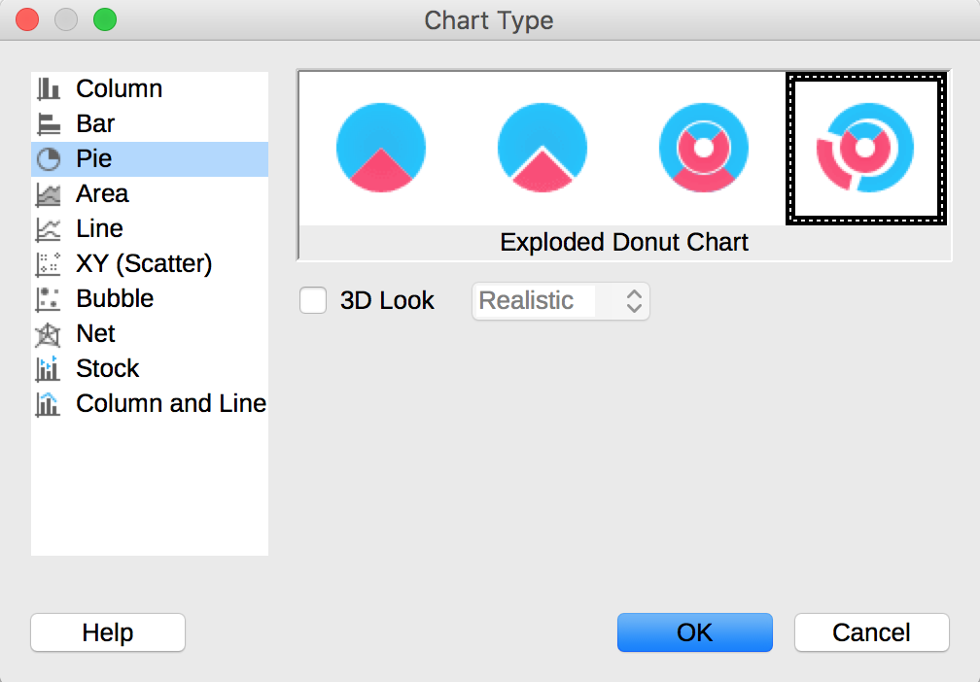
- In the Chart Type dialog box, select one of the proposed options and click OK
- Right-click on the inserted chart and select Data Table....
- Update the table with your data and click OK.
- Right-click on the chart shape you want to modify and select Format Data Series…
- In the Data Series dialog box, select settings that meet accessibility requirements, for the different elements of the chart.
Once the chart is created, its elements should be clearly identified, and it should be assigned a title.
To insert titles and data labels:
- Select the chart.
- Go to Insert > Titles
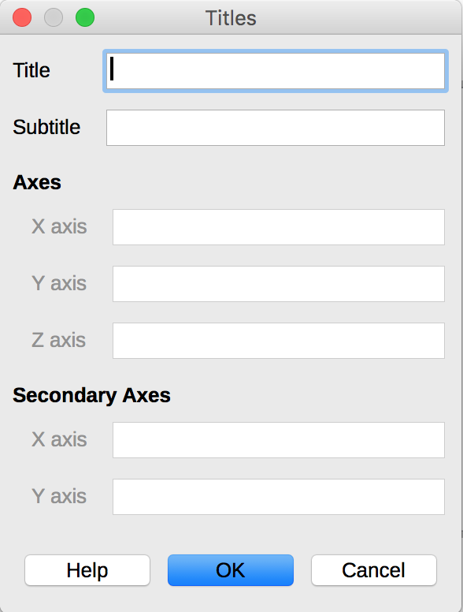
- Fill in the appropriate fields and click OK.
- Go to Insert > Data Labels…
- Define the data labels and click OK.
The title and labels of the axes provide necessary elements for the interpretation of the data presented, but will not suffice to transmit the specifics of the graphic necessary for its comprehension to someone who fails to see it.
For simple charts, a simple replacement text may suffice. For more complex or detailed charts, it is necessary to provided a detailed description. In both cases, it is necessary to avoid listing the raw data as a textual alternative, but rather to explain the information that you wish to convey by inserting the chart in the presentation.
There is no embedded mechanism in LibreOffice Impress 5.2 to associate a detailed description with an image. However, you can add a link next to the image, pointing to a detailed description in an annex of your document. Create this annex and the detailed description, and see the Summary slide and Internal links section for detailed procedure to link to it.
It is also possible to complete this description with information in the Notes area (see Notes). In this case, add a mention like “See notes for a detailed description”.

Multimedia
It is possible to insert and play video and audio files in a LibreOffice Impress presentation. However, by default, playback of media files starts as soon as the slide is displayed during the presentation, without the user having the option to stop or pause. This behavior does not comply with Criterion 4.18 [A] (each automatically triggered sound must be user-controllable). It is possible to bypass this behavior by inserting an object on which the user must click to start the playback of the media file.
To insert a video or audio clip with no automatic playback:
- Insert an image on which the user will click to play the media file (a poster from the video, or the “Play” icon for instance). Add an alternative text to it, describing its function (see Images).
- Right-click on the image, and select Interaction…
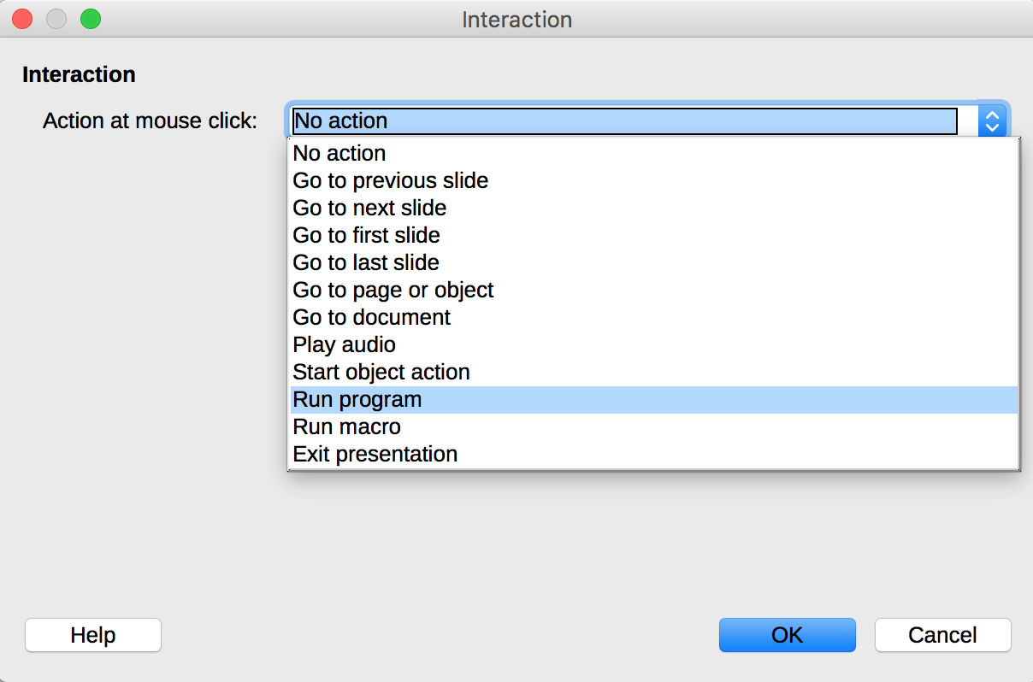
- In the list of possible interactions, select Run Program
- Browse to find the video or audio clip to be played, and click OK.
In Slideshow mode, the video or sound sequence will open with the player installed by default on the computer.
By default, Impress binds the media file to the presentation. If the presentation is moved, media playback will no longer work. To avoid this problem, place the media file in the same folder as the presentation and think about copying the presentation and the media file when you move the presentation.
A replacement text must accompany any video or audio clip (see techniques described in Images). It is also necessary to provide a transcript for any video or audio sequence, and to ensure that the videos include closed or open captions.
The purpose of a transcription is to provide a coherent alternative to multimedia content. Readers must have access to all the information conveyed by the video or audio file, including the dialogues between the participating protagonists, the location, the main actions and the atmosphere.
The transcript may be proposed in the notes area, or in a downloadable file located on a distant server, and accessed via a link located close to the object.

Mathematical Formulas
LibreOffice includes a formulas editor that works with all applications in the LibreOffice suite. It allows the insertion of mathematical and scientific formulas formatted and readable by assistive technologies. These formulas can be converted into accessible formats.
The formulas are written in a special module (Math) and inserted in the text in the same way as the charts. This way, they can be exported in MathML format, which can be rendered by assistive technologies.
To insert a formula:
- Go to the Insert > Object > Formula....
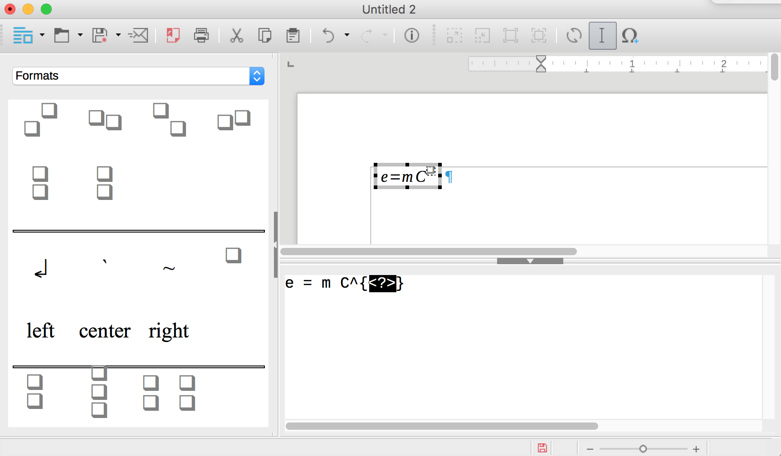
- The Math module opens with an Elements pane with predefined symbols, and an edition window at the bottom to manually enter the formula. Right-click at the bottom to open a contextual menu that provides access to the Equation Editor commands.
- Once the formula is entered, you must click on the page to exit the Math module.

Creating accessible tables

Applicable RGAA criteria

Category | criteria
Tables | Criterion 5.1 [A] Does each complex data table have a summary?  Criterion 5.2 [A] For each complex data table with a summary, is this summary relevant?  Criterion 5.3 [A] For each layout table, is the linearized content still understandable (except in particular cases)?  Criterion 5.4 [A] Does each data table have a title?  Criterion 5.5 [A] For each data table with a title, is this title relevant?  Criterion 5.6 [A] For each data table, are each column header and each row header correctly identified?  Criterion 5.7 [A] For each data table, is each cell associated with its header cell using the appropriate technique?  Criterion 5.8 [A] Each layout table must not use elements intended for data tables. Has this rule been followed?

Introduction
Tables constitute a complex environment for users of assistive technologies because the organization of information and the relationships between them can't be perceived and scanned quickly. The more complex is the table, the more difficult it is to access information.
It is necessary to ensure that each data cell in the table can be correctly linked to the header cell(s) that make it meaningful.

Layout tables
The use of tables for layout purposes is generally not a good practice: it is preferable to use the layout functions (columns, borders, etc.). To layout a text in columns, for example, it is appropriate to use the functionality described here: 9 Columns.
The use of the tab key and the space bar to simulate tables of data is to be avoided because assistive technologies are not able to interpret this type of formatting.

Data tables
To insert a data table, you must use the Insert a table feature proposed in the content areas dedicated to tables, or the features proposed under the Insert tab in the Tables group.
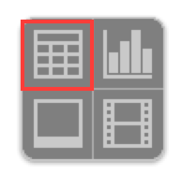
- When inserting a new slide, select the table icon at the center of the content area.
- In the Insert Table dialog box, choose the number of rows and columns then click Insert.

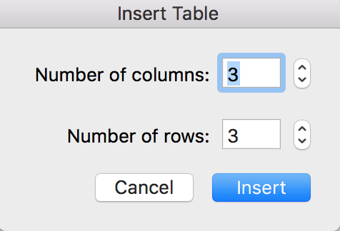
Formatting
If a data table proves to be the best option to present information, it is necessary to follow some formatting rules in order to make the presented data accessible and comprehensible to the greatest number:
- Create a uniform table facilitating the identification of each cell and its significance in the context.
- Prefer several simple tables to more complex tables.
- Avoid nesting tables in one another.
- If possible avoid merged cells.
- Eliminate empty cells - if data is missing, replace it with an explicit mention.
- Generate blank spaces using wider spacing and not by inserting blank rows.
- Avoid inserting images within the table, because they are poorly rendered by assistive technologies in this context.
- Choose colors that suit the needs of people with altered color perception, and fonts and shapes respectful of the needs of users with low vision or reading disorders.
- Choose visible cell borders, to ease their consultation by users of screen magnifiers.
It is then necessary to identify the contents of the table by means of the headers and the alternative text, and to define these properties to allow a better experience for screen readers users.

Row and column headers
The row and column headers indicate the relationship between the data presented. To specify the presence of a header row in a table, follow these steps:
- Insert a table, following the instructions above.
- In the Properties pane, a Table design is displayed. Select a design that suits your needs.
- In the proposed options, check that Header row is checked.
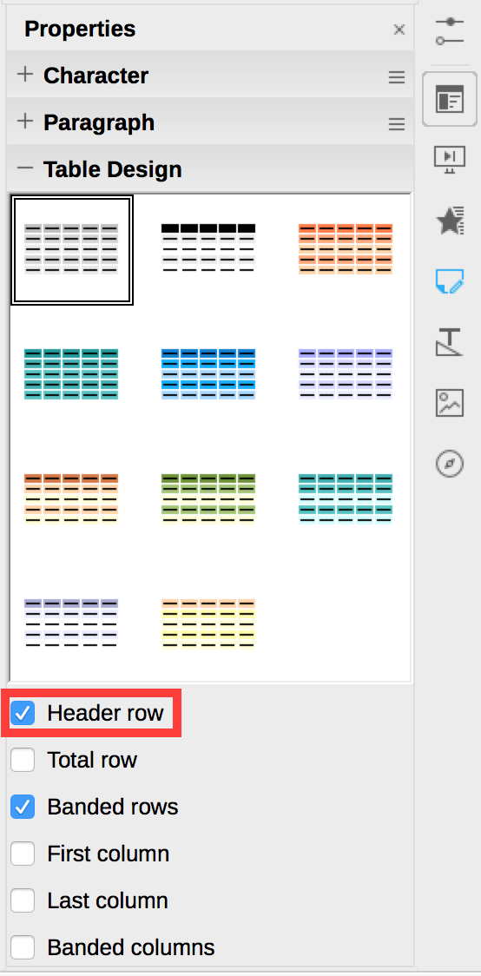
Note: headers content must be clear and concise.
LibreOffice Impress can not associate cells and their headers in a complex table (more than one row or more than one column of headers). If possible, complex tables should be simplified.
Since tables can not be split on multiple pages with Impress, it is necessary to ensure that the headers are repeated with each new iteration of the table.

Text alternative
In a simple data table, an explicit title may be sufficient to describe the contents of the table. For complex data tables, a textual alternative may be necessary to present the purpose of the data table in the context (see techniques to provide alternative texts: Images).

Copying and pasting tables from a LibreOffice Calc workbook or LibreOffice Writer document
When inserting a table in LibreOffice Impress from a LibreOffice Calc workbook or a LibreOffice Writer document, it is important to follow these guidelines to prevent the table from being pasted as an image and therefore becoming inaccessible to many users:
- Open the LibreOffice Calc sheet or the LibreOffice Writer document, and select the cells in the table that you want to copy.
- Right click and choose Copy.
- Switch to the Impress presentation, then click in an area dedicated to tables.
- Go to Edit > Paste Special…, and choose HTML (HyperText Markup Language)
- Set the headers and provide a text alternative for the table, by following the instructions above.
If necessary, a hyperlink to the Writer or Calc file can be inserted, provided they are accessible.

Creating navigation aids

Applicable RGAA criteria

Category | criteria
Links | Criterion 6.1 [A] Is each link explicit (except in particular cases)?  Criterion 6.2 [A] For each link with a link title, is this title relevant?  Criterion 6.3 [AAA] Is each link text alone explicit out of context (except in particular cases)?  Criterion 6.4 [A] For each web page, does each identical link have the same purpose and target?  Criterion 6.5 [A] On each Web page, does each link, except in anchors, have a text?
Navigation | Criterion 12.7 [AA] On each page within a collection of pages, are links facilitating navigation available?

Introduction
When the contents of the Impress presentation are clearly identified, they are easier to read. In addition to the structuring elements described in the previous sections, it is possible to enrich the document with navigation elements pointing to contents inside and outside the document.
The transition or animation features offered by Impress may be problematic for some users if their needs are not taken into account.

Summary slide and Internal links
It is not possible to generate a table of contents automatically in Impress. However, it is possible to automatically generate a summary slide listing all the slides titles, and then link these titles to their slides.
To create a summary slide:
- Go to Slide > Summary slide. A summary slide is created at the end of the presentation.
- To move the summary slide, drag and drop it with the mouse where you want it in the Slides pane.
Then insert hyperlinks to the slides listed in the summary.
To insert hyperlinks to named elements:
- Select the text you want to turn into a hyperlink.
- Go to Insert > Hyperlink.
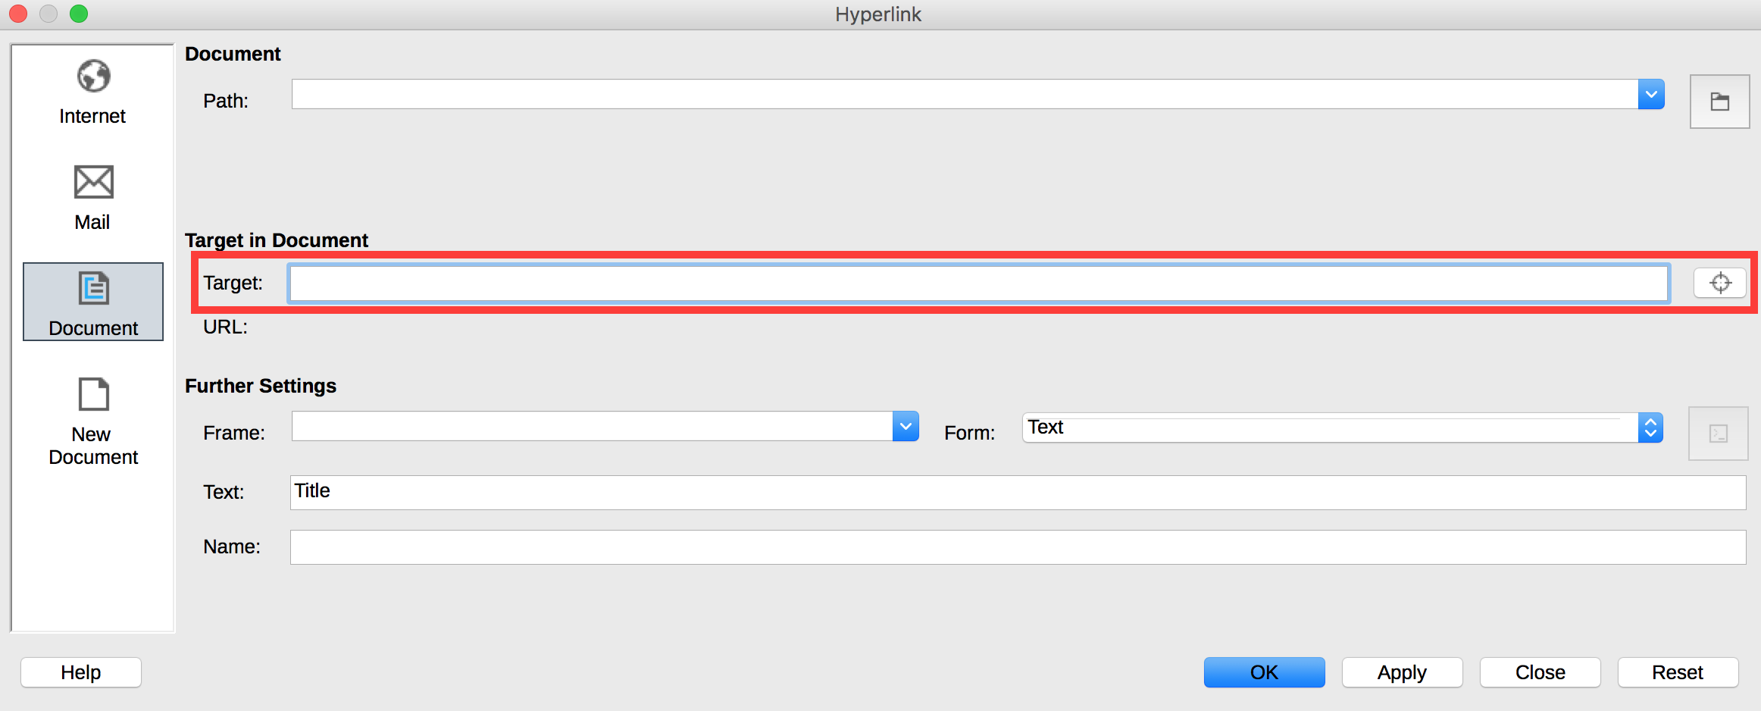
- In the Hyperlinks dialog box, in the left column, select the Document button. In the Target in Document section, click on the Target button (with a symbol looking like a cross-wire).
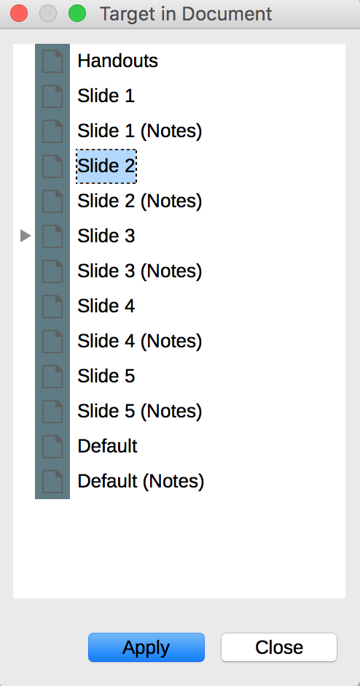
- In the Target in Document dialog box, select the slide you want to target (refer to the Slides pane for the slide number).
- Click on Apply then Close.
To insert a link to another slide inside the presentation, follow the instructions above. If the link text is not explicit, in the Further settings section of the Hyperlink dialog box, in the Text field add an explicit text to describe the destination of the link.

External links
Hyperlinks can also be used to provide access to resources in another file or on a web page.
Explicit link texts should be used, making them understandable in their context.
To insert and/or edit a hyperlink and define its text:
- Position the cursor where you want to insert and / or edit an internal link.
- Go to Insert > Hyperlink.
- In the Hyperlinks dialog box, in the left column, select the Internet button.
- In the URL field, insert the destination of the hyperlink.
- In the Further settings section, fill in the Text field to add an explicit text
- Click on Apply then Close.
Notes:
- For external links, inserting a footnote containing the complete link address provides adequate information to those who print the document.
- The hyperlinks in a foreign language must be properly marked, so that speech synthesizers pronounce them correctly.

Transitions
LibreOffice Impress 2016 offers many different types of transitions to make a presentation more dynamic, by animating the transition from one slide to another. Transitions are to be used with caution during the oral presentations, in order to avoid disturbance for the audience, because rapid movements or sudden changes in luminosity can cause discomfort, and even seizures for some people.
To keep control over the speed of keyboard and mouse transitions, once the transition has been created, in the Slide Transition pane, in the Advance Slide section, check On Mouse Click.
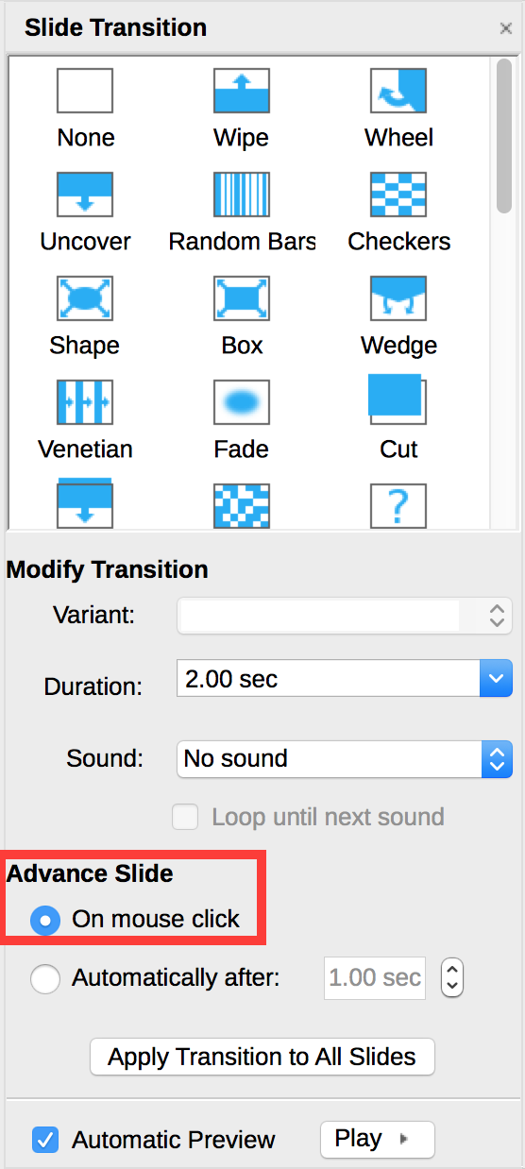
If transitions are used during the oral presentation, however, they can be removed before the Impress file is distributed for viewing, because they can disrupt reading for people using assistive technologies.

Animations
As with transitions, the numerous animations proposed by Impress are to be avoided because they can affect reading during an oral presentation, as well as during a later consultation.
If you need to include an animation, make sure that the animation is brief and triggered manually: in the Custom Animation tab, in the Start list box, select On Click.
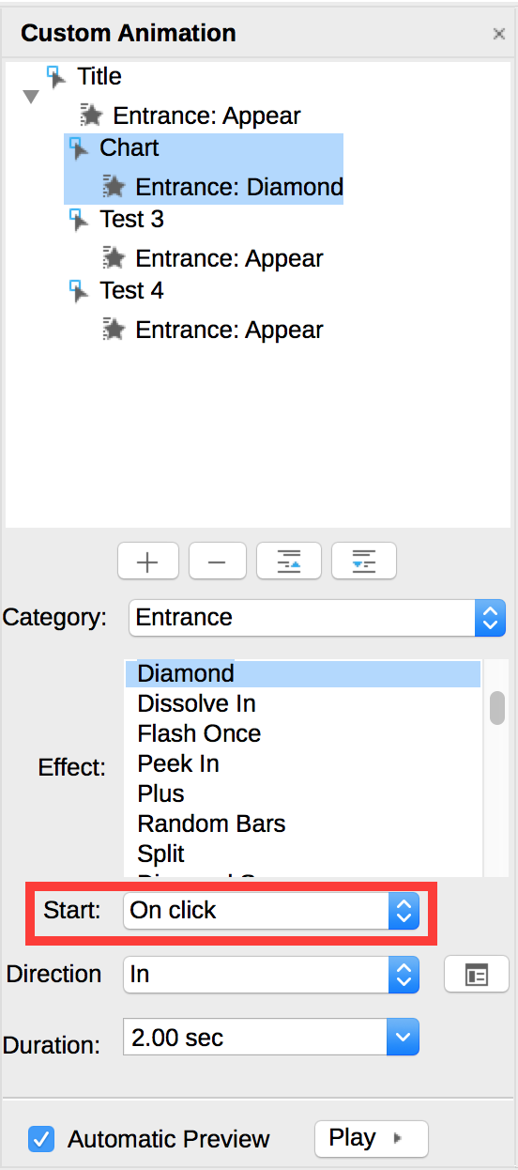

Providing additional information

Document properties
Document properties, also known as metadata, are information about a file that describe or identify it. They include information such as title, author's name, subject, and keywords identifying the topics or content of the presentation.
When opening a presentation, some assistive technologies refer to these properties to announce the title of the presentation and to summarize the content.
These properties are also preserved and used when the presentation is published in another format (see Error: Reference source not found).
To view and edit the properties of a presentation in LibreOffice Impress:
- Click File > Properties
- Under the Description tab, fill in the Title of the document, Keywords, and if appropriate, information in the Comments area about its accessibility. The title should always be set.

Publishing the presentation in other formats

Introduction
If the techniques described in this guide are used during the creation of an electronic document, this document will not only be read by users of assistive technologies for the software used for creation, but its semantic composition will also allow for better conversion into other formats, although some adjustments may still be necessary depending on the chosen format.
In this guide, the publication process is described for the following formats:
- HTML
- PDF
Conversion to these formats assumes that documents are properly structured upstream, by following the guidelines described in the previous chapters of this guide.
It is necessary to ensure that the elements related to the accessibility of the document are preserved when saving or exporting to other formats. This evaluation work and any corrections due to loss of information or conversion errors will not be discussed in detail in this guide.

Publishing in HTML
LibreOffice Writer allows to publish natively an HTML document. Proceed as follows:
- Go to File > Export...
- In the File type list, select HTML Document (Impress).
- Select a folder where all the created files will be saved, then click Save.
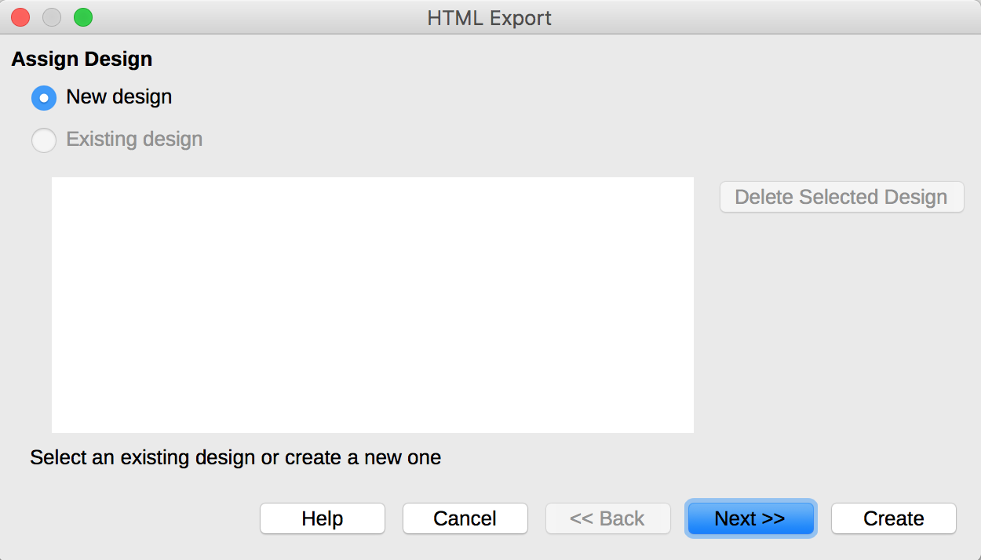
- A HTML Export wizard will guide you through the settings of your export.
- Follow the instructions, and in the end click Create.

Checking the accessibility of the HTML document
During export, some semantic information and some contents are not preserved. Open the HTML document in a browser such as Mozilla Firefox and use the HTML test tools to check the accessibility of the page and fix export issues.

Export to PDF
PDF (Portable Document Format) is a format developed by Adobe Systems. It preserves the formatting defined by the author, regardless of the application or platform used to read it.
PDF may contain tags that reflect the document structure. A tree of tags represents the organizational structure of the document and allows assistive technologies to determine the presentation and interpretation of its content.
When the techniques described in this guide are followed when creating the document, the conditions are optimal for the document to be converted to PDF without loss of structure or information.
To export to PDF:
- Go to File > Export as PDF...
- Under the General tag in the PDF Options dialog box, check Tagged PDF.
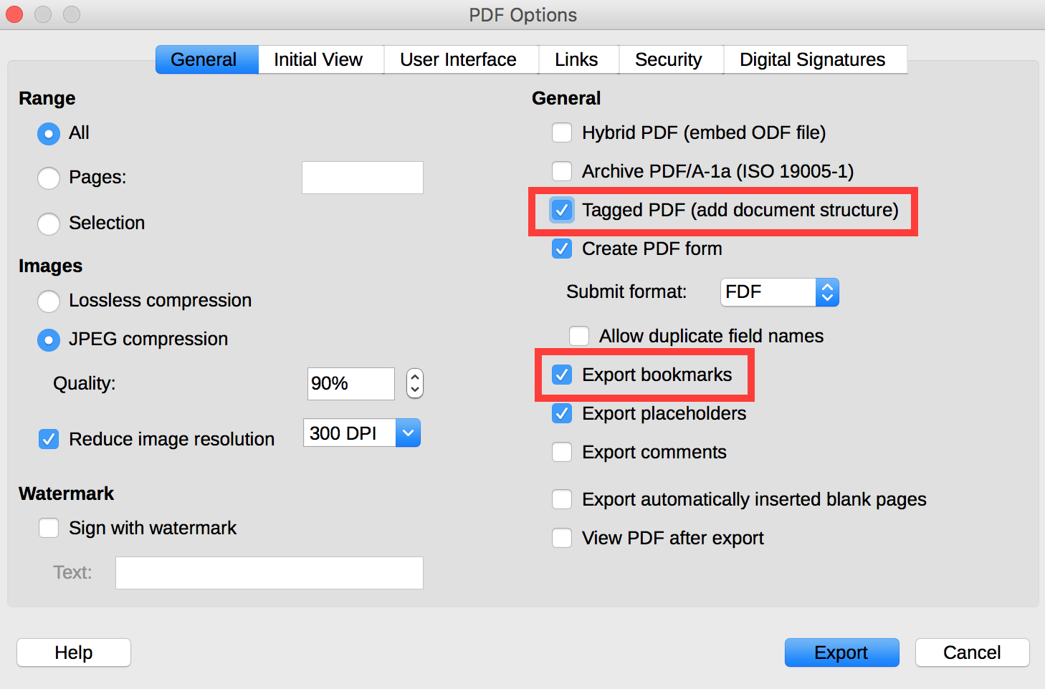
- Under the same tab, check Export bookmarks.
- Under the Initial View tab, in the Pane section, check Bookmarks and Page.
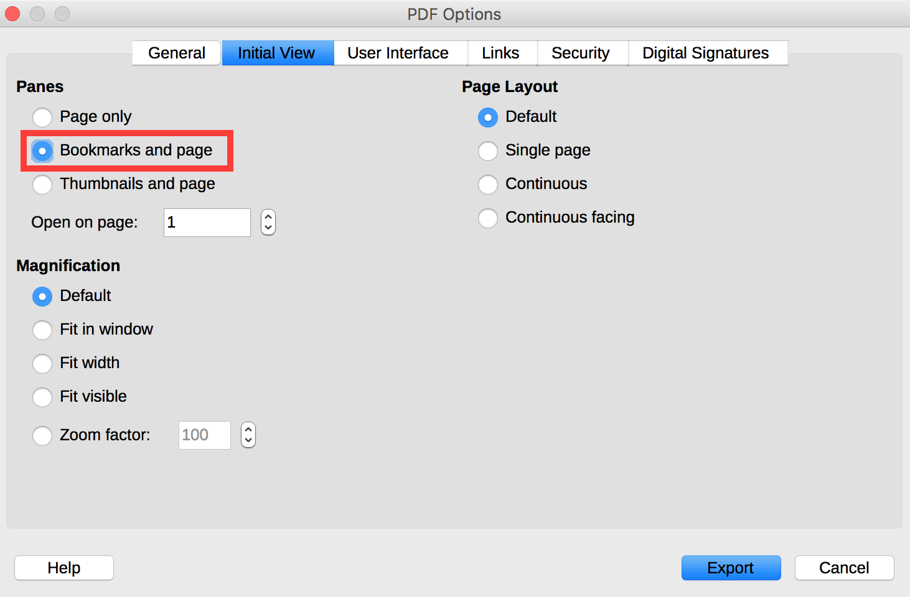
- Click on Export.
- Choose a name and a location for your file.
- Click on Export.

Accessibility evaluation of a PDF document
Some accessibility related contents, like the alternative texts for images, are not preserved during the export to PDF. The evaluation of the accessibility of the PDF document requires a screen reading software to check that the reading order and restitution of content are correct. To enable the consultation of the document with screen reading software, make sure that the permissions are set correctly:
- Open the file in Adobe Acrobat and open the File > Properties > Protection menu.
- In the Protection method drop-down list, select No protection.
- Click OK and close the dialog box.
If a number of conversion problems can be detected with a screen reader software (reading order, correct markup, passages in a foreign language, etc.), the Adobe Acrobat Professional software (paid solution) is required to correct possible markup errors.

Impress presentation as a support for oral presentation
Although an Impress presentation can be designed as a stand-alone document, it is often used to support an oral presentation with visual information.
To create Impress presentations that are accessible to all, regardless of the capabilities or limitations of the audience, it is imperative that any visual information that makes sense for the oral presentation is described, so that people who can’t see the projection have access to the same information. In no case should the slide replace speech.
To make the presented information accessible and understandable to the largest audience:
- If possible, distribute a digital version of your slides in advance, so that the audience can see the information on the screen of their laptops. Some participants will also benefit from a printed version in enlarged text;
- Express yourself clearly and accurately, at a reasonable speech rate;
- Begin by introducing yourself and announcing the format of the presentation (the allotted time, the outline, when the audience can ask their questions, etc.). If you agree that audience will interrupt you to solicit an explanation in case of misunderstanding, let it be known;
- Make sure that any text on the screen is announced verbally. And do not forget to limit yourself to between 3 and 7 sentences per slide;
- Explain any graph or diagram by stating the information you want to convey by presenting it;
- Describe, instead of pointing the finger, where on the slide the information you are referring to is located;
- If someone asks a question, repeat the question before answering it.

Sources
Authoring Techniques for Accessible Office Documents: OpenOffice Impress, Accessible Digital Office Document Project (ADOD), developed by the Inclusive Design Research Centre, OCAD University (Ontario, Canada) as part of an EnAbling Change Partnership project with the Government of Ontario and UNESCO (United Nations Educational, Scientific and Cultural Organization).
How to make visual presentations accessible to audience members with print impairments (PDF, 54 kb), IFLA & World Blind Union, adapted by Minna von Zansen and Jenny Craven from the WBU Guidelines.
LibreOffice Impress guide.

License
This presentation is the property of the Secrétariat général à la modernisation de l'action publique (SGMAP). It is placed under Open Licence 1.0 or later (PDF, 541 kb), equivalent to a Creative Commons BY license. To indicate authorship, add a link to the original version of the presentation available on the DINSIC's GitHub account.

URL: https://disic.github.io/rgaa_referentiel_en/criteria.html#crit-13-7
https://www.paciellogroup.com/resources/contrastanalyser/
http://contrast-finder.tanaguru.com/?lang=en
http://adod.idrc.ocad.ca/ooimpress
https://www.ifla.org/files/assets/hq/officers/documents/wbu-visual-presentations-guidelines-summary.pdf
https://wiki.documentfoundation.org/Documentation/Publications#LibreOffice_Impress_Guide
http://ddata.over-blog.com/xxxyyy/4/37/99/26/licence/Licence-Ouverte-Open-Licence-ENG.pdf
https://github.com/DISIC

