**CLOUD COMPUTING ASSIGNMENT**

Development of Simple web app in S3 BUCKET provided by

AWS

Done by,

**YAZHINIYAN .P**

**2021115306**

**S3 BUCKET Service Provider**: Amazon Web Services

**Set Up AWS Account:**

* Sign in to the AWS Management Console or create a new account if you don't have one.
* Navigate to the Amazon S3 (Simple Storage Service) console.

**Create a Bucket:**

* Click on "Create bucket" to make a new storage bucket.
* Choose a unique bucket name and select the region for your bucket.

**Upload PDF File:**

* Once the bucket is created, open it and click on "Upload" to add your PDF file.
* Select the PDF file from your local system and upload it to the bucket.

**Step 1**: AWS sign in :

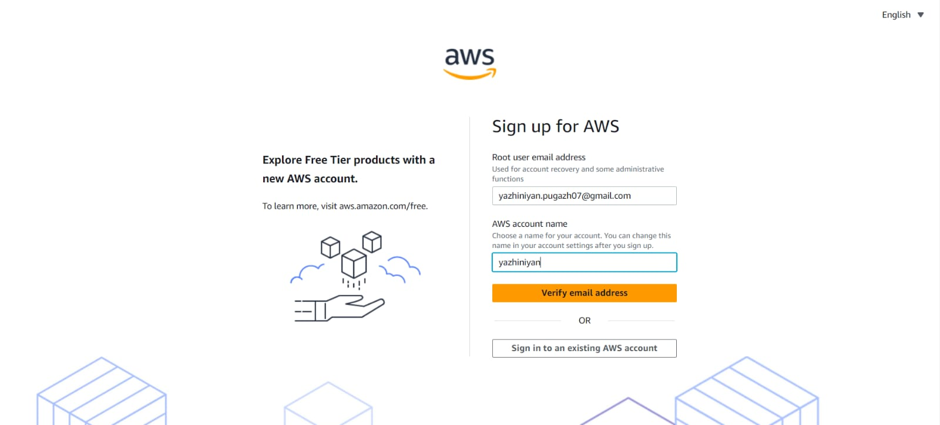

**Step 2**: Get in to the ROOT User:

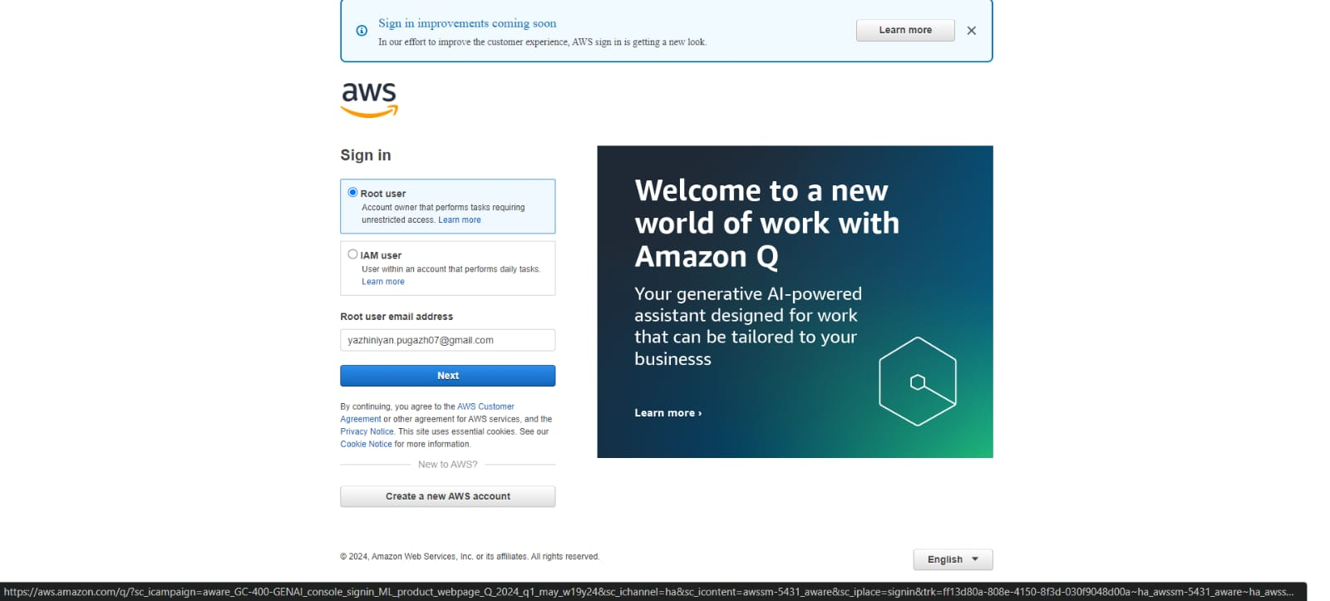

**Step 3 :** Creating s3 bucket in AWS:

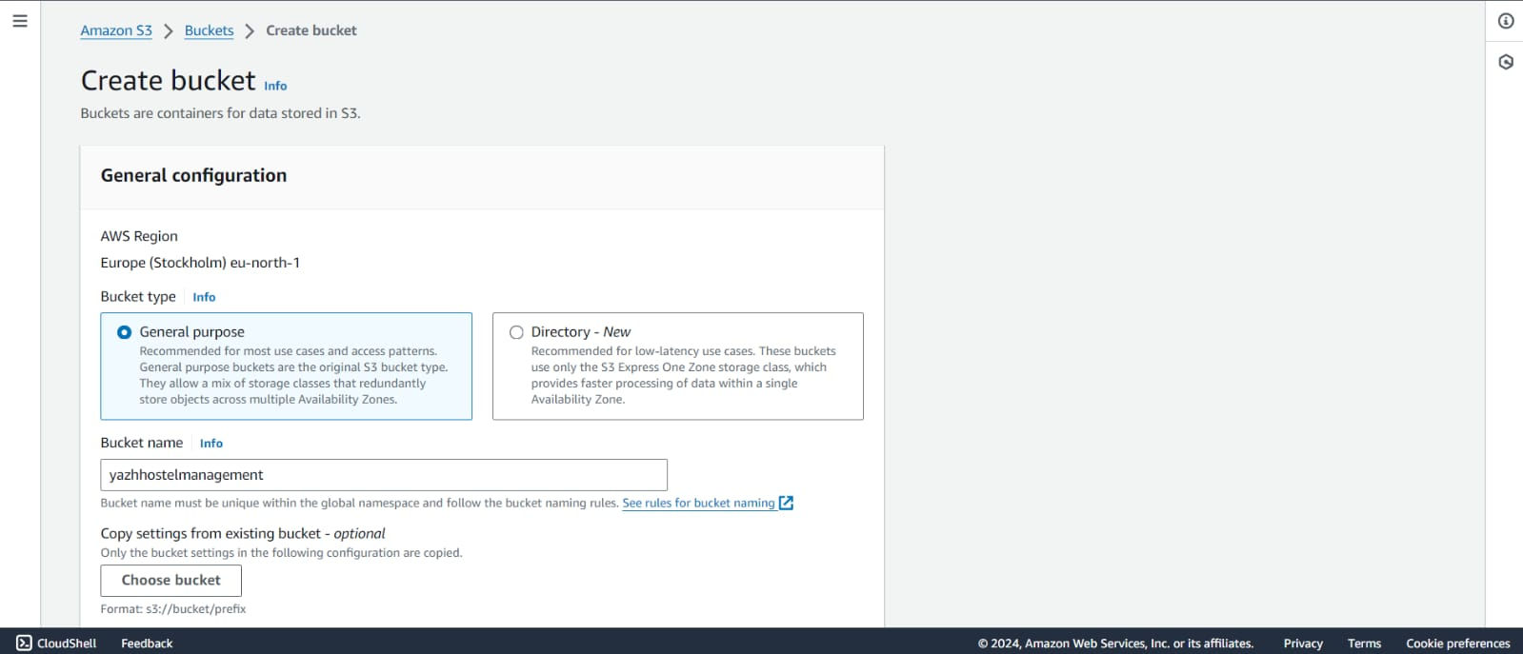

**Step 4**: Sucessfully created AWS s3 Bucket:

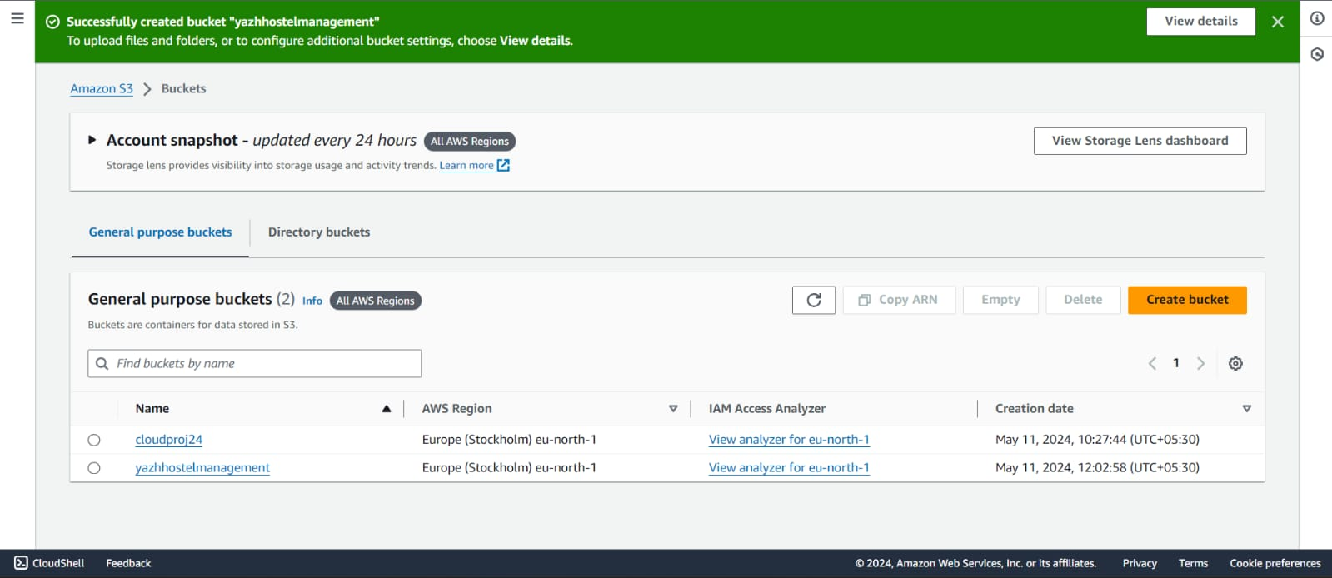

**Step 4**: WEB APPLICATION :

* User registeration:

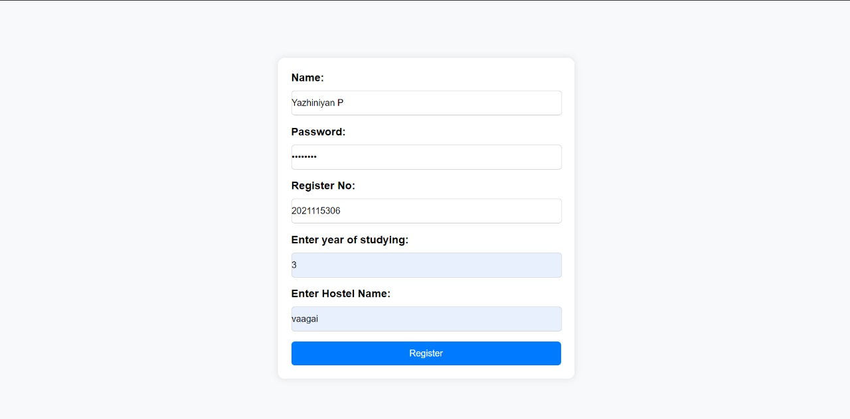

**Step 5**: User login :

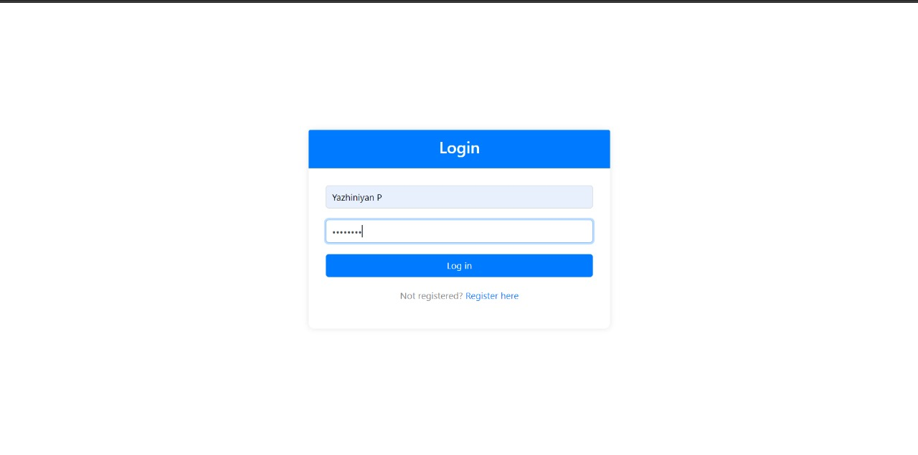

**Step 6**: user info:

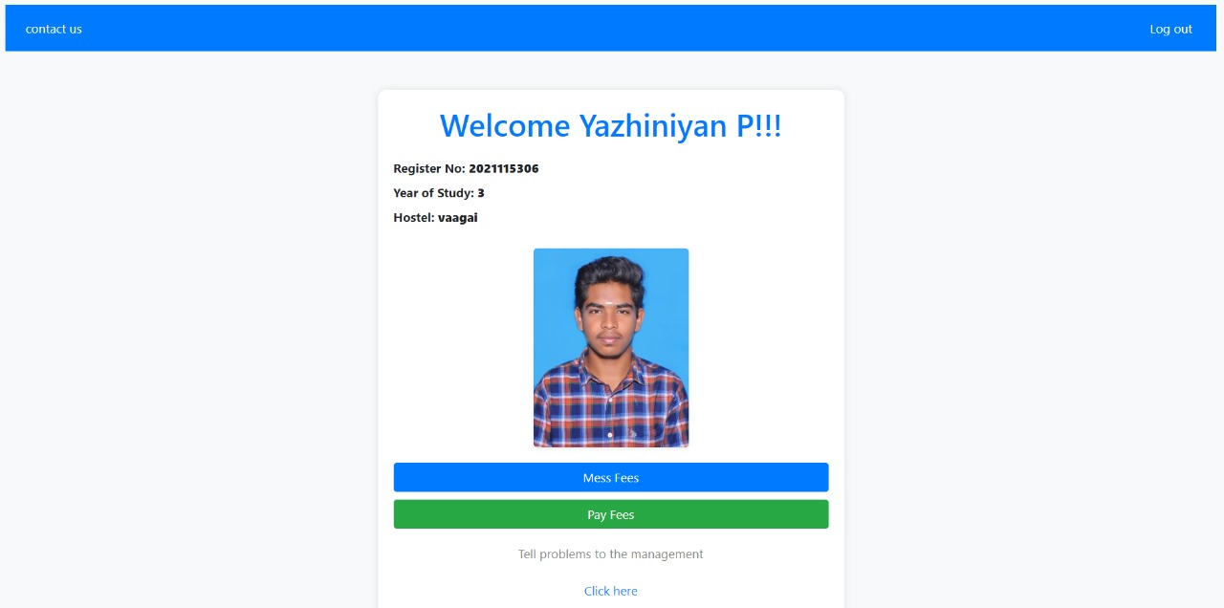

**Step 7**: Fees Payment And Generate Pdf:

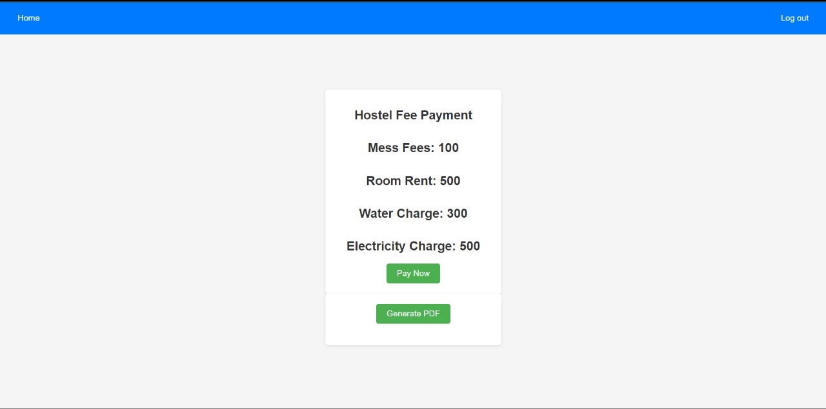

**Step 8:** [USER INFO AND FEES PAID STATUS ](PDF) STORE IN AWS CLOUD :

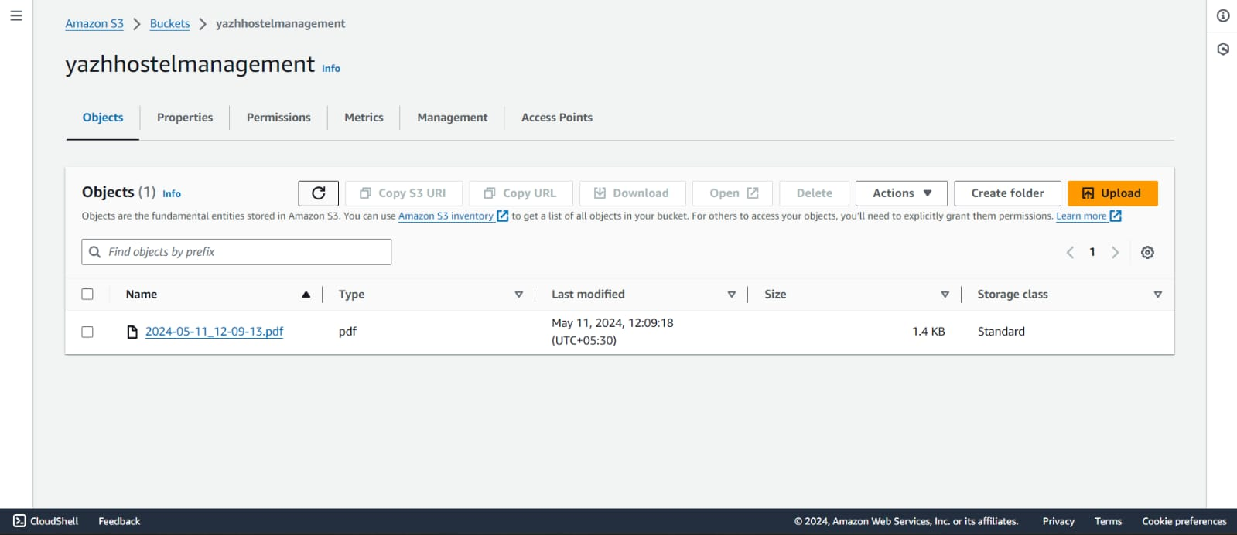

**Step 9:** Successfully Generated Pdf :

https://github.com/DIST-AnnaUniversity/assignment-2-Yazhiniyan.git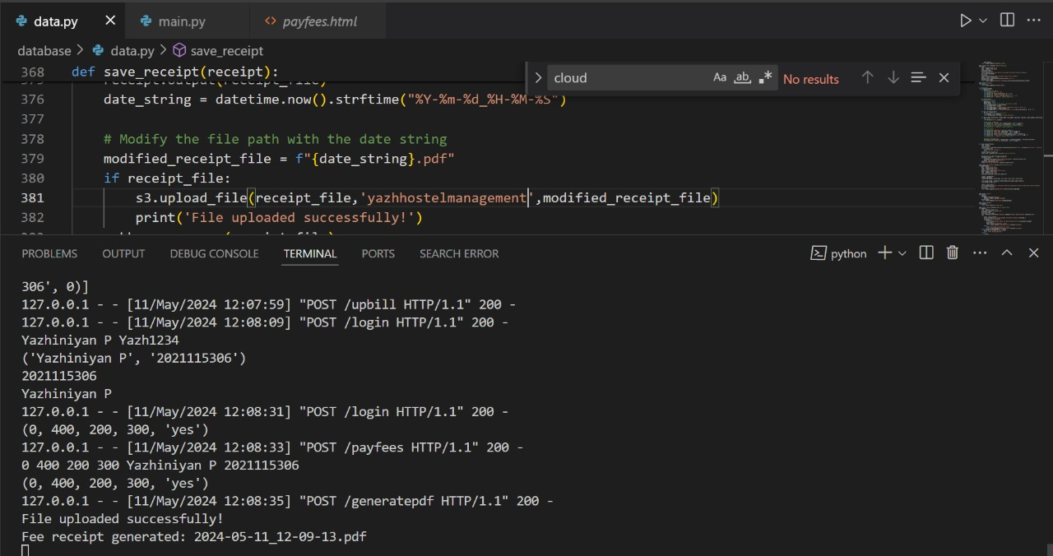

**Step 10**: The hostel management system project online fee payment, and PDF storage in AWS cloud