**Screenshots:**

**INPUT FILES:**

Sample project files: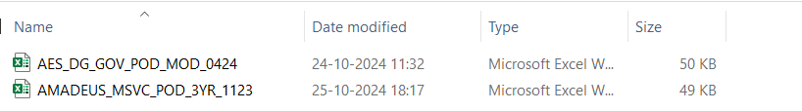

Base -Forecast Revenue data of the employees for a particular project name(project code):

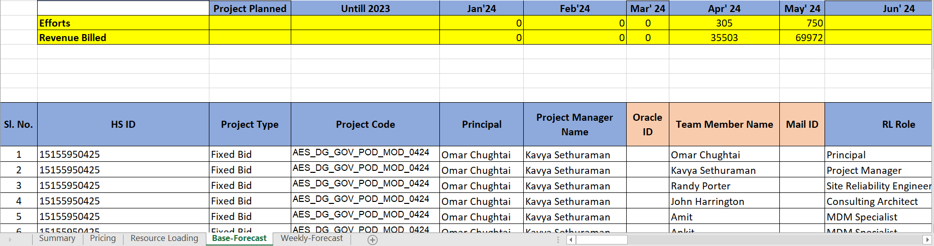

Weekly-Forecast Revenue data of the employees for a particular project name:

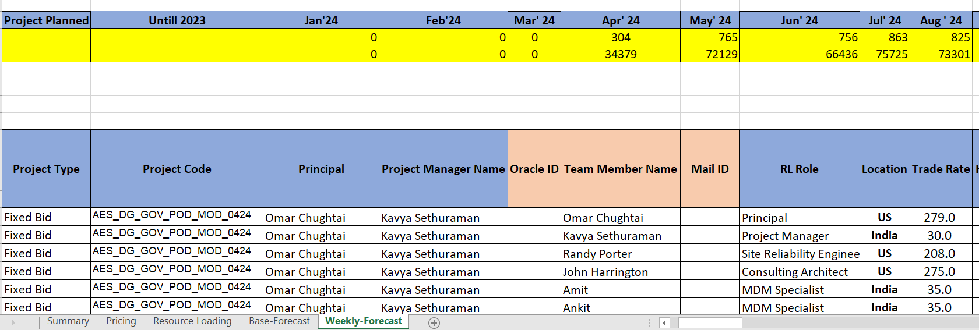

Employee Report(This contains all the employees ,the managers ,project details and no of hours the employee has actually worked on that particular project):

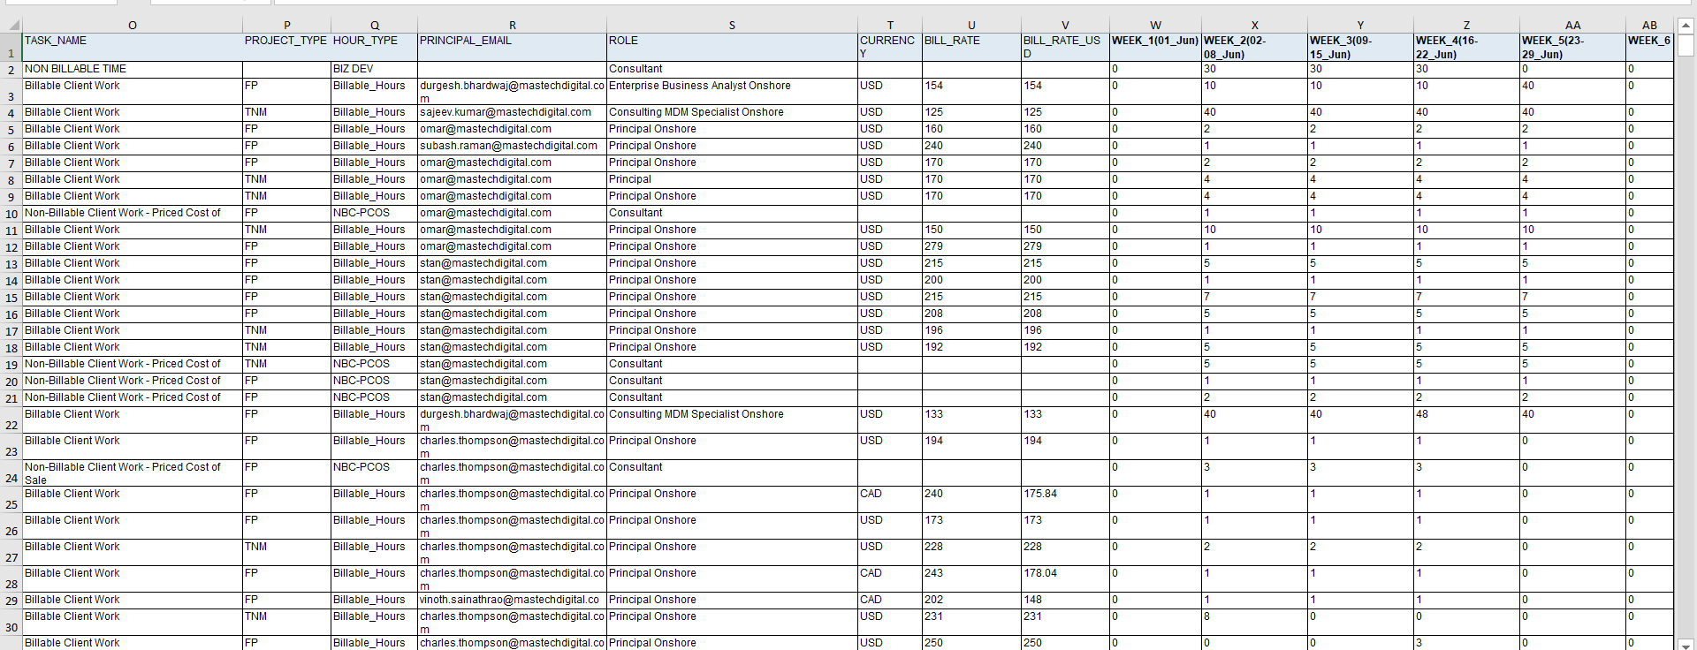

**OUTPUT FILES:**

**Consolidation of project details to a particular files:**

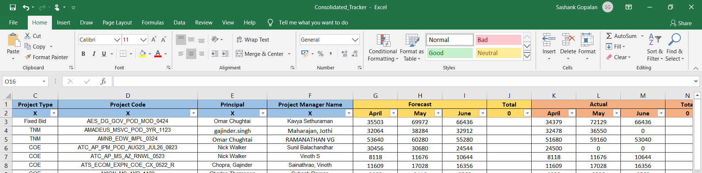

Console output:

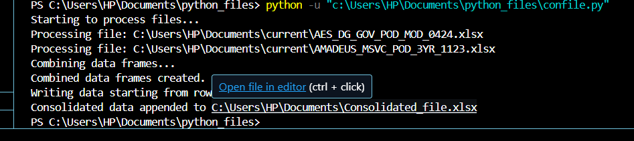

**Writing the weekly-Forecast hours of all the from the employee report file to the Weekly-Forecast sheet of the project file according to their project and the employees name if their names and project are in the employee report:**

Console output:

Identifies who are all involved in the project:

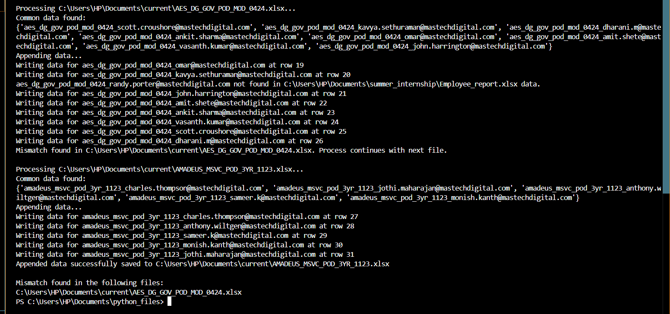

The code filters the common project data between employee report files and the weekly -forecast file as the employee report contains the employee and the project name which are not in the sample project files.

According to that the weekly -forecast hours from the employee report will be filled to the project file which has the weekly-Forecast.

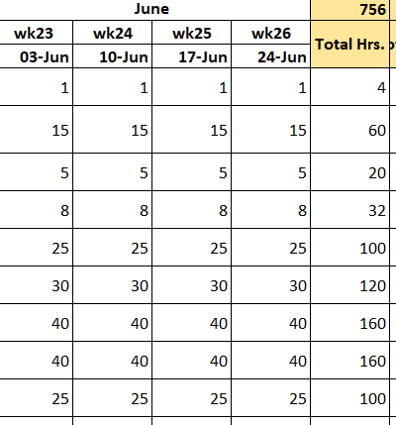

**Finding the difference in the working hours of the employee and loss in revenue:**

