DATA STRUCTURES HOMEWORK-03

1.Wirte a c program to store n elements in an array using dynamic allocation and find the largest element.
Code:
#include<stdio.h>
#include<stdlib.h>
int main()
{
int *arr,i,largest,n;
printf("Enter the number of elements:");
scanf("%d",&n);
arr=(int *)malloc(n*sizeof(int));
printf("Enter %d elements:",n);
for(i=0;i<n;i++)
{
scanf("%d",&arr[i]);
}
largest=arr[0];
for(i=1;i<n;i++)
{
if(arr[i]>largest)
{
largest=arr[i];
}
}
printf("The largest element in the array is %d",largest);
free(arr);
return 0;
}
OUTPUT:
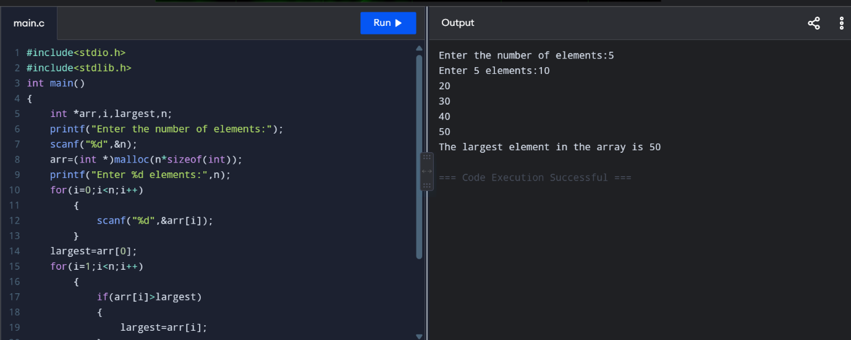

2.Print an array in reverse order using pointers.
CODE:
#include<stdio.h>
int main()
{
int *ptr,i,arr[100],n;
printf("Enter the number of elements:");
scanf("%d",&n);
printf("Enter %d elements:",n);
for(i=0;i<n;i++)
{
scanf("%d",&arr[i]);
}
ptr=&arr[n-1];
printf("Printing the elements in reverse order:");
for(i=n-1;i>=0;i--)
{
printf("%d ",*ptr);
ptr--;
}
return 0;
}
OUTPUT:
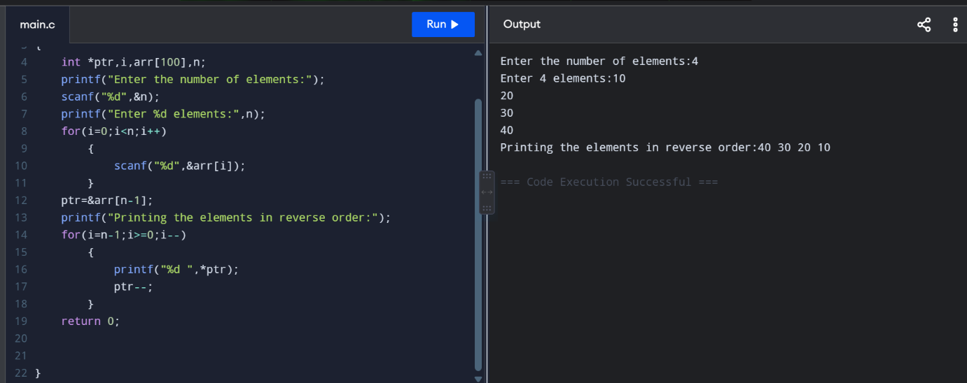

3.Write a c program to store information of students using structures. Sort them by name.
CODE:
#include<stdio.h>
#include<string.h>
struct student
{
int rollno;
char name[30];
float marks;
};
int main()
{
int i,n,j;

struct student S[100],temp;
printf("Enter the number of students:");
scanf("%d",&n);
for (i = 0; i < n; i++)
{
printf("\nEnter details of student %d:\n", i + 1);

printf("Roll Number: ");
scanf("%d", &S[i].rollno);

printf("Name: ");
scanf(" %[^\n]", S[i].name);

printf("Marks: ");
scanf("%f", &S[i].marks);
}
for(i=0;i<n-1;i++)
{
for(j=i+1;j<n;j++)
{
if(strcmp(S[i].name,S[j].name)>0)
{
temp=S[i];
S[i]=S[j];
S[j]=temp;
}
}
}
printf("\nStudents sorted by name:\n");

for (i = 0; i < n; i++)
{
printf("\nRoll Number: %d", S[i].rollno);
printf("\nName: %s", S[i].name);
printf("\nMarks: %.2f\n", S[i].marks);
}

return 0;
}

OUTPUT: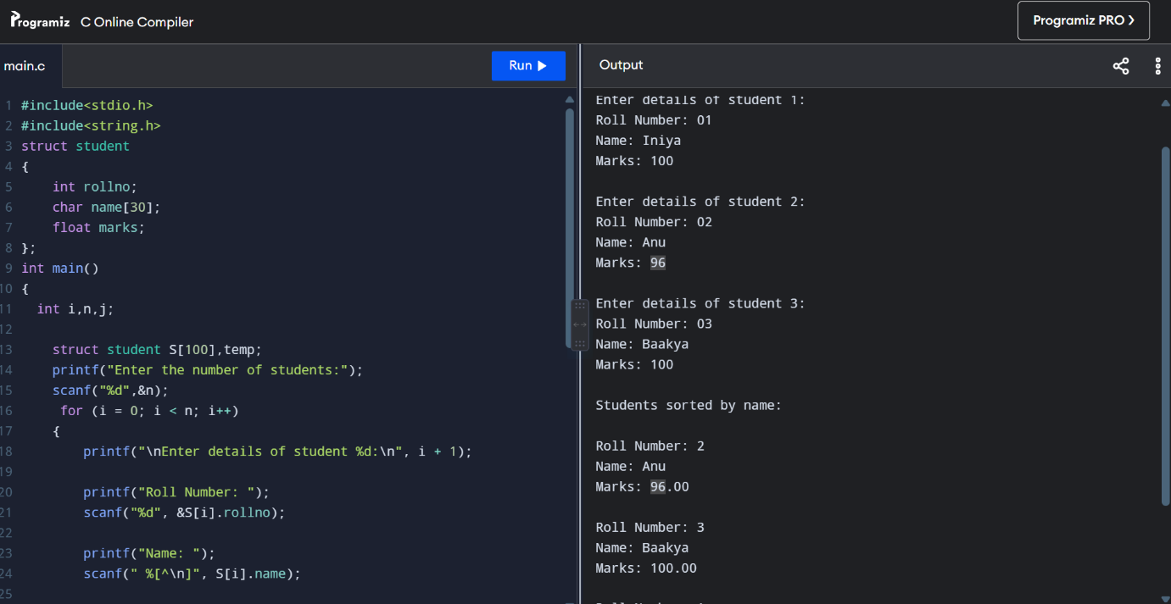

4.Write a c program to add ‘n’ distances given in inch-feet system using structures.
CODE:
#include <stdio.h>

struct Distance
{
int feet;
int inch;
};
int main()
{
struct Distance d[100], sum = {0, 0};
int n, i;
printf("Enter the number of distances: ");
scanf("%d", &n);
for (i = 0; i < n; i++)
{
printf("\nEnter distance %d:\n", i + 1);

printf("Feet: ");
scanf("%d", &d[i].feet);

printf("Inches: ");
scanf("%d", &d[i].inch);
}
for (i = 0; i < n; i++)
{
sum.feet = sum.feet + d[i].feet;
sum.inch = sum.inch + d[i].inch;
}
if (sum.inch >= 12)
{
sum.feet = sum.feet + sum.inch / 12;
sum.inch = sum.inch % 12;
}
printf("\nTotal Distance = %d feet %d inches\n",
sum.feet, sum.inch);
return 0;
}
OUTPUT: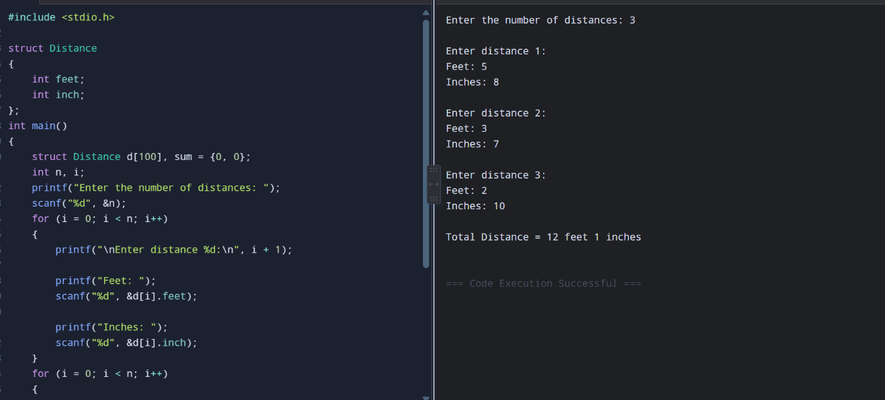

5.Write a c program to add two complex numbers by passing structures in a function.
CODE:
#include<stdio.h>
struct complex
{
float real;
float img;
};
struct complex add(struct complex c1,struct complex c2)
{
struct complex result;
result.real=c1.real+c2.real;
result.img=c2.img+c2.img;
return result;
}
int main()
{
struct complex c1,c2,sum;

printf("Enter the real and imaginary part of complex number 1:");
scanf("%f %f",&c1.real,&c1.img);
printf("Enter the real and imaginary part of complex number 2:");
scanf("%f %f",&c2.real,&c2.img);

sum=add(c1,c2);
printf("\nSum = %.2f + %.2fi\n", sum.real, sum.img);
}
OUTPUT:
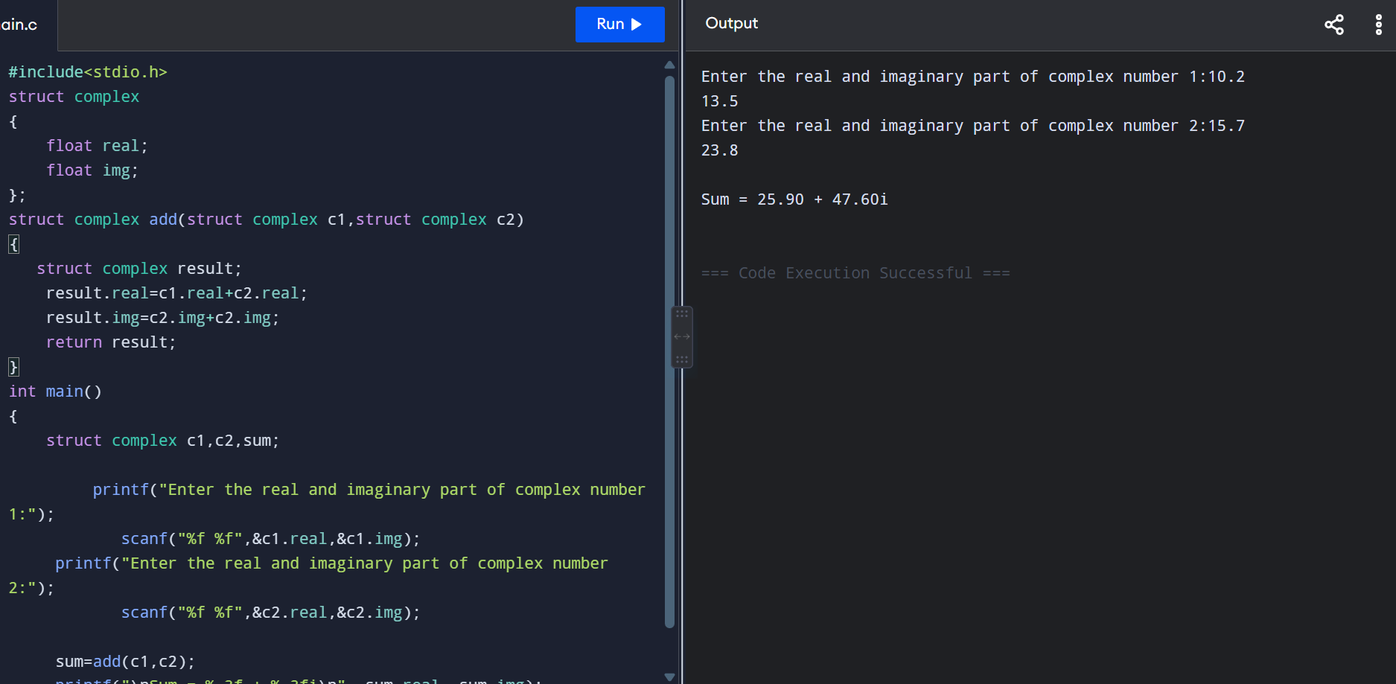
6.Write a c program to maintain the inventory management system using structures.
CODE:
#include <stdio.h>
struct Product
{
int id;
char name[50];
int quantity;
float price;
};
int main()
{
struct Product p[100];
int n, i;
float total;

printf("Enter the number of products: ");
scanf("%d", &n);
for (i = 0; i < n; i++)
{
printf("\nEnter details of product %d:\n", i + 1);
printf("Product ID: ");
scanf("%d", &p[i].id);
printf("Product Name: ");
scanf(" %[^\n]", p[i].name);
printf("Quantity: ");
scanf("%d", &p[i].quantity);
printf("Price per unit: ");
scanf("%f", &p[i].price);
}
printf("\n----- INVENTORY -----\n");
printf("ID\tName\t\tQuantity\tPrice\tValue\n");
total = 0;
for (i = 0; i < n; i++)
{
float value = p[i].quantity * p[i].price;
printf("%d\t%-15s\t%d\t\t%.2f\t%.2f\n",
p[i].id,
p[i].name,
p[i].quantity,
p[i].price,
value);
total = total + value;
}
printf("\nTotal Inventory Value = %.2f\n", total);
return 0;
}

OUTPUT:
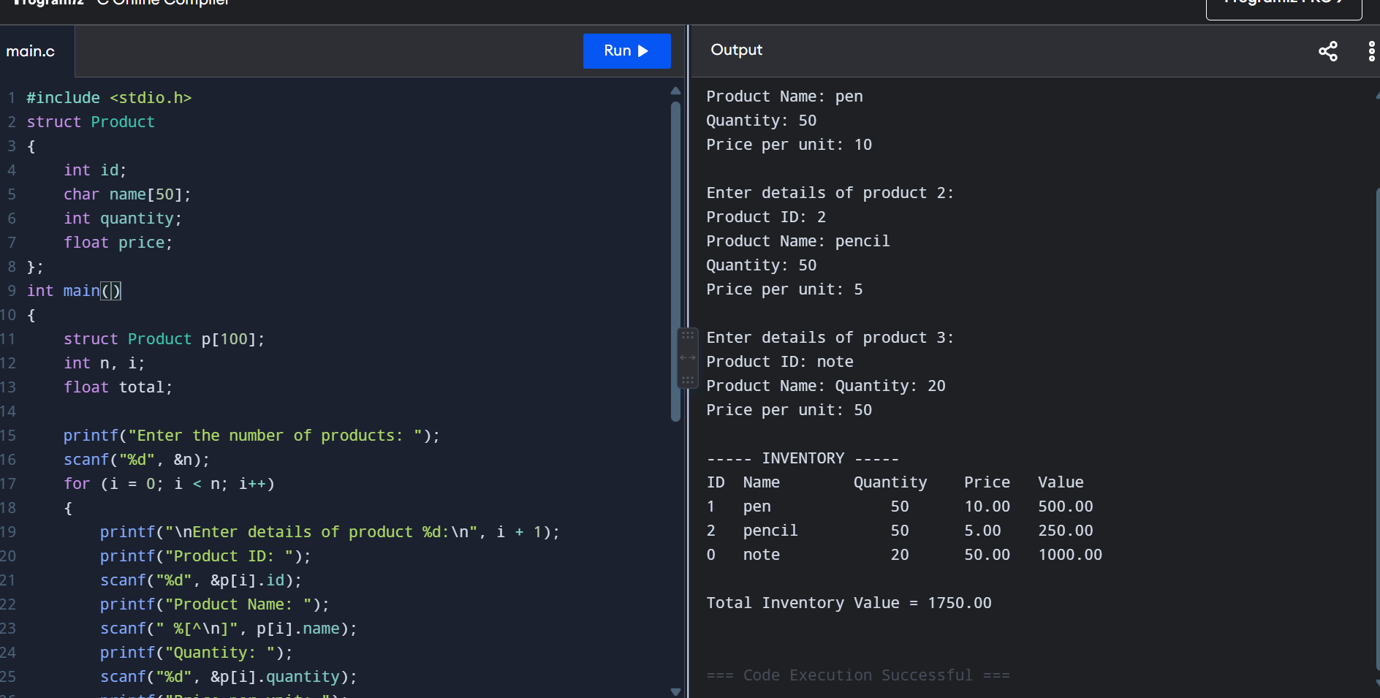

7.Write a c program for decimal to binary, octal to hexadecimal conversion.
CODE:
#include <stdio.h>
void decimalToBinary(int n)
{
int binary[32], i = 0;
if (n == 0)
{
printf("Binary = 0");
return;
}
while (n > 0)
{
binary[i] = n % 2;
n = n / 2;
i++;
}
printf("Binary = ");
for (i = i - 1; i >= 0; i--)
{
printf("%d", binary[i]);
}
}
void octalToHexadecimal(int octal)
{
int decimal = 0, base = 1, remainder;
while (octal > 0)
{
remainder = octal % 10;
decimal = decimal + remainder * base;
base = base * 8;
octal = octal / 10;
}
printf("Hexadecimal = ");
if (decimal == 0)
{
printf("0");
return;
}
char hex[20];
int i = 0;
while (decimal > 0)
{
remainder = decimal % 16;
if (remainder < 10)
hex[i] = remainder + '0';
else
hex[i] = remainder - 10 + 'A';
decimal = decimal / 16;
i++;
}
for (i = i - 1; i >= 0; i--)
{
printf("%c", hex[i]);
}
}
int main()
{
int decimal, octal;
printf("Enter a decimal number: ");
scanf("%d", &decimal);
decimalToBinary(decimal);
printf("\n\nEnter an octal number: ");
scanf("%d", &octal);
octalToHexadecimal(octal);
return 0;
}
OUTPUT:
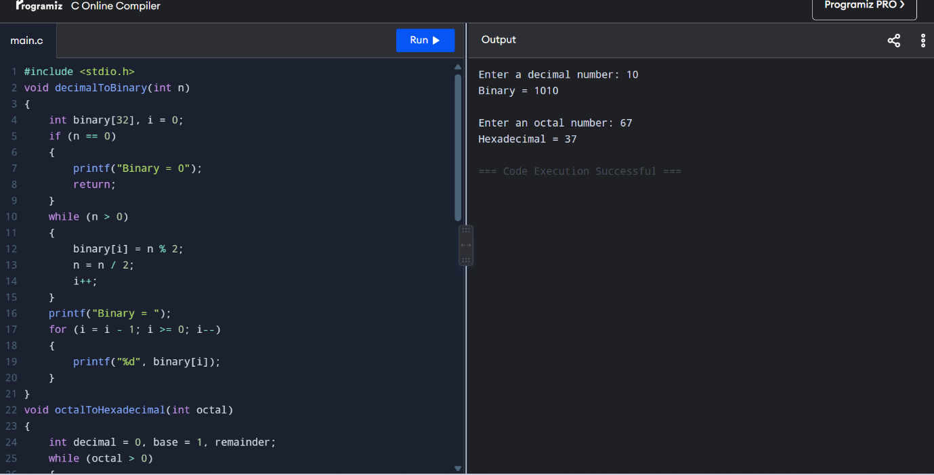

8.Write a c program to calculate difference between two time periods.
CODE:
#include <stdio.h>
struct Time
{
int hours;
int minutes;
int seconds;
};
int main()
{
struct Time t1, t2, diff;
printf("Enter first time period:\n");
printf("Hours: ");
scanf("%d", &t1.hours);
printf("Minutes: ");
scanf("%d", &t1.minutes);
printf("Seconds: ");
scanf("%d", &t1.seconds);
printf("\nEnter second time period:\n");
printf("Hours: ");
scanf("%d", &t2.hours);
printf("Minutes: ");
scanf("%d", &t2.minutes);
printf("Seconds: ");
scanf("%d", &t2.seconds);
if (t1.hours < t2.hours ||
(t1.hours == t2.hours && t1.minutes < t2.minutes) ||
(t1.hours == t2.hours && t1.minutes == t2.minutes &&
t1.seconds < t2.seconds))
{
struct Time temp = t1;
t1 = t2;
t2 = temp;
}
if (t1.seconds < t2.seconds)
{
t1.seconds += 60;
t1.minutes--;
}
diff.seconds = t1.seconds - t2.seconds;
if (t1.minutes < t2.minutes)
{
t1.minutes += 60;
t1.hours--;
}
diff.minutes = t1.minutes - t2.minutes;
diff.hours = t1.hours - t2.hours;
printf("\nDifference = %d hours %d minutes %d seconds\n",
diff.hours, diff.minutes, diff.seconds);
return 0;
}
OUTPUT:
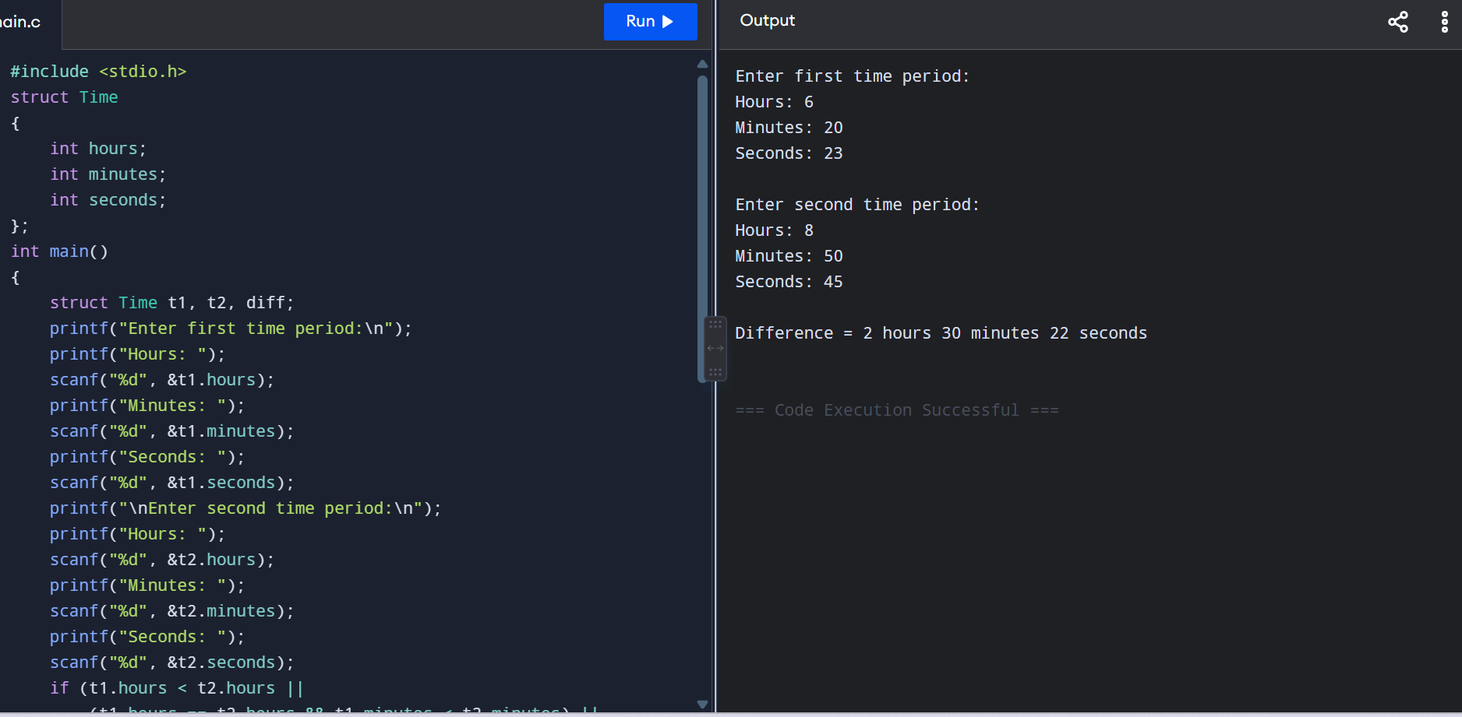
9.Write a c program to implement an employee management system using structures.
CODE:
#include <stdio.h>
#include <string.h>
struct Employee
{
int id;
char name[50];
char department[30];
float salary;
};
int main()
{
struct Employee emp[100];
int n, i, searchId, found = 0;
printf("Enter the number of employees: ");
scanf("%d", &n);
for (i = 0; i < n; i++)
{
printf("\nEnter details of Employee %d:\n", i + 1);
printf("Employee ID: ");
scanf("%d", &emp[i].id);
printf("Name: ");
scanf(" %[^\n]", emp[i].name);
printf("Department: ");
scanf(" %[^\n]", emp[i].department);
printf("Salary: ");
scanf("%f", &emp[i].salary);
}
printf("\n===== EMPLOYEE DETAILS =====\n");
for (i = 0; i < n; i++)
{
printf("\nEmployee ID : %d", emp[i].id);
printf("\nName : %s", emp[i].name);
printf("\nDepartment : %s", emp[i].department);
printf("\nSalary : %.2f\n", emp[i].salary);
}
printf("\nEnter Employee ID to search: ");
scanf("%d", &searchId);
for (i = 0; i < n; i++)
{
if (emp[i].id == searchId)
{
printf("\nEmployee Found!\n");
printf("Employee ID : %d\n", emp[i].id);
printf("Name : %s\n", emp[i].name);
printf("Department : %s\n", emp[i].department);
printf("Salary : %.2f\n", emp[i].salary);

found = 1;
break;
}
}
if (found == 0)
{
printf("Employee not found.\n");
}
return 0;
}
OUTPUT:
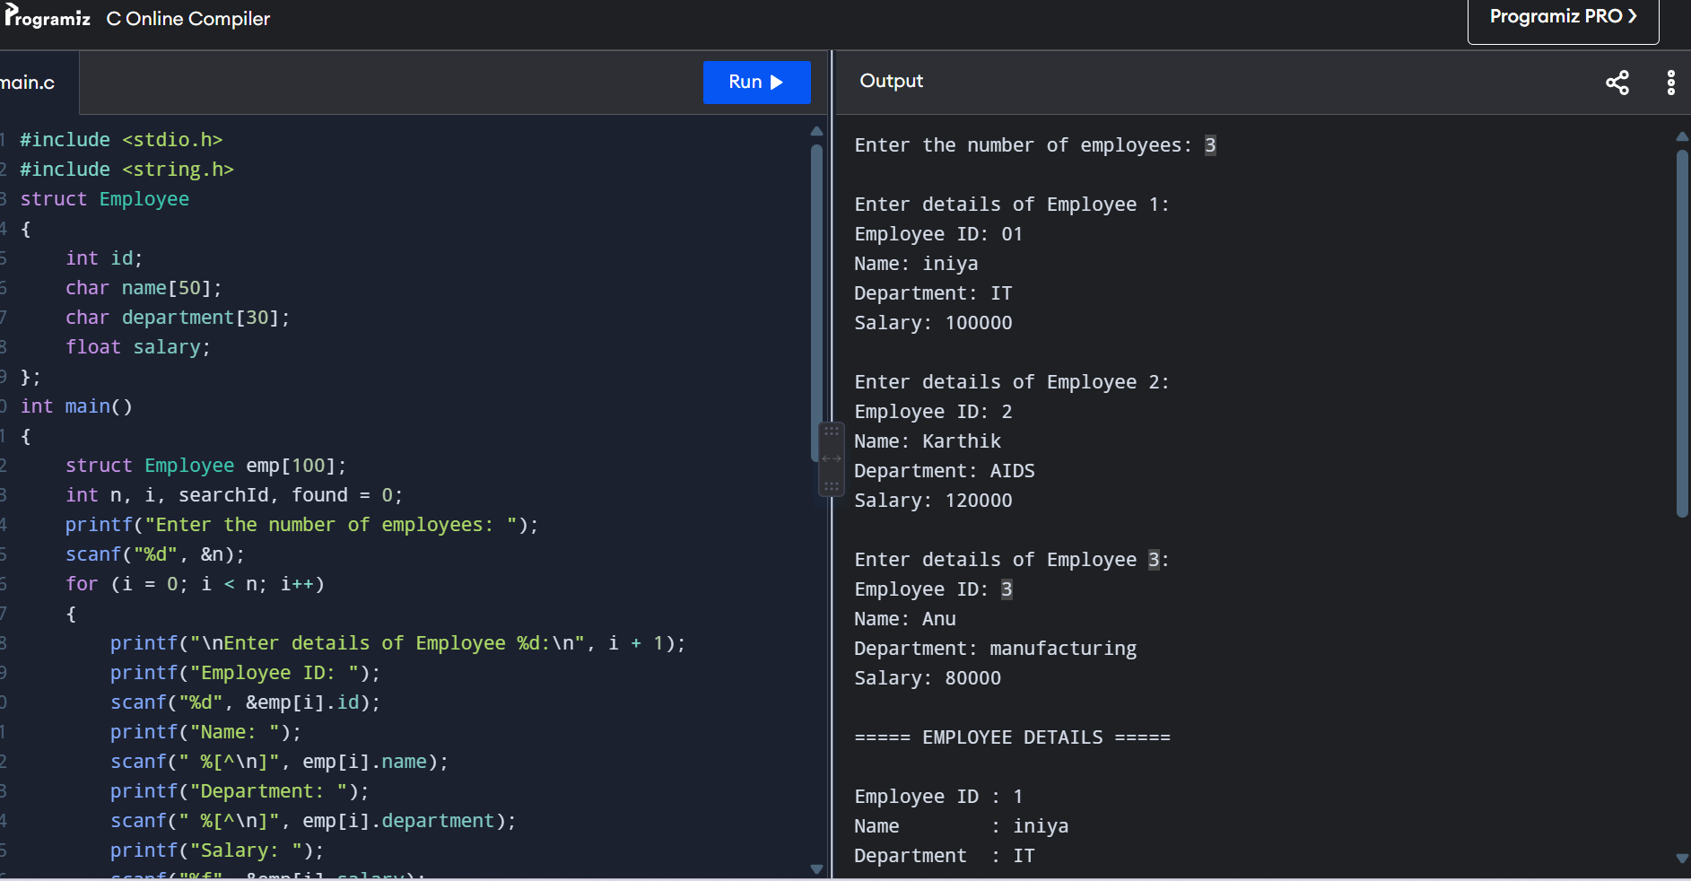

10.Write a c program to calculate area and perimeter of a rectangle and triangle using function pointers.
CODE:
#include <stdio.h>
#include <math.h>
float rectangleArea(float length, float width)
{
return length * width;
}
float rectanglePerimeter(float length, float width)
{
return 2 * (length + width);
}
float triangleArea(float base, float height)
{
return 0.5 * base * height;
}
float trianglePerimeter(float a, float b, float c)
{
return a + b + c;
}
int main()
{
float length, width;
float base, height, a, b, c;
float (*area)(float, float);
float (*perimeter)(float, float);
printf("Enter length and width of rectangle: ");
scanf("%f %f", &length, &width);
area = rectangleArea;
perimeter = rectanglePerimeter;
printf("\nRectangle Area = %.2f\n", area(length, width));
printf("Rectangle Perimeter = %.2f\n", perimeter(length, width));
printf("\nEnter base and height of triangle: ");
scanf("%f %f", &base, &height);
printf("Enter the three sides of triangle: ");
scanf("%f %f %f", &a, &b, &c);
area = triangleArea;
printf("\nTriangle Area = %.2f\n", area(base, height));
float (*trianglePeri)(float, float, float);
trianglePeri = trianglePerimeter;
printf("Triangle Perimeter = %.2f\n",
trianglePeri(a, b, c));
return 0;
}
OUTPUT:
