DATA STRUCTURES HOMEWORK-04

1. Implement a stack using queue data structure.
PROGRAM:
#include<stdio.h>
#define N 5
int q1[N], q2[N];
int front1=-1,front2=-1,rear1=-1,rear2=-1;
void push(int x)
{
int i;
if(rear1 == N-1)
{
printf("Stack overflow condition.\n");
return;
}
if(front1 == -1)
{
front1 = rear1 = 0;
q1[rear1] = x;
}
else
{
front2 = rear2 = 0;
q2[rear2] = x;
for(i=front1;i<=rear1;i++)
{
rear2++;
q2[rear2]=q1[i];
}
for(i=front2;i<=rear2;i++)
{
q1[i] = q2[i];
}
front1 = 0;
rear1 = rear2;
front2 = -1;
rear2 = -1;
}
}
void pop()
{
int x,i;
if(front1==-1)
{
printf("Stack is empty\n");
return;
}
x=q1[front1];
for(i = front1; i < rear1; i++)
{
q1[i] = q1[i + 1];
}
rear1--;
if(rear1<front1)
{
front1=-1;
rear1=-1;
}
printf("Popped element: %d",x);
}
void display()
{
if(front1==-1)
{
printf("Stack is empty\n");
return;
}
printf("Stack elements: ");
for(int i=front1;i<=rear1;i++)
{
printf("%d ",q1[i]);
}
printf("\n");
}
int main()
{
int choice,x;
while(1)
{
printf("\n-----MENU-----\n");
printf("1.push\n");
printf("2.Pop\n");
printf("3.Display\n");
printf("4.Exit\n");
printf("Enter the choice:");
scanf("%d",&choice);
switch(choice)
{
case 1:
printf("Enter element to push:");
scanf("%d",&x);
push(x);
break;
case 2:
pop();
break;
case 3:
display();
break;
case 4:
return 0;
default:
printf("Invalid choice.\n");
}
}
}
OUTPUT:
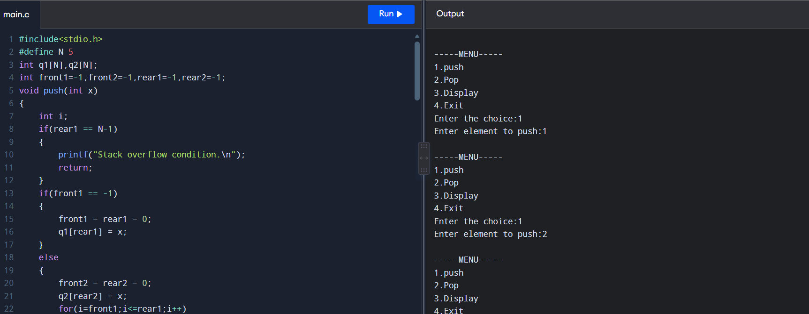

2. Implement a queue using stack data structure.
PROGRAM:
#include<stdio.h>
#define N 5
int s1[N],s2[N];
int top1=-1,top2=-1;
void push(int x)
{
if(top1==N-1)
{
printf("Queue overflow condition\n");
return;
}
else
{
s1[++top1]=x;
}
}
int pop()
{
if(top1==-1 && top2==-1)
{
printf("Stack underflow condition\n");
return -1;
}
else
{
if(top2==-1)
{
while(top1!=-1)
{
s2[++top2]=s1[top1--];
}
}
}
return s2[top2--];
}
void display()
{
if(top1==-1 && top2==-1)
{
printf("Stack is empty\n");
return;
}
else
{
printf("Queue elements: ");
for(int i=top2;i>=0;i--)
{
printf("%d ",s2[i]);
}

for(int i=0;i<=top1;i++)
{
printf("%d ",s1[i]);
}
}
}
int main()
{
int x,choice;
while(1)
{
printf("\n-------MENU-------");
printf("\n1.Push");
printf("\n2.Pop");
printf("\n3.Display");
printf("\n4.Exit");
printf("\nEnter the choice:");
scanf("%d",&choice);
switch(choice)
{
case 1:
printf("Enter element to push:");
scanf("%d",&x);
push(x);
break;
case 2:
x=pop();
if(x!=-1)
{
printf("\nPopped element: %d",x);
}
break;
case 3:
display();
break;
case 4:
return 0;
default:
printf("Invalid choice\n");
}
}
}
OUTPUT:
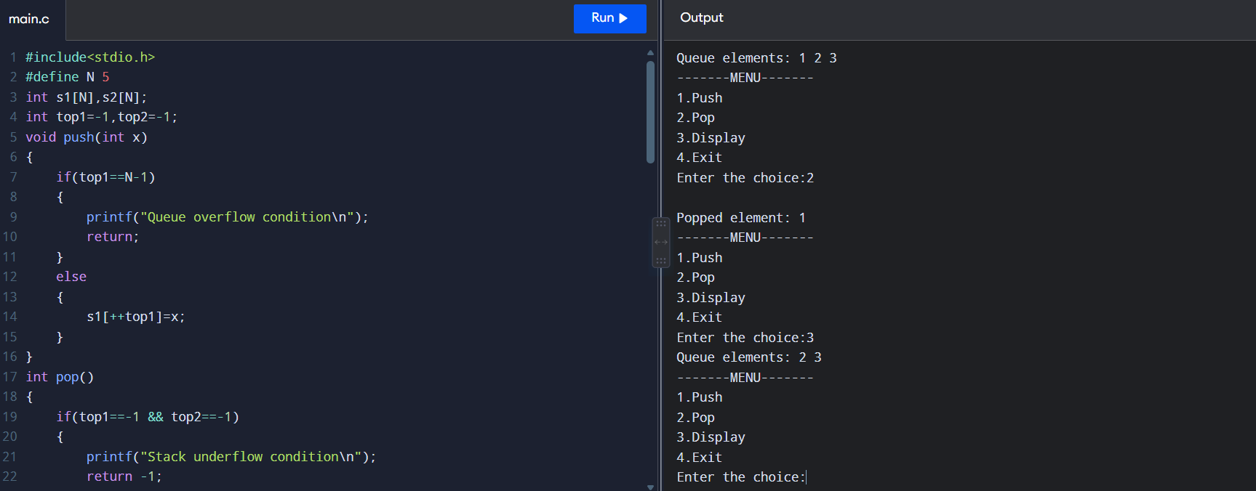
3. Write a c program using stack data structure to implement managing the history of web pages visited.
PROGRAM:
#include<stdio.h>
#include<string.h>
#define N 5
char history[N][100];
int top=-1;
void visit()
{
if(top==N-1)
{
printf("History is full\n");
return;
}
else
{
char webpage[50];
printf("Enter the webpage URL:");
scanf(" %[^\n]",webpage);
top++;
strcpy(history[top],webpage);
}
}

void goback()
{
if(top==-1)
{
printf("No pages visited yet\n");
return;
}
else
{
printf("Going back from %s\n",history[top]);
top--;
}
}
void display()
{
if(top==-1)
{
printf("History is empty\n");
return;
}
printf("Webpage History:\n");
for(int i=top;i>=0;i--)
{
printf("%s\n",history[i]);
}
}
int main()
{
int choice;
while(1)
{
printf("\n----- WEB PAGE HISTORY -----\n");
printf("1. Visit Page\n");
printf("2. Go Back\n");
printf("3. Display History\n");
printf("4. Exit\n");
printf("Enter your choice: ");
scanf("%d", &choice);
switch(choice)
{
case 1:
visit();
break;
case 2:
goback();
break;
case 3:
display();
break;
case 4:
return 0;
default:
printf("Invalid choice\n");
}
}
}
OUTPUT:
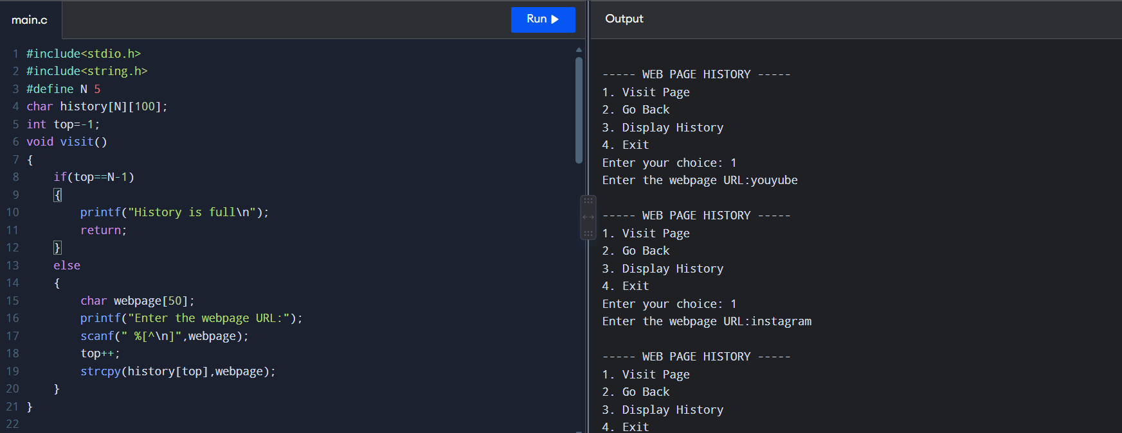
4. Write a c program to sort a stack using temporary stack.
PROGRAM:
#include <stdio.h>
#define N 5
int stack[N],temp[N];
int top=-1,ttop=-1;
void push(int x)
{
top++;
stack[top]=x;
}
int pop()
{
int x=stack[top];
top--;
return x;
}

void pushTemp(int x)
{
ttop++;
temp[ttop]=x;
}

int popTemp()
{
int x=temp[ttop];
ttop--;
return x;
}
void sort()
{
int x;
while(top!=-1)
{
x=pop();
while(ttop!=-1 && temp[ttop]>x)
{
push(popTemp());
}
pushTemp(x);
}
while(ttop!=-1)
{
push(popTemp());
}
}

int main()
{
int n,i,value;

printf("Enter number of elements: ");
scanf("%d",&n);
printf("Enter stack elements:\n");
for (i=0;i<n;i++)
{
scanf("%d",&value);
push(value);
}
sort();
printf("Sorted stack:\n");
while(top!=-1)
{
printf("%d ",pop());
}
return 0;
}
OUTPUT:
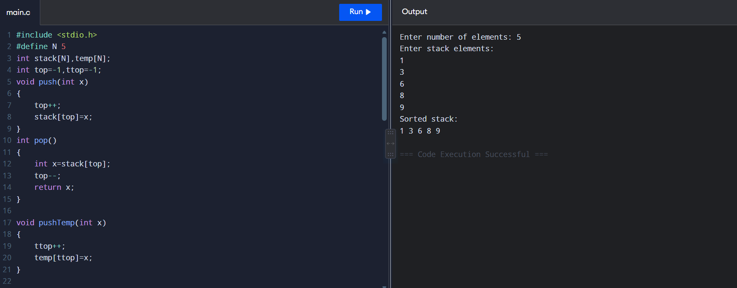
5. The stock span problem is a financial problem where we have a series of daily price queue for a stock denoted by an array and the task is calculate the span of the task is to calculate the span of the stocks price for all days. The span of a stocks price for i th day gives the maximum number of consecutive days leading up to i th day(including current day) where stocks price is less than or equal to its price on day i.(implement using stack)
Eg: Input: [100, 80, 60, 70, 60, 75, 85]
Output:[1, 1, 1, 2, 1, 4, 6].
PROGRAM:
#include<stdio.h>
#define N 100
int stack[N];
int top=-1;
void push(int x)
{
stack[++top]=x;
}
int pop()
{
return stack[top--];
}
int main()
{
int price[N],span[N];
int n,i;
printf("Enter number of days:");
scanf("%d",&n);
printf("Enter stock prices:");
for(i=0;i<n;i++)
{
scanf("%d",&price[i]);
}
span[0]=1;
push(0);
for(i=1;i<n;i++)
{
while(top!=-1 && price[stack[top]]<=price[i])
{
pop();
}
if(top==-1)
{
span[i]=i+1;
}
else
{
span[i]=i-stack[top];
}
push(i);
}
printf("Stock span:\n");
for(i=0;i<n;i++)
{
printf("%d ",span[i]);
}
return 0;
}
OUTPUT:
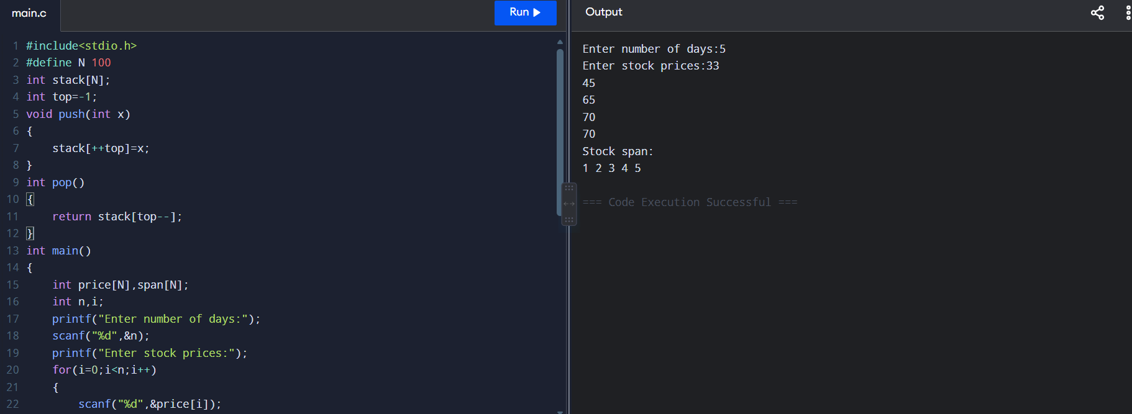

6. Given an array for each element. Find the nearest element to its right that has a higher frequency than the current element. If no such element exists set value to -1. Implement using stack.
Eg: Input: [2,1, 1, 3, 2, 1] Output: [1, -1, -1, 2, 1, -1]
PROGRAM:
#include <stdio.h>
#define MAX 100
int main()
{
int a[MAX], freq[MAX], stack[MAX], result[MAX];
int n, top = -1;
int i, j;
printf("Enter number of elements: ");
scanf("%d", &n);
printf("Enter elements:\n");
for (i = 0; i < n; i++)
scanf("%d", &a[i]);
for (i = 0; i < n; i++)
{
freq[i] = 0;

for (j = 0; j < n; j++)
{
if (a[i] == a[j])
freq[i]++;
}
}
for (i = n - 1; i >= 0; i--)
{
while (top != -1 && freq[stack[top]] <= freq[i])
{
top--;
}
if (top == -1)
result[i] = -1;
else
result[i] = a[stack[top]];
stack[++top] = i;
}
printf("Output:\n");
for (i = 0; i < n; i++)
printf("%d ", result[i]);
return 0;
}
OUTPUT:
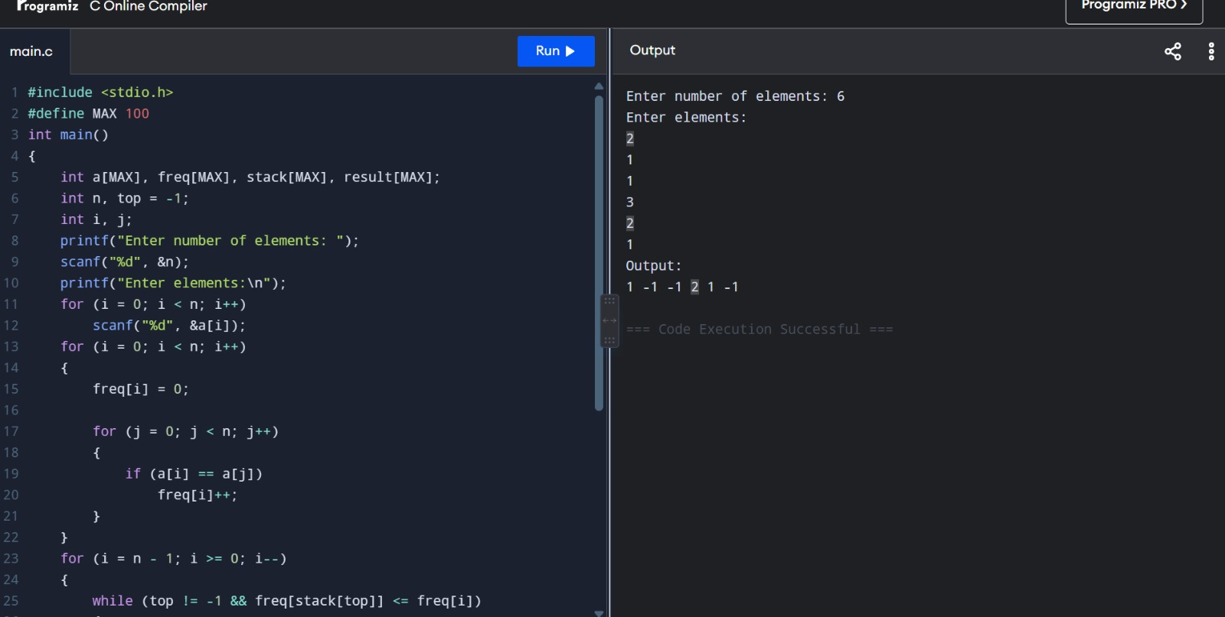

7. Given a pattern containing only I’s and D’s. ‘I’ for increasing and ‘D’ for decreasing. Device an algorithm using stack to print minimum number following that pattern.Digits from 1-9 and digits can’t repeat.
Eg: I/P: D → O/P: 21, I/P: DIDI → O/P: 21435
PROGRAM:
#include<stdio.h>
#include<string.h>
#define N 100
int stack[N];
int top=-1;
void push(int x)
{
stack[++top]=x;
}
int pop()
{
return stack[top--];
}
int main()
{
char pattern[N];
int i,n;
printf("Enter the pattern(I/D):");
scanf("%s",pattern);
n=strlen(pattern);
printf("Output: ");
for(i=0;i<=n;i++)
{
push(i+1);
if(i==n || pattern[i]=='I')
{
while(top!=-1)
{
printf("%d",pop());
}
}
}
return 0;
}
OUTPUT:
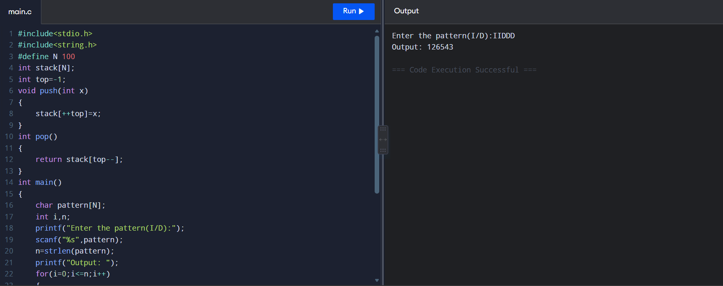

8. Given an array of digits (values are from 0 to 9) find the minimum possible sum of two numbers formed from digits of the array. All digits of given array must be used to form the two numbers. Use queue for implementation.
Eg: I/p: [6,8,4,5,2,3] O\p: 604 (min: Sum formed by no’s 358 and 246)
PROGRAM:
#include<stdio.h>
#define N 100
int queue[N];
int front=-1,rear=-1;
void enqueue(int x)
{
if(rear==N-1)
{
return;
}
if(front==-1)
{
front=0;
}
rear++;
queue[rear]=x;
}
int dequeue()
{
int x;
x=queue[front];
front++;
return x;
}
int main()
{
int a[N],n,i,j,temp;
int n1=0,n2=0;
printf("Enter number of digits:");
scanf("%d",&n);
printf("Enter the digits:");
for(i=0;i<n;i++)
{
scanf("%d",&a[i]);
}
for(i=0;i<n-1;i++)
{
for(j=i+1;j<n;j++)
{
if(a[i]>a[j])
{
temp=a[i];
a[i]=a[j];
a[j]=temp;
}
}
}
for(i=0;i<n;i++)
{
enqueue(a[i]);
}
for(i=0;i<n;i++)
{
if(i%2==0)
{
n1=n1*10+dequeue();
}
else
{
n2=n2*10+dequeue();
}
}
printf("Minimum sum = %d",n1+n2);
return 0;
}
OUTPUT:

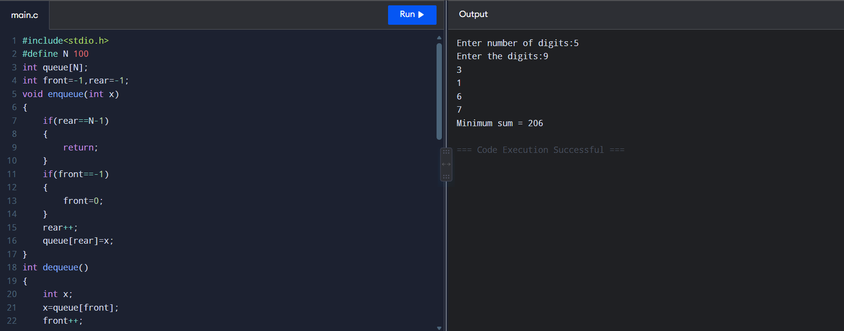
9. Given an array and a positive integer k,find the first negative integer for each window (contiguous subarray) of size k. If a window does not contain a negative integer, then print 0 for that window. Implement using queue.
Eg: I/P: [-8, 2, 3, -6,1] k=2, O/P: [-8, 0, -6, -6]. first negative integer for each window of size 2.
[-8, 2]=-8, [2, 3]=0 (no negative), [3,-6]=-6, [-6,1]=-6.
PROGRAM:
#include<stdio.h>
#define N 100
int queue[N];
int front=-1,rear=-1;
void enqueue(int x)
{
if(rear==N-1)
{
return;
}
if(front==-1)
{
front=0;
}
rear++;
queue[rear]=x;
}
int dequeue()
{
int x=queue[front];
front++;
return x;
}
int main()
{
int a[N],i,j,k,n;
printf("Enter number of elements:");
scanf("%d",&n);
printf("Enter array elements:");
for(i=0;i<n;i++)
{
scanf("%d",&a[i]);
}
printf("Enter window size:");
scanf("%d",&k);
printf("Output: ");
for(i=0;i<=n-k;i++)
{
front=-1;
rear=-1;
for(j=i;j<i+k;j++)
{
if(a[j]<0)
{
enqueue(a[j]);
}
}
if(front==-1)
printf("0 ");
else
printf("%d ",dequeue());
}
return 0;
}
OUTPUT:
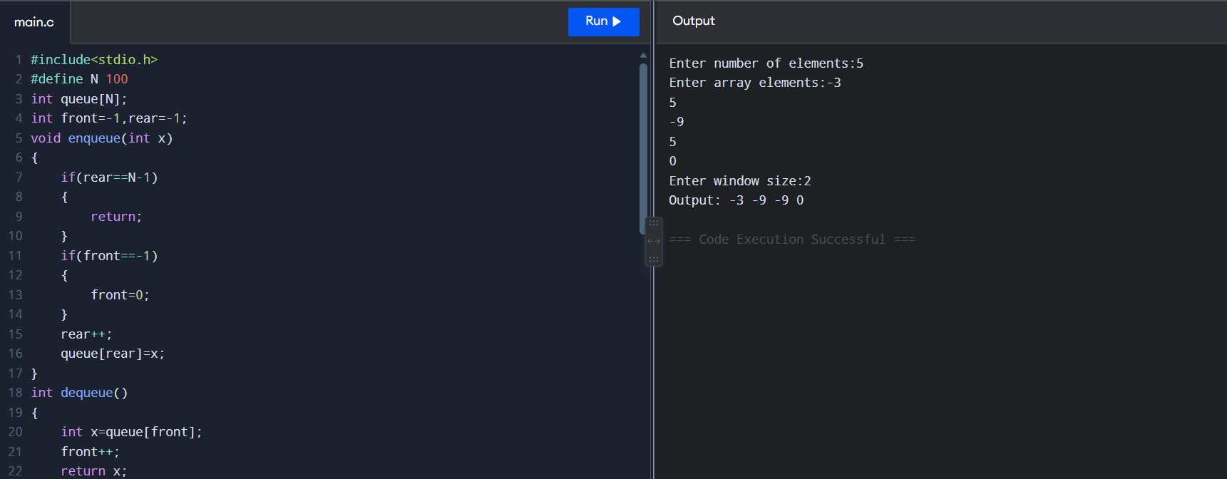

10. Given a matrix of dimension m × n where each cell can have values 0, 1, or 2, where:
- 0 → Empty cell
- 1 → Cell containing a fresh orange
- 2 → Cell containing a rotten orange
The task is to find the minimum time required so that all fresh oranges become rotten.A rotten orange at index (i, j) can rot the fresh oranges which are its 4-neighbors: up, down, left and right. If it is impossible to rot every fresh orange, return -1. Use queue implementation.
PROGRAM:
#include <stdio.h>
#define MAX 100
struct Node
{
int row;
int col;
};
int main()
{
int a[MAX][MAX];
struct Node queue[MAX * MAX];
int m, n;
int front = 0, rear = 0;
int fresh = 0;
int time = 0;
int i, j;
printf("Enter number of rows and columns: ");
scanf("%d %d", &m, &n);
printf("Enter matrix elements:\n");

for (i = 0; i < m; i++)
{
for (j = 0; j < n; j++)
{
scanf("%d", &a[i][j]);

if (a[i][j] == 1)
fresh++;

if (a[i][j] == 2)
{
queue[rear].row = i;
queue[rear].col = j;
rear++;
}
}
}
while (front < rear && fresh > 0)
{
int size = rear - front;

for (i = 0; i < size; i++)
{
int r = queue[front].row;
int c = queue[front].col;
front++;
if (r - 1 >= 0 && a[r - 1][c] == 1)
{
a[r - 1][c] = 2;
fresh--;

queue[rear].row = r - 1;
queue[rear].col = c;
rear++;
}
if (r + 1 < m && a[r + 1][c] == 1)
{
a[r + 1][c] = 2;
fresh--;

queue[rear].row = r + 1;
queue[rear].col = c;
rear++;
}
if (c - 1 >= 0 && a[r][c - 1] == 1)
{
a[r][c - 1] = 2;
fresh--;

queue[rear].row = r;
queue[rear].col = c - 1;
rear++;
}
if (c + 1 < n && a[r][c + 1] == 1)
{
a[r][c + 1] = 2;
fresh--;

queue[rear].row = r;
queue[rear].col = c + 1;
rear++;
}
}

time++;
}

if (fresh == 0)
printf("Minimum time required: %d\n", time);
else
printf("Minimum time required: -1\n");

return 0;
}
OUTPUT:
