IT23302-DATA STRUCTURES
NAME:- Dharshan Prabhu.S.B
ROLL NO:-2025115044

1. Use linked list for polynomial representation and perform addition of two polynomials.

Code

#include <stdio.h>
#include <stdlib.h>

struct Node {
int coeff, power;
struct Node *next;
};

struct Node* create(int c, int p) {
struct Node *n = malloc(sizeof(struct Node));
n->coeff = c;
n->power = p;
n->next = NULL;
return n;
}

struct Node* add(struct Node *a, struct Node *b) {
struct Node *r = NULL, *t, **p = &r;

while (a || b) {
int c, pow;

if (!b || (a && a->power > b->power)) {
c = a->coeff;
pow = a->power;
a = a->next;
}
else if (!a || b->power > a->power) {
c = b->coeff;
pow = b->power;
b = b->next;
}
else {
c = a->coeff + b->coeff;
pow = a->power;
a = a->next;
b = b->next;
}

t = create(c, pow);
*p = t;
p = &t->next;
}
return r;
}

void display(struct Node *p) {
while (p) {
printf("%dx^%d", p->coeff, p->power);
if (p->next) printf(" + ");
p = p->next;
}
}

int main() {
struct Node *a = create(3,2);
a->next = create(2,1);
a->next->next = create(1,0);

struct Node *b = create(4,2);
b->next = create(3,1);
b->next->next = create(2,0);

struct Node *r = add(a,b);

printf("Result: ");
display(r);

return 0;
}

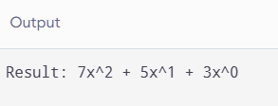

2. Find previous node of circular LL.

Code

#include <stdio.h>

struct Node {
int data;
struct Node *next;
};

int main() {
struct Node a = {10, NULL};
struct Node b = {20, NULL};
struct Node c = {30, NULL};

a.next = &b;
b.next = &c;
c.next = &a;

int key = 30;
struct Node *p = &a;

do {
if (p->next->data == key) {
printf("Previous node = %d", p->data);
break;
}
p = p->next;
} while (p != &a);

return 0;
}

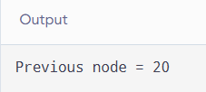

3. Insert at a given position of a circular LL.

Code

#include <stdio.h>
#include <stdlib.h>

struct Node {
int data;
struct Node *next;
};

int main() {
struct Node *head, *a, *b, *c, *n, *p;

a = malloc(sizeof(struct Node));
b = malloc(sizeof(struct Node));
c = malloc(sizeof(struct Node));

a->data = 10;
b->data = 20;
c->data = 30;

a->next = b;
b->next = c;
c->next = a;
head = a;

n = malloc(sizeof(struct Node));
n->data = 15;

p = head;
p = p->next;
n->next = p->next;
p->next = n;

p = head;
do {
printf("%d ", p->data);
p = p->next;
} while (p != head);

return 0;
}

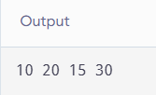

4. Find largest 2nd element in a Queue.

Code

#include <stdio.h>

int main() {
int q[] = {10, 40, 20, 50, 30};
int n = 5;
int largest = -9999, second = -9999;

for (int i = 0; i < n; i++) {
if (q[i] > largest) {
second = largest;
largest = q[i];
}
else if (q[i] > second && q[i] != largest) {
second = q[i];
}
}

printf("Second largest = %d", second);

return 0;
}

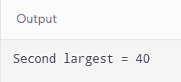

5. Insert 3rd element and check whether 1st and 3rd elements are same in a LL.

Code

#include <stdio.h>
#include <stdlib.h>

struct Node {
int data;
struct Node *next;
};

int main() {
struct Node *head, *a, *b, *c, *n;

a = malloc(sizeof(struct Node));
b = malloc(sizeof(struct Node));
c = malloc(sizeof(struct Node));

a->data = 10;
b->data = 20;
c->data = 30;

a->next = b;
b->next = c;
c->next = NULL;
head = a;

n = malloc(sizeof(struct Node));
n->data = 10;

n->next = head->next->next;
head->next->next = n;

if (head->data == head->next->next->data)
printf("1st and 3rd elements are same");
else
printf("1st and 3rd elements are not same");

return 0;
}

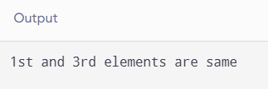

6. Implement two stacks in one array. Write a routine to traverse and display.

Code

#include <stdio.h>

#define MAX 10

int a[MAX];
int top1 = -1, top2 = MAX;

void push1(int x) {
if (top1 + 1 < top2)
a[++top1] = x;
}

void push2(int x) {
if (top1 + 1 < top2)
a[--top2] = x;
}

void display() {
int i;

printf("Stack 1: ");
for (i = 0; i <= top1; i++)
printf("%d ", a[i]);

printf("\nStack 2: ");
for (i = top2; i < MAX; i++)
printf("%d ", a[i]);
}

int main() {
push1(10);
push1(20);

push2(50);
push2(40);

display();

return 0;
}

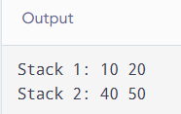

7. Given a linked list containing n head nodes where every node in the LL contains two pointers — vertical pointer to next node in the sub-linked list. The head nodes are sorted in ascending order based on their data. We need to flatten the LL so that all the nodes appear in a single LL while maintaining sorted order.

Code

#include <stdio.h>
#include <stdlib.h>

struct Node {
int data;
struct Node *next;
struct Node *down;
};

struct Node* createNode(int data)
{
struct Node *newNode =
(struct Node*)malloc(sizeof(struct Node));

newNode->data = data;
newNode->next = NULL;
newNode->down = NULL;

return newNode;
}

struct Node* merge(struct Node *a, struct Node *b)
{
struct Node dummy;
struct Node *temp = &dummy;

dummy.down = NULL;

while (a != NULL && b != NULL)
{
if (a->data <= b->data)
{
temp->down = a;
a = a->down;
}
else
{
temp->down = b;
b = b->down;
}

temp = temp->down;
}

if (a != NULL)
temp->down = a;
else
temp->down = b;

return dummy.down;
}

struct Node* flatten(struct Node *head)
{
if (head == NULL || head->next == NULL)
return head;

head->next = flatten(head->next);

head = merge(head, head->next);

return head;
}

void display(struct Node *head)
{
while (head != NULL)
{
printf("%d", head->data);

if (head->down != NULL)
printf(" -> ");

head = head->down;
}

printf("\n");
}

int main()
{
struct Node *head;

head = createNode(5);
head->next = createNode(10);
head->next->next = createNode(19);
head->next->next->next = createNode(28);

head->down = createNode(7);
head->down->down = createNode(8);

head->next->down = createNode(20);

head->next->next->down = createNode(22);

head->next->next->next->down = createNode(40);
head->next->next->next->down->down = createNode(45);

head = flatten(head);

printf("Flattened Linked List:\n");
display(head);

return 0;
}
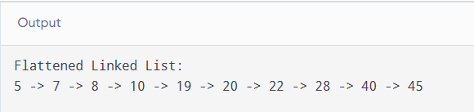

8. Given k sorted LL of different sizes, we need to merge them into a single LL for maintaining their sorted order.

Code

#include <stdio.h>
#include <stdlib.h>

struct Node {
int data;
struct Node *next;
};

struct Node* merge(struct Node *a, struct Node *b) {
struct Node dummy;
struct Node *t = &dummy;

dummy.next = NULL;

while (a && b) {
if (a->data < b->data) {
t->next = a;
a = a->next;
}
else {
t->next = b;
b = b->next;
}
t = t->next;
}

t->next = a ? a : b;
return dummy.next;
}

int main() {
struct Node *a, *b, *c, *r;

a = malloc(sizeof(struct Node));
b = malloc(sizeof(struct Node));
c = malloc(sizeof(struct Node));

a->data = 10;
a->next = NULL;

b->data = 20;
b->next = NULL;

c->data = 30;
c->next = NULL;

r = merge(a, b);
r = merge(r, c);

printf("Merged list: ");

while (r) {
printf("%d ", r->data);
r = r->next;
}

return 0;
}

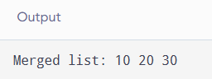

9. Swap kth node from beginning with kth node from end in a LL.

Code

#include <stdio.h>

struct Node {
int data;
struct Node *next;
};

int main() {
struct Node a = {10, NULL};
struct Node b = {20, NULL};
struct Node c = {30, NULL};
struct Node d = {40, NULL};
struct Node e = {50, NULL};

a.next = &b;
b.next = &c;
c.next = &d;
d.next = &e;

struct Node *p = &a;
struct Node *q = &a;
int k = 2, n = 0;

while (p) {
n++;
p = p->next;
}

p = &a;

for (int i = 1; i < k; i++)
p = p->next;

q = &a;

for (int i = 1; i <= n-k; i++)
q = q->next;

int temp = p->data;
p->data = q->data;
q->data = temp;

p = &a;

printf("After swapping: ");

while (p) {
printf("%d ", p->data);
p = p->next;
}

return 0;
}
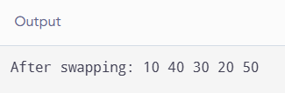

10. Multiply two numbers represented by two LL.

Code

#include <stdio.h>

struct Node {
int data;
struct Node *next;
};

long long value(struct Node *p) {
long long n = 0;

while (p) {
n = n * 10 + p->data;
p = p->next;
}

return n;
}

int main() {
struct Node a = {1, NULL};
struct Node b = {2, NULL};

struct Node c = {2, NULL};
struct Node d = {0, NULL};
struct Node e = {0, NULL};

a.next = &b;

c.next = &d;
d.next = &e;

printf("First number = %lld\n", value(&a));
printf("Second number = %lld\n", value(&c));
printf("Product = %lld", value(&a) * value(&c));

return 0;
}

